**Name: Arya Kashikar**

**PRN: 22070521036**

**Course- Certified System Administrator**

**Lab 2.1.1: Configure an Instance**

* **Section 1:**

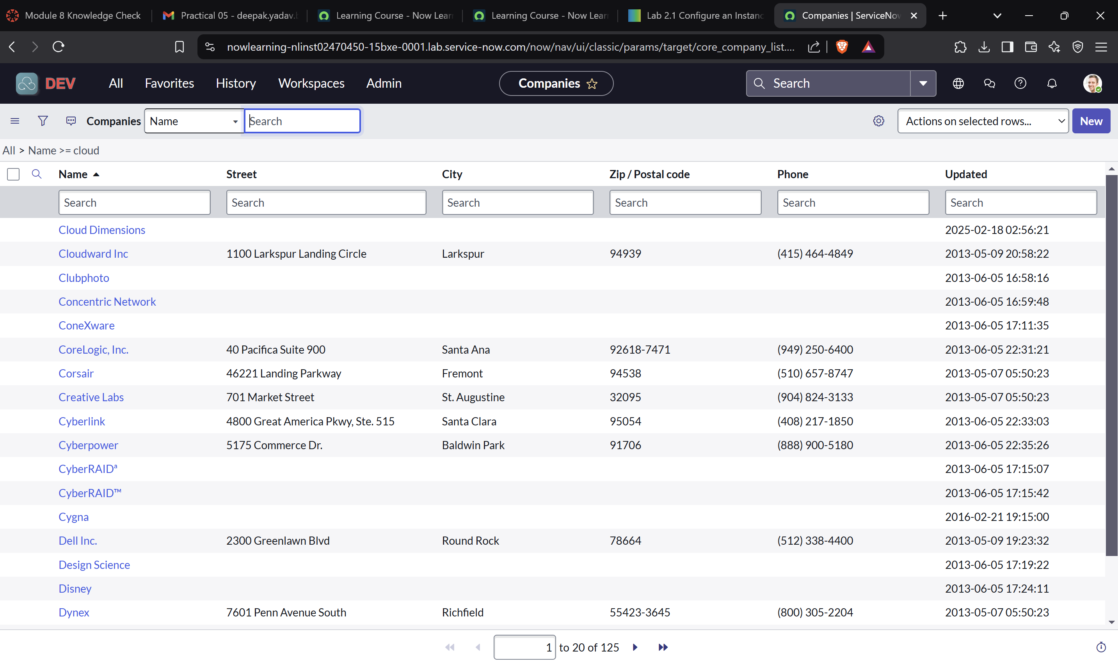

* **Section 2 :   
  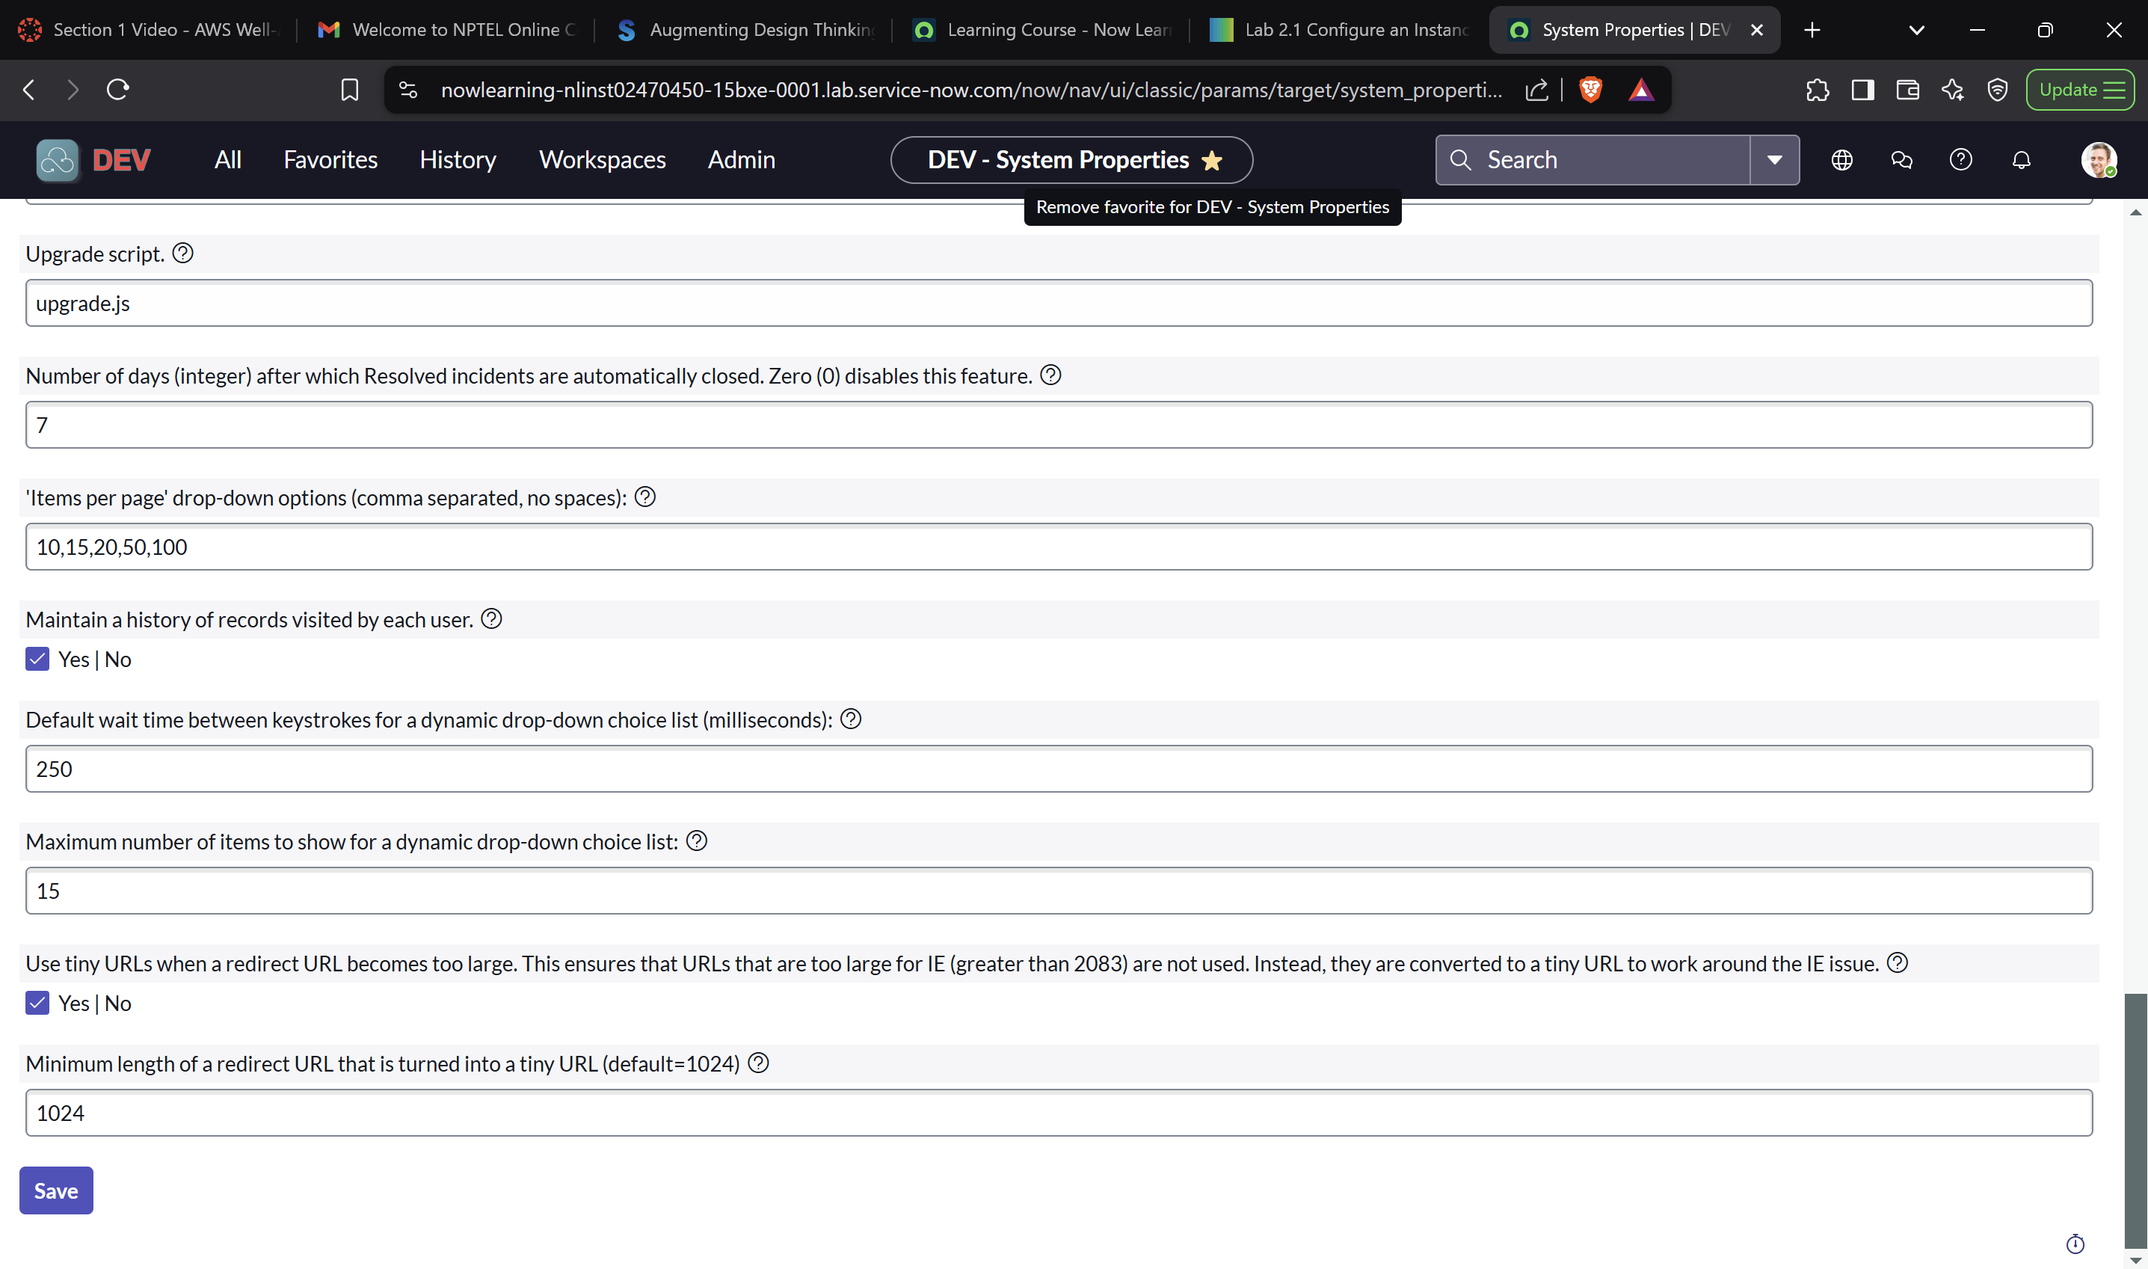**
* **Section : 3**

