**Name: Arya Kashikar**

**PRN: 22070521036**

**Course- Certified System Administrator**

**Lab 3.1.1 - Create Classic List Views**

* **Section 1: Add Pilot Column to Incident Table**

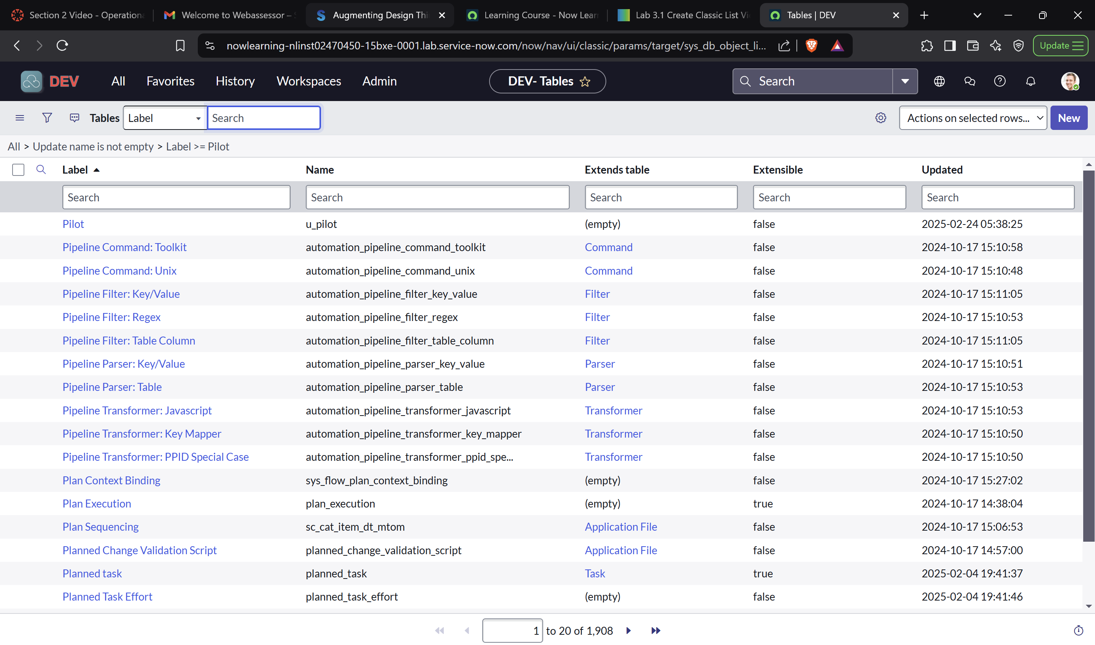

* **Section 2: View and Monitor HHD Incidents and Inquiries Using Classic View**

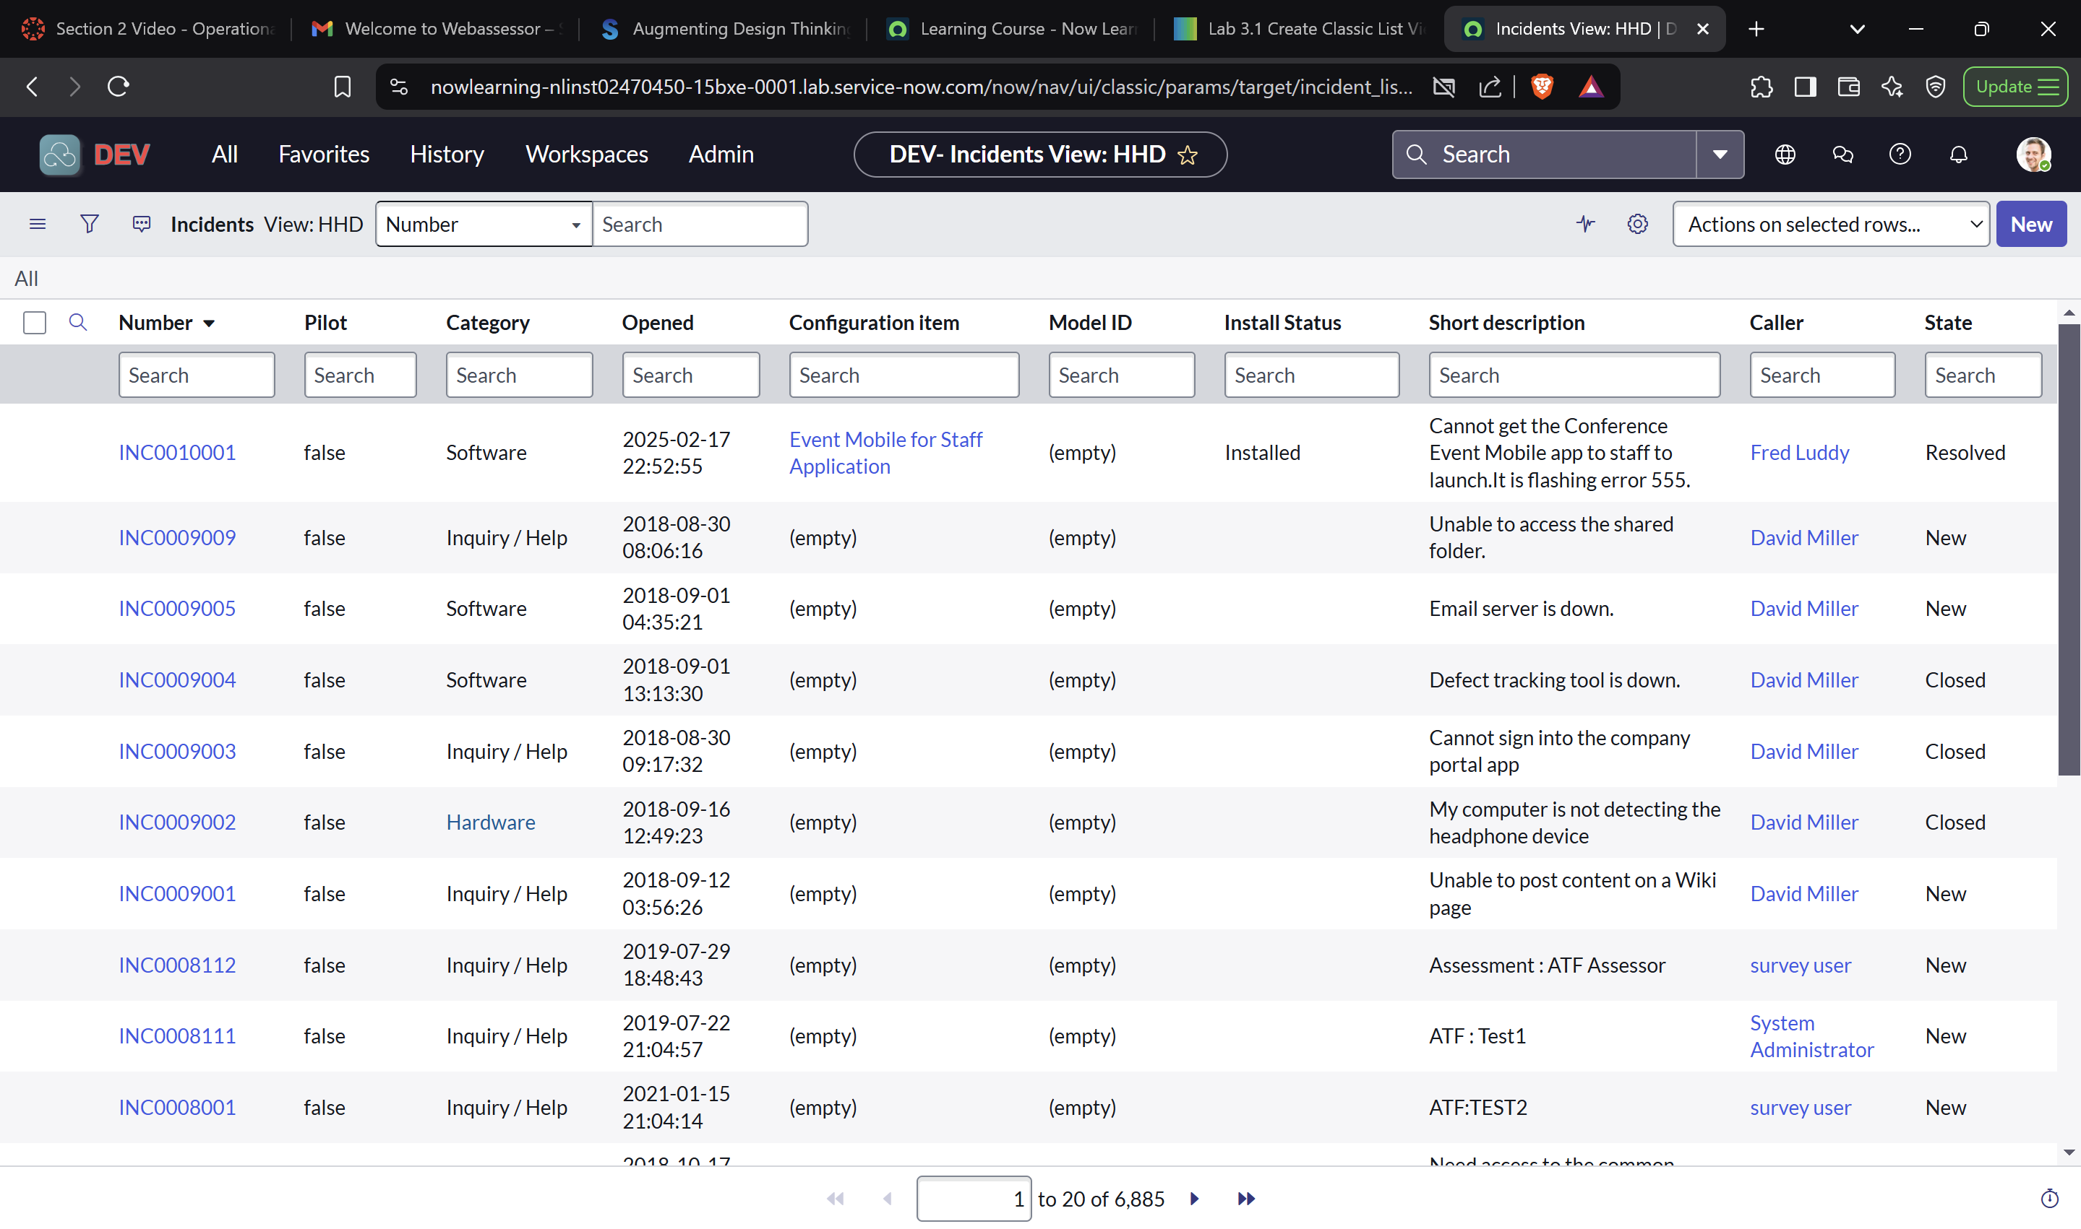

* **Section 3: Configure List on Application Menu**