Schematic Review
Power
We begin with defining the power requirements of this project. There will be both USB and LiPo battery power. The former would be responsible for charging the latter and there would be a switchover mechanism in place. That is, when USB is connected, the board is powered through it, and the LiPo battery gets charged. The battery acts as a backup source when USB is not plugged in.
First, let us consider the “USB Power” schematics:
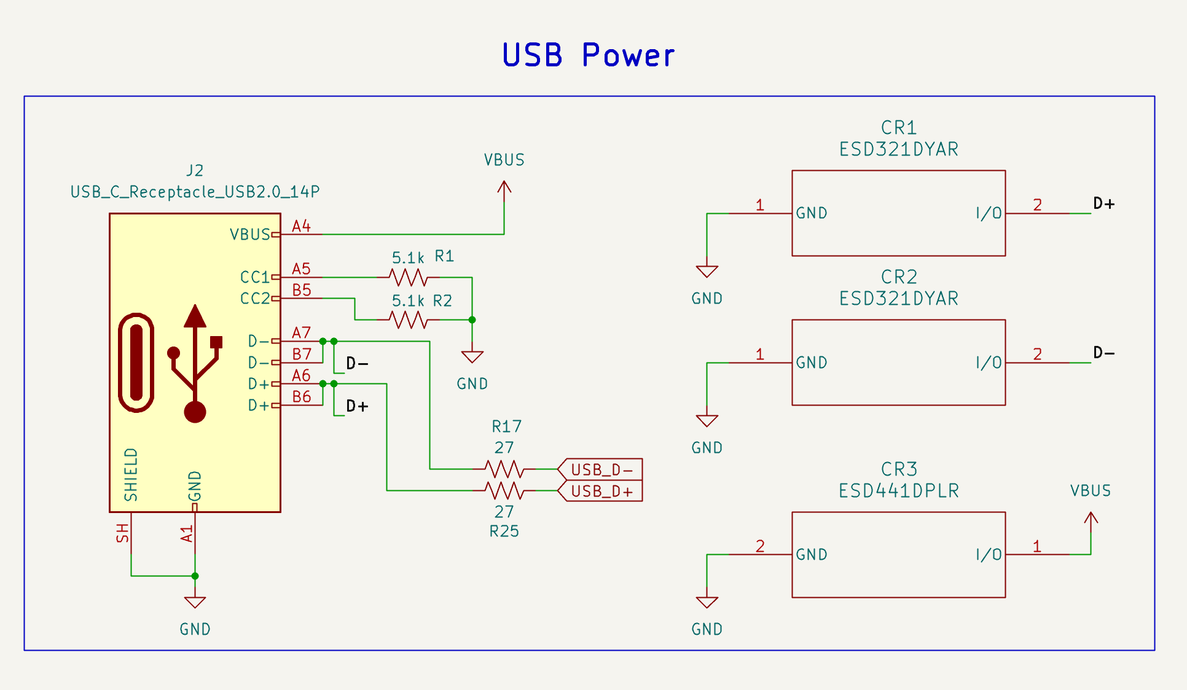
Figure 1: USB Power
We provide USB-C for power. The CC pins (configuration channel) are mainly used to signal to the source (the device providing power) to turn on +VBUS. The DFP (downstream-facing port, which is the data host and power source) has a processor that monitors the voltage at the CC lines (Enos & Gosselin, 2022, p. 4):
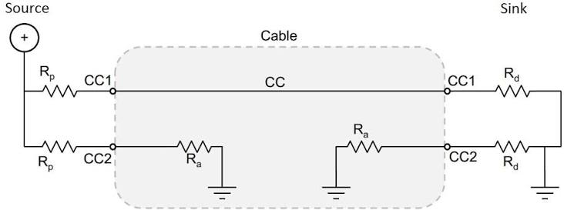
Figure 2: Configuration channel
If there is no connection, the DFP processor sees a digital high due to the pullup resistor $R_{p}$. However, when a connection is made, a voltage divider is formed. The voltage at CC1 drops and the processor knows that a connection is made, thereby turning on the voltage source. This is known as “Cable detection” (Enos & Gosselin, 2022, p. 4). The choice of $5.1kΩ$ is standard for USB-C and is used in designs such as the Adafruit Feather board (Rembor, 2025).
Since the current-carrying capability of the USB-C port is directly related to the value of the pullup resistor, by sensing the voltage at CC1, the sink can determine the advertised current. This feature is, however, not implemented in our schematic.
Additionally, $27Ω$ resistors are added in series to match the internal driver impedance (Rembor, 2025).
Finally, ESD protection is provided through an ESD diode that can dump electrostatic discharge to ground once the reverse stand-off voltage is exceeded. The recommendation given by TI in protecting USB-C ports is followed (Oji, 2024, p. 4). The reverse stand-off voltage for the ESD 321 and ESD 441 exceed the maximum possible voltage the lines can handle in normal operation (which is 3.3V for the data lines and 5V for the power lines). It can be found from the datasheet for the ESD 321 that $V_{RWM}=3.6V$ (ESD321 1-Channel 30kV ESD Protection Diode with Low Capacitance (< 1pF) in 0402 and SOD-523 Packages, 2025, p. 5) and $V_{RWM}=5.5V$ for ESD 441 (ESD441 1-Channel ±30kV Unidirectional ESD Diode in an 0201 and 0402 Package, 2026, p. 6), which meeting our constraints.
Next, we move towards the battery connector, which is shown below:
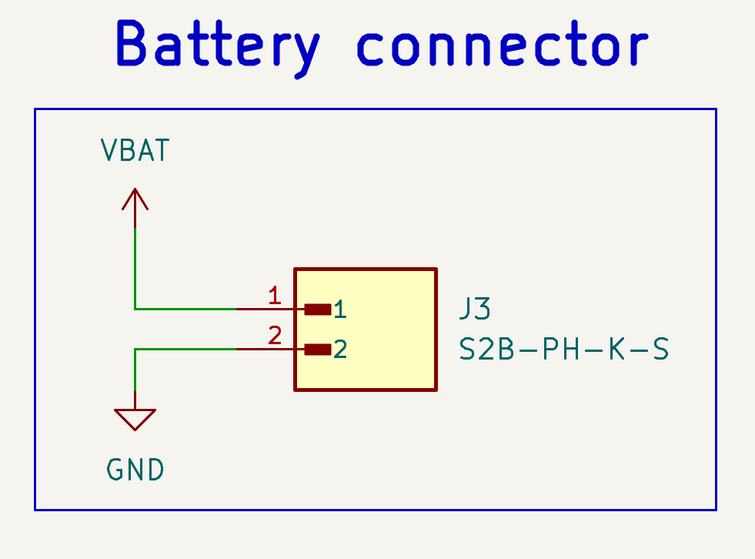
Figure 3: Battery connector
This is a 2-pin male JST PH-series connector that will mate with the female 2-pin JST-PH connector that has been crimped onto our chosen LiPo battery (Lithium Ion Polymer Battery - 3.7v 500mAh). Figure 4 shows that this connector is a 90-degree connector. This allows a more convenient and compact mounting solution for the LiPo battery.
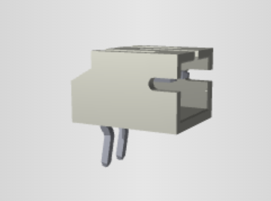
Figure 4: 3D Model of connector
Next, we review the switchover and LDO schematics:
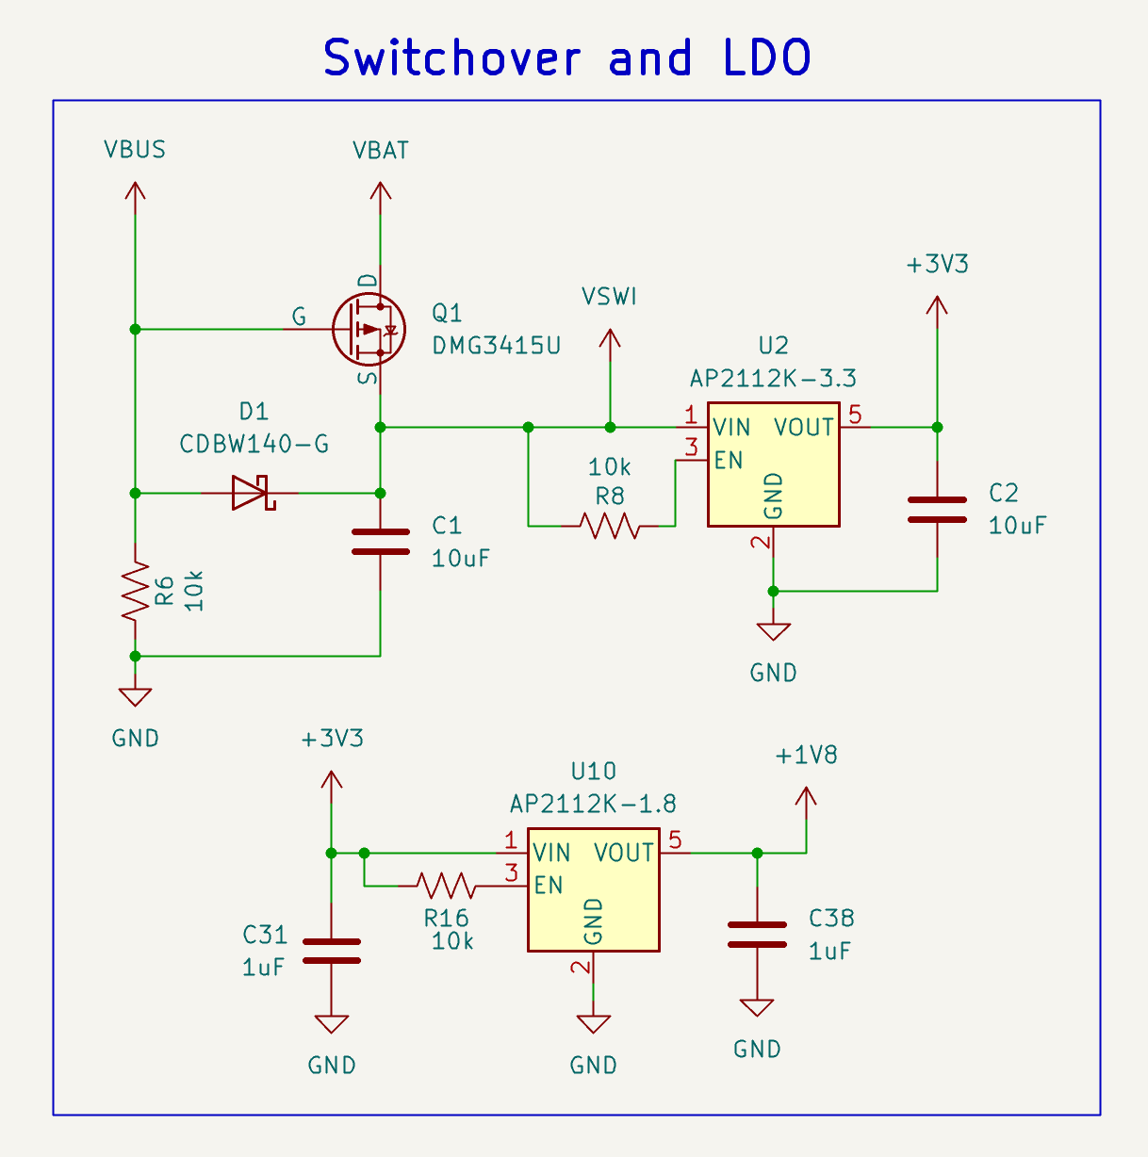
Figure 5: Switchover and LDO
Let us first discuss the switchover architecture. There are three key elements at play: $Q1, D1,$and $R6$. These correspond to a P-MOSFET, a Schottky diode and a pull-down resistor. There are two cases to be discussed:
Case 1: USB power
When USB power is on, VBUS feeds into VSWI (which represents the original, unregulated power source for the board) through a Schottky diode. The forward voltage of a D1 is around 0.60V for a current of 1A (CDBW140-G, p. 2). This would result in a drop to around 4.4V for the USB supply, at minimum. Our current draw would be significantly smaller, thereby resulting in an even lower voltage drop across the diode.
Additionally, the maximum reverse voltage is 40 V (CDBW140-G, p. 1), which guarantees that the diode would not breakdown.
The PMOSFET Q1 would have a gate voltage of roughly 5 V and a source voltage of slightly less than 5 V (around 4.4 V). Thus, it would be in an off condition. The body diode also does not conduct since VBAT has a maximum voltage of 4.2 V, which is the maximum value for a 1S LiPo battery (Lithium Ion Polymer Battery - 3.7v 500mAh) and source has a voltage of at least 4.4 V, thereby placing it in reverse bias. Thus, in this condition, $V_{SWI}=V_{BUS}-V_{f}≈V_{BUS}$.
Case 2: Battery power
Finally, when VBUS is turned off, the gate of the PMOS is pulled down by R6. The body diode initially conducts, allowing the source pin to have a voltage slightly smaller than VBAT. Now, $V_{GS}≈3V$ at minimum (assuming $V_{BAT}=3.2V$: at its lowest). Thus, the channel turns on since the gate threshold voltage for the DMG3415U is, at max, -1.0 V (DMG3415U P-Channel Enhancement Mode MOSFET, 2022, p. 2).
The diode now prevents current from flowing back to the USB connector. Its high reverse voltage prevents any scope of breakdown.
The design has been made in reference to Microchip’s recommendation for designing a switchover mechanism between a battery and USB supply (Chu, 2008). The following constraints have been observed and met in our design:
- Selecting a proper gate threshold voltage range so the MOSFET will be turned on (Chu, 2008, p. 5)
- Average forward current of diode is greater than maximum system load current for the application (Chu, 2008, p. 6)
- Low forward voltage of Schottky diode (Chu, 2008, p. 6)
Next, we have two voltage levels: 3.3 V and 1.8 V. These are generated using two LDOs. The capacitors filter out high-frequency noise in the input and output voltages. Finally, the enable pins are always set to digital high as is also done in the Adafruit Feather board (Rembor, 2025).
Subsequently, we move onto the battery charging mechanism.
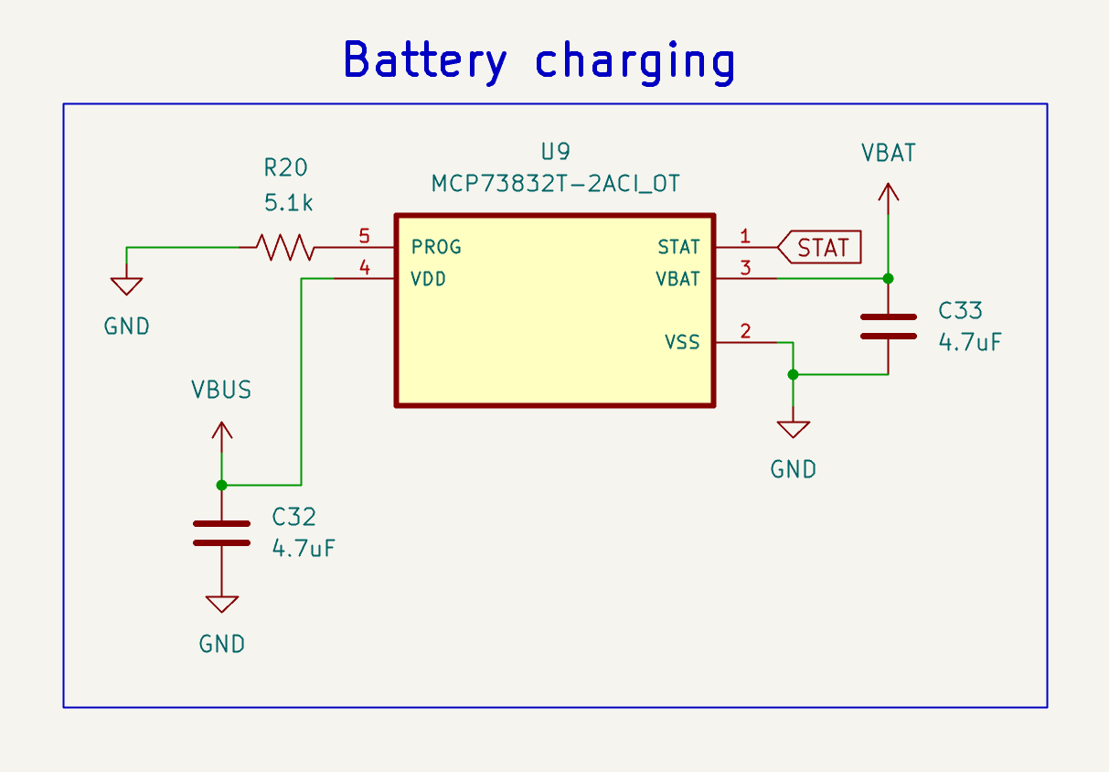
Figure 6: Battery charging
We begin by looking at the charging specifications for our choice of battery. The recommended charge rate range is from 100 to 500 mA (Lithium Ion Polymer Battery - 3.7v 500mAh). From the charging IC datasheet, the following equation is used for setting the charge rate (Miniature Single-Cell, Fully Integrated Li-Ion, Li-Polymer Charge Management Controllers, 2020, p. 15):
$$\begin{aligned}I_{reg}=\frac{1000}{R_{prog}} \#\left(1\right)\end{aligned}$$
By setting a programming resistor value of $5.1kΩ$, the charge rate comes to approximately $196 mA$. This is within the range of the recommended charge rate.
The VDD pin is the supply for charging the LiPo battery. It must be in the range 3.75 V to 6 V (Miniature Single-Cell, Fully Integrated Li-Ion, Li-Polymer Charge Management Controllers, 2020, p. 3), which is met by the USB supply. Additionally, a bypass capacitor of $4.7 μF$ is added as recommended by the datasheet (Miniature Single-Cell, Fully Integrated Li-Ion, Li-Polymer Charge Management Controllers, 2020, p. 11). Similarly, VBAT is for the positive terminal of the battery with a bypass capacitor of $4.7 μF$ (Miniature Single-Cell, Fully Integrated Li-Ion, Li-Polymer Charge Management Controllers, 2020, p. 11). Finally, the STAT pin is an open-drain pin that is low while the battery is charging and in high-Z in other states. This can be seen in Table 5.1: Status Output in the datasheet (Miniature Single-Cell, Fully Integrated Li-Ion, Li-Polymer Charge Management Controllers, 2020, p. 15):
Charge Cycle State | STAT 1
Charge Cycle State | MCP73831 | MCP73832
Shutdown | High Z | High Z
No Battery Present | High Z | High Z
Preconditioning | Low | Low
Constant-Current Fast Charge | Low | Low
Constant Voltage | Low | Low
Charge Complete | High | High-Z
Table 1: Status Output
By connecting this to a microcontroller GPIO pin and configuring its internal pullup resistor, the charge cycle state can be determined.
Next, we move on to the boost converter. Our MAX 30101 requires a separate 5 V power supply for its internal LEDs (High-Sensitivity Pulse Oximeter and Heart-Rate Sensor for Wearable Health, 2020, p. 1). The unregulated supply input can vary from 3V – 5.5V (the former is the lowest possible voltage with the LiPo battery, and the latter is the highest possible voltage with USB plugged in). This means that, in certain occasions, we would to “boost” the supply voltage to provide sufficient power to the LEDs on the MAX 30101.
The way we do this is with the TPS61099 variable output boost converter. We did not use the fixed-output voltage chip TPS610997 since it was only available in BGA and would have made assembly sufficiently more complicated. However, that would have been the more design-friendly option.
This boost converter has an absolute maximum voltage rating of 6 V and recommended operating range of 0.7V – 5.5V (TPS61099x Synchronous Boost Converter With Ultra-Low Quiescent Current, 2026, p. 4). These meet our input specifications. We have followed the recommended circuit given in the datasheet in Figure 7:
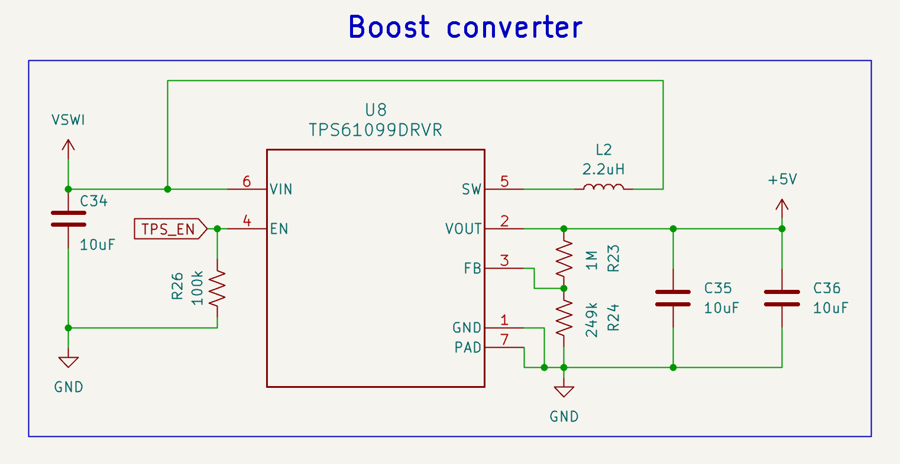
Figure 7: Boost converter
The equations for selecting the passive components are shown below (TPS61099x Synchronous Boost Converter With Ultra-Low Quiescent Current, 2026, p. 15):
$$\begin{aligned}V_{out}=\frac{R_{1}+R_{2}}{R_{2}} \#\left(2\right)\end{aligned}$$
$$\begin{aligned}I_{out}\left(max\right)=\frac{V_{in}*\left(I_{LIM}-\frac{I_{LH}}{2}\right)*η}{V_{out}} \#\left(3\right)\end{aligned}$$
$$\begin{aligned}\frac{V_{out}{*I}_{out}}{V_{in}*η}>\frac{I_{LH}}{2} \#\left(4\right)\end{aligned}$$
By using an output voltage of 5 V, we can derive the resistor values of R23 and R24 using equation (2). These should be as precise as possible since they would set the output voltage (1% tolerance resistors are chosen here).
A conservative estimate of the maximum output current for a switch current limit of 0.8 A, current ripple value of 350 mA and efficiency of 85% (TPS61099x Synchronous Boost Converter With Ultra-Low Quiescent Current, 2026, p. 5) is 319 mA using equation (3).
Finally, equation 4 is used to check for continuous conduction mode (CCM). That condition does not hold true for an output current of 50 mA, which is the expected draw by the MAX 30101 (High-Sensitivity Pulse Oximeter and Heart-Rate Sensor for Wearable Health, 2020, p. 11). Thus, the peak inductor current simple equals the current ripple (TPS61099x Synchronous Boost Converter With Ultra-Low Quiescent Current, 2026, p. 16), which is around 319 mA. The recommended inductance for an output voltage greater than 3 V is $2.2μH$. Its saturation current must be sufficiently more than 300 mA, preferably beyond 1 A. Finally, the DC resistance should be on the order of milliohms. The recommended part in the datasheet, 74404024022, is used in our design (WE-LQS SMT Semi-Shielded Power Inductor, 2022, p. 1). It has a saturation current of 1.9 A, DC resistance of $80 mΩ$ and an inductance of $2.2μH$.
The enable pin is, by default pulled low by a pulldown resistor. The RP2350 microcontroller will be responsible for sending a digital high to this pin, thereby turning it on. The EN input high threshold voltage is 1.2 V for when the input voltage, $V_{IN}>1.5 V$ (TPS61099x Synchronous Boost Converter With Ultra-Low Quiescent Current, 2026, p. 6). This means that a digital high of 3.3 V from the RP2350 is sufficient to activate the boost converter.
MCU
The microcontroller will have sudden changes in current demands as it generates oscillating signals such as clock waveforms. In such cases, the power supply goes through an interconnect with non-zero impedance. As current draws vary, the voltage drop across this impedance also changes, thereby causing fluctuations in the supply voltage. Decoupling capacitors are responsible for providing a local supply of charge in such situations. The hardware design guide for the RP2350 recommends using the following decoupling capacitors (Hardware design with RP2350, 2026, p. 8).
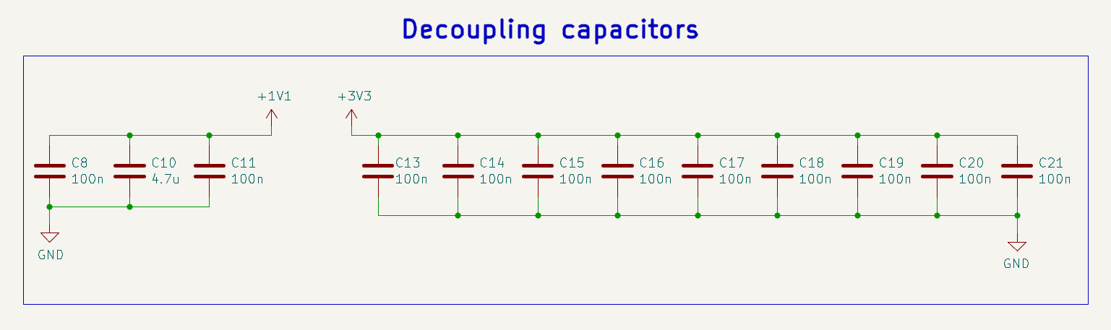
Figure 8: Decoupling capacitors
Next, we move on to the power circuitry for the RP2350:
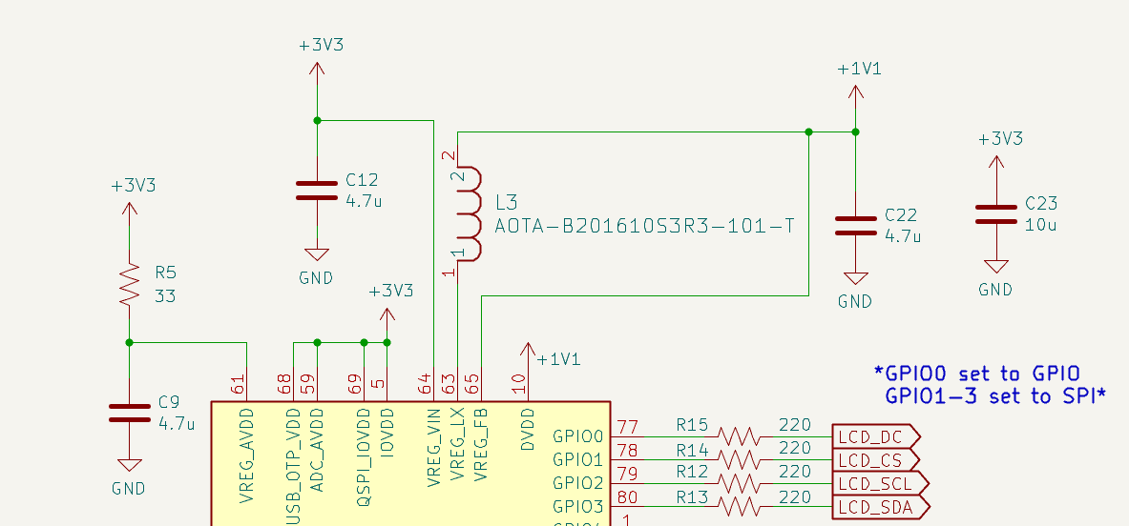
Figure 9: Power circuitry
First, we start off with VREG_AVDD, which is the supply for the analogue circuitry within the regulator. This has an RC low-pass filter. Next, VREG_VIN is the input voltage for a switching regulator that produces 1.1 V for DVDD. VREG_LX is connected to a polarized inductor. Finally, VREG_FB is connected to the output voltage, thereby allowing for setpoint voltage maintenance. The recommendations from the hardware design guide have been carefully followed (Hardware design with RP2350, 2026, p. 5).
A bulk capacitor, C23, is also added for low-frequency voltage stabilization.
Next, we can look at the external flash. The recommendation from the hardware design guide is taken yet again (Hardware design with RP2350, 2026, p. 10).
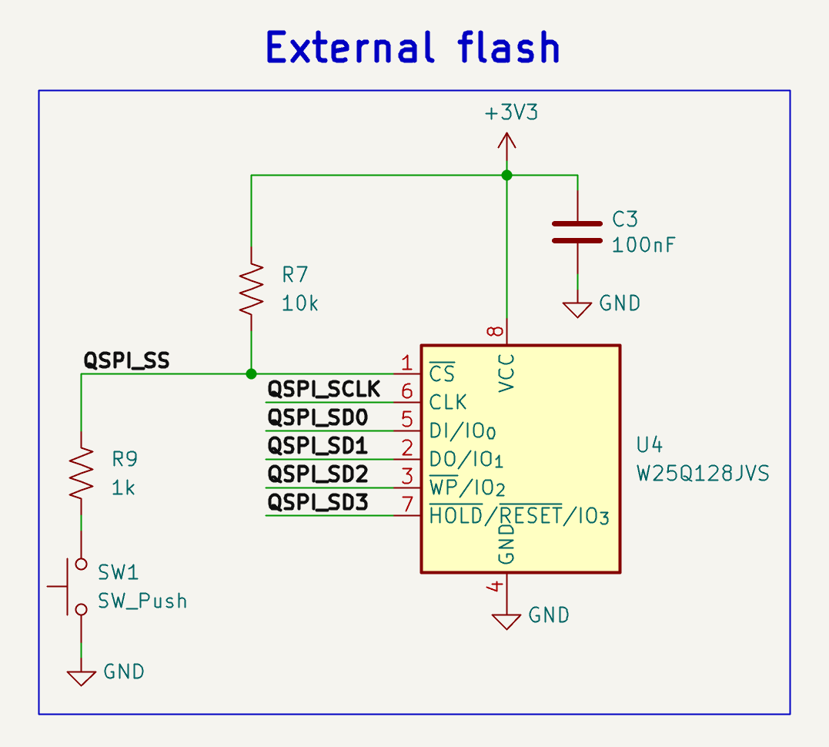
Figure 10: External flash
Normally, when the switch SW1 is not pressed, the MCU sees a digital high through R7. In this case, it runs the contents within the flash.
To program new code onto the MCU, a digital low must be recorded on the QSPI_SS pin by the MCU during the boot sequence. Therefore, before plugging in USB, hold SW1, plug in the power supply, and the MCU should enter BOOTSEL mode. Now, you can paste the new program files onto the flash (Hardware design with RP2350, 2026, p. 10).
C3 is a decoupling capacitor for the external flash.
Next, we proceed to the external crystal oscillator.
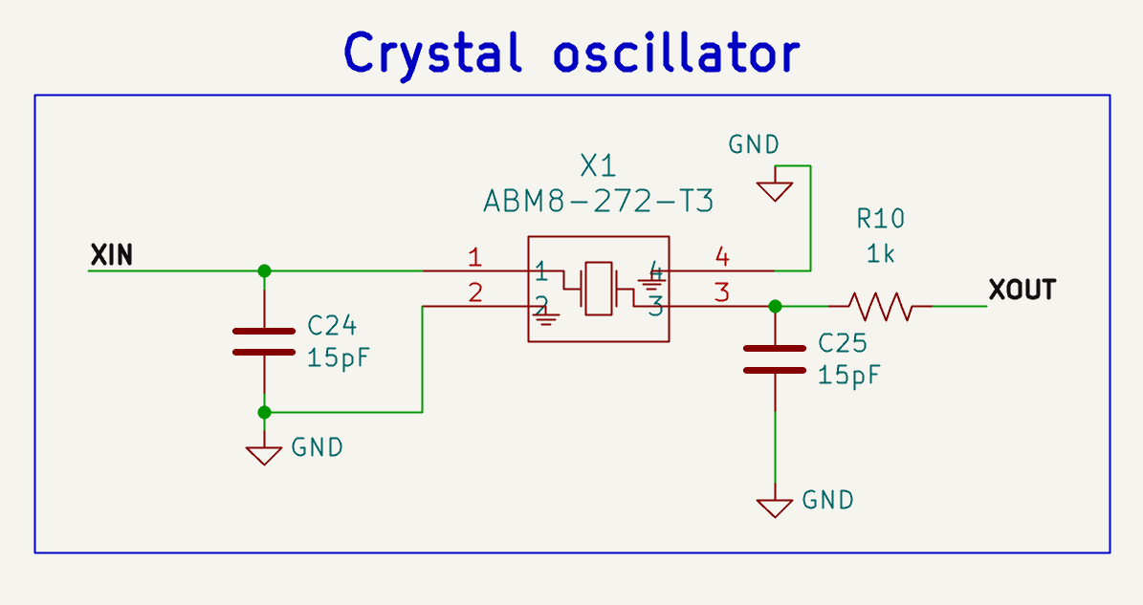
Figure 11: External oscillator
Yet again, the recommended part is used. The load capacitance is 7.5 pF, excluding any parasitic capacitances. If we use short PCB traces, the estimated parasitic capacitance of the interconnects is 3 pF, thereby giving an effective load capacitance of 10.5 pF, which is close to the manufacturer specification (Hardware design with RP2350, 2026, p. 13).
We also provide the functionality to reset the board:
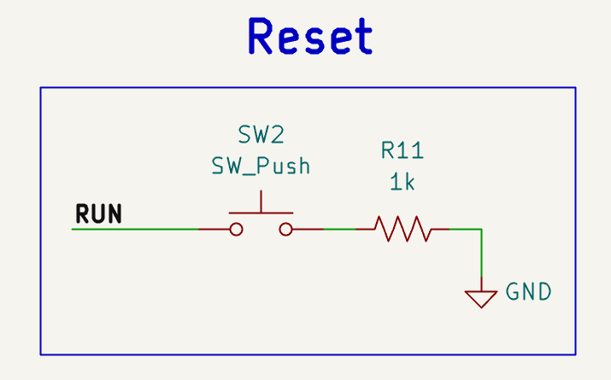
Figure 12: Reset
This is useful as it provides a way to reset without having to unplug both USB and the LiPo battery. The RUN pin has an internal pullup resistor. Thus, pressing SW2 resets the RP2350B MCU.
Peripherals
We have four peripherals to interface with:
- MCP7940N (Real-time clock) – I2C
- BNO085 (Inertial measurement unit) – I2C
- MAX30101 (Heart-rate sensor) – I2C
- GC9A01A (TFT Display) – SPI
The I2C buses would require external pullup resistors, since RP2350B’s internal pullups have high resistance, resulting in higher rise times ($t_{rise}=R_{pu}C_{bus}$). Let us investigate the real-time clock first. According to its datasheet, a $10 kΩ$ pullup supports data-transfer rates of 100 kHz while $2 kΩ$ supports 400 kHz.
Consider the following RTC schematic:
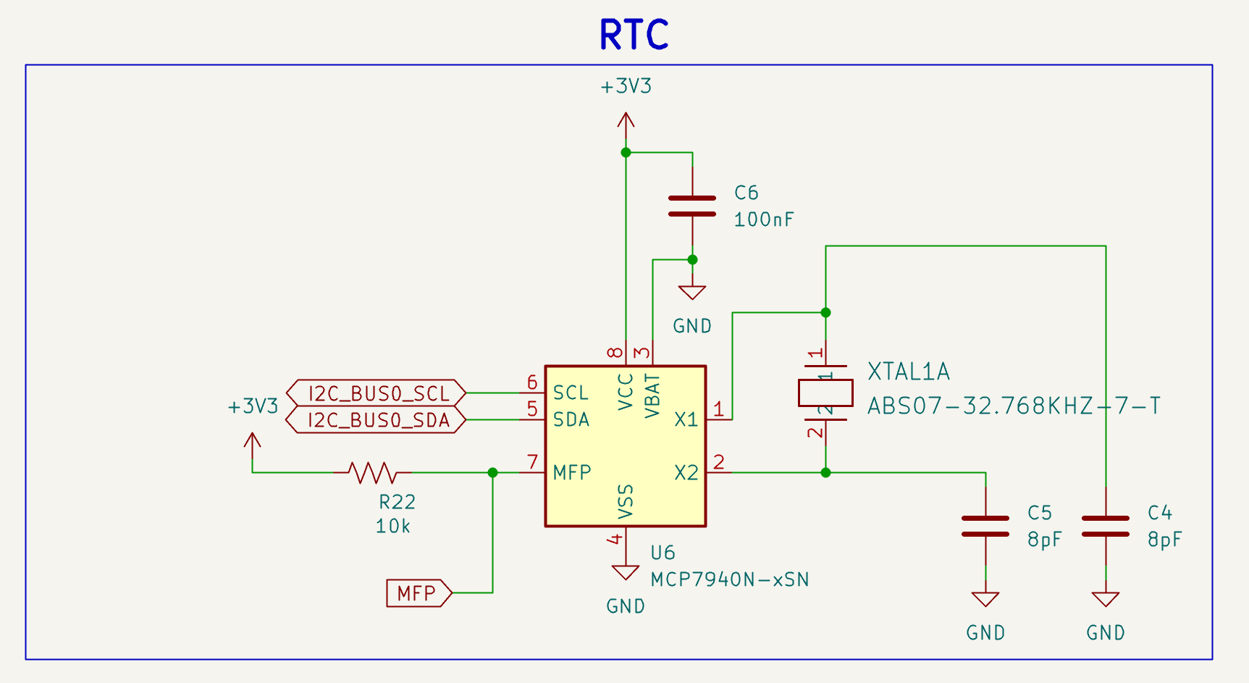
Figure 13: Real-time clock
There are a few things to be noted in this schematic. Firstly, the backup voltage supply VBAT is not used. As per the MCP7940N datasheet, this means that it can be tied to ground, as is done in Figure 13 (Battery-Backed I2C Real-Time Clock/Calendar with SRAM, 2022, p. 8).
Next, this chip uses 3.3V, which is within the operating range of 1.8V – 5.5V. A decoupling capacitor C6 is also added.
The IC uses I2C to transmit real-time data to the microcontroller. The microcontroller will request
Additionally, it has an external crystal oscillator for precise timing. As per the datasheet, its design is optimized for 6-9 pF crystals. The chosen 32 (Battery-Backed I2C Real-Time Clock/Calendar with SRAM, 2022, p. 13). By using equation 5-1 in the datasheet and using a stray capacitance of 3 pF, the effective load capacitance in Figure 13 matches the crystal’s requirements of 7 pF.
Finally, the MFP pin is used to trigger an alarm. It is an open-drain pin and requires a 10k pullup resistor (Battery-Backed I2C Real-Time Clock/Calendar with SRAM, 2022, p. 8). This is connected to the MCU for performing certain specific interrupts (for example, zeroing the number of daily steps at a specific time: midnight).
Next, we look at the heart-rate sensor. The schematics on Figure 14 have primarily been inspired by the Sparkfun breakout board (Lewis, 2020). The only change that has been made is that the level shifting has been removed. While a digital high is +1.8 V for the MAX30101 chip, the absolute maximum rating is 6 V. Additionally, $V_{IH}=0.7*V_{DD}=0.7*1.8=1.26 V$ (High-Sensitivity Pulse Oximeter and Heart-Rate Sensor for Wearable Health, 2020, p. 5). So, using 3.3 V as the digital high would be detected as a “1” by the chip. Thus, both the RTC and the heart-rate sensor can be placed on the same I2C bus with pullup resistors to 3.3V.
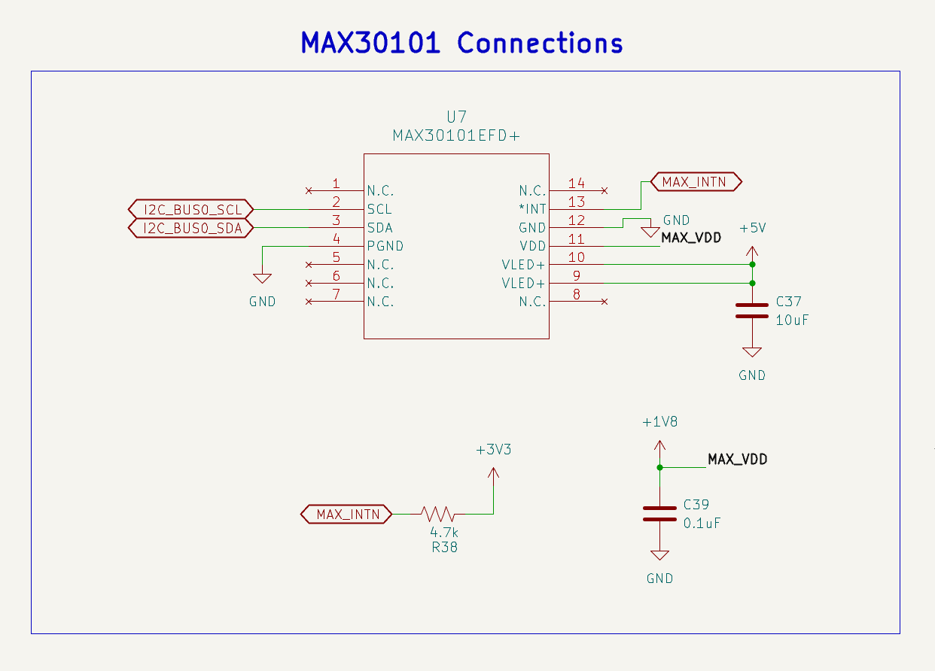
Figure 14: Heart-rate sensor
Let us go over the

References
(2022). Battery-Backed I2C Real-Time Clock/Calendar with SRAM. Microchip Technology Inc. Retrieved from https://ww1.microchip.com/downloads/aemDocuments/documents/MPD/ProductDocuments/DataSheets/MCP7940N-Battery-Backed-I2C-RTCC-with-SRAM-20005010J.pdf
CDBW140-G, S. S. (n.d.). Comchip Technology CO., LTD. Retrieved from https://www.comchiptech.com/upload/file/product/product/QW-BB020%20CDBW140-G%20RevG.pdf
Chu, B. (2008). Designing A Li-Ion Battery Charger and Load Sharing System With Microchip’s Stand-Alone Li-Ion Battery Charge Management Controller. Microchip Technology Inc. Retrieved from https://ww1.microchip.com/downloads/aemDocuments/documents/OTH/ApplicationNotes/ApplicationNotes/01149c.pdf
(2022). DMG3415U P-Channel Enhancement Mode MOSFET. Diodes Incorporated. Retrieved from https://www.diodes.com/datasheet/download/DMG3415U.pdf
Enos, N., & Gosselin, B. (2022). A Primer on USB Type-C and Power Delivery Applications and Requirements (Rev. B). Texas Instruments. Retrieved from https://www.ti.com/lit/wp/slyy109b/slyy109b.pdf
(2025). ESD321 1-Channel 30kV ESD Protection Diode with Low Capacitance (< 1pF) in 0402 and SOD-523 Packages. Texas Instruments. Retrieved from https://www.ti.com/lit/ds/symlink/esd321.pdf
(2026). ESD441 1-Channel ±30kV Unidirectional ESD Diode in an 0201 and 0402 Package. Texas Instruments. Retrieved from https://www.ti.com/lit/ds/symlink/esd441.pdf
(2026). Hardware design with RP2350. Raspberry Pi. Retrieved from https://pip-assets.raspberrypi.com/categories/1214-rp2350/documents/RP-008280-DS-2-hardware-design-with-rp2350.pdf
(2020). High-Sensitivity Pulse Oximeter and Heart-Rate Sensor for Wearable Health. Analog Devices, Inc. Retrieved from https://www.analog.com/media/en/technical-documentation/data-sheets/MAX30101.pdf
Lewis, P. (2020). SparkFun MAX30101 Qwiic. SparkFun. Retrieved from https://cdn.sparkfun.com/assets/e/a/e/d/f/SparkFun_MAX30101_Qwiic_Schematic.pdf
Lithium Ion Polymer Battery - 3.7v 500mAh. (n.d.). Retrieved from https://www.adafruit.com/product/1578
(2020). Miniature Single-Cell, Fully Integrated Li-Ion, Li-Polymer Charge Management Controllers. Microchip Technology Inc. Retrieved from https://ww1.microchip.com/downloads/aemDocuments/documents/APID/ProductDocuments/DataSheets/MCP73831-Family-Data-Sheet-DS20001984H.pdf
Oji, O. (2024). ESD and Surge Protection for USB Interfaces. Texas Instruments. Retrieved from https://www.ti.com/lit/an/slvaf82b/slvaf82b.pdf
Rembor, K. (2025, September 29). Adafruit. Retrieved from Adafruit: https://learn.adafruit.com/adafruit-feather-rp2040-pico/downloads
(2026). TPS61099x Synchronous Boost Converter With Ultra-Low Quiescent Current. Texas Instruments. Retrieved from https://www.ti.com/lit/ds/symlink/tps61099.pdf
(2022). WE-LQS SMT Semi-Shielded Power Inductor. Wurth Elektronik. Retrieved from https://www.we-online.com/components/products/datasheet/74404024022.pdf

