class A{

public static void main(String[] args){

System.out.println("HeyThereEarth");}

}

//(String[] args)

//(String []args)

//(String args[])

All are valid...

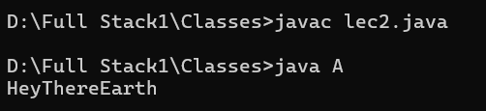

class Variable {

static int a = 100;

public static void main(String args[]) {

Variable v1 = new Variable();

Variable v2 = new Variable();

v1.a = 300;

v2.a = 200;

System.out.println(v1.a);

System.out.println(v2.a);

}

}

// The output is 200 both times because a is a static variable, meaning it is shared across all instances of the class, and when v2.a = 200 is set, it affects the value of a for both v1 and v2

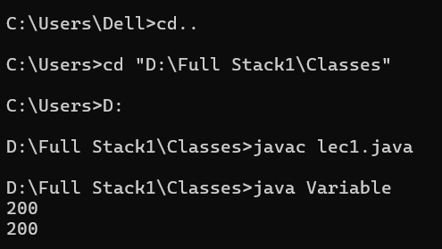

public class B {

public static void main(String args[]) {

System.out.println("I am learning java here!");

}

}

class C {

public static void main(String args[]) {

System.out.println("We have created another class in the same file.");

}

}



// The error occurs because in Java, the file name must match the public class name. Since your public class is B, the file should be named B.java. If the file name is not the same as the public class, you'll get a compilation error.

//After saving the file as B.java

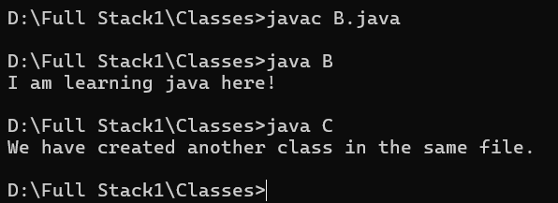

package test1;

import test2.B;

class A{

public static void main(String args[]){

B b = new B();

System.out.println("we are writing the value of a from class B "+b.x);

}

}

package test2;

public class B{

public int x=100;

public static void main(String args[]){

B b = new B();

System.out.println(b.x);

}

}

//In this code, class A in package test1 imports class B from package test2, creates an instance of B, and accesses its non-static field x, while class B defines the field x and prints its value when an instance is created.

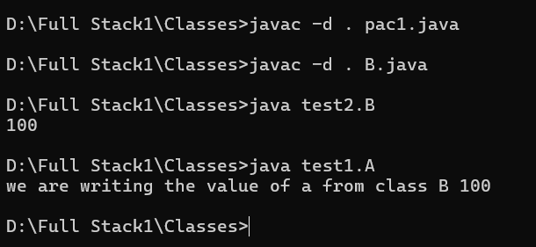

class Var{

static int b=100;

int a=100;

public static void main(String args[]){

int c=200;

Var b1=new Var();

var b2=new Var();

b1.b=300;

b2.b=400;

System.out.println("No Static Variable a accessed by b1 "+b1.a); //Non-Static Variable

System.out.println("No Static Variable a accessed by b2 "+b2.a);

System.out.println("It's a Local Variable c "+c); //Local Variable

System.out.println("Static Variable accessed by b1 "+b2.b); //Static Variable

System.out.println("Static Variable accessed by b1 "+b1.b);

}

}

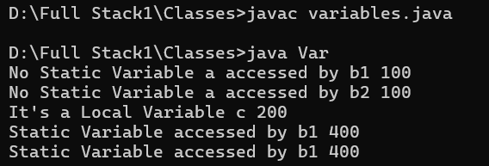

public class Members {

int id;

String name;

int age;

public Members(int id, String name, int age) {

this.id = id;

this.name = name;

this.age = age;

System.out.println("Id: " + id + " Name: " + name + " Age: " + age);

}

public static void main(String[] args) {

Members m1 = new Members(101, "Issar", 21);

Members m2 = new Members(102, "Anjali", 20);

}

}

