

Database Lab, Project Report

Project Name:
MahSa, Sahar va shoraka shop

Team Members:
MahSa Bikaran,
Sahar Ebrahimi,
Arya Khaligh

Late Winter of 2019
1) ER Diagram

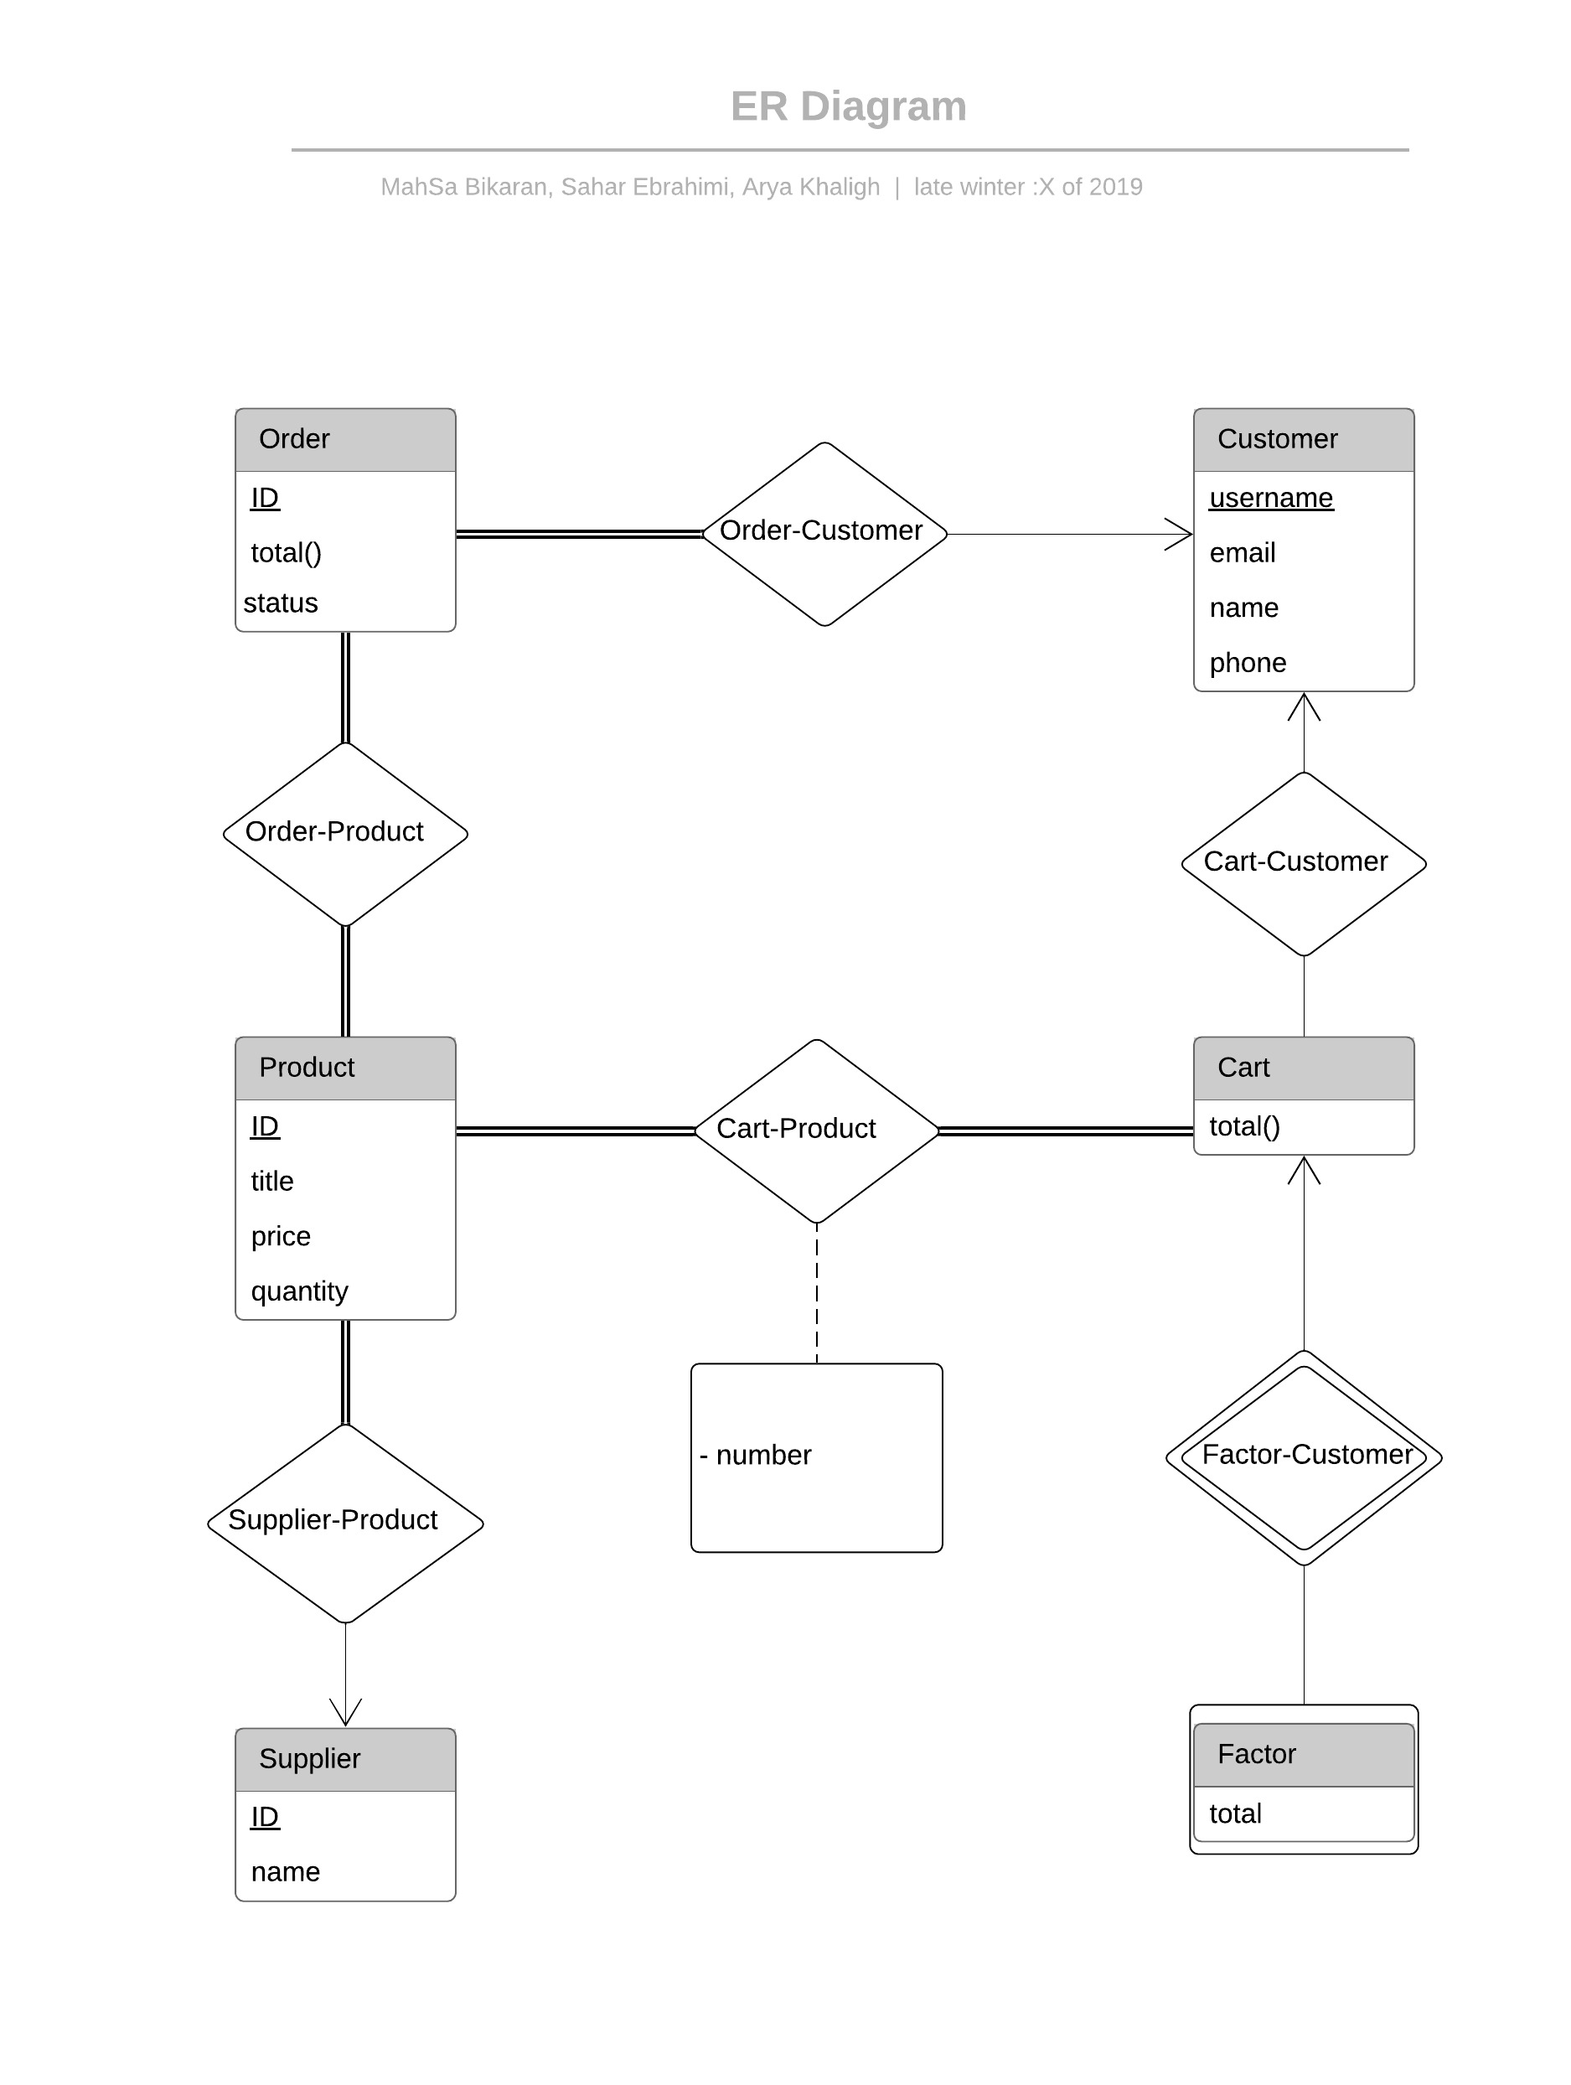
2) Project Overview

User has at most one cart. User should create a cart in order to buy one or many products. Each cart contains zero or more products in it. If user wants to buy more than one item of the same product, It can change number of that specific product in CartProduct relation.

If the user wants to buy the items in the cart, It should first create a factor for that specific cart, then pay that factor. After paying the factor, system deletes cart and its related factor, then inserts these deleted rows to proper log tables. System automatically adds a new row to order table which stands for items in cart that was just deleted. Status of an order can be either of values in the STATUS array.
3) ERD Design and Implementation

Entities)

Customer)

In diagram:
Customer(username, email, name, phone)
For implementation:
Customer(username, email, name, phone)

Fields:
username: VARCHAR(128)
email: VARCHAR(128)
name: VARCHAR(128)
phone: CHAR(11)
Cart)

In diagram:
Cart(total())
For implementation:
Customer(customerID)

Note: total is derivable field. I will write a view or function for it.

Fields:
- customerID: FOREIGN KEY REFERENCING Customer table

Factor)

In diagram:
Factor(total)
For implementation:
Factor(customerID, total)

NOTE: Factor is weak entity of Cart table.

Fields:
- customerID: FOREIGN KEY REFERENCING Cart table
- total: FLOAT
Order)

In diagram:
Order(ID, total(), status)
For implementation:
Order(ID, customerID, status)

Fields:
- ID: INT AUTO INCREMENT
- customerID: FOREIGN KEY REFERENCING Customer table
- status: VARCHAR(128) IN [‘shippd’, ‘pending’, ‘canceled’]

Product)

In diagram:
Product(ID, title, price, status)
For implementation:
Product(ID, supplier, customerID, status)

Fields:
- ID: INT AUTO INCREMENT
- supplier: FOREIGN KEY REFERENCING Supplier table
- title: VARCHAR(128)
- price: FLOAT
- quantity: INT

Supplier)

In diagram:
Supplier(ID, name)
For implementation:
Supplier(ID, name)

Fields:
- ID: INT AUTO INCREMENT
- name: VARCHAR(128)

Relations)

Order-Customer → Removed
Cart-Customer → Removed
Factor-Customer → Removed
Supplier-Customer → Removed
Order-Product)

Because relation is many to many both of primary keys are contained in OrderProduct fields as foreign keys.

OrderProduct(OrderID, ProductID)

Fields:
- OrderID: FOREIGN KEY REFERENCING Order table
- ProductID: FOREIGN KEY REFERENCING Product table

Cart-Product)

Because relation is many to many both of primary keys are contained in ProductCart fields as foreign keys.

CartProduct(customerID, ProductID, number)

Fields:
- customerID: FOREIGN KEY REFERENCING Cart table
- ProductID: FOREIGN KEY REFERENCING Product table
- number: INT

