RESULTS
INDIA
1.1 VAR Model for India
1. 2 VAR Model and Estimations Results for India
1.3 IRF Graphs for India
1.4 Forecasts for India

CHINA
1.5 VAR Model for China
1.6 VAR Model and Estimations Results for China
1.7 IRF Graphs for China
1.8 Forecasts for China

CONCLUSION AND INTERPRETATION

2.1 Overall Interpretation of VAR Results
2.2 Interpretation for India
2.3 Interpretation for China
2.4 Comparative Analysis
2.5 Forecasting Implications
2.6 Concluding Remarks

1.1 VAR Model for India

Variables
Trade Openness
Inflation Rate
Real Interest Rate

Model Specifications
Endogenous variables: Trade Openness, Inflation, Interest Rate
Deterministic variables: constant
Sample size: 42
Log Likelihood: -79.993

Augmented Dickey-Fuller Test

Lag selection criteria
AIC(n) – 2, HQ(n) – 2, SC(n) – 1, FPE(n) – 2
Lag = 2

1. 2 VAR Model and Estimations Results
Note: Signif. codes: 0 ‘***’ 0.001 ‘**’ 0.01 ‘*’ 0.05 ‘.’ 0.1 ‘ ’ 1
1. For Trade Openness
Estimation results for equation Trade Openness:
===============================================
Trade Openness = Trade Openness.l1 + Inflation.l1 + Interest Rate.l1 + Trade Openness.l2 + Inflation.l2 + Interest Rate.l2 + const

 | Estimate | Std. Error | t value | Pr (>|t|) | Signif. codes
Trade Openness.l1 | -0.216326 | 0.173327 | -1.248 | 0.22029
Inflation.l1 | -0.001710 | 0.001888 | -0.905 | 0.37143
Interest Rate.l1 | -0.009390 | 0.002775 | -3.384 | 0.00177 | **
Trade Openness.l2 | 0.203765 | 0.172531 | 1.181 | 0.24555
Inflation.l2 | 0.001405 | 0.001776 | 0.791 | 0.43421
Interest Rate.l2 | -0.005292 | 0.002044 | -2.589 | 0.01394 | *
const | 0.007913 | 0.004798 | 1.649 | 0.10804

Residual standard error: 0.02983 on 35 degrees of freedom
Multiple R-Squared: 0.2971, Adjusted R-squared: 0.1765
F-statistic: 2.465 on 6 and 35 DF, p-value: 0.04291

2. For Inflation Rate
Estimation results for equation Inflation:
==========================================
Inflation = Trade Openness.l1 + Inflation.l1 + Interest Rate.l1 + Trade Openness.l2 + Inflation.l2 + Interest Rate.l2 + const

 | Estimate | Std. Error | t value | Pr(>|t|) | Signif. codes
Trade Openness.l1 | -9.3442 | 14.6688 | -0.637 | 0.52826
Inflation.l1 | -0.5577 | 0.1598 | -3.489 | 0.00133 | **
Interest Rate.l1 | -0.4676 | 0.2348 | -1.991 | 0.05429 | .
Trade Openness.l2 | 30.3071 | 14.6014 | 2.076 | 0.04534 | *
Inflation.l2 | -0.2891 | 0.1503 | -1.923 | 0.06264 | .
Interest Rate.l2 | -0.3443 | 0.1730 | -1.990 | 0.05445 | .
const | -0.2482 | 0.4060 | -0.611 | 0.54501

Residual standard error: 2.524 on 35 degrees of freedom
Multiple R-Squared: 0.3238, Adjusted R-squared: 0.2078
F-statistic: 2.793 on 6 and 35 DF, p-value: 0.02513

3. For Interest Rate
Estimation results for equation Interest Rate:
=========================================
Interest Rate = Trade Openness.l1 + Inflation.l1 + Interest Rate.l1 + Trade Openness.l2 + Inflation.l2 + Interest Rate.l2 + const

 | Estimate | Std. Error | t value | Pr(>|t|)
Trade Openness.l1 | 32.67199 | 12.27870 | 2.661 | 0.0117 | *
Inflation.l1 | 0.25590 | 0.13378 | 1.913 | 0.0640 | .
Interest Rate.l1 | 0.08452 | 0.19657 | 0.430 | 0.6698
Trade Openness.l2 | -22.57154 | 12.22232 | -1.847 | 0.0733 | .
Inflation.l2 | 0.06721 | 0.12584 | 0.534 | 0.5966
Interest Rate.l2 | 0.09361 | 0.14482 | 0.646 | 0.5223
const | -0.13784 | 0.33988 | -0.406 | 0.6875

Residual standard error: 2.113 on 35 degrees of freedom
Multiple R-Squared: 0.2957, Adjusted R-squared: 0.175
F-statistic: 2.449 on 6 and 35 DF, p-value: 0.04403

Diagnostic | India
Serial correlation | Pass
ARCH | Pass
Normality | Pass
Stability | Stable

Granger Causality
Granger
Granger causality H0: trade openness does not Granger-cause inflation interest
data: VAR object var_model
F-Test = 2.8684, df1 = 4, df2 = 105, p-value = 0.02666

Instant
H0: No instantaneous causality between: trade openness and inflation interest
data: VAR object var_model
Chi-squared = 9.7814, df = 2, p-value = 0.007516

1.3 IRF Graphs for India
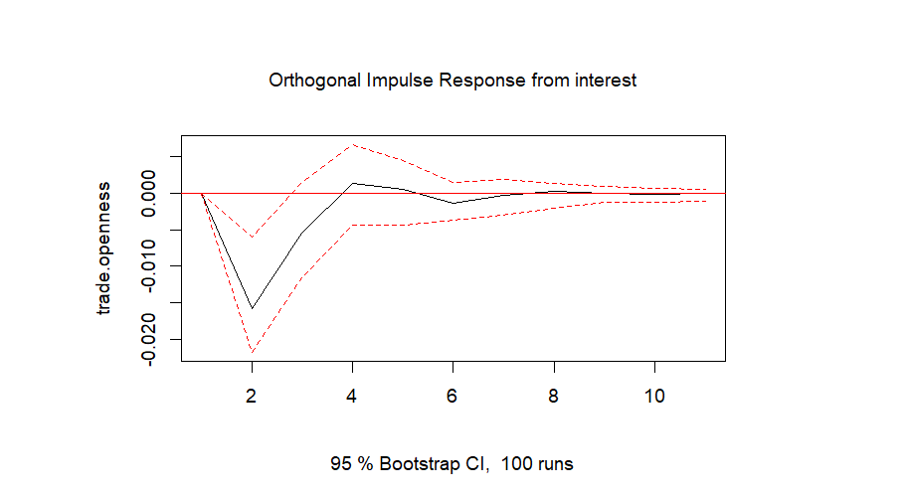

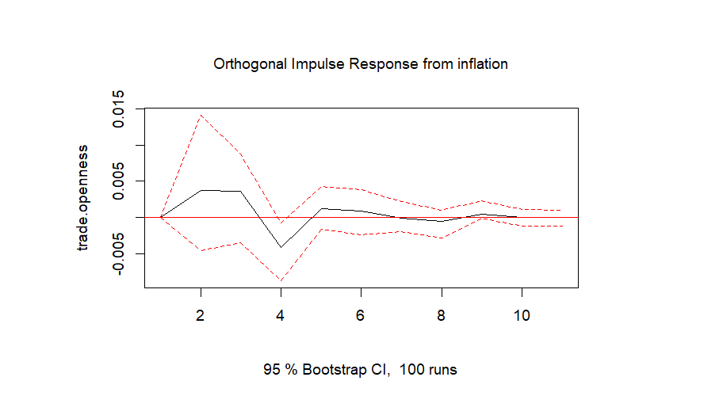

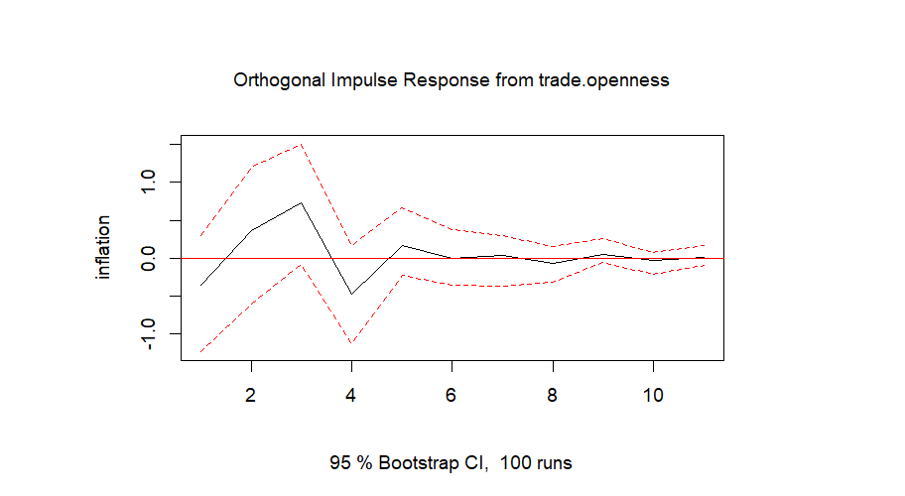

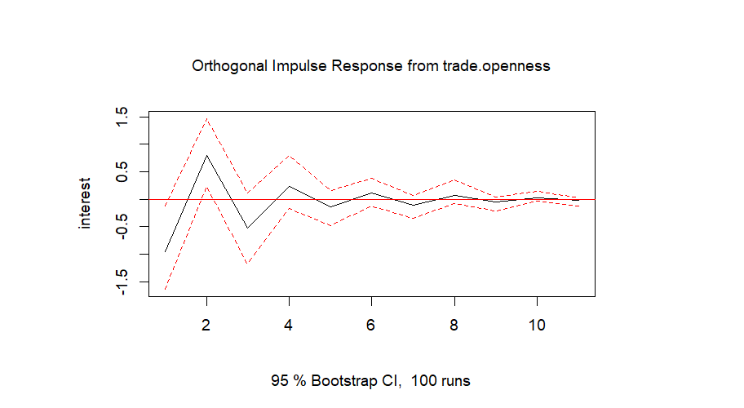

1.4 Forecasts for India

Forecast Error Variance Decomposition
- Trade Openness
 | Trade Openness | Inflation | Interest Rate
1 | 1.0000000 | 0.00000000 | 0.0000000
2 | 0.7743800 | 0.01187631 | 0.2137437
3 | 0.7476344 | 0.02205380 | 0.2303118
4 | 0.7360343 | 0.03574781 | 0.2282179
5 | 0.7366434 | 0.03653999 | 0.2268166
6 | 0.7355805 | 0.03695803 | 0.2274615
7 | 0.7356729 | 0.03694832 | 0.2273788
8 | 0.7354350 | 0.03722532 | 0.2273397
9 | 0.7353208 | 0.03738377 | 0.2272954
10 | 0.7353164 | 0.03738384 | 0.2272997

- Inflation Rate
 | Trade openness | Inflation | Interest Rate
1 | 0.01977025 | 0.9802297 | 0.00000000
2 | 0.03228042 | 0.8918240 | 0.07589557
3 | 0.09108192 | 0.8375367 | 0.07138137
4 | 0.11226966 | 0.8184743 | 0.06925600
5 | 0.11522178 | 0.8156848 | 0.06909342
6 | 0.11485721 | 0.8160358 | 0.06910702
7 | 0.11492329 | 0.8159976 | 0.06907908
8 | 0.11533952 | 0.8156044 | 0.06905612
9 | 0.11560256 | 0.8153619 | 0.06903555
10 | 0.11565221 | 0.8153163 | 0.06903145

- Interest Rate
 | Trade openness | Inflation | Interest Rate
1 | 0.2070109 | 0.1620961 | 0.6308930
2 | 0.2876813 | 0.1918792 | 0.5204395
3 | 0.3055093 | 0.1737099 | 0.5207808
4 | 0.3111901 | 0.1721257 | 0.5166842
5 | 0.3110589 | 0.1746701 | 0.5142710
6 | 0.3112874 | 0.1772683 | 0.5114443
7 | 0.3121701 | 0.1770731 | 0.5107567
8 | 0.3127193 | 0.1769154 | 0.5103653
9 | 0.3128894 | 0.1769026 | 0.5102080
10 | 0.3129193 | 0.1769704 | 0.5101103

Forecasts for next 5 years

- Trade Openness
 | fcst | lower | upper | CI
1 | 0.008201269 | -0.05025561 | 0.06665815 | 0.05845688
2 | 0.005672883 | -0.06113314 | 0.07247890 | 0.06680602
3 | 0.015373978 | -0.05274053 | 0.08348849 | 0.06811451
4 | 0.008332312 | -0.06031804 | 0.07698267 | 0.06865035
5 | 0.009150132 | -0.05975891 | 0.07805918 | 0.06890904

- Inflation Rate
 | fcst | lower | upper | CI
1 | 1.48129593 | -3.465949 | 6.428540 | 4.947244
2 | -0.85097566 | -6.434268 | 4.732317 | 5.583292
3 | 0.18463654 | -5.588860 | 5.958133 | 5.773496
4 | 0.14737472 | -5.721654 | 6.016403 | 5.869028
5 | 0.02333801 | -5.857126 | 5.903802 | 5.880464

- Interest Rate
 | fcst | lower | upper | CI
1 | -0.2182874 | -4.359452 | 3.922877 | 4.141165
2 | -0.2476388 | -4.823375 | 4.328098 | 4.575737
3 | -0.2971707 | -5.106278 | 4.511936 | 4.809107
4 | 0.1781663 | -4.654461 | 5.010794 | 4.832628
5 | -0.1752549 | -5.032022 | 4.681512 | 4.856767

Forecasting Graphs
1. Trade Openness Forecast 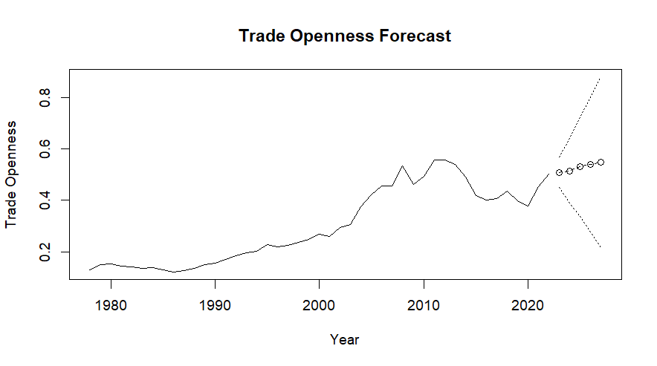

2. Inflation Rate Forecasts
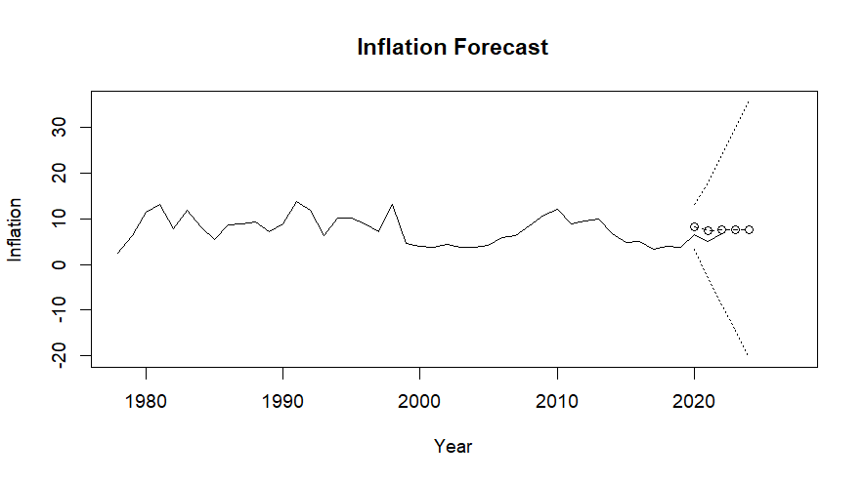

3. Interest rate Forecasts
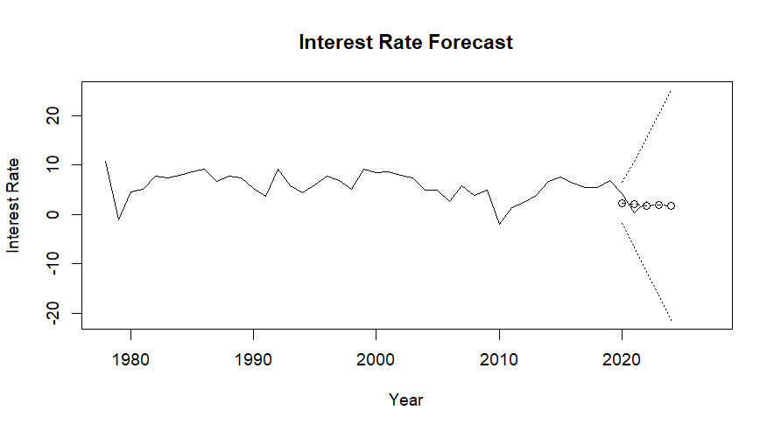
1.5 VAR Model for China

Variables
Trade Openness
Inflation Rate
Real Interest Rate

Model Specifications
Endogenous variables: Trade Openness, Inflation, Interest Rate
Deterministic variables: constant
Sample size: 36
Log Likelihood: -99.621
Augmented Dickey-Fuller Test

Selection
AIC(n) – 1, HQ(n) – 1, SC(n) – 1, FPE(n) – 1
Lag = 1
1.6 VAR Model and Estimations Results for China
Note: Signif. codes: 0 ‘***’ 0.001 ‘**’ 0.01 ‘*’ 0.05 ‘.’ 0.1 ‘ ’ 1

1. For Trade Openness
Estimation results for equation Trade Openness:
===============================================
trade.openness = trade.openness.l1 + inflation.l1 + interest.l1 + const
 | Estimate | Std. Error | t value | Pr(>|t|) | Signif. codes
trade.openness.l1 | 0.537539 | 0.192151 | 2.797 | 0.00865 | **
inflation.l1 | -0.001829 | 0.001771 | -1.033 | 0.30952
interest.l1 | 0.003672 | 0.002919 | 1.258 | 0.21750
const | -0.000270 | 0.006131 | -0.044 | 0.96515

Residual standard error: 0.03652 on 32 degrees of freedom
Multiple R-Squared: 0.2314, Adjusted R-squared: 0.1594
F-statistic: 3.212 on 3 and 32 DF, p-value: 0.03591

2. For Inflation Rate
Estimation results for equation inflation:
==========================================
inflation = trade.openness.l1 + inflation.l1 + interest.l1 + const
 | Estimate | Std. Error | t value | Pr(>|t|) | Signif. codes
trade.openness.l1 | 23.3056 | 22.2569 | 1.047 | 0.303
inflation.l1 | -0.1233 | 0.2051 | -0.601 | 0.552
interest.l1 | -0.3896 | 0.3381 | -1.152 | 0.258
const | -0.5898 | 0.7101 | -0.830 | 0.412

Residual standard error: 4.23 on 32 degrees of freedom
Multiple R-Squared: 0.1527, Adjusted R-squared: 0.07326
F-statistic: 1.922 on 3 and 32 DF, p-value: 0.1458
3. For Interest Rate
Estimation results for equation interest:
=========================================
interest = trade.openness.l1 + inflation.l1 + interest.l1 + const
 | Estimate | Std. Error | t value | Pr(>|t|) | Signif. codes
trade.openness.l1 | -6.73583 | 17.47684 | -0.385 | 0.702
inflation.l1 | 0.12617 | 0.16105 | 0.783 | 0.439
interest.l1 | -0.03845 | 0.26547 | -0.145 | 0.886
const | 0.26634 | 0.55763 | 0.478 | 0.636

Residual standard error: 3.322 on 32 degrees of freedom
Multiple R-Squared: 0.03722, Adjusted R-squared: -0.05304
F-statistic: 0.4123 on 3 and 32 DF, p-value: 0.7453

Diagnostic | China
Serial correlation | Pass
ARCH | Pass
Normality | Pass
Stability | Stable

Granger Causality
Granger
Granger causality H0: trade openness does not Granger-cause inflation interest
data: VAR object var_model
F-Test = 0.72701, df1 = 2, df2 = 96, p-value = 0.486

Instant
H0: No instantaneous causality between: trade openness and inflation interest
data: VAR object var_model
Chi-squared = 9.8586, df = 2, p-value = 0.007232
1.7 IRF Graphs for China

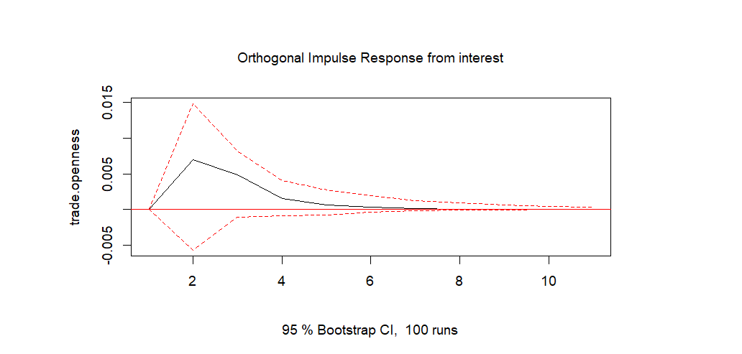

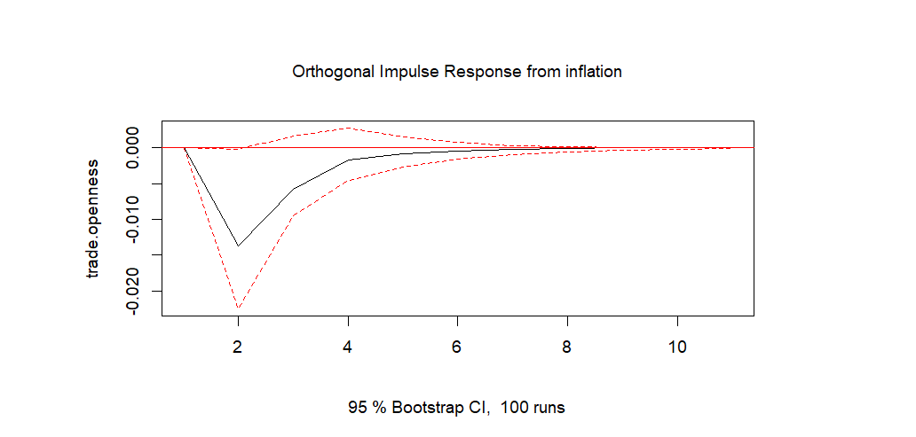

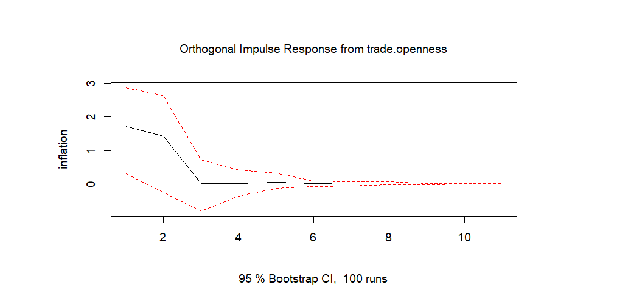

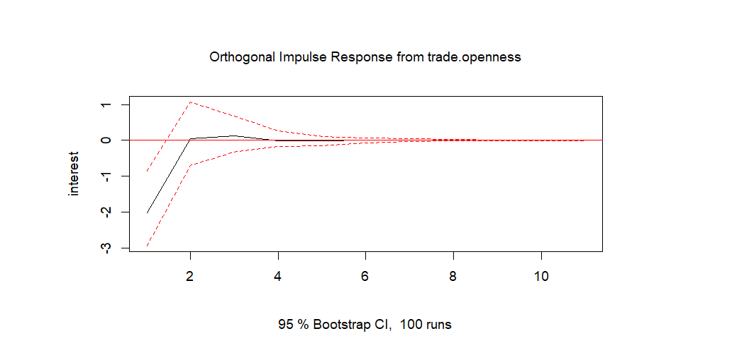

1.8 Forecasts for China
Forecast Error Variance Decomposition
- trade.openness
 | trade.openness | inflation | interest
1 | 1.0000000 | 0.0000000 | 0.00000000
2 | 0.8562030 | 0.1141854 | 0.02961168
3 | 0.8284039 | 0.1293596 | 0.04223649
4 | 0.8261135 | 0.1304010 | 0.04348548
5 | 0.8256374 | 0.1306859 | 0.04367671
6 | 0.8255036 | 0.1307657 | 0.04373063
7 | 0.8254783 | 0.1307799 | 0.04374186
8 | 0.8254736 | 0.1307825 | 0.04374390
9 | 0.8254726 | 0.1307831 | 0.04374431
10 | 0.8254724 | 0.1307832 | 0.04374440

- Inflation
 | trade.openness | inflation | interest
1 | 0.1648605 | 0.8351395 | 0.00000000
2 | 0.2429383 | 0.7302225 | 0.02683923
3 | 0.2383005 | 0.7315440 | 0.03015553
4 | 0.2379840 | 0.7310717 | 0.03094427
5 | 0.2380561 | 0.7309891 | 0.03095482
6 | 0.2380621 | 0.7309788 | 0.03095905
7 | 0.2380615 | 0.7309771 | 0.03096138
8 | 0.2380615 | 0.7309767 | 0.03096175
9 | 0.2380616 | 0.7309766 | 0.03096181
10 | 0.2380616 | 0.7309766 | 0.03096182

- Interest
 | trade.openness | inflation | interest
1 | 0.3715550 | 0.2992845 | 0.3291605
2 | 0.3613333 | 0.3182727 | 0.3203940
3 | 0.3611819 | 0.3179582 | 0.3208599
4 | 0.3611576 | 0.3180258 | 0.3208166
5 | 0.3611618 | 0.3180223 | 0.3208159
6 | 0.3611611 | 0.3180232 | 0.3208157
7 | 0.3611611 | 0.3180232 | 0.3208157
8 | 0.3611611 | 0.3180232 | 0.3208157
9 | 0.3611611 | 0.3180232 | 0.3208157
10 | 0.3611611 | 0.3180232 | 0.3208157

Forecasts for next 5 years
- trade.openness
 | fcst | lower | upper | CI
1 | 0.006418560 | -0.06515940 | 0.07799652 | 0.07157796
2 | 0.004610355 | -0.07508800 | 0.08430871 | 0.07969836
3 | 0.003650076 | -0.07754398 | 0.08484414 | 0.08119406
4 | 0.003214549 | -0.07817560 | 0.08460469 | 0.08139015
5 | 0.003029060 | -0.07840440 | 0.08446252 | 0.08143346

- Inflation
 | fcst | lower | upper | CI
1 | -0.4158336 | -8.706708 | 7.875041 | 8.290875
2 | -0.4599523 | -9.342295 | 8.422391 | 8.882343
3 | -0.4893346 | -9.457926 | 8.479257 | 8.968591
4 | -0.5109487 | -9.485575 | 8.463678 | 8.974626
5 | -0.5193991 | -9.494578 | 8.455780 | 8.975179

- Interest
 | fcst | lower | upper | CI
1 | 0.1824132 | -6.327857 | 6.692683 | 6.510270
2 | 0.1636297 | -6.439981 | 6.767240 | 6.603610
3 | 0.1709653 | -6.445100 | 6.787030 | 6.616065
4 | 0.1734445 | -6.443130 | 6.790019 | 6.616575
5 | 0.1735558 | -6.443055 | 6.790167 | 6.616611

Forecasting Graphs
- Trade Openness Forecast
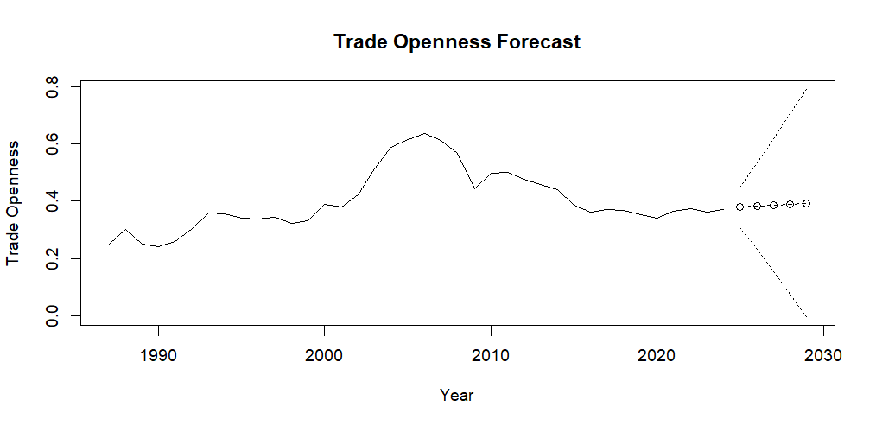
- Inflation
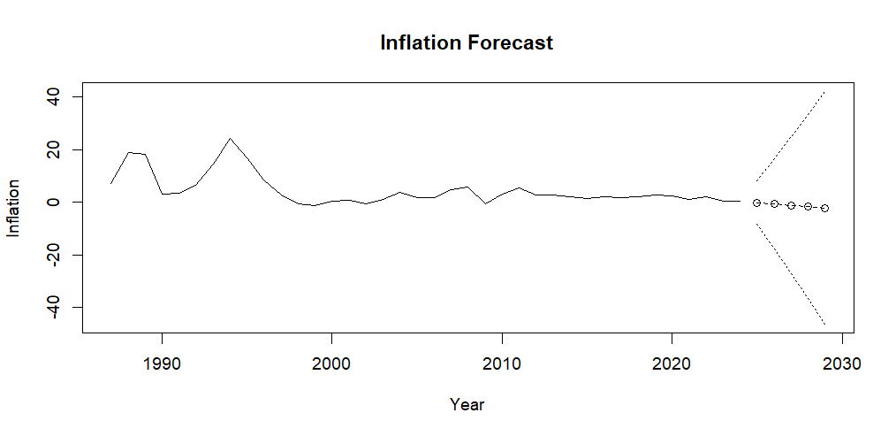

- Interest Rate

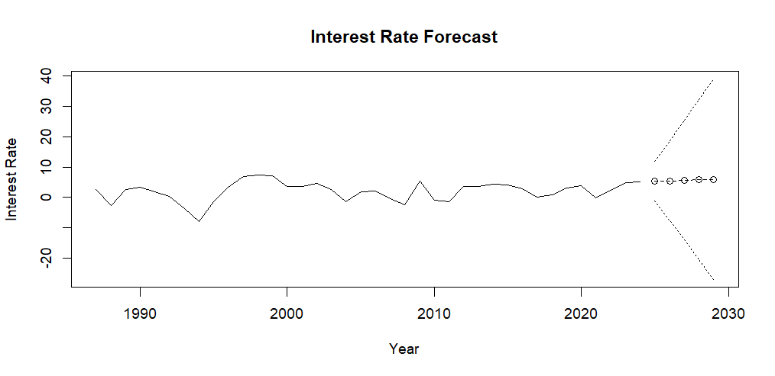
CONCLUSION AND INTERPRETATION

2.1 Overall Interpretation of VAR Results
The Vector Autoregression (VAR) results for India and China reveal important insights into the dynamic interactions between trade openness, inflation, and real interest rates, while also highlighting clear structural differences between the two economies.
For India, the VAR model indicates a moderate degree of interdependence among variables, supported by statistically significant coefficients and overall model significance. The F-statistics for all three equations (trade openness: p = 0.0429, inflation: p = 0.0251, interest rate: p = 0.0440) confirm that the system of equations is jointly meaningful. Additionally, specific lagged variables—particularly interest rates in the trade openness equation and inflation persistence—demonstrate statistically significant effects, suggesting the presence of short-run transmission mechanisms within the economy.
In contrast, the Chinese VAR model exhibits limited statistical significance and weaker dynamic interactions. Most coefficients across equations are insignificant, and the inflation and interest rate equations, in particular, show low explanatory power (e.g., R² = 0.1527 for inflation and R² = 0.0372 for interest rates). This indicates that the chosen variables do not strongly explain short-run fluctuations in China’s macroeconomic environment within the VAR framework.

2.2 Interpretation for India
The VAR results for India reveal a structured and economically meaningful interaction between trade openness, inflation, and real interest rates, with evidence of short-run transmission mechanisms and feedback effects across variables.
The trade openness equation highlights the significant role of monetary conditions in influencing external sector dynamics. Specifically, lagged interest rates are statistically significant at both lag 1 (p = 0.00177) and lag 2 (p = 0.01394), with negative coefficients. This indicates that higher interest rates tend to reduce trade openness over time, likely due to increased borrowing costs, reduced investment, and potential exchange rate appreciation affecting export competitiveness. In contrast, lagged values of trade openness and inflation are statistically insignificant, suggesting that trade dynamics are not strongly self-driven in the short run but are instead influenced by monetary policy variables.
The inflation equation demonstrates strong persistence, as evidenced by the highly significant coefficient of lagged inflation (p = 0.00133). This confirms the presence of inflation inertia within the Indian economy, where past price levels significantly influence current inflation. Additionally, trade openness at lag 2 is positive and statistically significant (p = 0.04534), suggesting that increased integration with global markets may introduce inflationary pressures, possibly through imported inflation or demand-side effects. Interest rates show marginal significance at both lags (approximately p ≈ 0.05), indicating a weaker but still relevant role of monetary policy in controlling inflation.
The interest rate equation reveals that trade openness significantly influences monetary policy adjustments, with lagged trade openness at lag 1 being positive and statistically significant (p = 0.0117). This suggests that increases in trade openness may lead to higher interest rates, potentially reflecting central bank responses to external sector pressures such as capital flows, exchange rate volatility, or inflationary risks. Other variables, including lagged inflation and interest rates, are largely insignificant, indicating that interest rate movements are less self-driven and more reactive to external economic conditions.
Further insights emerge from the Forecast Error Variance Decomposition (FEVD). Trade openness is largely explained by its own shocks in the short run (100% at period 1), but over time, the contribution of interest rates increases significantly (approximately 22–23%), highlighting the growing influence of monetary factors. Inflation remains predominantly self-driven (over 80% even in later periods), confirming strong persistence, although trade openness and interest rates gradually contribute to its variation. Interest rates, in contrast, exhibit a more balanced decomposition, with substantial contributions from trade openness (around 31%) and inflation (around 17%), indicating a multi-directional feedback system.
Overall, the Indian VAR results suggest a dynamic and interdependent macroeconomic structure, where trade openness acts as a key driving force, influencing both inflation and interest rates, while also being affected by monetary policy.
2.3 Interpretation for China
The VAR results for China indicate a relatively weak and statistically insignificant dynamic relationship between trade openness, inflation, and real interest rates, suggesting limited short-run interdependence among the selected macroeconomic variables.
In the trade openness equation, only its own lagged value is statistically significant (p = 0.00865), with a positive coefficient. This reflects a strong degree of persistence in trade openness, indicating that past levels of trade activity are the primary determinant of current openness. In contrast, lagged inflation and interest rates are statistically insignificant, implying that external trade dynamics in China are not strongly influenced by short-run fluctuations in domestic monetary conditions.
The inflation equation further reinforces this pattern of weak interaction. None of the explanatory variables—trade openness, lagged inflation, or interest rates—are statistically significant, and the overall explanatory power of the model is low (R² = 0.1527). This suggests that inflation in China is not adequately explained by the variables included in the VAR framework and may instead be driven by institutional factors, administrative controls, or supply-side conditions that are not captured in the model.
Similarly, the interest rate equation exhibits very low explanatory power (R² = 0.0372) and no statistically significant coefficients. This indicates that interest rate movements in China are largely independent of trade openness and inflation within the short-run VAR structure. Such a result may reflect the policy-driven nature of interest rate determination, where central bank decisions are influenced more by strategic objectives than by market-based interactions captured in the model.
The Forecast Error Variance Decomposition (FEVD) results align with these findings. Each variable is largely explained by its own shocks over time, with trade openness maintaining a dominant share (over 82%), inflation remaining primarily self-driven (around 73%), and interest rates showing only moderate contributions from trade openness (approximately 36%) and inflation (approximately 31%). This indicates a relatively independent evolution of variables, with limited cross-variable influence.
Overall, the Chinese VAR results suggest a less interconnected and more segmented macroeconomic structure, where trade openness, inflation, and interest rates operate with a high degree of independence in the short run.
2.4 Comparative Analysis
A comparative analysis of the VAR results for India and China reveals fundamental structural differences in the way trade openness, inflation, and real interest rates interact within the two economies.
The Indian economy demonstrates a relatively higher degree of macroeconomic interdependence, as evidenced by multiple statistically significant coefficients and meaningful causal relationships. In particular, interest rates significantly influence trade openness, while trade openness, in turn, affects both inflation and interest rates. The presence of Granger causality (p = 0.02666) further reinforces the existence of dynamic transmission mechanisms, where shocks in one variable propagate through the system over time. Additionally, moderate explanatory power across equations (R² values ranging from approximately 0.29 to 0.32) suggests that the selected variables capture a meaningful portion of macroeconomic fluctuations.
In contrast, the Chinese economy exhibits limited dynamic interlinkages among the variables. Most coefficients across equations are statistically insignificant, and the explanatory power of the model is notably lower, particularly for the interest rate equation (R² = 0.0372). The absence of Granger causality (p = 0.486) indicates that lagged relationships between trade openness, inflation, and interest rates are weak. This suggests that the variables evolve largely independently in the short run, with minimal evidence of systematic transmission effects.
Another key distinction lies in the role of persistence and self-dependence. While both countries exhibit some degree of persistence, it is more pronounced in China, where trade openness is primarily driven by its own past values (p = 0.00865), and other variables show limited responsiveness to external influences. In India, although inflation also shows strong persistence, the system as a whole is more interactive, with variables influencing one another across lags.
The Forecast Error Variance Decomposition (FEVD) further highlights these differences. In India, the contribution of other variables—particularly interest rates in explaining trade openness and trade openness in explaining interest rates—increases over time, indicating a gradually strengthening interdependence. In China, however, each variable remains largely dominated by its own shocks, with only modest contributions from others, reflecting a more isolated and stable structure.
Despite these differences, both countries exhibit instantaneous causality (India: p = 0.0075, China: p = 0.0072), suggesting that the variables are contemporaneously correlated. However, the absence of lagged causality in China implies that these relationships do not translate into dynamic feedback mechanisms over time.

2.5 Forecasting Implications
The forecasting results derived from the VAR model for both India and China provide useful insights into the expected future trajectories of trade openness, inflation, and real interest rates. However, these forecasts must be interpreted with caution due to the inherent uncertainty reflected in the wide confidence intervals.
For India, the forecasts indicate relative stability in trade openness, with predicted values remaining within a narrow range over the forecast horizon. This suggests that external trade dynamics are expected to follow a steady path, consistent with the persistence observed in the VAR results. Inflation forecasts for India exhibit considerable variability, with both positive and negative projected values across periods. This aligns with the earlier finding of inflation persistence combined with sensitivity to external factors such as trade openness and interest rates. Interest rate forecasts in India appear highly unstable, fluctuating between positive and negative values across the forecast horizon. This reflects the complex and reactive nature of interest rate determination identified in the VAR analysis, where monetary policy responds to multiple macroeconomic influences rather than following a predictable trend. The large confidence intervals further indicate that interest rate projections are subject to significant uncertainty.
For China, the forecasts similarly indicate stable but weakly dynamic behaviour across variables. Trade openness remains relatively constant over time, reflecting its strong dependence on past values. Inflation forecasts, however, display substantial uncertainty, with extremely wide confidence intervals (approximately ±9 units), suggesting that the model has limited ability to capture inflation dynamics in China. Interest rate forecasts also exhibit wide intervals, reinforcing the conclusion that these variables are not strongly explained within the VAR framework.

2.6 Concluding Remarks
This study set out to examine the dynamic relationship between trade openness, inflation, and real interest rates using a VAR framework for India and China. The findings provide meaningful insights into how macroeconomic variables interact within different economic structures, while also highlighting important cross-country differences. For India, the results demonstrate a relatively interconnected macroeconomic system, where trade openness, inflation, and interest rates influence one another through identifiable short-run dynamics. The presence of statistically significant relationships, along with evidence of Granger causality, indicates that macroeconomic indicators play an active role in shaping trade-related outcomes. These findings suggest that India’s economy is more market-responsive, with observable transmission mechanisms linking the external sector and monetary variables. In contrast, the results for China reveal a more segmented and less responsive system, where the relationships between trade openness, inflation, and interest rates are weak and largely statistically insignificant.
The comparative analysis underscores that economic structure and policy orientation play a crucial role in determining the extent to which macroeconomic variables interact. While India exhibits characteristics of a more open and dynamically linked system, China reflects a more controlled framework with limited observable interdependence among variables. From a methodological perspective, the study confirms that the VAR model is effective in capturing short-run dynamics and directional relationships, particularly in economies where variables are more interlinked. However, the forecasting results highlight limitations in predictive accuracy, especially over longer horizons, due to increasing uncertainty and the influence of external shocks not fully incorporated in the model.
Overall, the study concludes that the relationship between macroeconomic indicators and trade flows is not uniform across countries, but instead depends on underlying economic structures, institutional frameworks, and policy regimes. These findings have important implications for policymakers, suggesting that strategies aimed at influencing trade outcomes must consider the broader macroeconomic environment and the specific transmission mechanisms operating within each economy.

