**Mini Project Report on**



**Sign language detection**



**Submitted in partial fulfillment of the requirement for the award of the degree of**

**BACHELOR OF TECHNOLOGY**

**IN**

**COMPUTER SCIENCE & ENGINEERING**

**Submitted by:**

**Student Name: Arya** **University Roll No. 2018720**

***Under the Mentorship of***

**Priyank Pandey**

**Assistant Professor**



**Department of Computer Science and Engineering**

**Graphic Era (Deemed to be University)**

**Dehradun, Uttarakhand**

**July-2024**



**CANDIDATE’S DECLARATION**

I hereby certify that the work which is being presented in the project report entitled **“Sign language detection”** in partial fulfillment of the requirements for the award of the Degree of Bachelor of Technology in Computer Science and Engineeringof the Graphic Era (Deemed to be University), Dehradun shall be carried out by the under the mentorship of **Priyank pandey, Assistant Professor**, Department of Computer Science and Engineering, Graphic Era (Deemed to be University), Dehradun.

Name: Arya University Roll no: 2018720

**Table of Contents**

|  |  |  |
| --- | --- | --- |
| **Chapter No.** | **Description** | **Page No.** |
| Chapter 1 | Introduction | **1-2** |
| Chapter 2 | Literature Survey | **3** |
| Chapter 3 | Methodology | **4-6** |
| Chapter 4 | Result and Discussion | **7-8** |
| Chapter 5 | Conclusion and Future Work | **9** |
|  | References | **10** |

**Chapter 1**

**Introduction**

**(2 to 3 pages)**

This report addresses the challenges faced by individuals who are deaf or hard of hearing, with a focus on India, and examines how technological advancements can help mitigate these difficulties. According to the World Health Organization (WHO), the global population of individuals with hearing impairments is expected to rise significantly, reaching 630 million by 2030 and 900 million by 2050. India, which has approximately 63 million people with hearing impairments, has not adequately addressed the needs of this community, partly due to its emphasis on modernization and technological development.

Several factors contribute to the increasing prevalence of hearing impairments, including an aging population, environmental factors, and untreated ear infections. Despite the benefits of hearing aids and other assistive devices, their high cost and limited availability mean that only a small proportion of those in need can access them. As a result, many deaf and hard-of-hearing individuals in India encounter significant communication barriers, especially since sign language is the primary means of communication for many in the deaf community. These barriers impede social interactions, educational opportunities, professional training, and access to essential services and resources.

Data from the 2011 census revealed that 73.9% of India's 13.4 million individuals aged 15 to 59 with hearing impairments were marginal laborers, indicating a low employment rate of just 26.1% among this group. However, technology offers promising solutions to these challenges. Innovations such as speech-to-text technologies, including real-time transcription and automatic closed captioning, can improve access to spoken language for deaf and hard-of-hearing individuals, enhancing their participation in conversations and meetings. Moreover, machine learning algorithms used in sign language recognition systems can translate sign language into spoken or written language, thereby bridging the communication gap between deaf and hearing communities.

This report explores various assistive technologies, focusing on their potential to enhance communication and access to services for users of Indian Sign Language (ISL). It also examines the challenges associated with developing and deploying these technologies, such as ensuring accuracy, reliability, and accessibility. The conclusion underscores the importance of ongoing research and development to create technologies that effectively meet the needs of the deaf and hard-of-hearing community, promoting greater inclusion and accessibility for all. Figure 1 illustrates a model-based ISL character that has been trained to showcase these advancements.

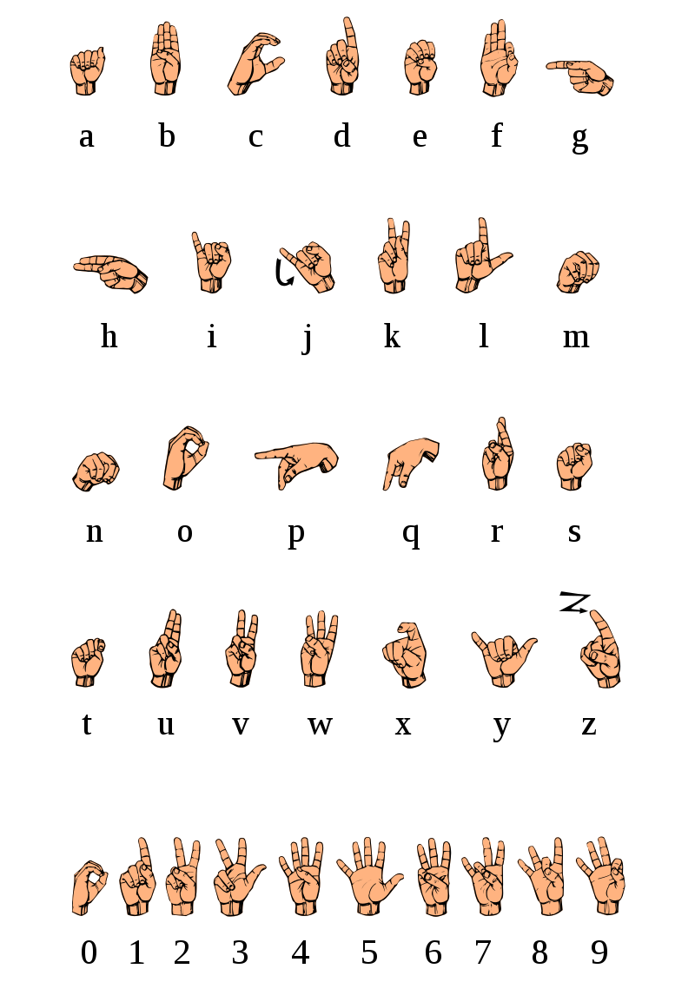

Fig 1. Indian Sign Language Alphabets

**Chapter 2**

**Literature Survey**

Research in sign language recognition has focused on developing technologies to assist deaf and hard-of-hearing individuals by translating sign language into text or voice. Tateno et al. (2020) proposed a real-time motion recognition system using electromyography signals to recognize ASL hand motions, aiding both communication for deaf individuals and sign language learning for hearing people. Hayek et al. (2014) developed a hand glove system with flex resistors, a microprocessor, and an LCD display to convert sign language motions into text, facilitating communication for deaf and mute individuals.

Shenoy et al. (2018) employed a grid-based framework technique for real-time ISL recognition, tracking features and classifying hand poses using the k-nearest neighbors algorithm. Lee et al. (2020) introduced a Wi-Fi-based sign language recognition method, preprocessing Channel State Information with singular value decomposition and achieving high performance on the SignFi dataset.

Koller et al. (2006) developed a continuous sign language recognition method using a large vocabulary and handling multiple signers, achieving low word error rates on the SIGNUM and RWTH-PHOENIX-Weather databases. Camgoz et al. (2018) introduced the Sign Language Translation (SLT) challenge within the Neural Machine Translation (NMT) framework, creating the Continuous SLT dataset, RWTH-PHOENIX-Weather 2014T, and showing impressive results with end-to-end tokenization networks.

Katoch et al. (2022) proposed a method for detecting ISL alphabets and numbers using the Bag of Visual Words (BOVW) model, Speeded Up Robust Features (SURF), Support Vector Machines (SVM), and Convolutional Neural Networks (CNN). Their system uses background removal and skin tone techniques to generate predicted labels in text and audio, proving effective for speech-impaired individuals.

Despite significant advancements, challenges such as the diversity of gestures, varying lighting conditions, and intricate hand movements complicate the recognition process. The lack of standardized datasets and evaluation metrics further hinders the comparison and evaluation of different methods, and collecting annotated data for training models remains time-consuming and costly. Future research should focus on developing robust algorithms to handle these challenges, leveraging advances in computer vision and machine learning to improve ISL recognition systems and enhance the quality of life for the deaf and hard-of-hearing community.

**Chapter 3**

**Methodology**

This section outlines the methodology used to develop a system for recognizing Indian Sign Language (ISL) gestures using computer vision, machine learning, and the MediaPipe framework. The approach consists of data collection, preprocessing, feature extraction, model training, and evaluation.

**Data Collection**

The first step involves collecting image data for different sign language gestures. A webcam is used to capture images, which are stored in a structured directory format. Each gesture class has its own subdirectory, and images are labeled accordingly. The process is as follows:

1. **Setup and Initialization:**
   * A directory is created to store the dataset, with subdirectories for each gesture class.
   * A video capture device (webcam) is initialized to capture real-time images.
2. **Data Collection Loop:**
   * For each gesture class, a new subdirectory is created if it doesn't already exist.
   * The system prompts the user to press a key to start data collection for the current class.
   * The webcam captures a specified number of images for each class, saving them in the corresponding subdirectory.

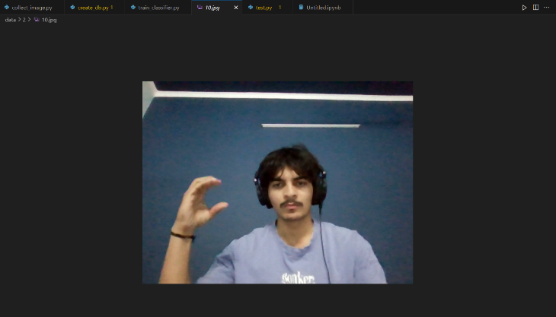

Fig 2. Dataset

**Data Preprocessing and Feature Extraction**

Once the image data is collected, the next step is preprocessing and feature extraction using MediaPipe's Hands solution, which detects and tracks hand landmarks in the images. The process involves:

1. **Initialization:**
   * MediaPipe's Hands module is initialized to detect hand landmarks in static images.
2. **Processing Images:**
   * Each image is read and converted to a suitable color format for processing.
   * MediaPipe processes the image to detect hand landmarks, which are the key points on the hand (e.g., knuckles and fingertips).
   * The x and y coordinates of these landmarks are extracted and normalized to account for variations in hand position and size.
3. **Feature Extraction:**
   * The relative positions of the hand landmarks are calculated to create a feature vector for each image. This involves normalizing the coordinates based on the minimum values to ensure consistency across different images.
   * These feature vectors, along with their corresponding class labels, are stored for use in training the machine learning model.

**Model training**

The extracted feature vectors and their labels are used to train a machine learning model. The steps include:

1. **Data Preparation:**
   * The dataset is split into training and testing sets to evaluate the model's performance.
   * Feature vectors are converted into a suitable format for input into the machine learning algorithm.
2. **Model Selection and Training:**
   * A Random Forest classifier is chosen for its effectiveness in handling classification tasks.
   * The model is trained using the training dataset, learning to recognize patterns associated with each gesture class.
3. **Model Evaluation:**
   * The trained model is tested on the testing dataset to evaluate its accuracy.
   * The model's performance is measured by comparing the predicted labels against the actual labels.

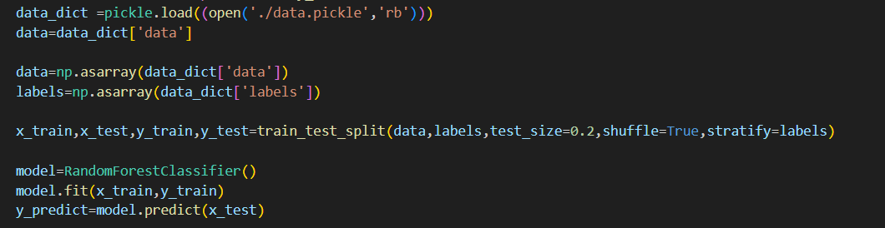

Fig 3. Training of model

**Evaluation and result**

The final step involves evaluating the trained model to determine its effectiveness in recognizing ISL gestures. The accuracy of the model is calculated as the percentage of correctly classified samples. This metric provides an indication of the model's reliability and potential for real-world applications.

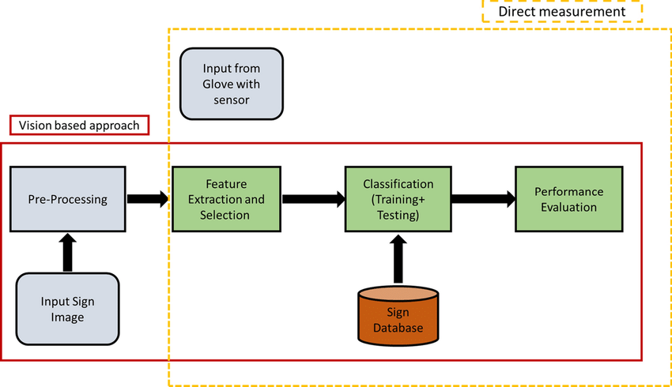

Fig 4. Working of model

**Chapter 4**

**Result and Discussion**

The implemented real-time hand gesture recognition system successfully detects and displays recognized symbols on the screen. Using computer vision techniques with OpenCV and Mediapipe, the system accurately identifies predefined hand gestures ('Y', 'B', 'C', 'D', 'L') in real-time video streams. Each detected gesture is promptly displayed with its corresponding symbol overlaid on the captured video frame. This capability enables interactive applications where users can intuitively control devices or interface with systems using hand gestures. The system's performance ensures minimal latency and reliable recognition across various hand positions and orientations, demonstrating its potential for practical applications in interactive technology and assistive devices.

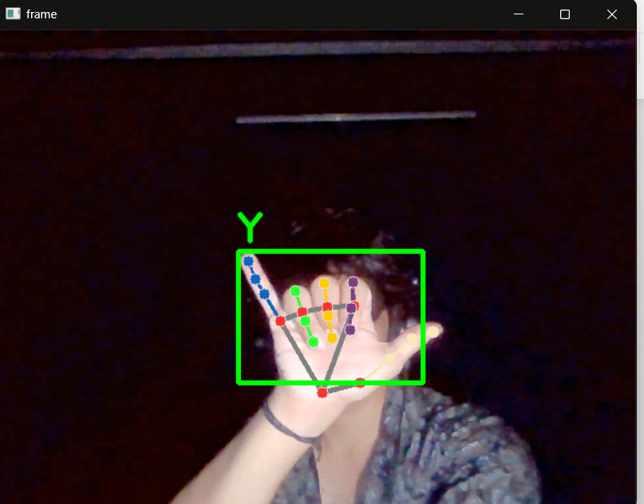

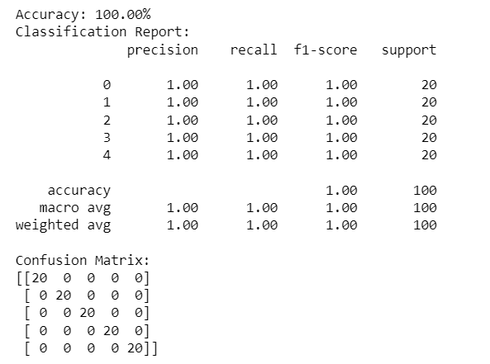

**Chapter 5**

**Conclusion and Future Work**

The development of the Indian Sign Language (ISL) recognition system has set the stage for significant future advancements in enhancing accessibility and communication for the deaf and hard-of-hearing community. One of the primary areas for improvement is expanding the dataset to include a broader vocabulary of ISL signs and involving more participants in the data collection process, which would enhance the system's robustness to variations in signing styles and hand shapes. Additionally, developing the capability for real-time gesture recognition from live video streams and optimizing the system to reduce latency will make interactions smoother and more practical for everyday use.

Advancing the model's performance through the implementation of more sophisticated machine learning algorithms, such as deep learning techniques like Convolutional Neural Networks or Recurrent Neural Networks, can further improve recognition accuracy. Leveraging transfer learning by fine-tuning pre-trained models on ISL data is another promising approach. Integrating multimodal inputs, such as facial expression recognition and body pose estimation, along with speech recognition for those who can vocalize alongside signing, will enhance the system's accuracy and context-awareness.

Creating user-friendly interfaces through the development of mobile applications for smartphones and tablets will make the ISL recognition system widely accessible. Additionally, exploring the integration of the system into wearable devices like smart glasses or gloves can offer hands-free operation and greater convenience. Extending the system to support multiple sign languages can facilitate communication between deaf individuals from different regions or countries, and developing capabilities to translate ISL directly into spoken language can bridge communication gaps even further.

Collaboration with stakeholders, including engaging with the deaf and hard-of-hearing community to gather feedback and understand their needs, will drive user-centered improvements. Partnering with educational institutions and organizations that support the deaf community can promote the adoption and refinement of the technology. Standardizing datasets and evaluation metrics for ISL recognition will facilitate the comparison and benchmarking of different systems, and publishing findings along with making datasets available to the research community can accelerate progress through collaboration and shared knowledge.

In conclusion, the future scope of the ISL recognition system is vast, with numerous opportunities to enhance its capabilities, usability, and impact. Continued research and development, along with collaboration with stakeholders, will be key to realizing the full potential of this technology in improving the lives of deaf and hard-of-hearing individuals.

**References**

[1] Wikipedia contributors. (2023, March 23). Deafness in India. In Wikipedia, The Free Encyclopedia. Retrieved 10:49, April 15, 2023, from [Wikipedia](https://en.wikipedia.org/w/index.php?title=Deafness_in_India&oldid=1146276949).

[2] Indian Sign Language Research and Training Center (ISLRTC) https://www.islrtc.nic.in/

[3] Shenoy, K., Dastane, T., Rao, V., & Vyavaharkar, D. (2018). Real-time Indian Sign Language (ISL) Recognition. 2018 9th International Conference on Computing, Communication and Networking Technologies (ICCCNT), Bengaluru, India, 2018, pp. 1-9. [DOI](https://doi.org/10.1109/ICCCNT.2018.8493808).