Task 1. Kode yang sudah dikerjakan dapat diunduh di

<https://github.com/aryaevan/express-js/archive/refs/heads/main.zip>

atau di clone via

<https://github.com/aryaevan/express-js.git>

Html todo

1. Convert react to vue js script
2. Use typescript
3. How to unit test vue code

Node JS todo

1. How to change database in express js
2. How to debug typescript code
3. How to split express js to separate module
4. Fix bug in database init script
5. How to normalize database
6. Sample of database join
7. Create CRUD sample
8. Create Dockerfile
9. Create Docker-Compose file
10. Create git action CI/CD
11. Create unit test

PHP todo

1. Create Laravel project based on the code snippet
2. Improve medicine outgoing controller

Task 2

1. How would you handle downtime during holiday/weekends  
     
   preventive way: I want to make sure that the code is stable before weekend and freeze the code during weekend.  
   emergency way: there should be on call rotation schedule where team member take turns being available to respond to emergencies during holiday/weekend  
   personal way: in case It is my turn to standby for the weekend I would ensure that I’m reachable through appropriate channels in case of critical issues that require immediate attention.
2. Sometimes we have a problem with stale Pull Request. How would you solve that?  
     
   Break Down Large Pull Request: encourage team member to break down large complex PR to smaller, more manageable chunks. Smaller PR are easier to review so it help to make PR not staled.  
   Prioritize older PR first: to prevent PR for being staled we should be prioritize older PR first.
3. We have an unfinished handbook, kindly check this (<https://github.com/medigoid/tech-handbook/blob/develop/programming-concepts.md>) section. What will you improve?  
     
   I notice that in this section there are lack of example code. If we can add more example in this section I thnk it will be easier to follow:  
     
   Konsep Clean Code

Konsep Clean Code mempunyai beberapa penafsiran dan karakteristik, di antaranya :

1. Kode tersebut harus mudah dipahami
   1. Memiliki alur kerja/pertukaran data yang jelas dan konsisten  
        
      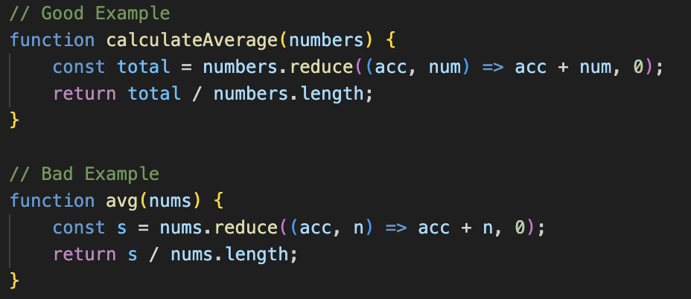
   2. Kolaborasi antar class atau berkas harus mudah dipahami  
        
      