Graph Challenge 1

Aryah Rao

2024-09-12

**Instructions**: Read in the dataset named gc1_data.csv into R (it’s in the _data folder). It has two variables called x and y. Use the data to create a scatter plot with x on the x-axis and y on the y-axis. Below the plot output, in plain text briefly summarize what the data appears to be telling you. When you’re done, hit the render button and submit the .docx file this Quarto document produces to Canvas.

## First, read the data into R  
library(tidyverse)  
  
# Read in the data from the _data folder  
data <- read_csv("../_data/gc1_data.csv")  
  
  
## Second, make your data viz using ggplot2  
ggplot(data) +  
 aes(x = x, y = y) +  
 geom_point()

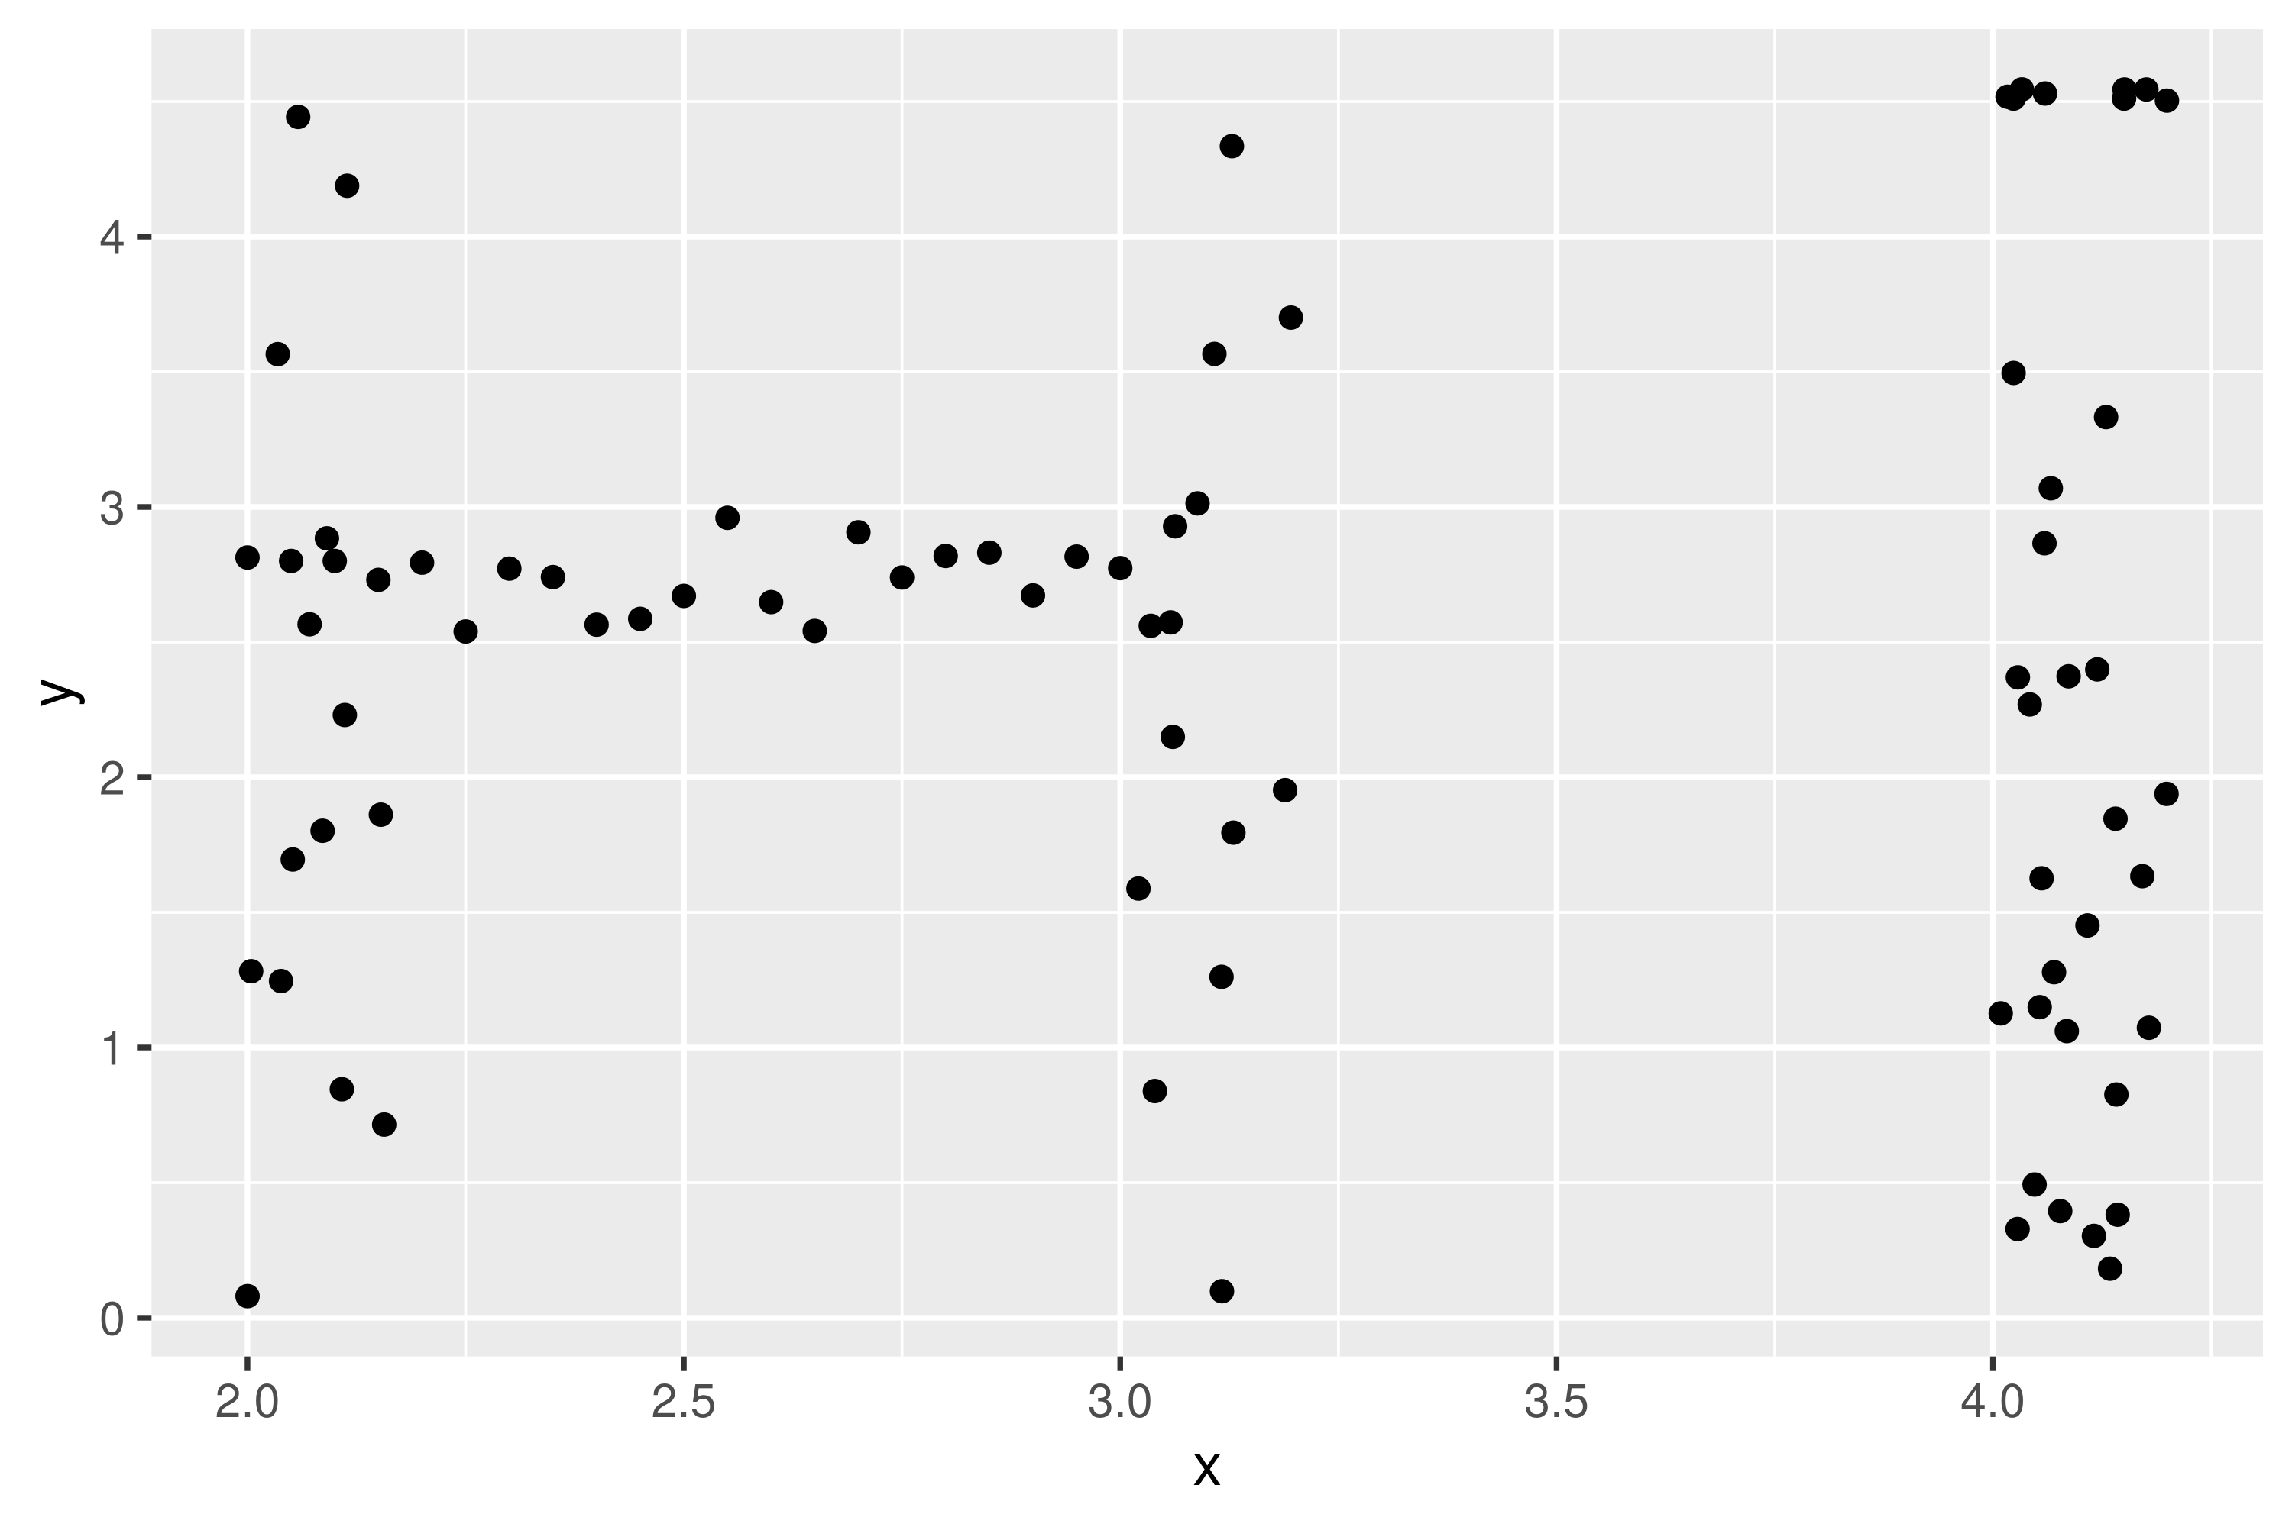

Summary: It is random dataset that is designed to spell out the word “HI”!