Graph Challenge 4

Aryah Rao

2024-10-11

For this graph challenge, you will produce a graph that compares two different metrics for MID initiation rate over time. Remember that a rate is calculated with a numerator and a denominator (miles per gallon is a good example of a rate). When it comes to calculating the MID initiation rate, we can compute the yearly rate conflicts get started by dividing the number of newly initiated MIDs by the total number of countries in the world at a given point in time. We can also use a modified denominator that accounts for the fact that countries have different opportunities for starting conflicts. A major power that is close to many other countries will have more opportunities to start fights than a non-major power that is geographically isolated, for example. How might our assessment of conflicts over time change by adjusting for opportunity?

For this graph challenge you’ll produce a graph that shows both the unadjusted yearly rate of MID initiation and the yearly rate of MID initiation adjusting for opportunity. The first is just the number of initiated MIDs divided by the total number of countries. The second is the number of initiated MIDs divided by the sum of country opportunities to fight.

I’ve already included code to open the packages you need along with a call to the source() function which reads in a special “helper function” I’ve created called add_opportunity(). This function works just like other {peacesciencer} add_*() functions, and it will populate a country-year dataset with a new column called opportunity. Its values represent the share of countries in the world in a given year that a country could potentially start fights with. It’s computed using the Braumoeller-Carson metric of political relevance. Google “Political Irrelevance, Democracy, and the Limits of Militarized Conflict” if you want to learn more about the origins of this measure.

The rest of the code is up to you. The skills you need to complete this task are covered in the lecture notes and our in-class discussion. You’ll need to create a state-year dataset with measures of MIDs and of opportunity, collapse it to the year level with metrics for the unadjusted and adjusted MID initiation rate, and then give this data to ggplot() to compare these metrics. After you’ve produced your graph, write a brief summary of what it shows and offer your thoughts on whether the unadjusted or adjusted measure provides a better picture of conflict initiation over time.

## open packages  
library(tidyverse)  
library(peacesciencer)  
library(socsci)  
source(  
 "https://raw.githubusercontent.com/milesdwilliams15/dpr-101-project-files/refs/heads/main/_helper_functions/add_opportunity.R"  
)

## start with function that creates state-year data  
Data <- create_stateyears(subset_years = 1816:2010) |>  
 ## add indicators for whether countries were involved in a MID  
 add_gml_mids() |>  
 ## add opportunities for countries  
 add_opportunity()

# Group the data by year and compute unadjusted and adjusted MID initiation rates for each year  
yearly_data <- Data |>  
 group_by(year) |> # Group the dataset by the 'year'  
 summarize(  
 # Calculate the unadjusted MID initiation rate:  
 unadjusted_rate = sum(gmlmidonset) / n(),  
  
 # Calculate the adjusted MID initiation rate:  
 adjusted_rate = sum(gmlmidonset) / sum(opportunity)  
 )

# Create plot comparing unadjusted and adjusted MID initiation rates over time  
ggplot(yearly_data) +  
 aes(x = year) +  
 # Add a line for the unadjusted MID initiation rate  
 geom_line(aes(y = unadjusted_rate, color = "Unadjusted Rate")) +  
   
 # Add a line for the adjusted MID initiation rate  
 geom_line(aes(y = adjusted_rate, color = "Adjusted Rate")) +  
   
 # Add labels for the axes, title, and legend  
 labs(  
 x = "Year",  
 y = "MID Initiation Rate",  
 title = "Comparison of Unadjusted and Adjusted MID Initiation Rates Over Time",  
 color = "Rate Type"  
 )

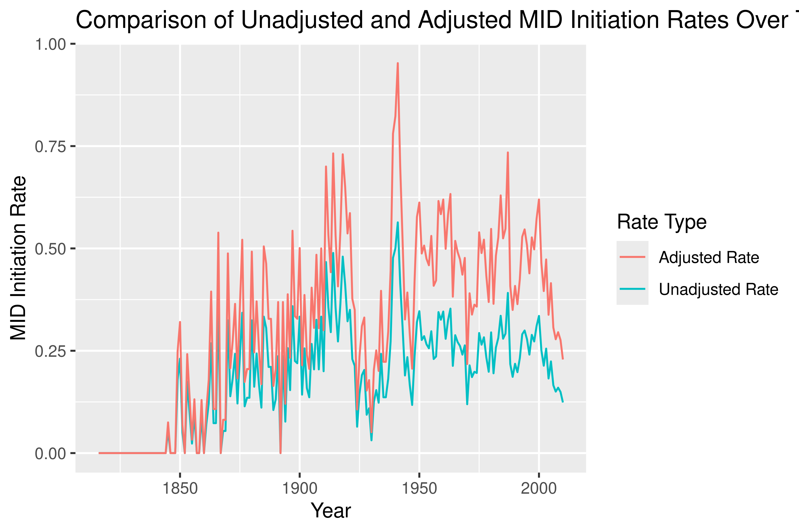

The graph compares the unadjusted and adjusted rates of MID initiation from 1816 to 2000. The unadjusted rate represents the number of MIDs divided by the total number of countries each year, while the adjusted rate accounts for the opportunities available to each country for initiating conflicts, providing a more context-sensitive measure.

From the graph, we can see that the adjusted rate of MID initiation is generally higher than the unadjusted rate, indicating that accounting for the opportunities available makes conflict initiation seem more frequent. The adjusted measure appears to provide a more nuanced view of conflict initiation by highlighting disparities in opportunities that different countries have to initiate conflicts. It suggests that unadjusted rates may underestimate the likelihood of conflict initiation in countries with greater interaction opportunities. Therefore, the adjusted rate might provide a better picture of how geopolitical realities shape conflict initiation over time.