Graph Challenge 5

Aryah Rao

2024-10-14

The long peace theory generally holds that conflict is less likely now than in the past, but it argues this is true especially for major powers. Create a plot that shows the rate of conflict initiation over time among non-major powers versus major powers to see if this is the case. Use {peacesciencer} to create a state-year dataset and then populate it with the variables you need using add_cow_majors() and add_mid_opportunity() (remember that this is a custom function I made, so check the lecture notes to see how to use it). Use {geomtextpath} in some way to help compare trends in a single graph.

First, we create a state-year dataset, add indicators for major powers, and conflict opportunity. This dataset spans from 1816 to 2010.

# Load necessary packages  
library(tidyverse)  
library(peacesciencer)  
library(ggplot2)  
library(geomtextpath)  
source(  
 "https://raw.githubusercontent.com/milesdwilliams15/dpr-101-project-files/refs/heads/main/_helper_functions/add_opportunity.R"  
)  
  
# Create a state-year dataset and add major power and conflict data  
state_year_data <- create_stateyears(subset_years = 1816:2010) %>%  
 add_cow_majors() %>% # Add major power indicator  
 add_mid_opportunity() # Add conflict opportunity  
  
# Summarize data to calculate MID initiation rate for major and non-major powers  
data_summary <- state_year_data %>%  
 group_by(year, cowmaj) %>%  
 summarize(mid_init_rate = sum(mid_inits) / sum(n_pairs), .groups = 'drop') %>%  
 mutate(power_status = ifelse(cowmaj == 1, "Major Power", "Non-Major Power"))

# Find the peaks of each line for labeling  
peak_labels <- data_summary %>%  
 group_by(power_status) %>%  
 filter(mid_init_rate == max(mid_init_rate))  
  
# Plot the conflict initiation rate over time  
ggplot(data_summary, aes(x = year, y = mid_init_rate, color = power_status)) +  
 geom_line(size = 1.2) +  
 geom_text(data = peak_labels, aes(label = power_status, x = year, y = mid_init_rate), hjust = -0.1) +  
 labs(  
 x = "Year",  
 y = "Conflict Initiation Rate",  
 title = "Conflict Initiation Rate Over Time:\nMajor vs Non-Major Powers"  
 ) +  
 theme(legend.position = "none")

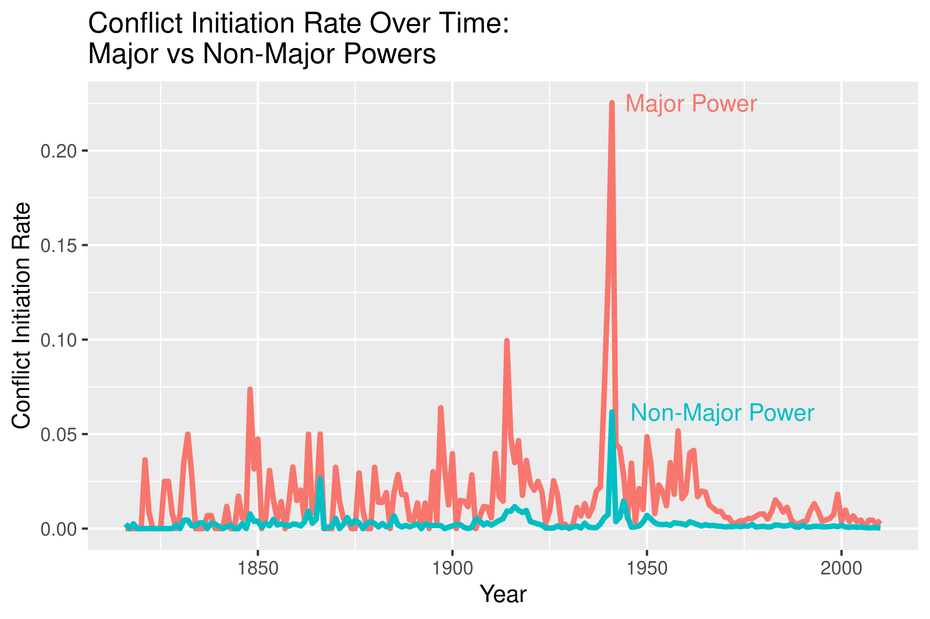

The plot shows that major powers had significantly higher peaks in conflict initiation rates, especially around World War II, while non-major powers maintained consistently lower rates over time (except the peak around World War II).