Graph Challenge 6

Aryah Rao

2024-10-26

For this graph challenge, apply a custom palette set with set_palette() from {coolorrr} in a data visualization. The specifics are up to you, but the graph must show something related to conflict, either over time, or how it’s correlated with some other factor in a dataset that you’ve constructed using {peacesciencer}. If you get stuck, instead of coming up with something new, you can take code from a previous graph challenge submission and update it with a custom palette.

## open packages  
library(tidyverse)  
library(peacesciencer)  
library(socsci)  
library(coolorrr)  
source(  
 "https://raw.githubusercontent.com/milesdwilliams15/dpr-101-project-files/refs/heads/main/_helper_functions/add_opportunity.R"  
)  
  
# Define custom palettes  
set_palette(  
 qualitative = c("#E88EED", "#2A9D8F","#FF3366","#20A4F3","#011627" ),  
 sequential = c("#FF3366", "#2A9D8F"),  
 diverging = c("#FF3366", "#20A4F3", "#2A9D8F"),  
 binary = c("#E88EED", "#20A4F3")  
)

## start with function that creates state-year data  
Data <- create_stateyears(subset_years = 1816:2010) |>  
 ## add indicators for whether countries were involved in a MID  
 add_gml_mids() |>  
 ## add opportunities for countries  
 add_opportunity()

# Group the data by year and compute unadjusted and adjusted MID initiation rates for each year  
yearly_data <- Data |>  
 group_by(year) |> # Group the dataset by the 'year'  
 summarize(  
 # Calculate the unadjusted MID initiation rate:  
 unadjusted_rate = sum(gmlmidonset) / n(),  
  
 # Calculate the adjusted MID initiation rate:  
 adjusted_rate = sum(gmlmidonset) / sum(opportunity)  
 )

# Create plot comparing unadjusted and adjusted MID initiation rates over time  
ggplot(yearly_data) +  
 aes(x = year) +  
 # Add a line for the unadjusted MID initiation rate  
 geom_line(aes(y = unadjusted_rate, color = "Unadjusted Rate")) +  
   
 # Add a line for the adjusted MID initiation rate  
 geom_line(aes(y = adjusted_rate, color = "Adjusted Rate")) +  
   
 # Add labels for the axes, title, and legend  
 labs(  
 x = "Year",  
 y = "MID Initiation Rate",  
 title = "Comparison of Unadjusted and Adjusted MID Initiation Rates \nOver Time",  
 color = "Rate Type"  
 ) +  
 ggpal()

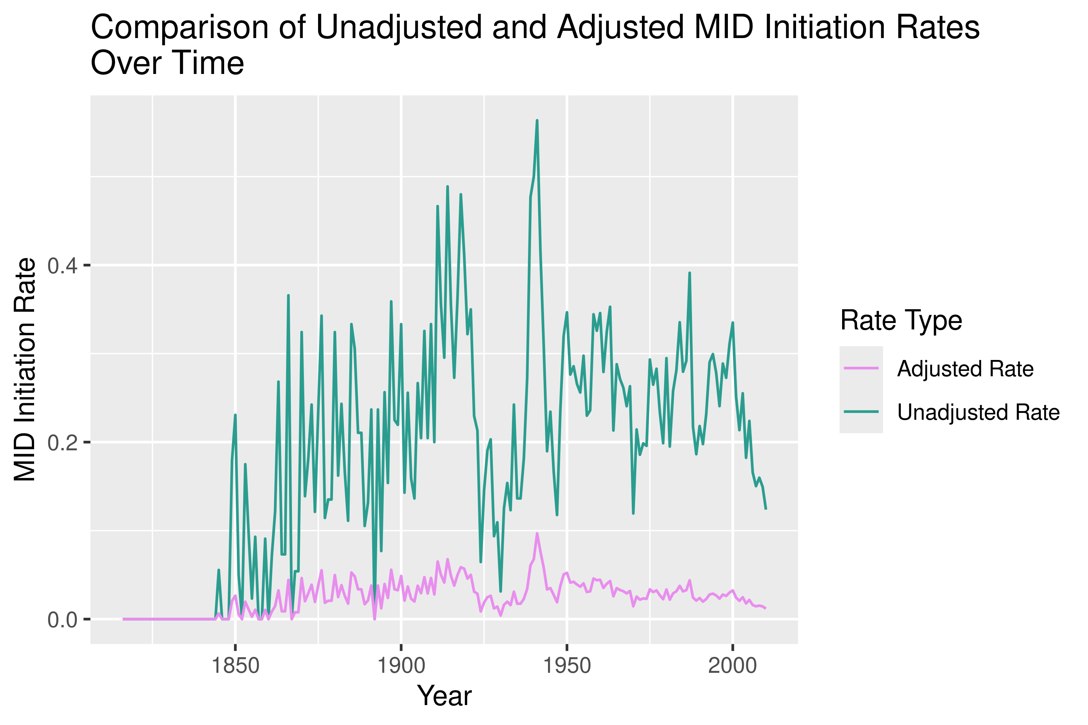

# Create plot comparing unadjusted and adjusted MID initiation rates over time  
ggplot(yearly_data) +  
 aes(x = year) +  
   
 # Add points for the unadjusted MID initiation rate with translucency  
 geom_point(aes(y = unadjusted_rate, color = "Unadjusted Rate"), alpha = 0.6) +  
   
 # Add points for the adjusted MID initiation rate with translucency  
 geom_point(aes(y = adjusted_rate, color = "Adjusted Rate"), alpha = 0.6) +  
   
 # Add a line of best fit for the unadjusted MID initiation rate  
 geom_smooth(aes(y = unadjusted_rate, color = "Unadjusted Rate"), se = FALSE) +  
   
 # Add a line of best fit for the adjusted MID initiation rate  
 geom_smooth(aes(y = adjusted_rate, color = "Adjusted Rate"), se = FALSE) +  
   
 # Add labels for the axes, title, and legend  
 labs(  
 x = "Year",  
 y = "MID Initiation Rate",  
 title = "Comparison of Unadjusted and Adjusted MID Initiation Rates \nOver Time",  
 color = "Rate Type"  
 ) +  
 ggpal()

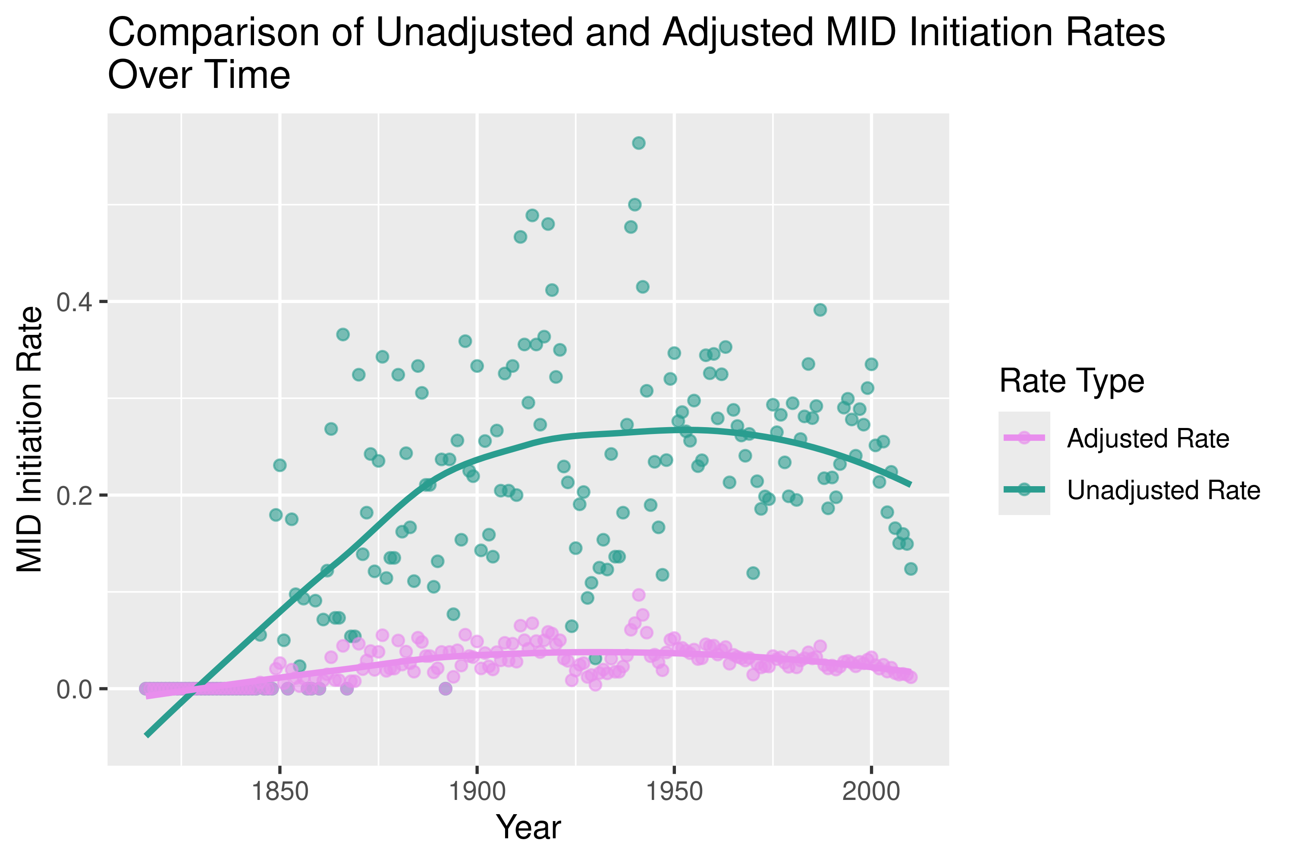

This plot compares the unadjusted and adjusted MID initiation rates over time. It visually represents how these rates have evolved, with points displaying the data and lines of best fit illustrating the underlying trends. This plot is based on the same framework as the one used in GC4; however, the results appear different, which may be attributed to updates in the data, packages, or functions used in the analysis.