Main Assignment 1
Aryah, Nguyen, Jordyn
2026-02-21

1 Introduction

2 Data and Design

3 Analysis
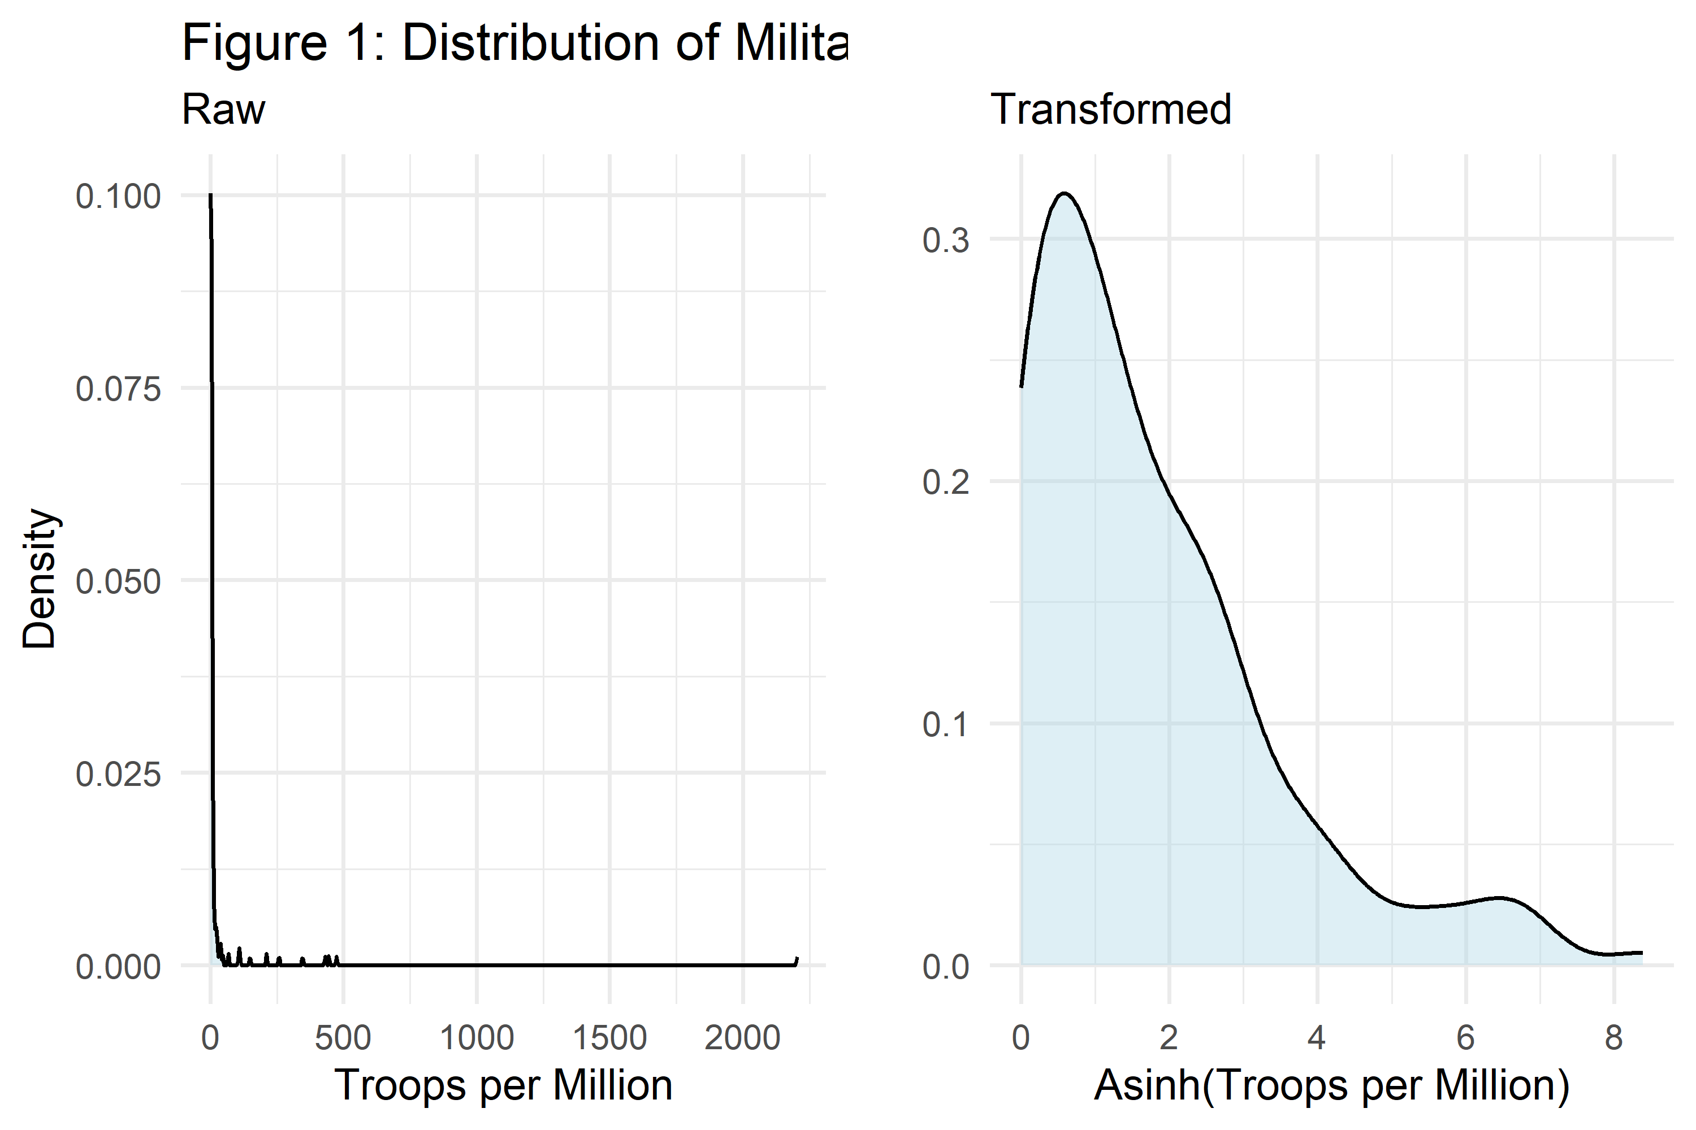
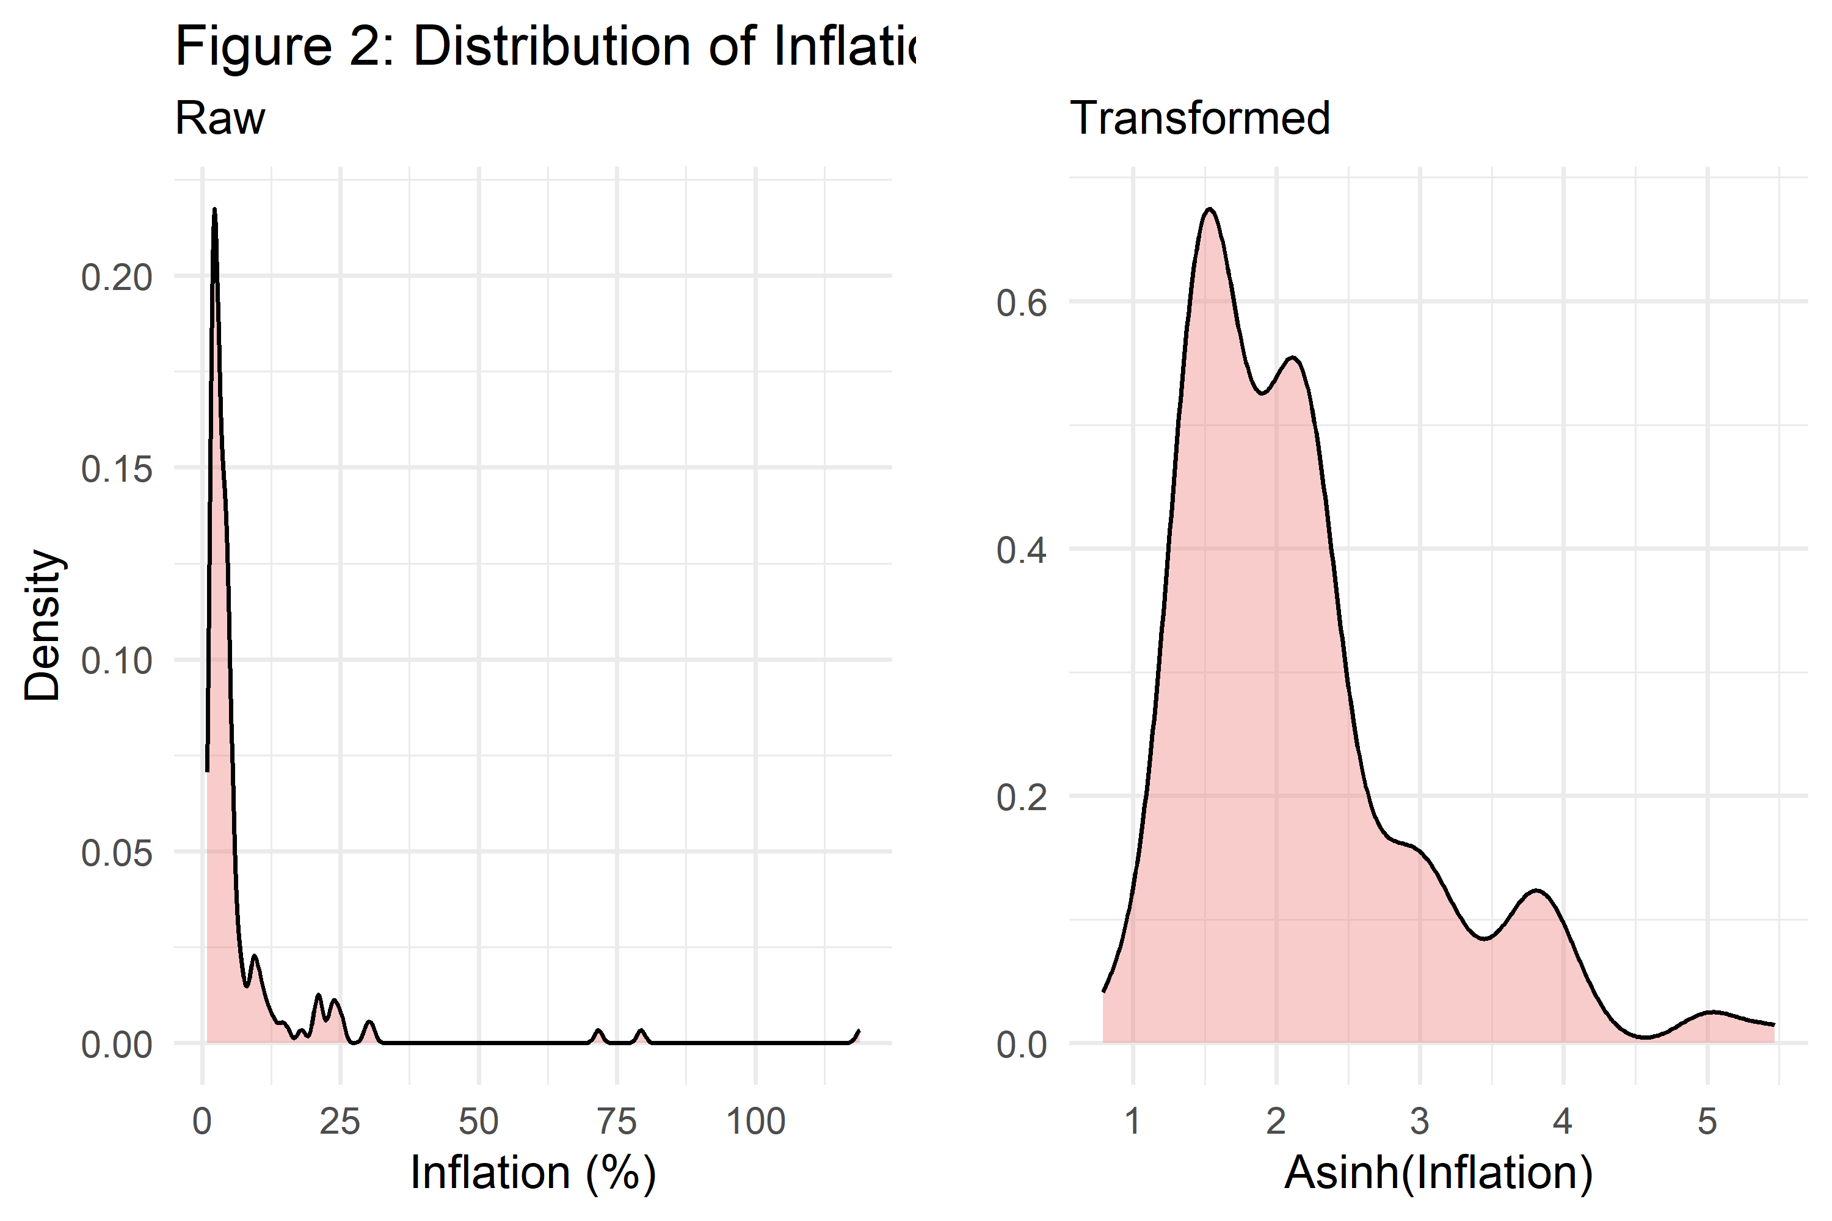
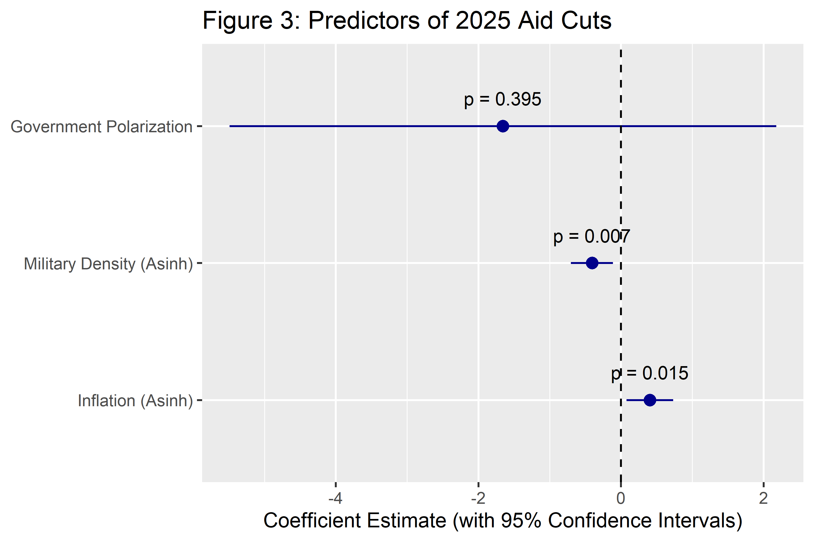
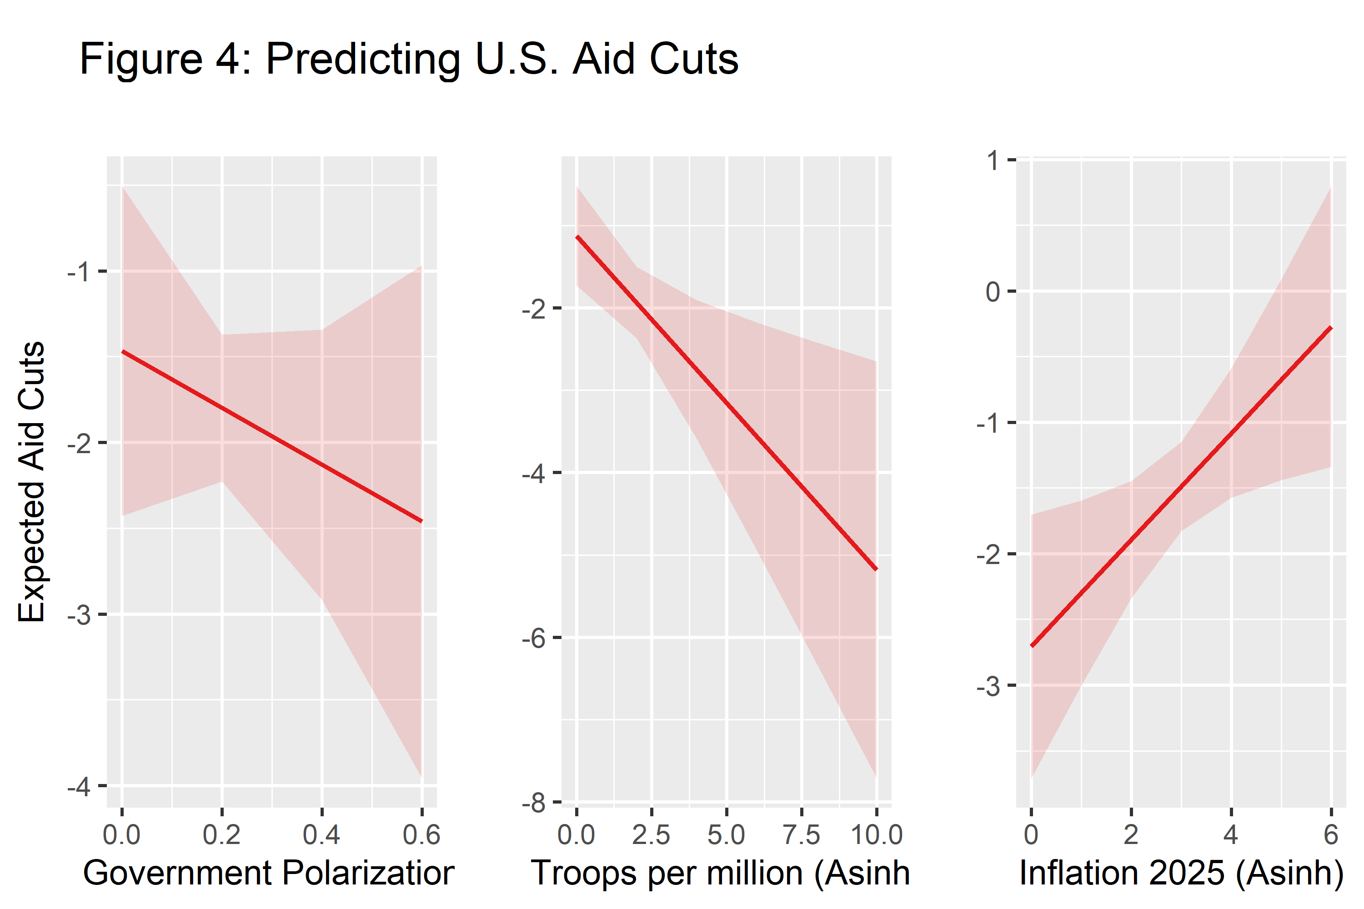

4 Conclusion

5 Code Appendix
## open packages:
library(tidyverse) # for data wrangling tools and data viz
library(estimatr) # for model estimation with robust standard errors
library(sjPlot) # for making prediction plots
library(cowplot) # for combining plots
## the aid dataset:
dt <- read_csv("https://raw.githubusercontent.com/milesdwilliams15/Teaching/refs/heads/main/DPR%20201/Data/dpr201_unit1_data.csv")
## Data wrangling & Feature Engineering
analysis_data <- dt %>%
mutate(
# Dependent Variable
aid_cut = asinh(disbursed_2025) - asinh(disbursed_2024),
# Factor 1
military_density = us_troops/pop_2024,
asinh_military_density = asinh(military_density),
# Factor 2
asinh_inf_2025 = asinh(inf_2025),
# Factor 3
gov_polarization = abs(vdem_score - 0.5)
) %>%
drop_na(aid_cut, asinh_military_density, asinh_inf_2025, gov_polarization) %>%
filter(is.finite(aid_cut))
## Estimate the model
model <- lm_robust(aid_cut ~ asinh_military_density + asinh_inf_2025 + gov_polarization, data = analysis_data, se_type = "HC1")
model_smry <- tidy(model)
# Figure 1: Military density transformation
p1 <- ggplot(analysis_data, aes(x = military_density)) +
geom_density(fill = "lightblue", alpha = 0.4) +
labs(title = "Figure 1: Distribution of Military Density", subtitle = "Raw",x = "Troops per Million", y = "Density") +
theme_minimal()
p2 <- ggplot(analysis_data, aes(x = asinh_military_density)) +
geom_density(fill = "lightblue", alpha = 0.4) +
labs(title = "", subtitle = "Transformed", x = "Asinh(Troops per Million)", y = "") +
theme_minimal()
plot_grid(p1, p2, nrow = 1)
# Figure 2: Inflation 2025 transformation
p3 <- ggplot(analysis_data, aes(x = inf_2025)) +
geom_density(fill = "lightcoral", alpha = 0.4) +
labs(title = "Figure 2: Distribution of Inflation 2025",subtitle = "Raw", x = "Inflation (%)", y = "Density") +
theme_minimal()
p4 <- ggplot(analysis_data, aes(x = asinh_inf_2025)) +
geom_density(fill = "lightcoral", alpha = 0.4) +
labs(title = "", subtitle = "Transformed", x = "Asinh(Inflation)", y = "") +
theme_minimal()
plot_grid(p3, p4, nrow = 1)
# Figure 3: Coefficient Plot
model_smry %>%
filter(term != "(Intercept)") %>%
ggplot(aes(
x = estimate,
xmin = conf.low,
xmax = conf.high,
y = term
)) +
geom_pointrange(color = "darkblue") +
# Add the p-values above the points
geom_text(aes(label = paste0("p = ", round(p.value, 3))),
vjust = -1.5,
size = 3.5,
color = "black") +
geom_vline(xintercept = 0, linetype = 2) +
labs(
title = "Figure 3: Predictors of 2025 Aid Cuts",
x = "Coefficient Estimate (with 95% Confidence Intervals)",
y = NULL
) +
scale_y_discrete(labels = c(
"gov_polarization" = "Government Polarization",
"asinh_inf_2025" = "Inflation (Asinh)",
"asinh_military_density" = "Military Density (Asinh)"
))
# Figure 4: Prediction Plots
# Generate individual plots
# Figure 4: Prediction Plots
# Generate individual plots with short sub-titles
p1 <- plot_model(model, type = "pred", terms = "gov_polarization",
title = "",
axis.title = c("Government Polarization", "Expected Aid Cuts"))
p2 <- plot_model(model, type = "pred", terms = "asinh_military_density",
title = "",
axis.title = c("Troops per million (Asinh)", ""))
p3 <- plot_model(model, type = "pred", terms = "asinh_inf_2025",
title = "",
axis.title = c("Inflation 2025 (Asinh)", ""))
# Combine the three plots into one row
plot_row <- plot_grid(p1, p2, p3, nrow = 1)
# Create a standalone title object
main_title <- ggdraw() +
draw_label("Figure 4: Predicting U.S. Aid Cuts", x = 0.3, vjust = 1)
# Combine the title and the row of plots
plot_grid(main_title, plot_row, ncol = 1, rel_heights = c(0.1, 1))

