Experiment No. 01
Time-Domain and Frequency-Domain Analysis of Temple Bell, Conch Sound, or Classical “Sa” Note

Aim:
To:
- Record a natural or musical sound (bell, conch, or “Sa”)
- Plot its waveform (time domain)
- Plot its frequency spectrum (FFT)
- Identify fundamental frequency and harmonics
- Compare with Just Intonation (JI) and Equal Temperament (ET)
Prerequisites:
Basic Science and Mathematics

Course Outcome:
On successful completion of the course, learners will be able to analyze traditional Indian acoustic practices and interpret their relevance to frequency analysis.

Hardware / Software Requirement:
- Smartphone / Microphone
- Laptop
- Software:
  - Python (NumPy, Matplotlib, SciPy)
  - Audacity (for recording) optional

Theory:

What is Sound?
Sound is a vibration that changes with time. We can study it in two ways:

1. Time Domain (Waveform)
- Shows how sound changes over time
- Example: Loud/soft pattern

2. Frequency Domain (Spectrum)
- Shows which frequencies are present
- Helps find:
  - Main pitch → Fundamental frequency (f₀)
  - Extra frequencies → Harmonics

Harmonics
If:
- Fundamental = f₀
Then:
- Harmonics = 2f₀, 3f₀, 4f₀ …

Music Systems

Just Intonation (JI)
- Based on simple ratios
- Example:
  - Sa–Pa = 3:2
  - Sa–Ma = 4:3

Equal Temperament (ET)
- Used in piano
- Frequencies are evenly spaced
- Formula: f=f_{0​}×2^{n/12}
Procedure:

Step 1: Record Sound
Record any one:
- Temple bell
- Conch (shankh)
- “Sa” note (sing or instrument)
Keep recording clear (no noise)

Step 2: Transfer File
- Save as .wav file
- Move to laptop

Step 3: Plot Time Domain
Show how sound varies with time

Step 4: Plot Frequency Spectrum
Show frequencies present in sound

Step 5: Find Fundamental Frequency
Highest peak = main pitch

Step 6: Find Harmonics
- Look for other peaks
- Example:
  - f₁ = 200 Hz
  - f₂ = 400 Hz
  - f₃ = 600 Hz
- 200 Hz, 400 Hz, 600 Hz
👉 These are harmonics
Check ratios:
- f₂ / f₁ = 2
- f₃ / f₁ = 3
Divide frequencies:
- 400 / 200 = 2
- 600 / 200 = 3
👉 Compare with:
- Just Intonation: simple ratios (2, 3/2, 5/4)
- Equal Temperament: not exact ratios

Step 7: Compare with Theory

Type | What to Check
JI | Simple ratios (2:1, 3:2, 5:4)
ET | Equal spacing (log scale)

(TO BE COMPLETED BY STUDENTS)
(Students must submit the soft copy as per following segments within two hours of the respective practical. The soft copy must be uploaded on the MsTeams at the end of the practical. Failure in submitting the soft copy may lead to reduction of marks.)
Roll No.: 2403064 | Name: Arya Idnani
Program: | Division: C1
Semester: 5 | Batch : C14
Date of Experiment: 08/07/2026 | Date of Submission: 14/07/2026
Grade :

Program:

import numpy as np
import matplotlib.pyplot as plt
from scipy.io import wavfile
from scipy.signal import find_peaks

# Step 1 & 2: Load the recorded .wav file
file_name = "conch.wav" # Replace with your actual file name
sample_rate, data = wavfile.read(file_name)

# If the audio is stereo (2 channels), convert it to mono by taking the first channel
if len(data.shape) > 1:
data = data[:, 0]

# Step 3: Time-Domain Analysis (Waveform)
# Calculate the duration of the audio to create a time array
duration = len(data) / sample_rate
time = np.linspace(0., duration, len(data))

# Step 4: Frequency-Domain Analysis (Spectrum using FFT)
n = len(data)
yf = np.fft.fft(data) # Perform Fast Fourier Transform
xf = np.fft.fftfreq(n, 1 / sample_rate) # Generate frequency axes

# We only need the positive half of the frequencies
yf = np.abs(yf[:n//2])
xf = xf[:n//2]

# Step 5 & 6: Find Fundamental Frequency and Harmonics
# Find peaks in the frequency spectrum
# 'height' filters out background noise, 'distance' ensures peaks aren't too close
peaks, _ = find_peaks(yf, height=np.max(yf)*0.1, distance=sample_rate/50)

peak_freqs = xf[peaks]
peak_amps = yf[peaks]

# Sort peaks by amplitude to find the main pitch (highest peak)
sorted_indices = np.argsort(peak_amps)[::-1]
fundamental_freq = peak_freqs[sorted_indices[0]]

# Sort the remaining peaks by frequency to identify harmonics above the fundamental
sorted_freq_peaks = np.sort(peak_freqs)
harmonics = [f for f in sorted_freq_peaks if f > fundamental_freq][:3] # Get the first 3 harmonics

# --- Console Output ---
print("-" * 30)
print(f"Fundamental Frequency (f0): {fundamental_freq:.2f} Hz")
for i, harm in enumerate(harmonics, start=1):
print(f"Harmonic {i}: {harm:.2f} Hz")
print(f"Ratio (Harmonic / f0): {harm/fundamental_freq:.2f}")
print("-" * 30)

# --- Plotting ---
plt.figure(figsize=(12, 6))

# Plot 1: Time Domain
plt.subplot(2, 1, 1)
plt.plot(time, data, color='teal')
plt.title('Time Domain (Waveform)')
plt.xlabel('Time (seconds)')
plt.ylabel('Amplitude')
plt.grid(True, alpha=0.3)

# Plot 2: Frequency Domain (FFT)
plt.subplot(2, 1, 2)
plt.plot(xf, yf, color='darkred')
plt.title('Frequency Spectrum (FFT)')
plt.xlabel('Frequency (Hz)')
plt.ylabel('Magnitude')
plt.xlim(0, max(harmonics)*1.5 if harmonics else 2000) # Zoom into the relevant frequency range
plt.grid(True, alpha=0.3)

# Highlight the fundamental frequency on the plot
plt.axvline(x=fundamental_freq, color='gold', linestyle='--', label=f'f0 = {fundamental_freq:.1f} Hz')
plt.legend()

plt.tight_layout()
plt.show()

Output:

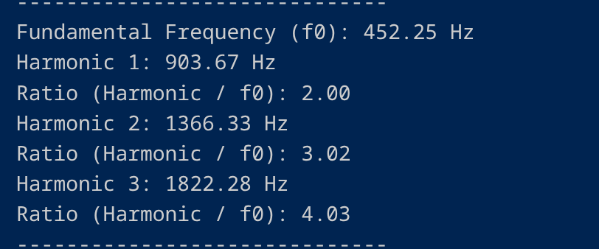
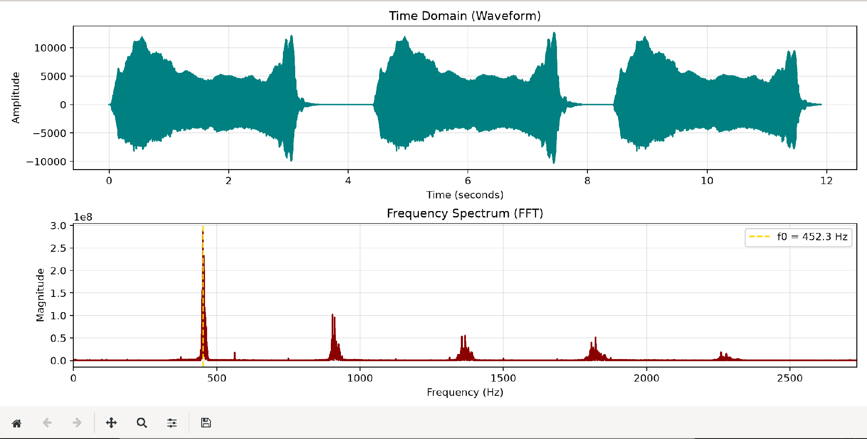

Observations:

Observation Table
Parameter | Value
Fundamental Frequency (f₀) | 452.25 Hz
Harmonic 1 | 903.67 Hz
Harmonic 2 | 1366.33 Hz
Ratio (f₂/f₁) | 2.00
Matches JI? | Yes
Matches ET? | No

Conclusions:
- The fundamental frequency is 452.25 Hz
- Harmonics are: Regular
- The sound follows: Just Intonation

Question of Curiosity:

- What is fundamental frequency?

The fundamental frequency (f_0) is the lowest frequency produced by a vibrating object and represents the primary pitch that our ears perceive. On a frequency spectrum graph, it is typically the first prominent peak.

- What are harmonics?

Harmonics are the additional sound waves present in a sound whose frequencies are positive integer multiples of the fundamental frequency (e.g., 2f_0, 3f_0, 4f_0). The presence and strength of these harmonics determine the timbre or "character" of the sound, which is why a conch shell sounds different from a flute even when playing the same note.

- What is the Difference between JI and ET?

Just Intonation (JI) is a tuning system based entirely on simple, exact whole-number ratios (such as 2:1, 3:2, or 5:4). Natural acoustic instruments, like the conch shell or the human voice, naturally follow JI, resulting in a very pure and resonant sound.
Equal Temperament (ET) is a mathematical compromise used for modern instruments like the piano. It divides an octave into 12 equally spaced logarithmic steps using the formula $f = f_0 \times 2^{n/12}$. This allows instruments to change musical keys without sounding out of tune, but the resulting frequencies are complex decimals rather than pure integer ratios.

- Why is the bell sound not perfectly harmonic?
A temple bell is a rigid, three-dimensional metallic object. Unlike the single column of air in a conch shell that supports simple, repeating standing waves, a bell vibrates in highly complex, chaotic patterns (radial, torsional, and axial modes) when struck. Because of its physical shape and metallic stiffness, these varying vibrational modes produce an "inharmonic" spectrum, meaning the extra frequencies are scattered and do not form simple, whole-number multiples of the fundamental pitch.
References:
- A. V. Oppenheim and A. S. Willsky, Signals and Systems, 2nd ed. Upper Saddle River, NJ, USA: Prentice Hall, 1997.
- S. W. Smith, The Scientist and Engineer's Guide to Digital Signal Processing. San Diego, CA, USA: California Technical Publishing, 1997.
- A. H. Benade, Fundamentals of Musical Acoustics. New York, NY, USA: Oxford University Press, 1976.

