Badung, {issue_date} No. Invoice : {invoice_number}

Dear,
{client_name}

About Invoice {invoice_percent}% {invoice_label} MEP Drawing {project_name}

Under the contract hereby submit Invoice {invoice_label} for Design Mechanical Electrical & Plumbing Project {project_name}

INVOICE
Progress | Invoice | Total Contract | Total | Remaining
{invoice_percent} % | Invoice {invoice_label} | Rp. {contract_value},- | Rp. {billed_amount},- | Rp. {remaining_amount},-
 |  | PPN ({ppn_percent}%)  PPh (-{pph_percent}%) | Rp. {ppn_amount},-  Rp. {pph_amount},-
 |  | Total Payment | Rp. {total_billed},-
Be Calculated : ({terbilang})

Please transferred to the account payment:
Name : CV.Sinar Mandiri Engineering
Account No : 1797915388
Bank : BNI

Please send proof of PPh tax deduction to email acc.sinarmandiri@gmail.com no later than {pph_deadline}

Thus we submit the filing of this bill, the attention and good cooperation we thank you.

Yours Sincerely,
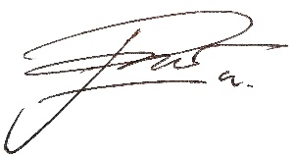

I Putu Dhian Pradewa,ST
Ph. +62 8125204175

