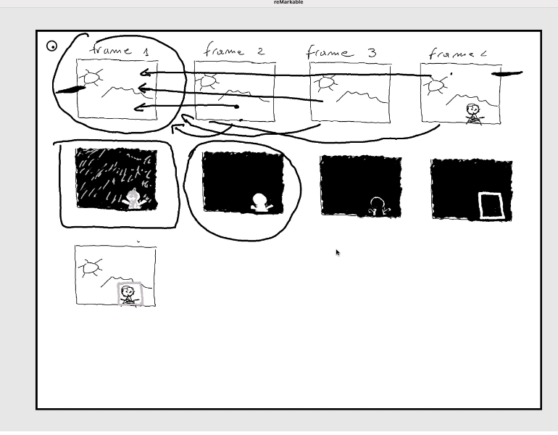

* So the camera captures the first frame and keeps it as a reference, then it compares the all next frames with frame 1 to see if anything is different in new frames.
* The way we compare the other frames to the first frames is by taking the difference of those frames to the first frames.
* When we compare the frame 4 with frame 1, we end up with a matrix of black bg and white figure (img. 5)
* And then we will clear up that image, we'll apply some algorithms to smooth that area, and then we will draw some rectangles around that area here.
* And then we'll find the rectangle in this frame here,the rectangle around the object.
* So then we get that rectangle, and then we draw that rectangle in the original frame, in the original current frame, and we display the frame on the screen on the computer.