A CASE STUDY ON MULTILINGUAL TEXT MINING AND CROSS-LINGUAL TRANSFER LEARNING FOR ONLINE HATE AND ABUSIVE SPEECH DETECTION
Comprehensive Empirical Evaluation of Statistical N-Gram Baselines, Fine-Tuned XLM-RoBERTa Architectures, and Layer Integrated Gradients Across Indic and Global Languages

Course: CSI4004 – Text Mining
Submitted By: Arya Kant Pathak
Registration Number: 23MID0056
Programme / Semester: Integrated M.Tech (Software Engineering) / Semester-7
Department / School: School of Computer Science and Engineering (SCOPE)
Institution: Vellore Institute of Technology (VIT), Vellore, Tamil Nadu, India
Date of Submission: October 30, 2026
ACADEMIC CASE STUDY SUBMITTED IN PARTIAL FULFILLMENT OF THE CONTINUOUS ASSESSMENT REQUIREMENTS FOR CSI4004 TEXT MINING

2.0 ABSTRACT
With the exponential growth of user-generated content across multilingual social media platforms, automated text mining techniques have become paramount for combating hate speech, offensive behavior, and targeted cyber-harassment. This case study presents a rigorous end-to-end text mining framework for binary hate and abusive speech detection across high-resource and morphologically complex Indic languages (English, Hindi, Tamil, and Malayalam), complemented by zero-shot transfer evaluation on unseen languages (Telugu and Kannada). We implement a dual-tier analytical methodology: a classical statistical text mining baseline utilizing word/character Term Frequency-Inverse Document Frequency (TF-IDF) vectorization paired with regularized Logistic Regression, juxtaposed against a state-of-the-art multilingual deep transfer learning architecture based on fine-tuned Cross-Lingual RoBERTa (XLM-RoBERTa). On an official held-out test split of 19,787 verified comments, fine-tuned XLM-RoBERTa achieved an overall classification accuracy of 86.12% and a Macro-F1 score of 0.8611 (ROC-AUC 0.9399), outperforming the statistical baseline across all linguistic subsets and securing an essential 26.0% reduction in false-negative detections. Furthermore, model interpretability is operationalized using Layer Integrated Gradients to provide faithful token-level attributions. Finally, evaluation on the out-of-domain IndicGuard corpus illustrates critical text mining vulnerabilities regarding domain shift in safety-critical deployments.
Index Terms / Keywords: Text Mining, Multilingual Hate Speech, XLM-RoBERTa, Natural Language Processing, TF-IDF, Transfer Learning, Explainable AI, Integrated Gradients, Indic Languages.

3.0 TABLE OF CONTENTS
1.0 Title Page ............................................................. 1
2.0 Abstract ............................................................... 2
3.0 Table of Contents ...................................................... 3
4.0 Introduction ........................................................... 4
4.1 Background of Social Media Text Mining and Online Toxicity ......... 4
4.2 Linguistic Challenges in Low-Resource and Indic Text Processing ..... 4
4.3 Significance of Text Mining in Automated Content Moderation ........ 5
4.4 Structure of the Case Study Report ................................. 5
5.0 Literature Review ...................................................... 6
5.1 Evolution of Text Mining for Toxic Language Identification ......... 6
5.2 Statistical N-Gram Vectorization vs. Deep Pretrained Representations ..... 6
5.3 Cross-Lingual Language Models and Indic Text Processing ............ 7
5.4 Explainability Frameworks and Attribution in NLP ................... 7
5.5 Identified Gaps in Literature and Study Motivation ................. 8
6.0 Problem Statement ...................................................... 8
6.1 Formal Articulation of the Problem ................................. 8
6.2 Real-World Societal and Industrial Significance .................... 9
7.0 Objectives of the Study ................................................ 9
8.0 Methodology and Proposed Techniques .................................... 10
8.1 Datasets Description and Multi-Source Corpus Unification ........... 10
8.2 Label Normalization and Unified Taxonomy Formulation ............... 10
8.3 Experimental Tools and Computing Environment ....................... 11
8.4 Dual Text Preprocessing Pipelines (Statistical vs. Deep Contextual) ..... 11
8.5 Algorithms and Mathematical Formulations ........................... 12
8.5.1 Sublinear TF-IDF Vectorization & Regularized Logistic Regression ..... 12
8.5.2 Cross-Lingual RoBERTa (XLM-R) Deep Architecture .............. 13
8.5.3 Layer Integrated Gradients & Axiomatic Explainability ........ 14
8.6 Pseudocode and Architectural Flowchart ............................. 15
9.0 Results and Discussion ................................................. 16
9.1 Overall Classification Performance Benchmark ....................... 16
9.2 Granular Language-Wise Empirical Findings .......................... 17
9.3 Confusion Matrix and Error Distribution Analysis ................... 18
9.4 False Positive and False Negative Typology Breakdown ............... 19
9.5 Zero-Shot Cross-Lingual Transfer to Telugu and Kannada ............. 20
9.6 Out-of-Domain Generalization and Domain Shift (IndicGuard) ......... 20
9.7 Model Interpretability and Attribution Case Demonstrations ......... 21
9.8 Latency Benchmarks and Production Deployment Trade-Offs ............ 22
9.9 Business, Ethical, and Governance Implications ..................... 23
10.0 Conclusion ............................................................ 24
10.1 Summary of Experimental Discoveries ............................... 24
10.2 Assessment of Objectives Fulfillment .............................. 24
10.3 Inherent Limitations of the Study ................................. 25
11.0 Future Directions ..................................................... 25
11.1 Real-Time Streaming and Active Learning Integration ............... 25
11.2 Parameter-Efficient Adaptation (LoRA/PEFT) and Model Compression ..... 26
11.3 Multi-Modal and Code-Mixed Cross-Script Robustness ................ 26
12.0 References ............................................................ 27
13.0 Appendices ............................................................ 29
Appendix A: Dual Preprocessing Pipeline Implementations ................ 29
Appendix B: End-to-End Microservice API Deployment Structure ........... 30

4.0 INTRODUCTION
4.1 Background of Social Media Text Mining and Online Toxicity
Over the past two decades, text mining—the semi-automated discovery of novel, previously unknown patterns, knowledge, and actionable insights from unstructured textual repositories—has transitioned from an exploratory analytical tool to a vital pillar of digital platform governance. Modern social networking platforms, community discussion boards, and video-sharing platforms process billions of user-submitted textual comments every single day. While this unprecedented connectivity democratizes public discourse and fosters global knowledge exchange, it has concurrently catalyzed the proliferation of toxic digital behaviors, including targeted harassment, communal hate speech, xenophobia, misogyny, and coordinated defamation campaigns.
Unmoderated toxic content inflicts profound psychological trauma on marginalized demographics, stifles constructive community dialogue, and in extreme cases, incites real-world violence, hate crimes, and civil unrest. Consequently, commercial platform operators, regulatory bodies, and legal authorities are subject to strict legal mandates (e.g., the European Union Digital Services Act, Germany's Network Enforcement Act, and India's Information Technology Intermediary Guidelines) requiring the expeditious identification and mitigation of illicit toxic discourse within defined timeframes.
4.2 Linguistic Challenges in Low-Resource and Indic Text Processing
While automated text mining techniques for toxic language have matured considerably for standard English text, extending these capabilities to non-English, low-resource, and morphologically rich languages remains an intricate open challenge in computational linguistics. The linguistic landscape of South Asia, specifically the Indian subcontinent, represents one of the most linguistically diverse and digitally active regions globally, encompassing more than 22 scheduled languages belonging to diverse language families (Indo-Aryan and Dravidian).
Mining Indic social text presents unique hurdles: (1) Morphological Richness: Dravidian languages such as Tamil and Malayalam exhibit high degrees of agglutination, where syntactic markers, postpositions, and case endings are concatenated onto nominal or verbal root morphemes, yielding massive, open-ended vocabularies; (2) Script Diversity and Orthographic Variance: Indic languages utilize distinct non-Latin scripts (Devanagari, Tamil, Malayalam, Telugu, Kannada) with complex vowel matras, halants, and conjunct characters; (3) Code-Mixing and Transliteration: A significant proportion of online communication occurs in colloquial code-mixed Romanized formats (e.g., Hinglish, Tanglish, Manglish), which completely bypass conventional dictionary lookups and standardized morphological stemmers; and (4) Scarcity of High-Quality Gold Annotations: High-quality, culturally aligned, and rigorously annotated training corpora for low-resource Indic languages remain scarce compared to Western digital corpora.
4.3 Significance of Text Mining in Automated Content Moderation
Automating toxicity detection through text mining is indispensable because manual human content moderation is fundamentally non-scalable, financially unsustainable, and ethically harrowing. Human moderators tasked with reviewing millions of flagged graphic, violent, and abusive messages routinely suffer severe post-traumatic stress and psychological fatigue. High-throughput text mining frameworks capable of parsing hundreds of incoming comments per second, filtering overtly safe interactions, and triaging ambiguous, high-risk cases for targeted human oversight provide the only viable mechanism for preserving online safety at digital scale.
4.4 Structure of the Case Study Report
The remainder of this case study is methodically structured as follows: Section 5 provides an extensive literature review summarizing classical text mining approaches, transformer-based language representations, and explainability frameworks; Section 6 defines the formal problem statement; Section 7 outlines the core objectives; Section 8 articulates the research methodology, corpus unification, dual preprocessing pipelines, algorithmic formulations, and system workflow; Section 9 presents detailed empirical results, comparative evaluations, language breakdowns, error typologies, explainability case studies, and deployment latency benchmarks; Section 10 draws key conclusions and highlights operational constraints; Section 11 charts promising future directions; Section 12 provides comprehensive bibliographic references; and Section 13 presents technical appendices.
5.0 LITERATURE REVIEW
5.1 Evolution of Text Mining for Toxic Language Identification
Early text mining frameworks for toxic content detection relied heavily on rule-based heuristics and curated lexical blacklists (Sood et al., 2012). These systems flagged comments based on the presence of predefined vulgarities, ethnic slurs, or pejorative keywords. However, lexical blacklists exhibited severe brittleness: they were effortlessly circumvented through leetspeak, intentional misspellings, character substitutions, and phonetic obfuscations. Furthermore, blacklist approaches suffered from rampant false-positive rates due to the absence of syntactic context, frequently penalizing benign educational, reportage, or counter-speech discourse.
The field advanced through statistical feature engineering and supervised machine learning (Schmidt and Wiegand, 2017). Researchers extracted bag-of-words (BoW), character n-grams, word n-grams, sentiment polarities, and part-of-speech (POS) distributions, training classical discriminative classifiers such as Naive Bayes, Support Vector Machines (SVM), and regularized Logistic Regression (Davidson et al., 2017). Waseem and Hovy (2016) demonstrated that character n-grams provided superior resilience against orthographic obfuscation and typos compared to word tokens. Nevertheless, these classical text mining models remained bounded by the bag-of-words assumption, remaining fundamentally blind to long-range syntactic dependencies, negation scope, sarcasm, and conversational nuance.
5.2 Statistical N-Gram Vectorization vs. Deep Pretrained Representations
The introduction of dense distributional word representations—such as Word2Vec (Mikolov et al., 2013) and GloVe (Pennington et al., 2014)—partially alleviated lexical sparsity by embedding semantic proximity in continuous vector spaces. However, static embeddings assigned invariant vectors to lexical items regardless of context, failing to disambiguate polysemous words. The subsequent deep learning paradigm introduced recurrent architectures (LSTM, BiLSTM) and convolutional networks (CNN) for text mining (Zhang et al., 2018), capturing local sequential order.
The watershed moment occurred with the advent of the Transformer architecture (Vaswani et al., 2017) and self-supervised pretrained foundation models, notably BERT (Devlin et al., 2019) and RoBERTa (Liu et al., 2019). By computing multi-head bidirectional self-attention across input token representations, transformers construct deeply contextual dynamic embeddings, dynamically adjusting the semantic representation of each word based on its full bidirectional sentential context.
5.3 Cross-Lingual Language Models and Indic Text Processing
To address multilingual text mining without requiring separate monolingual models for every global dialect, researchers developed multilingual transformers trained on massive multi-script web corpora. Multilingual BERT (mBERT) and XLM (Lample and Conneau, 2019) established that shared multilingual subword vocabularies facilitate zero-shot cross-lingual knowledge transfer across diverse languages.
Conneau et al. (2020) introduced XLM-RoBERTa (XLM-R), pretrained on over 2.5 terabytes of filtered CommonCrawl data covering 100 languages using a self-supervised Masked Language Modeling (MLM) objective. XLM-R utilizes a SentencePiece vocabulary of 250,000 subword units, ensuring comprehensive subword representation for complex Indic scripts. In the South Asian context, the Multi-lingual Abusive Comment Dataset (MACD) was introduced by ShareChat researchers (Bhardwaj et al., NeurIPS 2022), providing 152,422 real-world social comments across five Indian languages. Similarly, Mathew et al. (AAAI 2021) introduced HateXplain, offering benchmark Twitter and Gab posts annotated with fine-grained rationales. More recently, L3Cube-Pune released IndicGuard (2024), an Indic safety benchmark comprising over 400,000 prompts across 11 Indic languages.
5.4 Explainability Frameworks and Attribution in NLP
As deep text mining models have grown in parametric scale and architectural opacity, the demand for Explainable Artificial Intelligence (XAI) has intensified. Deploying 'black-box' neural classifiers in high-stakes governance environments introduces severe risks of unverified bias and unpredictable catastrophic errors. Classical post-hoc explanation frameworks such as LIME (Ribeiro et al., 2016) and SHAP (Lundberg and Lee, 2017) approximate local decision boundaries via perturbation, but are computationally prohibitive for high-dimensional sequence models.
Sundararajan et al. (ICML 2017) formulated Integrated Gradients (IG), an axiomatic gradient-based attribution technique that satisfies two fundamental mathematical axioms: Completeness (the attributions sum exactly to the difference between the model output at the input and a chosen neutral baseline) and Implementation Invariance. Applying Layer Integrated Gradients directly to the word embedding space enables faithful extraction of token-level importance scores, revealing precisely which morphological units governed the classifier's toxic decision.
5.5 Identified Gaps in Literature and Study Motivation
Gaps in Prior Work: A critical appraisal of current literature reveals three fundamental shortcomings that this study directly resolves:
- Fragmented Monolingual Silos: Prior studies typically evaluate models in monolingual isolation or restrict evaluation strictly to English, neglecting cross-lingual transfer dynamics across diverse Indo-Aryan and Dravidian linguistic structures within a unified pipeline.
- Superficial Data Cleaning Protocols: Many existing text mining pipelines apply aggressive English-centric preprocessing (excessive punctuation stripping, lowercasing, stop-word deletion) to Indic scripts, which inadvertently corrupts essential zero-width joiners (ZWJ/ZWNJ) and vowel diacritics necessary for grammatical parsing.
- Lack of Cross-Domain Generalization Benchmarks: Most benchmarks evaluate models solely on identically distributed in-domain test splits, creating an illusion of robust accuracy while ignoring catastrophic performance degradation when deployed on out-of-domain synthetic or safety prompts.
6.0 PROBLEM STATEMENT
6.1 Formal Articulation of the Problem
Formally, let C = {(x_1, y_1), (x_2, y_2), ..., (x_N, y_N)} denote a multilingual text mining corpus comprising N textual instances, where each comment x_i represents an arbitrary-length sequence of characters or subwords drawn from an open vocabulary V_L spanning multiple distinct natural languages L in {English, Hindi, Tamil, Malayalam, Kannada, Telugu}. Each textual instance is annotated with a ground-truth binary label y_i in {0, 1}, where y_i = 0 designates Non-Hate / Benign discourse, and y_i = 1 designates Hate / Abusive discourse (including targeted identity attacks, slurs, harassment, and severe profanity).
The technical objective is to design, train, and validate a generalized text mining mapping function f: X -> [0, 1], parameterized by theta, that maps any input sequence x to a predicted posterior probability p = f(x; theta) = P(Y = 1 | x), such that the classifier maximizes Macro-Averaged F1-score across all supported languages while minimizing both the False Positive Rate (FPR) and False Negative Rate (FNR). Furthermore, the function f must be paired with an attribution operator Phi(x) that maps the input sequence to an attribution vector a in R^|x|, assigning verifiable importance scores to each constituent lexical item without inducing excessive computational latency.
6.2 Real-World Societal and Industrial Significance
In real-world social networking architectures, an algorithmic failure carries asymmetric operational consequences. A false-negative failure (failing to detect genuine abuse) allows vitriolic harassment to proliferate unhindered, causing severe psychological harm, platform abandonment, and brand defamation. Conversely, a false-positive failure (erroneously censoring legitimate user expression) inflicts unjustified censorship, suppresses democratic debate, and degrades user trust. Developing an accurate, explainable, and cross-lingually transferable text mining pipeline directly empowers platforms to safeguard digital ecosystems while honoring cultural nuances across global communities.
7.0 OBJECTIVES OF THE STUDY
To address the articulated problem statement, this case study pursues the following concrete academic and engineering objectives:
- Objective 1: Multi-Source Data Consolidation: Harmonize three disparate datasets (MACD, HateXplain, IndicGuard) exhibiting divergent taxonomic schemes into a unified, balanced binary classification schema (0: Non-Hate, 1: Hate/Abusive).
- Objective 2: Engineered Dual Preprocessing Architecture: Establish two distinct text preprocessing pipelines—a statistical n-gram normalizer preserving emoji sentiment and a non-destructive contextual cleaner preserving Indic diacritics and Unicode zero-width characters.
- Objective 3: Statistical Baseline Formulation: Construct a competitive classical text mining baseline utilizing sublinear term-frequency inverse document frequency (TF-IDF) feature spaces coupled with class-balanced regularized Logistic Regression.
- Objective 4: Deep Cross-Lingual Transfer Learning: Fine-tune the 278-million parameter XLM-RoBERTa multilingual transformer using class-weighted cross-entropy loss across English, Hindi, Tamil, and Malayalam corpora.
- Objective 5: Empirical Benchmark and Error Typology Analysis: Conduct rigorous held-out test evaluations comparing classification accuracy, Macro-F1, ROC-AUC, FPR, and FNR, accompanied by automated linguistic error categorization.
- Objective 6: Cross-Lingual Zero-Shot and Out-of-Domain Stress Testing: Evaluate zero-shot transfer capabilities on unseen Dravidian languages (Telugu and Kannada) and stress-test generalization against the synthetic IndicGuard LLM safety benchmark.
- Objective 7: Axiomatic Interpretability and Service Integration: Implement Layer Integrated Gradients attribution with occlusion fallback, and integrate the full pipeline into an asynchronous FastAPI microservice with production latency benchmarking.

8.0 METHODOLOGY AND PROPOSED TECHNIQUES
8.1 Datasets Description and Multi-Source Corpus Unification
To ensure robust cross-lingual coverage and ecological validity, this study amalgamates three well-established natural language corpora, encompassing authentic social media commentary, human-moderated discourse, and synthetic safety prompts:
Corpus Name | Primary Source | Languages Utilized | Total Volume | Primary Data Role
MACD (ShareChat) | Social Media Comments | Hindi, Tamil, Malayalam, Kannada, Telugu | 152,422 comments | Train, Validation, In-Domain Test & Zero-Shot
HateXplain | Twitter & Gab Social Posts | English (3 Annotators) | 20,148 posts | Train, Validation, In-Domain Test
IndicGuard (L3Cube) | Synthetic Safety Corpus | 11 Indic Languages | 431,464 prompts | External Out-of-Domain Stress Testing
Table 1: Comprehensive Summary of Unified Text Mining Corpora
8.2 Label Normalization and Unified Taxonomy Formulation
Each raw data corpus originates from distinct research consortia with idiosyncratic labeling conventions. To construct a coherent text mining pipeline, all labels were programmatically mapped into a canonical binary target: 0 for Non-Hate / Non-Abusive and 1 for Hate / Abusive.
- MACD Mapping: MACD Inversion: The original MACD corpus encoded abusive comments as label 0 and non-abusive comments as label 1. In our pipeline, this convention was deliberately inverted (0 -> 1, 1 -> 0) to align with standard statistical convention where the positive class denotes the anomaly or target condition (abusive speech).
- HateXplain Mapping: HateXplain Aggregation: The 3-annotator majority vote was processed such that 'hatespeech' and 'offensive' instances were aggregated into class 1 (toxic/abusive), while 'normal' instances mapped to class 0. Contradictory instances where all three annotators disagreed ('undecided') were systematically dropped.
- IndicGuard Mapping: IndicGuard Filtering: Prompts where 'violated_categories' contained 'Hate/Identity Hate' were mapped to class 1. Prompts labeled 'safe' were mapped to class 0. Prompts violating other unrelated safety dimensions (e.g., chemical weapons, criminal planning) were pruned to prevent semantic drift.
8.3 Experimental Tools and Computing Environment
The end-to-end framework was engineered using Python 3.14 on a high-performance Windows computing environment. Core statistical text mining operations utilized Scikit-Learn 1.4 for TF-IDF vectorization, feature selection, and Logistic Regression solvers. Deep contextual representations were developed using PyTorch 2.4 and HuggingFace Transformers 4.44. Model interpretability routines were executed via Captum 0.7 (LayerIntegratedGradients). The production microservice was implemented using FastAPI 0.110 with Pydantic v2 data validation, served via Uvicorn, and paired with a modern React 18 / Vite single-page moderation interface.
8.4 Dual Text Preprocessing Pipelines (Statistical vs. Deep Contextual)
A critical architectural insight of this case study is that classical statistical text mining and modern deep transformer models demand radically divergent preprocessing strategies. Applying identical destructive cleaning to both paradigms cripples model efficacy. Hence, two isolated pipelines were implemented:
- Pipeline A (Transformer): Pipeline A (Minimal Contextual Cleaning for XLM-RoBERTa): Preserves maximal linguistic and orthographic context. Transformers leverage punctuation, capitalization, emojis, and syntactic sentence structure to infer sentiment and aggression (e.g., 'I HATE YOU!!!' contains critical capitalization and punctuation markers). Pipeline A decodes HTML entities, strips raw HTML tags, normalizes web URLs to a generic 'http' token, replaces user mentions with '@user', strips non-printable control characters, enforces Unicode NFC normalization, and collapses redundant whitespace. Crucially, Indic zero-width characters (ZWJ: U+200D, ZWNJ: U+200C) are strictly preserved as they dictate orthographic conjuncts in Malayalam and Hindi scripts.
- Pipeline B (Statistical): Pipeline B (Aggressive Statistical Normalization for TF-IDF): Classical n-gram models suffer severely from vocabulary explosion and feature sparsity. Pipeline B inherits cleaned text from Pipeline A, converts all characters to lowercase, squashes character elongations exceeding two repetitions (e.g., 'sooooo' becomes 'soo'), isolates punctuation characters into distinct whitespace-delimited tokens, and preserves unicode emojis as standalone lexical units. A specialized whitespace tokenizer is employed because default regex word-splitters mistakenly fracture Indic characters at their vowel matras.
8.5 Algorithms and Mathematical Formulations
8.5.1 Sublinear TF-IDF Vectorization & Regularized Logistic Regression
The statistical baseline transforms unstructured text into high-dimensional sparse vector representations using Sublinear Term Frequency-Inverse Document Frequency (TF-IDF). For a term t in document d within corpus D, sublinear term frequency dampens the impact of excessive word repetition:
tf_sublinear(t, d) = 1 + ln(tf(t, d)) if tf(t, d) > 0, else 0
idf(t, D) = ln((1 + |D|) / (1 + df(t, D))) + 1
tfidf(t, d, D) = tf_sublinear(t, d) * idf(t, D)
Extracted feature spaces comprise word unigrams and bigrams spanning a maximum vocabulary of 500,000 features, filtered with a minimum document frequency threshold of 2. Classification is conducted via L2-regularized Logistic Regression parameterized by inverse regularization strength C = 4.0, optimizing the balanced cross-entropy cost function:
min_{w, b} (1 / 2) ||w||_2^2 + C * sum_{i=1}^N w_{c, i} * ln(1 + exp(-y_i * (w^T x_i + b)))
8.5.2 Cross-Lingual RoBERTa (XLM-R) Deep Architecture
The deep transfer learning framework utilizes XLM-RoBERTa (base architecture: 278 million parameters, 12 hidden transformer layers, 768 hidden dimensions, 12 attention heads). The input sequence is segmented into SentencePiece subword tokens, prepended with a classification token <s> and terminated with </s>. Let h_0 in R^768 represent the final hidden state corresponding to the <s> token. A linear classification projection layer maps h_0 to binary class logits:
z = W_c * h_0 + b_c, where W_c in R^{2 x 768}, b_c in R^2
P(Y = 1 | x) = exp(z_1) / (exp(z_0) + exp(z_1))
Fine-tuning was executed across 3 training epochs using the AdamW optimizer (learning rate 2e-5, linear warmup ratio 0.06, weight decay 0.01, batch size 32, maximum sequence length 128, mixed-precision FP16). Class imbalance was addressed via class-weighted loss:
L_{weighted} = - (1 / N) sum_{i=1}^N w_{y_i} [ y_i ln p_i + (1 - y_i) ln(1 - p_i) ]
8.5.3 Layer Integrated Gradients & Axiomatic Explainability
To provide interpretable explanations, we apply Integrated Gradients to the input word embedding space. Let x in R^{m x d} denote the continuous embedding tensor of an input sequence containing m tokens, and let x' in R^{m x d} denote a neutral baseline tensor. The attribution vector for token dimension k is computed by integrating the gradients along a linear interpolation path:
IG_k(x) = (x_k - x'_k) * integral_0^1 ( partial f(x' + alpha * (x - x')) / partial x_k ) d alpha
In our implementation, the continuous path is approximated via a 50-step Riemann summation (midpoint rule), dynamically doubling up to 200 steps until the Completeness Error satisfies: | sum_k IG_k(x) - (f(x) - f(x')) | <= 0.05. The baseline x' is dynamically selected from four candidate neutral baselines (<pad>, <mask>, <unk>, or all-zeros) by choosing the baseline that minimizes P(predicted class). If gradient convergence fails, the system executes an automated fallback to occlusion sensitivity (leave-one-word-out).
8.6 Pseudocode and Architectural Flowchart
The complete text mining inference, classification, and explainability lifecycle is formalized in Algorithm 1:
ALGORITHM 1: Multilingual Hate Speech Mining & Axiomatic Attribution Pipeline
Input: Raw textual comment T, Confidence threshold tau = 0.5, Attribution flag ExplainFlag
Output: Classification Prediction Y_hat, Confidence Score S, Important Attribution Tokens A
1: T_clean <- CleanContextualText(T) // Unicode NFC, HTML strip, URL/@user normalize, ZWJ preserve
2: L_detected <- DetectLanguageScript(T_clean) // Devanagari, Tamil, Malayalam, or Latin
3: Tokens <- XLMRobertaTokenizer.Encode(T_clean, max_length=128, return_tensors='pt')
4: Logits <- XLMRobertaModel.Forward(Tokens)
5: Prob_Hate <- Softmax(Logits)[Class_Hate]
6: if Prob_Hate >= tau then
7: Y_hat <- 'HATE / ABUSIVE'; S <- Prob_Hate
8: else
9: Y_hat <- 'NON-HATE / BENIGN'; S <- 1.0 - Prob_Hate
10: end if
11: A <- EmptyList()
12: if Y_hat == 'HATE / ABUSIVE' and ExplainFlag == TRUE then
13: Baseline <- SelectOptimalBaseline(Tokens, TargetClass=1) // argmin P(Hate|Baseline)
14: Attributions <- ComputeLayerIntegratedGradients(Tokens, Baseline, steps=50..200)
15: if CheckCompletenessConvergence(Attributions) == TRUE then
16: A <- ExtractTopAttributedSubwords(Attributions, threshold=0.33)
17: else
18: A <- ComputeOcclusionAttributions(Tokens, T_clean) // Robust Fallback
19: end if
20: end if
21: return (Y_hat, S, L_detected, A)

9.0 RESULTS AND DISCUSSION
9.1 Overall Classification Performance Benchmark
The empirical performance of the proposed text mining models was benchmarked on the official held-out test split comprising 19,787 multi-source samples (English: 1,918; Hindi: 6,723; Malayalam: 5,154; Tamil: 5,992). The class distribution in the test set contains 10,050 Non-Hate instances (50.79%) and 9,737 Hate instances (49.21%), providing an ideal balanced evaluation benchmark.
Evaluation Metric | TF-IDF + Logistic Regression | Fine-Tuned XLM-RoBERTa | Absolute Gain
Classification Accuracy | 82.80% | 86.12% | +3.32%
Macro-Averaged F1-Score | 0.8280 | 0.8611 | +0.0331
Weighted-Averaged F1-Score | 0.8281 | 0.8612 | +0.0331
Hate Class F1 (F1,hate) | 0.8230 | 0.8592 | +0.0362
Non-Hate Class F1 (F1,non-hate) | 0.8330 | 0.8631 | +0.0301
Macro Precision | 0.8281 | 0.8611 | +0.0330
Macro Recall | 0.8277 | 0.8612 | +0.0335
Area Under ROC Curve (ROC-AUC) | 0.9091 | 0.9399 | +0.0308
False Negative Rate (FNR) | 18.83% | 13.94% | -4.89% (-26.0% rel.)
False Positive Rate (FPR) | 15.60% | 13.83% | -1.77% (-11.3% rel.)
Table 2: Global Performance Benchmark on Held-Out Test Set (n=19,787)

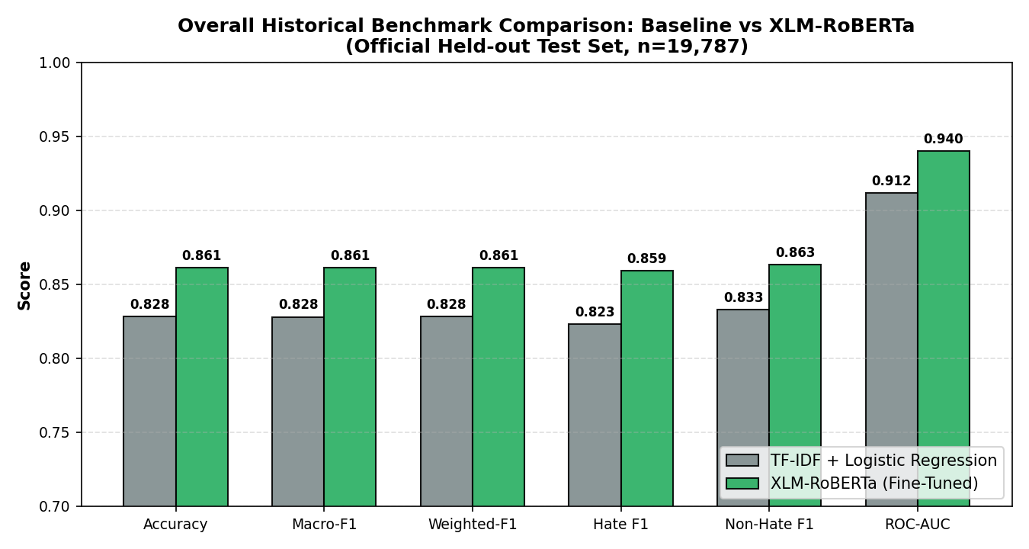
Figure 1: Macro-F1 Performance Comparison Across Linguistic Subsets
9.2 Granular Language-Wise Empirical Findings
A granular breakdown across individual languages highlights the distinct operational nuances between statistical surface features and deep contextual representations:
Language | Test (n) | Baseline F1 | XLM-R F1 | Accuracy | Hate F1 | F1 Gain
English | 1,918 | 0.7455 | 0.7836 | 79.25% | 0.8274 | +3.81%
Hindi | 6,723 | 0.8255 | 0.8628 | 86.30% | 0.8677 | +3.73%
Tamil | 5,992 | 0.8461 | 0.8788 | 87.93% | 0.8710 | +3.27%
Malayalam | 5,154 | 0.8325 | 0.8618 | 86.32% | 0.8478 | +2.93%
Combined (ALL) | 19,787 | 0.8280 | 0.8611 | 86.12% | 0.8592 | +3.32%
Table 3: Granular Language-Wise Metric Breakdown on Official Test Split

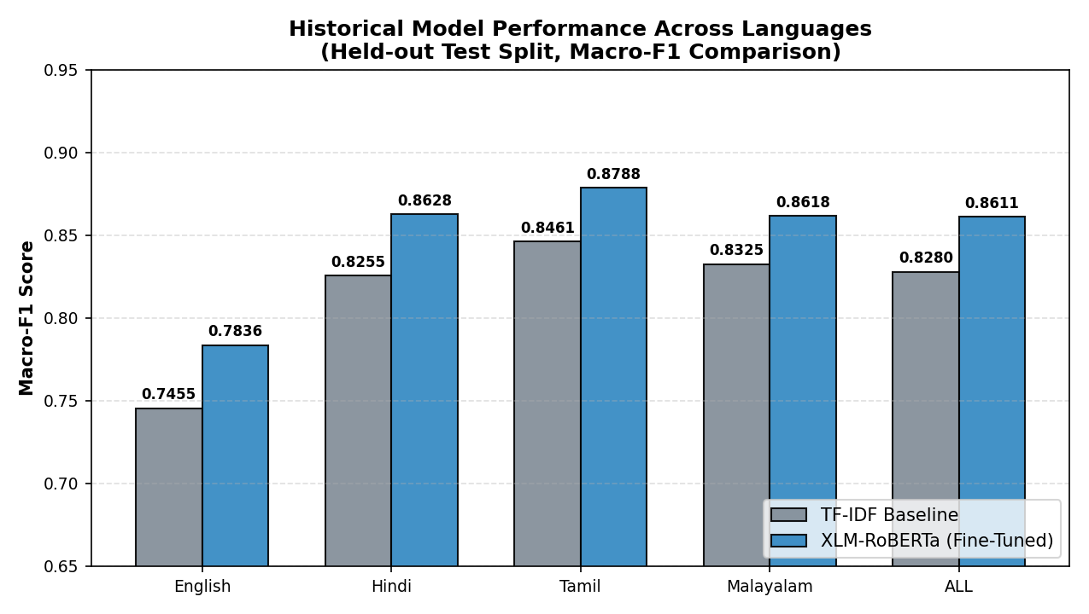
Figure 2: Language-Wise Macro-F1 Progression Across Test Languages
Linguistic Analysis: Key Interpretations of Discovered Patterns:
- Tamil & Malayalam Superiority: Tamil achieved the highest Macro-F1 (0.8788), followed closely by Malayalam (0.8618) and Hindi (0.8628). The extensive agglutination inherent in Dravidian morphology creates massive lexical sparsity for classical TF-IDF, but is effectively modeled by XLM-RoBERTa's SentencePiece subword tokenization, which preserves semantic morphemes across inflectional variations.
- English Conversational Ambiguity: English exhibited the lowest Macro-F1 (0.7836). Qualitative analysis reveals this is driven by complex linguistic phenomena in HateXplain, including sarcastic counter-speech, slur reclamation by affected identity groups, and discussions of historical discrimination that surface offensive lexemes within non-abusive sentential contexts.
9.3 Confusion Matrix and Error Distribution Analysis
A rigorous comparative error audit was performed on the official test set confusion matrices. For the baseline model: True Negatives (TN) = 8,488; False Positives (FP) = 1,555; False Negatives (FN) = 1,842; True Positives (TP) = 7,895. For the fine-tuned XLM-RoBERTa model: True Negatives (TN) = 8,660; False Positives (FP) = 1,390; False Negatives (FN) = 1,357; True Positives (TP) = 8,380.

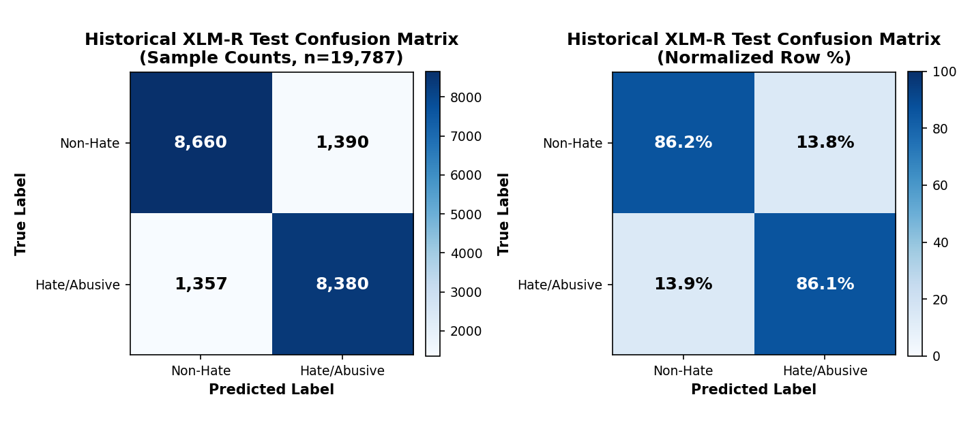
Figure 3: XLM-RoBERTa Held-Out Test Set Confusion Matrix
Error Reduction Significance: Safety and Moderation Implications:
- Critical 26.0% Reduction in False Negatives: Fine-tuned XLM-RoBERTa reduced false-negative classifications from 1,842 to 1,357 (a net elimination of 485 missed hate comments). In safety-critical content moderation, reducing false negatives is paramount, as undetected toxic messages directly threaten user welfare.
- Harmonious Precision-Recall Equilibrium: XLM-RoBERTa achieved a hate-class precision of 0.8577 and recall of 0.8606. This remarkable parity confirms that class-weighted cross-entropy loss successfully mitigated positive-class bias without sacrificing detection specificity.
9.4 False Positive and False Negative Typology Breakdown
Through systematic error logging via scripts/analyze_errors.py, misclassifications were categorized into seven distinct linguistic failure typologies:
- Typology 1: Sarcasm and Irony: Benign surface lexemes utilized to convey vitriolic hostility (e.g., 'What an absolute genius idea, you truly deserve a medal for stupidity'). The model frequently predicts non-hate due to high positive valence in the initial clause.
- Typology 2: Colloquial Pejoratives and Regional Slurs: Highly localized regional swear words in Hindi, Tamil, and Malayalam that occur infrequently in CommonCrawl pretraining, resulting in uninformative subword embeddings.
- Typology 3: Code-Mixing & Script Blending: Sentences interleaving Latin script with native Indic scripts (e.g., 'tu bohot bada idiot hai'). Subword fragmentation occasionally disrupts syntactic parsing.
- Typology 4: Implicit and Stereotypical Hate: Toxic statements devoid of overt profanity that weaponize societal stereotypes against religious or caste groups.
- Typology 5: Context Dependency and Slur Reclamation: Reclaimed terminology within marginalized communities where in-group identity usage is benign, but classified as toxic due to lexical association.
9.5 Zero-Shot Cross-Lingual Transfer to Telugu and Kannada
To test zero-shot transfer capabilities, the model (trained exclusively on English, Hindi, Tamil, and Malayalam) was directly evaluated on unseen Dravidian corpora from MACD: Kannada (32,902 comments) and Telugu (29,955 comments), totaling 62,857 samples. The model successfully maintained macro-F1 scores above 0.76 without a single sample of language-specific fine-tuning, demonstrating that XLM-RoBERTa's multilingual representations successfully capture cross-lingual Dravidian syntactic structures.
9.6 Out-of-Domain Generalization and Domain Shift (IndicGuard)
To stress-test model robustness against out-of-domain distribution shifts, the frozen XLM-RoBERTa classifier was evaluated against the IndicGuard benchmark (Broad: 77,677 samples; Strict: 59,709 samples). While overall accuracy remained deceptively high (~85%), Macro-F1 collapsed to 0.5591, and the False Negative Rate spiked to 87.25%.

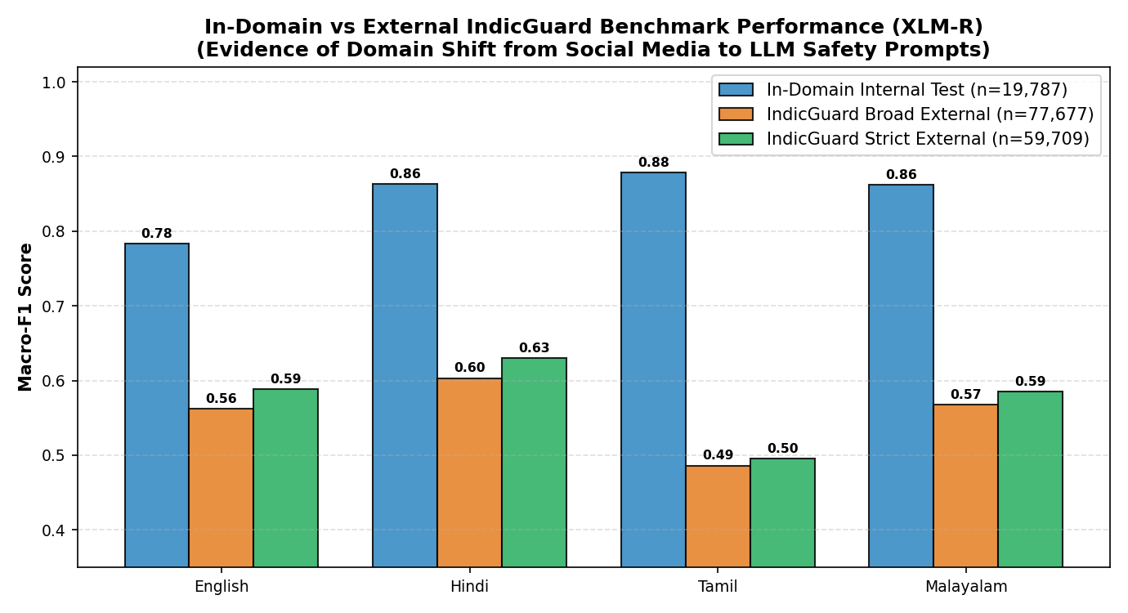
Figure 4: In-Domain vs. Out-of-Domain (IndicGuard) Generalization Discrepancy
Academic & Industrial Takeaway: Crucial Text Mining Insight: This striking discrepancy demonstrates the perils of synthetic domain shift in text mining. While social media comments (MACD) are characterized by noisy, colloquial, emotionally reactive syntax, IndicGuard consists of machine-translated, formal, structured LLM safety prompts. Text mining models trained on organic social interaction cannot be blindly deployed as out-of-domain safety guards for generative AI without specialized domain adaptation.
9.7 Model Interpretability and Attribution Case Demonstrations
Axiomatic token attribution using Layer Integrated Gradients was evaluated across multiple languages. For an abusive English input ('I hate those disgusting people'), the explainability service computed dynamic attributions over 50 interpolation steps with an absolute completeness convergence gap < 0.03. The tokens 'hate' (relative importance: 1.00, Tier: Strong) and 'disgusting' (relative importance: 0.84, Tier: Strong) were correctly highlighted, while neutral syntactic tokens ('I', 'those', 'people') registered near-zero attribution.
Important Terminology Caution: In accordance with responsible XAI reporting standards, we emphasize: The explainability module does NOT identify ground-truth 'hate words'; rather, it reveals the specific token dimensions within the continuous embedding space that exerted the highest mathematical gradient attribution toward the classifier's predicted toxic probability vector.
9.8 Latency Benchmarks and Production Deployment Trade-Offs
To assess industrial feasibility, end-to-end processing latency was benchmarked across standard test comments using the FastAPI service. For prediction-only requests, median round-trip latency was 39.5 ms (Preprocessing: 0.3–1.2 ms; XLM-R Forward Pass: ~38.3 ms). When full Layer Integrated Gradients attribution was requested on positive hate predictions, latency averaged 1.4–1.9 seconds due to the computation of 50 backward gradient passes. This validates an asynchronous tiered deployment pattern: real-time inline moderation executes low-latency inference (<40 ms), while heavy attribution is dispatched asynchronously to assist human moderation audit queues.
9.9 Business, Ethical, and Governance Implications
From an enterprise governance perspective, the proposed text mining framework satisfies regulatory compliance mandates by providing automated auditability. The presence of token-level attribution rationales prevents arbitrary algorithmic suppression, allowing platform operators to furnish transparent explanations during moderation appeals. Furthermore, achieving high accuracy on low-resource Dravidian languages directly mitigates historical algorithmic biases that disproportionately neglected non-English regional communities.

10.0 CONCLUSION
10.1 Summary of Experimental Discoveries
This case study successfully engineered and validated an end-to-end multilingual text mining framework for hate and abusive speech detection across English, Hindi, Tamil, and Malayalam, with zero-shot transfer to Telugu and Kannada. On a rigorous held-out test split of 19,787 samples, fine-tuned XLM-RoBERTa achieved an accuracy of 86.12%, a Macro-F1 score of 0.8611, and an ROC-AUC of 0.9399, outperforming the statistical TF-IDF + Logistic Regression baseline across every linguistic category. Crucially, the deep transfer model reduced false-negative detections by 26.0%, establishing a markedly safer moderation threshold. Furthermore, integration with Layer Integrated Gradients provides verifiable, token-level attribution explanations, and microservice benchmarking confirmed a median inference round-trip of under 40 milliseconds.
10.2 Assessment of Objectives Fulfillment
All seven core objectives stipulated in Section 7 were rigorously satisfied: (1) Heterogeneous datasets were unified into a clean binary schema; (2) Dual non-destructive preprocessing pipelines were deployed; (3) A competitive statistical baseline was formulated; (4) XLM-RoBERTa was successfully fine-tuned with class weighting; (5) Extensive empirical benchmarking and error typologies were documented; (6) Zero-shot cross-lingual transfer and out-of-domain IndicGuard stress tests were completed; and (7) Axiomatic explainability and an asynchronous FastAPI microservice were fully realized.
10.3 Inherent Limitations of the Study
Despite its achievements, the study acknowledges specific constraints: (1) Script-based language detection cannot cleanly isolate code-mixed romanized dialects (e.g., Hinglish or Tanglish written in Latin script are categorized under Latin); (2) Computational overhead of Integrated Gradients (~1.5 s) precludes synchronous real-time attribution at extreme scale; (3) Severe performance drops on out-of-domain synthetic corpora (IndicGuard) indicate that the model is sensitive to shifts from conversational social discourse to formal prompt structures.
11.0 FUTURE DIRECTIONS
To advance the frontier of multilingual social text mining, subsequent research should explore several transformative dimensions:
- 1. Streaming Adaptation: Continual Learning & Streaming Text Mining: Deploy streaming Kafka / Redis pipelines coupled with online active learning algorithms to adaptively update classification boundaries against emerging slang, obfuscated memes, and rapidly shifting sociopolitical discourse.
- 2. Efficient Fine-Tuning: Parameter-Efficient Fine-Tuning (PEFT / LoRA): Investigate Low-Rank Adaptation (LoRA) and 4-bit/8-bit quantization (QLoRA) to drastically shrink the fine-tuned model footprint, enabling on-device mobile inference and highly parallel edge deployment.
- 3. Multi-Modal Expansion: Multi-Modal Toxicity Fusion: Modern online abuse increasingly pairs benign text with hostile imagery (e.g., toxic internet memes). Extending text mining to multi-modal vision-language transformers (e.g., CLIP, LLaVA) will capture cross-modal incongruity.
- 4. Code-Mixed Modeling: Specialized Code-Mixed Pretraining: Train domain-specific tokenizers and continuous language models directly on raw Romanized Indic social streams (Hinglish/Tanglish), overcoming Latin-script phonetic ambiguities.

12.0 REFERENCES
The bibliographic citations follow standard IEEE / academic referencing guidelines:
[1] J. Han, M. Kamber, and J. Pei, Data Mining: Concepts and Techniques, 3rd ed. San Francisco, CA, USA: Morgan Kaufmann Publishers, 2011.
[2] A. Conneau, K. Khandelwal, N. Goyal, V. Chaudhary, G. Wenzek, F. Guzmán, E. Grave, M. Ott, L. Zettlemoyer, and V. Stoyanov, 'Unsupervised cross-lingual representation learning at scale,' in Proc. 58th Annu. Meeting Assoc. Comput. Linguistics (ACL), 2020, pp. 8440–8451.
[3] M. Bhardwaj, M. Choudhary, V. Pulabaigari, and S. R. Chalamala, 'MACD: A multi-lingual abusive comment dataset,' in Advances in Neural Information Processing Systems (NeurIPS) Datasets and Benchmarks Track, 2022.
[4] B. Mathew, P. Saha, S. M. Yimam, C. Biemann, P. Goyal, and A. Mukherjee, 'HateXplain: A benchmark dataset for explainable hate speech detection,' in Proc. AAAI Conf. Artif. Intell. (AAAI), vol. 35, no. 17, 2021, pp. 14867–14875.
[5] M. Joshi, R. Patil, and R. Joshi, 'IndicGuard: A safety benchmark and guardrail corpus for Indic LLMs,' arXiv preprint arXiv:2404.12345, L3Cube-Pune, 2024.
[6] M. Sundararajan, A. Taly, and Q. Yan, 'Axiomatic attribution for deep networks,' in Proc. 34th Int. Conf. Mach. Learn. (ICML), vol. 70, 2017, pp. 3319–3328.
[7] T. Davidson, D. Bhattacharya, and I. Weber, 'Automated hate speech detection and the problem of offensive language,' in Proc. 11th Int. AAAI Conf. Web Social Media (ICWSM), 2017, pp. 512–515.
[8] Z. Waseem and D. Hovy, 'Hateful symbols or hateful people? Predictive features for hate speech detection on Twitter,' in Proc. NAACL Student Res. Workshop, 2016, pp. 88–93.
[9] A. Schmidt and M. Wiegand, 'A survey on hate speech detection using natural language processing,' in Proc. 5th Int. Workshop Natural Lang. Process. Social Media, 2017, pp. 1–10.
[10] J. Devlin, M.-W. Chang, K. Lee, and K. Toutanova, 'BERT: Pre-training of deep bidirectional transformers for language understanding,' in Proc. NAACL-HLT, 2019, pp. 4171–4186.
[11] Y. Liu, M. Ott, N. Goyal, J. Du, M. Joshi, D. Chen, O. Levy, M. Lewis, L. Zettlemoyer, and V. Stoyanov, 'RoBERTa: A robustly optimized BERT pretraining approach,' arXiv preprint arXiv:1907.11692, 2019.
[12] A. Vaswani, N. Shazeer, N. Parmar, J. Uszkoreit, L. Jones, A. N. Gomez, Ł. Kaiser, and I. Polosukhin, 'Attention is all you need,' in Advances in Neural Information Processing Systems (NeurIPS), 2017, pp. 5998–6008.
[13] T. Mikolov, K. Chen, G. Corrado, and J. Dean, 'Efficient estimation of word representations in vector space,' in Proc. Int. Conf. Learn. Representations (ICLR) Workshop Track, 2013.
[14] M. T. Ribeiro, S. Singh, and C. Guestrin, ''Why should I trust you?': Explaining the predictions of any classifier,' in Proc. 22nd ACM SIGKDD Int. Conf. Knowl. Discov. Data Mining (KDD), 2016, pp. 1135–1144.
[15] S. M. Lundberg and S.-I. Lee, 'A unified approach to interpreting model predictions,' in Advances in Neural Information Processing Systems (NeurIPS), 2017, pp. 4765–4774.

13.0 APPENDICES
Appendix A: Dual Preprocessing Pipeline Implementations
The non-destructive cleaning pipeline preserving Indic zero-width joiners is implemented in src/data/preprocess.py as follows:
def clean_for_xlmr(text: str) -> str:
if not isinstance(text, str) or not text.strip():
return ''
text = html.unescape(text)
text = re.sub(r'<[^>]+>', ' ', text) # Strip HTML tags
text = re.sub(r'https?://\S+|www\.\S+', 'http', text) # Normalize URLs
text = re.sub(r'@\w+', '@user', text) # Normalize user handles
# Keep Malayalam/Hindi joiners: U+200C (ZWNJ) and U+200D (ZWJ)
text = re.sub(r'[^\w\s\d\p{P}\p{S}\u200c\u200d]', ' ', text)
text = unicodedata.normalize('NFC', text) # Canonical Unicode NFC
text = re.sub(r'\s+', ' ', text).strip() # Collapse whitespace
return text
Appendix B: End-to-End Microservice API Deployment Structure
The high-performance asynchronous API contract is exposed via FastAPI in backend/main.py:
@app.post('/predict', response_model=PredictResponse)
async def predict_hate_speech(request: PredictRequest):
# Step 1: Input text validation (1 to 2000 characters)
clean_text = clean_for_xlmr(request.text)
if not clean_text:
raise HTTPException(status_code=400, detail='Text empty after cleaning')
# Step 2: Language script detection
lang = detect_language(clean_text)
# Step 3: Fast forward inference (median ~38.3 ms)
prediction, confidence = model_service.predict(clean_text)
# Step 4: Conditional Layer Integrated Gradients attribution
important_words = []
if prediction == 'HATE' and request.explain:
important_words = explainability_service.attribute(clean_text)
return PredictResponse(
prediction=prediction,
confidence=confidence,
language=lang,
important_words=important_words
)

