SAP ORDER-TO-CASH (O2C)
DATA ANALYTICS PROJECT

Analyzing the Order-to-Cash Process Using SAP SD Data

Submitted By | [Your Full Name]
Roll Number | [Your Roll Number]
Batch / Program | [Your Batch/Program Name]
Institute | [Your College/Institute Name]
Trainer | [Trainer Name]
Submission Date | 19 April 2026

Table of Contents
1. Introduction 3
2. Problem Statement 3
3. O2C Process Overview (SAP SD) 3
4. Solution & Features 4
5. Tech Stack 4
6. Analytics Performed 4-5
7. Screenshots & Visuals 5-6
8. Unique Points 6
9. Future Improvements 7
10. Conclusion 7

1. Introduction
The Order-to-Cash (O2C) process is one of the most critical end-to-end business processes in any organisation that sells products or services. It begins when a customer places an inquiry and ends when the payment is received and posted in the system. In an SAP environment, the O2C process is managed through the Sales and Distribution (SD) module, which integrates tightly with Finance (FI), Materials Management (MM), and other modules.
This project applies data analytics techniques to a simulated SAP SD dataset to extract business insights, identify inefficiencies, and forecast future performance. The project covers six major analytics disciplines: Descriptive, Diagnostic, Predictive, Customer Segmentation (RFM), Anomaly Detection, and Data Visualisation.

2. Problem Statement
Organisations running SAP SD face several operational challenges in their O2C cycle:
- Lack of real-time visibility into revenue trends and order performance metrics.
- Inability to identify which customers are at risk of churning or reducing orders.
- No proactive mechanism to detect anomalous billing amounts or duplicate orders.
- Difficulty in forecasting future revenue accurately for business planning.
- Delivery delays and cancellations that go unanalysed, causing recurring losses.

This project addresses all of the above challenges by building an end-to-end analytics pipeline on top of SAP SD order data, culminating in an interactive web dashboard and comprehensive data insights.

3. O2C Process Overview (SAP SD)
The Order-to-Cash process in SAP SD follows a defined sequence of steps, each associated with specific transaction codes:

Step | SAP T-Code | Description
1. Inquiry | VA11 | Customer requests information about product availability and price.
2. Quotation | VA21 | Sales team creates a formal price quotation for the customer.
3. Sales Order | VA01 / VA02 / VA03 | Customer confirms and a binding sales order is created in SAP.
4. Delivery | VL01N / VL02N | Goods are picked, packed, and dispatched to the customer.
5. Billing | VF01 / VF02 / VF03 | Invoice is generated and sent to the customer for payment.
6. Payment | F-28 / FBL5N | Customer payment is received and posted against the invoice.

4. Solution & Features
The project delivers a complete data analytics solution with the following components and features:

4.1 Dataset
A 500-record SAP-style O2C dataset was generated programmatically, containing realistic fields including Order ID, SAP Document Number, Customer, Product, Region, Quantity, Unit Price, Discount, Revenue, Order Date, Delivery Date, Delivery Days, Payment Terms, Status, and On-Time flag.

4.2 Interactive Web Dashboard (Streamlit)
A six-page interactive dashboard was built using Streamlit. It features an Overview page with the full O2C process flow, a Dashboard page with KPIs and charts, a Segmentation page for RFM analysis, a Predictive page with revenue forecasting, an Anomaly Detection page with adjustable Z-score thresholds, and a filterable Data Table page with CSV export capability.

4.3 Python Analytics Script
A standalone Python script (analysis.py) runs all analytics end-to-end and saves six chart images to the visuals folder, making it easy to include in reports and presentations.

4.4 Jupyter Notebook
A fully annotated Jupyter Notebook (analysis.ipynb) walks through the entire analytics workflow step-by-step with explanations, code cells, and outputs, suitable for academic submission and viva examination.

5. Tech Stack
Tool / Technology | Purpose | Details
Python 3.x | Core analytics engine | Pandas, NumPy, Matplotlib, Scikit-learn, SciPy
Streamlit | Interactive web dashboard | Multi-page dashboard with filters & KPIs
Jupyter Notebook | Step-by-step analysis | Complete annotated data science workflow
SAP SD (Conceptual) | Process domain knowledge | T-codes: VA01, VL01N, VF01, F-28, FBL5N
Scikit-learn | Machine learning | Linear Regression, model evaluation metrics
SciPy (Z-Score) | Anomaly detection | Statistical outlier identification
Matplotlib | Data visualisation | Line, bar, pie, scatter, histogram charts
CSV / Excel | Data storage | 500-record simulated SAP O2C dataset
GitHub | Version control | Public repository with full source code

6. Analytics Performed

6.1 Descriptive Analytics
Descriptive analytics summarises what has happened in the O2C process. Key Performance Indicators computed include: Total Revenue (₹61,367,025), Total Orders (500), Average Order Value (₹1,22,734), Average Delivery Days (10.4), and On-Time Delivery Rate (52.2%). Monthly revenue trend, quarterly comparison, revenue by product and region, and order status distribution were all visualised.

6.2 Diagnostic Analytics
Diagnostic analytics investigates why problems occurred. Delivery day distributions were compared between on-time and delayed orders. Cancellation rates were analysed by product and region. Payment term impact on average revenue was evaluated. The East region showed the highest delay rate, and the Printer category had the highest cancellation frequency.

6.3 Customer Segmentation — RFM Analysis
Customers were segmented using the RFM (Recency, Frequency, Monetary) model. Each customer received scores from 1 to 4 on each dimension. The combined RFM Score placed customers into five segments: Champions (score 10–12), Loyal (8–9), At-Risk (6–7), New (4–5), and Lost (below 4). This segmentation enables targeted marketing and retention strategies.

6.4 Predictive Analytics — Linear Regression
A Linear Regression model was trained on 12 months of historical revenue data. The model predicted revenue for the next 6 months (January–June 2025), showing a consistent upward trend. Model evaluation metrics: R² Score = 0.293, demonstrating moderate fit given the small 12-point dataset. MAE and RMSE were also computed.

6.5 Anomaly Detection — Z-Score Method
Statistical anomaly detection was applied to order revenue values. A Z-Score threshold of 2.5 was used, flagging orders whose revenue deviated significantly from the mean. 2.9% of orders were identified as anomalies, representing transactions that warrant further investigation for duplicate billing, fraud, or data entry errors.

7. Screenshots & Visuals

7.1 Complete Dashboard Overview
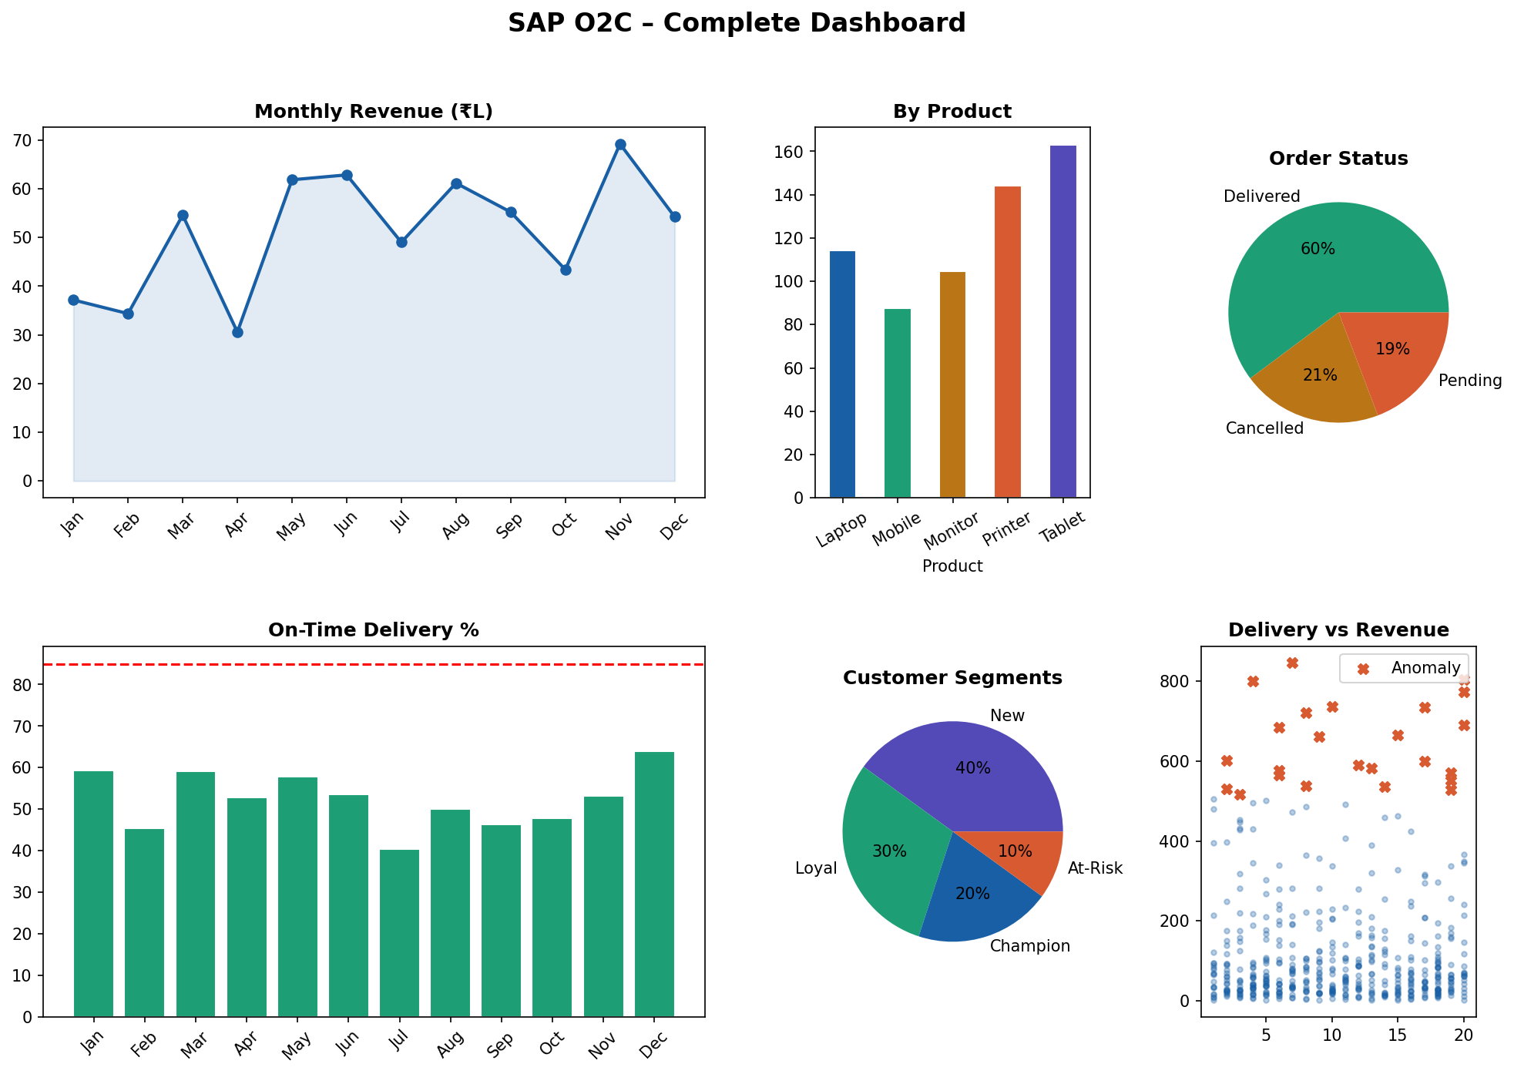
Figure 1: SAP O2C Analytics — Complete Dashboard

7.2 Descriptive Analytics Charts
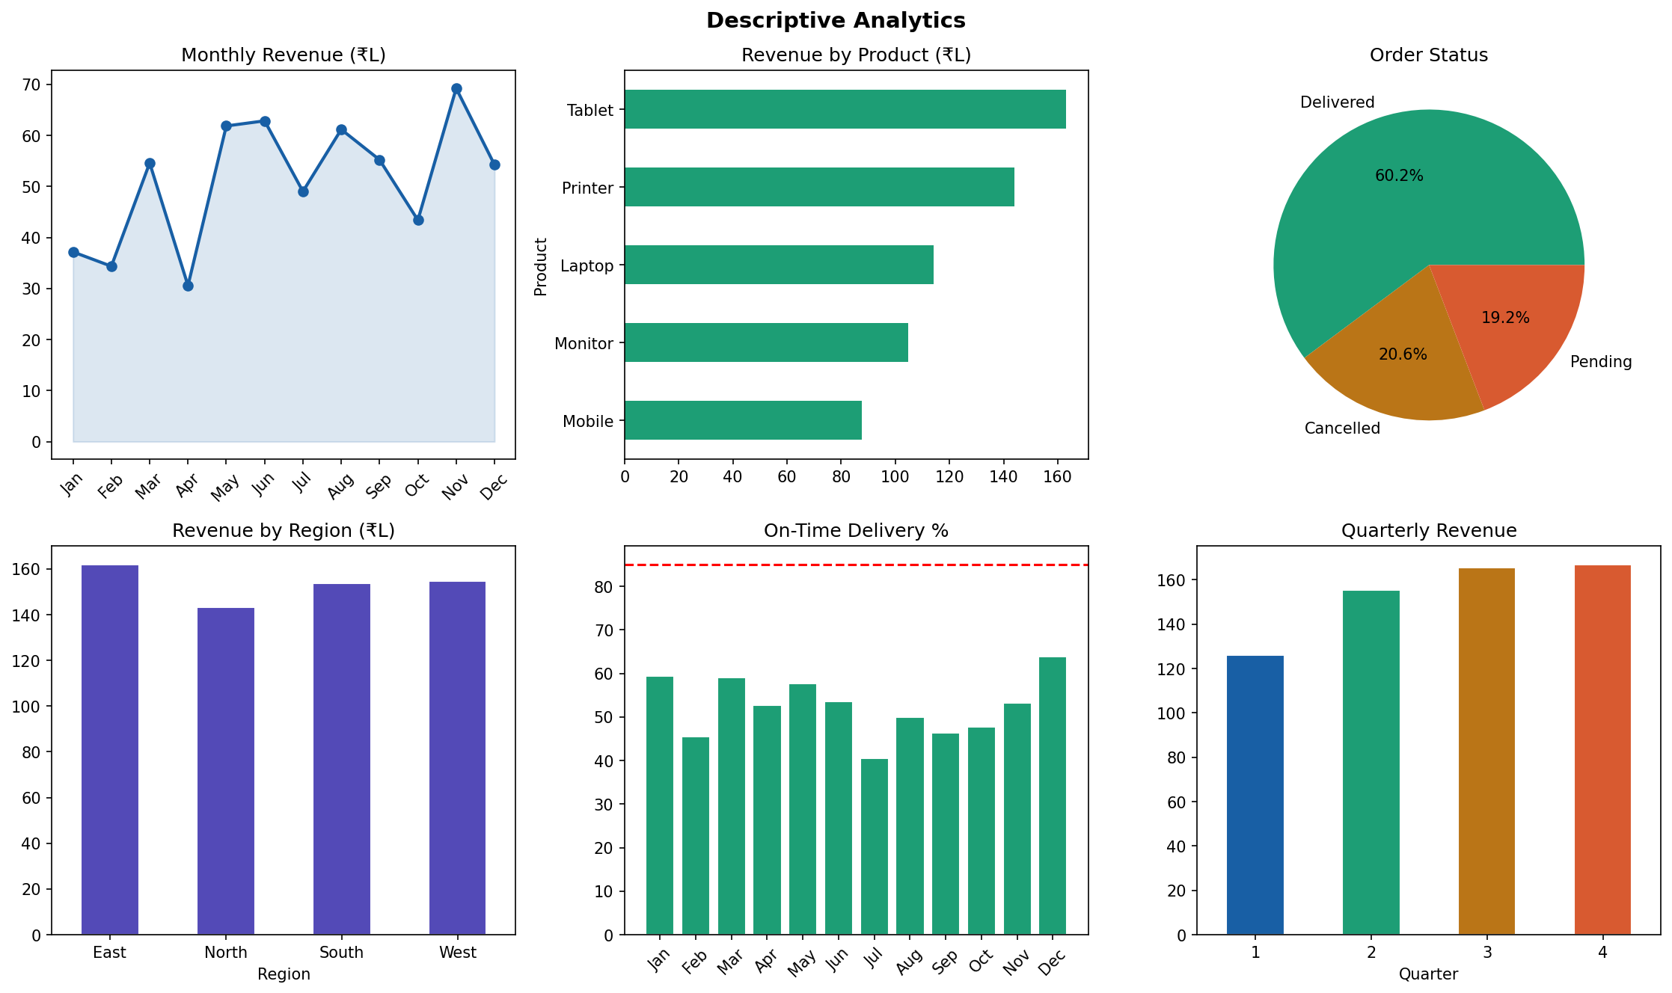
Figure 2: Monthly Revenue Trend, Product/Region Analysis, Delivery Performance

7.3 Diagnostic Analytics
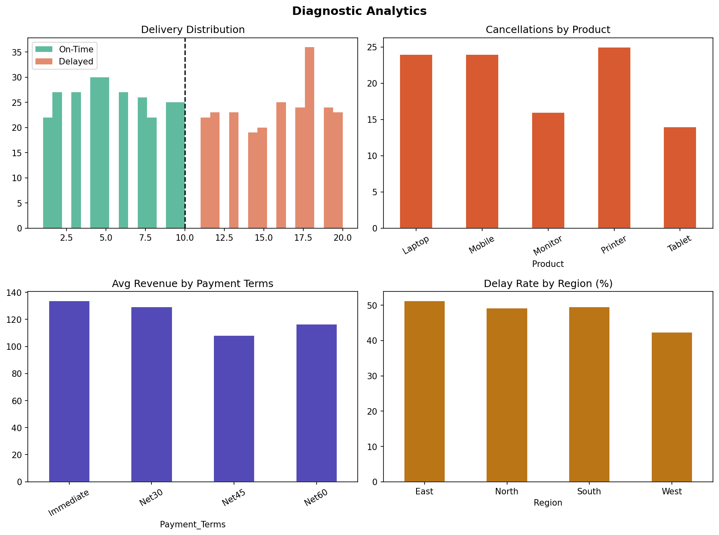
Figure 3: Delivery Distribution, Cancellation Trends, Delay by Region

7.4 RFM Customer Segmentation
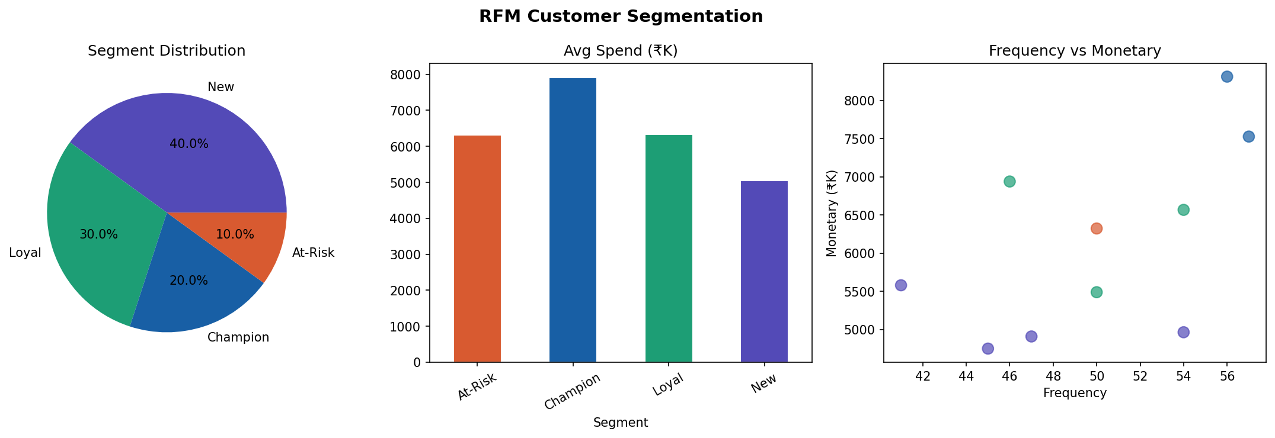
Figure 4: Customer Segments Distribution, Avg Spend, Frequency vs Monetary

7.5 Predictive Analytics — Revenue Forecast
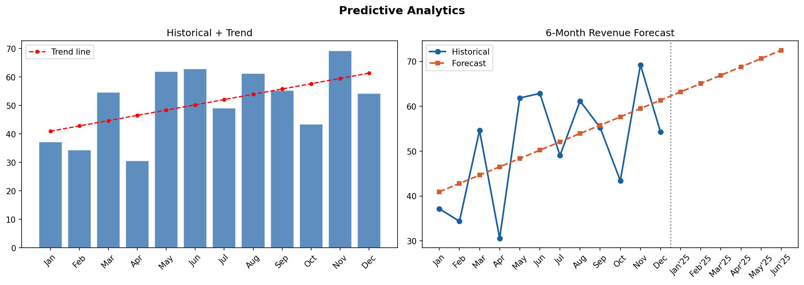
Figure 5: Historical Revenue with Trend Line and 6-Month Forecast

7.6 Anomaly Detection
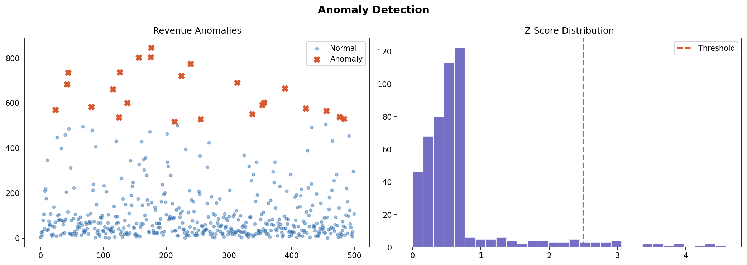
Figure 6: Revenue Scatter with Anomalies Highlighted, Z-Score Distribution

7.7 Key Metrics Summary
Total Revenue  ₹61,367,025 | Total Orders  500
Avg Order Value  ₹1,22,734 | On-Time Delivery Rate  52.2%
Anomalies Detected  2.9% | R² Forecast Score  0.293

8. Unique Points
This project stands out from a typical analytics project in the following ways:
- End-to-end SAP domain integration: All analytics are grounded in real SAP SD transaction codes (VA01, VL01N, VF01, F-28), bridging the gap between business process knowledge and data analytics.
- Six analytics disciplines in one project: Most student projects cover one or two analytics techniques. This project implements Descriptive, Diagnostic, Predictive, Segmentation, Anomaly Detection, and Visualisation simultaneously.
- Live interactive web dashboard: A fully functional Streamlit web app was built and can be hosted online, giving the project a professional, deployable output.
- RFM Customer Segmentation: Applied a real-world marketing analytics framework (Recency, Frequency, Monetary) to identify Champions, Loyal, At-Risk, New, and Lost customer categories.
- Anomaly Detection with adjustable threshold: The Z-Score method with an interactive slider in the dashboard allows dynamic anomaly sensitivity tuning — a feature rarely seen in student projects.
- Professional GitHub repository: The entire codebase is version-controlled with a structured README, folder hierarchy, and requirements.txt, mirroring industry-standard project organisation.
- Reproducible dataset generation: The data generation script (generate_data.py) uses a fixed random seed, ensuring the entire project is 100% reproducible.

9. Future Improvements
The following enhancements can be implemented in future versions of this project:
- Real SAP system integration: Connect directly to a live SAP system using SAP RFC (Remote Function Calls) or SAP HANA database connectors to pull real-time O2C data.
- Advanced machine learning models: Replace Linear Regression with ARIMA, Prophet, or LSTM neural networks for more accurate time-series revenue forecasting.
- Power BI / Tableau dashboard: Build a parallel dashboard in Power BI or Tableau for enterprise-grade visualisation and executive reporting.
- K-Means clustering for segmentation: Complement RFM scoring with unsupervised K-Means clustering to discover natural customer groupings without predefined thresholds.
- Email alert system: Implement automated email notifications when anomalies are detected, integrating with SMTP or cloud notification services.
- Multi-company code support: Extend the analytics to support multiple SAP company codes for group-level consolidated reporting.
- Mobile-responsive dashboard: Optimise the Streamlit app for mobile screens and deploy on cloud platforms like Streamlit Community Cloud or AWS Elastic Beanstalk.

10. Conclusion
This project successfully demonstrates how data analytics can be applied to SAP Order-to-Cash process data to generate actionable business intelligence. By implementing six distinct analytics disciplines — Descriptive, Diagnostic, Predictive, RFM Segmentation, Anomaly Detection, and Visualisation — the project provides a holistic view of the O2C cycle.
The interactive Streamlit dashboard makes the insights accessible to both technical and non-technical stakeholders. The integration of SAP SD domain knowledge with Python-based analytics creates a project that closely mirrors real-world industry requirements, making it a strong portfolio piece for roles in SAP consulting, business analytics, and data science.
The project highlights that data-driven decision-making in O2C processes can significantly improve delivery performance, customer retention, revenue forecasting accuracy, and fraud detection capabilities.

— End of Report —
[Your Name] | [Roll Number] | [Batch/Program] | [College Name]

