Academic Writing is generally defined as a piece of work performed to fulfill a requirement of college or University. A wide meaning include any composing work given for academic setting. Characteristics includes conventional tone, utilization of third person perspective rather than first person perspective, a reasonable spotlight on the exploration issue under investigation and precious word choice. Academic writing is generalize in four main types which include descriptive, analytical, persuasive and critical which has specific languages features and purposes.

### Characteristics of Academic Writing includes

*Clear and constrained core interest:*

Every academic writing reports connects back to the primary focus on research questions and thesis statements. All the content of academic writing support the thesis statements while it also include background and contextual information.

*Logical Structure*

Academic writing mostly follow straightforward structure which included an introduction, body and a conclusion. Here background information, scope, direction of work and states the thesis is included in introduction. The main body part support the thesis statement and conclusion summarizes the main points.

*Proof based contentions*

A well arguments is expected in academic writing where proper evidence should be used to support arguments. Proper use of evidence helps to support the arguments.

*Generic tone*

A sensible logic arguments is expected in academic writing where emotional, inflammatory and one-sided language should be avoided. It must be exhibited precisely and objectively in paper where student agree or disagree with the idea.

While academic writing comes in many forms, Dissertation and coursework are most commonly used in universities/college as part of academic settings.

# Dissertation and Course work

## Dissertation

According to Cambridge Dictionary “Dissertation is a long piece of writing on particular subject, especially on that is done in order to receive a degree at college or university.” It is a research intensive self-directed process which is a lot like writing book. It expects to develop a research proposal and complete under the supervision of university. The aim of dissertation in university is to test the independent research skills during the time of university with the evaluation used to help determine their final grade. The point of dissertation writing is to deliver a unique and original piece of research work on clearly defined topic.

Deciding a topic for dissertation is one of the toughest decisions that need to make at university. We need to discover a topic that we find fascinating and interesting, one that will empower us to progress well and demonstrate our academic strengths and will likewise intrigue a planned business with our interests and abilities. What’s more, obviously, we need to keep away from the topics that will lead us down a blind alley or paint us into a corner. It is additionally expected to prove that we can process complicated information and fill the gap. A special reward would be if it help us to set our future profession. (Rutherford, 2018)

Writing dissertation has competitive advantage over its challenges. It will help us to obtain good knowledge of specialized area. We can take ownership of our personal development and it is already a career plan in a related area which will put us very strong position. It is individual research project which will enhance a wide range of skills, including; project planning, project management, time management, and communication which may develop through fieldwork interviews during dissertation. These skills enhance our qualification in a real business world.

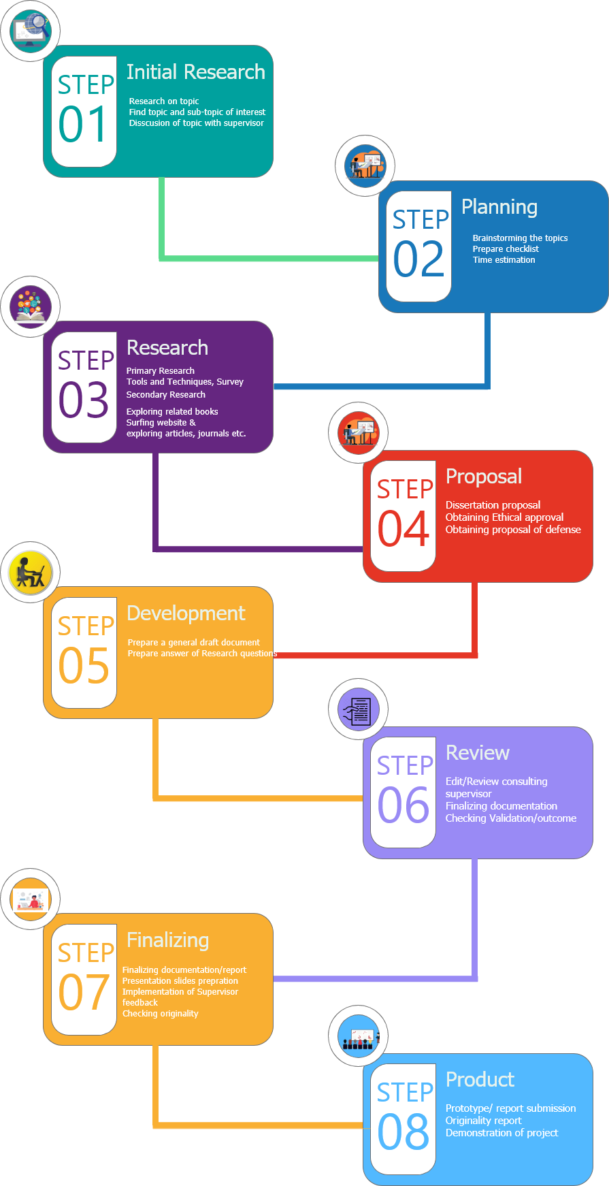

## Coursework

Macmillan dictionary defines coursework as “It is a student work that must be done as part of course of study, with the ark that they achieve forming part of their exam result.” It is performed by students in partial fulfillment of a degree or training. It includes long essays, field work, design studies, projects etc. In high schools course work are performed to determine overall course scores of students assessed exams or assignments. Course work can be assigned by instructor or guide as an assessment per course structure intended to reflect understanding of what has been taught. It can be performed by group so that students can learn both how to work in groups and from each other. It helps to broaden knowledge, enhance research skills and demonstrate that they can discuss, reason and contrast practical outcomes from learned theoretical knowledge. Students prospective about the topic is reflected in the final work. (Category, 2019)

Coursework are done often rather than exams. The more we use our brain, the more they develop which is scientifically proven where student get familiar when they learn or work on something independent from anyone else. It helps in the practical examination where they are trained hard to work and focus on the things that matter most. Doing coursework ourselves will polish us and will make us prepare us to compete will real work. It teach students about task management, tasks prioritization etc. (Admin, 2014) Students are permitted to look for guidance and assistance on picking appropriate subject to write in a situations when you don’t know what to write on.

On the other hand, doing work every weekly or monthly could be headache for students. Deadlines loom students. Coursework provides much free time but it’s easy to fall into a trap of time-wasting. If its group coursework, one lazy guy can ruin whole project which in turn deceased overall group marks.

While writing coursework, we must be clear about what areas topic wants us to cover. Almost all coursework are written in a pattern which include introduction, main body and conclusion. Styling and citation are different according to university rules.

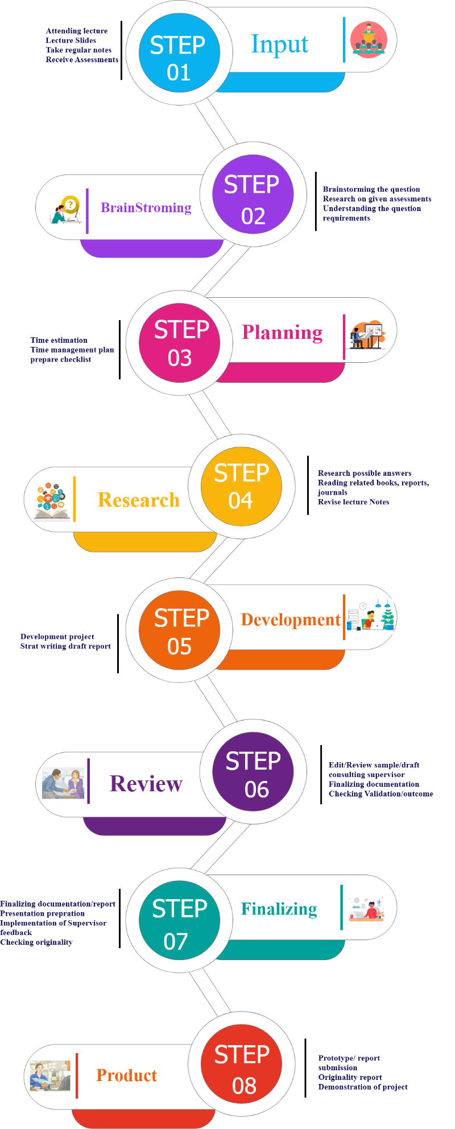

**Similarities between Coursework and Dissertation**

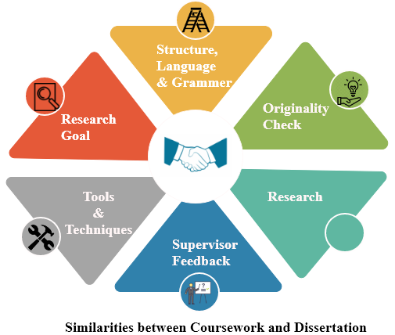

Originality

Both Coursework and Dissertation are strict in case of plagiarism. A student is expected to submit an original work and not copied from other source. Student’s work are checked for plagiarism using various software’s that checks plagiarism. Plagiarism limits for coursework and dissertation are different according to the university under which work is submitted.

Structured and out input

Student input is most for both coursework and dissertation. It will reflect the understanding and applicability of our topic which is the whole propose of these coursework/dissertation. Work submitted should be well structured and presented.

Research purpose

Both dissertation and coursework are generally submitted to achieve degree. These are performed for academic purpose. Students have to do wide range of research and show their capabilities to complete both of these research work.

Supervisor Guidance

Students are allowed to take regular supervisor feedback during coursework/dissertation writing. Supervisor provides the proper throughout the project.

Tools and Techniques

Both dissertation and coursework uses similar tools and techniques. Students can use all sorts of tools and techniques to prove the outcome of the study.

Research Materials

Journals, Books, Website, reports, survey are different source to gather data and information to find out the outcomes of study. Internet source makes student convenient to find resource as they want by just surfing keywords in websites.

**Differences between coursework and Dissertation**

Research topic

In coursework, student had to research on the given particular topic by instructors or supervisor on the core undertaken course where as dissertation allows students to choose any topic of their interest.

Teacher Assistance

In case of coursework, students are not generally allowed to seek help from the instructors unless it is group coursework. An instructor is only allowed to convey to deliver directions on how to handle a coursework paper just as pointing specific areas that are basically by examiners.

In case of Dissertation, students are allowed to seek help from instructors and they are free to choose the topic of interest. They are instructed to research deeper on a specific topic to the extent they can go through. Dissertation is not about studying specific area that examiners check, it’s about the research and findings to some short of topic student are interested on. (Academic writting, 2018)

Proper Structure and Guidelines

There is fixed structure and guidelines while writing coursework. To complete coursework, students should attend their regular classes and their attendance percentage should be acceptable (70% to 80% according to college rule). The guidelines include font type, color, size, line spacing, minimum book referencing, document structure, research topic etc. In case of dissertation, there is less constraint by structure. Student are allowed to provide their research work with basic structured followed. They are allowed to choose their own topic of interest and provide wide research on the chosen topic.

Research Outcomes

Mostly in case of coursework, there is pre-defined outcome and student have to research and prove the given outcome. The findings are clearly defined and students are expected to prove the outcome with different research. Example “Illustrate the importance of predictive analysis in Expense management”. But, dissertation does not have any pre-defined outcome. Research are done in any particular topic and student are not sure if the outcome meets their expectation or not. Example “Is predictive analysis helpful in expense management”.

Project Length/Word count

Coursework are generally done for partial fulfilment of course and its word count/length is shorter from 1500 – 2500 i.e. 10-15 pages of documentation whereas dissertation is vague research on particular which have larger word count from 10,000 to 18,000 i.e. 50-70 pages of documentation. Here, appendices, references and footnotes are not counted for word count limit. It also varies for both coursework and dissertation according to university acceptance.

Are exams included in coursework?

A Stanford study says Scores of boys and girls can be impacted by questions format on standardized tests. Researchers found that girls perform better on standardized tests that have open ended questions, while boys score better when the tests include more multiple-choice questions. Exams makes students memories facts where some syllabi lack emphasis of knowledge application and does little to develop students’ critical thinking skills. On the other hand, Coursework provides wider range of skills – range of activities are included in coursework like quizzes, class participation, assignments and presentations. These steady assessment over academic year suggests there is fair representation of students’ educational attainment while also catering for different learning styles. (Kamil, 2019)

Examinations are flawed because many external factors affects students’ performance. It will affect students’ performance if they are suffering from different factors like stress, panic and anxiety in the examination day. It is unfair to calculate student capacity while they cannot perform their 100%. On the other hand, coursework are carried out over the course of months which guarantee the students’ results to be accurate summary of their academic standards. (Exams vs coursework, n.d.)

Weather exams to be included under coursework is a big debate. From different research, coursework accurately summaries student ability rather depending on single particular exam days. The exam grade race is ultimately self-defeating and does not guarantee the better educated people in comparison to Coursework.