# 1. Introduction

From recent decades, utilization of cell phones has significantly expanded (around 6 billion till 2018), that has prompted simplicity of completing everyday exercises. Everything daily activities are automated and controlled by mobile phones. Business and money related exchanges would be able to be done effectively and safely, anyplace and whenever. The staggering assignments looked in daily lives can now be accomplished by few of snaps on our smartphones. In this Internet dragged world, any devices almost anywhere can communicate and share necessary information in a click. I want to build up an online stage where people can choose and purchase item on just a click on their phones.

## a. Project Introduction

Conventional shopping is a monotonous and tedious job where Individuals need to surge out to advertise and need to complete their shopping less assortments appeared by retailers. This project manages building up an internet-based business application for online item deal. A web-based business is virtual platform where clients can peruse the items and select best product of their advantage. The principal motivation behind this project is to build up a universally useful product where clients will find computers, their accessories from the solace of home through web.

## b. Justification of Project

Background of the project

Shopping was an issue till a decade prior. Customers need to crosswise over various market to get the item that they need. With loss of their time, they do need to pay more than the real expense and without comparisons between products which was extremely troublesome. I want to build up an internet business stage where clients will get what they need at reasonable cost. It will assist clients with saving their time with speedier and simpler shopping experience. An online ecommerce with the user-friendly interface ought to be developed that overcomes all the issue faced during physical shopping.

Problem Statements

An ecommerce application gives a straightforward technique to pitch things to a significant customer base. Regardless, there is huge amount of contention among different electronic business goals. Right when Customers touch abase on application, they would like to get which they are hunting down quickly and adequately. In addition, clients don't consider the brands or the real things they need to buy. They have a sweeping idea regarding what they need to purchase. Different clients these days check for their things in google as opposed to visiting express online business locales and they trust it will take them to e-business areas that have their things.

## c. Description of project

This project ought to develop an online ecommerce application which will solve the issue faced during physical shopping. This application can be accessed almost 24 hours which will provide ease for shopping time. Peoples are busy in their own activities and this will help them to buy products in their own free time.

Features of project

* View Catalog

At the point when client visit to application, he/she will most likely to sight different product and select the product which match their needs.

* Register/Login account

It will assist them with getting data about what they picked when they lastly visited to site. They additionally can give review about the product they purchased through this application.

* An easy to use checkout

At the point when the client settled the item they need, they will have easy and faster checkout options. Individuals personal account will aid them providing delivery address, payment methods etc. quickest.

* Shopping cart

A shopping basket is incorporated into this site where customer can pick the thing they need and store result of their decision. At the purpose of checkout, they can refilter the result of their choice too.

* Product search option

Search bar will assist clients to successfully find the thing they need. They can glance through the thing name or thing type in the search bar.

* Easy product comparisons

Utilizing this application, individuals visiting can undoubtedly make examination between items based on quality, cost, features, review etc.

* Product rating

Item evaluating is one of the most powerful features where clients can see real audit about the item and settle on simple choice weather, they should purchase the item or not. They can give feedback in the meantime which will help different client in buying the item.

* Easy User Interface

This application will be easy to utilize and will offer maximum facilities to client with least issues.

# 2. Aims and Objectives

This ecommerce project lifts heap of numerous aims and objective to upgrade shopping nature of individuals.

Aims

The ultimate aim is to build up a web-based application and address the issue looked amid physical shopping.

Objectives

A portion of the principle objectives heap by this project are:

* To design and implement user friendly online business platform/application.
* To develop a comprehensively valuable electronic business where things can be acquired from the comfort of home through application.
* To ensure platform satisfies every one of the necessities and recorded prerequisites.
* To improve the proficiency of the application created.
* To offer access to the latest items available in the market.

# 3. Development Methodology

A development methodology is a framework that is used to structure, plan and control the way toward building up a product/project. Scrum, Lean Development (LD), JAD, RAD, Waterfall, Agile are some of them.

## a. Development Methodology

I lean toward waterfall approach which is the organized advancement process that portrays a strategy that is unbending and linear. I have picked this in light of the fact that each stage has masterminded in detail which drives the assignment being passed on calendar and conveyed on schedule. This methodology ensues the product to be delivered or task to be completed in given time.(Anon., 2018)

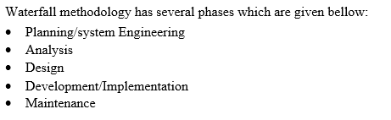

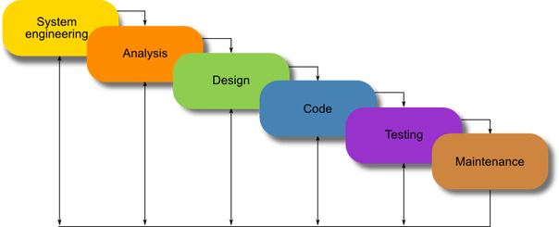

Fig (1) Waterfall model

Here in this methodology, all the phases from Analysis to Maintenance are done from top to bottom in series and is difficult to return to previous phase that was not thought of in concept stage.

## b. Design Pattern

In software development, design pattern is a solution for repeatedly occurring issues in programming structure. It is a format or description for how to take care of an issue that can be utilized in a wide range of circumstances. It can accelerate the development procedure by providing tested, proven development pattern. Reusing design pattern anticipates unpretentious issues during development and improves code readability. (Sourcemaking.com, 2019). MVP, MVC and MVVP are three mainly used design pattern during android project development.

MVC (Model-View-Controller)

In MVC pattern, application is separated in different micro units that interact each other provided by different responsibilities.

Model

Model provides data, state and business logic for application. It is the central part of application were business logic is defined called as brain of application. It is reusable in different unique circumstances and is independent to View or controller.

View

It defines the user interacting part where it only conveys information from controller to user and vice versa.

Controller

Controller acts as glue that integrates the application and is the master controller for what happen in the application. Controller decides how to interact with model itself according to provided action on view part in an application.

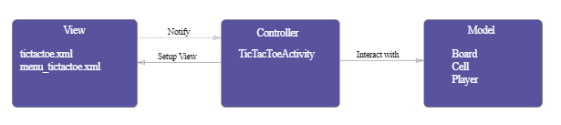

Fig (3) MVC pattern

## c. System Architecture

A lot of individuals underestimate the significance of system architecture. When you are planning to build a system, a good architecture is foundation of the system. It is the blue print of system which is primary carrier of system qualities such as scalability and performance.

i. Three Tire Architecture

A three-tier architecture is a client-server architecture. All the functional process logic, data access, computer data stockpiling and UI are created and kept up as independent modules on independent stage. It permits any of the three levels to be updated or supplanted autonomously. The RDBMS on the database server contains all the data storage logic and the center level tiers are usually multitiered.

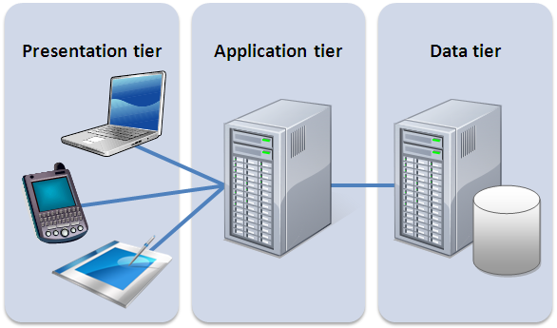

Fig(2): Three tier architecture

Presentation tier

Involves the top measurement and shows information related to organizations available on a site or application. It speaks with different levels by sending results to the program and different levels in the network.

Application tier

In this tier, all the central level or business control applications functionality are performed with definite operations or processing.

Data Tier

This tier stores database where all the information is stored in different/recoverable place and kept independent of application server or business logics.

# 4. Configuration Management

Configuration management is a technique of handling changes methodically so a framework keeps up its integrity over time. The procedure guarantees that the deliverable meets the predefined execution criteria. It additionally guarantees that sufficient procedure is set up to provide continuing support for the duration of the product life cycle. Mostly now a days, GitHub (an online tool) is used to maintain integrity in application. The main reason of using github for as configuration management is because it provides version controlling and other collaboration features for task management. It infers the version control framework which enables developer to monitor the consistent amendments to their code.

Project GitHub link: <https://github.com/aryalaashish121/online-store.git>

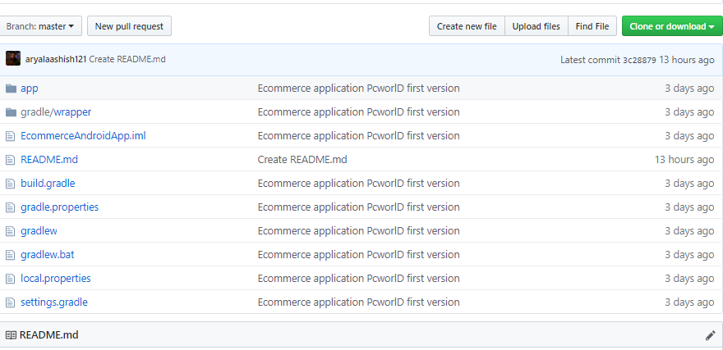

Fig (4) Sample GitHub upload

# 5. Prototyping

Prototyping isn’t for every project, but for the project it is right for, it can be a tremendous asset. It has numerous advantages over a time. Prototyping is not a final product but it symbolizes how the actual product will be. It will make coding easier and faster with quality specification that address the need of users. I have used online tool *Figma* for prototyping some basic user interfaces. *Figma* is online tool which helps to design different prototyping modules.

i. Home/Initial Page

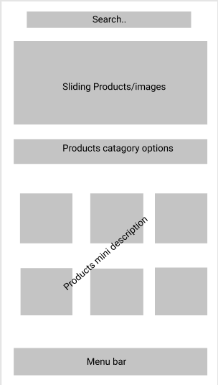

Fig (5) Home page

ii. Registration page

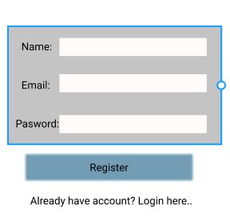

Fig (6) Registration page

iii. Login page

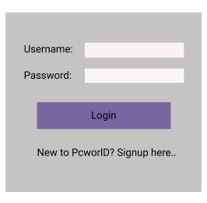

Fig (7) Login Page

iv. Product page respect to description

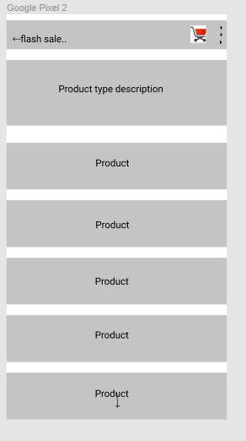

Fig (8) Product page

# 6. Conclusion

In this venture, a site will be created which will change all the shopping background from physical to virtual reality where individuals can without much of a stretch access a large number of items from the solace of their home. User interface prototyping is already done which ensures the project completes on time.