# Persistent Data Storages for NoSQL (Mongoose) database structure for PcworlD

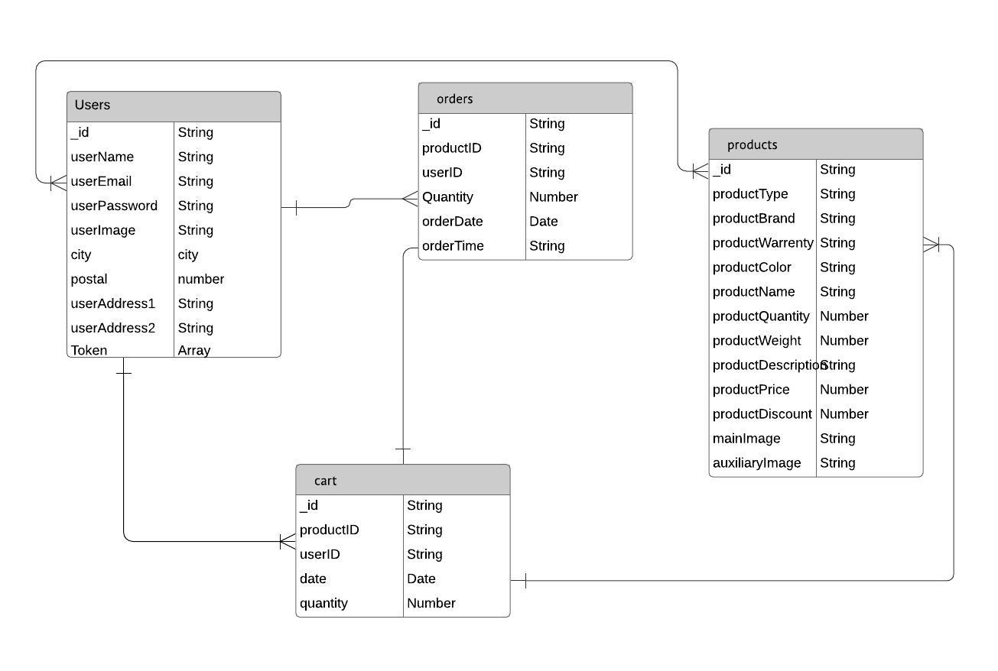

Figure 1: Persistent data storage NoSQL database structure for PcworlD

Mongoose is the database which is used for Pcword. Relational databases were never intended to adapt to the scale and readiness challenges that face present day applications – and aren't worked to exploit shoddy stockpiling and preparing power that is accessible today through the cloud. Social database sellers have created two fundamental specialized ways to deal with location these inadequacies. NoSQL databases are built to allow the insertion of data without a predefined schema. That makes it easy to make significant application changes in real-time, without worrying about service interruptions – which means development is faster, code integration is more reliable, and less database administrator time is needed.

Here the above ER diagram is of Pcworld. As one figure there are four collections into database named user, products, cart and orders. Users database is used to store every information about the user ‘s like their name, email, address and password. Similarly products store all the information needed about products. Here users table and products have many to many relation. This is because a user can buy multiple products and at another end same kinds of product can be bought by multiple users. So a linking table (orders) was made to store the data of the users, product, quantity ordered, date and time. Similarly for cart, is also a linking table between users and products. This was made because a user can store multiple products in cart. Cart store data of both users and product table which consist of entit like productid, userid, date and quantity. Later on the cart table is used to send product and user details to orders table when any used want to buy them.

**Brief description of NoSQL database**

Recently NoSQL database is getting widely adopted to solve various business problems. NoSQL database are called as non-relational or distributed database. NoSQL database are the document based database, key-value pairs, graph databases or wide-column stores. NoSQl data base present the data n form of document, graph, key-value pair etc. It has dynamic schema for unstructured data. NoSQL database are horizontally scalable whereas SQL data base are vertically scalable. They are scaled by increasing the database servers in the pool of resources to reduce the load and queries in NoSQL database focus on collection of documents. The structure of query varies from one database to another. NoSQL databases can strore the large amount of data unlike SQL databases.

For Example MongoDB, BigTable,Redis etc.

**NoSQL database working mechanism:**

The data in NoSQL database is stored in document-oriented structure. So the large amount of data like images, articles, videos can be stored in database. It makes the system more user-friendly and gives a better solution in competitive world. NoSQL database has another advantage, unlike SQL database NoSQL databases doesn’t require specific programming language-oriented syntax to retrieve data and the developers later on changing or modifying the database information retrieving doesn’t need to learn the SQL structure and data retrieval syntax.

**Types of NoSQL databases:**

There are 4 basic types of NoSQL databases:

1. Key-Value Store – It has a Big Hash Table of keys & values

The schema-less format of a key value database like Risk is just about what you need for your storage needs. The key can be synthetic or auto-generated while the value can be String, JSON, BLOB (basic large object) etc.

{Example- Riak, Amazon S3 (Dynamo)}

1. Document-based Store- It stores documents made up of tagged elements.

The data which is a collection of key value pairs is compressed as a document store quite similar to a key-value store, but the only difference is that the values stored

{Example- CouchDB}

1. Column-based Store- Each storage block contains data from only one column,

In column-oriented NoSQL database, data is stored in cells grouped in columns of data rather than as rows of data. Columns are logically grouped into column families

{Example- HBase, Cassandra}

1. Graph-based-A network database that uses edges and nodes to represent and store data.

In a Graph Base NoSQL Database, you will not find the rigid format of SQL or the tables and columns representation, a flexible graphical representation is instead used which is perfect to address scalability concerns.

{Example- Neo4J}

**Database used in the system of PC World**

Modern data is unstructured, vast and unwieldy. So Mongoose (NoSQL) database was used in the backend of PC World web application. Mongoose is the different version of MongoDB. Programmers can develop database creating models. It generally stores data in the MEAN software stack pattern format. It is open source and available freely to use. By using the inbuilt features, the mongoose can be customized. It helps in developing fast and secured product. The data processing and retrieving is fast in Mongoose. Mongoose was used in the system of PC world web application for its following features:

1. Multi-Model

Where relational databases require data to be put into tables and columns to be accessed and analyzed, the various data model capabilities of NoSQL databases make them extremely flexible when it comes to handling data.

2. Easily Scalable

It’s not that relational databases can’t scale, it’s that they can’t scale EASILY or CHEAPLY, and that’s because they’re built with a traditional master-slave architecture, which means scaling UP via bigger and bigger hardware servers as opposed to OUT or worse via sharing.

3. Flexible

Where relational databases require data to be put into tables and columns to be accesses and analyzed, the multi-model capabilities of NoSQL databases make them extremely flexible when it comes to handling data.

4. Distributed

Look for a NoSQL database that is designed to distribute data at global scale, meaning it can use multiple locations involving multiple data centers and/or cloud regions for write and read operations. 5. Zero Downtime

The final but certainly no less important key feature to seek in a NoSQL database is zero downtime. This is made possible by a master less architecture, which allows for multiple copies of data to be maintained across different nodes

NoSQL vs. SQL Decision Making