**Arun Aryal** 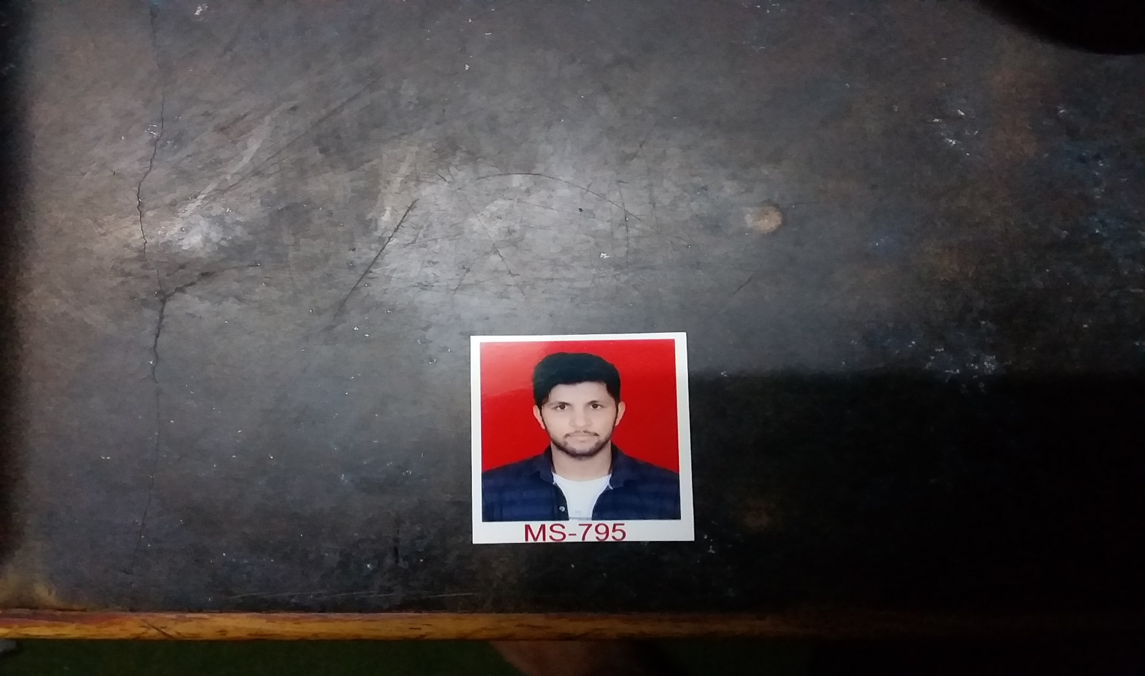

**Email**: arunaryal55@gmail.com

**Address**: Kirtipur, Kathmandu

|  |
| --- |
| Objectives  To seek a challenging environment that encourages continuous learning and creativity provides exposure to new ideas and simulates personal and professional growth, also seeking a position to utilize my skill and ability. |

|  |
| --- |
| Personal Details  *Date of birth: 28-July-1993*  *Permanent Address: Chandrakot-8, Gulmi*  *Marital Status: Single*  *Religion: Hindu*  *Nationality: Nepali*  *Hobbies: Reading articles, Travelling, Exploring etc.*  Education  Shree Gyanodhaya H. S. School  Degree: SLC Chandrakot-8, Gulmi  Shree Gyanodhaya H. S. School  Degree:10+2  Chandrakot-8, Gulmi  Baneshor Campus  Degree: Bachelor in Business Study  Baneshor, Kathmandu  Tribhuwan University  Degree: Master in Business Study  Kirtipur, Kathmandu  Skills  CTEVT 15 month Annex Program in computer, Good in communication, Adaptive in new environment, Excellent Coordination, Skills of proposal and report writing, Good interpersonal, Ability to work in team etc.  Languages  English: Advanced  Nepali: Advanced  Hindi: well  References  Shree Gyanodhaya H. S. School, Majuwa, Gulmi  Center Department of Management, Kirtupur  Deepak Aryal  9804444393 |

***(I hereby solemnly affirm that the information contained herein is correct to the best of my knowledge. Any false Statement in this resume is a cause for my dismissal.)***