**Analysis Specification on**

**Tandoor Ecommerce Website**

Sweta Shrestha

0016112

Computing Project

Level 5 Diploma in Computing

Softwarica College of IT & E-Commerce

Kathmandu, Nepal

April 23, 2017

Contents

Introduction 3

Rich Picture 4

Use Case 5

Requirements: 6

Interview: 6

Questionnaire: 6

Functional Requirements: 7

Non-Functional Requirement: 8

System Architecture 10

Class Diagram 11

Activity Diagram 14

Conclusion 15

# Introduction

Analysis is the first step of project. It is the critical step to ensure the development of any project that involve requirement gathering and identifying problem and scope of our project. Through analysis specification, we will identify functional and non-functional requirements of our system.

In my project I have done some research and analysis. There is many analysis process I have done all analysis in different phase they are describe below.

## Rich Picture

Rich picture is over view of system. Before any process of development we have to create rich picture, it defines the flow of system and different roles of actors.

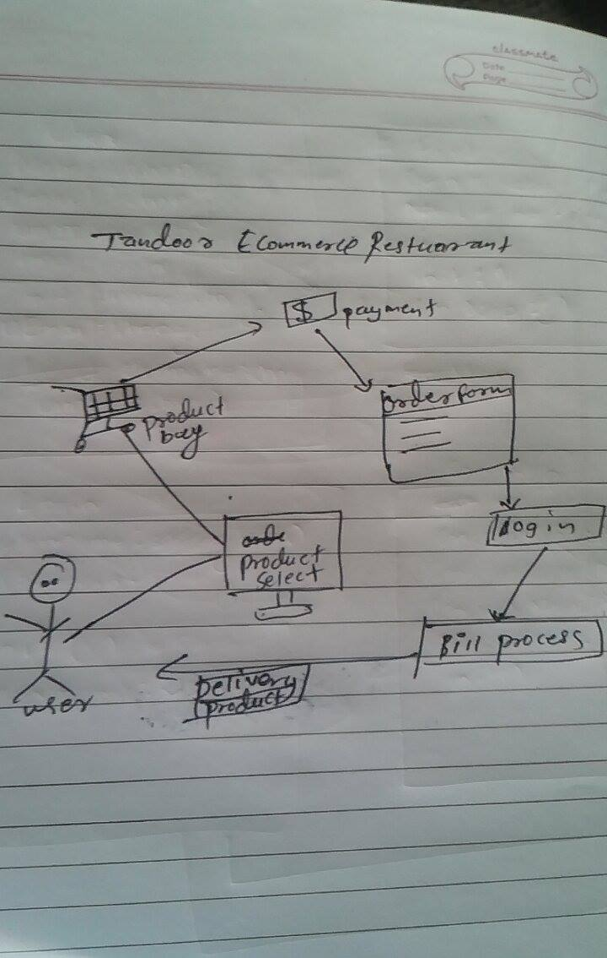

Fig: Rich Picture.

# Use Case

A use case chart is a realistic delineation of the associations among the components of a framework. A use case is a technique utilized as a part of framework examination to distinguish, elucidate, and arrange framework necessities. The on-screen characters, typically people required with the framework characterized by their parts.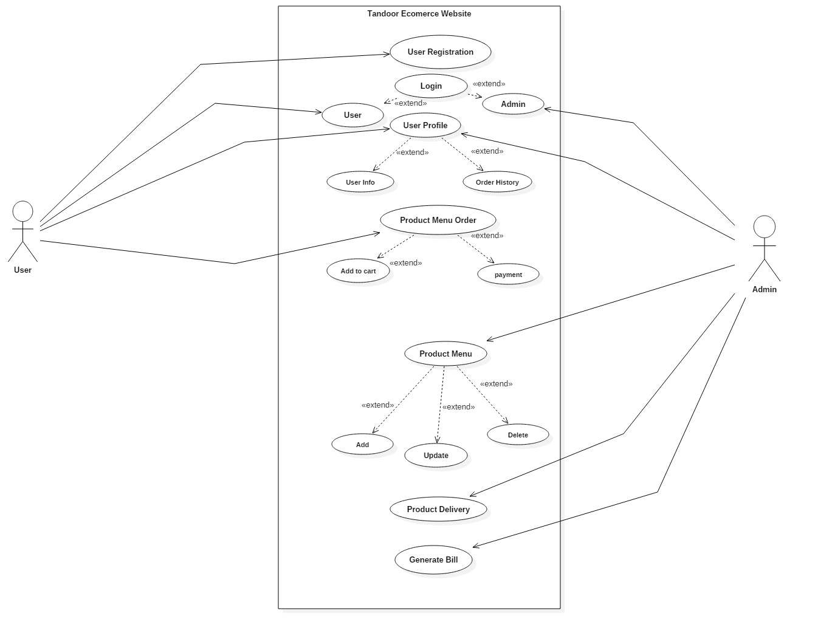

Fig: Use Case Diagram.

# Requirements:

The process in which required necessary features in a system is identified so that clients are

satisfied with the system is called requirement analysis. It helps to identify, investigate and

archive developing process of the fundamental system.

Requirements are dynamic as per imaginations of external stakeholders. So, identification of

requirements should be done properly before initializing project development.

There are many methods of gathering information for analysis. Some of them can be:

## Interview:

Interview with the public people can help know the root problem they are facing which also performs as a big help in information gathering process.

## Questionnaire:

Questionnaires are another way to extract the requirements from the public. Public users are

asked numbers of question which helps to find out what exactly the users want in their

system. Therefore, questionnaires are effective way to find out the requirements.

Through these methods, defects in system can be identified. Therefore, suitable solution is extracted from the system. Even it considers about the technical, social, and ethical feasibility of

the system in the future.

Also, functional, non-functional, operational and traditional requirements are used to develop the

System in proper manner. And the utilization of system standard to magnify the process of

project.

## 

## Functional Requirements:

Functional Requirement should to incorporate capacities performed by particular screens, diagrams of work processes performed by the framework, and different business or consistence necessities the framework must meet.

**User Class : User**

Id : FR1

Title : Registration

Description : Users cannot buy product without restriction.

Rational : It help User to sign in process. .

Dependencies: N/A

**User class : User**

Id : FR2

Title : Login

Description : Users can Login for buy a product.

Rational : It can secure and identify for buying a product.

Dependencies: N/A

**User Class : User**

Id : FR3

Title : Select Product

Description : User are allowed to Select product from website for order.

Rational : It provides product information to user for order a product.

Dependencies: N/A

**User Class : User**

Id : FR4

Title : Profile

Description : User can view their profile.

Rational : It helps user to modify their account.

Dependencies: FR5

**User Class : User**

Id : FR5

Title :Logout

Description : User can log out after buying product from website.

Rational : it helps user for security reason.

Dependencies: FR4

**User Class : Admin**

Id : FR8

Title : Login

Description : Admin can login to their account for review the order and other information.

Rational : It help for identifies a Admin.

Dependencies: N/A

**User Class : Admin**

Id : FR8

Title : View Order

Description : Admin can view order for delivery the product.

Rational : with out view of order admin can not delivery product.

Dependencies: N/A

**User Class : Admin**

Id : FR8

Title : View Customer

Description : Admin can view Customer for conform customer register or not.

Rational :It stores customer order history and admin can manage customer.

Dependencies: N/A

## Non-Functional Requirement:

**Id : NFR1**

Title : Performance

Description : It determines speed, time, transactions and utilization of the resources in

system’s activities. It compares expected output with actual output.

Rational : The functionality of the system should be efficient and accurate.

Dependencies: NFR3

**Id : NFR2**

Title : Reliability

Description : The system should be reliable and must be accurate.

Rational : To enhance performance and accuracy of the system.

Dependencies: NFR3

**Id : NFR3**

Title : Security

Description : Username and password is integrated to promote security to a system.

Rational : Unauthorized user should be denied to access to the system. To maintain the

confidentiality within the system.

Dependencies: FR1

**Id : NFR4**

Title : Availability

Description : Reports of the transaction can be easily accessible when required.

Rational : To use the information for future reference.

Dependencies: N/A

**Id : NFR5**

Title : Usability

Description : The system should be user-friendly so that it can be easily accessible by every

user.

Rational : More user-friendly tends to more participation of the clients.

Dependencies: NFR1 and NFR2

**Id : NFR6**

Title : Maintainability

Description : The system should be maintained if incase any defects arises.

Rational : Can be easily maintained.

Dependencies: NFR3

**Id : NFR7**

Title : Testability

Description : The system should be tested in order to ensure user about system defects.

Rational : To ensure functionality of the system.

Dependencies: NFR2

**Id : NFR8**

Title : Scalability

Description : The system should be able to cooperate when business grows.

Rational : To make system more scalable.

Dependencies: NFR1

# System Architecture

A System architecture design is a theoretical model that characterizes the structure, conduct, and more perspectives of a framework. A design portrayal is a formal depiction and portrayal of a framework, composed in a way that backings thinking about the structures and practices of the framework.

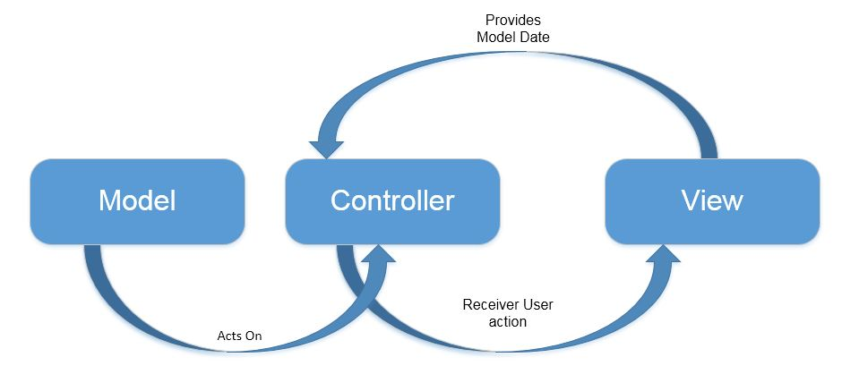

# Class Diagram

a class diagramin the Unified Modeling Language (UML) is a type of static structure diagram that describes the structure of a system by showing the system's classes, their attributes, operations (or methods), and the relationships among objects.

I have research about ecommerce concept and restaurant system and I collect some possible classes and function which can be useful in my project.

Some of possible Classes and functionality are as follow.

|  |  |
| --- | --- |
| **Classes** | **Functionality** |
| Customer, product, order, admin, delivery, login , registration, | Customer registration, customer login, select product, order product, profile manage, update profile, admin login, add product, update product, delete product, view order, view customer, view stock, |

**Registration**

Registration is a class where user or customer can register their data, which is used in future use. For example by register customer can login to website for order and other process, it is a type of security for website.

**Login**

It is a login class where customer can login using their registration username and password.

By login they can buy some product from website, it is important part of ecommerce website.

**Product**

A product class consists of all the different attributes that stores the detail of the products i.e. images, name, price, type, brand, etc. The product class is used during the process of view the products in the website. The users are allow to view the products and add to the cart during the process of checking out.

**Order**

The order class stores all the information during the process of checking out. It stores the date of order, the customer’s detail, product ids, etc.

**Admin**

The admin class stores the admin details. It is used to verify whether the user is admin or not while logging into the admin panel. Admin control content for website.

**Delivery**

This class stores the product details, delivery date, order number, customer address and name etc. It is used after the product has been registered into the order class.

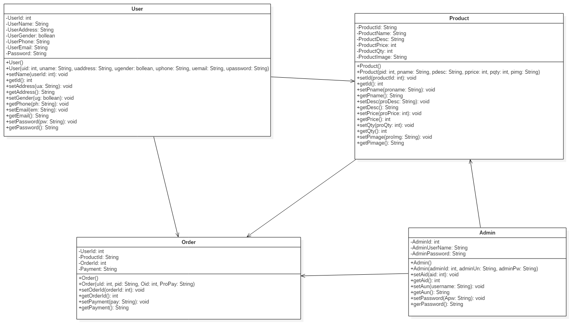

Fig: Class Diagram.

In the above class diagram there is four class which are interrelated to each other. We can see there is user class which is directly related to product class and order class is also relation with product class , for order first of all user need to select product which is comes from product class. Admin class is directly related to all class because admin controls product, customer, Order.

# Activity Diagram

An activity diagram visually presents a series of actions or flow of control in a system similar to a flowchart or a data flow diagram. Activity diagrams are often used in business process modeling. They can also describe the steps in a use case diagram. Activities modeled can be sequential and concurrent.

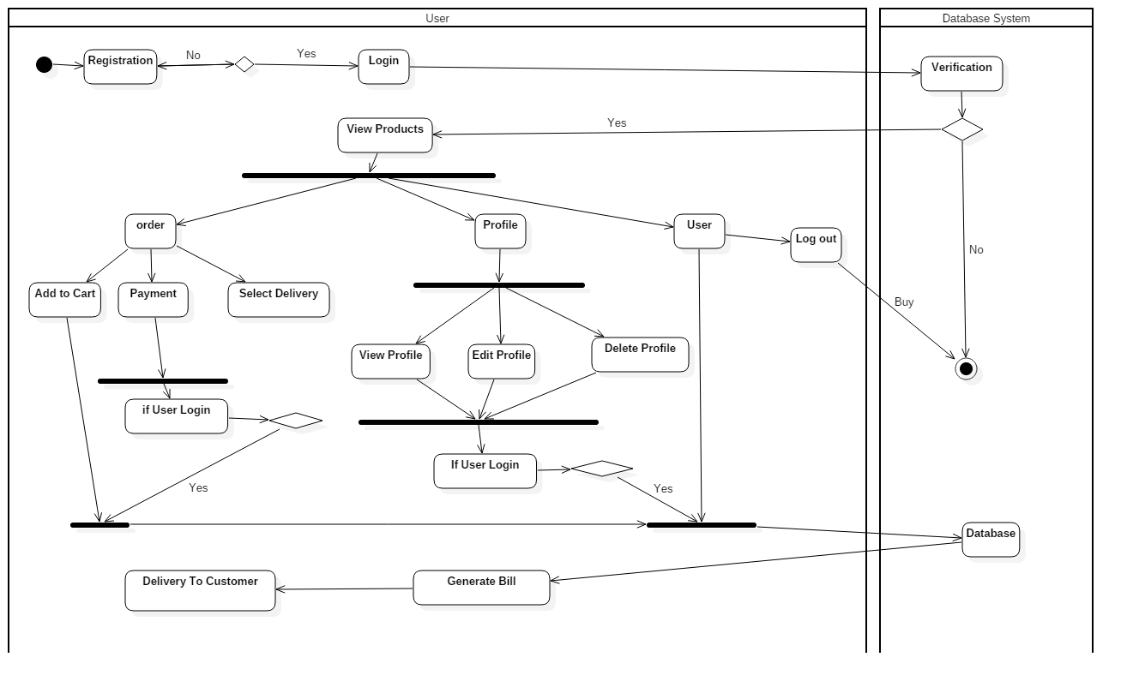

Fig: Activity Diagram.

# Conclusion

The water fall development method, the first step of requirement and analysis is done successfully. The project “ ecommerce tandoor restaurant website” first step analysis is complete ,I have describe all analysis process in this report.

First of all I have collect some data that are important while doing my analysis process from respected teachers and friends, I have describe sort and sweet introduction about analysis in my project, after that I have draw project rich picture which shows the over view of my project.

I have complete use case diagram by help of rich picture and some analysis process, then after i have describe requirement , in this section I have describe functional and non-functional requirement. After that class diagram is drawn by help of star WML software. Also I have design activity diagram of my project. I have done my analysis process successfully. It helps me in my project development .