Contents

1. Introduction 2

2. Structural diagram 2

a) Data flow diagram 3

3. Behavioral diagram 4

a) Activity diagram 4

b) Sequential diagram 6

4. Database design 9

a. ER diagram 9

b. Data dictionary 10

5. User Interface design 12

6. References 15

# Introduction

Design phase seeks to develop detailed specification that emphasize the physical solution to the user information technology needs. Design one of the key phase during the project development. In this phase, we design how the actual project look like and how will it be developed. Some of the importance of carrying out the design are

* Objectives can be easily established.
* To create mutual understanding between stakeholder’s.
* It helps to clearly define the goals of the project.
* Help to reduce the communication failure which will ensure the developed product is correct.

I have used multiple design tools and techniques to produce different design. I have used UML i.e. Unified modelling language that represents set of comprehensive graphical diagrams and elements that specifies, documents and visualize components the system. Different tools were used to develop different diagram as bellow:

* StarUML: This is the powerful tool which I have used to develop class diagrams.
* Visual Paradigm 15.0: I have used Visual paradigm to develop ER diagrams, Activity diagrams, Sequence diagram etc.
* Figma: This is one of the powerful online tool used to develop different UI. I have used this tool to design User interface. (Mehta, Mehta and profile, 2018)

# Structural diagram

A structural diagram is a conceptual modelling tool used to document the different structure that make up a system such as a database or an application. It shows the hierarchy or structure of the different components or modules of the system and shows how they connect and interact with each other. It visualizes how the system works from initial input to processing and final output. (Techopedia.com, 2018). There are various kind of structural diagram including the following:

1. Static structural diagram

I have used two static structural diagram for this project.

* Class diagram
* Data flow diagram

1. Composite Structure diagram

## Data flow diagram

A Data flow diagram is graphical representation which shows the flow of data across the system. It makes easy understanding of data flow through the system. With the use of defined symbols like rectangle, arrows, arrow etc. it show the data input, outputs, storage points and route. (Lucidchart, 2018)

Rules

* Each process should have at least one input and an output.
* Data stored must go through the process.
* All the process can go to another process or a data store.
* At least one data flow in and out must have in each data store.

Keeping this rules in mind, I have developed two different DFDs i.e. for admin and General users.

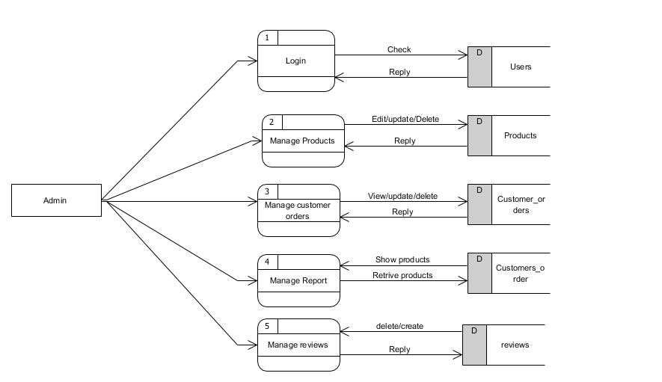

Fig (1) DFDs of Administrator

As above, Admin will have direct in build login access. They don’t need to be registered. Admin can manage products, customers order, manage report about customers and also can view review regarding the products. User’s tables will be used to store both customer and admin data which also can be managed by admin.

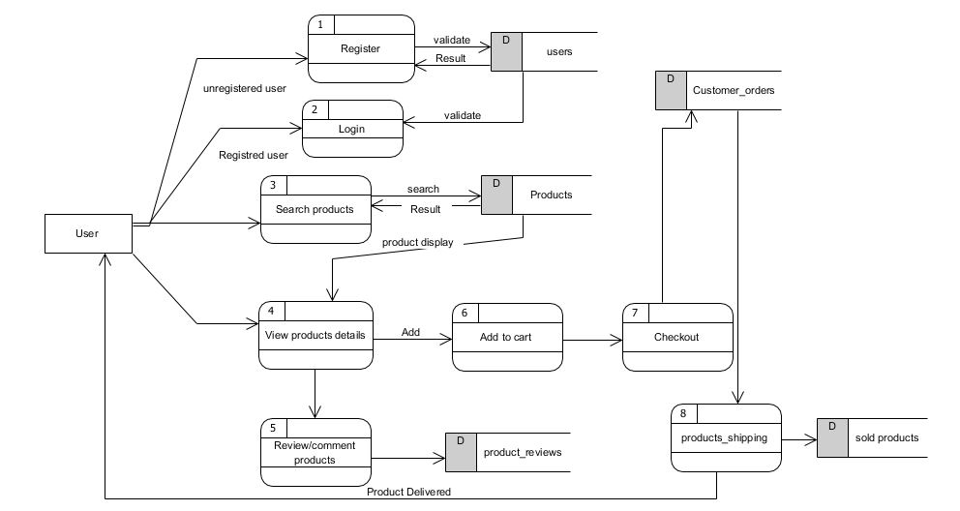

Fig (2) DFD of General user

Here, The process how a general user can access website is mentioned in above diagram. Here unregistered user can register their details which will be stored in users table. A registered user can directly login into the system where his data will be retrieved from users table. He/she can search for their products where the products details will be accessed from products table. After choosing right product to cart they can check out where the checkout details will be stored in sold products table. Similarly, a user can give feedback to respective products and also view earlier feedbacks.

# Behavioral diagram

## Activity diagram

Activity diagrams are probably the most important UML diagram. It is used describe the flow of different activities and action across the system. They describes the objects used, consumed or produced by an activity and the relationship between the different activities. The main reason behind using activity diagram in this project is to model the work flow behind the ‘The computer store’s system.

Advantages

* They are easy comprehensible for both analysts and stakeholders.
* They are most user friendly diagrams as they regarded as essential tool in an analyst’s repertoire.

To make easy understanding of data flow of admin and user, I have developed two separate diagrams for both admin and general user.

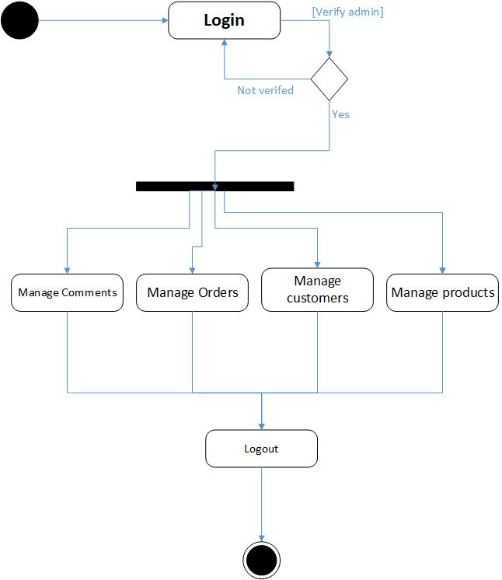

Fig (4) Activity diagram for Administrator

As show in this diagram, Admin do not have to register themselves. They can directly logged in to the system. If the login fails, they will be redirected to login page and verified login will take admins to their dashboard. After successful login, they can add, update and delete products. They have all rights to manage orders, manage customer data, comments and products as above.

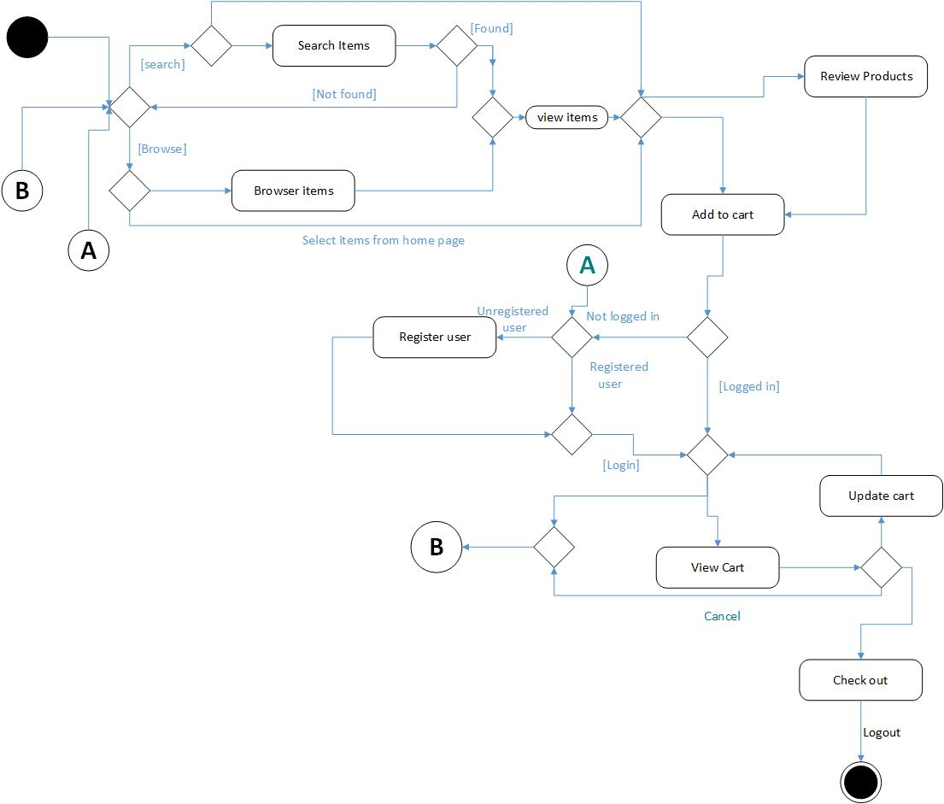

Fig (5) Activity diagram for General User

As above general user activity diagrams, user are redirected to home page where they can view products details, search products, select products of their desire and view comments regarding to the specific product. If they want to give their feedback and access to check out option they have to be registered. If the user is logged into the system, he/she will have access to all the features in website. Eventually, user can update their profile, change their passwords, profile picture. As mentioned above, user can login at any time they desire. After the complete visits to site, an additional features is available i.e. logout so that they avoid other to access their profile.

## Sequential diagram

Sequential diagram is UML diagram that graphically describes the chronology of exchange of message/information between objects and actors for a use case, execution of operation, or an interaction between classes, with an emphasis on their chronology. (Infocenter.sybase.com, 2018).

I have developed two separated sequential diagrams for both admin and general user because to make easy understanding exchange of message of admin and general as bellow:

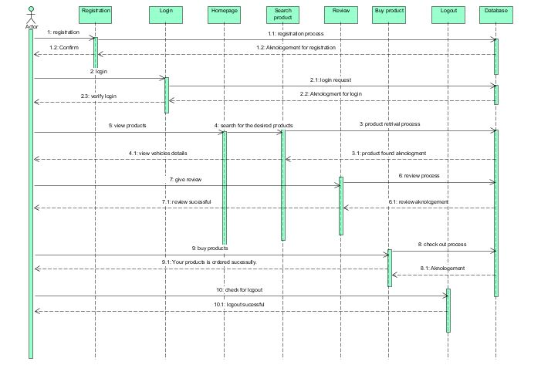

Fig (6) Sequence diagram of General Customers

As mentioned in diagram, In order to login or register user will enters information to login and register page respectively which are navigated in home page. A registered user can login, if the information are valid he/she will be redirected to general dashboard else redirected back to login page with error message. Similarly, to view and update their profile, they have to go to respective pages. They can directly search their desired products, If the product is available users will be able to view them but if searched product is not available a message will be displayed showing no product found.

Also, user can give feedback to the product. If the user is logged in to the system, he/she will able to review products and error message with please login first will be displayed if the user is not logged in to the system. In this way all the work of objects in time are shown in sequence diagram.

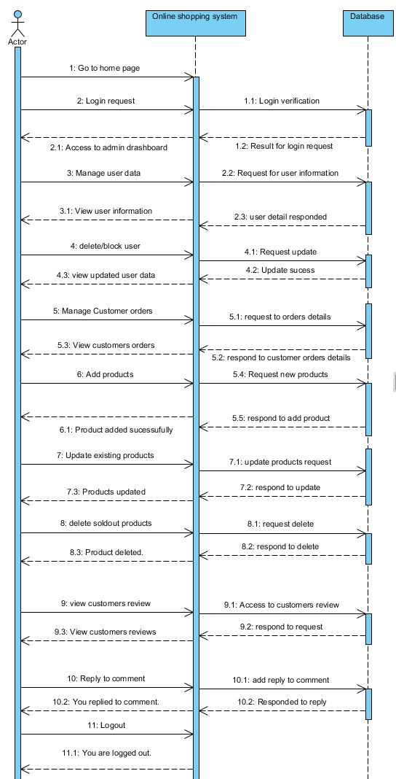

Fig (7) Sequence diagram for Admin user

As mentioned in image, admin can request for login. If the information are valid he/she will be redirected to admin dashboard. Similarly admin can request to manage user data, products, reviews and orders details.

# Database design

## ER diagram

ER diagram is a graphical way of representing the logical relationships of entities in order to create a database. It describes the structure of database, tables including their relationships. It works around real world entities and the association among them. (EDUGRABS, 2018)

Benefits

* Very simple to understand and better visual representation
* Easy conversion to table and any data models

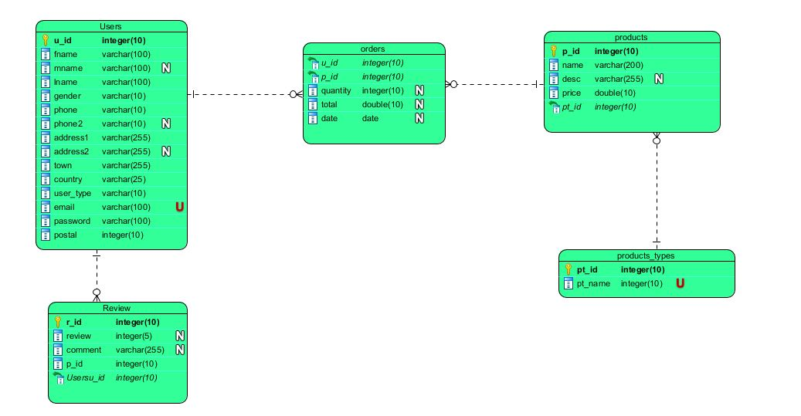

Fig (8) ER diagram of ‘The computer store’

As show in above figure, there are five main tables for this project. Users table will contain all users login and delivery details. Users and Review table have one-to-many relationship because one user can give multiple feedback to multiple products. Products table will contain all the products details. Products type table and products have one-to-many relationship because there may have many products of one product type. Similarly, Users and products have many-to-many relationship because a product can be bought by multiple user and vice versa. A linking table orders is derived where all the orders details will be stored.

## Data dictionary

Data dictionary shows the information about the tables or views and their structure. It helps to clarify the properties of tables, their data structure and Meta data about the data elements. Here I have generated data dictionary using the publisher features in Visual paradigm. The generated data dictionary is mentioned bellow:

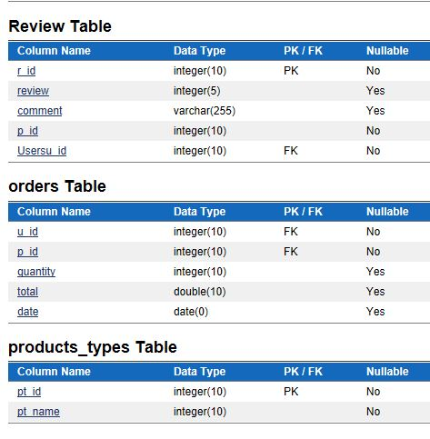

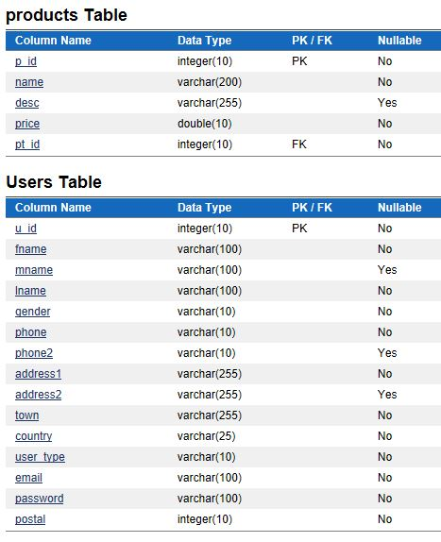

# User Interface design

User interface design is the process of making interfaces for software with a focus on looks or style. This aims to create design of pages which are find easy to use and pleasurable. UI design is more concerned with the surface and overall feel of a design and a good UI design will help us to develop a good webpage. I have designed some of the main pages as bellow:

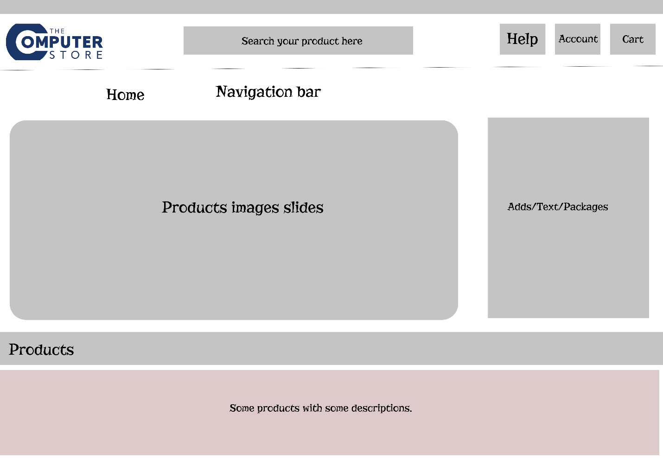

Fig (9) UI Home page

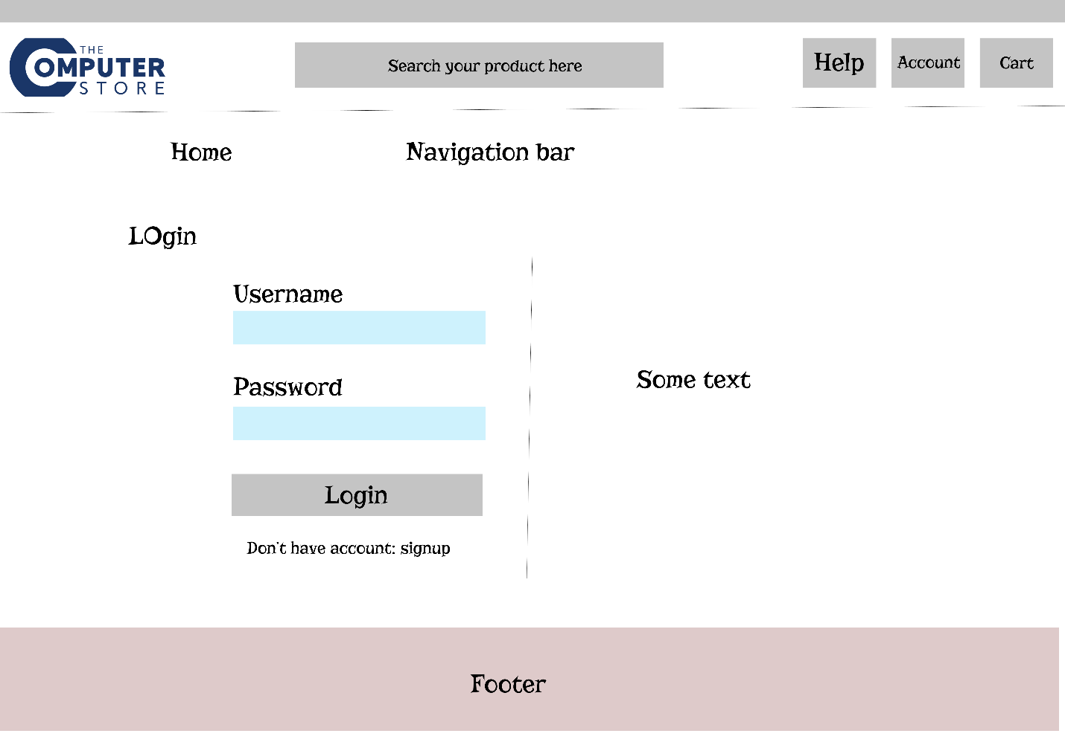

Fig (10) UI Login page

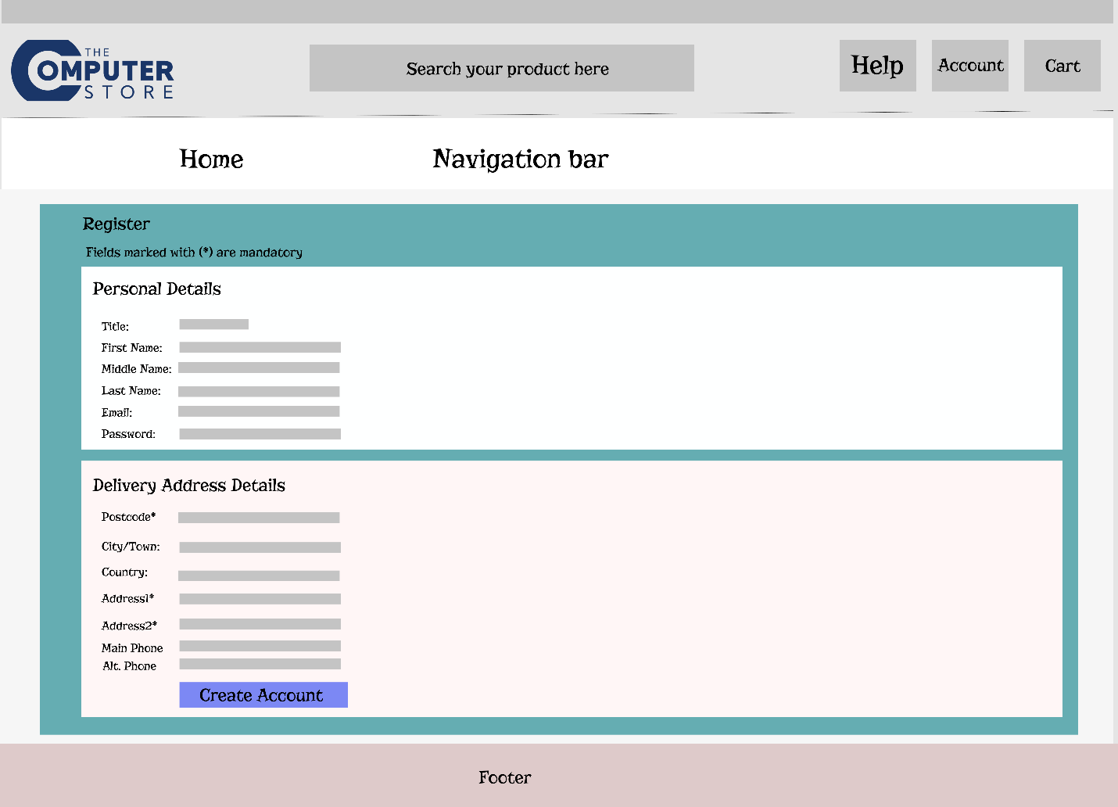

Fig (11) UI Registration Page

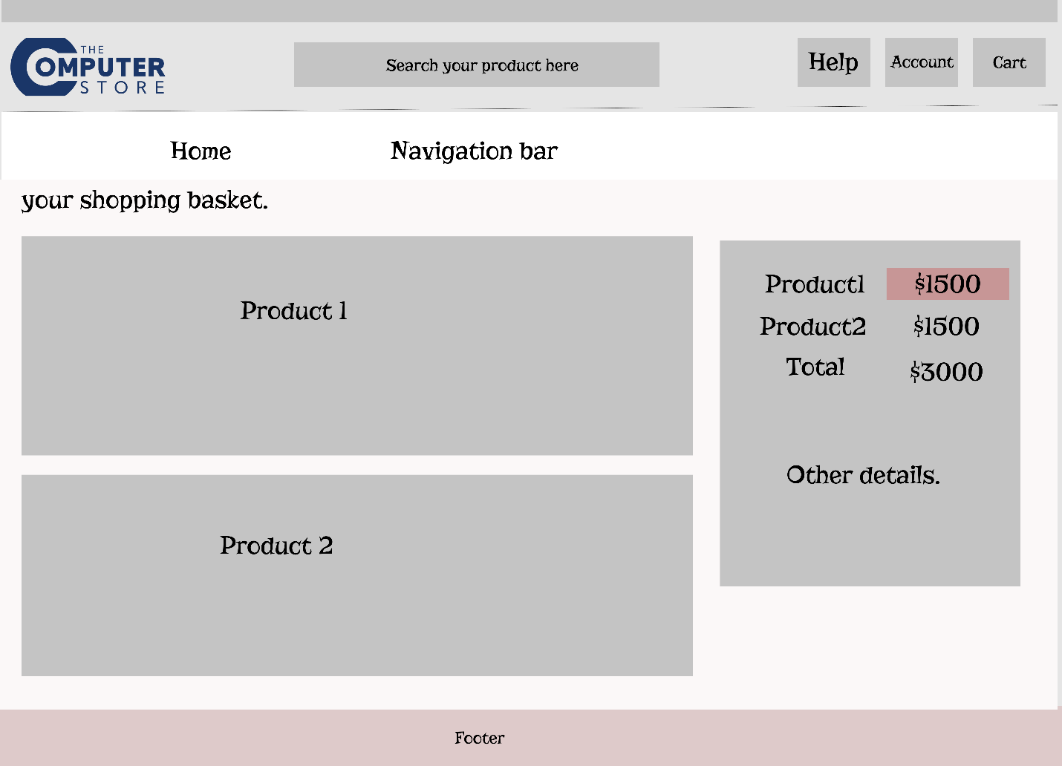

Fig (12) UI Shopping Cart page

# References

Lucidchart. (2018). *What is a Data Flow Diagram*. [online] Available at: https://www.lucidchart.com/pages/data-flow-diagram [Accessed 5 Jun. 2018].

Mehta, D., Mehta, D. and profile, V. (2018). *Importance of Design in SDLC*. [online] Techblog-dm.blogspot.com. Available at: http://techblog-dm.blogspot.com/2013/07/importance-of-design-in-sdlc.html [Accessed 4 Jun. 2018].

Techopedia.com. (2018). *What is a Structure Diagram? - Definition from Techopedia*. [online] Available at: https://www.techopedia.com/definition/22358/structure-diagram [Accessed 5 Jun. 2018].