# Analysis Specification on

## 



**Name**: Aashish Aryal

**NCC** **ID**: 00168690

**Subject**: Computing Project

**Project title**: The computer Store

**Level**: L5DC

**Module** **Leader**:Sudeep Bajimaya

**Submitted** **to**: Sudeep Bajimaya

**Email**: [aryalaashish121@gmail.com](mailto:aryalaashish121@gmail.com)

**Submission** **Date**: 10 May 2018

*Softwarica College of IT and E-commerce*

*Dillibazar-pipalbot, Kathmandu*

Contents

1. Introduction 3

2. Analysis 4

2.1 Introduction: 4

2.2 Information Gathering 5

2.3 Feasibility Study 6

2.4 Analysis Methodology 7

2.5Architecture 8

2.6 System Requirement Specification 10

2.7 Use case 16

2.8 Natural Language Analysis 19

2.9 Class diagram 21

3. Conclusion 22

4. Refercences 23

# Introduction

An online store is virtual store on the internet where customers can browse the catalog and select product of their own interest. I want to develop ecommerce because of its numerous advantages and benefits and more people prefer online over the conventional method of going into stores. After the acceptance of my project proposal on ‘The Computer Store’ now its turn to start the analysis of project. In this documentation I deal with project analysis of my project. Analysis is the basic before starting the development of the system we can identify how the system will be developed. It helps like blue print of the project. I have explained the project scenario by using a powerful tool know as rich picture.

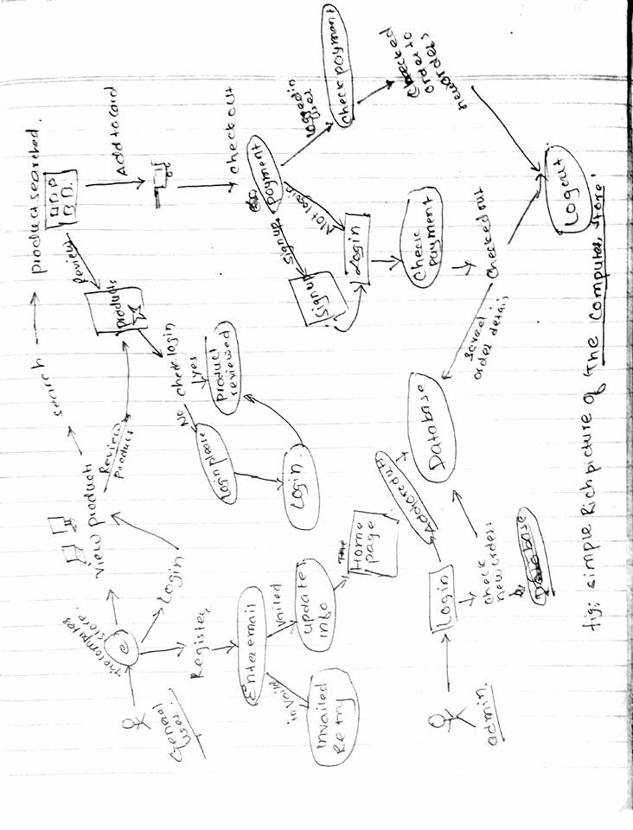

Fig (1): Rich picture about the project.

In this document, Analysis of the project is done in section 2, system architecture and requirement analysis are under the section 2 and reference at section 4.

# Analysis

## 2.1 Introduction:

Analysis simply means realizing what actually we need and how we perform to get that goal. It is a systematic examination and evaluation of data and information, by breaking it into its component parts to uncover their interrelationships. An examination of data and facts to uncover and understand cause-effect relationships, thus providing basis for problem solving and decision making. Data analysis helps to make sense of our data otherwise they will remain a pile of unwieldy information; perhaps a pile of figures. I have done data analysis because of following benefits.

Analysis have several benefits as bellow:

* It helps to determine if an investment is sound.
* It provides a basis for comparing projects which involve cost expected against expected benefits.
* It uncovers the hidden interrelationships.

The analysis is performed by identifying problem statement. A document which explains what the client wants. A proper understanding is made to the document and the system to develop. Then, problem domain is identified which clarify the actual problems and also express the project scope. A problem domain is simply looking to the topic needed excluding other. It is the area of expertise’s that need to examine to solve the problem. There are different analysis technique like descriptive analysis, comparative analysis, and SWOT analysis. I have used SWOT analysis which helps to identify strength, weakness, Opportunities and Threat of the system and solve them.

If the project is done without analysis, there might be chance of project failure. This helps to identify what the clients actually wants. The components of system analysis are briefly described:

## 2.2 Information Gathering

As with any project, data collection is incredibly important. It is the process of collecting information from various sources through various means. The collected data will help dealing with the organization’s and individual’s needs from the current situation. Generally, it is done to get access to background information quick without the necessary reviews and research. There are different technique to perform information gathering. In my project, I am using two major information gathering techniques as bellow:

* Questionaries’
* Interviews

1. Questionaries’ :

Questionaries’ is a cost effective one of the most affordable way to gather data. It is the one of speedy method. In Questionaries’ a collection of the questions are prepared about the current system as well as the expectation from the new one. A well designed questions meets the research objectives and obtain the most possible and accurate information possible. Questions should be clearly worded and response options clearly identified. (Fao.org, 2018) Those questions are presented in front of the stakeholders. We can analysis the problems and actual needs from the answers obtained. This is mostly used technique and I am using it as well.

1. Interviews:

Verbal conversations (actual screening) between interviewer and interviewee with the objective of collection relevant information. This remain face-to-face can no doubt capture interviewee’s emotions and behavior. It help to be aware from the data misleading. I doing interview with different stakeholders about what they actually need. This will help me to find out what should I actually develop for them.

## 2.3 Feasibility Study

Feasibility study is initial design stage of any project which brings together elements of knowledge that indicates if the project is possible or not. (Course, 2018). It is the most important activity that analyses the proposed system from different aspects sot that it makes clear that how practical or beneficial the system will be to the organization. There are different level of feasibility study done to ensure that the project is feasible.

1. **Economically Feasible:**

It concerns with the cost effectiveness. During economic feasibility study, we estimate the development cost and operational cost of the developed system and also the benefits gain from the system.

1. **Technically Feasible:**

It is concern with the software, hardware and the supports equipment’s for the complete development of the system. The designed project is technically feasible.

1. **Operational Feasibility:**

It related to the smoothness of the system. Here we study about the problems that may come during the operation the system after its development.

1. **Legal Feasibility:**

It concern with the legal issue of the system. It the system is illegal than designing is meaningless. The system should meet the legal criteria and follow law which include copyright law, foreign law, tax etc.

1. **Schedule feasibility:**

Schedule is the process of splitting the project into task and estimate time and resource to complete each task. If the scheduling is not feasible then there is no meaning of starting design.

1. **Behavior feasibility:**

It is concern with how the society and the users react to the system. If the employee are not ready to upgrade themselves with the new system then is project failure is high. So, Behavior feasibility is done for the project.

## 2.4 Analysis Methodology

A methodology refers to the steps that need to be followed when working on a task/project and in what order they should be taken and how each should be undertaken. In the context of analysis, it deals with step taken when collecting information, analyzing information and documenting the requirements. It offers the structure when working on project and makes analysis and design more manageable. There are different methodology available like soft, hard, combine etc. I am using ***Hard system analysis (SSADM)*** for my project.

**Structural system Analysis and Design Methodology** is highly structured approach to the analysis which follow logical sequences of steps and address the rules and guidelines. It is the step by step process where we cannot shift to another with the completing one step. I used SSADM in project analysis because:

* It is easy to measure progress.
* It ensures through planning and scheduling.
* Ensure all the procedures associated with each step are undertaken.

Steps followed during SSADM (The water fall) are:

* Feasibility study
* Analysis and requirements specification
* Design
* Implementation
* Testing
* Maintenance

SSADM have three techniques to provide different views of the same system and are shortly pointed bellow:

* Logical Data modelling

In this process the identification, modelling and documentation of the data requirements of the system. It consist of entity-relationship model and associated documentation.

* Data flow Modelling

This is the process of modelling and documenting how data flows around a system. A DFDs (Data flow Diagram) and supportive document consist in this process. It represents process and functions, data stores, external entities and final data flows.

* Entity Event modelling

The process of identifying, modelling and documenting the business events that affect each and the sequence in which these events occur. It consists of a set of entity life histories and supporting documentation.

## 2.5Architecture

A lot of people underestimates the importance of system architecture. When you are planning to develop a system a good architecture is foundation of the system. System architecture is a blue print of both system and project. The architecture is the primary carrier of system qualities such as scalability, performance. IT dictates technical standards, including software coding standards, tools, and platforms. It gives right technical solution to ensure the success. (Apiumtech, 2018)

Advantage of System architecture:

* It creates a solid foundation for the project and make platform scalable.
* It helps to manage complexity.
* Increase the quality of platform
* Make the platform faster.
* Better code maintainability.
* Enables quick changes in IT systems.
* Increase performance, reduce costs, and avoid codes duplicity.

Here, in this project I am using MVC pattern. MVC stands for Model, view and Controller. MVC offers for rapid and parallel development. This is very useful pattern for the reuse of object code and pattern allows them to significantly reduce the time to develop application with user interface. (WhatIs.com, 2018)

Benefits of MVC design model.

* Modification never affects the entire model.
* Offers the multiple views.

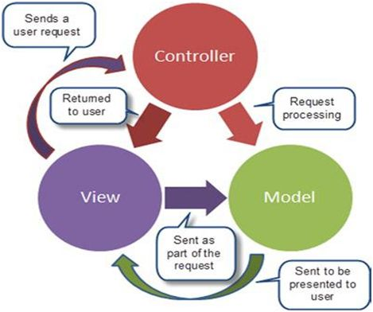

*Fig (2). MVC architecture*

Model – Model represents the logical structure of data in system. This contains information about the logic used in website and does not contain any information about user interface.

View – view represent a collection of classes representing the elements in user interface. It contains the user interface part of the system.

Controller – Controller represents the classes connecting the model and view part. It works as intermediate which carries data from the view to model and result from model to view.

## 2.6 System Requirement Specification

A System Requirement specification is a document that describe the features and behavior of the system. This section provides a detailed description of all the software/hardware, functional requirements and non-functional requirements also use-case. It help to produce a common understanding between the developer and clients about the features of the product. (Inflectra.com, 2018) It creates a common idea between developers and helps to convert business idea into software product. This can work as agreement between the client and developer about the product features, functionality and hardware/software required. A detailed exploitation of functional requirements, non-functional requirement and hardware/software requirement is presented below:

1. Hardware and software requirements

This section describe the hardware and software required to develop and install the software.

Following hardware and software are required to complete the project.

*Hardware*

* A pc with min 4GB RAM, 500GB hard disk and X64 bit processor

*Software*

* Net Beans IDE for development
* Xampp
* ProjectLibre
* word document for documentation
* Star UML and MS Visio

1. Functional requirements

Functional requirement are those which are intended function in the system developed. It explains the expected inputs and outputs and can related to calculations, technical details, data manipulation and processing which defines what a system is supposed to accomplish. (techopedia, 2016).

Here are some functional requirements of ‘The computer Store’.

|  |  |  |  |  |  |
| --- | --- | --- | --- | --- | --- |
| FR/N | Function | Data | Rationality | Dependency | |
|  | User  Registration | -Name  -Email  -Password  -Address  -phone number more. | In order for customer to register on the e-commerce. | | N/A | |
|  | User  Login | -email  -password | In order for user login to website. | | FR (i) | |
|  | Add product | -Product id  -product name  -product image  -price  More. | To add the product in site by admin. | | FR (ii) | |
|  | Search Product | -product name | In order for user to search for products. | | FR (ii) | |
|  | Update product | -product id | In order to update the existing product | | FR (ii)  FR(iii) | |
|  | Delete Product | -product id | In order to delete the existing product | | FR (ii)  FR(iii) | |
|  | Retrieve products |  | In order to display the existing product in website | | FR (iii) | |
|  | Product rating | Product id  Ratings | In order to product ratings so that customer can get information about product. | | FR (ii) | |
|  | Discount calculation on product | -product  -discount % | In order to provide discount to customers. | | FR (iii) | |
|  | Online transaction |  | In order to collect the product amount online. | | FR (iii) | |
|  | Password Retrieval | -customer id  -password | In order to check the password entered on retype is correct | | N/A | |
|  | chat group | -customer id  -customer name | In order to share the experience among other customers | | FR (ii) | |
|  | Total views on website |  | In order to view the number of views in the website. | | FR (ii) | |
|  | Logout |  | To restrict access to unauthorized person | | FR (ii) | |
|  | Customer GPS tracking |  | To get the verified customers location for delivery. | | N/A | |
|  | Mobile verification | -customer id  -customer no. | To register only verified customer | | FR (i) | |
|  | Email verification | -customer id  -email address | To register only genuine customers. | | FR (i) | |

1. Non-functional requirements

Nonfunctional Requirements (NFRs) define system attributes such as security, reliability, performance, maintainability, scalability, and usability. It is refer as software quality which ensures the effectiveness and useability of the entire system.

Here are some non-functional requirements of ‘The computer store’.

|  |  |  |  |  |
| --- | --- | --- | --- | --- |
| NFR/N | Functionality | Description | Rationality | Dependency |
|  | Availability | Able to accessible to the customers | In order to maintain availability | NFR –ii  NFR- V |
|  | Reliability | Site should be reliable for customers and admin to use. | To maintain reliability reducing the problems working with site. | NFR - vii |
|  | Performance | Should be able to response fast. | To maintain the system work accurately and fast. | NFR - iii |
|  | Scalability | System should be able to withstand large number of customers data | To maintain scalability. | NFR - ii |
|  | Recoverability | System should have proper backup plan so that we can recover data. | To maintain data available. | None |
|  | Maintainability | System should be able to restore services even after failure. | To maintain maintainability to restore into normal state after any failure | NFR- v |
|  | Security | System should securely store and manipulate data. | To make data confidentiality and secure. | NFR – iii  NFR – iv |
|  | Legal | System must be legal | To provide legal security | None |
|  | Social | System should meet social acceptance | To maintain social working environment | None |

**Prioritization**

Prioritization is ability to see which tasks and objectives are more important at the current movement and give them more time, attention and energy. While determining priorities, we will focus on what is more important at the expense of lower value activities. 80/20 is the key rule why prioritization is done. Mostly 80% of the task is done in 20% of time and rest 20% in 80%. We have to prioritize what are the features to keep in 80% task. Needs-Based Analysis, Crowd Sourcing, Opportunity Scoring, etc. are popular Prioritization techniques. But the most popular answer among them is MoSCoW prioritization technique.

MoSCoW prioritization technique is originated for dynamic software development method. According to this technique, we can categorize list of requirements into following groups:

M – Must have: these are non-negotiable features and the project will fail without them.

S – Should have: these are high-priority features and are high value features to the user.

C – Could have: these are desirable features but not necessary

W -- Won’t have: these features are not current releasing but may be included in future stage of development.

*Prioritization of functional and non-functional requirements of this project are given below.*

|  |  |  |
| --- | --- | --- |
| ID | Functionality | MoSCoW |
| FR (i) | User Registration | M |
| FR (ii) | User Login | M |
| FR (iii) | Add products | M |
| FR (iv) | Search product | C |
| FR (v) | Update product | M |
| FR (vi) | Delete Product | M |
| FR (vii) | Retrieve Product | M |
| FR (viii) | Product Rating | S |
| FR (ix) | Discount Calculation | C |
| FR (x) | Online transaction | C |
| FR (xi) | Password retrieval | S |
| FR(xii) | Chat group | C |
| FR(xiii) | Total views | S |
| FR (xiv) | Logout | M |
| FR (xv) | Customer GPS tracking | W |
| FR (xvi) | Mobile verification | W |
| FR (xvii) | Email verification | C |

|  |  |  |
| --- | --- | --- |
| ID | Functionality | MoSCoW |
| NFR(i) | Availability | M |
| NFR (ii) | Reliability | M |
| NFR (iii) | Performance | M |
| NFR (iv) | Scalability | C |
| NFR (v) | Recoverability | C |
| NFR (vi) | Maintainability | S |
| NFR (vii) | Security | S |
| NFR (viii) | Legal | M |
| NFR (ix) | Social | S |

## 2.7 Use case

Use case is a methodology to identify, clarify and organize system requirements. It represents the functionality of the system in picture. We know it is very easy to understand pictures representation rather than a long paragraph. It is a simple technique easily understandable by all stakeholders, including customers, users and executives not only by developers. (SearchSoftwareQuality, 2018) It can be used to different aspects like project planning, objects models, test case definitions and user documentation once it is driven.

Benefits of use case:

* Provides basic groundwork of the requirements.
* Encourages designer to envision outcome before attempting to specify outcome.
* Easily understand by non-technical persons.

It consist of actor (individual’s role), boundary (system), use case (requirements/functions) and relationship (between use case and actor). Use case diagram for the given project are presented below:

* **Administration system**

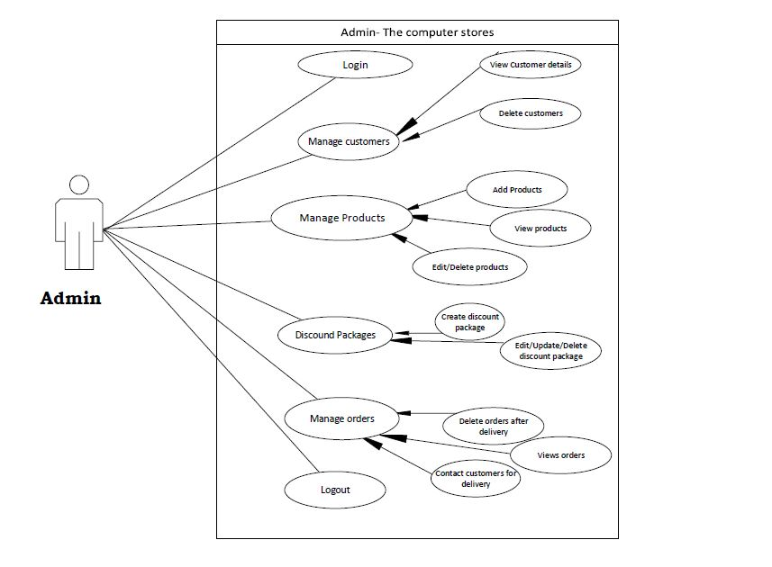 *Fig (3) Administration system use case diagram*

* **General user system**

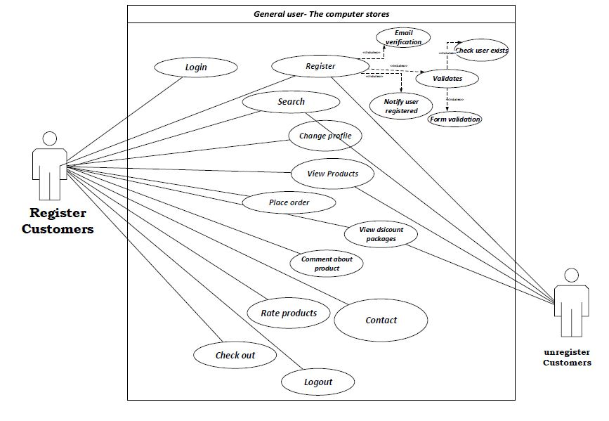

*Fig (4) General user use case diagram*

## 2.8 Natural Language Analysis

The most difficult when it comes to build class diagram is working out with classes to include. While looking at the scenario, we came to dilemma which class to include and which to exclude. So I am using NLA to identify classes. NLA is a powerful tool which helps to obtain candidate classes, relationships between classes and their attributes. It is so much easy technique. We had to find just verbs, adjectives and noun from the scenario. In NLA,

* Noun represents the candidate classes
* Adjective represents the attributes
* Verbs represents the functionality

Now from the use of noun, verbs and adjective, I have identified some candidate classes as bellow:

*Noun*: Admin, customers, Kathmandu, Year, products, order, order type

*Verbs*: buy, update, delete, edit, view, add etc.

*Adjectives*: total, average, less, cheap, expensive, good, bad etc.

|  |  |  |
| --- | --- | --- |
| Candidate class | Candidate operation | Candidate attribute |
| Customer/User | Register();  Login();  Add details(); | Customer id  Name  Email address  Address  Contact no |
| Admin | Add/Edit/Delete products();  CUD discount packages();  Delete customers();  Manage order(); | Admin_id  Name  Email  Address |
| Products | Retrieve products(); | Product id  Product name  Price  Product details |
| Order | Calculate total(); | Order id  Product id  Quantity  Order Date |

Justification for the candidate classes

**User/Customer:**

User are the base line of the whole project. The information about data is the most essential value for whole project. Most of the function falls under this class which leads dependency. A user registration is the main gate to use whole e-commerce.

**Admin:**

Admin have the major task in this project. All CRUD operation are done by the Admin. This class have major functions to add products, manage orders etc.

**Products:**

In this class all product display is featured. This class will aid to display the stored product in the database.

**Order:**

This class seems to work in the final check out time of customers. In this class all the order are confirmed, discount calculations and final calculation are done.

Operation Selected with reason:

|  |  |  |
| --- | --- | --- |
| S/N | Operations | Reason |
| 1. | Register | To register new customers. |
| 2. | Login | For registered user to use all features. |
| 3. | Add products | To add products in the website. |
| 4. | Update products | To update existing products. |
| 5. | Delete Products | To delete sold out products. |
| 6. | Manage discount | To add/edit/delete different discount packages. |
| 7. | Reviews on product | To give feedback about products. |
| 8. | Online chat | To make online chat with customer to cure queries. |
| 9. | Cart service | To make customers easy to buy different customer at a time. |
| 10. | Logout | To logout from the site. |

## 2.9 Class diagram

A class diagram is a static structure diagram that describes the structure of a system by showing the system’s classes, their attributes, operation and the relationships among objects. It provides a blueprint to get an overview of how the application is structured before examining the actual code. It helps during update and maintenance of the system too. I have used the classes obtained by using NLA and developed initial class diagram of the system using StarUML.

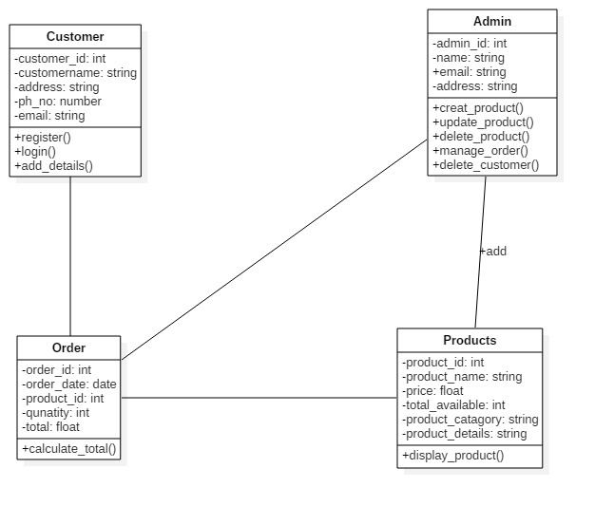

*Fig (5) Initial class diagram*

# Conclusion

Hence, A e-commerce ‘The computer Stores’ store analysis report is presented. Analysis is the key task that need to perform before starting the development of the system. This document will now fully guide how the system will be developed. This provide all the features of the system and upcoming features that could be include in future. All the problems are discussed and required solution are identified at the early phase of analysis. Here in the analysis, I have used different information gathering technique and find the system is feasible (technically, economically etc.). A hard approach is been used because I don’t have to be so much flexible to users. All the hardware/software, functional and non- functional requirements are identified. I also used use case and class diagram to improve the understanding of project by both technical and non-technical persons. Thus the report of analysis is done successfully.

# Refercences

Fao.org. (2018). *Chapter 4: Questionnaire Design*. [online] Available at: http://www.fao.org/docrep/w3241e/w3241e05.htm [Accessed 8 May 2018].

Course, M. (2018). *What is a Feasibility Study? - Definition | Meaning | Example*. [online] My Accounting Course. Available at: https://www.myaccountingcourse.com/accounting-dictionary/feasibility-study [Accessed 8 May 2018].

Inflectra.com. (2018). *What are System Requirements Specifications/Software (SRS)?*. [online] Available at: https://www.inflectra.com/ideas/topic/requirements-definition.aspx [Accessed 8 May 2018].

Apiumtech. (2018). *15 benefits of software architecture - Apiumtech*. [online] Available at: https://apiumtech.com/blog/15-benefits-of-software-architecture/ [Accessed 9 May 2018].

WhatIs.com. (2018). *What is model-view-controller (MVC)? - Definition from WhatIs.com*. [online] Available at: https://whatis.techtarget.com/definition/model-view-controller-MVC [Accessed 9 May 2018].

SearchSoftwareQuality. (2018). *What is use case? - Definition from WhatIs.com*. [online] Available at: https://searchsoftwarequality.techtarget.com/definition/use-case [Accessed 9 May 2018].