Download the project, extract the project and place it to the xampp/htdocs directory for the case of XAmpp or var/www for the case of Wampp.

Inside Phpmyadmin, import events.sql file for the data from the project.

For admin login,

Visit <http://localhost:8000/login> and enter

email ‘admin@example.com’

password : ‘password’

from the events.sql file data.

After then, visit to <http://localhost:8000/events> for the list of events.

Click on ‘Add Event’ for creating an Event.

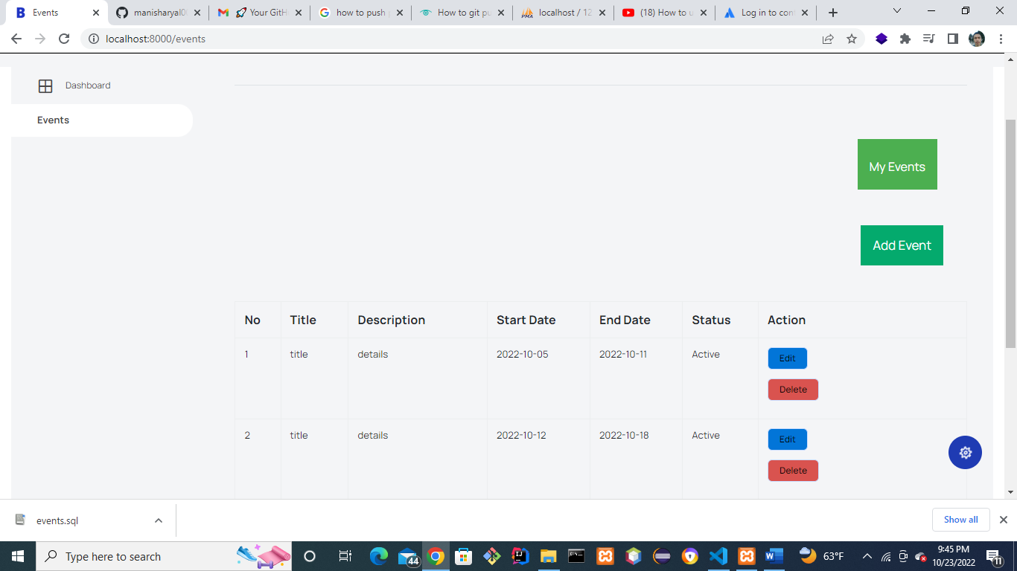

After that in create page, create an event from the following page.

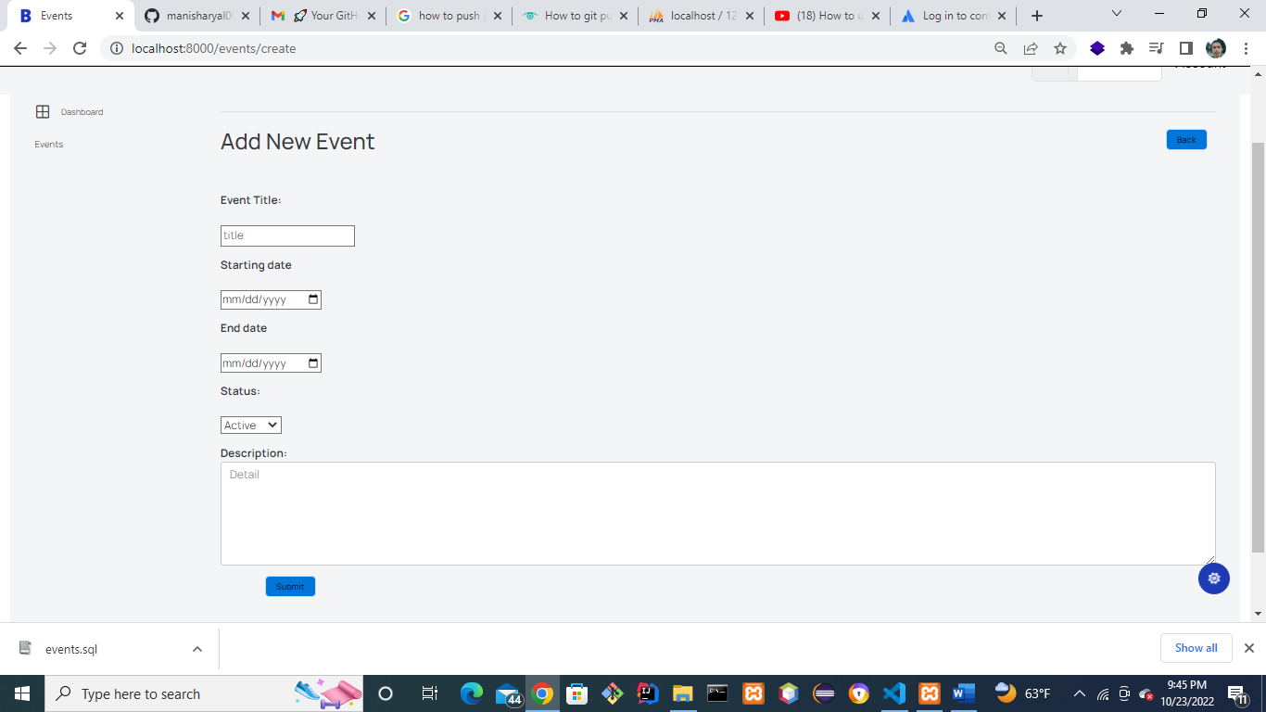

For finished events, upcoming events, upcoming events within 7 days, finished event within 7 days, buttons put mouse hover on the “My Events button” like the following way.

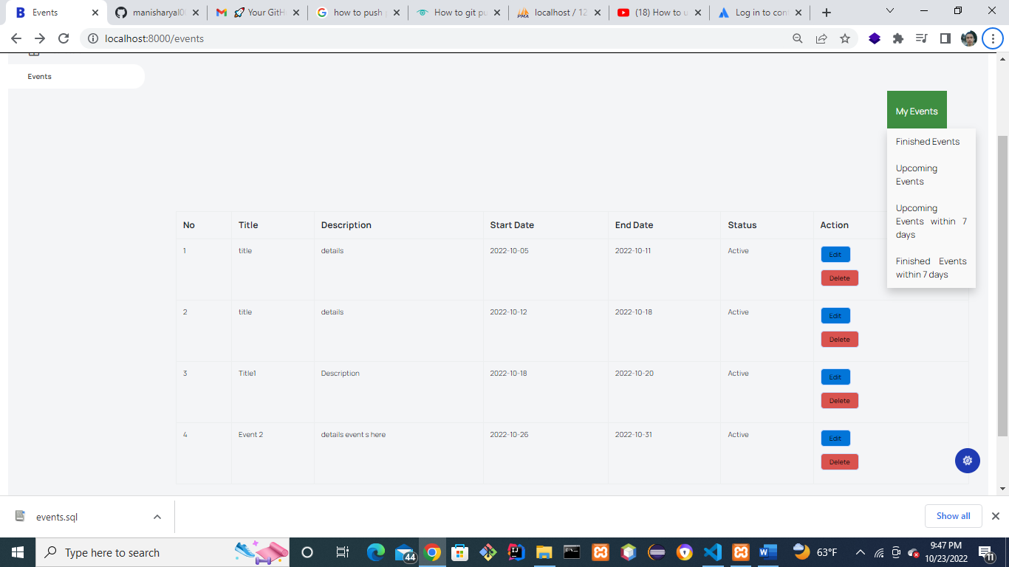

For Deleting, click on delete button and the system will delete the event data using AJAX.