**PATAN MULTIPLE CAMPUS**

**(Affiliated to Tribhuvan University)**

Patandhoka, Lalitpur



**Final Year Project Report On**

**"Number Plate Detection System"**

For the partial fulfillment of the requirement for the degree of Bachelor of Science in Computer Science and Information Technology awarded by Tribhuvan University

**Under the supervision of**

**Mr. Dadhi Ram Ghimire**

**Coordinator/Lecturer**

**Submitted By:**

**Sudarshan Bastola (T.U. Exam Roll No. 23096/076)**

**Saurav Aryal (T.U. Exam Roll No. 23085/076)**

**Submitted To:**

**Patan Multiple Campus**

**Department of Computer Science**

**PatanDhoka, lalitpur, Nepal**

**October, 2024**

# INTRODUCTION

## Background

Vehicles on the road are rising in extensive numbers, particularly in proportion to the industrial revolution and growing economy. The significant use of vehicles has increased the probability of traffic rules violation, causing unexpected accidents, and triggering traffic crimes. To overcome these problems, an intelligent traffic monitoring system is required. The intelligent system can play a vital role in traffic control through the number plate detection of vehicles. In this proposed project, a system will be developed for detecting and recognizing vehicle number plates using a convolutional neural network (CNN), a deep learning technique.

## Problem Statement

The drastic increase in vehicular traffic on the roadways stimulates a huge demand for technology for traffic monitoring and management. In this scenario, manual tracking of vehicles running fast on the road is practically not feasible. There will be a wastage of manpower and time. Even if it is operated manually, that will reflect huge difficulties and enormous errors.

With the increase in the number of automobiles, it has become increasingly challenging to track them and almost impossible to identify the owners of these vehicles in case of violation of any traffic law. Traffic law violation has been recognized as a major cause of road accidents in most parts of the world with the majority occurring in developing countries. Even with the presence of rules and regulations stipulated against this, violators are still on the increase. This is because the rules are not properly enforced by appropriate authorities in those parts of the world.

Several cases of kidnapping, hit and run, robbery, smuggling, and on-road fatalities are continuously reported, and this is because these vehicles cannot be easily recognized especially moving at high speed.

## Objectives

The project aims to achieve the following objectives:

1. Detect the number plate from the moving vehicles.
2. Recognize the number plate information like vehicle number, state information from the detected number plate.
3. Store the recognized number plate information in a database for further evaluation.

## Scope and Limitations

The scope of the number plate detection system is to first detect the number plate and then recognizes the number and state information from that plate. This is commonly used for traffic monitoring systems worldwide.

ANPR is useful for the police, who can browse the data collected and check for suspicious vehicles, or vehicles that were involved in a crime. Thanks to the need to store the data for a short while, ANPR data can provide both alibis and incriminating data. ANPR also provides security on a lower level, such as open workplace parking where it can manage permit parking for staff vehicles, or recognise a vehicle that has previously been banned from your premises.

Using ANPR cameras raises privacy concerns for many people, who dislike the idea of their data being stored for months. There is the concern that storing information could lead to data leaks and theft, or misuse of their personal information. People also dislike the idea of their whereabouts being known at all times. However, ANPR is not considered an infringement on an individual’s privacy, and the data is always stored securely and should only be accessed for good reason by a senior official.

## Development Methodology

We reviewed many research articles to discover the best methodologies, parameters, and hyper parameters to create efficient solutions for our project. We explored numerous datasets available on the internet and building our own custom dataset by photographing various car number plates. By exploring others articles we developed a following methodology.

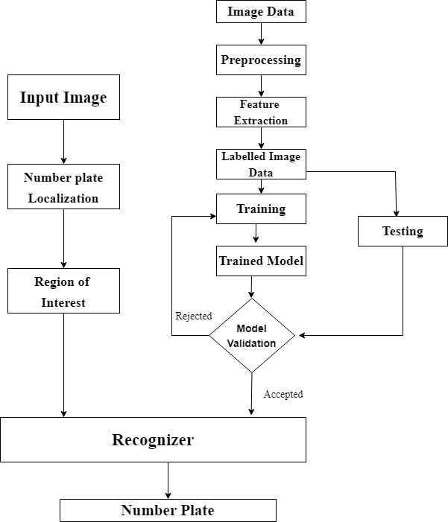

**Figure 1: Development of Number Plate Detection System**

We will be starting by downloading the relevant datasets for English number plate detection from Kaggle. We will then be creating our own Nepali dataset by conducting several procedures such as preprocessing, labeling, and converting it to xml data.

We will use the taining dataset to train our model once we have the labelled dataset. We will then save our model in different checkpoints after training it. When the training is finished, we will save our model so that it can be used again later. We will test our by using a test dataset simultaneously. After that, we will validate the model. When we will reach a high level of accuracy, we will stop validating. If a validated model is rejected, we will go through the preprocessing procedure again, keeping our model and validating it. This will be repeated until our model met our specifications. After that, we will preserve the model and use it to create a classifier. After that, the model will be kept and we will be made classifer using that model. The classifier can detect an Number plate and recognize the number plate's character and display the character's.

## Requirement Analysis

1. **Software Requirements**

* Operating system: Windows or Linux or Mac OS
* Programming language: Python
* Framework: Django framework
* Packages: Numpy, Pandas, OpenCV, Easy OCR

1. **Hardware Requirements**

* An IP camera or webcam
* CPU: intel i3 7th gen or better
* RAM: At least 2GB or more

# LITERATURE STUDY / REVIEW

## Background and Contextual Research

A vehicle registration plate, also known as a number plate, license plate, or license plate, is a metal or plastic plate attached to a motor vehicle or trailer for official identification purposes. The registration identifier is a numeric or alphanumeric ID that uniquely identifies the vehicle or vehicle owner within the issuing region's vehicle register. In some countries, the identifier is unique within the entire country, while in others it is unique within a state or province [1].

Automatic number-plate recognition is a technology that uses optical character recognition on images to read vehicle registration plates to create vehicle location data. It can use existing closed-circuit television, road-rule enforcement cameras, or cameras specifically designed for the task. ANPR is used by police forces around the world for law enforcement purposes, including to check if a vehicle is registered or licensed. It is also used for electronic toll collection on pay-per-use roads and as a method of cataloging the movements of traffic, for example by highway agencies [2].

Automatic number-plate recognition can be used to store the images captured by the cameras as well as the text from the license plate, with some configurable to store a photograph of the driver. Systems commonly use infrared lighting to allow the camera to take the picture at any time of day or night. ANPR technology must take into account plate variations from place to place [3].

Deep learning is a machine learning technique that teaches computers to do what comes naturally to humans: learn by example. Deep learning is a key technology behind driverless cars, enabling them to recognize a stop sign, or to distinguish a pedestrian from a lamppost. It is the key to voice control in consumer devices like phones, tablets, TVs, and hands-free speakers. Deep learning is getting lots of attention lately and for good reason. It’s achieving results that were not possible before.In deep learning, a computer model learns to perform classification tasks directly from images, text, or sound [4].

A Convolutional Neural Network (ConvNet/CNN) is a Deep Learning algorithm which can take in an input image, assign importance (learnable weights and biases) to various aspects/objects in the image and be able to differentiate one from the other. The pre-processing required in a ConvNet is much lower as compared to other classification algorithms. While in primitive methods filters are hand-engineered, with enough training, ConvNets have the ability to learn these filters/characteristics [5].

Optical Character Recognition, or OCR, is a technology that enables us to convert different types of documents, such as scanned paper documents, PDF files or images captured by a digital camera into editable and searchable data. Optical character recognition (OCR) technology is a business solution for automating data extraction from printed or written text from a scanned document or image file and then converting the text into a machine-readable form to be used for data processing like editing or searching [6].

Image processing is the process of transforming an image into a digital form and performing certain operations to get some useful information from it. The image processing system usually treats all images as 2D signals when applying certain predetermined signal processing methods.

There are five main types of image processing:

* Visualization - Find objects that are not visible in the image
* Recognition - Distinguish or detect objects in the image
* Sharpening and restoration - Create an enhanced image from the original image
* Pattern recognition - Measure the various patterns around the objects in the image
* Retrieval - Browse and search images from a large database of digital images that are similar to the original image [7].

# SYSTEM ANLYSIS

## System Analysis

### Requirement Analysis

1. **Functional Requirements**

Functional requirements define the basic system behavior. Essentially, they are what the system does or must not do, and can be thought of in terms of how the system responds to inputs. The functional requirements of this system are described by the following use case diagram.

1. **Use Case Diagram for Admin**

Here, admin develops the system and provide maintenance if it needs. He/ She perform analysis and direct other users too.

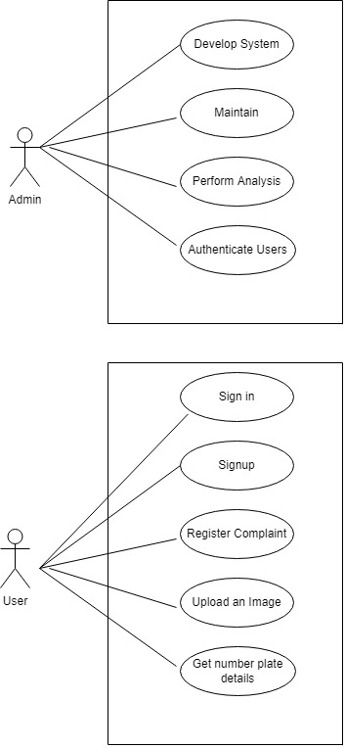

**Figure 2: Use Case Diagram for Admin**

1. **Use Case Diagram for Users**

Here users operate the number plate detection system and make necessary arrangements to run the system like fits the camera, install web application etc. Users also store the visuals of the number plates in database and also get the number plates details from system.



**Figure 3: Use Case Diagram for Customers**

1. **Non Functional Requirements**

Non-functional requirements help us to describe exactly how our system works, what properties and characteristics a particular development has. Nonfunctional requirements are Performance (Response Time, Utilization), Scalability, Capacity, Availability, Reliability, Data Integrity, Usability, Maintainability, Security etc.

### Feasibility Study

Various feasibility studies are conducted for the development of a project which is summarized below.

1. **Technical Feasibility**

The system developed will detect the number plate of vehicles automatically. This can be done by image and video processing. To achieve this, various libraries such as Tensorflow, Pandas, Numpy, etc will be used. All the libraries are easily available. Hence, the project is technically feasible.

1. **Operational Feasibility**

This project can be conducted with a minimum human resource. Two developers are working in the project which is more than enough manpower required for this project. The project after development requires only one person to operate. Person with simple computer knowledge can use and monitor this project.

1. **Economic Feasibility**

The project is economically feasible as well. This project can be easily developed using all the open-source packages and tools. Developer’s laptops are used for the development of the project. There is no need for any expensive systems. Hence, the project is economically feasible.

1. **Schedule Feasibility**

Since we have a whole semester to complete this project we can easily complete this project on time. The project has enough time for completion. This project has schedule feasibility also. We plan to finish this project in nearly 4 months.

The Schedule of this project is given by the following Gantt chart.

**Figure 4: Gantt chart**

### Analysis

1. **Data modelling using ER Diagrams**

ER diagram consists of three entities user, vehicle and admin. User entities have four attributes UID (user id), name, and address and associated company. Vehicle entities has three attributes VID (vehicle id), state and number. User monitors the vehicle information. Amin has three attributes address, AID (admin id) and name.

Admin adds the vehicle information in the database.

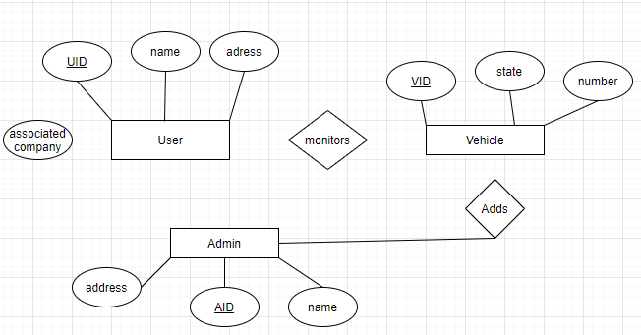

**Figure 5: ER diagram for Number Plate Detection System**

1. **Process modeling using DFD**
2. **DFD level 0**

The data flow diagram consists of three entities admin, user, camera, and one main process Number Plate Detection System. Admin develops the system and gets details from the process. The user operates the system and the system provides the number plate information to the user. The camera is controlled by the process and the camera provides images to the system.

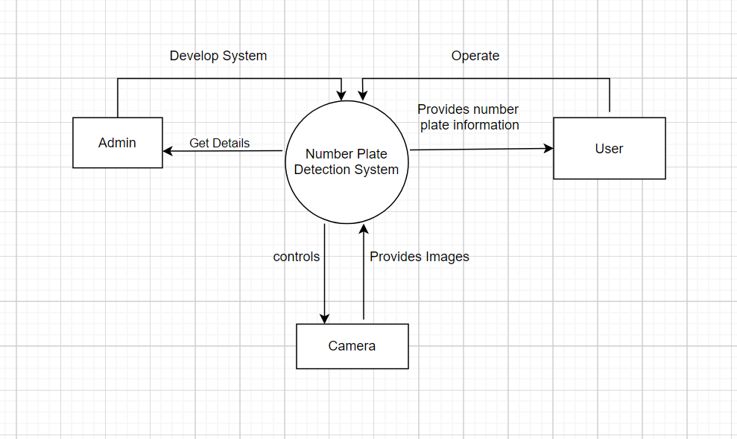

**Figure 6: DFD level 0 for Number Plate Detection System**

1. **DFD level 1**

In the DFD level 1 process Number Plate Detection System is divided into two parts admin section and user section. There is a database also which can store data like images, number plate details, user details, etc.

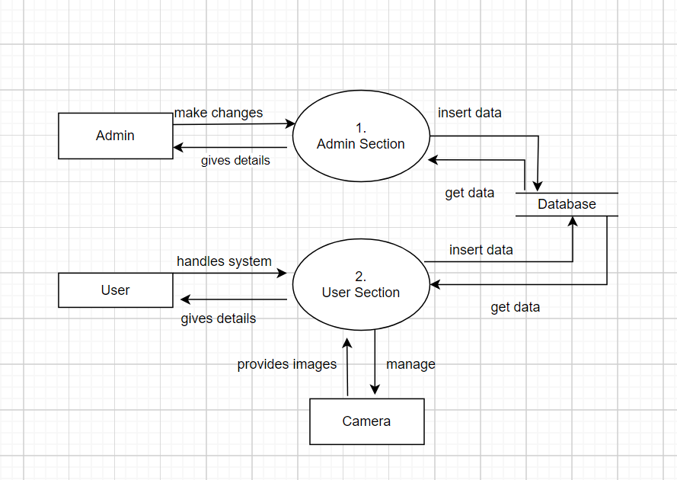

**Figure 7: DFD level 1 for Number Plate Detection System**

1. **Object modelling using Class Diagrams**

We used diagram to describesthe structure of a system by showing the system's classes, their attributes, operations (or methods), and the relationships among objects.There are three classes MyAccountManager, Account and ImageUpload. MyaAccountManager has four attributes FirstName, Lastname, Email and Password. It has two methods create_superuser and create_user. Similarly Account class has Firstname, Lastname, Email, Phone and Password attribute. It has five methods register, login, logout, forgotpassword and resetpassword.

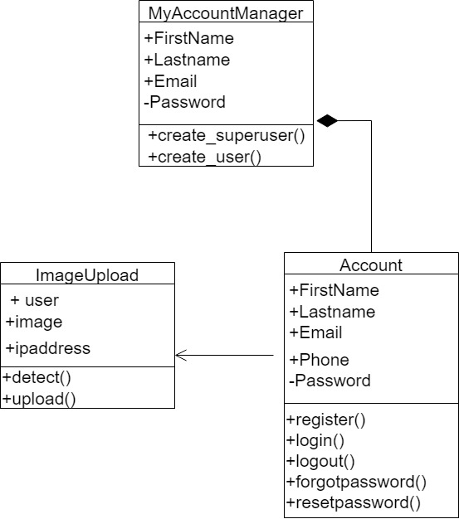

**Figure 8: Class diagram for Number Plate Detection System**

1. **Dynamic modelling using State and Sequence Diagrams**
2. **State Diagrams**

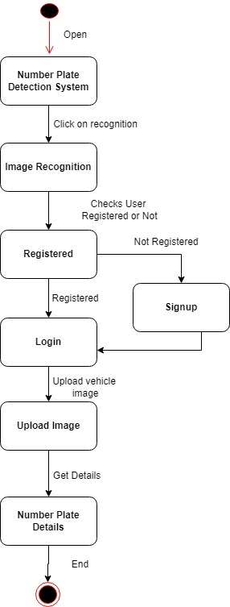

**Figure 9: State diagram for Number Plate Detection System**

We draw state diagram to represent the condition of the system. It’s a behavioral diagram and it represents the behavior using finite state transitions. There are several states. States are changed by certain transactions. Different states are image recognition, checking whether the user is registered or not, signing up user if not user is registered, login, upload image and getting number plate's details.

1. **Sequence Diagrams**

A sequence diagram is a type of interaction diagram because it describes how and in what order a group of objects works together. There are two objects Number plate detection system and database. There is also an end user who is an actor. They interact with a variety of tasks, such as requesting number plate recognition, NPDS check if the user is valid, registering the user, and so on. The activities are carried out in a specific order, as indicated by the sequence number.

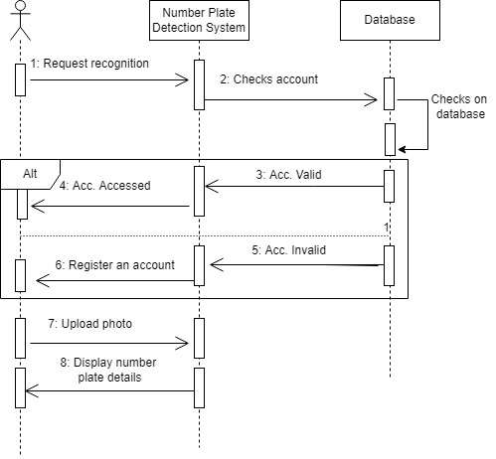

**Figure 10: Sequence diagram for Number Plate Detection System**

1. **Process modelling using Activity Diagrams**

We draw activity diagram to show behavioral of our system. An activity diagram portrays the control flow from a start point to a finish point showing the various decision paths that exist while the activity is being executed. There are different activities like opening a application, upload an image, image preprocessing, number plate localization, finding region of interest, character recognition and providing number plate details.

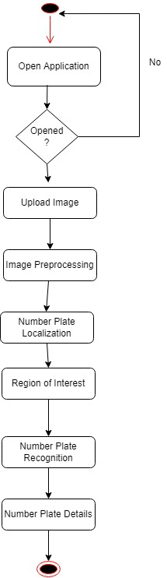

**Figure 11: Activity diagram for Number Plate Detection System**

# CONCLUSIONS

## Expected Outcome

The system is expected to provide an easy to use interface for users to identify the number plates and store it in the database.

## Refrence

|  |
| --- |
| [1] Kaggle |
| [2] Youtube ANPR |
|  |
|  |