EXPERIMENT No. 11
Name : Arya Manoj Madhavi
Class : D15B
Roll No.: 29

Aim : To use google Lighthouse PWA Analysis Tool to test the PWA functioning.

Theory :
Reference : https://www.semrush.com/blog/google-lighthouse/

Google Lighthouse :
Google Lighthouse is a tool that lets you audit your web application based on a number of
parameters including (but not limited to) performance, based on a number of metrics, mobile
compatibility, Progressive Web App (PWA) implementations, etc. All you have to do is run it on
a page or pass it a URL, sit back for a couple of minutes and get a very elaborate report, not
much short of one that a professional auditor would have compiled in about a week.
The best part is that you have to set up almost nothing to get started. Let’s begin by looking at
some of the top features and audit criteria used by Lighthouse.
Key Features and Audit Metrics
Google Lighthouse has the option of running the Audit for Desktop as well as mobile version of
your page(s).

The top metrics that will be measured in the Audit are:
1. Performance: This score is an aggregation of how the page fared in aspects such as (but
not limited to) loading speed, time taken for loading for basic frame(s), displaying
meaningful content to the user, etc. To a layman, this score is indicative of how decently
the site performs, with a score of 100 meaning that you figure in the 98th percentile, 50
meaning that you figure in the 75th percentile and so on.
2. PWA Score (Mobile): Thanks to the rise of Service Workers, app manifests, etc., a lot of
modern web applications are moving towards the PWA paradigm, where the objective is
to make the application behave as close as possible to native mobile applications. Scoring
points are based on the Baseline PWA checklist laid down by Google which includes
Service Worker implementation(s), viewport handling, offline functionality, performance
in script-disabled environments, etc.
3. Accessibility: As you might have guessed, this metric is a measure of how accessible
your website is, across a plethora of accessibility features that can be implemented in
your page (such as the ‘aria-’ attributes like aria-required, audio captions, button names,
etc.). Unlike the other metrics though, Accessibility metrics score on a pass/fail basis
i.e. if all possible elements of the page are not screen-reader friendly (HTML5
introduced features that would make pages easy to interpret for screen readers used by
visually challenged people like tag names, tags such as <section>, <article>, etc.), you
get a 0 on that score. The aggregate of these scores is your Accessibility metric score.
4. Best Practices: As any developer would know, there are a number of practices that have
been deemed ‘best’ based on empirical data. This metric is an aggregation of many such
points, including but not limited to:Use of HTTPS
Avoiding the use of deprecated code elements like tags, directives, libraries, etc.
Password input with paste-into disabled
Geo-Location and cookie usage alerts on load, etc.

Changes made to the code :
For theme color add a meta tag in index.html-
<meta name="theme-color" content="#4285f4">

For a maskable icon add "purpose": "any maskable" to the icons in manifest.json file
For apple touch icon add the following meta tag in index.html-

<link rel="apple-touch-icon" href="">

Changes in manifest.json
{
"name": "flower shop website",
"short_name": "flowers",
"start_url": "index.html",
"scope": "./",
"theme_color": "#ffd31d",
"background_color": "#333",
"display": "standalone",
"icons": [
{
"src": "icon-1.png",
"sizes": "192x192",
"type": "image/png"
“purpose”:"any maskable"
},
{
"src": "icon-2.png",
"sizes": "512x512",
"type": "image/png"
“purpose”:"any maskable"
}
]
}
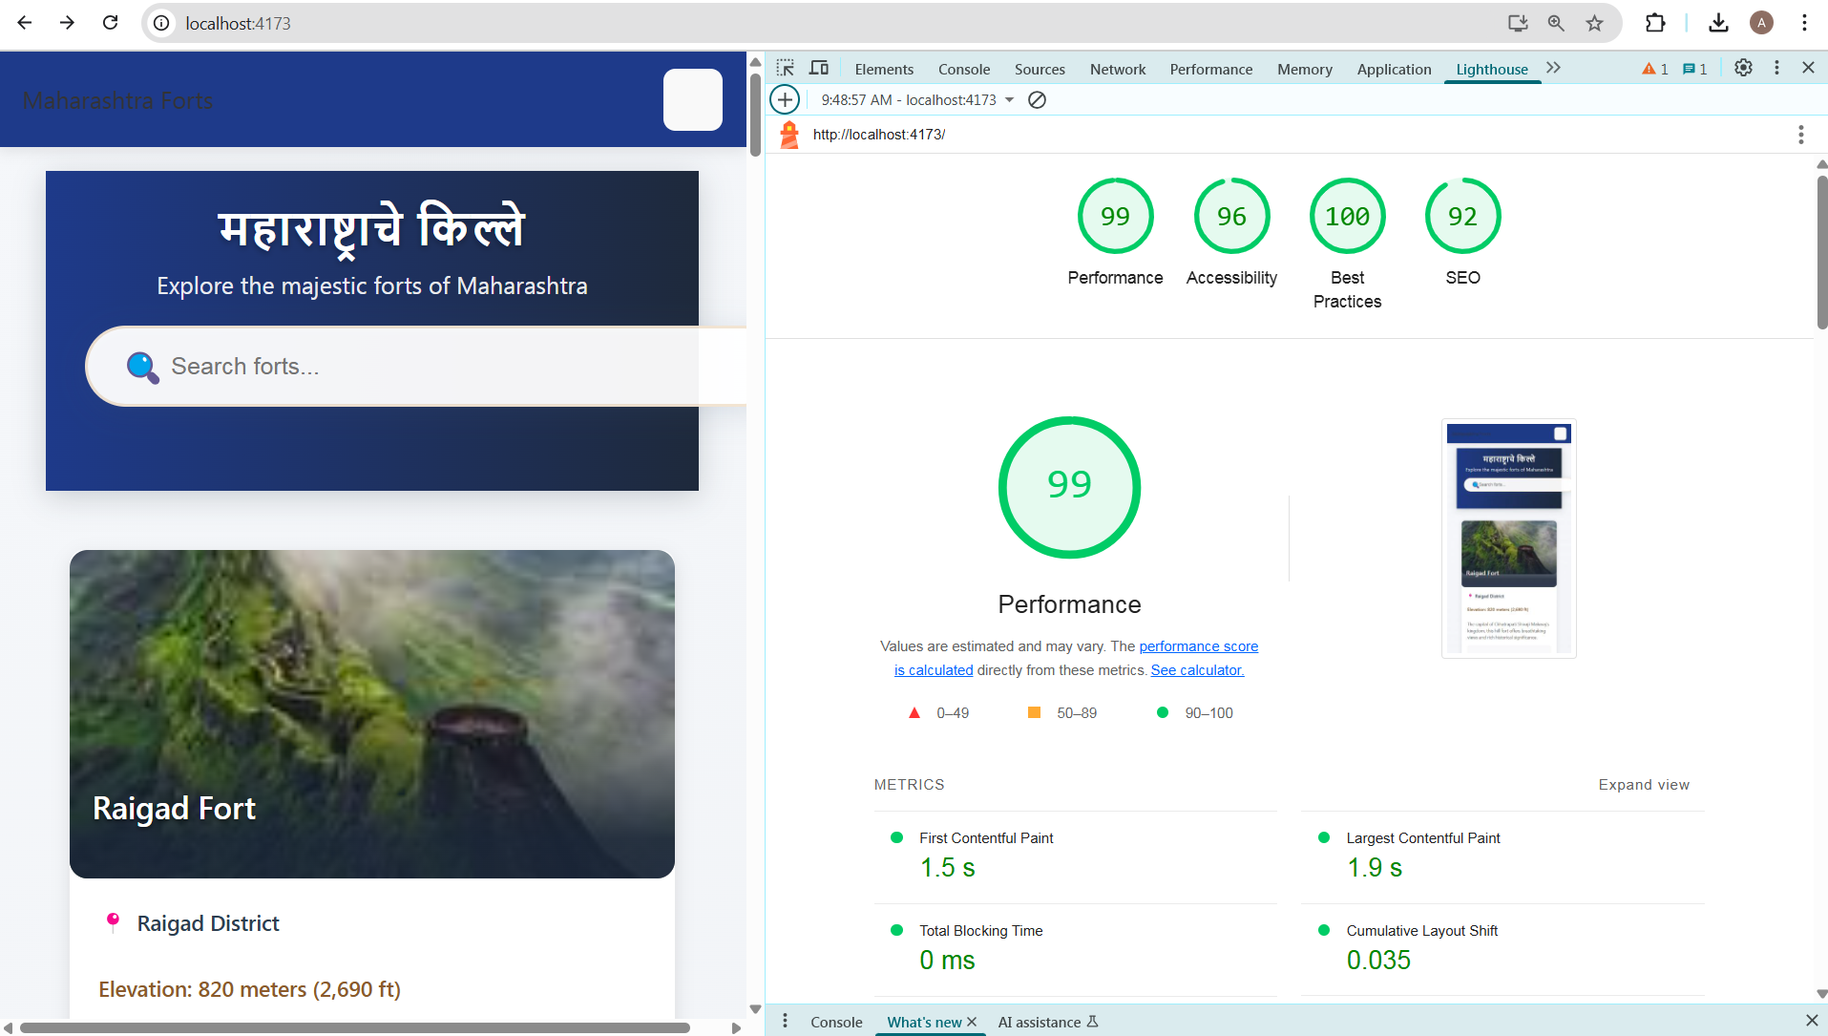

Conclusion:
Thus, we successfully used the Google Lighthouse PWA Analysis Tool to evaluate the performance and compliance of our Progressive Web App. The tool provided detailed insights into various parameters such as performance, accessibility, best practices, and PWA capabilities. It helped us identify strengths and areas for improvement. Overall, it proved to be an effective and user-friendly auditing solution for testing PWA functionality.

