EXPERIMENT No. 4
Name : Arya Manoj Madhavi
Class : D15B
Roll No.: 29

Aim : To create an interactive Form using form widget

Objective:
To understand the process of building interactive forms in Flutter using the Form widget. Forms are essential components of any application that involves user input, such as login screens, registration pages, and feedback forms. This experiment aims to explore how to efficiently create, validate, and manage form inputs to provide a seamless user experience.

Introduction:
Flutter, a powerful UI framework for building cross-platform applications, offers a comprehensive suite of widgets to create interactive user interfaces. One such essential widget is the Form widget, which enables developers to create and manage forms efficiently. By utilizing Form, TextFormField, and other related widgets, developers can easily handle user inputs, perform validations, and manage form states.
Creating interactive forms in Flutter is not just about capturing user data but also about enhancing the user experience through intuitive designs, real-time feedback, and efficient error handling. Properly designed forms contribute to higher user engagement and better data accuracy. This experiment will demonstrate how to implement an interactive form with input validation and state management in Flutter.

Theory:

Form Widget in Flutter:
The Form widget in Flutter acts as a container for form fields like TextFormField, DropdownButton, and more. It provides a convenient way to group input fields, manage their state, and perform validations. Forms in Flutter are typically used in conjunction with a GlobalKey to access form states, such as validating input fields or saving the form's data.
The Form widget offers the following key features:
- State Management: Using GlobalKey<FormState>, developers can manage the state of form fields, check for validation errors, and save the inputs.
- Validation: The Form widget supports custom validation logic, ensuring data accuracy and completeness before submission.
- Input Handling: It allows easy integration with various input fields, including text, numbers, dates, and dropdowns.

TextFormField in Flutter:
TextFormField is a commonly used input widget within a Form. It provides built-in features like:
- Input Decoration: Customizable labels, icons, and hints for better UX.
- Validation: Using the validator property, custom validation rules can be implemented.
- Keyboard Type: The keyboard layout can be adjusted (e.g., numeric, email, text) based on the input requirement.
- Controllers: TextEditingController manages the text entered, allowing for easy retrieval and manipulation of user inputs.

Form Validation:
Validating user input is crucial for maintaining data integrity and enhancing user experience. Flutter allows developers to:
- Implement custom validation logic using the validator property.
- Display error messages for invalid inputs.
- Use the FormState’s validate() method to check the form's validity before submission.

Form Submission:
Form submission is triggered after validating all inputs. Using FormState's save() method, developers can collect and process user data efficiently. This can involve sending data to a server, storing it locally, or performing other actions.

Steps:
- Set up Form Widget:
  - Create a Form widget and associate it with a GlobalKey<FormState> to manage the state of the form fields.
  - Wrap the form in a SingleChildScrollView to ensure it’s scrollable on smaller screens.
- Add Input Fields:
  - Use TextFormField widgets for text inputs such as Name, Email, and Password.
  - Customize input fields with labels, hints, and icons for better UX.
  - Use DropdownButtonFormField for selection inputs (e.g., Gender, Country).
- Implement Validation:
  - Add validation logic to each TextFormField using the validator property.
  - Display error messages for invalid inputs, such as empty fields or incorrect email formats.
  - Use FormState’s validate() method to ensure all fields are valid before submission.
- Submit Form Data:
  - Use ElevatedButton for the form submission button.
  - On pressing the submit button, validate all inputs.
  - If the form is valid, use FormState’s save() method to collect input data.
  - Display a success message or navigate to another screen upon successful submission.

Code:-
Signup page
// lib/screens/signup_screen.dart
import 'package:flutter/material.dart';
import 'package:shared_preferences/shared_preferences.dart';
class SignupScreen extends StatefulWidget {
@override
_SignupScreenState createState() => _SignupScreenState();
}
class _SignupScreenState extends State<SignupScreen> {
final TextEditingController nameController = TextEditingController();
final TextEditingController emailController = TextEditingController();
final TextEditingController passwordController = TextEditingController();
final _formKey = GlobalKey<FormState>();
bool isLoading = false;
Future<void> _signup() async {
if (_formKey.currentState!.validate()) {
setState(() {
isLoading = true;
});
try {
print("Starting signup...");
await Future.delayed(Duration(seconds: 2)); // Simulate network delay
// Save User Data Locally
SharedPreferences prefs = await SharedPreferences.getInstance();
await prefs.setString('userName', nameController.text);
await prefs.setString('userEmail', emailController.text);
print("Signup successful. Navigating to profile...");
setState(() {
isLoading = false;
});
// Navigate to Home Screen
Navigator.pushReplacementNamed(context, '/home');
} catch (e) {
setState(() {
isLoading = false;
});
print('Error: $e');
}
}
}
@override
Widget build(BuildContext context) {
return Scaffold(
backgroundColor: Colors.green[50],
body: Center(
child: SingleChildScrollView(
child: Padding(
padding: const EdgeInsets.all(16.0),
child: Form(
key: _formKey,
child: Card(
shape: RoundedRectangleBorder(
borderRadius: BorderRadius.circular(15.0),
),
elevation: 8,
child: Padding(
padding: const EdgeInsets.all(20.0),
child: Column(
crossAxisAlignment: CrossAxisAlignment.stretch,
children: [
Text(
'Sign Up',
style: TextStyle(
fontSize: 30,
fontWeight: FontWeight.bold,
color: Colors.green,
),
textAlign: TextAlign.center,
),
SizedBox(height: 20),
TextFormField(
controller: nameController,
decoration: InputDecoration(
labelText: 'Name',
border: OutlineInputBorder(),
prefixIcon: Icon(Icons.person),
),
validator: (value) {
if (value == null || value.isEmpty) {
return 'Please enter your name';
}
return null;
},
),
SizedBox(height: 15),
TextFormField(
controller: emailController,
decoration: InputDecoration(
labelText: 'Email',
border: OutlineInputBorder(),
prefixIcon: Icon(Icons.email),
),
keyboardType: TextInputType.emailAddress,
validator: (value) {
if (value == null || value.isEmpty) {
return 'Please enter your email';
}
if (!RegExp(r'^[^@]+@[^@]+\.[^@]+').hasMatch(value)) {
return 'Enter a valid email';
}
return null;
},
),
SizedBox(height: 15),
TextFormField(
controller: passwordController,
decoration: InputDecoration(
labelText: 'Password',
border: OutlineInputBorder(),
prefixIcon: Icon(Icons.lock),
),
obscureText: true,
validator: (value) {
if (value == null || value.isEmpty) {
return 'Please enter your password';
}
if (value.length < 6) {
return 'Password must be at least 6 characters';
}
return null;
},
),
SizedBox(height: 20),
isLoading
? Center(child: CircularProgressIndicator())
: ElevatedButton(
onPressed: _signup,
child: Text('Sign Up'),
style: ElevatedButton.styleFrom(
backgroundColor: Colors.green,
shape: RoundedRectangleBorder(
borderRadius: BorderRadius.circular(10),
),
padding: EdgeInsets.all(15),
),
),
TextButton(
onPressed: () {
Navigator.pushNamed(context, '/login');
},
child: Text('Already have an account? Login'),
),
],
),
),
),
),
),
),
),
);
}
}

Profile page
// lib/screens/profile_screen.dart
import 'package:flutter/material.dart';
import 'package:shared_preferences/shared_preferences.dart';
class ProfileScreen extends StatefulWidget {
@override
_ProfileScreenState createState() => _ProfileScreenState();
}
class _ProfileScreenState extends State<ProfileScreen> {
String userName = "User Name";
String userEmail = "user@example.com";

@override
void initState() {
super.initState();
_loadUserData();
}
Future<void> _loadUserData() async {
SharedPreferences prefs = await SharedPreferences.getInstance();
setState(() {
userName = prefs.getString('userName') ?? "User Name";
userEmail = prefs.getString('userEmail') ?? "user@example.com";
});
}
Future<void> _logout() async {
SharedPreferences prefs = await SharedPreferences.getInstance();
await prefs.clear();
Navigator.pushReplacementNamed(context, '/login');
}
@override
Widget build(BuildContext context) {
return Scaffold(
backgroundColor: Colors.blue[50],
body: Center(
child: Column(
mainAxisAlignment: MainAxisAlignment.center,
children: [
CircleAvatar(
radius: 50,
child: Icon(
Icons.person,
size: 50,
color: Colors.green[800],
),
),
SizedBox(height: 20),
Text(
userName,
style: TextStyle(fontSize: 24, fontWeight: FontWeight.bold),
),
SizedBox(height: 10),
Text(
userEmail,
style: TextStyle(fontSize: 16, color: Colors.grey),
),
SizedBox(height: 20),
ElevatedButton(
onPressed: _logout,
child: Text('Logout'),
style: ElevatedButton.styleFrom(
backgroundColor: Colors.redAccent,
shape: RoundedRectangleBorder(
borderRadius: BorderRadius.circular(10),
),
),
),
],
),
),
);
}
}

Output:
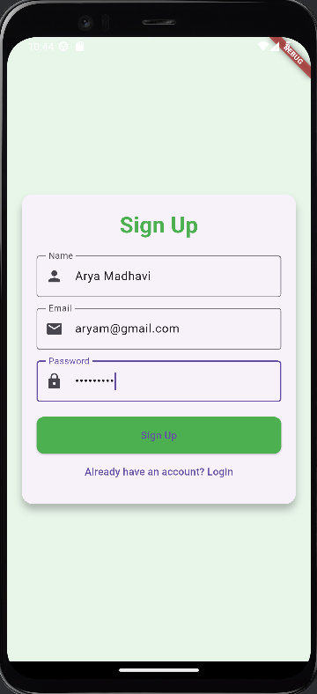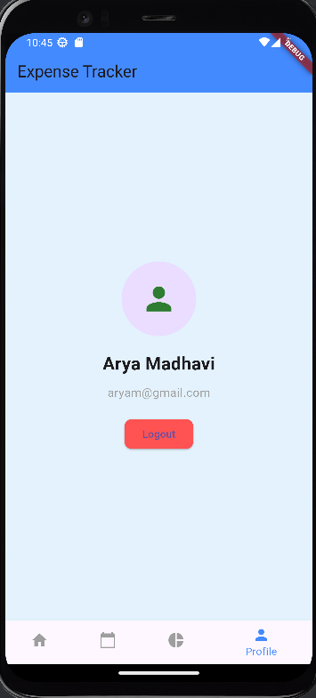

Conclusion:
Creating an interactive form using the Form widget in Flutter is crucial for capturing user input efficiently and enhancing the overall user experience. Proper implementation ensures data accuracy, smooth validation, and seamless state management. However, attention must be given to input handling, validation logic, and responsive design. Misconfigurations in the form’s state management or inadequate validation rules can lead to issues such as form submission errors or inconsistent user feedback. By following best practices and thoroughly testing on various devices, these issues can be minimized, resulting in a reliable, user-friendly form that enhances usability and engagement.

