EXPERIMENT No. 5
Name : Arya Manoj Madhavi
Class : D15B
Roll No.: 29

Aim : To apply navigation, routing and gestures in Flutter App

Objective:
To understand the process of applying navigation, routing, and gestures in a Flutter application. These elements are fundamental for creating interactive and user-friendly apps, enabling users to move between different screens, pages, or components seamlessly. This experiment aims to explore how to efficiently implement navigation, manage routes, and integrate gesture controls to enhance the overall user experience.

Introduction:
Flutter, a versatile UI framework for cross-platform application development, provides powerful tools for navigation, routing, and gesture recognition. Efficient navigation ensures smooth transitions between screens, improving usability and user engagement. Flutter’s Navigator widget and routing system offer various navigation techniques, including named routes, anonymous routes, and dynamic routing.
Gestures, on the other hand, enable users to interact with the app using taps, swipes, pinches, and other touch inputs. By leveraging Flutter’s GestureDetector widget and pre-built gesture widgets, developers can create intuitive and interactive user experiences. This experiment will demonstrate how to implement navigation, routing, and gestures effectively in a Flutter application.

Theory:

Navigation in Flutter:
Navigation in Flutter is handled using the Navigator widget, which manages a stack of route objects. Routes represent different screens or pages within the application. Flutter provides multiple ways to navigate between these routes:
- Anonymous Routes: Directly push and pop routes without naming them, suitable for simple navigation flows.
- Named Routes: Define routes with specific names in the MaterialApp widget, allowing for organized and maintainable navigation.
- Dynamic Routing: Utilize onGenerateRoute for flexible route management and advanced navigation scenarios.
Flutter’s navigation system supports various transitions, such as slide, fade, or custom animations, enhancing the user experience with smooth screen transitions.

Routing in Flutter:
Routing is the mechanism of mapping paths or URLs to specific screens. Flutter supports:
- Static Routing: Defined in the MaterialApp's routes property for fixed navigation paths.
- Dynamic Routing: Managed through onGenerateRoute or onUnknownRoute for more flexible routing scenarios, such as deep linking or dynamic URL handling.
Proper routing management ensures efficient navigation flow and improves app maintainability by keeping route definitions centralized and organized.

Gestures in Flutter:
Gestures are an essential aspect of interactive app design, enabling users to engage with the app through touch inputs. Flutter provides the GestureDetector widget to capture various gestures, including:
- Tap: Single or double taps for actions like button clicks.
- Swipe: Horizontal or vertical swipes for navigation or item dismissal.
- Long Press: Used for context menus or additional options.
- Pan and Drag: For draggable UI elements or custom animations.
Flutter also offers pre-built gesture widgets like InkWell and GestureDetector, which provide ripple effects and custom gesture handling, enhancing interactivity and user experience.

Steps:
- Set up Navigation:
  - Use MaterialApp as the root widget and define routes in the routes property.
  - Implement both named and anonymous routes for flexible navigation patterns.
  - Use Navigator.push() and Navigator.pop() for stack-based navigation.
  - Apply Navigator.pushReplacement() or Navigator.pushNamedAndRemoveUntil() for controlled navigation flows.
- Implement Routing:
  - Define static routes in MaterialApp for commonly used paths (e.g., Home, About, Contact).
  - Use onGenerateRoute for dynamic routing, supporting scenarios like passing parameters between screens.
  - Apply onUnknownRoute for custom 404 pages or error handling.
- Add Gestures:
  - Use GestureDetector for custom gesture recognition (e.g., tap, double-tap, swipe).
  - Implement InkWell for material ripple effects and standard touch interactions.
  - Add swipe gestures for navigation (e.g., swiping between screens or dismissing items).
  - Integrate advanced gestures like drag and drop for enhanced interactivity.
- Customize Navigation Transitions:
  - Implement custom page transitions using PageRouteBuilder.
  - Add animations like slide, fade, or scale for smooth navigation experiences.
  - Customize transition duration and curves for a polished UI effect.

Best Practices:
- Organize Routes: Centralize route definitions for maintainability and better code organization.
- Consistent Navigation Flow: Maintain a consistent navigation pattern for better usability.
- Accessibility Considerations: Ensure gestures are intuitive and accessible for all users.
- Testing on Multiple Devices: Verify navigation and gesture performance on various screen sizes and platforms.

Code:-
import 'package:flutter/material.dart';
import 'screens/auth/login_screen.dart';
import 'screens/auth/signup_screen.dart';
import 'screens/home_screen.dart';
import 'screens/add_expense_screen.dart';
import 'screens/add_income_screen.dart';
import 'screens/calendar_screen.dart';
import 'screens/statistics_screen.dart';
import 'screens/profile_screen.dart';

void main() {
runApp(ExpenseTrackerApp());
}

class ExpenseTrackerApp extends StatelessWidget {
@override
Widget build(BuildContext context) {
return MaterialApp(
title: 'Expense Tracker',
theme: ThemeData(primarySwatch: Colors.blue),
initialRoute: '/signup',
routes: {
'/login': (context) => LoginScreen(),
'/signup': (context) => SignupScreen(),
'/home': (context) => HomeScreen(),
// '/add-expense': (context) => AddExpenseScreen(),
// '/add-income': (context) => AddIncomeScreen(),
// '/calendar': (context) => CalendarScreen(),
// '/statistics': (context) => StatisticsScreen(),
'/profile': (context) => ProfileScreen(),
},
);
}
}

Navigation
Future<void> _logout() async {
SharedPreferences prefs = await SharedPreferences.getInstance();
await prefs.clear();
Navigator.pushReplacementNamed(context, '/login');
}

Gestures
import 'package:flutter/material.dart';
import 'package:flutter_calendar_carousel/flutter_calendar_carousel.dart'
show CalendarCarousel;
import 'package:intl/intl.dart';

class CalendarScreen extends StatefulWidget {
final List<Map<String, dynamic>> expenses;

CalendarScreen({required this.expenses});

@override
_CalendarScreenState createState() => _CalendarScreenState();
}

class _CalendarScreenState extends State<CalendarScreen> {
DateTime? _selectedDate;
List<Map<String, dynamic>> _selectedDateExpenses = [];

// Function to filter expenses for the selected date
void _filterExpensesByDate(DateTime date) {
setState(() {
_selectedDate = date;
String formattedDate = DateFormat('yyyy-MM-dd').format(date);
_selectedDateExpenses = widget.expenses.where((expense) {
return expense['date'] == formattedDate;
}).toList();
});
}

@override
Widget build(BuildContext context) {
return Scaffold(
appBar: AppBar(title: Text('Expense Calendar')),
body: Column(
children: [
CalendarCarousel(
onDayPressed: (date, events) {
_filterExpensesByDate(date);
},
weekendTextStyle: TextStyle(color: Colors.red),
thisMonthDayBorderColor: Colors.grey,
weekFormat: false,
height: 420.0,
selectedDateTime: _selectedDate,
daysHaveCircularBorder: false,
),
SizedBox(height: 10),
// Display expenses for the selected date with Scrollbar
Expanded(
child: Scrollbar(
thumbVisibility: true,
thickness: 8,
radius: Radius.circular(8),
child: _selectedDateExpenses.isNotEmpty
? ListView.builder(
itemCount: _selectedDateExpenses.length,
itemBuilder: (context, index) {
var expense = _selectedDateExpenses[index];
return Card(
color: Colors.pink[50],
child: ListTile(
title: Text(expense['category']),
subtitle: Text("Date: ${expense['date']}"),
trailing: Text(
"₹${expense['amount'].toStringAsFixed(2)}",
style: TextStyle(
color: Colors.redAccent,
fontWeight: FontWeight.bold),
),
),
);
},
)
: Center(
child: Text(
"No expenses for this date",
style: TextStyle(fontSize: 18, color: Colors.grey),
),
),
),
),
],
),
);
}
}

Output:
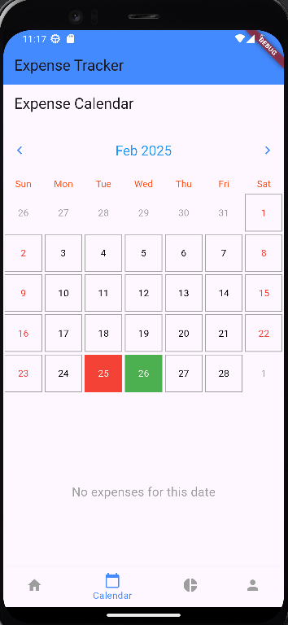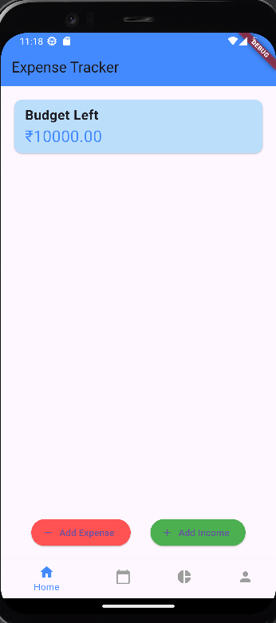

Conclusion:
Applying navigation, routing, and gestures in Flutter is crucial for building intuitive and interactive applications. Proper implementation ensures seamless user flow, organized route management, and engaging touch interactions. However, attention must be given to state management, route organization, and gesture handling to avoid issues like navigation loops, unexpected gestures, or inconsistent UI behavior. By following best practices and thorough testing, these challenges can be minimized, resulting in a smooth, user-friendly application with dynamic navigation and responsive gestures.

