EXPERIMENT No. 2
Name : Arya Manoj Madhavi
Class : D15B
Roll No.: 29

Aim : To Design Flutter UI by Including Common Widgets

Introduction:
Flutter is an open-source UI software development kit created by Google. It is primarily used to develop applications for Android, iOS, Linux, macOS, Windows, Google Fuchsia, and the web from a single codebase. Flutter's appeal lies in its ability to craft visually stunning user interfaces with smooth animations, coupled with the fact that it uses Dart as its programming language. In this experiment, the focus is on understanding how to design user interfaces by incorporating various common widgets available in Flutter.

Objective:
The aim of this experiment is to design and develop a user-friendly Flutter UI using common widgets such as containers, rows, columns, buttons, text fields, and other essential components. This helps in gaining a clear understanding of how to efficiently utilize these widgets to create interactive and responsive UIs.

Theory:
Flutter revolves around a widget tree, where everything is a widget, from the structural elements like containers and rows to the interactive components such as buttons and text fields. Widgets can be broadly categorized into two types: Stateful and Stateless widgets.
- Stateless Widgets: These widgets are immutable, meaning their properties cannot change during the runtime of the app. Common examples include Text, Icons, and Containers.
- Stateful Widgets: These widgets maintain state, meaning their properties can change dynamically during the app’s lifecycle. Examples include Checkbox, Switch, and Slider.
Some of the most commonly used widgets in Flutter include:
- Container: A flexible widget used for layout control, it can contain other widgets and control the padding, alignment, and size.
- Row and Column: These widgets are used for arranging child widgets in a horizontal (Row) or vertical (Column) direction.
- Text: This widget displays a string of text and can be customized with various properties like font size, style, and alignment.
- Buttons: Buttons like ElevatedButton, TextButton, and IconButton are used to handle user interactions.
- Image: Displays an image, which can be loaded from assets or the internet.
- TextField: Allows users to input text, a key component for forms.
By combining these widgets, developers can design UIs that are both aesthetic and functional. Flutter’s rich collection of pre-built widgets provides great flexibility in UI design, enabling developers to create complex interfaces with ease.

Code:
import 'package:flutter/material.dart';

void main() {
runApp(ExpenseTrackerApp());
}

class ExpenseTrackerApp extends StatelessWidget {
@override
Widget build(BuildContext context) {
return MaterialApp(
debugShowCheckedModeBanner: false,
home: HomePage(),
);
}
}

class HomePage extends StatelessWidget {
@override
Widget build(BuildContext context) {
return Scaffold(
appBar: AppBar(
title: Text("Expense Tracker"),
backgroundColor: Colors.brown,
),
body: Column(
children: [
// Budget Left Section
Container(
padding: EdgeInsets.all(16.0),
decoration: BoxDecoration(
color: Colors.brown.shade200,
borderRadius: BorderRadius.circular(10),
),
margin: EdgeInsets.all(16.0),
child: Column(
crossAxisAlignment: CrossAxisAlignment.start,
children: [
Text("Monthly Budget Left", style: TextStyle(fontSize: 18, fontWeight: FontWeight.bold)),
SizedBox(height: 8),
Text("₹25,000", style: TextStyle(fontSize: 22, fontWeight: FontWeight.bold, color: Colors.red)),
],
),
),

// Expense Sections
Expanded(
child: ListView(
padding: EdgeInsets.all(16.0),
children: [
TransactionItem("Food", "₹500", Colors.red),
TransactionItem("Transport", "₹150", Colors.blue),
TransactionItem("Shopping", "₹1200", Colors.purple),
TransactionItem("Entertainment", "₹800", Colors.orange),
],
),
),

// Buttons for Adding Expense & Income
Padding(
padding: const EdgeInsets.all(16.0),
child: Row(
mainAxisAlignment: MainAxisAlignment.spaceEvenly,
children: [
ElevatedButton(
onPressed: () {},
style: ElevatedButton.styleFrom(backgroundColor: Colors.red),
child: Text("Add Expense"),
),
ElevatedButton(
onPressed: () {},
style: ElevatedButton.styleFrom(backgroundColor: Colors.green),
child: Text("Add Income"),
),
],
),
),
],
),
);
}
}

class TransactionItem extends StatelessWidget {
final String category;
final String amount;
final Color color;

TransactionItem(this.category, this.amount, this.color);

@override
Widget build(BuildContext context) {
return Container(
margin: EdgeInsets.symmetric(vertical: 8.0),
padding: EdgeInsets.all(16.0),
decoration: BoxDecoration(
color: color.withOpacity(0.1),
borderRadius: BorderRadius.circular(10),
),
child: Row(
mainAxisAlignment: MainAxisAlignment.spaceBetween,
children: [
Text(category, style: TextStyle(fontSize: 16, fontWeight: FontWeight.bold)),
Text(amount, style: TextStyle(fontSize: 16, fontWeight: FontWeight.bold, color: Colors.red)),
],
),
);
}
}

OUTPUT:

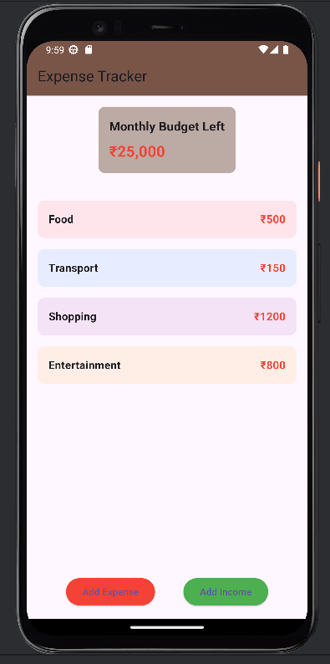

Conclusion:

Designing a Flutter UI involves an understanding of the different common widgets and how they can be organized within the widget tree. By using widgets like Container, Row, Column, Text, Buttons, and TextField, developers can create responsive, interactive, and visually appealing UIs. This experiment helps in mastering the fundamental components of Flutter UI design, providing the basis for building more complex user interfaces in future projects.

