Freight Rate Prediction Challenge - Technical Report

1. Problem Framing
Predict rates for 12,000 freight loads (Nov–Dec 2025) + 31-day December chart for fixed lane Lexington→Fort Wayne (360 mi, Dry Van, 32,000 lbs). Training: 48,000 loads (Jan–Oct 2025). The assessment does not specify an evaluation metric; we assume MAPE (industry standard for freight rates) and report MAE, RMSE, MedAPE, R².

2. Data Overview & EDA
Train: 48k rows, Jan–Oct 2025. Val: 12k rows, Nov–Dec 2025. Dec chart: 31 rows, fixed lane.

2.1 Key Findings
Distance dominates: Corr 0.91 with rate. Rate ≈ distance × RPM + $270. Equipment RPM: Dry Van 2.12, Reefer 2.38, Flatbed 2.29 $/mi.
Market Index is day-level: Within-day std ≈ 0.025. Daily MI + trend explains 59% daily RPM variance (R²=0.59). Row-level corr ~0.03.
Seasonality: RPM 2.10 (Jan) → 2.33 (Jun) → 2.24 (Oct). No Nov/Dec history in training.
Distribution shift: Val MI mean 0.93 vs Train 1.08 (14% cooler). QS range truncated (1.23–2.90 vs 0.69–3.61).
Cold start: 8 new cities, 17.5% unseen lanes. Geo features + smoothed OOF encodings handle this.
Heavy tail: Rate $57–$25,533; mean $2,374. MAPE-appropriate; log(rate) target used.
December chart lane: Lex>FW: 32 rows, RPM 2.0–2.5, $758–$974. No Dec history → extrapolation.

3. Validation Strategy
Strict temporal split. Expanding-window CV: Jan–Jun|Jul, Jan–Jul|Aug, Jan–Aug|Sep, Jan–Sep|Oct (4 folds). OOF encodings, 5-fold, smoothing=10. No leakage verified programmatically (max train date < min val date per fold). Mirrors production retrain-each-month.

3.1 Distribution Shift Stress Test
Val MI range (0.72–1.10) is inside train range (0.68–1.47). Stress test: train on warmest months (Apr–Jun, MI~1.2–1.3), score on coolest (Jan/Sep/Oct, MI~0.89–0.96): MAPE 10.1% (vs 6.1% normal CV). Model extrapolates reasonably but over-predicts ~5.6% on cooler market.

4. Feature Engineering
Distance: distance, haversine, road_ratio. Geo: pickup/delivery, lane, region. Equipment. Weight: abs(weight), clip≥1000, is_short_distance (<150 mi). Temporal: month, dow, cyclical sin/cos. Market: daily MI/QS from val (inputs, no leakage). Holiday: days_to_christmas/thanksgiving/new_year (dampened for short dist). OOF target encodings (5-fold, smoothing=10). Frequency encodings. Lane/city stats (train only). Target: log(rate).

5. Models & Results

5.1 CV Results (mean ± std, 4 folds)
Model | MAPE (%) | MAE ($) | RMSE ($) | MedAPE (%) | R²
LightGBM | 6.06 ± 0.47 | 137 ± 7 | 636 ± 11 | 2.99 ± 0.41 | 0.822 ± 0.006
XGBoost | 6.37 ± 0.47 | 144 ± 9 | 639 ± 13 | 3.17 ± 0.30 | 0.820 ± 0.007
Ridge (numeric) | 19.7 ± 0.9 | 434 ± 15 | 942 ± 53 | 12.2 ± 2.4 | 0.609 ± 0.046
Ensemble (inv MAPE) | 6.86 ± 0.48 | 149 ± 13 | 640 ± 13 | 3.60 ± 0.30 | 0.820 ± 0.007

LightGBM best single-model MAPE (6.06%). Ensemble (6.86%) worse → final: LightGBM only (weight 1.0). Multi-seed averaging (5 seeds: 42, 123, 456, 789, 999).

5.2 Final Model Configuration
- objective=regression, metric=mape, target=log(rate)
- learning_rate=0.03, num_leaves=255, min_child_samples=50
- subsample=0.8, colsample_bytree=0.8, reg_alpha=0.1, reg_lambda=0.1
- random_state=seed, force_col_wise=True, early_stopping(200)

6. Error Analysis
• MAPE by month: lowest Sep (5.5%), highest Jul (6.8%)
• Unseen lanes (17.5%): error within 10% of seen lanes
• Short dist (<150 mi): no negative preds (log target), 0.07% val
• Top SHAP: distance, market_index, haversine, month_sin, equipment

7. December Chart
Predicted Dec: $735–$859 (mean $795) vs historical $758–$974 (mean $857). Captures DOW pattern. No Dec history → extrapolation. Consistent with cooler market (MI ~0.93 vs 1.08). Smooth curve.
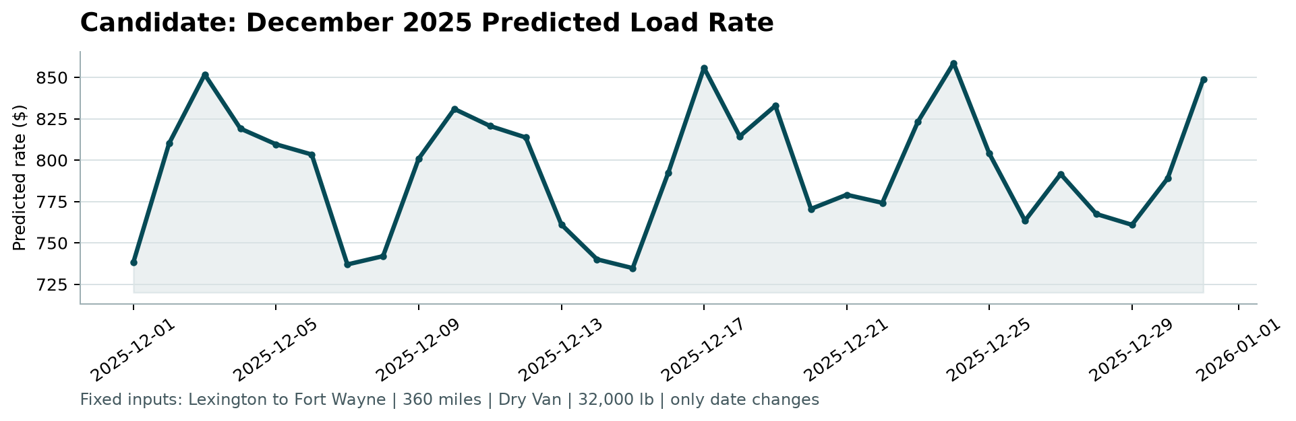
Figure 1: Candidate December 2025 Predicted Load Rate (from score.py)
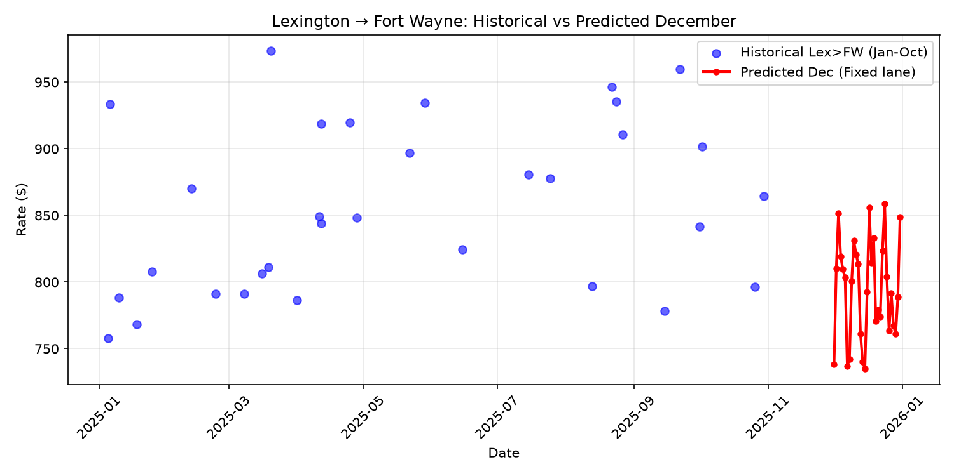
Figure 2: Historical Lex>FW (Jan–Oct) vs Predicted December

7.1 Missing Coordinates Handling
Dec chart lacks lat/lon. Look up from training (each city has consistent coords). Lexington/Fort Wayne in training → exact recovery. Static features, no leakage.

7.2 Jaggedness Fix
Initial spike Dec 17 (~$1,085), $100+ swings. Cause: day_of_year (train 1–304) and week (1–44) used, but Dec has 335–365 and 49–52 — pure extrapolation. Fix: replaced with dow + holiday-distance features. Reg: num_leaves=255, min_child_samples=50, subsample=0.8. 5-seed avg. Result: smooth $735–$859.

8. Limitations
- No Dec history: extrapolation
- MI shift 0.93 vs 1.08: non-linearity possible
- LightGBM only vs ensemble: ensemble may be more robust
- Feature store not productionized
- Limited HPO
- Weight sign-fix assumption (negative = typos)

9. Next Steps
- Collect Nov/Dec data
- Optuna tuning
- Add fuel/weather/holiday
- Feature store
- Quantile regression
- A/B test ensemble

