Sahayog AI
Technical Documentation
Empowering Citizens Through Accessible Government Services

Team: aryamangarg2005
Hackathon MVP Submission · 2026

1. Overview
Sahayog AI is an AI-powered, multilingual citizen assistance platform that helps users discover government welfare schemes, verify eligibility, understand benefits, and receive step-by-step application guidance through a simple conversational interface. The platform allows users to communicate via text or voice in their preferred language.
By analyzing user information such as age, occupation, income, location, and category, Sahayog AI recommends relevant schemes and simplifies the entire process of accessing government services — a process that today requires navigating dozens of fragmented portals and dense eligibility rules.

2. Problem Statement
Millions of eligible citizens across India miss out on government schemes and welfare benefits due to a lack of awareness, language barriers, digital illiteracy, and fragmented information sources. Navigating multiple government portals and understanding complex eligibility requirements can be challenging, particularly for rural and underserved communities.

3. Proposed Solution
Sahayog AI addresses this gap with a conversational, multilingual assistant that takes a citizen's basic profile and instantly surfaces every scheme they qualify for, explains the benefit in plain language, lists the exact documents required, and walks them through how to apply — removing the need to know which scheme to search for in the first place.

Core capabilities
- Eligibility matching across central and state welfare schemes based on age, occupation, income, location, and gender
- Conversational assistant for natural-language Q&A about matched schemes
- Multilingual and voice-ready architecture (text/voice in the user's preferred language)
- Transparent match scoring with plain-language reasons for every recommendation
- Document checklists and application guidance per scheme

4. System Architecture
The system follows a clean three-tier architecture: a React frontend, a FastAPI backend exposing REST endpoints, and a rule-based eligibility engine backed by a structured scheme database. See the architecture diagram (system_architecture.png) included in this submission for the full data flow.
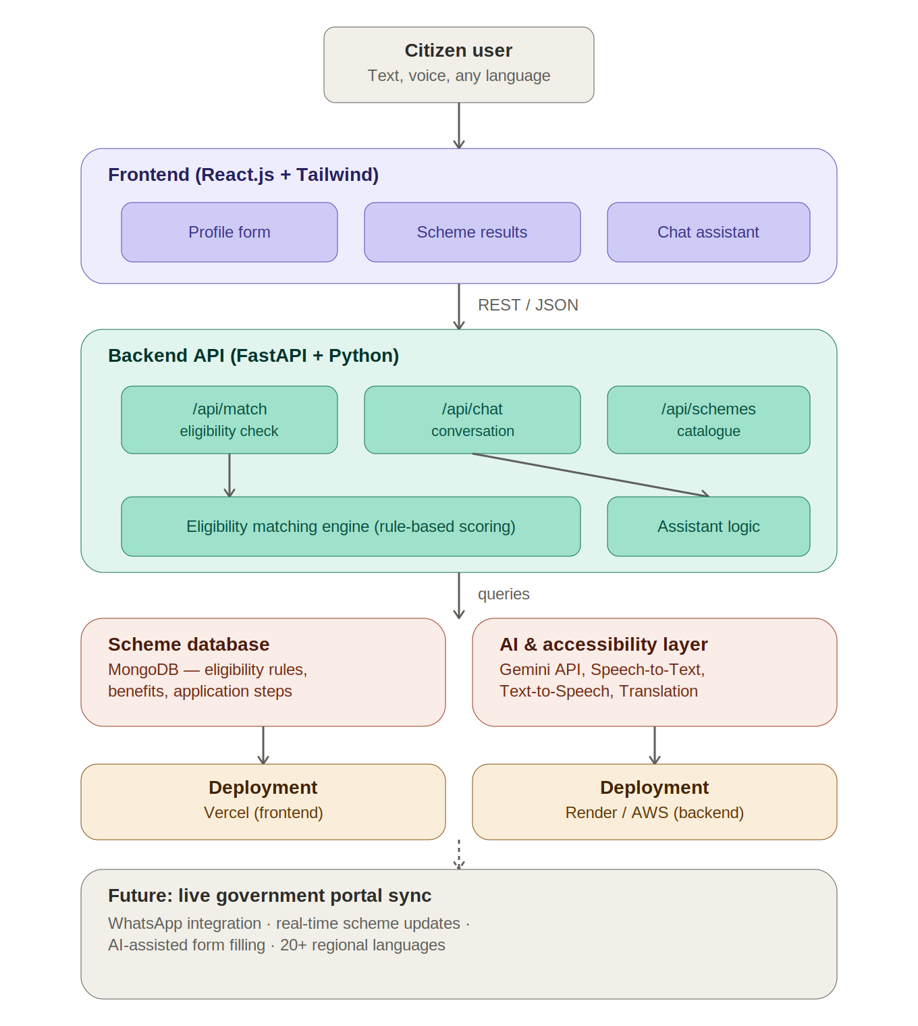

5. Technology Stack
Layer | Technologies
Frontend | React.js, Tailwind CSS (design tokens), Vite
Backend | Python, FastAPI, Pydantic
Database | MongoDB (production) — structured JSON in MVP
AI Layer | Gemini API, NLP-based intent matching
Accessibility | Speech-to-Text, Text-to-Speech, Translation APIs
Deployment | Vercel (frontend), Render / AWS (backend)

6. Backend API Reference

GET /api/health
Returns service health status. Used for uptime checks.

GET /api/schemes/
Returns the full catalogue of government schemes in the system, including eligibility rules, benefits, and application instructions.

GET /api/schemes/{scheme_id}
Returns full details for a single scheme by its ID (e.g. pmkisan, ayushman_bharat).

POST /api/match/
Accepts a citizen profile and returns ranked, explained scheme matches.
Request body:
- age (integer, 0–120)
- occupation (string — e.g. farmer, student, self-employed, unemployed)
- annual_income (integer, INR)
- location_type (string — rural or urban)
- gender (string, optional)
- state (string, optional)
Response: a ranked list of matched schemes, each with a match_score (0–100) and a list of plain-language reasons explaining the match.

POST /api/chat/
Conversational endpoint. Accepts a free-text message plus optional profile fields, and returns an assistant reply grounded in the citizen's matched schemes. When a GEMINI_API_KEY environment variable is set, replies are generated by the Gemini API; otherwise the MVP falls back to a rule-based response generator so the demo works fully offline.

7. Eligibility Matching Engine
The matching engine (app/data/matcher.py) scores each scheme against the citizen's profile using a transparent, weighted rule system: occupation match (40 points), age range (20 points), income ceiling (25 points), gender criteria where applicable (10 points), and location type (5 points). A scheme is excluded entirely if any hard eligibility criterion fails (e.g. occupation, age range, or income ceiling), ensuring users are never shown schemes they cannot actually apply for.
This rule-based design was a deliberate MVP choice: it is fully explainable, requires no external API calls, and works completely offline for demo purposes — while the conversational layer (app/data/assistant.py) is built with a clear integration point for the Gemini API to add natural-language understanding on top of these structured results.

8. Expected Impact
- Increase awareness of welfare programs among underserved populations
- Simplify access to government services through a single conversational entry point
- Reduce misinformation and confusion regarding eligibility criteria
- Promote digital inclusion through multilingual and voice-enabled support
- Empower citizens to make informed decisions about available opportunities and benefits

9. Project Roadmap

Phase 1 — Data Collection
- Compile government schemes and eligibility criteria
- Structure and categorize scheme information

Phase 2 — Core Development
- Build user registration and profile system
- Develop eligibility matching engine

Phase 3 — AI Integration
- Implement conversational AI assistant
- Generate personalized recommendations

Phase 4 — Accessibility Features
- Add voice interaction and multilingual support
- Optimize for mobile devices and low-bandwidth networks

Phase 5 — Testing & Deployment
- Conduct user testing
- Improve recommendation accuracy
- Deploy MVP for public use

10. Future Scope
- WhatsApp integration for zero-app access
- Real-time sync with government portals
- AI-powered form-filling assistance
- Regional language expansion across India (20+ languages)

11. Local Setup Instructions

Backend
- cd backend
- pip install -r requirements.txt --break-system-packages
- uvicorn app.main:app --reload --port 8000
- API docs available at http://localhost:8000/docs

Frontend
- cd frontend
- npm install
- npm run dev
- App available at http://localhost:5173

12. Team
Team name: aryamangarg2005
Built for the Sahayog AI Hackathon submission.

