**Assignment**

Accessing of nuclear project from package of America into package of india using access modifiers.

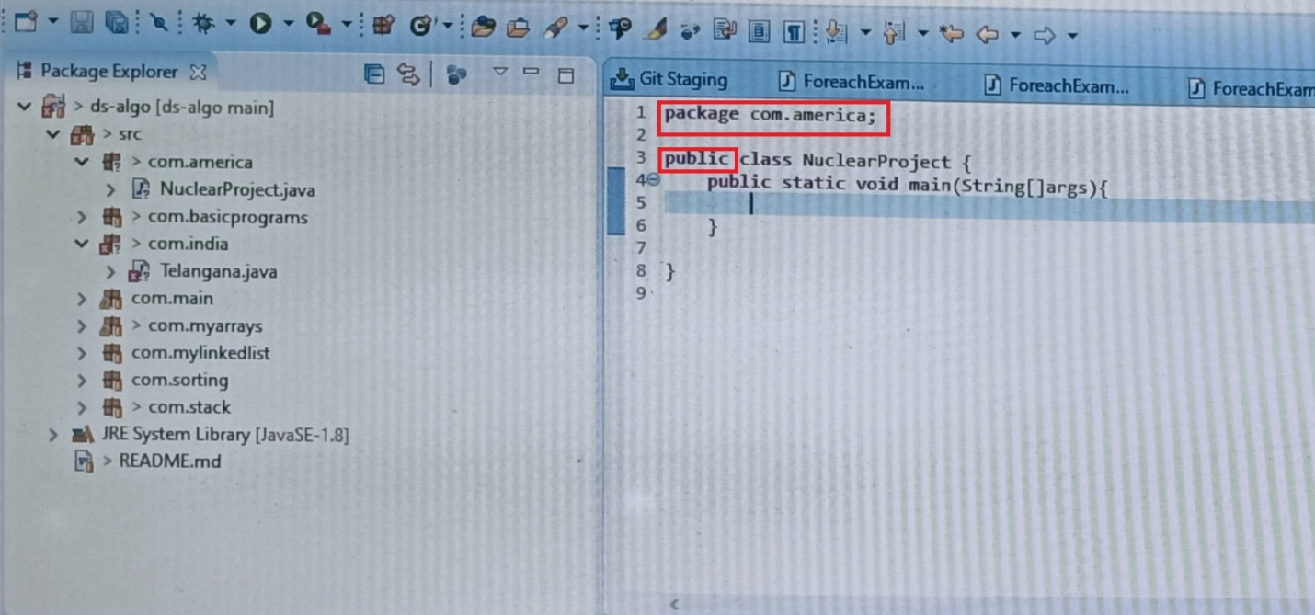

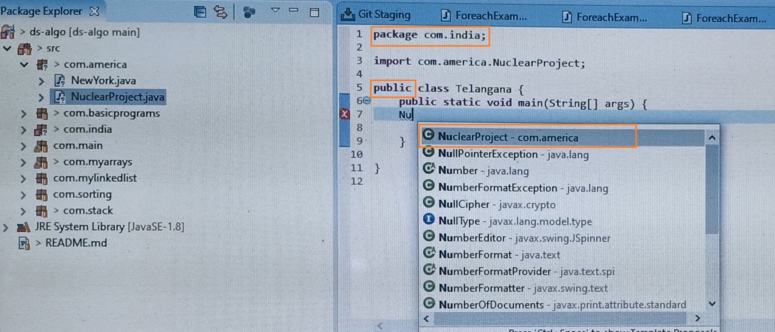

We can see that ,we can access the nuclear project from different package because of using public access modifier .