GitShield AI
An Intelligent Machine Learning Framework for Predicting Repository Health, Growth, Sustainability and Security Risk in Open Source Software
Consolidated Project Report: Digital Assignments 1, 2 and 3 (DA1–DA3)
Part I (DA1): Dataset Understanding, Data Cleaning, Feature Engineering and Exploratory Data Analysis
Part II (DA2): Repository Risk Classification, Model Development, Database Connectivity and Comparative Analysis
Part III (DA3): Final Evaluation, Statistical Analysis, Validity Audit and Interactive Dashboard
Submitted by: -
Name: - Aryaman Kumar Singh
Reg. No. : - 24BDS1141
Course: Programming for Data Science, VIT Chennai
Final submission: 16 October 2026

Abstract
Repositories for open-source code on GitHub constitute one of the largest, fastest-growing datasets of software artefacts available for empirical analysis. The problem lies in distinguishing repositories that are healthy, sustainable and safe: star counts are a common proxy, but they show popularity, not quality. GitShield AI is a machine learning framework that derives health, growth, sustainability and security-exposure indicators from repository metadata and classifies repositories into Low, Medium and High risk. This consolidated report documents the complete project in three parts: DA1 (data preparation and exploration), DA2 (model development and comparative analysis) and DA3 (final evaluation, statistical analysis, validity audit and an interactive dashboard).
In DA1, a subset of 80,489 repositories from the Kaggle GitHub Repository Metadata dataset was cleaned and explored, and sixteen features describing popularity, activity, community involvement, maintenance, growth, stability, security exposure and overall risk were engineered. Twenty-four exploratory visualisations showed highly right-skewed popularity metrics that are only weakly related to repository age, and forks and stars that move together almost one-for-one. In DA2, the data were stored in SQLite and retrieved with SQL; a three-class risk target was derived from the heuristic risk score; mutual-information selection kept 20 of 39 features; and twelve classifiers (five of them tuned) were compared on a stratified 80:20 split.
In DA3, all 17 models were re-fitted and evaluated on the same 16,098-repository held-out test set. The MLP Neural Network was best (accuracy 0.9504 (95% CI 0.9473–0.9538); macro-F1 0.9504 (95% CI 0.9472–0.9538); macro ROC-AUC 0.9879 (95% CI 0.9868–0.9892)). Bootstrap confidence intervals and paired McNemar tests with Holm correction show that it is significantly and practically better than the next model family (HistGradientBoosting), but not distinguishable from its own tuned variant; five-fold cross-validation on the training split agrees. Error, feature-importance and leakage analyses were added, and an interactive R Shiny + Plotly dashboard was built on exported results.
A validity audit qualifies these results. The risk label is an exact closed-form function of repository columns that are also model inputs (maximum reconstruction error 2.2e-16 over all 80,489 repositories), so the high scores show that the heuristic is learnable by machine learning, not that real-world repository risk or vulnerability is predicted. With every formula input removed, accuracy falls to about 0.57–0.59. GitShield AI is therefore presented as a transparent metadata-analytics framework, not a validated vulnerability scanner.

Structure of this report
Part | Chapters | Content
Part I – DA1 | Chapters 1–11 | Problem statement, objectives, dataset, literature review, feature description, preprocessing, feature engineering, exploratory data analysis (24 figures)
Part II – DA2 | Chapters 12–21 | SQLite connectivity, modelling features, feature selection, target creation, 12 classifiers, hyper-parameter tuning, comparative metrics and visualisations
Part III – DA3 | Chapters 22–30 | Reproducible final evaluation, statistical analysis, error and importance analysis, leakage audit, interactive dashboard, consolidated discussion
Consolidated closing | Chapters 31–34, Appendix A | Conclusion, limitations, future scope, references, reproducibility instructions covering all three parts

Reading note. Parts I and II are the DA1 and DA2 submissions, retained in full. Where the DA3 analysis showed that a DA2 statement needed correction or qualification, the original wording was amended in place and the change is listed in Chapter 30. Figures are numbered consecutively across all parts (Figures 1–37 from DA1/DA2, Figures 38 onwards from DA3).
PART I — PROJECT PROPOSAL AND DATA PREPARATION (DA1)

1. Introduction
Open source software is software that has its source code available to be studied, used, modified, and redistributed by anyone. Within the last two decades, this type of software development culture has evolved from an alternate approach to one of the key pillars in contemporary computing. Open source components are present in operating systems, cloud systems, mobile applications and enterprise software. GitHub is where the majority of open source activity takes place. It is rich with tens of millions of repositories and social features such as starring, forking, watching and issue tracking that enable developers to express their appreciation and collaborate.
Since GitHub tracks all the actions taken on a repository, it is a great source of information for repository analytics. Repository analytics is a part of software engineering research that extracts valuable signals from the repository metadata in order to assess the project’s current status. It falls under software engineering analytics, which uses data-driven methods to answer questions previously answered by manual inspection, such as the maintenance status of the project, its growth rate and vulnerability to abandonment/security threats.
The problem of repository health prediction applies to more than one stakeholder group. Businesses that rely on open-source parts should be aware of whether a particular library is actively maintained before deploying it. Developers choosing a project to commit themselves to are interested in knowing whether it will even be alive a year later. Project maintainers may see repository health metrics as a way to detect the onset of burnout and decline in community engagement. GitShield AI was developed to answer these challenges. Health, growth, sustainability, and vulnerability have been treated as measurable and predictable phenomena in this study.

2. Problem Statement
It is actually quite difficult to select a trustworthy open source repository. A developer considering using a particular library or an organization considering what software to incorporate into its production line will have very little information available about a repository. The most important and the most evident piece of information is the number of stars a repository has earned. Stars are easily readable and easily comparable, which is precisely the reason why they tend to dominate developers' decision-making process. At the same time, stars are the measure of popularity of a repository but not its condition.
Stars alone may be highly misleading for many reasons. Two repositories with equal number of stars will differ substantially by their update frequency, issues resolution speed, size of contributors' community and presence of fundamental elements such as a license or a code of conduct. None of that can be reflected in a star count. An archived repository or a repository which is plagued with issues or has not seen a single commit in the last year cannot be a good choice.
This is the challenge which GitShield AI seeks to overcome. Instead of using popularity as an indication of quality, GitShield builds indices using activity, maintenance, community and governance indicators, thereby creating separate measures of health, growth, sustainability and exposure to security risks. In other words, the repositories that people choose nowadays are popular instead of being backed by data, and choosing one needs a more detailed analysis.

3. Objectives

3.1 Primary and Secondary Objectives
The primary objective of the GitShield AI project is to design, and ultimately train, a machine learning framework which predicts four indices at the repository level using GitHub metadata: the Repository Health Index, the Repository Growth Index, the Repository Sustainability Index and the Repository Security Exposure Index. DA1 has a more focused objective. It involves gaining understanding of a suitable dataset, cleansing it, engineering the features on which the indices are dependent, profiling the dataset well through exploratory analysis so that development of the model in DA2 can be started from a sound footing. There are secondary objectives which aid in the achievement of the main objective. Each step in the process, from reading the raw metadata to creating the cleaned dataset, needs to be replicable and verifiable. The problems like missing values have to be quantified so that future modelling decisions can be made based on the strengths and weaknesses of the dataset. Raw attributes of the repository have to be transformed into composite scores rather than making the model base its conclusions on raw counts. A maintenance score or security exposure score is easier for a layman to comprehend than the simple number of commits.

3.2 Expected Outcome and Future Implementation
By the completion of DA1, the anticipated output would be a cleaned and feature-engineered dataset containing 80,489 repositories, a descriptive statistics report and twenty-four exploratory plots. These outputs would provide insight on what features have information in them, and which have enough skewness to warrant transformation. They are directly inputted into DA2, where these engineered features would then act as the input variables for a series of supervised machine learning models. Based on the labelling strategy that would be decided upon during modelling, these features would either act as the target variable to predict or a baseline feature.

4. Dataset Identification and Justification

4.1 Dataset Name and Source
Data will be collected using the GitHub Repository Metadata dataset on Kaggle (Kaggle, n.d.), accessible at https://www.kaggle.com/datasets/pelmers/github-repository-metadata-with-5-stars. This dataset contains metadata of publicly available GitHub repositories which have five or more stars. The features include information related to ownership, number of stars and forks, number of watchers, languages and topics, disk usage, number of pull requests and issues, licensing, creation date, last push date, commits, code of conduct, and visibility and archival information.

4.2 Dataset Description and Selection Rationale
The raw data file contains metadata for about 4.25 million repositories, which is too many to work with directly. Therefore, an 80,489-repository sample using stratification and a reservoir sample design was selected from among the repositories. This includes all repositories with 5,000 or more stars, along with a reservoir of repositories with fewer stars.
This sample aligns well with the four indices that the GitShield AI is designed to predict:
- Popularity and community interaction can be estimated based on stars, forks, and watchers.
- Activity and maintenance can be estimated based on commits, pull requests, issues, and freshness of the updates.
- Sustainability can be estimated based on repository age and archiving status.
- Security risk can be estimated based on license and code of conduct presence, as well as staleness metrics.

4.3 Advantages and Limitations
The key features of this dataset are the large number of records, the multiple programming languages, and the governance attributes (license and code of conduct presence). Smaller GitHub datasets lack these features; however, these are important for the security exposure part of this project.
These are not the only drawbacks of the dataset. Since the dataset comprises only the repositories with five or more stars, it will contain very few (if any) of those which have just appeared recently. The data is only a snapshot at one point in time and does not contain the commits history. Moreover, there is no vulnerability scan and CVE data included in the dataset. Therefore, any security scores that would be obtained using it will be governance-based heuristics, not the actual security measures.

5. Literature Review
The analysis of repository data from GitHub has long been the subject of scholarly investigation, starting the moment that data became available. For the purposes of this project, five papers were selected, all of which employed a unique methodology in collecting, analyzing, or predicting GitHub data.

5.1 Data Quality in Mining GitHub
One of the most cited empirical studies of the dangers of using mining GitHub data is Kalliamvakou et al. (2016). Mining from a large corpus of repositories, the researchers revealed that a significant number of repositories were personal projects or inactive repositories or repositories for which collaboration on software development was not a primary purpose. The second point noted by the researchers is that a significant number of code change merges do not happen via pull requests. The important finding of the researchers is that a GitHub repository is not automatically an active software project. DA1 relies heavily on this study.

5.2 Methodological Rigour in Repository Mining
As noted in Vidoni (2022), the analysis of studies on mining software repositories was performed as a collection of works, not as one particular dataset. In the systematic literature review, it was revealed that many studies that have been published lack proper description of their repository selection process and data extraction approach to be reproduced. In fact, there is a template suggested for making future research more reproducible. All of this defined the structure of the current report. Stratified sampling approach, the method of handling missing values in each column, as well as encoding were all recorded for reproducibility purposes.

5.3 Predicting Project Lifespan through Network Centrality
The paper by He et al. (2024) addressed the issue of when an open-source repository would be deprecated. Rather than only considering the static point in time metrics, the authors introduced repository centrality, a metric calculated using the HITS weighting in the star relationship network. The metric was incorporated into the survival analysis model developed using over one hundred thousand GitHub repositories collected over more than a decade. Lower centrality was linked with the increased risk of being deprecated and lower lifespan expectancy. It is relevant to the sustainability aspect of GitShield AI. Time-based popularity signals are more indicative than the count of popularity once, something to keep in mind during future phases.

5.4 Predicting Popularity
Borges et al. (2016) were interested in predicting the number of stars a project will get, and employed multiple linear regression analysis based on historical star counts. Significantly higher prediction accuracy was achieved only when there was at least six months of star history available, and projects with similar star patterns benefitted from separate modelling. Regarding GitShield AI, this work is largely a lesson. Popularity is well-predicted as a specific measure, which supports the viewpoint presented in the problem statement that popularity should not be confused with health, sustainability, or security.

5.5 Mixed Methods and Replication
The paper by Chen et al. (2019) is a repetition of the earlier work in which the authors investigated the determinants behind the acceptance of a GitHub pull request. By combining crowd-sourced qualitative assessments and quantitative features of a bigger dataset, they constructed a much better predictor than the previous one, which was based on the set of qualitative factors. GitShiled AI goes along the same line. From the qualitative assessments of what constitutes healthy code repository (e.g., the availability of license and issues handling), GitShield constructs quantitative scores.

5.6 Research Gap
Overall, the evolution in these five articles is very clear. Studies started from asking whether the GitHub data can be trusted, progressed to methodology, and are now building predictors for very specific outcomes like stars' growth, pull requests' acceptance, or risks of deprecation. None of these research papers uses multiple dimensions of the state of a repository in one approach and none provides its results in the form of a composite score as opposed to a black box predictor. This is the gap that this paper is going to fill. GitShield AI combines methodological approaches of Kalliamvakou et al. (2016), Vidoni (2022) and the ideas of prediction from He et al. (2024), Borges et al. (2016) and Chen et al. (2019).

6. Dataset Understanding
The input data for DA1 was constructed using the loading of the raw metadata data into R, followed by the conversion to a ready-for-analysis CSV file called github_dataset.csv, as well as analyzing the structure of the data prior to any cleaning. This dataset consists of 80,489 repositories with 23 raw columns, and uses about 38.01 MB of RAM to load. No duplicate rows were found since they should not be present, considering the sampling strategy.
The 23 raw columns can be grouped into five main categories:
- Identity: owner, name and name_with_owner represent identity and name of repository.
- Fame and engagement: stars, forks, watchers and topic_count.
- Activity and size: commits, pull_requests, issues, disk_usage_kb and language_count.
- Governance and state: license, code_of_conduct, is_fork, is_archived, visibility and forking_allowed.
- Time-related: created_at and pushed_at, which were converted into Date during preprocessing to calculate age and recency of repository.
The majority of the columns are numeric, while some others are categorical or boolean. The only unstructured column is the description column. This is also the only column containing missing values even after data cleaning, as it would not make sense to fill a missing description.
In general, the quality of the data was satisfactory once we took care of the expected missingness in a couple of optional columns. Impossible values, for instance negative counts or inconsistent fork counts with respect to star counts, were not present. Also, the sampling process took care of a broad range of sizes, age and popularity of repositories.

7. Feature Description
Table 1 provides an overview of the selected raw and engineered features in this project, along with their data types, descriptions, importance to the objectives of GitShield AI, and any transformation if any made during preprocessing.
Feature | Datatype | Description | Importance | Transformation
stars | Integer | Number of users who starred the repository | Primary popularity signal | None (used directly and log-transformed for pair plot)
forks | Integer | Number of times the repository was forked | Reuse and collaboration signal | None (used in fork_ratio)
watchers | Integer | Number of users watching the repository | Secondary popularity/engagement signal | None
commits | Integer | Total number of commits recorded | Development intensity | Median imputation (median = 34) for 243 missing values
issues | Integer | Number of issues raised | Maintenance burden / engagement | None
pull_requests | Integer | Number of pull requests raised | Contribution and collaboration activity | None
disk_usage_kb | Integer | Repository size on disk in kilobytes | Complexity / maintenance burden proxy | Used in repository_density
primary_language | Categorical | Main programming language of the repository | Ecosystem stratification | 6,941 missing values filled with "Unknown"; integer-encoded
license | Categorical | License type declared for the repository | Governance / security exposure signal | 34,854 missing values filled with "Unknown"; integer-encoded
code_of_conduct | Categorical | Whether a code of conduct is present | Governance / community health signal | 74,237 missing values filled with "Unknown"; integer-encoded
is_archived | Boolean | Whether the repository has been archived | Sustainability / risk signal | Integer-encoded
is_fork | Boolean | Whether the repository is a fork of another | Originality / community signal | Integer-encoded
visibility | Categorical | Public or archived visibility status | Sustainability stratification | Integer-encoded
created_at | Date | Repository creation timestamp | Basis for repository age | Converted to Date type
pushed_at | Date | Timestamp of the last push | Basis for update recency | Converted to Date type; 2 missing values median-imputed after conversion
repository_age_years | Numeric (engineered) | Years elapsed since repository creation | Maturity indicator for sustainability modelling | Derived from created_at
days_since_update | Numeric (engineered) | Days elapsed since the last push | Core recency / staleness signal | Derived from pushed_at
fork_ratio | Numeric (engineered) | forks divided by (stars + 1) | Balance between popularity and reuse | Derived
issue_resolution_rate | Numeric (engineered) | pull_requests divided by (issues + pull_requests + 1) | Maintenance responsiveness proxy | Derived
repository_risk_score | Numeric (engineered) | Composite of security exposure with weak maintenance, stability and community signals | Overall risk proxy — the core GitShield AI output | Derived composite
Table 1. Feature dictionary for selected raw and engineered variables used in GitShield AI.
The complete dictionary with the full list of features (including both raw and engineered features) is included in the ReportData/feature_summary.csv file, which was generated using the DA1 pipeline. Table 1 contains some of those selected for use as an illustration.

8. Data Preprocessing
Preprocessing was done after loading the dataset and after analyzing the structure of the dataset. Missing values were imputed on a per column basis instead of using any general rule since the value of being missing in each field carries a different meaning. The primary_language column has 6,941 missing values which have been labeled 'Unknown', instead of dropping them as a repository with no detected language is a valid repository. There were 34,854 missing values in the license column and 74,237 missing values in the code_of_conduct column, both have been labeled 'Unknown'. This high value of missingness in code_of_conduct is highlighted as later on, it becomes one of the main contributors to the security exposure score. There were 243 missing values in the commits column that have been imputed using median imputation (median = 34) and there were two missing values in the pushed_at column after date conversion which have also been imputed using median imputation of days_since_update.
The search for identical row pairs within the entire set of columns resulted in no duplicates found in the sample of 80,489 rows, which is in accordance with the sampling procedure followed, as all the repository identities are unique by design. Next, the created_at and pushed_at variables were transformed from text to Date data types in R, in order to calculate the repository age and the recency of updates. Finally, impossible values, e.g., negative numbers, as well as inconsistencies in fork count and star counts, were not found and no row had to be deleted.
Finally, the integers were assigned to categorical variables meant for machine learning purposes in the future: primary_language, license, visibility, is_fork and is_archived. This was done after the missing value handling step so that 'Unknown' got a proper code and was not left unencoded. No normalization or scaling was done because, in DA1, there is no need to train the model; the process of normalizing will be done in DA2 after determining the algorithm and its sensitivity to feature scale. After doing all the above steps, the cleaned dataset still had 80,489 rows but now had 44 columns where raw fields were added to the 16 created scores described in the following section. There were still missing values of 10,637 rows in the text field called 'description'. It was decided not to impute the field because it was meaningless to create a text description.

9. Feature Engineering
There were sixteen features built atop the twenty-three columns of raw data, all generated after created_at and pushed_at were transformed into dates. Each feature was such that it provides a proxy for the four indices the GitShield AI wishes to predict, namely health, growth, sustainability, and security exposure, before the first machine learning model is trained.

9.1 Age, Popularity and Activity
Repository_age_years measures the number of years elapsed since creation. On its own, it is not a good indicator of popularity, as later shown in the exploratory analysis, but it still proves helpful when assessing the sustainability of a repository because an extremely young repository does not have any long-term maintenance history that can be evaluated yet. The repository_popularity combines stars, forks and watchers instead of considering just one metric in order to avoid interpreting any short-term interest as a real popularity. The repository_activity_score combines commits, pull requests and issues in order to measure the actual development effort of a repository, as well as commit_activity and repository_density.

9.2 Community, Growth and Stability
The metric repository_community_score includes the number of forks, watchers, number of users who can be assigned to the repository and topics to determine the number of people who are truly interested in the repository rather than simply watching it. The repository_growth_score combines popularity, activity and repository_freshness (recency) score based on days_since_update, such that if a repository is popular and active in recent days, then it scores better than the repository which is popular but inactive. The repository_stability_score is the combination of age, archive status, freshness and issue_resolution_rate.

9.3 Security Exposure and Overall Risk
The heuristic repository_security_exposure_score is made up of missing a license, missing a code of conduct, staleness, archivability, low maintainer capacity (assignable_user_count) and skewed fork ratio. As it is important to note once more, the repository_security_exposure_score is a metadata-based heuristic, not a result of any security assessment or vulnerability scan. It indicates issues in governance and maintainership usually associated with higher risks, but not actual vulnerabilities. The next level up the hierarchy, repository_risk_score, is the top-level composite metric for Phase DA1, which makes up security exposure along with problems related to maintainership, stability and community into one number. repository_risk_score can be considered the best approximation of the Repository Security Exposure Index estimated by the GitShield AI in Phase DA2, and its relations to the other metrics have been analyzed in Section 10.
The resulting engineered features were included in the dataset with the twenty-three raw variables, making a total of forty-four columns in the final analysis-ready dataset. This is because each of the engineered features is a clear combination of existing metadata and not a black-box derived variable; hence, there is an explanation for the prediction that the GitShield AI will make.

10. Exploratory Data Analysis
Twenty-four figures have been generated from the exploratory data analysis using a combination of various packages such that most of them are saved in PNG format with 300 dpi, while one of the alternative correlation charts was saved using the corrplot package. Below are the descriptions for each figure explaining what it is showing, the outstanding features of each, and the significance of the pattern.

10.1 Distribution Analysis
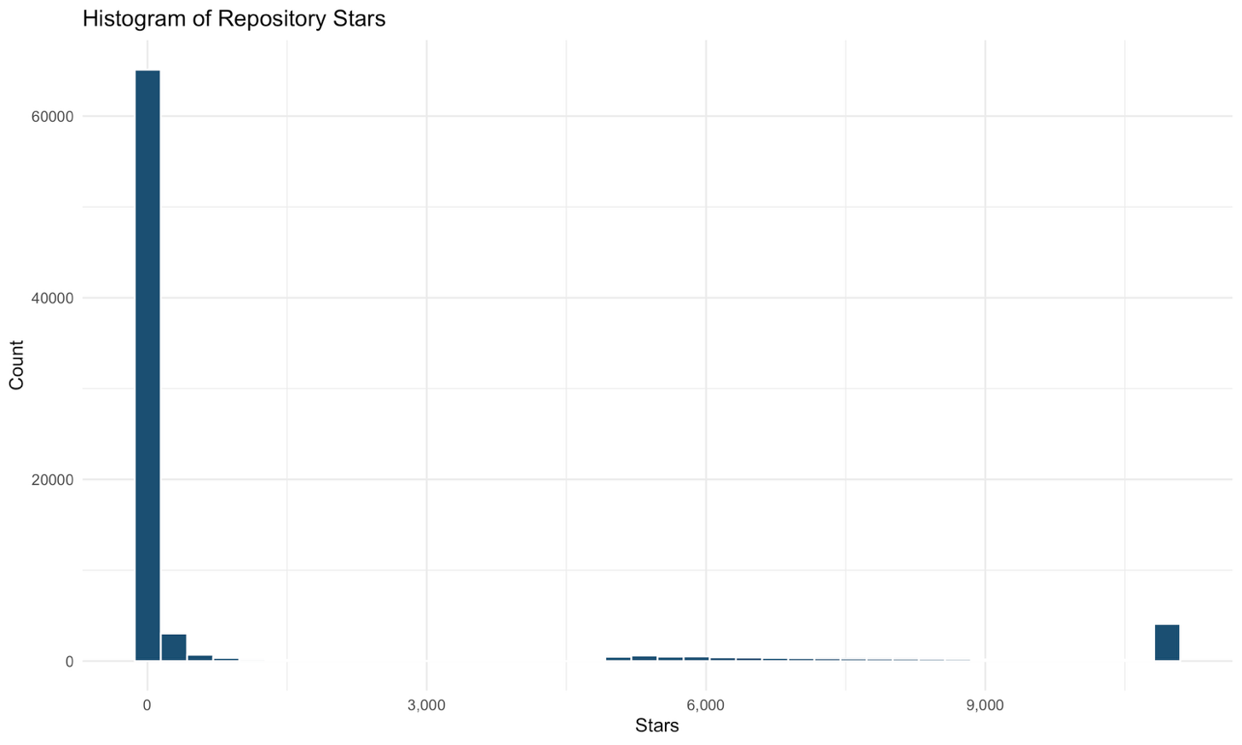
Figure 1. Histogram of Repository Stars
The histogram above shows how the distribution of the number of stars looks like in our sample. It is highly skewed to the right, with the median value much lower (15) than the mean (1,924.4). In other words, a huge portion of the repositories receives little to no attention while a small number of them become highly popular. In such circumstances, it is highly probable that any assessment based on the mean number of stars would be misleading. For instance, a comparison of the number of stars in any given repository and the mean would indicate poor performance of the repository; however, in reality, it can have sufficient or even decent number of stars. Particularly, for GitShield AI, I would consider using assumptions of log transformation or heavy-tailness when talking about the number of stars as an input.
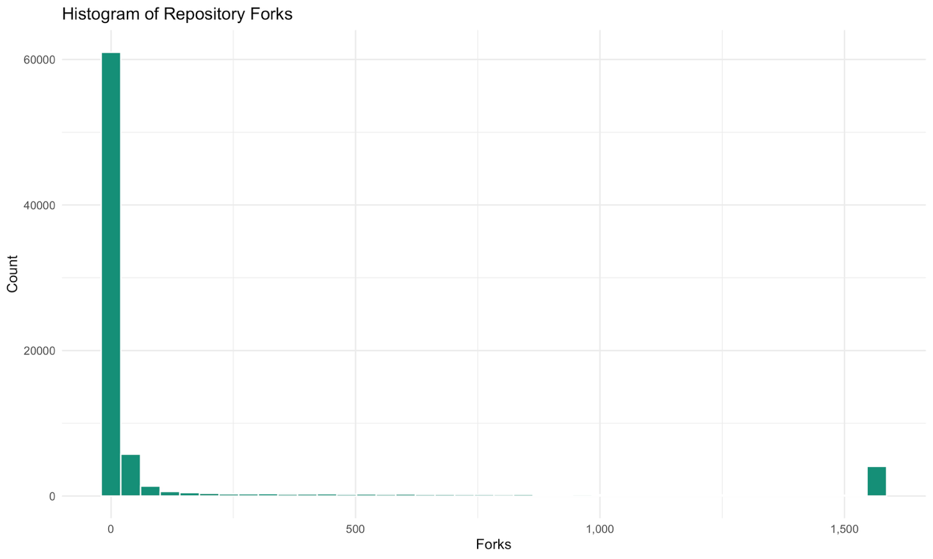
Figure 2. Histogram of Repository Forks
Forks show similar distributions to stars, with a mean value of 314.4, skewed due to the very high numbers of forks for a few projects, and most forks occurring in projects with only a small number of forks. Nevertheless, forking indicates higher interest than starring, hence this skew is understandable. Forking occurred in a very few projects; this is why fork_ratio became an independent feature, and did not depend on the number of stars.
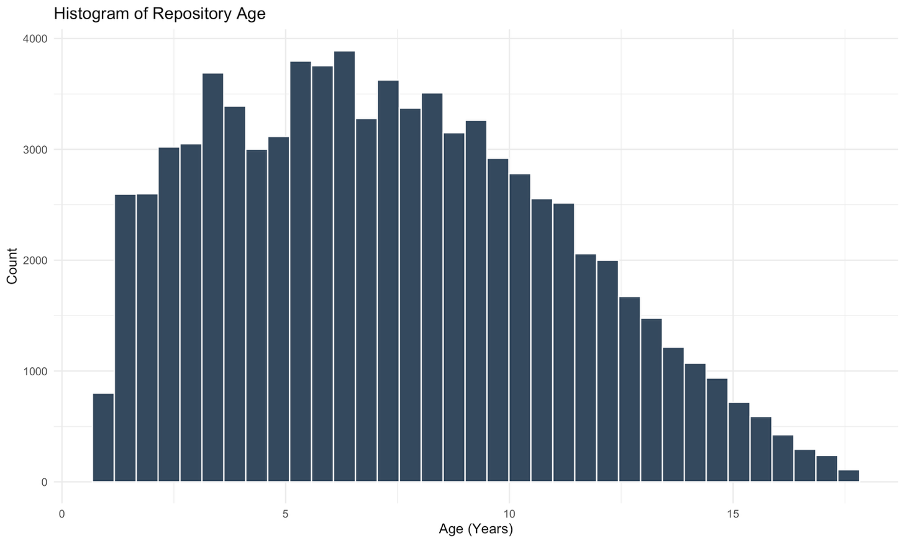
Figure 3. Histogram of Repository Age

The age of repository has a mean of 7.36 years and its range is from the youngest to the oldest project. From the above discussion, it seems that there is no stage of the lifecycle dominating in this set of observations. This is helpful for further analysis, because the final model will take into account the effect of the age if it influences positively on the health/sustainability of projects regardless of their lifecycle stage.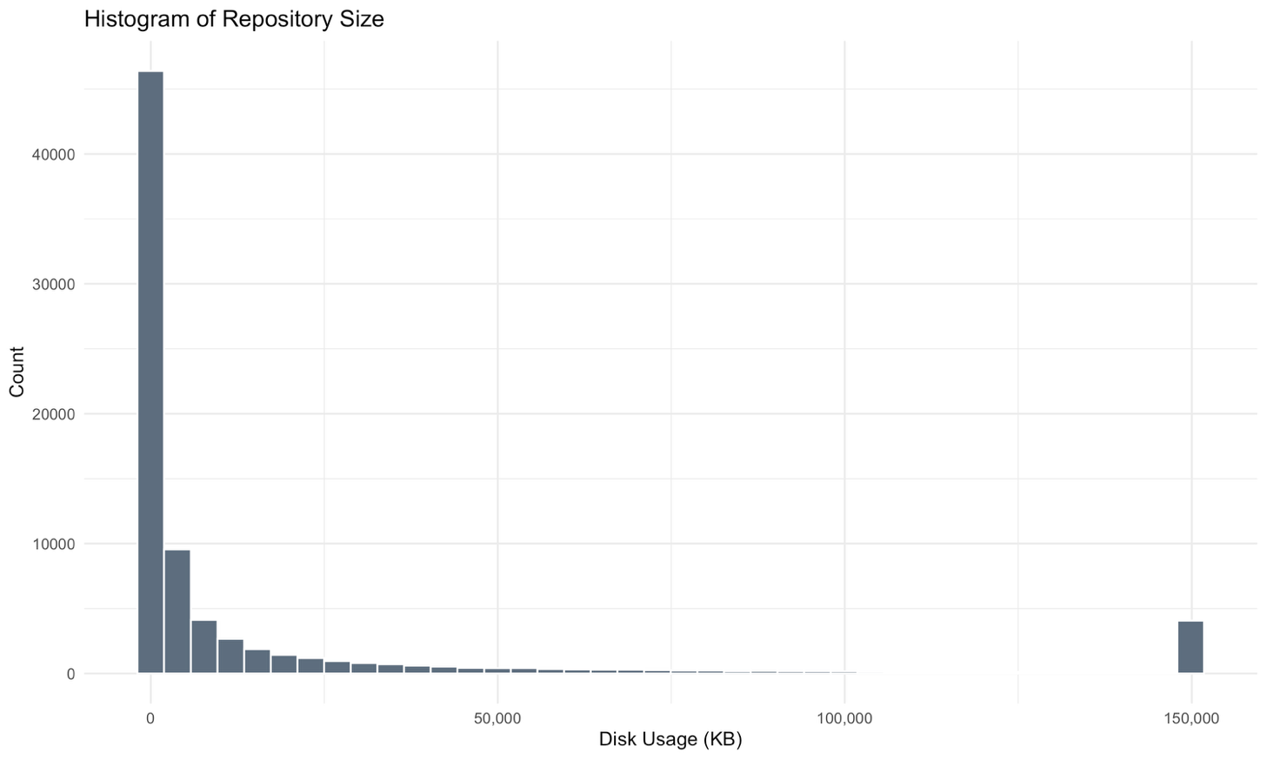
Figure 4. Histogram of Repository Size

The sizes of repositories in kilobytes tend to have a highly skewed-right distribution because there will usually be lots of small repositories and just a few large repositories. Large repositories need more maintenance by their respective developers, hence we consider size as one of the input factors for our understanding of maintenance effort. This skewness is also why there was a metric developed called repository_density (number of commits to kilobytes) that was used as input factor.

10.2 Outlier Detection
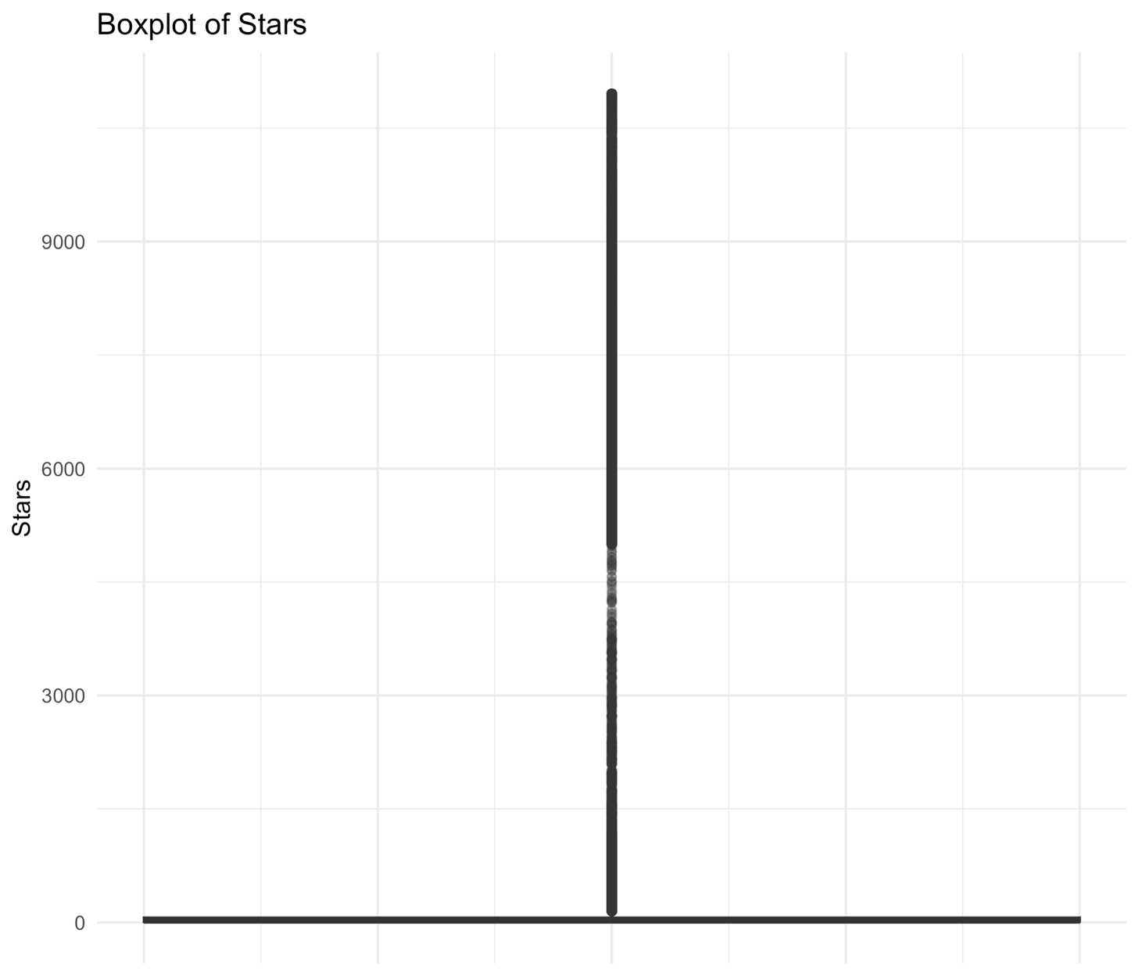
Figure 5. Boxplot of Stars

There is a long upper whisker in the star plot as well as a large number of outliers beyond the upper whisker. There is a small set of repositories with an exceptionally large number of stars compared to the mean value. In such cases, one should consider using either a logarithmic transformation of the values or any robust statistic while creating a model.
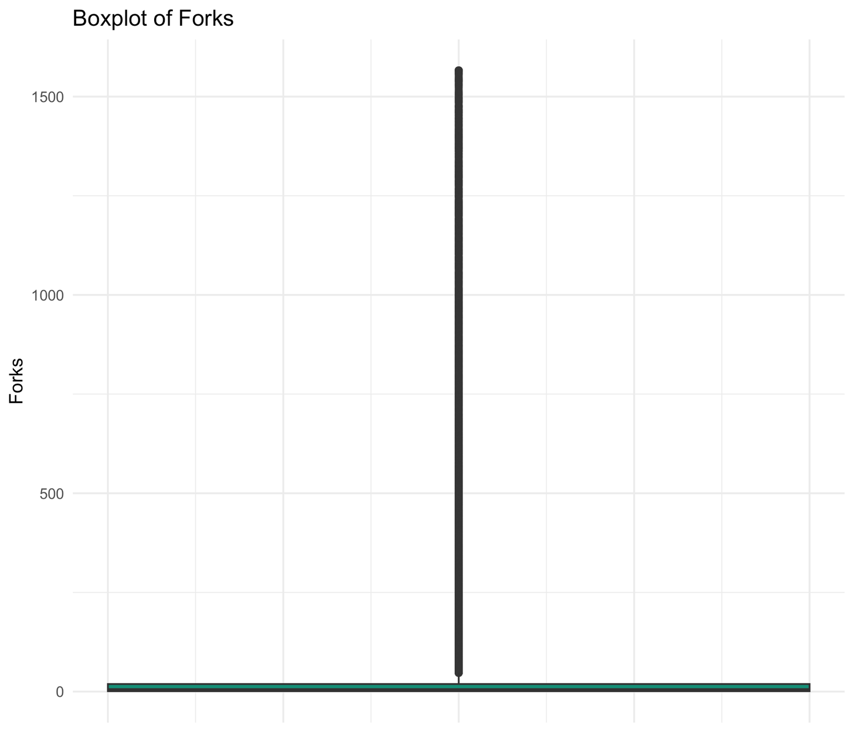
Figure 6. Boxplot of Forks

The exact same pattern of the long tail distribution is seen again here. The plots of the fork counts have a long whisker on the top side and many high-valued outliers. The two box plots are close to each other so much that we can assume popularity and reuse to be the same thing.

10.3 Bivariate Relationships
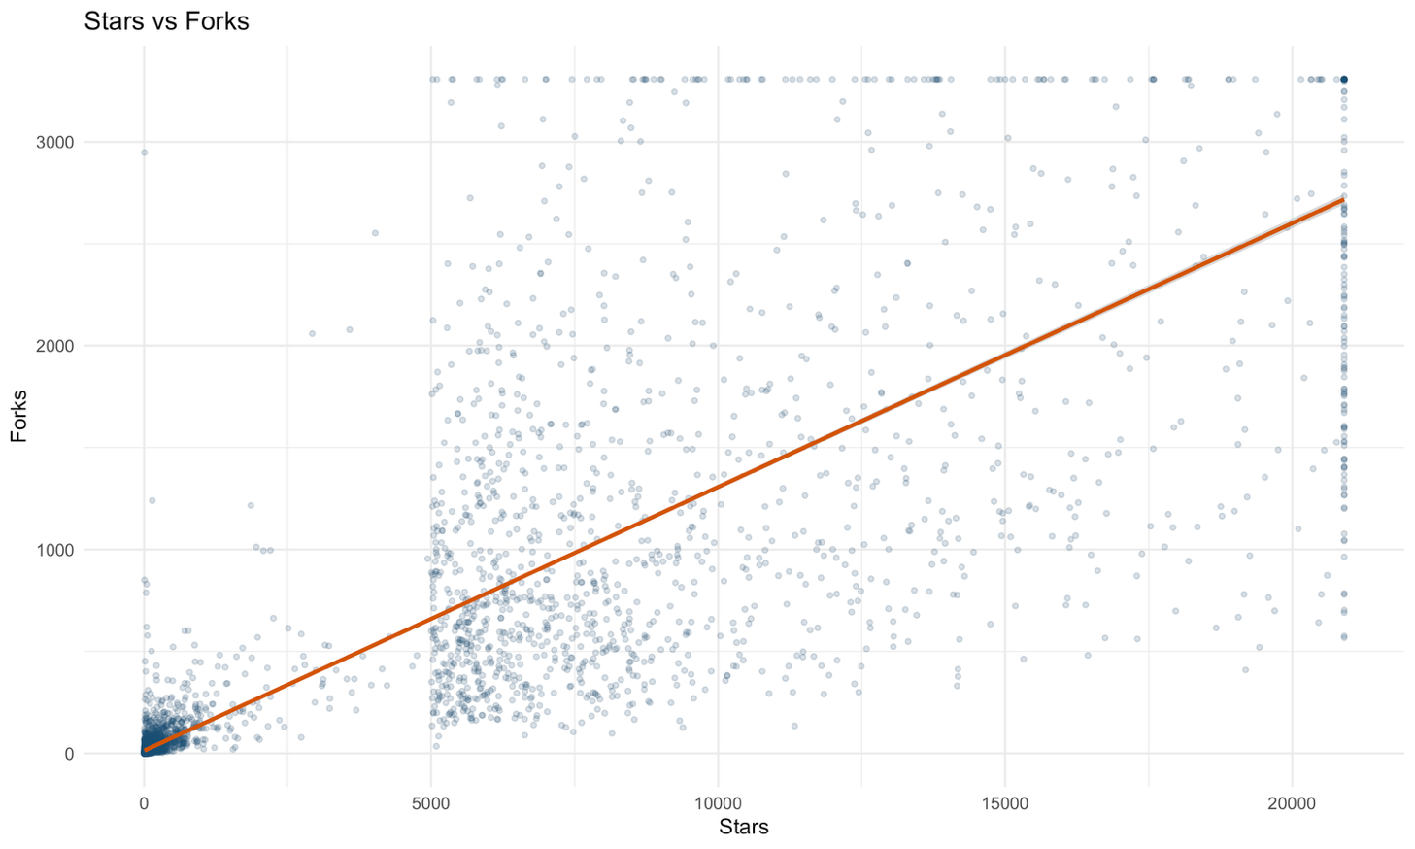
Figure 7. Stars versus Forks

There is correlation between stars and forks (Pearson: r = 0.647), which suggests that projects that attract more interest with the help of stars also receive more forks, and, therefore, visibility and reuse are separate but related aspects of a project that need to be grouped into repository_popularity and repository_growth, respectively.
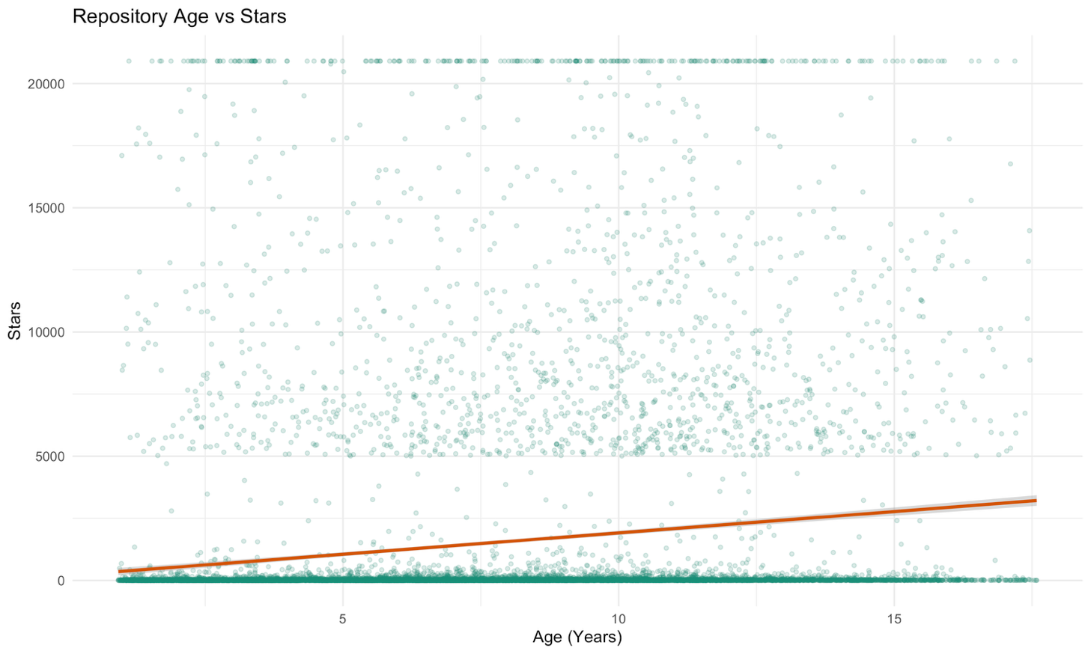
Figure 8. Repository Age versus Stars
The coefficient of correlation between the two features – the age of the project and the number of stars – turned out to be rather low, r = 0.105. Age does not guarantee popularity because some young projects quickly become popular while others remain popular for many years. It is clear evidence that the thesis statement raised in the problem statement is true.
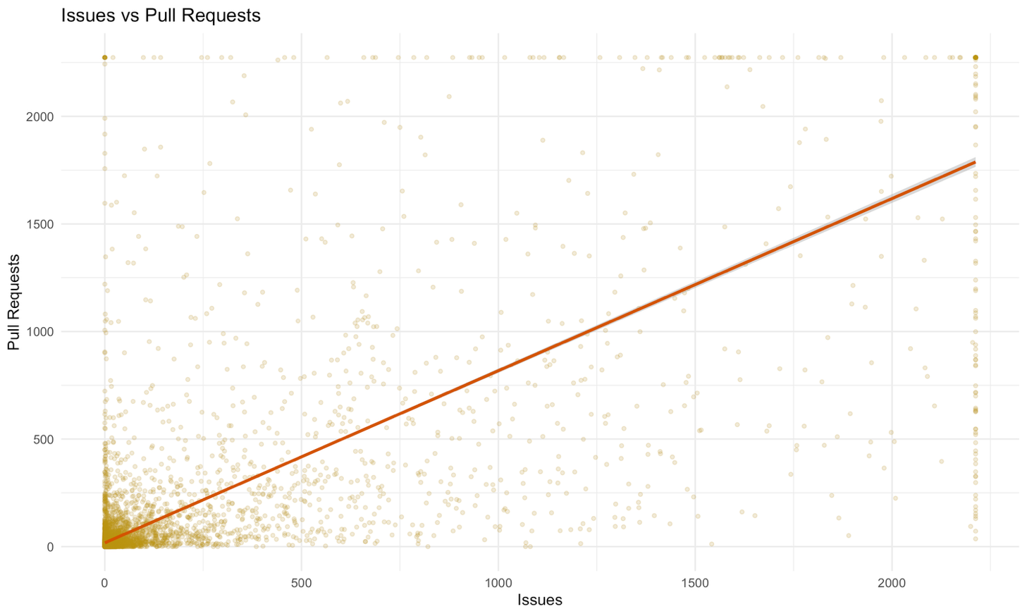
Figure 9. Issues versus Pull Requests
The relationship between issues and pull requests is positive with an r-value of 0.534, indicating that an increase in the number of issues results in an increase in the number of pull requests rather than balancing each other out. In other words, when a repository shows a lot of issues but few pull requests, it may show that there is a maintenance problem.

10.4 Correlation Structure
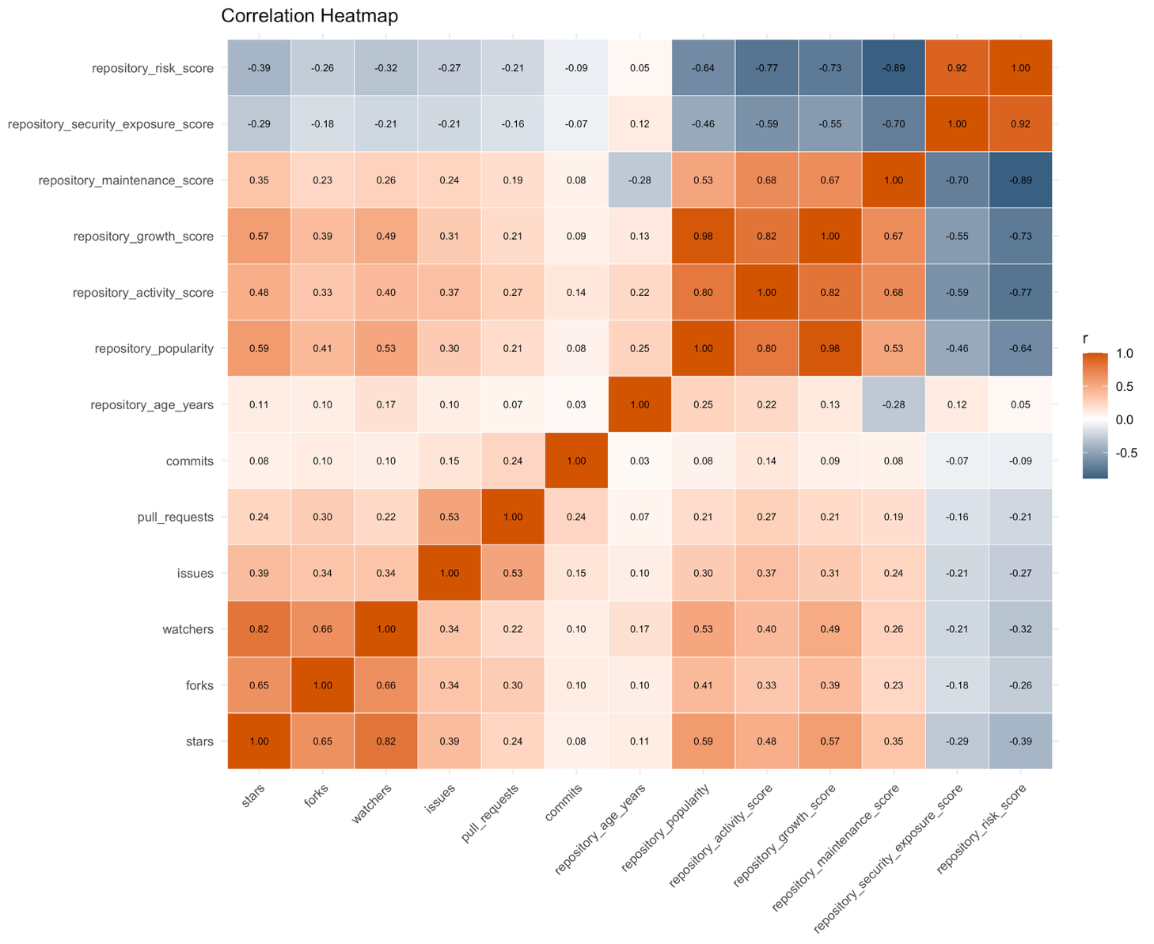
Figure 10. Correlation Heatmap
In the heatmap given below, a complete correlation matrix for the raw and synthetic numerical features can be seen. There is a very clear cluster of the popularity-based features present in the heatmap. The synthetic score is almost identical to the raw score from which the synthetic feature was created. This is because the synthetic features are valid and are not contradicting the original data.
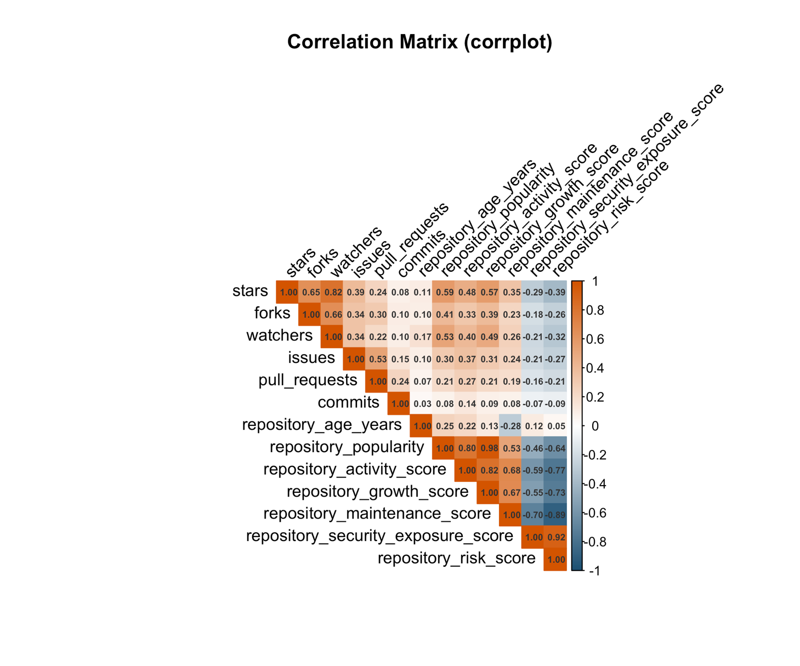
Figure 11. Correlation Matrix (corrplot, upper triangle)

Furthermore, as an additional verification process, the same correlation plot has been generated again using the package called corrplot, which once again reveals the same clusters and connections that have been observed in the ggplot2 heatmap. The fact that both visualizations reveal the same kind of relationships means that these relationships are indeed genuine and not only a result of one of these two visualization techniques. This verification has been done in the context of selecting features for DA2.

10.5 Categorical Distributions
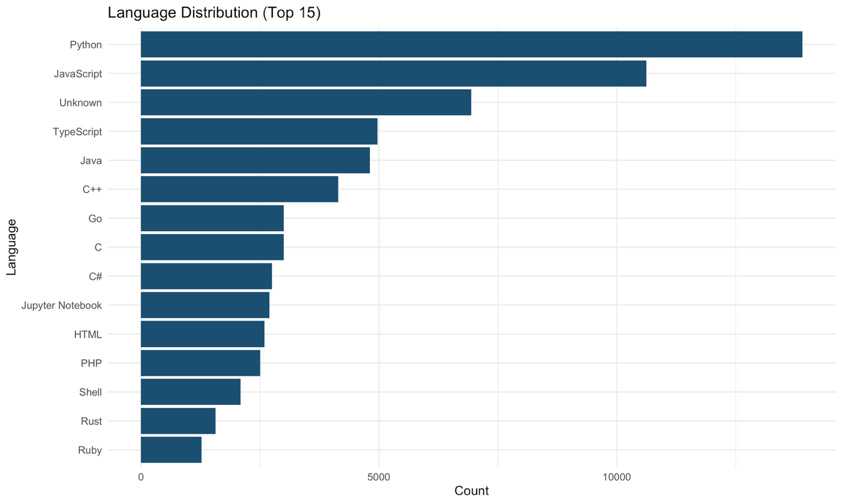
Figure 12. Language Distribution (Top 15)
The most commonly occurring primary language in the dataset is Python, followed by some other popular ecosystems. It is a representation of how Python is used in general on GitHub, and nothing unusual can be observed about the sample in question; therefore, the language feature was encoded in order to allow models to capture the ecosystem-specific trends in the future.
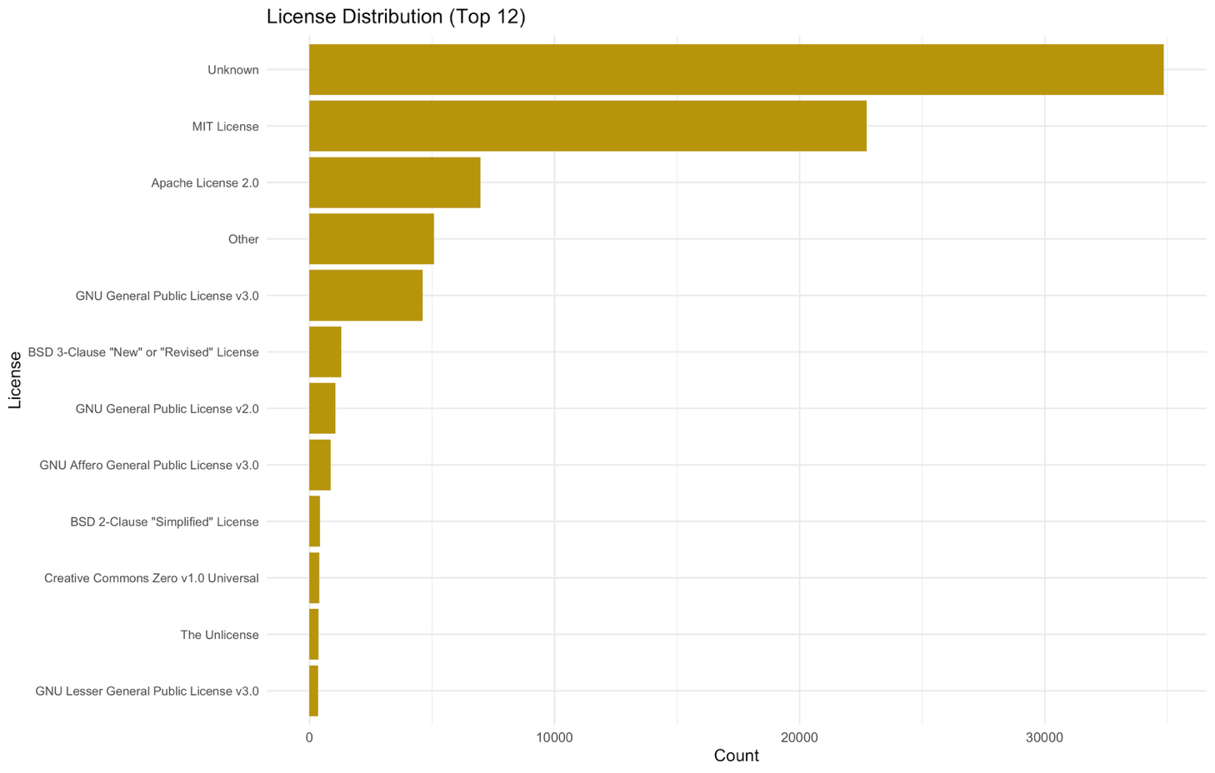
Figure 13. License Distribution (Top 12)

The most frequent license name is “Unknown”, which shows how high the percentage of repository entries without a license was in the preprocessing stage. The most popular license is MIT, while the second is Apache 2.0. It should be noted that the number of repositories that declare that they have no license is high, but this is a governance problem rather than a data problem. This is the reason why lack of a license impacts the repository_security_exposure_score.
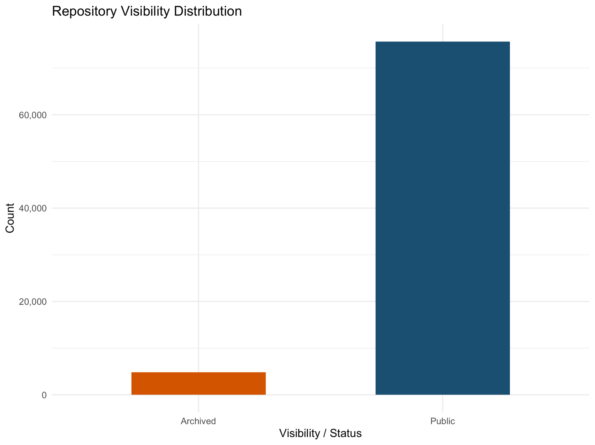
Figure 14. Repository Visibility Distribution

Among the 80,489 repositories, 75,673 are public while 4,816 are archived, which constitutes a very small percentage of almost six percent, not an insignificant one. The fact that these are archived implies that they are no longer under active development, and therefore, is_archived is a highly significant feature for both these metrics.

10.6 Ranking Analyses
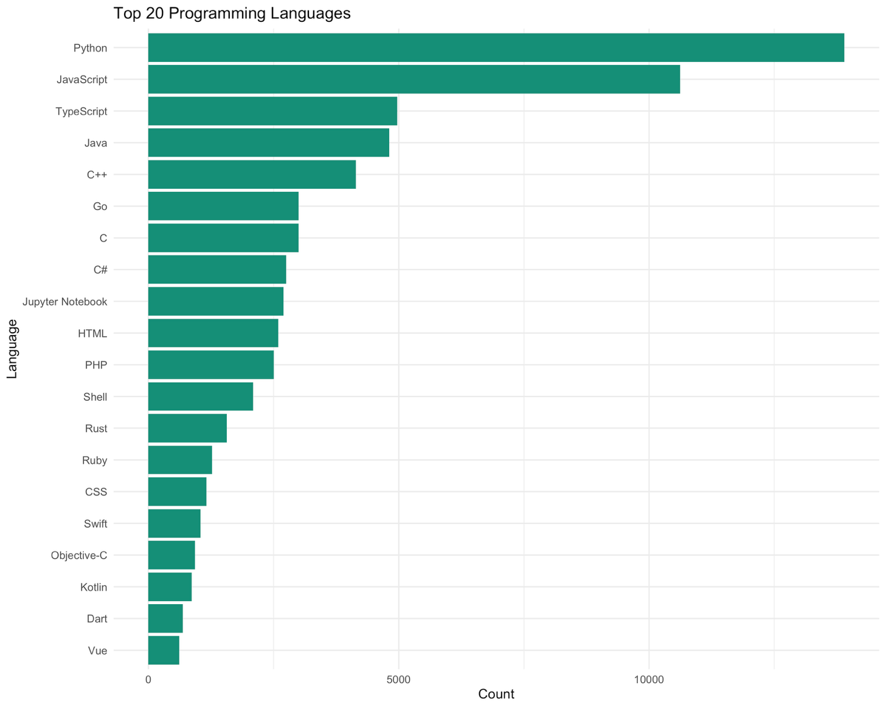
Figure 15. Top 20 Programming Languages

From the analysis of the Popular Languages Except for Unknowns, it is clear that programming languages such as Python, JavaScript, TypeScript, Java, and C++ are the most popular. In addition, they have the largest developer populations on GitHub. Any tool developed from the findings of this study will be more accurate for these programming languages because they have the largest developer population.
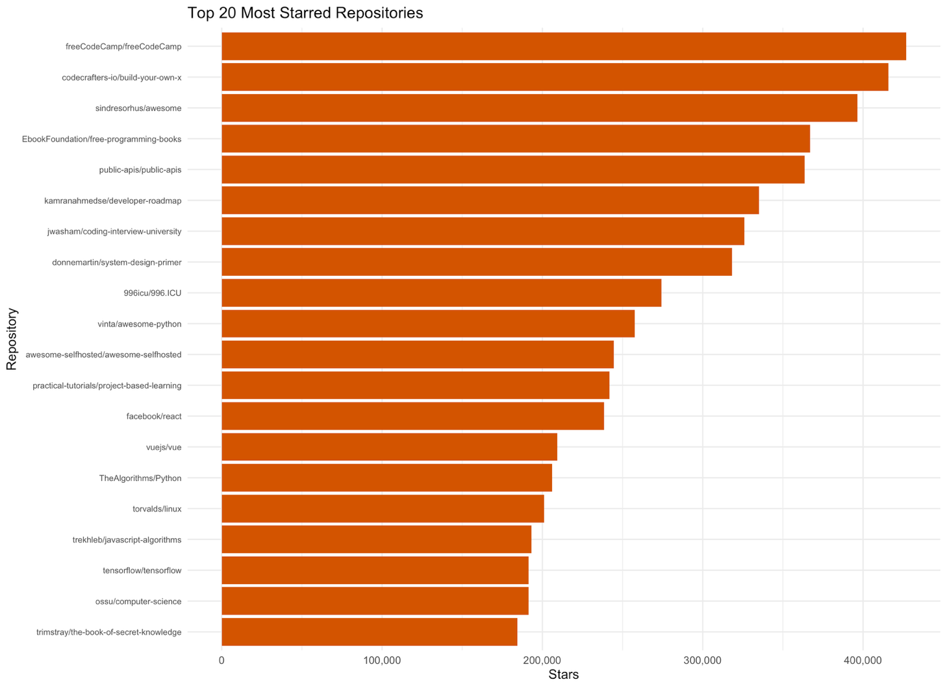
Figure 16. Top 20 Most Starred Repositories

The repository in the sample that has the highest number of stars has 426,893 stars. This small subset of flagship repositories is at the top end of the popularity distribution as shown in figure below. It helps to set benchmarks of what the most popular repository would be in other features.
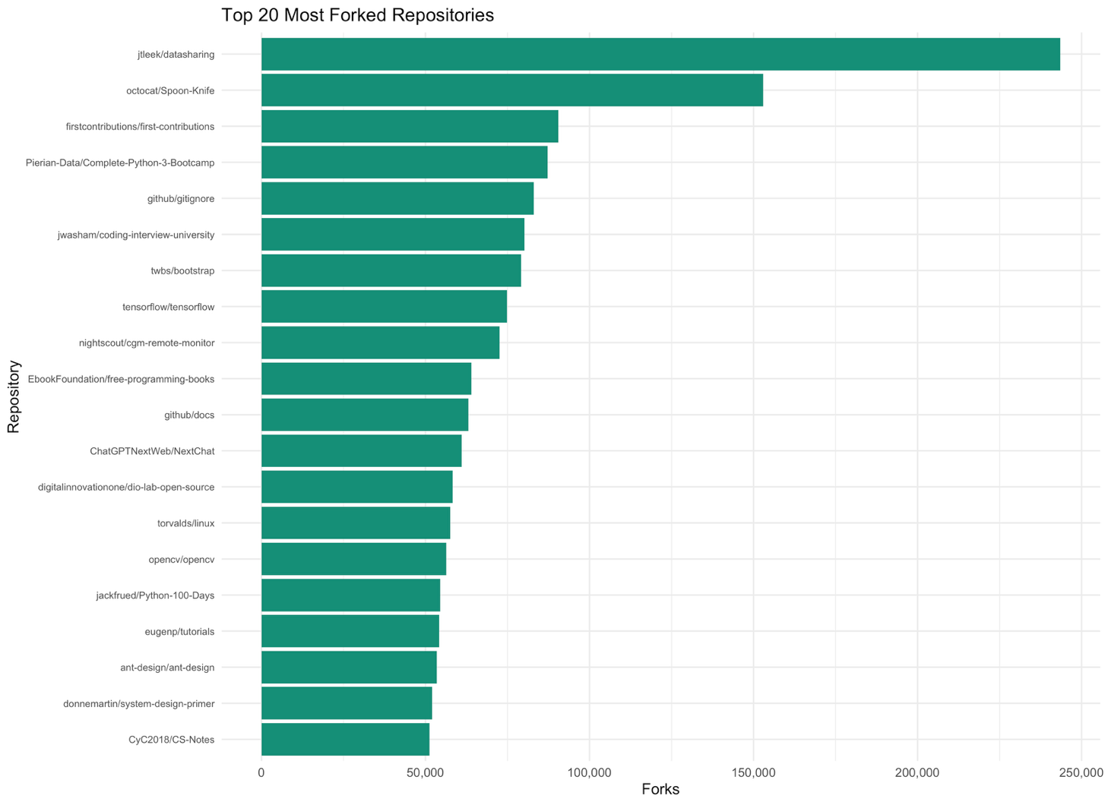
Figure 17. Top 20 Most Forked Repositories

The most forked repository in the dataset receives 243,520 forks. The repositories that lead in forks may not be the same as those that lead in stars, and being popular and reused can be two different things, which showed a moderate correlation between stars and forks.

10.7 Temporal Patterns
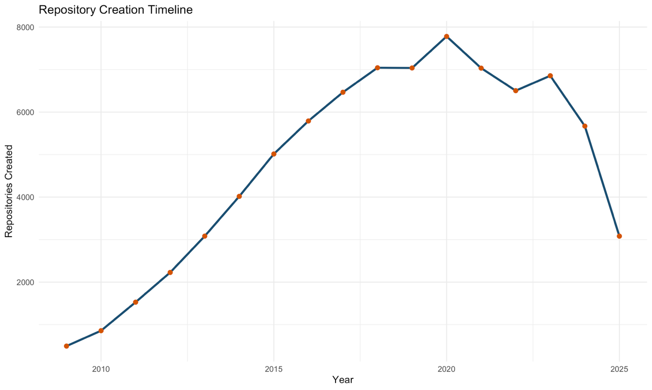
Figure 18. Repository Creation Timeline

The number of projects that are developed in certain years goes up and down depending on the overall trend of rise and fall of GitHub popularity (linearly). The mentioned information can help you figure out whether the particular repository is relatively old or new among other projects and compare cohorts later on.
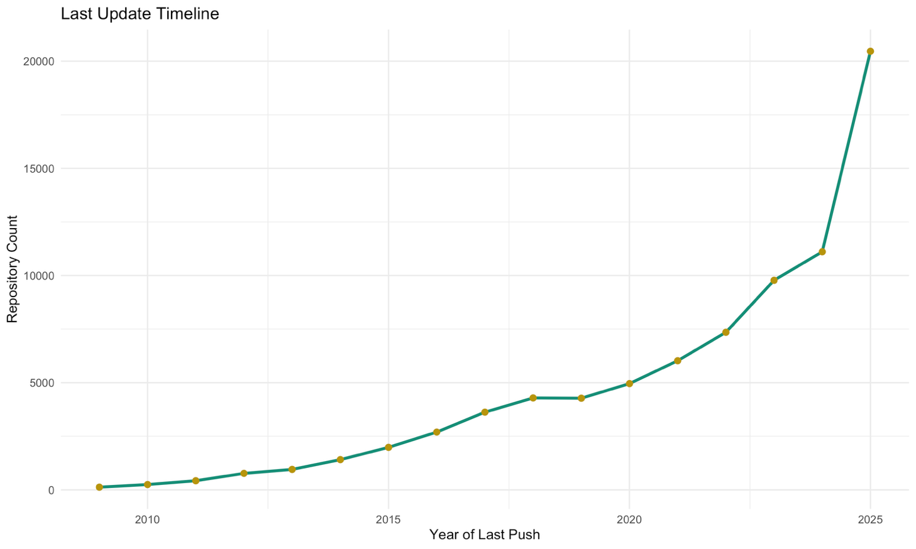
Figure 19. Last Update Timeline

Most of the repositories in the sample are recently updated; however, there is also a long tail of very old repositories, for which the date of the last update is quite some time in the past. Update recency can be considered one of the most straightforward proxies for the viability of the repository as a dependency source, which is why days_since_update and repository_freshness are used as the building blocks for maintenance, stability, and risk scores.

10.8 Density Estimates
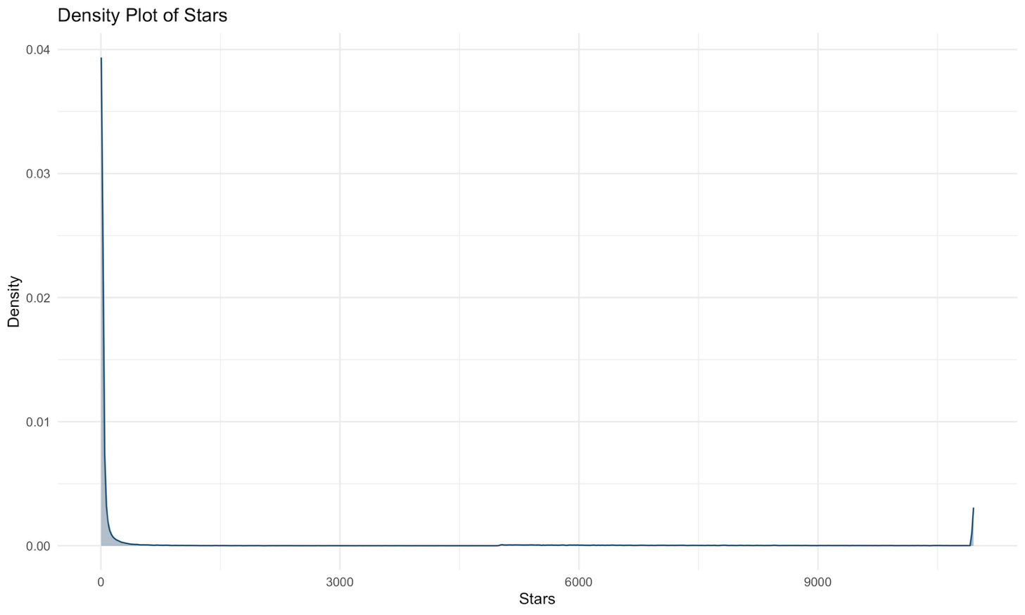
Figure 20. Density Plot of Stars

The smooth kernel estimate of the distribution density shows a sharp peak at low numbers of stars and then slowly decays to a long thin tail. This is an illustration of the existing skew from the histogram above, but not a revelation of anything new, as it is just another hint about medians vs means.
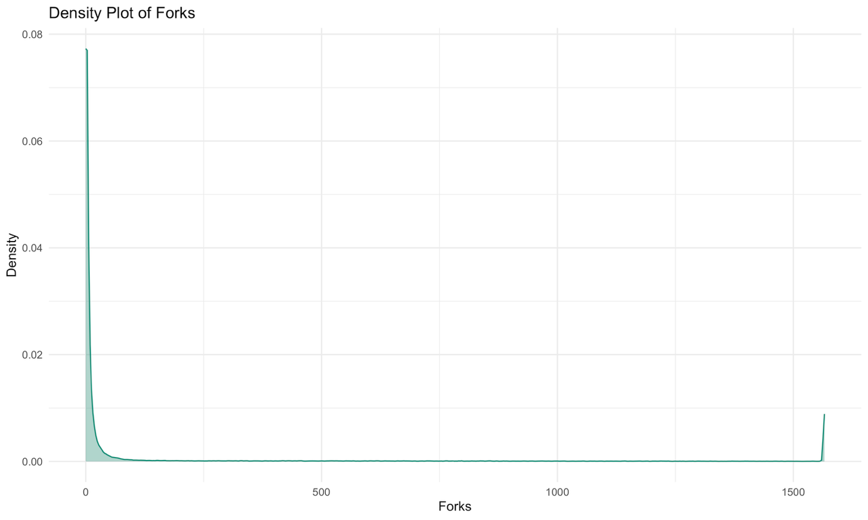
Figure 21. Density Plot of Forks

The estimated density of the forks exhibits the same small value peak and narrow tail that has been shown for the stars. The commonality of the distribution allowed easily setting up the weights of the repository_community_score metric.

10.9 Multivariate and Composite Analysis
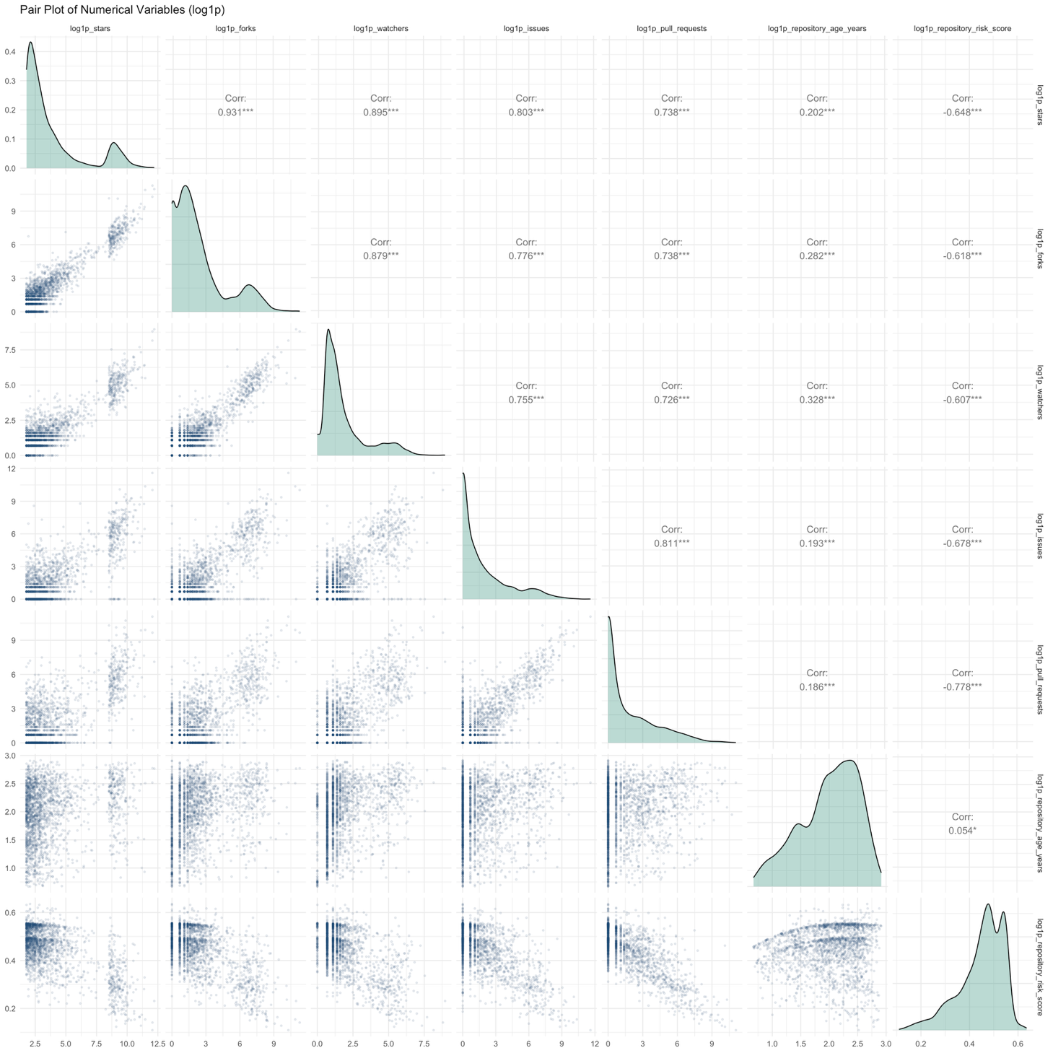
Figure 22. Pair Plot of Numerical Variables (log1p transformed)

The scatterplot matrix for the numerical features, after being transformed using log1p to minimize skewness, shows that the popularity measurements become more clustered around their common mean in the transformed space, whereas the repository risk score follows the opposite behavior when compared to maintenance indicators. Poorly maintained repositories are those with high risk scores, as one would expect due to the way the risk score was constructed as the inverse of maintenance signals.
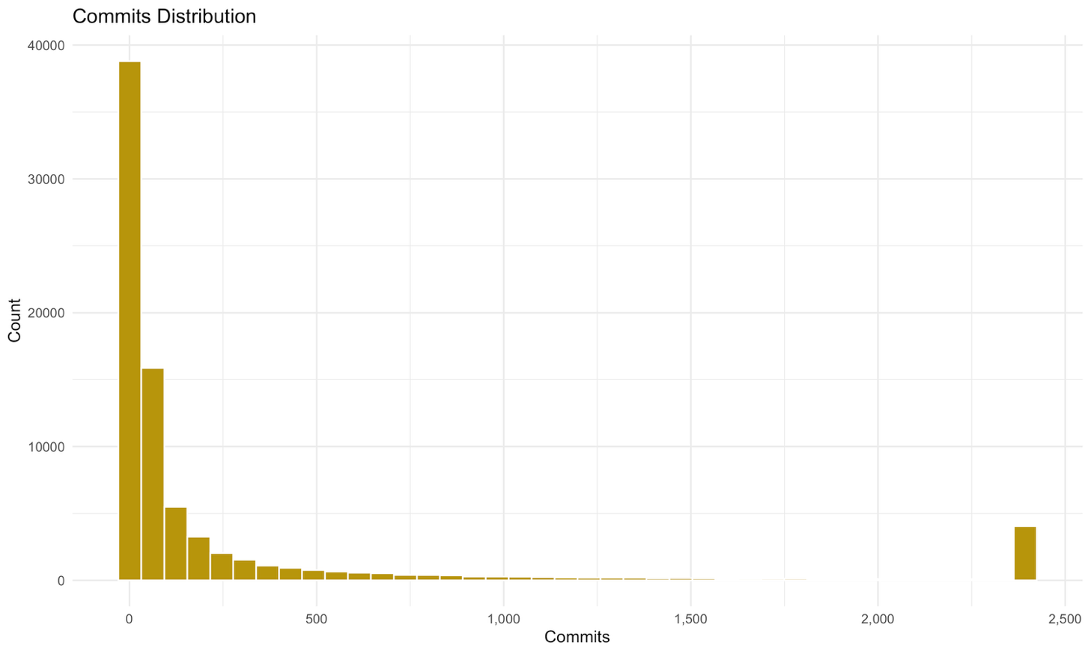
Figure 23. Commits Distribution

The commits follow a skewed-right distribution pattern, with an average value of approximately 1,336.7, due to the influence of some very active repositories, although most of them in the sample are relatively inactive when it comes to commits. Commit activity should be viewed in relation to age since younger projects with intensive development could have fewer commits compared to old projects that do not see much maintenance.
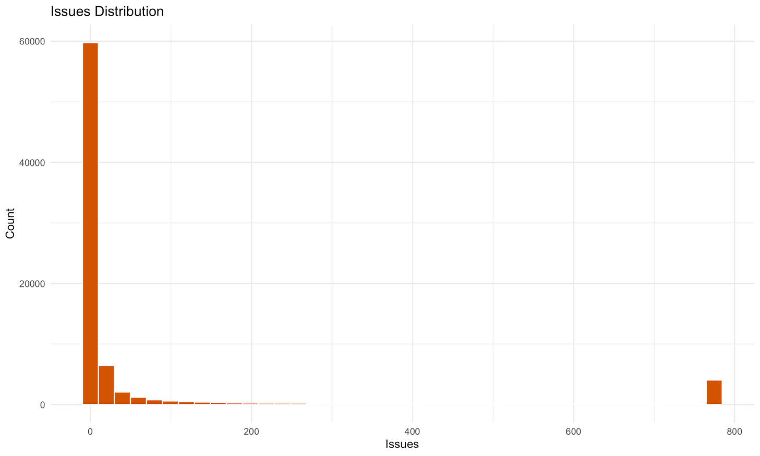
Figure 24. Issues Distribution

Issues that favor a mean value of roughly 203.1 issues exist, per repository. This is once again a heavily skewed distribution that revolves around a very small number of highly-used projects, and these projects are similar to the others in terms of having lots of stars and lots of forks. The fact that there are many issues is not always a negative aspect, although when it's combined with the issue_resolution_rate, it becomes one.

11. Initial Results and Progress (DA1)
At the end of DA1, the project will have created a cleaned and feature-engineered dataset of 80,489 repositories with 44 columns out of the 23-column raw extract. Every column in the raw extract that contained a large proportion of missing data has been subjected to the right process, and the only missing column in the dataset is the free text description of the repository. This particular column was left as it is because there were no missing data. 16 new features have been created in the project. These are the features that define popularity, activity, community, maintenance, growth, stability, security exposure, and general risk.
Twenty-four valuable visualizations of the data have been made in a format ready for publishing, and each one has been analyzed and discussed in Section 10. Among the visualizations are plots of distribution analysis, outlier detection, relationship and correlation analysis of two variables, analysis of categorical distribution and ranking, analysis of trends, density estimation, and multi-variable composite analysis. Thanks to the documented files that have been created and to the automatically documented DA1 pipeline, it is now possible to move on to the supervised machine learning phase of the project. It is noteworthy that no models have been trained at this point, and none of the four indexes generated by DA1 have been validated with respect to the ground truth result – namely, abandoned repositories – which will be done in DA2. [Consolidation note: this validation against abandoned repositories was not carried out in DA2 or DA3; it remains future work, Chapter 33.]
PART II — MODEL DEVELOPMENT, DATABASE CONNECTIVITY AND COMPARATIVE ANALYSIS (DA2)

12. Database Connectivity
SQLite has been used since it is one of the accepted databases which do not require a server. The DA1 dataset (Output/cleaned_dataset.csv) has been uploaded into the SQLite file DA2/gitshield.db, where it is present in the table named 'repositories' (80,489 rows and 43 columns, except the text description column). Next, the required columns have been extracted from the database using a SQL query to a pandas DataFrame (80,489 rows), and this retrieved DataFrame alone will be used for the rest of the analysis.
Query used for retrieval:
SELECT name_with_owner,
stars, forks, watchers, is_archived, language_count, topic_count,
disk_usage_kb, pull_requests, issues, commits, assignable_user_count,
primary_language, license, code_of_conduct,
repository_age_years, days_since_update, fork_ratio,
issue_resolution_rate, repository_density, commit_activity,
repository_risk_score
FROM repositories
WHERE repository_risk_score IS NOT NULL

13. Feature Engineering for Modelling (DA2)
Simple ratio or time-related features in the DA1 set (repository_age_years, days_since_update, fork_ratio, issue_resolution_rate, repository_density, commit_activity) were combined with the original repository data. The additional machine learning preprocessing consists of:
- • Logarithmic transformation (log1p) of the 14 numerical features with skewness >1 in the training set: stars, forks, watchers, language_count, topic_count, disk_usage_kb, pull_requests, issues, commits, assignable_user_count, days_since_update, fork_ratio, repository_density, commit_activity.
- • 2 new binary features: has_license, has_code_of_conduct (created row by row from the DA1 categorical variables).
- • One-hot encoding for primary_language and license (10 categories at maximum, other categories are 'infrequent') – this eliminates arbitrary integer codes of DA1 set, which would confuse distance- and linear-based models.
- • Standard scaling of all numerical variables (fitting only on the training set).
• Leakage prevention: repository_risk_score feature was used only to create the target label. The composite scores of DA1 (popularity, activity, community, maintenance, growth, stability, engagement, security exposure) and repository_freshness directly form or consist of the same parts as the risk score, so these features can not be used as predictors. The number of input features grew from 21 to 39 after encoding. Note (DA3): the raw inputs of these composite scores (for example days_since_update, licence and code-of-conduct flags, repository_age_years, forks, watchers, pull_requests) remain among the predictors, so the label is still reproducible from the model inputs; see Chapter 28.

14. Feature Selection
For feature selection, SelectKBest using mutual information (mutual_info_classif) is used and the top 20 out of 39 features are kept. Feature selection is trained only on the training set (64,391 samples) and applied to the test set (16,098 samples), so no information from the test set affects this process. The feature names that are selected are stored in DA2/outputs/selected_features.json.
Selected features: stars, forks, watchers, language_count, topic_count, disk_usage_kb, pull_requests, issues, commits, assignable_user_count, days_since_update, fork_ratio, repository_density, commit_activity, repository_age_years, issue_resolution_rate, has_license, has_code_of_conduct, license_MIT License, license_Unknown.
Mutual Information Scores:

Feature | Mutual information
days_since_update | 0.3555
has_license | 0.2922
license_Unknown | 0.2918
pull_requests | 0.2499
commit_activity | 0.2389
issue_resolution_rate | 0.2242
commits | 0.2007
issues | 0.1673

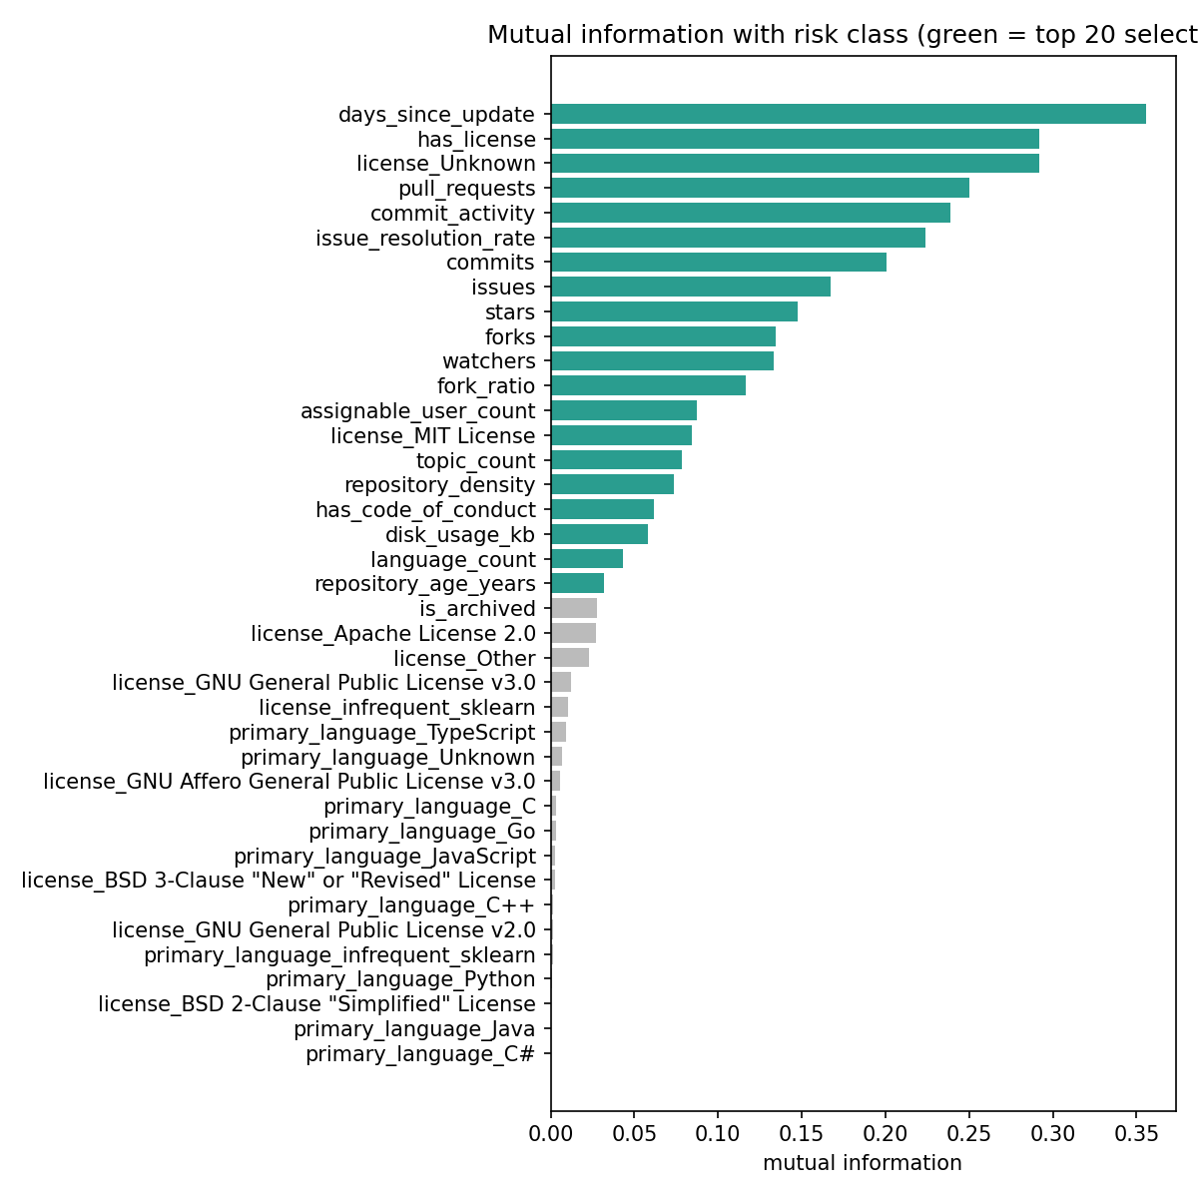
Figure 25. Mutual information of each engineered feature with the risk class.

15. Target Creation
Classification target is based on repository_risk_score (DA1). It is numeric, left skewed with a mean of 0.5756, a median of 0.6031, minimum of 0.0723, and maximum of 0.899. Cut-off points were set up at one-third and two-thirds percentiles and rounded off to two decimal places, resulting in three evenly distributed classes.

Class | Rule | Repositories | Share
Low Risk | score < 0.54 | 26,831 | 33.33%
Medium Risk | 0.54 <= score < 0.65 | 27,152 | 33.73%
High Risk | score >= 0.65 | 26,506 | 32.93%

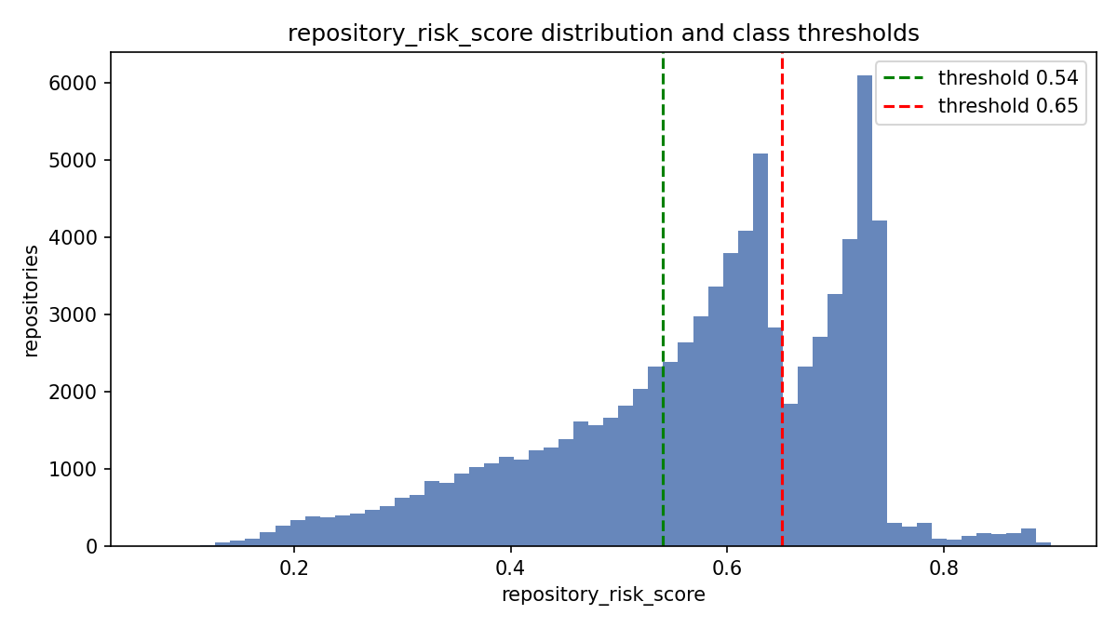
Figure 26. Distribution of repository_risk_score with class thresholds.

16. ML Algorithms
Twelve classifiers were implemented with scikit-learn; all 12 trained successfully. Data split: 80% train / 20% test, stratified, random_state=42.

Algorithm | Family
Logistic Regression | Linear
KNN (k=7) | Instance-based
Decision Tree (depth 12) | Tree
Random Forest | Bagging ensemble
Extra Trees | Bagging ensemble
Gradient Boosting | Boosting ensemble
AdaBoost | Boosting ensemble
HistGradientBoosting | Boosting ensemble
Gaussian Naive Bayes | Probabilistic
Linear SVM (LinearSVC) | Linear margin
MLP Neural Network (64, 32) | Neural network
Linear Discriminant Analysis | Linear / probabilistic

17. Hyperparameter Tuning
Five models were optimized using GridSearchCV with 3-fold stratified cross-validation, where the score function is macro F1. In order to keep the run time manageable, the parameter search space was applied to a random subsample of 10,000 rows from the training data.

Model | Grid searched | Best parameters | CV macro-F1 | Test F1 before | Test F1 after
Logistic Regression | C: [0.1, 1, 10, 100] | {"C": 1} | 0.9212 | 0.9218 | 0.9218
Random Forest | n_estimators: [100, 200]; max_depth: [10, 20, None]; min_samples_leaf: [1, 3] | {"max_depth": 20, "min_samples_leaf": 1, "n_estimators": 200} | 0.9185 | 0.9305 | 0.9302
Gradient Boosting | n_estimators: [100, 200]; learning_rate: [0.05, 0.1]; max_depth: [3, 5] | {"learning_rate": 0.1, "max_depth": 5, "n_estimators": 200} | 0.9242 | 0.9239 | 0.9358
Linear SVM | C: [0.01, 0.1, 1, 10] | {"C": 10} | 0.8583 | 0.8514 | 0.8514
MLP Neural Network | hidden_layer_sizes: [[64], [64, 32], [128, 64]]; alpha: [0.0001, 0.01]; learning_rate_init: [0.001, 0.01] | {"alpha": 0.01, "hidden_layer_sizes": [128, 64], "learning_rate_init": 0.01} | 0.9355 | 0.9504 | 0.9504

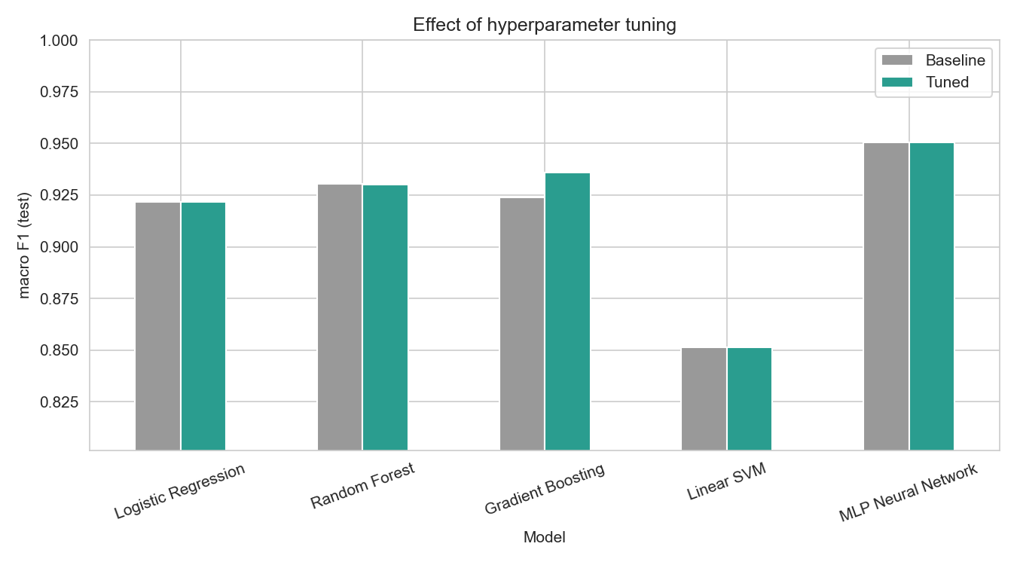
Figure 27. Test macro-F1 before and after tuning.

The benefit was greater for tuning Gradient Boosting (F1 +0.0119). In the other cases, tuning resulted in minimal or no difference at all, which demonstrates that the parameter value chosen by default was close to optimal.

18. Evaluation Metrics
All scores are calculated on the held out test set. The precision, recall and F1 scores presented in the primary table above are macro-averages (each class is treated equally). The weighted averages are saved in the file DA2/outputs/model_comparison_detailed.csv. ROC-AUC score is the macro-average one-vs-rest AUC score, except for Linear SVM which does not output probabilities.

19. Comparative Results
Model | Accuracy | Precision | Recall | F1 | ROC_AUC
MLP Neural Network | 0.9504 | 0.9523 | 0.9502 | 0.9504 | 0.9879
MLP Neural Network (Tuned) | 0.9504 | 0.9526 | 0.9501 | 0.9504 | 0.9887
HistGradientBoosting | 0.9372 | 0.9394 | 0.9370 | 0.9374 | 0.9857
Gradient Boosting (Tuned) | 0.9355 | 0.9376 | 0.9354 | 0.9358 | 0.9849
Extra Trees | 0.9311 | 0.9333 | 0.9310 | 0.9313 | 0.9833
Random Forest | 0.9302 | 0.9322 | 0.9301 | 0.9305 | 0.9839
Random Forest (Tuned) | 0.9299 | 0.9319 | 0.9298 | 0.9302 | 0.9840
Gradient Boosting | 0.9233 | 0.9259 | 0.9232 | 0.9239 | 0.9820
Logistic Regression (Tuned) | 0.9213 | 0.9232 | 0.9212 | 0.9218 | 0.9714
Logistic Regression | 0.9213 | 0.9232 | 0.9212 | 0.9218 | 0.9714
Decision Tree | 0.9184 | 0.9201 | 0.9183 | 0.9187 | 0.9557
KNN | 0.8906 | 0.8929 | 0.8907 | 0.8914 | 0.9650
Linear Discriminant Analysis | 0.8820 | 0.8868 | 0.8822 | 0.8834 | 0.9672
Linear SVM (Tuned) | 0.8543 | 0.8554 | 0.8551 | 0.8514 | 0.9607
Linear SVM | 0.8543 | 0.8554 | 0.8551 | 0.8514 | 0.9607
AdaBoost | 0.8015 | 0.8457 | 0.8002 | 0.8020 | 0.8330
Gaussian Naive Bayes | 0.7564 | 0.7691 | 0.7571 | 0.7574 | 0.9150

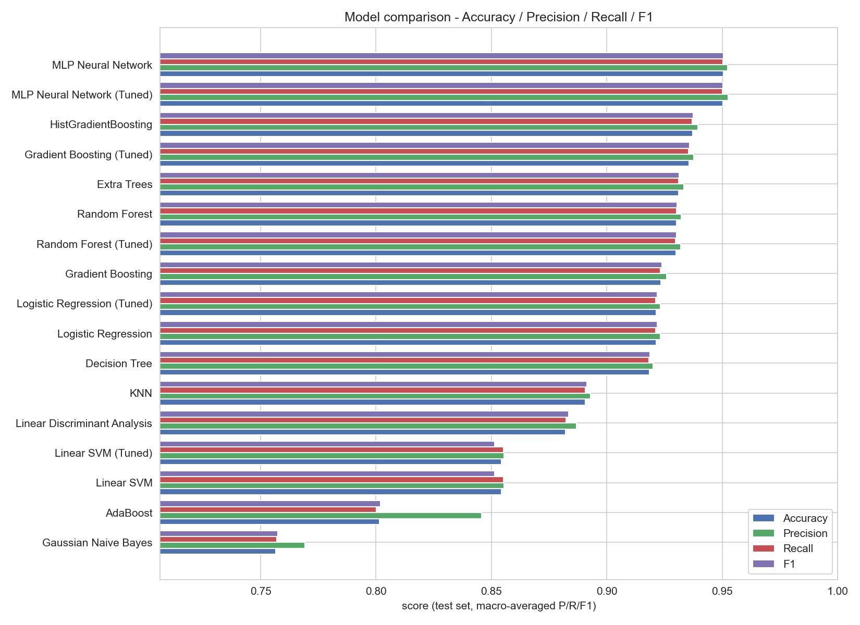
Figure 28. Accuracy, Precision, Recall and F1 for every model.
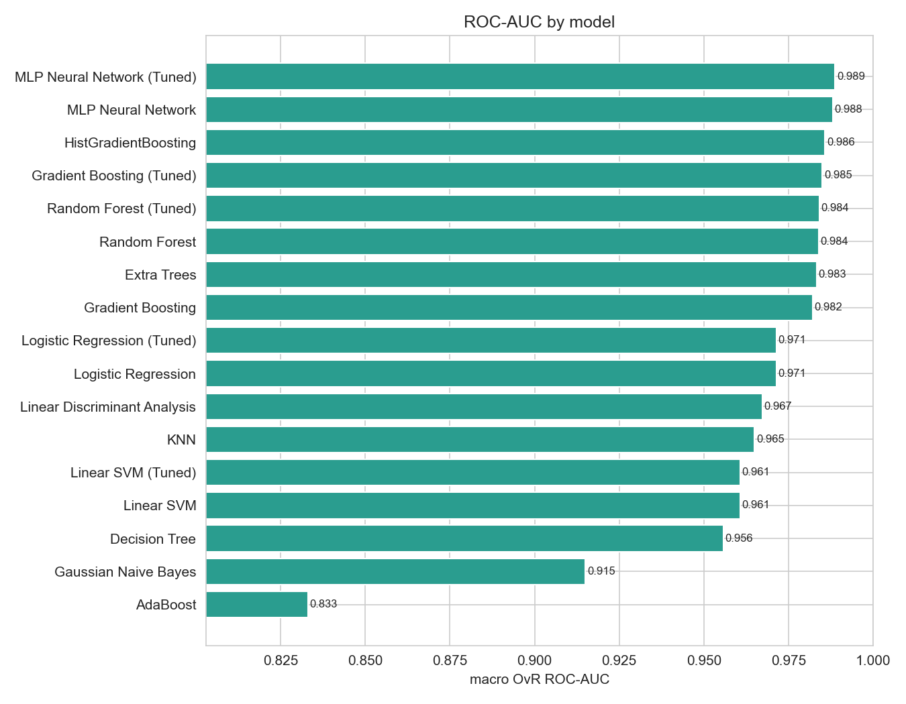
Figure 29. Macro one-vs-rest ROC-AUC per model.

20. ROC, Confusion Matrix, Precision-Recall and Feature Importance
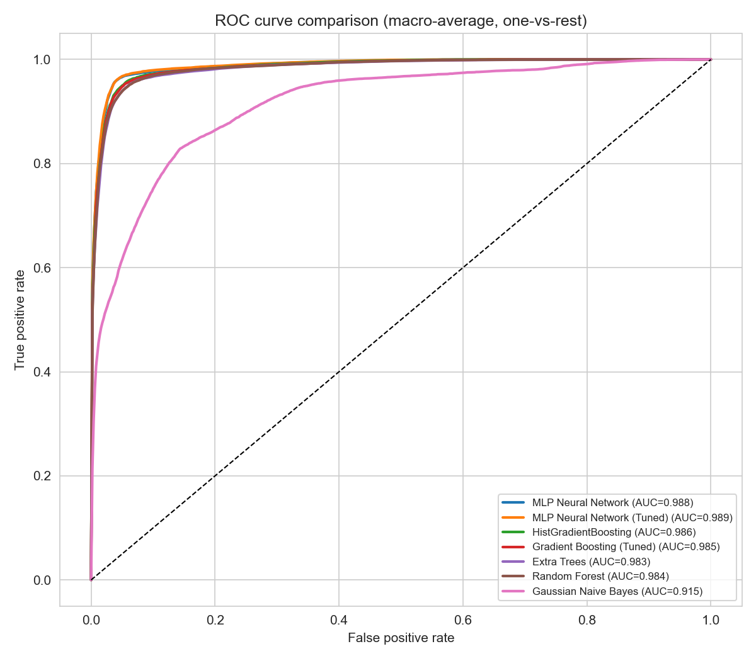
Figure 30. Macro-average ROC curves of the six best models and Gaussian Naive Bayes for contrast.
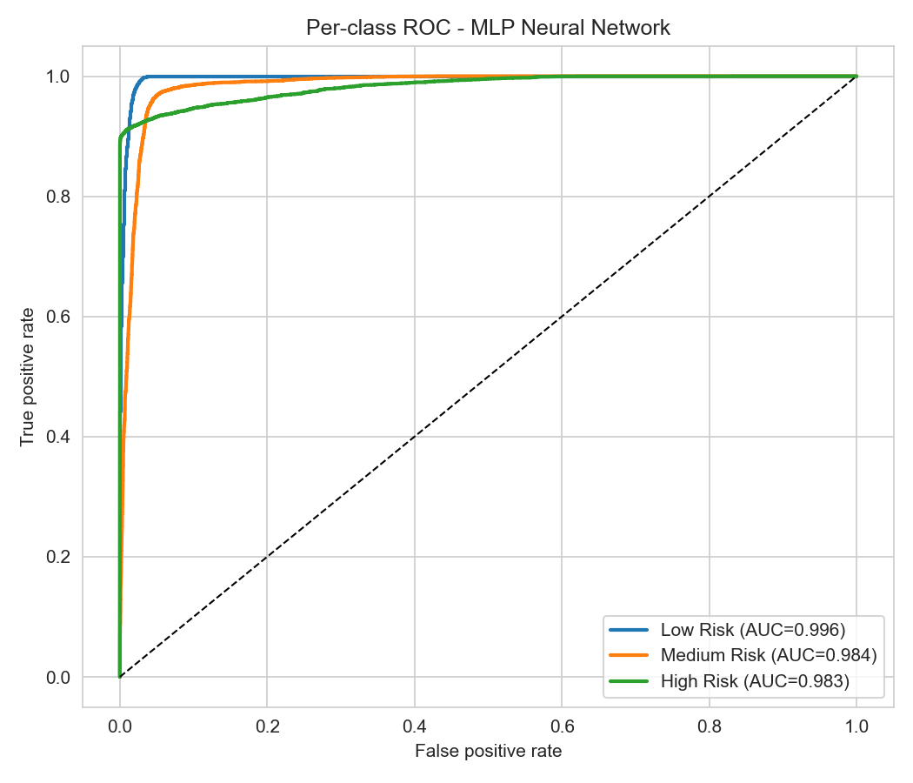
Figure 31. Per-class ROC curves of the best model (MLP Neural Network).
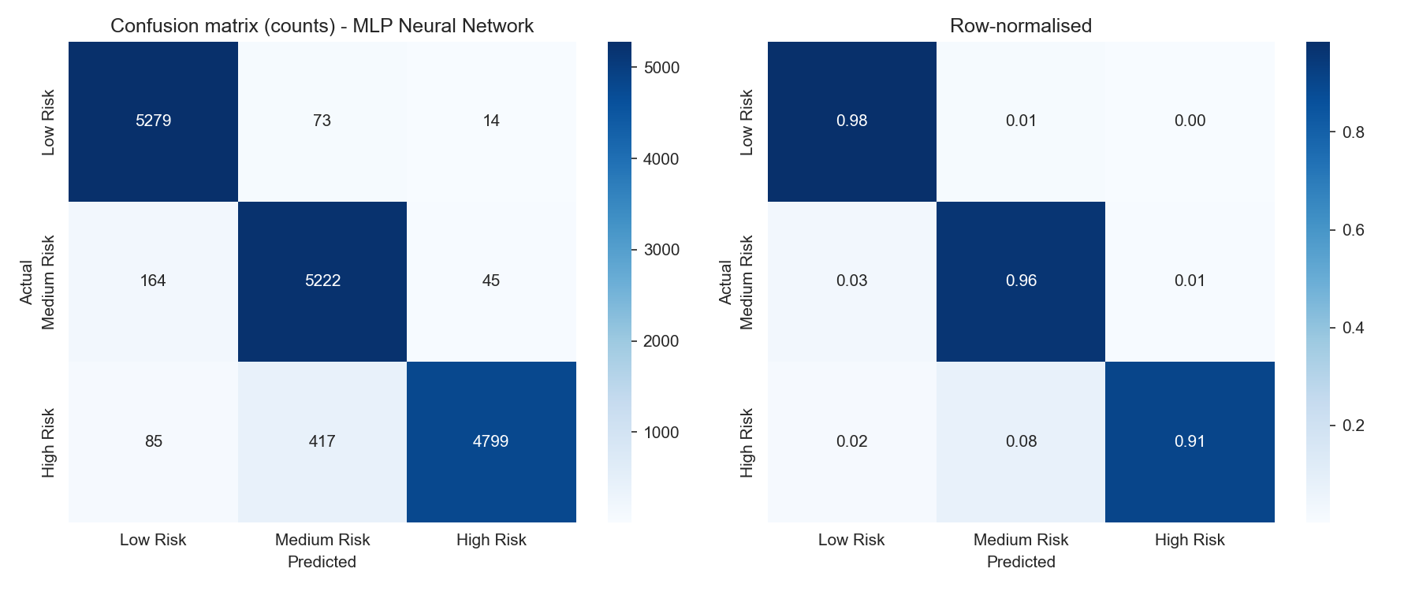
Figure 32. Confusion matrix of the best model (MLP Neural Network).
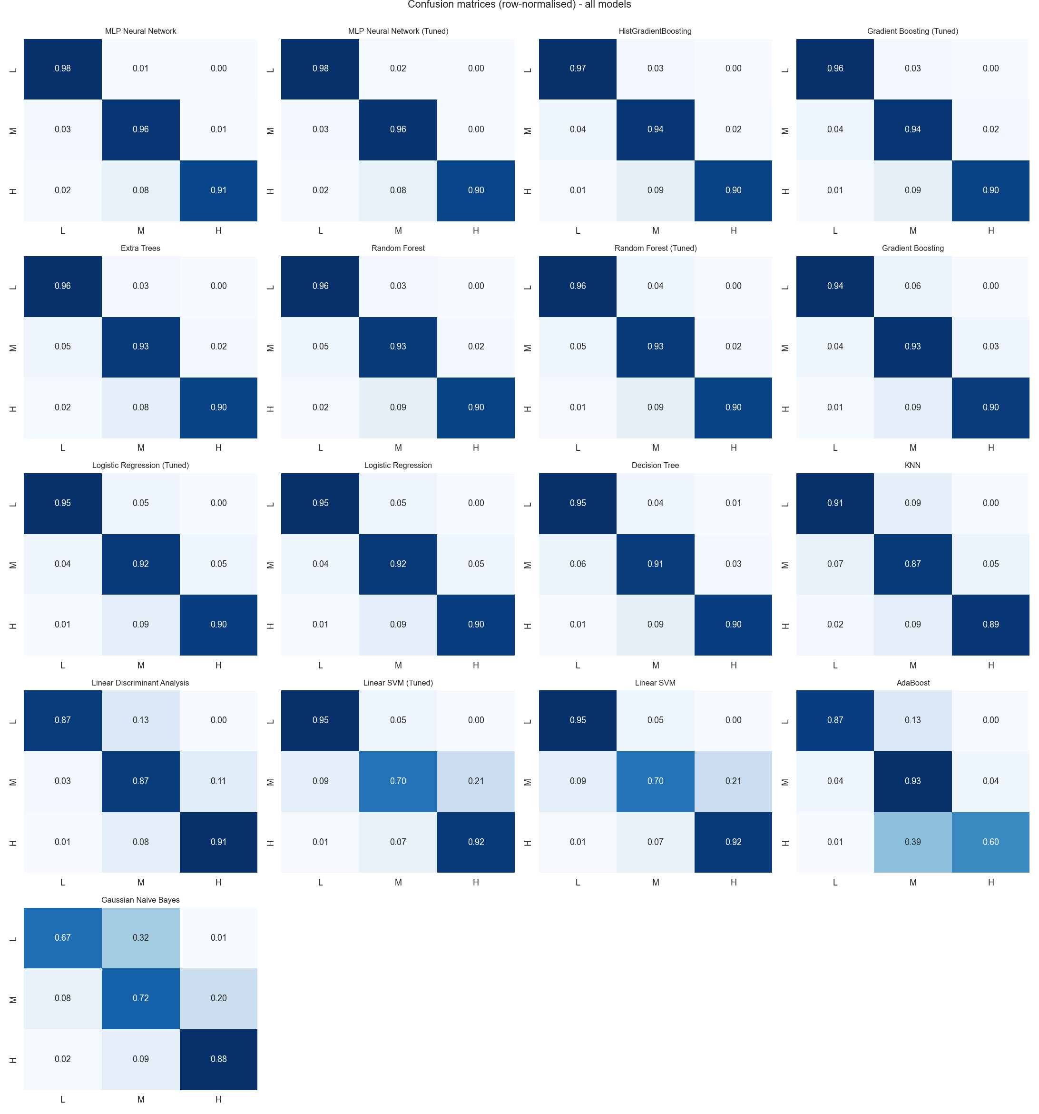
Figure 33. Row-normalised confusion matrices of all models (L = Low, M = Medium, H = High).
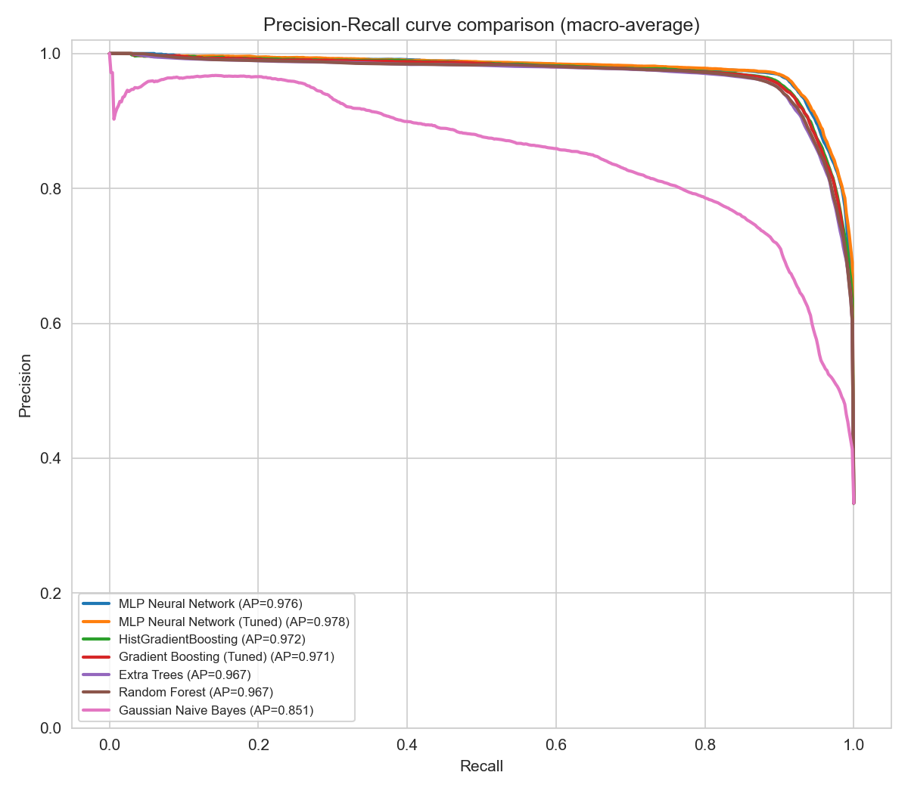
Figure 34. Macro-average Precision-Recall curves.
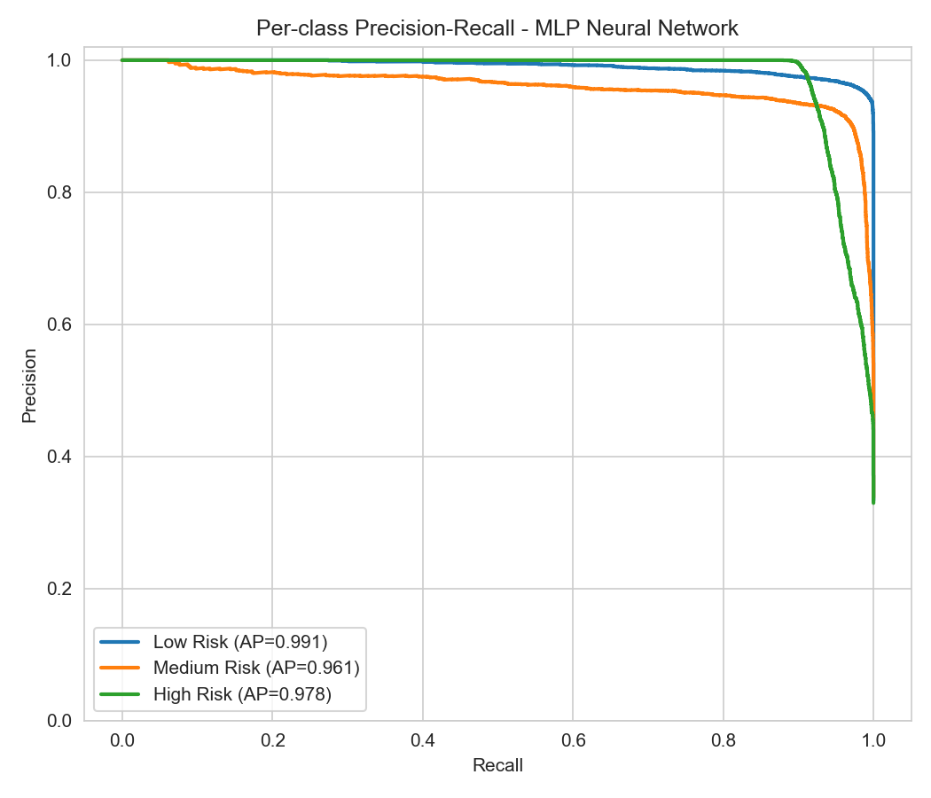
Figure 35. Per-class Precision-Recall curves of MLP Neural Network.
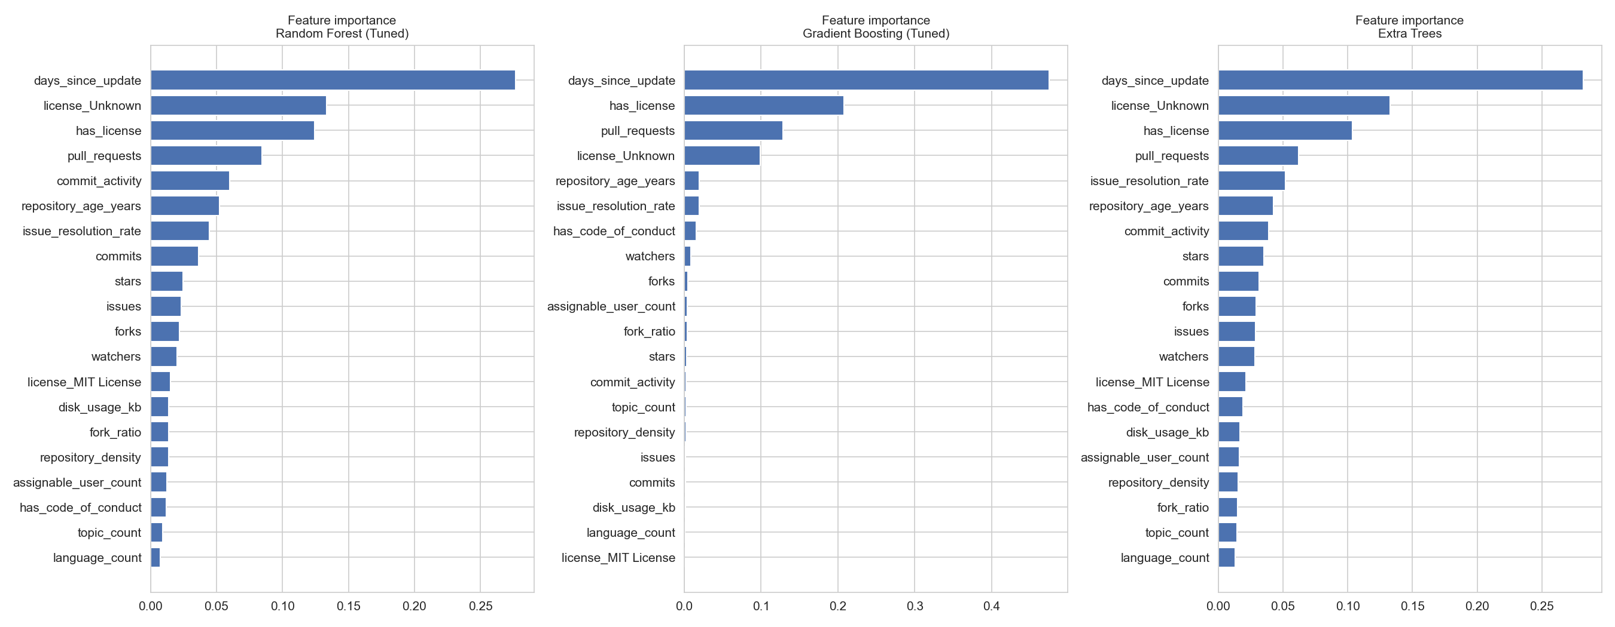
Figure 36. Built-in feature importance of tree ensembles.
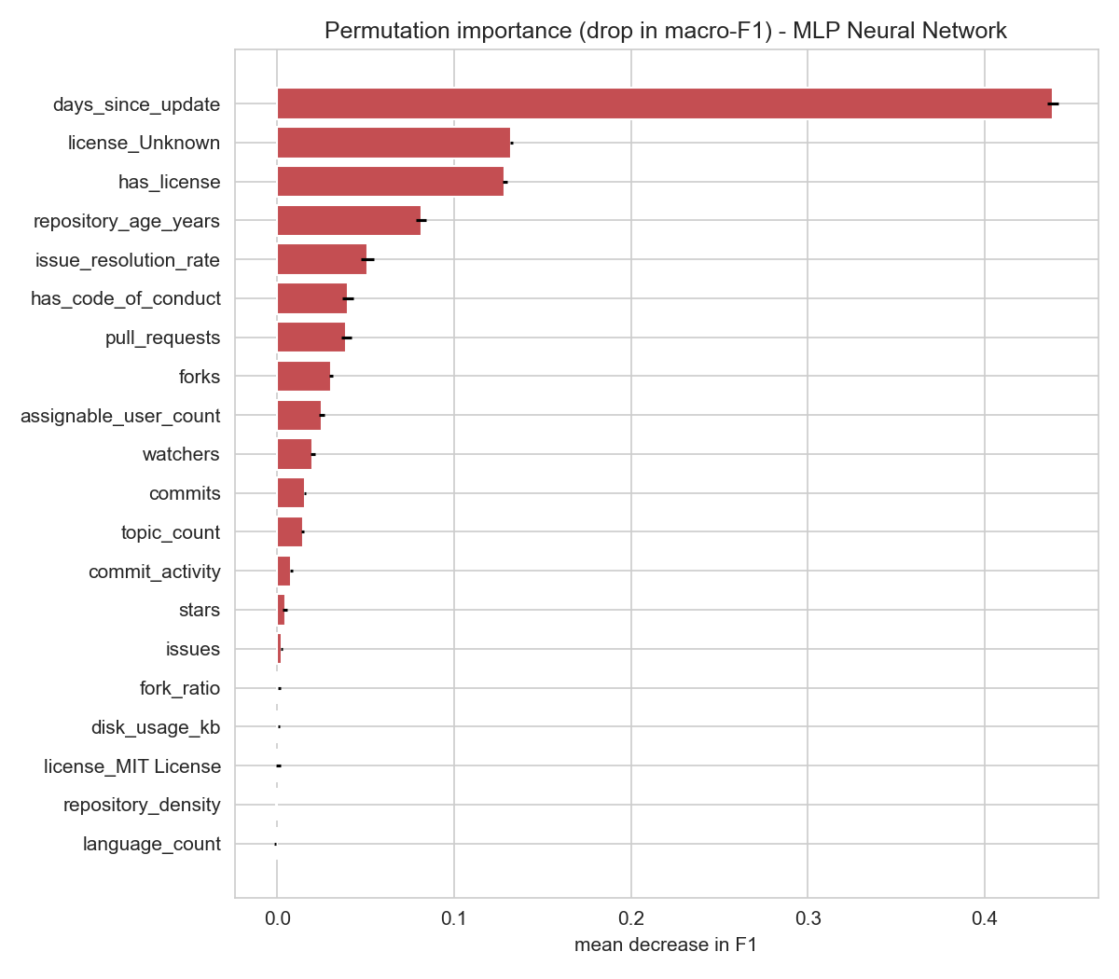
Figure 37. Permutation importance for the best model (MLP Neural Network).

21. Results Discussion (DA2)
- Best model. MLP Neural Network obtained the best macro F1 (0.9504), with an accuracy of 0.9504 and an ROC-AUC score of 0.9879. The worst-performing model is Gaussian Naive Bayes with an accuracy of 0.7564 and F1 score of 0.7574.
- Model families. The four ensembles of trees get F1 scores from 0.9239 to 0.9374, the linear models between 0.8514 and 0.9218, while MLP obtains 0.9504. So non-linear models perform better in terms of fitting the risk classes than linear models, but Logistic Regression alone is also quite competitive (F1 0.9218).
- Overfitting. Random Forest and Extra Trees obtain an accuracy of 1.0000 / 1.0000 on the training split, but only 0.9302 / 0.9311 on the test split (difference is approximately 0.070). No significant difference can be seen for linear models.
- Per-class performance of MLP Neural Network. Low Risk: precision 0.955, recall 0.984. Medium Risk: precision 0.914, recall 0.962. High Risk: precision 0.988, recall 0.905. Most errors occur between neighbouring classes (87.6% in the DA3 re-computation; Figure 32), as expected for consecutive slices of a continuous score, but not all: 85 High Risk repositories were predicted as Low Risk (Chapter 26). [Corrected in the consolidated report: the DA2 draft stated that all errors were between neighbouring classes.]
- Most important features. For the best model, permutation feature importance results in: days_since_update (0.439), license_Unknown (0.132), has_license (0.129), repository_age_years (0.081), issue_resolution_rate (0.051). The inherent importances of the tree ensembles (Fig. 12) suggest the same features: recency (days_since_update) and license information.
PART III — FINAL EVALUATION, STATISTICAL ANALYSIS AND INTERACTIVE DASHBOARD (DA3)

22. DA3 Overview: Scope, Objectives and Evaluation Plan
DA1 prepared and explored the data; DA2 built and compared the classifiers. DA3 completes the project with a reproducible final evaluation, statistical analysis, error and importance analysis, a validity audit of the heuristic target, and an interactive dashboard. Its objectives are:
• Re-evaluate the twelve DA2 classifiers (and five tuned variants) reproducibly on a single held-out test set.
• Quantify uncertainty with bootstrap confidence intervals and test whether differences between models are statistically and practically meaningful.
• Analyse errors by class and examine which features the models rely on.
• Audit the validity of the heuristic target and the predictor set for leakage.
• Deliver an interactive R Shiny + Plotly dashboard driven by exported pipeline outputs.
Scope statement. GitShield AI predicts a heuristic, metadata-derived risk category. It does not scan code, detect vulnerabilities or verify that any repository is safe.

23. Final Experimental Setup and Reproducibility Check
• Split: stratified 80:20, random_state = 42 → 64,391 training and 16,098 test repositories (unchanged from DA2).
• Preprocessing and mutual-information feature selection are fitted on the training split only and applied to the test split.
• Tercile cut-offs were computed on all rows in DA2. Recomputing them on training rows only gives identical cut-offs (0.54, 0.65) and changes 0 test labels.
• Hyper-parameters of the five tuned models are taken from the DA2 grid searches (not repeated); final models are re-fitted on the full training split.
• Metrics: accuracy, macro/weighted precision, recall and F1, per-class metrics, one-vs-rest macro ROC-AUC, confusion matrices, fit and predict time.
• Selection rule: highest test macro-F1 (ties broken by ROC-AUC). Because 17 candidates are ranked on the same test set, the winner's score is mildly optimistic.
• Reproducibility check: all 17 re-computed accuracies, macro-F1 and ROC-AUC values agree with the stored DA2 results to within 0.0011; the differences are attributable to library-version tie-breaking. No DA2 number was substituted for a re-computed one. The DA2 tables in Chapters 16–20 are therefore retained as submitted, and the DA3 tables below show the re-computed values.

24. Final Comparison of the Classifiers
Rank | Model | Accuracy | Macro P | Macro R | Macro F1 | ROC-AUC | Fit (s)
1 | MLP Neural Network | 0.9504 | 0.9523 | 0.9502 | 0.9504 | 0.9879 | 5.9
2 | MLP Neural Network (Tuned) | 0.9504 | 0.9526 | 0.9501 | 0.9504 | 0.9887 | 15.2
3 | HistGradientBoosting | 0.9379 | 0.9400 | 0.9378 | 0.9382 | 0.9858 | 3.8
4 | Gradient Boosting (Tuned) | 0.9355 | 0.9376 | 0.9354 | 0.9358 | 0.9849 | 222.2
5 | Extra Trees | 0.9304 | 0.9325 | 0.9303 | 0.9306 | 0.9831 | 4.0
6 | Random Forest (Tuned) | 0.9302 | 0.9322 | 0.9301 | 0.9304 | 0.9841 | 23.8
7 | Random Forest | 0.9296 | 0.9316 | 0.9295 | 0.9299 | 0.9838 | 11.5
8 | Gradient Boosting | 0.9233 | 0.9259 | 0.9232 | 0.9239 | 0.9820 | 63.1
9 | Logistic Regression | 0.9213 | 0.9232 | 0.9212 | 0.9218 | 0.9714 | 0.5
10 | Logistic Regression (Tuned) | 0.9213 | 0.9232 | 0.9212 | 0.9218 | 0.9714 | 0.5
11 | Decision Tree | 0.9173 | 0.9189 | 0.9172 | 0.9176 | 0.9547 | 0.5
12 | KNN | 0.8906 | 0.8929 | 0.8907 | 0.8914 | 0.9650 | 0.0
13 | Linear Discriminant Analysis | 0.8820 | 0.8869 | 0.8822 | 0.8834 | 0.9672 | 0.1
14 | Linear SVM (Tuned) | 0.8543 | 0.8554 | 0.8551 | 0.8514 | 0.9607 | 0.7
15 | Linear SVM | 0.8543 | 0.8554 | 0.8551 | 0.8514 | 0.9607 | 0.7
16 | AdaBoost | 0.8015 | 0.8457 | 0.8002 | 0.8020 | 0.8330 | 8.2
17 | Gaussian Naive Bayes | 0.7564 | 0.7691 | 0.7571 | 0.7574 | 0.9150 | 0.0
Table 2. Held-out test performance of all 17 models (12 baseline + 5 tuned), sorted by macro-F1 (re-computed in DA3).
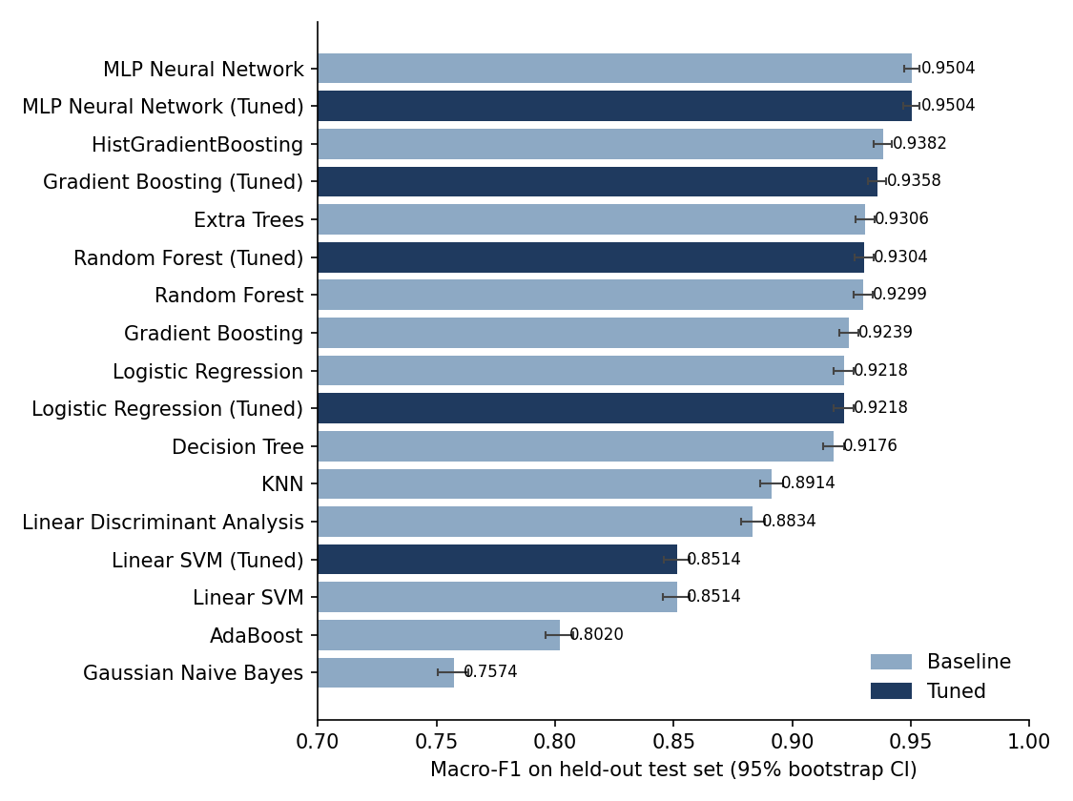
Figure 38. Macro-F1 with 95% bootstrap confidence intervals (2,000 paired resamples).
Hyper-parameter tuning. Gradient Boosting: baseline 0.9239 → tuned 0.9358; Linear SVM: baseline 0.8514 → tuned 0.8514; Logistic Regression: baseline 0.9218 → tuned 0.9218; MLP Neural Network: baseline 0.9504 → tuned 0.9504; Random Forest: baseline 0.9299 → tuned 0.9304. Tuning therefore produced no meaningful improvement for any of the five models: the tuned Logistic Regression selected the default C = 1, the tuned Linear SVM differs from the baseline on only two test predictions, and the tuned MLP changes 213 test predictions without changing accuracy (the two MLP variants differ by a single test repository). The grid searches used only 10,000 training rows and 3-fold CV, which limits their resolution.

25. Statistical Analysis and Confidence Intervals
Method. Percentile bootstrap (B = 2,000) of the test set, with the same resampled indices used for every model so that differences are paired. Models are compared on identical observations with McNemar's exact test on the discordant pairs, Holm-adjusted within each comparison family. Effect sizes are the accuracy difference with a paired-bootstrap CI, the discordant-pair odds ratio and Cohen's d_z. A difference is called practically meaningful only if it is at least one percentage point (a threshold fixed a priori).
Model | Accuracy [95% CI] | Macro-F1 [95% CI] | ROC-AUC [95% CI]
MLP Neural Network | 0.9504 [0.9473, 0.9538] | 0.9504 [0.9472, 0.9538] | 0.9879 [0.9868, 0.9892]
MLP Neural Network (Tuned) | 0.9504 [0.9469, 0.9538] | 0.9504 [0.9470, 0.9538] | 0.9887 [0.9875, 0.9898]
HistGradientBoosting | 0.9379 [0.9343, 0.9417] | 0.9382 [0.9344, 0.9419] | 0.9858 [0.9846, 0.9871]
Gradient Boosting (Tuned) | 0.9355 [0.9317, 0.9393] | 0.9358 [0.9320, 0.9396] | 0.9849 [0.9836, 0.9863]
Extra Trees | 0.9304 [0.9263, 0.9344] | 0.9306 [0.9266, 0.9346] | 0.9831 [0.9817, 0.9846]
Random Forest (Tuned) | 0.9302 [0.9261, 0.9342] | 0.9304 [0.9264, 0.9345] | 0.9841 [0.9827, 0.9854]
Random Forest | 0.9296 [0.9255, 0.9337] | 0.9299 [0.9258, 0.9339] | 0.9838 [0.9824, 0.9852]
Gradient Boosting | 0.9233 [0.9192, 0.9274] | 0.9239 [0.9198, 0.9280] | 0.9820 [0.9805, 0.9835]
Table 3. Bootstrap 95% confidence intervals for the eight leading models.
Comparator | Acc. diff, MLP − other (pp) [CI] | MLP right / other wrong | MLP wrong / other right | Holm p | Interpretation
MLP Neural Network (Tuned) | 0.01 [-0.16, 0.19] | 103 | 102 | 1.000 | No significant difference
HistGradientBoosting | 1.25 [1.02, 1.49] | 299 | 98 | < 0.001 | Significant and practically meaningful (>= 1 pp)
Gradient Boosting (Tuned) | 1.49 [1.25, 1.76] | 343 | 103 | < 0.001 | Significant and practically meaningful (>= 1 pp)
Extra Trees | 2.00 [1.73, 2.27] | 417 | 95 | < 0.001 | Significant and practically meaningful (>= 1 pp)
Random Forest (Tuned) | 2.03 [1.74, 2.30] | 425 | 99 | < 0.001 | Significant and practically meaningful (>= 1 pp)
Random Forest | 2.08 [1.80, 2.35] | 435 | 100 | < 0.001 | Significant and practically meaningful (>= 1 pp)
Gradient Boosting | 2.71 [2.40, 3.01] | 538 | 102 | < 0.001 | Significant and practically meaningful (>= 1 pp)
Table 4. MLP Neural Network versus the seven next-ranked models (McNemar exact test; Holm family size 16).
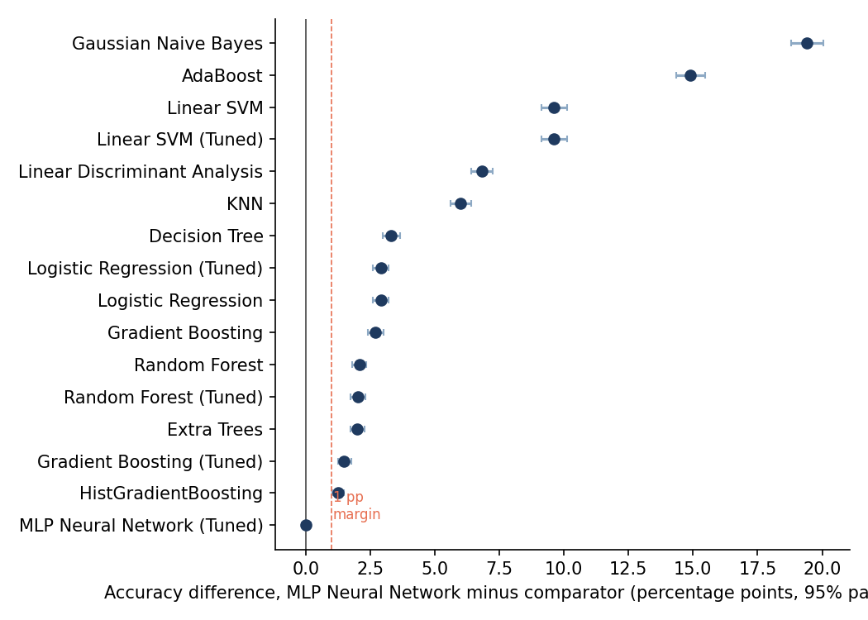
Figure 39. Paired accuracy differences with 95% bootstrap CIs; the dashed line marks the 1-pp practical margin.
Findings. (i) The two MLP variants are statistically indistinguishable (discordant pairs 103 vs 102, Holm p = 1.00); the 'best' label between them rests on a difference of about 0.00004 in macro-F1 and should not be over-interpreted. (ii) The MLP exceeds HistGradientBoosting by 1.25 pp (95% CI 1.02–1.49; Holm p < 0.001), which is both statistically significant and above the 1-pp margin. (iii) Several comparisons among lower-ranked models are significant but practically small. Statistical significance says only that an observed difference is unlikely under chance on this test set; it does not say the difference would persist for other repository populations.
Model | Acc mean | Acc SD | F1 mean | F1 SD
MLP Neural Network (Tuned config) | 0.9579 | 0.0176 | 0.9579 | 0.0176
HistGradientBoosting | 0.9457 | 0.0198 | 0.9459 | 0.0197
Extra Trees | 0.9390 | 0.0167 | 0.9391 | 0.0167
Random Forest | 0.9384 | 0.0173 | 0.9386 | 0.0173
Gradient Boosting | 0.9327 | 0.0181 | 0.9331 | 0.0179
Logistic Regression | 0.9318 | 0.0255 | 0.9322 | 0.0253
Table 5. Five-fold stratified cross-validation on the training split (preprocessing and feature selection refitted inside each fold).
Cross-validated comparison. With the Nadeau–Bengio corrected resampled t-test on the five fold scores (Holm-adjusted), the reference (MLP with the DA2 tuned configuration) differs from its closest comparator (HistGradientBoosting) by 1.20 pp macro-F1 (Holm p = 0.003) and from every other cross-validated model (Holm p ≤ 0.008). With only five folds, power is limited and the fold standard deviations are large (about 0.02), so this analysis complements rather than replaces the test-set comparison. Only six representative models were cross-validated, for computational reasons.
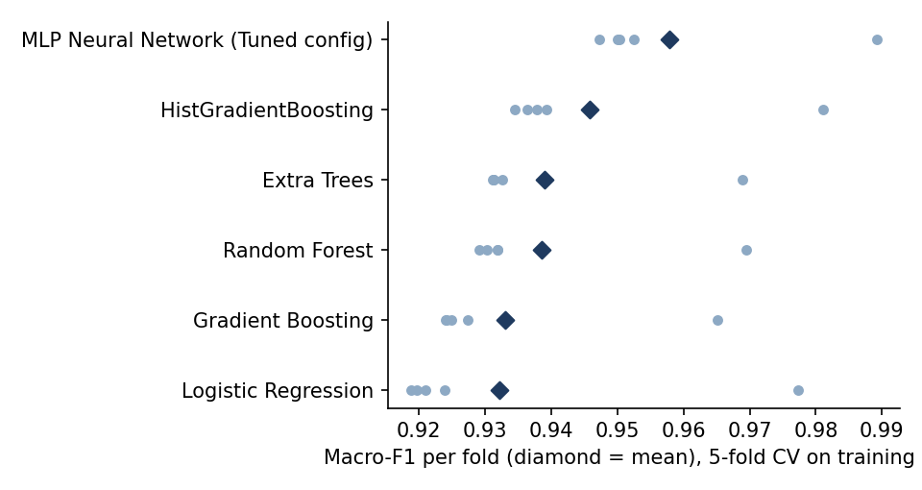
Figure 40. Fold-level macro-F1 in five-fold cross-validation (diamond = mean).

26. Confusion Matrix and Class-Level Error Analysis
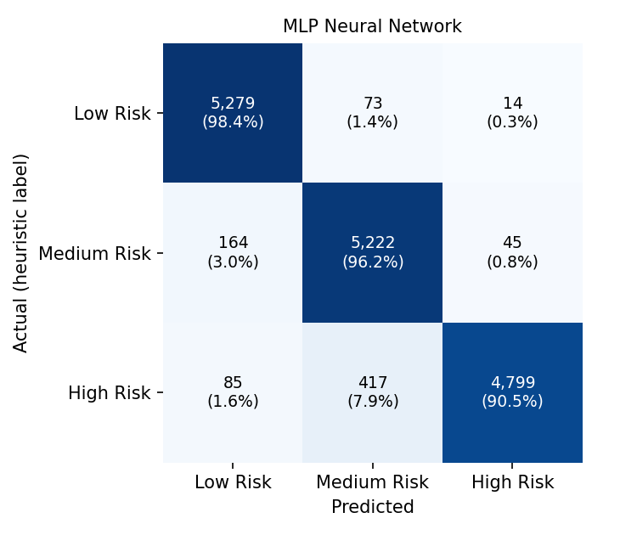
Figure 41. Confusion matrix of the MLP Neural Network on the held-out test set (DA3 re-computation).
Class | Precision | Recall | F1 | Support | ROC-AUC (OvR)
Low Risk | 0.9550 | 0.9838 | 0.9692 | 5366 | 0.9963
Medium Risk | 0.9142 | 0.9615 | 0.9373 | 5431 | 0.9843
High Risk | 0.9879 | 0.9053 | 0.9448 | 5301 | 0.9833
Table 6. Per-class metrics, MLP Neural Network.
The model makes 798 errors on 16,098 test repositories. 87.6% are between adjacent classes, as expected for an ordinal score cut into bands. The weakest pattern is High Risk recall (0.905) despite very high High Risk precision (0.988): the model is conservative about assigning High Risk, and High → Medium accounts for 52.3% of all errors. Of more concern for a risk-screening use, 85 High Risk repositories (10.7% of errors) were labelled Low Risk, so the DA2 statement that all errors are between neighbouring classes does not hold. The strongest pattern is Low Risk recall (0.984).
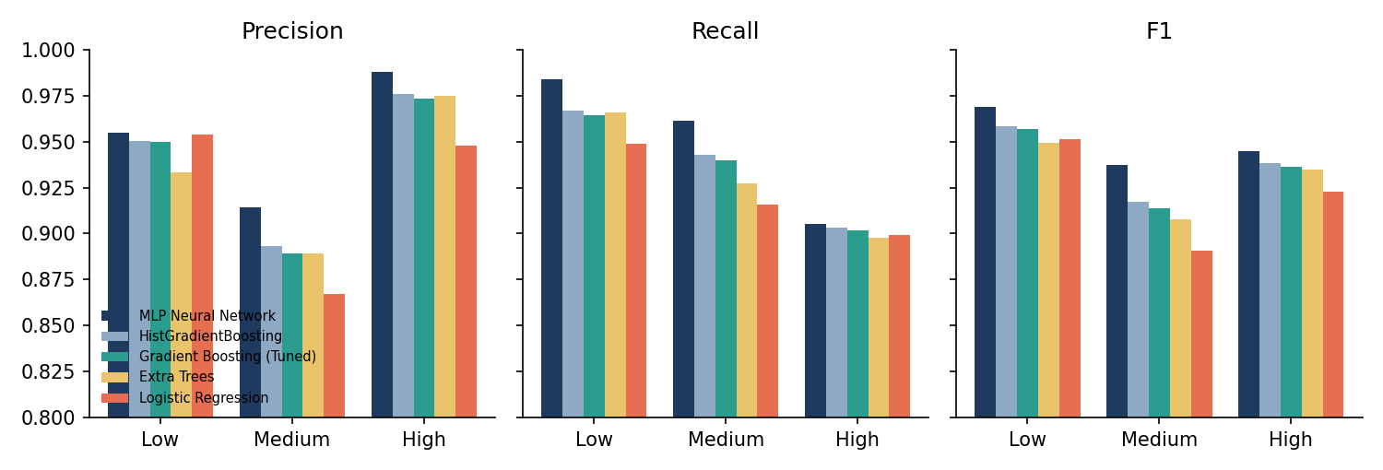
Figure 42. Per-class precision, recall and F1 for five leading models.
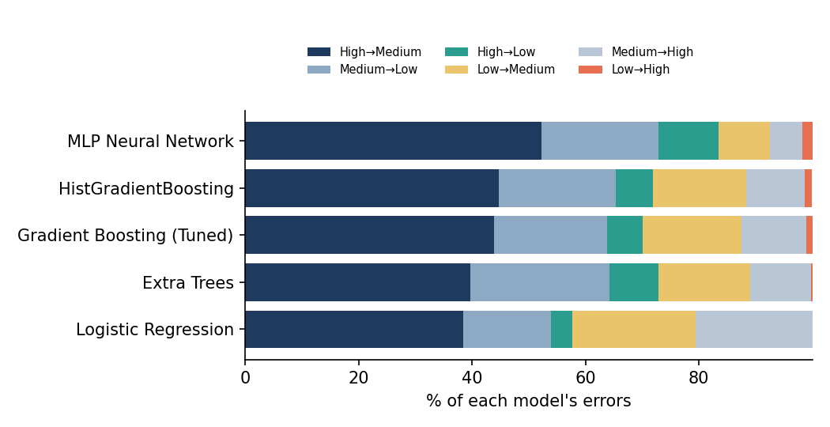
Figure 43. Composition of each model's errors by (actual → predicted) pattern.
Errors versus distance to the class cut-off. The error rate is 20.7% when the heuristic score lies within 0.005 of a cut-off, but only 28.8% of errors lie within 0.02 of a cut-off, and the median distance to the nearest cut-off is similar for errors (0.051) and correct predictions (0.049). Boundary proximity therefore explains part of the errors but not all of them; the rest reflect the model's imperfect approximation of the score formula away from the cut-offs.
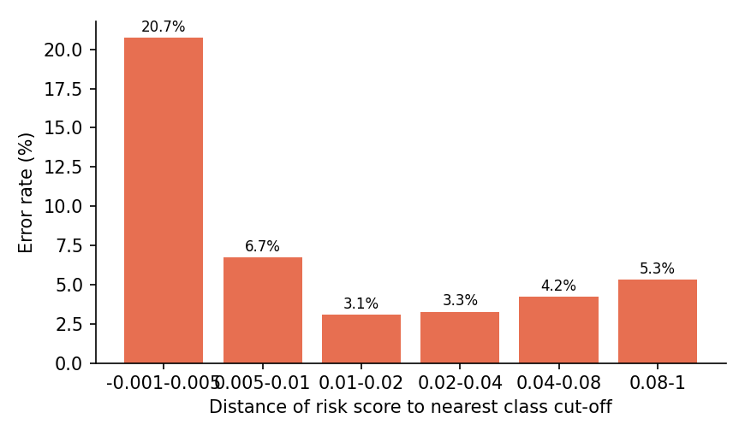
Figure 44. Test error rate of the best model by distance to the nearest class cut-off.

27. Feature Importance and Interpretation
Permutation importance (drop in macro-F1 when a feature is shuffled; 5 repeats on 5,000 test rows) was computed for seven models, and impurity importance for four tree models. Feature names come from the fitted pipeline. For the MLP Neural Network the leading features are days_since_update (0.439), license_Unknown (0.131), has_license (0.126), repository_age_years (0.085), issue_resolution_rate (0.050), pull_requests (0.043). Rankings agree reasonably across models (pairwise Spearman ρ: median 0.79, range 0.37–0.97).
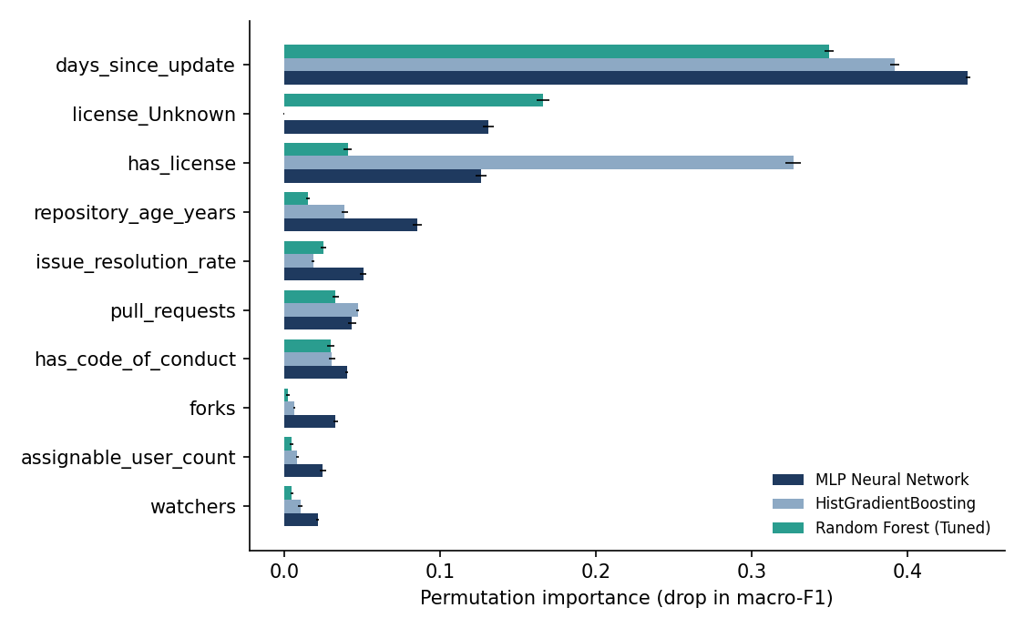
Figure 45. Permutation importance of the ten leading features for three models (± 1 SD over repeats).
Interpretation caution. Importance describes what a fitted model relies on to reproduce the label; it does not show that a feature causes repository risk, and correlated features (for example has_license and license_Unknown) share credit. Moreover, the most important features are ingredients of the label formula (Chapter 28), so the ranking largely mirrors the formula's weights and normalisations rather than an independently discovered risk factor.

28. Data-Leakage and Target-Validity Audit
This is a supplementary analysis. It does not alter the DA2 methodology or the headline results above.
• Overlap: 15 of 21 predictor columns are inputs, direct or indirect, to repository_risk_score. The composite scores themselves were correctly excluded from the predictors (Chapter 13), but their raw ingredients were not.
• Exact reconstruction: recomputing the score from the DA2 input columns reproduces the stored value with maximum absolute error 2.2e-16 on all 80,489 rows, and every class label (100% agreement).
• Minor DA1/DA2 inconsistency: 14 repositories have code-of-conduct values (the strings 'None' and 'No Code Of Conduct') that DA1 counts as present but the DA2 feature counts as absent; pandas parsed the literal 'None' as missing for 9 rows.
• Consequence: the classifiers approximate a known deterministic function from its inputs. High accuracy shows that the function is learnable; it is not evidence about real-world repository risk.
Predictor set | Dummy (class prior) | Logistic Regression | HistGradientBoosting | MLP Neural Network
A. Full DA2 predictor set (as reported) | 0.3374 | 0.9213 | 0.9379 | 0.9504
B. Without direct security flags (license, code of conduct, archived, days since update) | 0.3374 | 0.6268 | 0.6473 | 0.6439
C. Without ANY label-formula input | 0.3374 | 0.5690 | 0.5854 | 0.5896
Table 7. Test accuracy under feature ablation (same split and protocol).
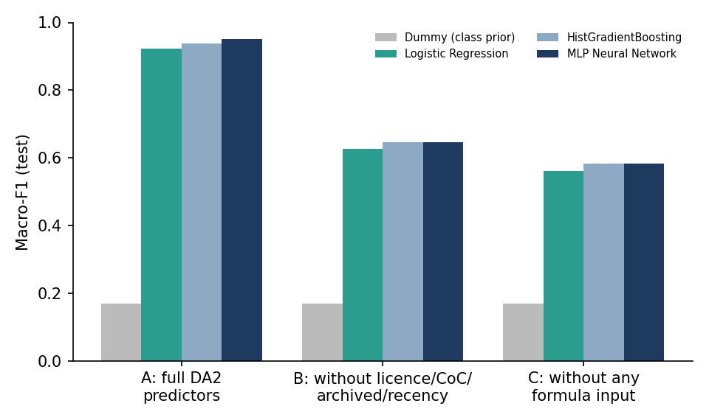
Figure 46. Macro-F1 by predictor set (A = DA2 predictors; B = without licence, code-of-conduct, archived and recency; C = without any formula input).
Even with every formula input removed, models beat the class-prior baseline (about 0.34), plausibly because the remaining metadata (for example commits and repository density) is correlated with the formula inputs (not tested here); this still does not establish that a model captures risk beyond the heuristic. A methodologically corrected design would define the target from information not used as predictors, or validate against independent outcome labels (Chapter 33).

29. Interactive Dashboard (R Shiny + Plotly)
The dashboard is an R Shiny application using Plotly, DT, dplyr and readr. It reads only pre-computed CSV/JSON files exported by the Python pipeline (DA3/dashboard/data); no model is retrained in R, and the data are loaded once at start-up and shared by all sessions.
Tab | Content
Overview | Dataset size, models evaluated, best model with CIs, class distribution, scope statement
Model comparison | Metric selector (6 metrics), bar chart with CIs, baseline vs tuned, ranking table
Classification performance | Interactive confusion matrix (counts / row %), per-class metrics, error patterns, FP/FN table
Feature importance | Method and model selectors, top-N bar chart, cross-model agreement
Repository explorer | Search; language, class, recency, age and star filters; scatter plot; searchable table with heuristic and predicted classes shown separately
Statistics & validity | CI forest plot, significance tests, label-reconstruction facts, boundary-error and ablation charts
Table 8. Dashboard tabs.
Testing. A server-logic test suite (DA3/dashboard/tests/test_server.R) renders every output across all metric, model, method and filter settings, including empty-result cases (64 checks), and the application was launched and served over HTTP. Browser screenshots must be inserted in the slots below by running the dashboard.
[INSERT SCREENSHOT — Overview tab]

[INSERT SCREENSHOT — Model comparison tab]

[INSERT SCREENSHOT — Classification performance tab (confusion matrix)]

[INSERT SCREENSHOT — Feature importance tab]

[INSERT SCREENSHOT — Repository explorer tab]

[INSERT SCREENSHOT — Statistics & validity tab]

30. Consolidated Results Discussion (DA1–DA3)
Modelling. On the DA2 protocol the MLP is the best-supported model (macro-F1 0.9504 (95% CI 0.9472–0.9538)), followed by HistGradientBoosting, tuned Gradient Boosting, Extra Trees and Random Forest. Simple linear models (Logistic Regression 0.922) are already strong, which is consistent with a label produced by a smooth weighted formula; AdaBoost (0.802) and Gaussian Naive Bayes (0.757) do worst. The MLP's advantage is plausibly explained by its ability to approximate this continuous function, and the ablation shows that all of it depends on access to the formula's inputs.
Metrics. Macro-F1 is the selection metric because the three classes matter equally and it penalises poor performance on any one class; accuracy is almost identical here only because the classes are near-balanced. Macro ROC-AUC (one-vs-rest) complements it by measuring ranking quality independent of the decision threshold.
From exploration to modelling. The DA1 findings (heavy right skew, weak popularity–age relation) motivated the log transform and scaling used in DA2, and the DA1 recency, licence and age indicators turn out to be the features the models rely on most (Chapter 27). That continuity is also the source of the validity concern: the engineered indicators that define the label are the same information the classifiers receive.
Corrections and clarifications to the DA1/DA2 text, made in place in this consolidated report:
• Chapter 21 (per-class performance): the draft said all errors occur between neighbouring classes; the re-computed confusion matrix shows 87.6% do, and 85 High Risk repositories were predicted Low Risk. The figure reference was also corrected from Figure 8 to Figure 32.
• Chapter 13 (leakage prevention): the statement that composite scores were excluded is correct, but is now qualified: their raw inputs remain predictors and the label is exactly reproducible (Chapter 28).
• Chapter 14: the selected-feature name days_since_last_update was corrected to days_since_update, the name used in the data and code.
• Chapter 11: the DA1 plan to validate the indices against abandoned repositories was not carried out; this is recorded as future work.
• Chapters 16–20 report the DA2 numbers as submitted; DA3 re-computed values differ by at most 0.0011 (library-version tie-breaking). Heading numbering and styles were also normalised (for example, two chapters numbered 19 and no chapter 20 became 19 and 20).

31. Conclusion
The project delivers a complete, reproducible workflow for repository-level analytics. DA1 produced a cleaned, feature-engineered dataset of 80,489 GitHub repositories and an exploratory analysis; DA2 stored it in SQLite, derived a three-class risk target, selected 20 of 39 features and compared 12 classifiers (5 tuned); and DA3 re-evaluated all models reproducibly, quantified uncertainty, tested differences statistically, analysed errors and feature importance, audited the target for leakage, and built an interactive R Shiny + Plotly dashboard.
The MLP Neural Network is the best-supported final model (accuracy 0.9504 (95% CI 0.9473–0.9538); macro-F1 0.9504 (95% CI 0.9472–0.9538); macro ROC-AUC 0.9879 (95% CI 0.9868–0.9892)). It is significantly and practically better than the next family, HistGradientBoosting (+1.25 pp, Holm p < 0.001), is indistinguishable from its tuned variant, and the ranking is confirmed by cross-validation. Hyper-parameter tuning added no measurable benefit.
Repository-level metadata analytics is a practical and transparent way to summarise maintenance, community and governance signals, and the dashboard makes the comparisons, uncertainty, errors and individual repositories explorable.
The validity audit sets the limit on what can be claimed. Because the label is an exact function of columns that are also model inputs, the project demonstrates that a heuristic risk score is reproducible by machine learning, not that GitShield AI detects insecure repositories. No claim of validated vulnerability detection is made. With the formula inputs removed, accuracy falls to about 0.57–0.59. The project is complete (100%) against the DA1–DA3 deliverables.

32. Limitations
• Labels are tercile bands of a heuristic score; the models learn to reproduce them, not verified vulnerabilities, and the DA1 plan to validate the indices against abandoned repositories was not carried out.
• Label construction and predictors overlap (Chapter 28); ablated accuracy is much lower.
• The dataset is a single snapshot; repository metadata change over time, and test performance does not guarantee generalisation to other repository populations or later snapshots.
• The dataset was selected from repositories with at least five stars (six cleaned rows have four), so low-visibility repositories are not represented.
• Feature importance is not causal; correlated features share importance.
• Missing metadata and class-definition choices (terciles, formula weights) affect results; DA1 and DA2 encode the code-of-conduct field differently for 14 rows.
• The test set is used both to rank 17 candidates and to report performance; tuning used a 10,000-row subsample with 3-fold CV.
• Cross-validation covers six models only, and the tuned Random Forest and Gradient Boosting configurations were not re-searched in DA3.

33. Future Scope
Completed in this project: reproducible evaluation, statistical analysis, error and importance analysis, leakage audit and interactive dashboard.
Proposed (not done):
• Evaluate against independently verified vulnerability or incident labels, and against abandoned-repository outcomes.
• Integrate vulnerability databases and dependency scanning.
• Temporal validation using later repository snapshots.
• Probability calibration and uncertainty estimation.
• Repository-level explanations (for example SHAP-style) and a redesigned target that excludes its own inputs.
• Periodic dataset refreshes.

34. References
- Borges, H., Hora, A., & Valente, M. T. (2016). Predicting the popularity of GitHub repositories. In Proceedings of the 12th International Conference on Predictive Models and Data Analytics in Software Engineering (PROMISE 2016) (pp. 1–10). ACM.
- Breiman, L. (2001). Random forests. Machine Learning, 45, 5–32.
- Chen, D., Stolee, K. T., & Menzies, T. (2019). Replication can improve prior results: A GitHub study of pull request acceptance. In Proceedings of the 27th IEEE/ACM International Conference on Program Comprehension (ICPC 2019) (pp. 179–190). IEEE.
- Dietterich, T. G. (1998). Approximate statistical tests for comparing supervised classification learning algorithms. Neural Computation, 10(7), 1895–1923.
- Efron, B., & Tibshirani, R. J. (1993). An introduction to the bootstrap. Chapman & Hall.
- He, R., Ye, H., & Zhou, M. (2024). Revealing the value of repository centrality in lifespan prediction of open source software projects (arXiv:2405.07508). arXiv. https://arxiv.org/abs/2405.07508
- Holm, S. (1979). A simple sequentially rejective multiple test procedure. Scandinavian Journal of Statistics, 6(2), 65–70.
- Kaggle. (n.d.). GitHub repository metadata with 5+ stars [Data set]. Retrieved 2026, from https://www.kaggle.com/datasets/pelmers/github-repository-metadata-with-5-stars
- Kalliamvakou, E., Gousios, G., Blincoe, K., Singer, L., German, D. M., & Damian, D. (2016). An in-depth study of the promises and perils of mining GitHub. Empirical Software Engineering, 21(5), 2035–2071. https://doi.org/10.1007/s10664-015-9393-5
- McNemar, Q. (1947). Note on the sampling error of the difference between correlated proportions or percentages. Psychometrika, 12(2), 153–157.
- Nadeau, C., & Bengio, Y. (2003). Inference for the generalization error. Machine Learning, 52, 239–281.
- Pedregosa, F., et al. (2011). Scikit-learn: Machine learning in Python. Journal of Machine Learning Research, 12, 2825–2830.
- Sievert, C. (2020). Interactive web-based data visualization with R, plotly, and shiny. Chapman & Hall/CRC.
- Vidoni, M. (2022). A systematic process for Mining Software Repositories: Results from a systematic literature review. Information and Software Technology, 144, Article 106791. https://doi.org/10.1016/j.infsof.2021.106791

Appendix A. Reproducibility and Execution Instructions
Full instructions are in DA3/README.md. In brief, from the repository root:
• DA2 (unchanged): run_da2.py with gitshield.db, outputs/ and requirements.txt.
• pip install -r requirements.txt statsmodels matplotlib python-docx joblib; Rscript -e 'install.packages(c("shiny","bslib","plotly","dplyr","readr","DT","jsonlite"))'
• python DA3/evaluation/01_train_and_evaluate.py (17 models, metrics, predictions)
• bash DA3/evaluation/run_all_after_training.sh (statistics, audit, importance, dashboard export, cross-validation)
• python DA3/report/make_figures.py; python DA3/report/build_consolidated_report.py (figures and this report)
• Rscript DA3/dashboard/run.R (dashboard); Rscript DA3/dashboard/tests/test_server.R (tests)

