GDG-2CC PROJECT
NAME: ARYAMAN SRIRAM
REG NO.: 17BCE2113

ABSTRACT
The project aims plot the real time position the International Space Station over a 2D Map of the Earth and also give the user information about the astronauts currently on board the ISS.

INTRODUCTION

METHODOLOGY
- Basic Concept
Data regarding the astronauts and the position of the ISS is fetched using the requests library and stored in the form of a dictionary. This positioning data is then fetched from the dictionary and plotted on a basemap generated using the cartopy library. Plotting is done using the matplotlib.pyplot module.
- Block Diagram
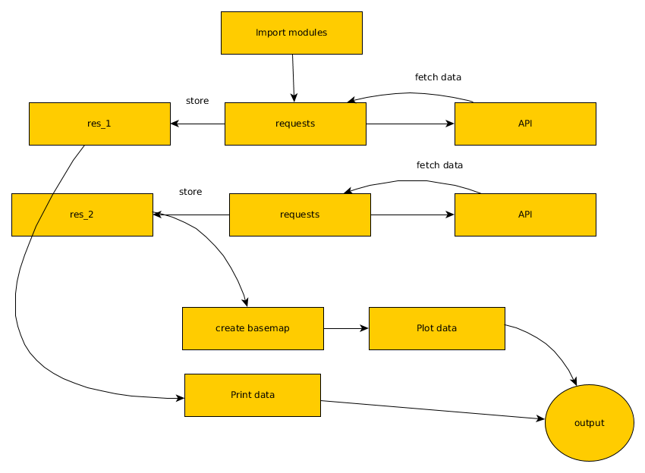
Code Implemented
#!/usr/bin/env python3
# -*- coding: utf-8 -*-
"""
Created on Sun Mar 17 17:42:19 2019

@author: aryaman
"""
#import modules
import requests
import cartopy.crs as ccrs
import matplotlib.pyplot as plt
import matplotlib.animation as animation

#fetch data of astronauts
res_1 = requests.get('http://api.open-notify.org/astros.json')
data_ISS = dict(res_1.json())
people = []

for i in data_ISS['people']:
people.append(i['name'])

#fetch data of ISS Position
res_2 = requests.get('http://api.open-notify.org/iss-now.json')
data_ISS_pos = dict(res_2.json())

iss_pos_lat = data_ISS_pos['iss_position']['latitude']
iss_pos_long = data_ISS_pos['iss_position']['longitude']

#Plot
fig = plt.figure()
ax = plt.axes(projection=ccrs.Mollweide())
ax.stock_img()

ax.plot([iss_pos_lat, iss_pos_long],color='blue', linewidth=2, marker='o',transform=ccrs.Geodetic())

plt.show()

#Print names of astronauts
print("The ISS Heroes are:-")
for i in people:
print(i)

- API’s Used
  - http://api.open-notify.org/astros.json (Names of Astronauts)
  - http://api.open-notify.org/iss-now.json (Position of the ISS)

Result of the execution

