Cycle 1

Write a syntax and usage the directory management commands with
all options.

Command: ls ,Command cd,command mkdir,command pwd

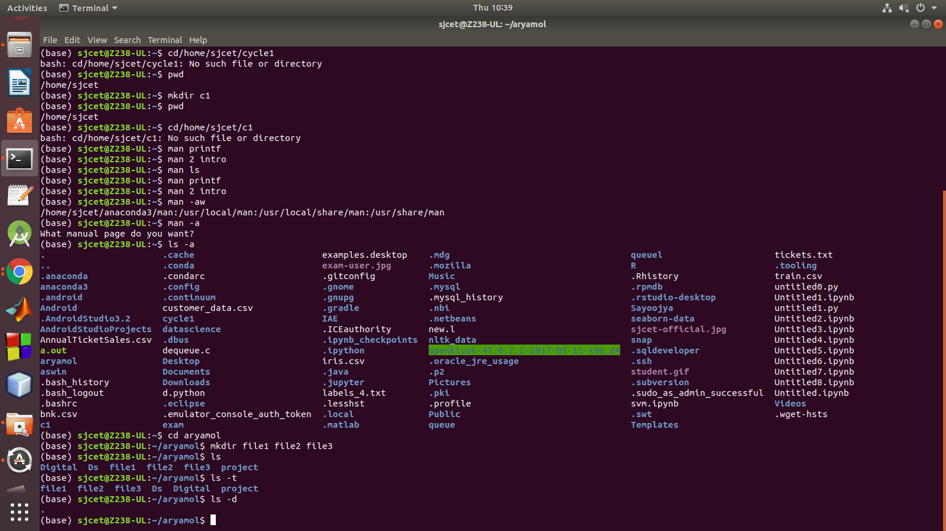

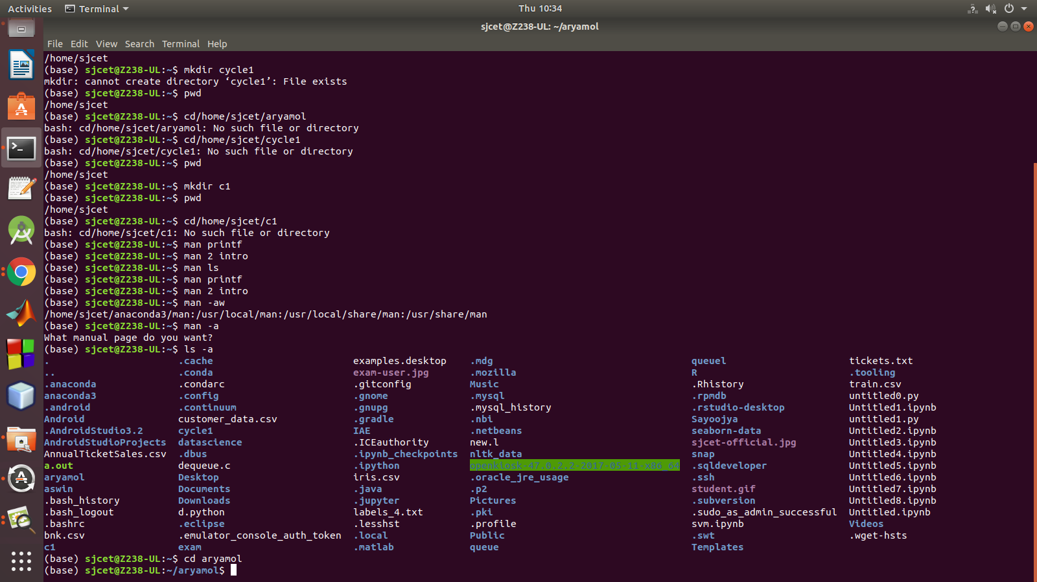
command man- man printf ,man 2 intro,man ls

