**NAME:** ARYAN KORE

**PRN:** 22070122101

**BATCH:** 2022-26

**CLASS:** CS-B1

**DATE OF SUBMISSION:** 29/08/2023

**TITLE OF THE ASSIGNMENT:** IMPLEMENT THE FOLLOWING SORTING TECHNIQUES AND FIND THE TIME COMPLEXITY: (i) BUBBLE (ii) SELECTION (iii) INSERTION

**THEORY:** DISCUSS THE BEST CASE, WORST CASE TIME COMPLEXITIES OF BUBBLE, SELECTION AND INSERTION SORT.

**PROGRAM:**

1. BUBBLE SORT

TIME COMPLEXITY:

1. Best case: O(n^2)
2. Average case: O(n^2)
3. Worst case: O(n^2)

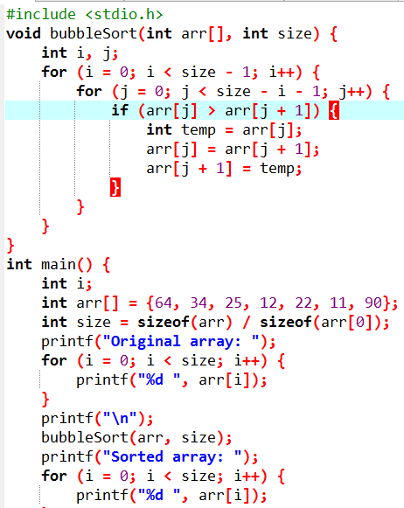

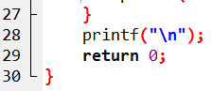

**OUTPUT:**

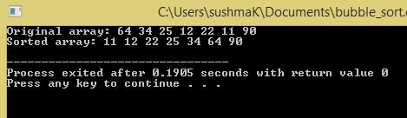

1. **SELECTION SORT:**

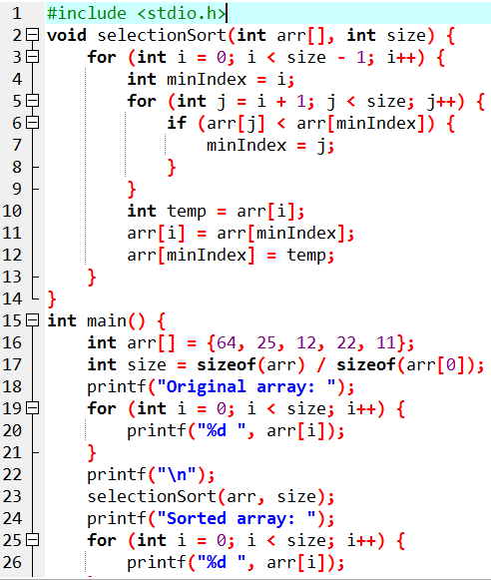

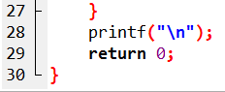

**OUTPUT:**

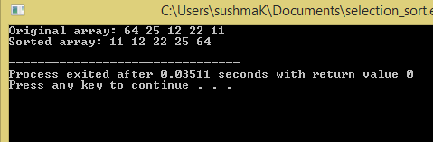

**TIME COMPLEXITY:**

1. Best case: O(n^2)
2. Average case: O(n^2)
3. Worst case: O(n^2)
4. **INSERTION SORT:**

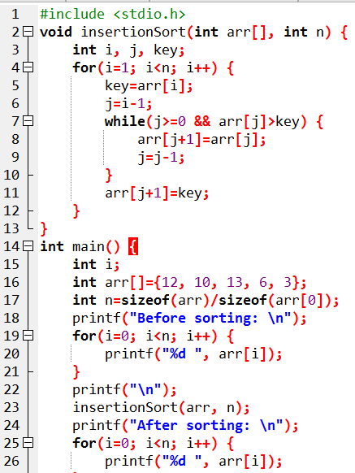

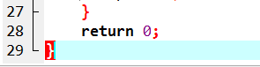

**OUTPUT:**

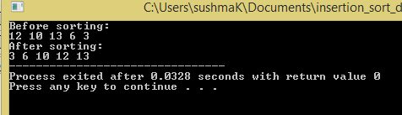

**TIME COMPLEXITY:**

1. Best case: O(n)
2. Average case: O(n^2)
3. Worst case: O(n^2)

**CONCLUSION:** Thus we have studies different sorting algorithms and their time complexities.