**NAME:** ARYAN KORE

**PRN:** 22070122101

**BATCH:** 2022-26

**CLASS:** CS-B1

**DATE OF SUBMISSION:** 29/08/2023

**TITLE OF THE ASSIGNMENT:** IMPLEMENT MERGE SORT AND FIND ITS TIME COMPLEXITY

**THEORY**: DISCUSS THE BEST CASE, AVERAGE CASE AND WORST CASE TIME COMPLEXITY OF MERGE SORT

**PROGRAM:**

**TIME COMPLEXITY:**

1. Best case: O(n log n)
2. Average case: O(n log n)
3. Worst case: O(n log n)

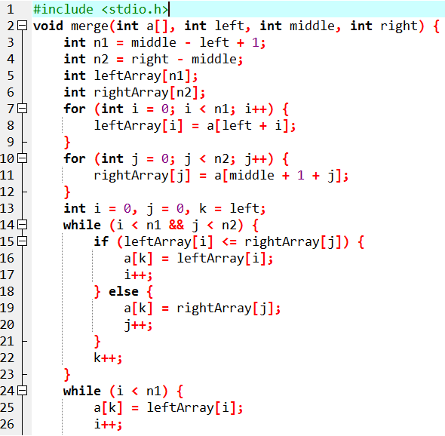

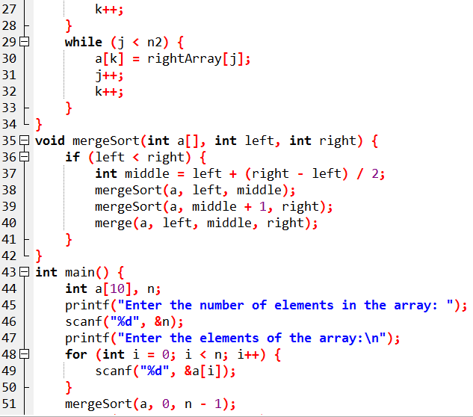

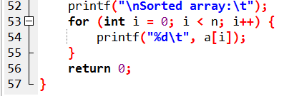

**OUTPUT:**

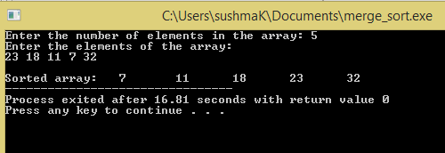

**CONCLUSION:** Thus we have studies merge sort algorithm and their time complexities.