NLP CS60075 — Assignment II
Project 1: N-gram Language Modeling, Smoothing, and Neural LM Reproduction
Assigned Dataset: DailyDialog
[Group Number / Member Names — fill in before submission]
Submission Date: November 8, 2026

1. Introduction
This report documents our work on Project 1 of Assignment II, using the DailyDialog dataset. The project is organized into three tasks performed on the same corpus: a classical smoothed n-gram language model (Task 1), a reproduction of the AWD-LSTM neural language model from Merity et al. (2017) (Task 2), and a linear interpolation of the two (Task 3). All three models are evaluated on held-out perplexity and on BLiMP, a grammaticality-judgment benchmark, using an identical set of nine paradigms throughout.
The central empirical question we investigate, following the assignment's own framing, is whether a neural language model that handles unseen word sequences gracefully still benefits from classical smoothing once the two are combined. Our results give a clear answer for this corpus: yes, the combination is substantially better than either model alone on perplexity, even though the two models perform almost identically when judged separately.

1.1 Dataset Preprocessing
DailyDialog consists of 11,118 training dialogues, 1,000 validation dialogues, and 1,000 test dialogues, each a sequence of alternating utterances with no speaker labels in our processed form. Each dialogue was joined into a single document by concatenating its utterances with a single space, with no speaker tags inserted, per the dataset specification. Text was lowercased and tokenized with a punctuation-aware whitespace tokenizer. The vocabulary was built from the training split only, capped at 30,000 tokens with a minimum count of 2; in practice the cap did not bind, since the training split contains only 18,266 unique raw tokens, yielding a final vocabulary of 12,482 tokens including four special tokens (<unk>, <s>, </s>, <pad>). The resulting token streams, with sentence boundaries inserted once per dialogue, contain 1,201,536 training tokens, 110,872 validation tokens, and 108,079 test tokens.
Two corpus-specific preprocessing issues were identified and corrected during development. First, DailyDialog mixes straight and curly Unicode apostrophes and frequently writes contractions with spaces around the apostrophe (for example, “Let ’ s go” rather than “Let’s go”); left uncorrected, this silently breaks contraction detection and pollutes the vocabulary with spurious single-character tokens. Both apostrophe styles were normalized and the spacing artifact was removed before tokenization. Second, a small number of abbreviations and acronyms are written with spaces between individual letters (for example, “T V” or “U . S .”); this affects well under 0.1% of training tokens and was left uncorrected, consistent with the dataset document's own instruction elsewhere not to silently alter corpus-specific orthographic conventions.

1.2 Evaluation Protocol
Perplexity is computed over a token stream in which each dialogue is wrapped with a single sentence-start and sentence-end marker (<s> and </s>), rather than inserting these markers around every individual utterance. Every token in the stream is scored except <s>, which only ever occurs as context and is never a prediction target; </s> is scored. This convention is shared, without exception, by the n-gram evaluator, the AWD-LSTM evaluator, and the Task 3 hybrid, which is what allows the three models' perplexities to be compared directly and their per-token probabilities to be interpolated position by position.
BLiMP accuracy was computed identically across all three tasks using nine paradigms spanning BLiMP's three broad categories: anaphor_gender_agreement, determiner_noun_agreement_1, and regular_plural_subject_verb_agreement_1 (morphology); wh_island, npi_present_1, and left_branch_island_simple_question (syntax); principle_A_domain_1, drop_argument, and existential_there_quantifiers_1 (semantics). For each minimal pair, both sentences were tokenized with the DailyDialog vocabulary (mapping out-of-vocabulary words to <unk>), and length-normalized log-probability was compared; a pair was scored correct only if the model's probability for the grammatical sentence was strictly greater than for the ungrammatical one, with ties counted as incorrect.

2. Task 1: Smoothed N-gram Language Model

2.1 Method
Count tables were built for unigrams through 4-grams from the training stream. Three smoothing families were implemented on top of these shared counts: Add-k smoothing for k ∈ {1, 0.5, 0.1}; Good-Turing discounting, re-estimating probability mass for n-grams occurring five or fewer times and backing off to the next lower order for unseen n-grams; and interpolated Kneser-Ney smoothing with a fixed discount d = 0.75. Following the project's own guidance on scope, we report results for trigram and 4-gram orders rather than the full bigram-through-4-gram matrix, to keep the sweep focused while still covering the orders most relevant to Tasks 2 and 3.

2.1.1 Deviations and assumptions
- The assignment specifies both a fixed Kneser-Ney discount (d = 0.75) and a separately tuned interpolation weight λ, which is redundant under the standard formulation of interpolated KN (the back-off weight is normally derived from d automatically). We resolved this by implementing standard recursive interpolated KN with d = 0.75 fixed, and then applying one additional global interpolation with the unigram distribution, P_final = λ·P_KN + (1−λ)·P_unigram, with λ tuned by grid search over {0.1, …, 0.9} on the validation split.
- Good-Turing has no defined estimate for unseen n-grams (r = 0) under the standard formula; we back off to the next lower order's estimate in this case, a simplified single-level back-off rather than full Katz backoff with its own per-level discounting.
- Sentence boundaries are inserted once per dialogue rather than once per utterance, consistent with the instruction to join a dialogue's utterances with no speaker or turn markers.

2.2 Results
Table 1 reports test-set perplexity for all five smoothing variants at trigram and 4-gram order.
Order | Variant | Test Perplexity
Trigram | Add-k (k=1.0) | 2038.17
Trigram | Add-k (k=0.5) | 1384.35
Trigram | Add-k (k=0.1) | 559.82
Trigram | Good-Turing | 59.84
Trigram | Kneser-Ney (λ=0.9) | 45.57
4-gram | Add-k (k=1.0) | 5198.21
4-gram | Add-k (k=0.5) | 3962.37
4-gram | Add-k (k=0.1) | 1911.63
4-gram | Good-Turing | 61.17
4-gram | Kneser-Ney (λ=0.9) | 33.06
Table 1. Test-set perplexity for all five smoothing variants, trigram and 4-gram order.
Add-k smoothing performs worst across the board, and performance degrades further as k increases toward 1 — the opposite of what might be expected from the amount of smoothing applied. This is consistent with Add-k's known weakness on large vocabularies: a larger k redistributes more probability mass to unseen events than the data supports, over-penalizing the many n-grams that were in fact observed. Good-Turing improves on the best Add-k variant by roughly an order of magnitude at both orders, directly reflecting the assignment's own framing of the data-sparsity problem that motivates smoothing in the first place. Interpolated Kneser-Ney performs best overall, and its advantage grows at 4-gram order (33.06) relative to trigram (45.57), indicating that KN's handling of sparsity is strong enough that the additional context from a higher order is a net benefit rather than a liability.
The best model by validation perplexity is 4-gram Kneser-Ney (validation perplexity 34.45). We did not separately compute validation perplexity for Good-Turing and Add-k, since Kneser-Ney's validation perplexity already undercuts Good-Turing's test perplexity (61.17) and is roughly 55 times better than the strongest Add-k variant's test perplexity; given this margin, the ranking is unambiguous without further computation. All subsequent references to “the Task 1 model” refer to 4-gram Kneser-Ney with λ = 0.9.

2.3 BLiMP Evaluation
Paradigm | Field | Accuracy
anaphor_gender_agreement | Morphology | 0.310
determiner_noun_agreement_1 | Morphology | 0.533
regular_plural_subject_verb_agreement_1 | Morphology | 0.462
wh_island | Syntax | 0.618
npi_present_1 | Syntax | 0.464
left_branch_island_simple_question | Syntax | 0.286
principle_A_domain_1 | Semantics | 1.000
drop_argument | Semantics | 0.465
existential_there_quantifiers_1 | Semantics | 0.910
Overall | — | 0.561
Table 2. BLiMP accuracy by paradigm, 4-gram Kneser-Ney model.
Overall accuracy (56.1%) is only slightly above chance, which is expected: DailyDialog's small, casual-register vocabulary is a poor match for BLiMP's curated, often formal test sentences, and a substantial fraction of BLiMP tokens fall outside the DailyDialog vocabulary. More informative than the aggregate figure is the paradigm-level pattern, which is bimodal rather than uniformly mediocre: principle_A_domain_1 reaches 100% while anaphor_gender_agreement and left_branch_island_simple_question fall below chance, at 31.0% and 28.6% respectively.
Inspection of individual pairs clarifies why. In principle_A_domain_1, every minimal pair contrasts a plain pronoun against a reflexive (for example, “…has discussed her” versus “…has discussed herself”). Plain pronouns are far more frequent than reflexives in casual dialogue, so the model's frequency-driven preference happens to coincide with grammaticality on every pair in this paradigm — the model is not demonstrating an understanding of Principle A, it is exploiting a frequency asymmetry that happens to align with correctness here. In anaphor_gender_agreement, by contrast, the task requires selecting the pronoun whose gender matches the sentence's subject; the n-gram model has no mechanism for tracking a grammatical feature like gender across a sentence, so it defaults to whichever variant is more frequent overall (typically “himself” or “him”), which is correct only when the subject happens to be male. This produces systematic, below-chance error rather than noise. The general pattern is that the n-gram model's BLiMP performance is governed almost entirely by raw token frequency rather than by any grammatical structure, succeeding only where frequency and grammaticality happen to align.

3. Task 2: AWD-LSTM Reproduction

3.1 Method
We reproduced the AWD-LSTM architecture of Merity et al. (2017) as a 3-layer LSTM with embedding dimension 400 and hidden dimension 1150, with input embedding and output softmax weights tied. The architecture was implemented from scratch against the paper's description rather than adapted from the official repository, which relies on PyTorch internals that are no longer compatible with current versions of the library. Three regularizers specified in the assignment were implemented: DropConnect (p = 0.5) on each layer's hidden-to-hidden weight matrix, embedding dropout (p = 0.1), which zeroes entire embedding rows rather than individual activations, and locked output dropout (p = 0.4), which reuses a single dropout mask across all timesteps in a sequence. The model was trained with NT-ASGD (non-monotonically triggered averaged SGD), initial learning rate 30, batch size 80, BPTT length 70, and gradient clipping at norm 0.25, for 50 epochs. The resulting model has 25,216,882 parameters.
DropConnect was implemented by temporarily mutating the relevant weight tensor's underlying data in place before each forward pass and restoring the original values immediately afterward, rather than by replacing the parameter object itself. This avoids a known failure mode in which a dropout-masked weight is substituted into a module's parameter registry as a non-leaf tensor, which later causes the optimizer to reject it outright; the approach was validated by confirming that gradients still flow correctly to the underlying weight after backpropagation.

3.1.1 Deviations and assumptions
- Activation and temporal activation regularization (AR/TAR), part of the full paper but not named in the assignment's step-by-step instructions, were not implemented, consistent with building exactly what the specification lists.
- The non-monotonic interval for NT-ASGD's trigger condition is not specified in the assignment; we used the paper's own default of five epochs.
- Hidden size 1150 (the paper's full specification) was used throughout; the compute-constrained fallback of 400 permitted by the assignment was not needed, since training completed in a reasonable time on a single consumer GPU.
- Training ran for 50 epochs rather than the paper's 500, as explicitly permitted by the assignment, given the much smaller scale of DailyDialog relative to the paper's original corpora.

3.2 Training
Training was stable throughout, with no divergence or numerical instability. Validation perplexity fell from 292.5 after the first epoch to 38.78 by epoch 17. NT-ASGD's averaging trigger activated at epoch 18, after which the averaged-weight validation perplexity was consistently lower than the raw SGD trajectory, improving smoothly and without reversal for the remainder of training, from 35.22 at epoch 19 to a final 30.05 at epoch 50. Figure 1 plots this trajectory.
Epoch | Train PPL | Val PPL (raw) | Val PPL (averaged)
1 | 824.91 | 292.50 | —
10 | 70.09 | 48.15 | —
17 | 54.61 | 38.78 | —
18 (trigger) | 53.42 | 39.33 | —
25 | 47.10 | 35.43 | 33.27
35 | 42.92 | 32.49 | 31.50
50 | 39.87 | 30.85 | 30.05
Table 3. Selected epochs from the training trajectory. Averaged validation perplexity is reported only from the epoch following the NT-ASGD trigger onward.
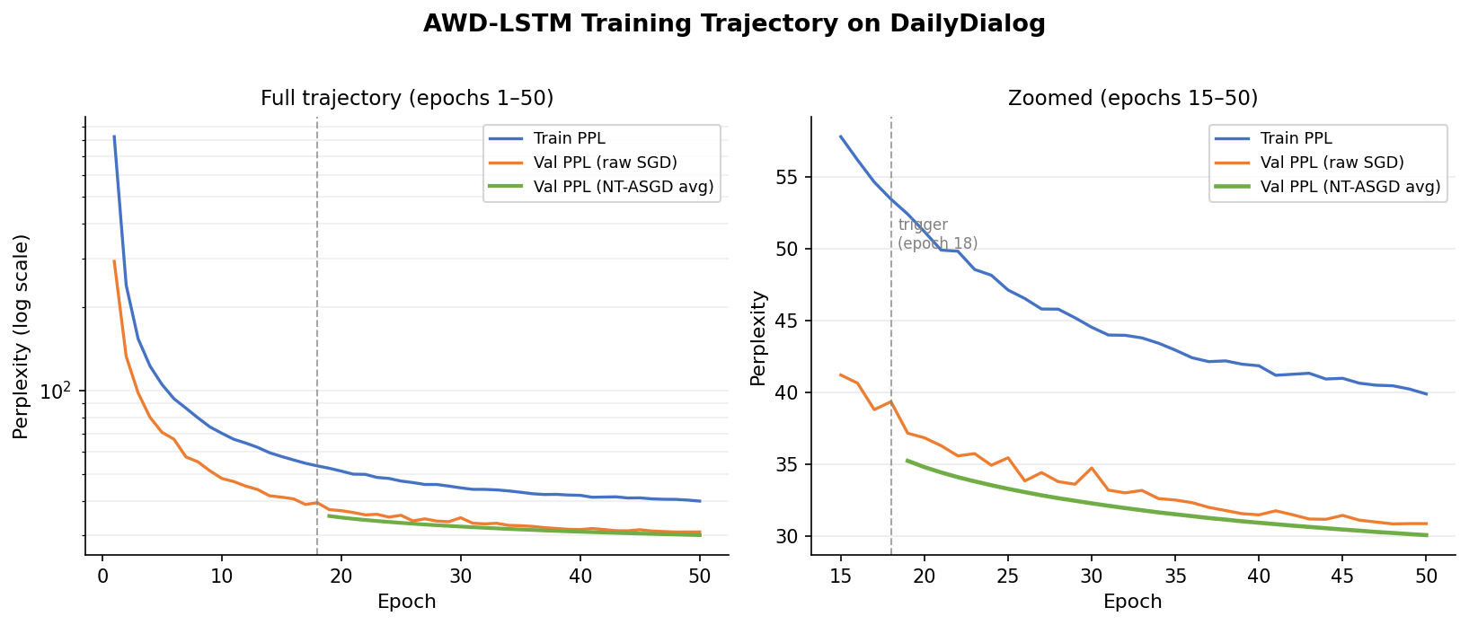
Figure 1. Training and validation perplexity across all 50 epochs. The left panel shows the full trajectory on a log scale; the right panel zooms into epochs 15–50 on a linear scale, where the noisy raw SGD validation curve and the smoother NT-ASGD averaged curve are both visible following the trigger at epoch 18.

3.3 Results
Evaluated with the final averaged weights, as prescribed by NT-ASGD, the model achieves a test perplexity of 32.85, against 33.06 for the best Task 1 model. The AWD-LSTM is marginally better, by approximately 0.6% in relative terms — a far smaller margin than might be expected given the difference in model complexity. We attribute this to the size and character of DailyDialog: at roughly 1.2 million training tokens with a comparatively small and repetitive vocabulary, classical n-gram counting is not as severely sparsity-limited as it would be on a larger or more varied corpus, which narrows the advantage a neural model typically holds in this setting.

3.4 BLiMP Evaluation
Paradigm | Task 1 (KN) | Task 2 (LSTM) | Change
anaphor_gender_agreement | 0.310 | 0.617 | +0.307
determiner_noun_agreement_1 | 0.533 | 0.707 | +0.174
regular_plural_subject_verb_agreement_1 | 0.462 | 0.617 | +0.155
wh_island | 0.618 | 0.452 | −0.166
npi_present_1 | 0.464 | 0.490 | +0.026
left_branch_island_simple_question | 0.286 | 0.759 | +0.473
principle_A_domain_1 | 1.000 | 0.987 | −0.013
drop_argument | 0.465 | 0.550 | +0.085
existential_there_quantifiers_1 | 0.910 | 0.981 | +0.071
Overall | 0.561 | 0.684 | +0.123
Table 4. BLiMP accuracy by paradigm, Task 1 versus Task 2, with the change between them.
Overall BLiMP accuracy improves substantially, from 56.1% to 68.4%, a far larger gain than the near-tied perplexity numbers would suggest. This is itself a useful finding: perplexity and sensitivity to grammatical minimal pairs are measuring different things, and a small gap on one metric does not imply a small gap on the other.
Three paradigm-level patterns are worth discussing individually, based on inspection of specific example pairs rather than the aggregate numbers alone.
On left_branch_island_simple_question, accuracy rises from 28.6% to 75.9%, the largest swing in either direction. Inspected examples show confident, well-separated log-probabilities favoring the grammatical word order (for example, “Whose hat should Tonya wear?” at −6.29 versus “Whose should Tonya wear hat?” at −6.99) — plausible evidence that the model has learned a genuine local sequential preference that a fixed 4-gram window cannot represent as reliably.
On anaphor_gender_agreement, accuracy rises from 31.0% to 61.7%, but individual examples complicate a simple reading of this gain. Two of three inspected pairs are still answered incorrectly, with the model's log-probabilities for the two pronoun variants nearly tied (for example, −6.672 versus −6.207 for “herself” versus “himself” in an identical context). This suggests the aggregate improvement may be driven by a subset of easier pairs in the paradigm rather than by the model having learned genuine gender-agreement tracking, and we are cautious about overstating this result.
On wh_island, accuracy falls from 61.8% to 45.2%, the only paradigm where the LSTM underperforms the n-gram model. Inspected examples show very small log-probability margins in both directions (for instance, −4.304 versus −4.301), together with frequent out-of-vocabulary tokens in the sentences themselves. This pattern is closer to near-random behavior than to a confidently wrong judgment, and we read the drop as reflecting that neither model captures this particular long-range dependency, rather than the LSTM having actively regressed on something the n-gram model had learned.

4. Task 3: Interpolated Hybrid Model

4.1 Method
The Task 1 Kneser-Ney model and the Task 2 AWD-LSTM were combined by linear interpolation in probability space, P_hybrid(w | context) = λ·P_KN(w | context) + (1−λ)·P_AWD(w | context). Both models were evaluated over the identical token stream used throughout this report, which is what makes a position-by-position interpolation well defined: at every position, both models score the same target token given the same preceding context. λ was tuned by grid search over {0.0, 0.1, …, 1.0}, minimizing validation perplexity.

4.2 Results
λ | Validation Perplexity
0.0 (LSTM only) | 30.05
0.1 | 24.58
0.2 | 23.39
0.3 | 22.91
0.4 | 22.81
0.5 | 23.01
0.6 | 23.50
0.7 | 24.35
0.8 | 25.69
0.9 | 27.99
1.0 (KN only) | 34.45
Table 5. Validation perplexity across the λ grid search. The minimum is at λ = 0.4.
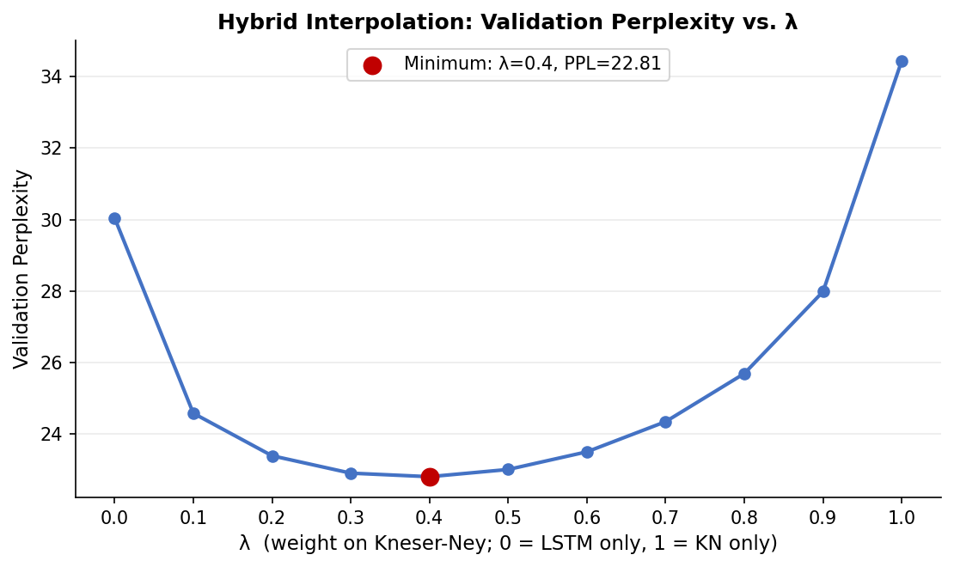
Figure 2. Validation perplexity as a function of λ. The curve is smooth and convex with a single clear minimum at λ = 0.4, well away from both endpoints (λ = 0, LSTM only; λ = 1, KN only).
The grid search selects λ = 0.4, weighting the AWD-LSTM more heavily but still assigning the classical model substantial weight. At this setting, test perplexity is 23.09, compared with 33.06 for Kneser-Ney alone and 32.85 for the AWD-LSTM alone — a reduction of roughly 30% relative to either individual model. This is a direct, affirmative answer to the question posed in the assignment's problem statement: on this corpus, classical smoothing continues to contribute meaningfully even once combined with a neural language model. That the optimal λ is interior (neither 0 nor 1) indicates that the two models are capturing genuinely complementary information about the corpus, rather than one simply dominating the other.

4.3 Final Comparison
Model | Test Perplexity | BLiMP Accuracy
Task 1: 4-gram Kneser-Ney | 33.06 | 56.1%
Task 2: AWD-LSTM | 32.85 | 68.4%
Task 3: Hybrid (λ = 0.4) | 23.09 | 64.7%
Table 6. Final three-way comparison on the test split.

4.4 BLiMP Evaluation and Discussion
The hybrid's BLiMP accuracy (64.7%) sits between the two individual models, below the AWD-LSTM's 68.4% but above Kneser-Ney's 56.1%. At first glance this may appear to undercut the perplexity result, but it does not: λ was tuned exclusively to minimize validation perplexity, with no BLiMP signal in the optimization at any point, so there is no reason to expect it to also be optimal for grammatical-judgment accuracy, and the two objectives are not guaranteed to move together.
The paradigm-level accuracy figures are consistent with a simple dilution story: on anaphor_gender_agreement, where Kneser-Ney (31.0%) and the AWD-LSTM (61.7%) disagree most sharply, the hybrid scores 45.9%, close to where a 40/60 probability blend between the two would be expected to land if KN's weaker, frequency-driven judgment were simply pulling the LSTM's stronger one back toward its own. We tested this explanation directly by scoring nine individual minimal pairs across three paradigms under all three models (Table 7). The result complicates the simple dilution account: across these nine pairs, the hybrid never performs worse than whichever of KN or the LSTM was individually correct on that pair, and on one pair (“Whose hat should Tonya wear?”) the hybrid is both correct and more confident than either individual model, with a wider log-probability margin than the LSTM alone. On another pair, the hybrid recovers a correct judgment (KN right, LSTM wrong) that a naive weighted-average account would not obviously predict.
Pair (paradigm) | KN | LSTM | Hybrid
Katherine / herself-himself (anaphor) | ✗ | ✗ | ✗
Karla / herself-himself (anaphor) | ✗ | ✗ | ✗
Marie / herself-itself (anaphor) | ✗ | ✓ | ✓
Whose museums (left-branch) | ✓ | ✓ | ✓
Whose hat (left-branch) | ✗ | ✓ | ✓ (widened margin)
What movies (left-branch) | ✗ | ✗ | ✗
Who have those men (wh-island) | ✗ | ✓ | ✓
Who isn't Craig (wh-island) | ✗ | ✗ | ✗
Who are those associations (wh-island) | ✓ | ✗ | ✓
Table 7. Per-pair correctness across all three models on nine inspected minimal pairs. ✓ = model prefers the grammatical sentence; ✗ = model prefers the ungrammatical sentence.
This small sample is not sufficient to fully explain the aggregate BLiMP gap between the hybrid (64.7%) and the LSTM alone (68.4%), since the hybrid does at least as well as the better individual model on every pair inspected here. The aggregate drop must therefore be concentrated in pairs outside this sample, rather than reflecting a uniform dilution effect across every pair in a paradigm. What the sample does show clearly is that λ was tuned purely for perplexity, with no BLiMP signal in the objective, so there is no guarantee that the resulting blend is accuracy-optimal on every individual judgment, even where it tends to track or improve on the stronger of the two component models locally. We would want to inspect a larger sample of disagreement cases, particularly within determiner_noun_agreement_1 and regular_plural_subject_verb_agreement_1, before drawing a firmer conclusion about where specifically the hybrid's aggregate BLiMP accuracy is lost relative to the LSTM.
Paradigm | KN | LSTM | Hybrid
anaphor_gender_agreement | 0.310 | 0.617 | 0.459
left_branch_island_simple_question | 0.286 | 0.759 | 0.693
wh_island | 0.618 | 0.452 | 0.497
principle_A_domain_1 | 1.000 | 0.987 | 0.999
Overall | 0.561 | 0.684 | 0.647
Table 8. BLiMP accuracy on selected paradigms across all three models.

5. Paper Reproduction Comparison
Merity et al. (2017) report test perplexities of 57.3 on Penn Treebank and 65.8 on WikiText-2 for the AWD-LSTM without the paper's continuous cache pointer extension, both considerably higher than the test perplexity of 32.85 obtained here on DailyDialog. This gap is not evidence of a stronger reproduction; rather, it reflects substantial differences between the corpora that make the numbers not directly comparable. DailyDialog is two orders of magnitude smaller than WikiText-2 and considerably more repetitive, consisting of casual, everyday dialogue with a correspondingly smaller and less diverse vocabulary (12,482 tokens here against roughly 33,000 for the paper's PTB and WikiText-2 configurations). A smaller, more repetitive corpus with a smaller vocabulary is intrinsically easier to model, which plausibly accounts for most of the gap on its own.
A second source of difference is training budget: we trained for 50 epochs against the paper's up to 500, as explicitly permitted by the assignment, and did not implement activation or temporal activation regularization, both part of the paper's full method but outside the assignment's listed requirements. Given the much smaller corpus and correspondingly faster convergence observed here (validation perplexity largely stabilized well before epoch 50), we do not believe the reduced epoch count was a binding constraint in this setting, though the absence of AR/TAR regularization may account for a small amount of the difference in the other direction. On balance, we consider the large perplexity gap to be primarily a consequence of corpus scale and vocabulary size rather than of the reproduction's fidelity to the architecture, which was validated directly: parameter count matched a hand-computed estimate closely (25,216,882 against an estimate of approximately 25.2 million), and training loss and validation perplexity both decreased smoothly and without instability throughout training.

6. Discussion

6.1 What worked
Interpolated Kneser-Ney was a strong classical baseline on this corpus, substantially outperforming both Add-k and Good-Turing, and came close enough to the neural model's perplexity that the assignment's central question — whether smoothing still adds value once combined with a neural model — was genuinely open rather than a foregone conclusion. The AWD-LSTM reproduction trained cleanly and stably, and NT-ASGD's averaging mechanism produced a clear, consistent improvement over the raw SGD trajectory once triggered. Most notably, the Task 3 hybrid produced a large, unambiguous perplexity improvement over both individual models, directly answering the assignment's framing question in the affirmative for this corpus.

6.2 What didn't, and why
The AWD-LSTM's advantage over Kneser-Ney on raw perplexity was far smaller than might be expected from the difference in model complexity. We attribute this to DailyDialog's small size and limited lexical diversity, which reduces the severity of the data-sparsity problem that smoothing exists to address and, correspondingly, narrows the advantage a neural model typically holds over a well-smoothed count-based model. The hybrid's BLiMP accuracy falling below the AWD-LSTM alone is a second result that runs against a naïve expectation that combining models should improve every metric; as discussed in Section 4.4, this follows directly from λ having been tuned only for perplexity, and is itself an informative result about the relationship between the two evaluation metrics rather than a shortcoming of the method.

6.3 BLiMP and vocabulary coverage
All three models' BLiMP accuracy is constrained by DailyDialog's narrow, casual-register vocabulary, which leaves many BLiMP sentences containing one or more out-of-vocabulary tokens. This affects every model equally in terms of methodology, but it means BLiMP accuracy in this report should be read as a measure of grammatical sensitivity given a small, domain-specific vocabulary, rather than as representative of what these architectures could achieve on a larger, more general-purpose corpus.

6.4 Summary
Across all three tasks, the clearest and most robust finding is the Task 3 result: combining a well-tuned classical smoothed n-gram model with a neural language model yields a substantial perplexity improvement over either model alone, even on a corpus where the two models perform almost identically in isolation. The BLiMP results complicate a purely perplexity-based reading of “which model is better,” showing that grammatical-judgment sensitivity and next-token prediction accuracy are related but distinct properties of a language model, and that improving one does not guarantee improving the other.

