FRESHMART — PROJECT STRUCTURE & FLOW DOCUMENT
File Structure · Architecture · Flowcharts · ER Diagrams · 0-Level DFD

Field | Details
Project | FreshMart — Online Grocery Delivery Platform
Architecture | Microservices — 6 ASP.NET Core 10 services + YARP API Gateway
Frontend | Angular 21 + Tailwind CSS + Nginx
Database | SQL Server 2022 — 6 isolated databases (one per service)
Real-Time | ASP.NET Core SignalR (NotificationHub + SupportHub)
Payments | Razorpay (INR) — cards, UPI, netbanking
Container | Docker + Docker Compose — 9 containers total
Document Date | April 2026

1. Project Overview
FreshMart is a full-stack online grocery delivery platform built with a microservices architecture. The project was originally a monolithic ASP.NET Core application and has been re-architected into 6 independent microservices, each owning its own domain and database. All client traffic flows through a YARP-based API Gateway. The Angular 21 frontend is served via Nginx. Everything runs in Docker containers orchestrated by Docker Compose.
The platform supports 4 user roles: Customer (browse, shop, pay, track), Store Manager (manage products and orders), Delivery Driver (update delivery status), and Admin (full platform control). Key features include real-time notifications via SignalR, transactional emails via MailKit, Razorpay payment integration, product reviews, coupon system, and a live support chat.

1.1 Technology Summary
Layer | Technology | Version | Role
Frontend | Angular | 21 | SPA — UI, routing, HTTP calls to API Gateway
Frontend Server | Nginx | Alpine | Serves Angular static files on port 80
API Gateway | YARP + ASP.NET | 10.0 | Routes all /api/v1/* traffic; validates JWT centrally
Auth Service | ASP.NET Core | 10.0 | User management, JWT issuance, Google OAuth2
Product Service | ASP.NET Core | 10.0 | Product catalog, categories, reviews, stock
Order Service | ASP.NET Core | 10.0 | Cart, orders, coupons, checkout
Payment Service | ASP.NET Core | 10.0 | Razorpay integration, payment verification
Notification Svc | ASP.NET Core | 10.0 | SignalR push + MailKit email notifications
Support Service | ASP.NET Core | 10.0 | Support tickets + SignalR live chat
Database | SQL Server | 2022 | 6 isolated databases, one per service
ORM | EF Core | 10.0 | Code-First, EnsureCreated on startup
Auth | JWT Bearer | HS256 | Stateless auth; shared secret across all services
Payments | Razorpay | v1 API | INR payments — cards, UPI, netbanking, wallets
Email | MailKit | 4.8 | SMTP via Gmail — transactional emails
Real-Time | SignalR | 1.2 | WebSocket push notifications and live chat
Containers | Docker Compose | v3 | 9 containers: 6 services + gateway + SQL + frontend

2. System Architecture
The diagram below shows the complete system architecture of FreshMart. The Angular 21 SPA runs in the browser and communicates only with the API Gateway. The Gateway validates JWT tokens and routes each request to the correct microservice based on URL path. Each microservice has its own isolated SQL Server database. Services communicate with each other via direct HTTP calls. SignalR hubs in NotificationService and SupportService handle real-time WebSocket connections. External integrations include Razorpay for payments, Gmail SMTP for emails, and Google OAuth2 for social login.
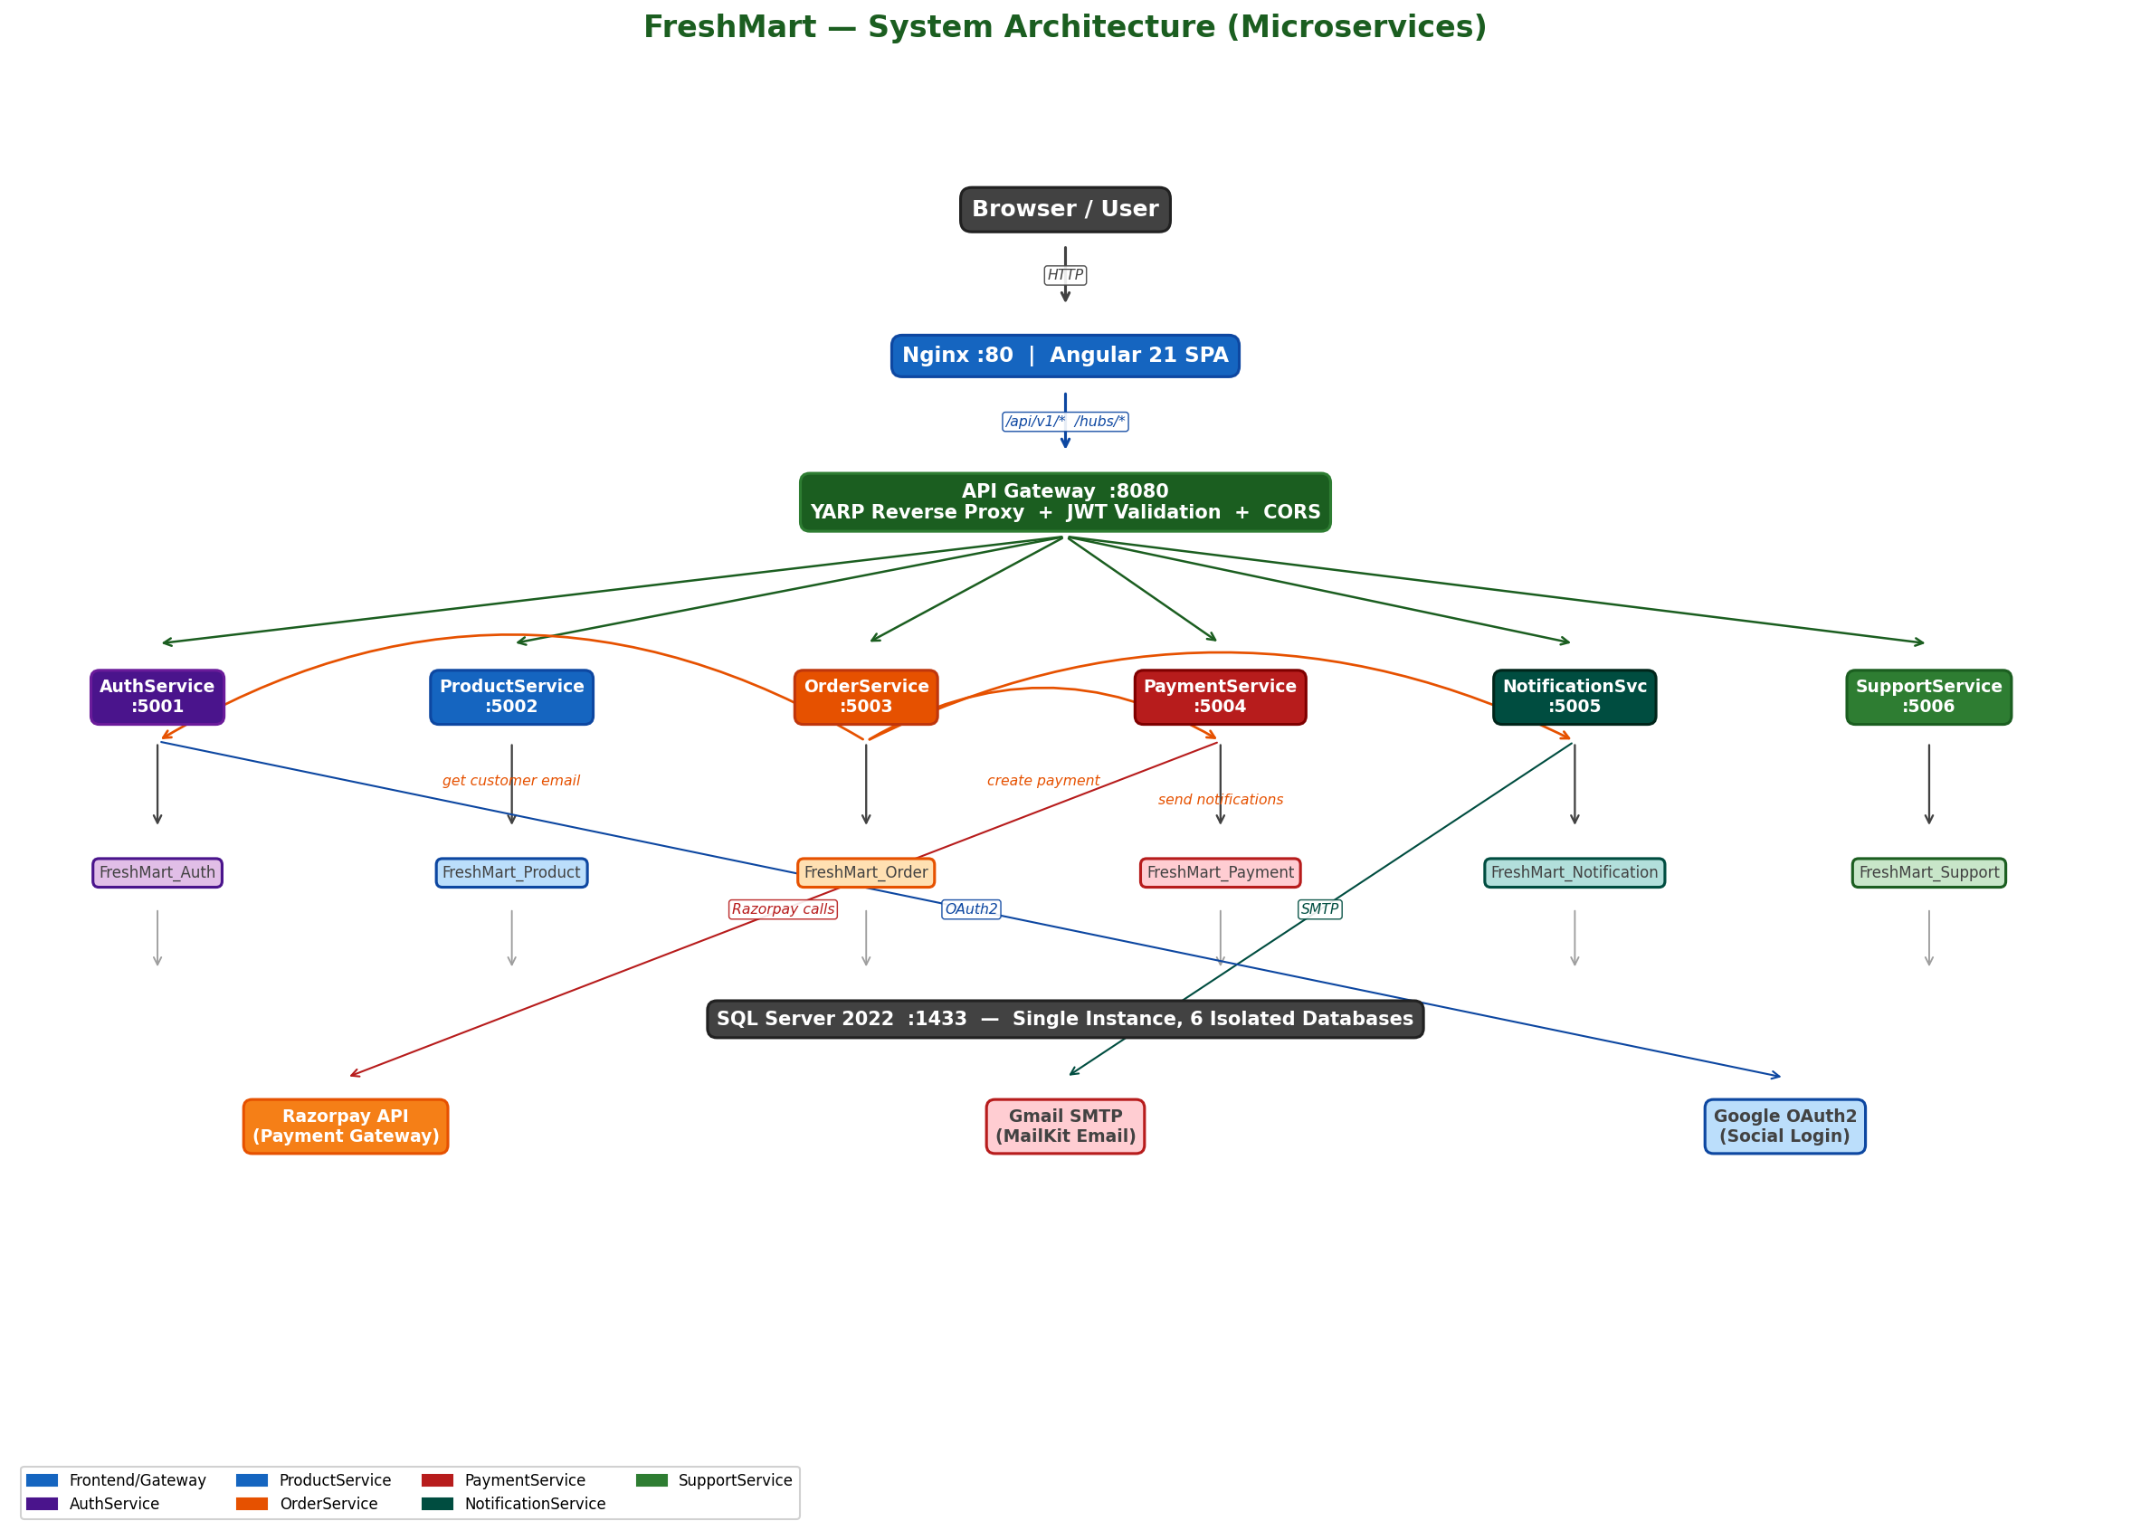
Figure 1: FreshMart System Architecture — Microservices with API Gateway

3. Level 0 DFD — Context Diagram
The Level 0 DFD (Context Diagram) shows FreshMart as a single system and all external entities that interact with it. It defines the system boundary and shows what data flows in and out. External entities are: Customer, Store Manager, Admin, Delivery Driver, Razorpay (payment gateway), Gmail SMTP (email), and Google OAuth2 (social login).

3.1 External Entities & Data Flows
External Entity | Data INTO System | Data FROM System
Customer | Register/Login credentials, Product search queries, Cart items, Order details, Coupon codes, Payment info, Support tickets, Review ratings | JWT token, Product catalog, Cart state, Order confirmation, Order status updates, Real-time notifications, Invoices, Support replies
Store Manager | Product create/update data, Stock updates, Discount settings, Order status updates | Product list, Order list, Low-stock alerts, Real-time notifications for new orders
Admin | User management actions, Coupon creation, Role changes, Platform queries | User list, Platform statistics, All orders, All support tickets, All products
Delivery Driver | Delivery status updates (Shipped/OutForDelivery/Delivered) | Assigned orders list, Delivery details, Real-time notifications
Razorpay | Payment status events (webhook), Payment ID + signature after payment | Create payment order request, Signature verification request
Gmail SMTP | Email delivery status | HTML transactional emails for 6 order lifecycle events
Google OAuth2 | User profile (name, email, Google sub ID) | ID token verification request

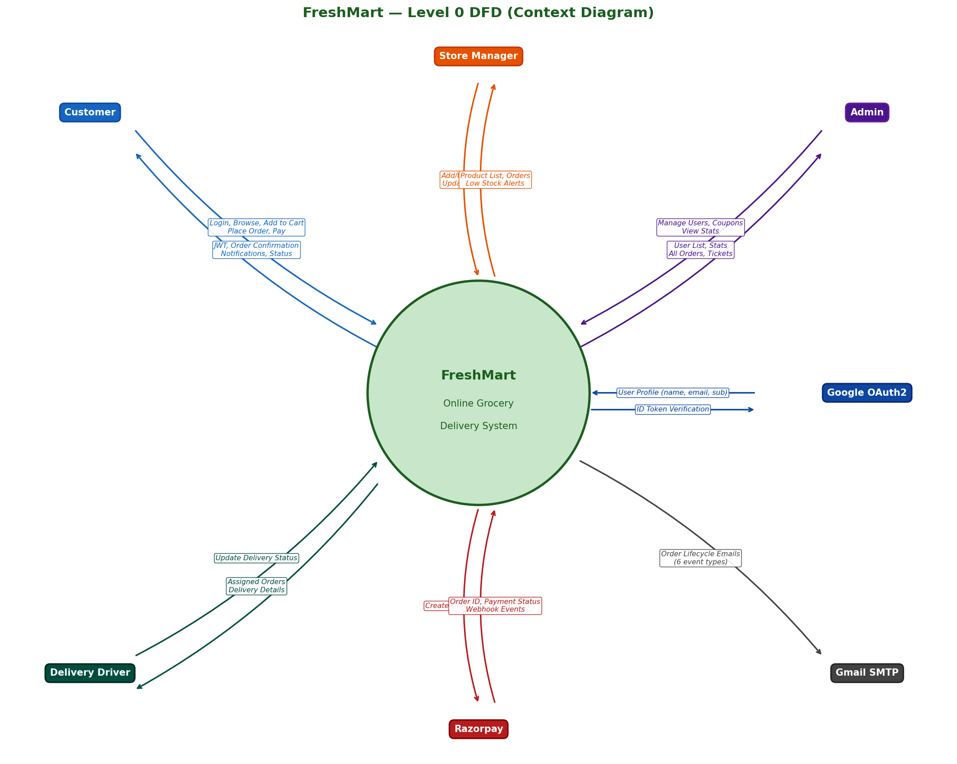
Figure 2: Level 0 DFD — FreshMart Context Diagram

4. Project Folder Structure
The workspace root contains two main folders: Frontend (Angular 21 SPA) and Microservices (all backend services). Docker Compose at the root orchestrates everything. The diagram below shows the complete folder hierarchy with all key files.
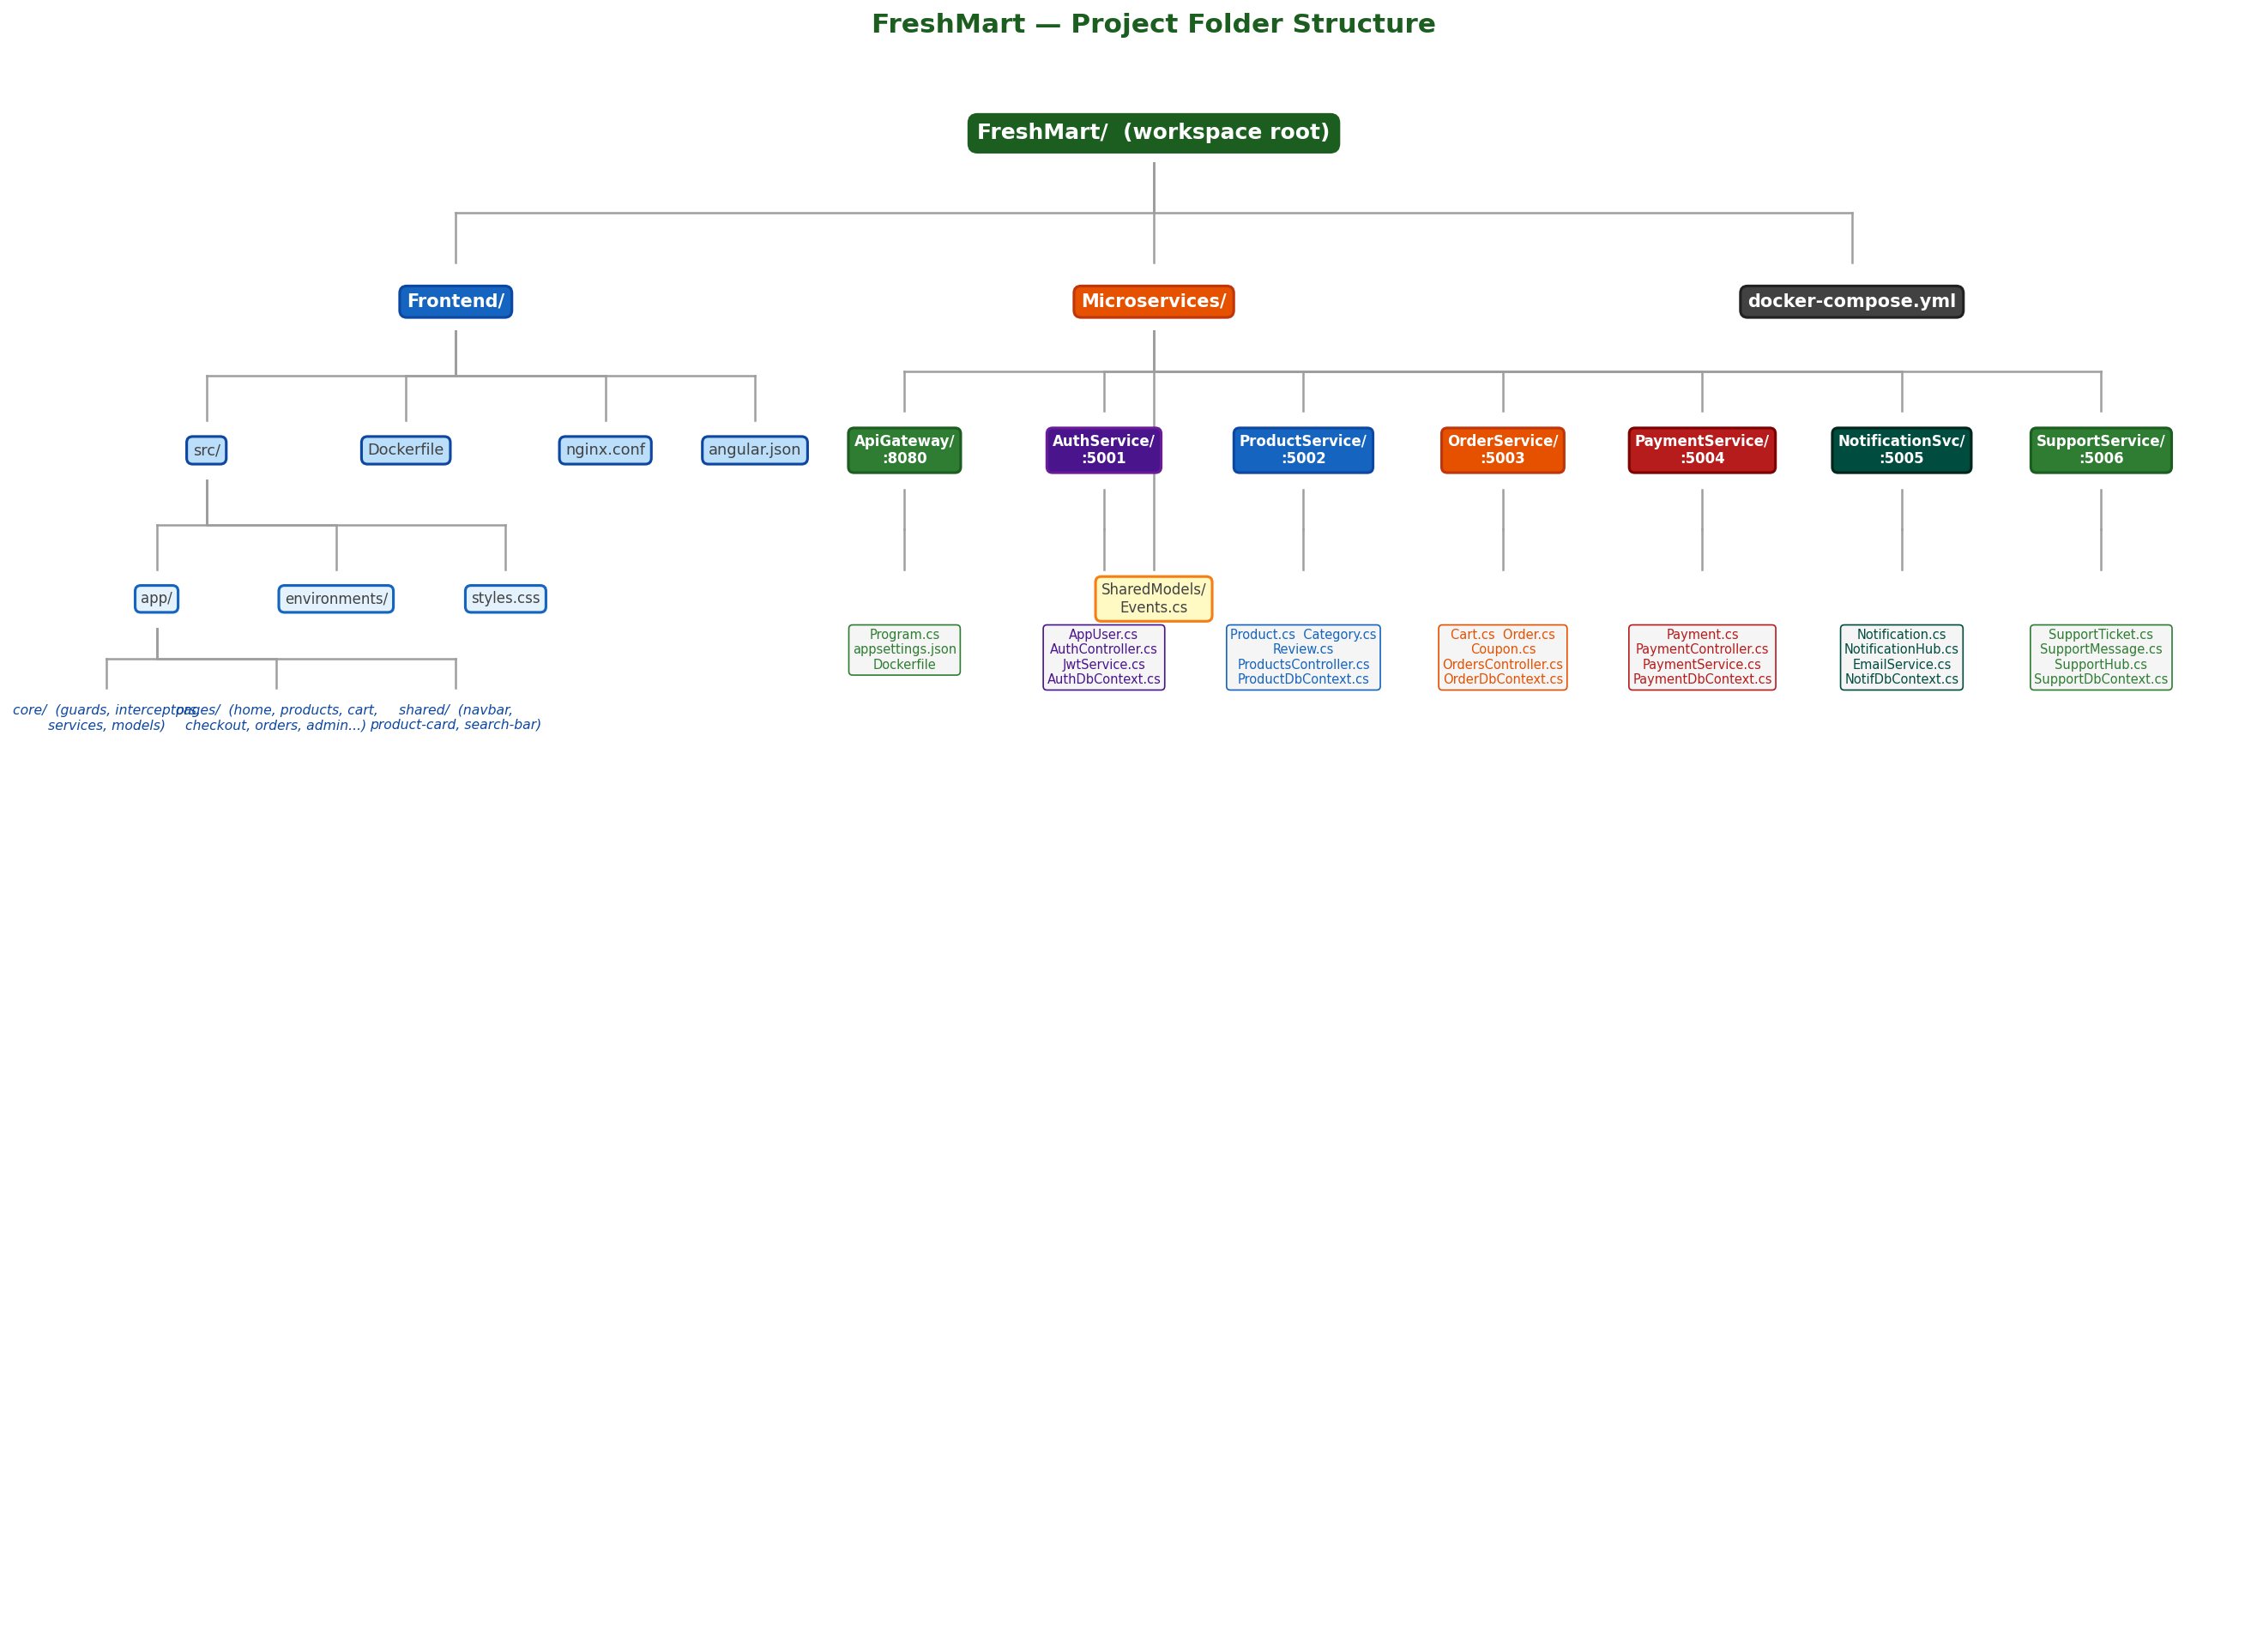
Figure 3: FreshMart Project Folder Structure

4.1 Root Level Files
Path | Description
docker-compose.yml | Orchestrates all 9 containers — SQL Server, API Gateway, 6 microservices, Frontend
FreshMart_SRS.docx | Software Requirements Specification document (v2.0 — microservices edition)
generate_srs.py | Python script that generates the SRS DOCX using python-docx
generate_project_doc.py | Python script that generates this project structure document
generate_diagrams.py | Python script that generates all architecture/ER/flow diagrams using matplotlib
Frontend/ | Angular 21 SPA — complete frontend application
Microservices/ | All backend microservices — 6 services + API Gateway + SharedModels
diagrams/ | Auto-generated PNG diagram images (created by generate_diagrams.py)

4.2 Frontend Structure
The Angular 21 frontend uses standalone components (no NgModules), lazy loading for all routes, and Tailwind CSS for styling. It is built and served via Nginx in Docker.
Path | Description
Frontend/src/main.ts | Angular bootstrap entry point
Frontend/src/index.html | Root HTML shell — Angular mounts here
Frontend/src/styles.css | Global Tailwind CSS imports and custom styles
Frontend/src/app/app.ts | Root AppComponent — contains router-outlet
Frontend/src/app/app.routes.ts | All 25 application routes with lazy loading and guards
Frontend/src/app/app.config.ts | Angular app config — registers HttpClient, Router, interceptors
Frontend/src/app/core/guards/auth.guard.ts | AuthGuard — redirects unauthenticated users to /auth/login
Frontend/src/app/core/guards/role.guard.ts | RoleGuard — checks JWT role claim; redirects to /unauthorized if mismatch
Frontend/src/app/core/interceptors/auth.interceptor.ts | Attaches JWT Bearer token to every outgoing API request; handles 401 refresh
Frontend/src/app/core/models/index.ts | All TypeScript interfaces: User, Product, Cart, Order, Payment, Notification, etc.
Frontend/src/app/core/services/auth.service.ts | Login, register, Google OAuth2, token refresh, logout, profile
Frontend/src/app/core/services/cart.service.ts | Cart CRUD, budget management
Frontend/src/app/core/services/product.service.ts | Product listing, search, filters, suggestions, categories
Frontend/src/app/core/services/order.service.ts | Order creation, history, status tracking
Frontend/src/app/core/services/notification.service.ts | Notification CRUD + SignalR connection management
Frontend/src/app/shared/components/navbar/ | Navbar — search, cart icon, notifications bell, user menu
Frontend/src/app/shared/components/product-card/ | Reusable product card component
Frontend/src/app/shared/components/search-bar/ | Search bar with autocomplete suggestions
Frontend/src/app/pages/home/home.ts | Home page — featured products, categories, banners
Frontend/src/app/pages/products/products.ts | Product listing — search, filters, sorting, pagination
Frontend/src/app/pages/product-detail/product-detail.ts | Product detail — full info, reviews, add to cart
Frontend/src/app/pages/cart/cart.ts | Cart page — items, quantities, budget tracker
Frontend/src/app/pages/checkout/checkout.ts | Checkout — address, coupon, Razorpay payment
Frontend/src/app/pages/orders/orders.ts | Order history page
Frontend/src/app/pages/order-tracking/order-tracking.ts | Real-time order status tracking
Frontend/src/app/pages/rate-order/rate-order.ts | Submit star rating and review for ordered products
Frontend/src/app/pages/offers/offers.ts | All products with active discounts
Frontend/src/app/pages/compare/compare.ts | Side-by-side product comparison
Frontend/src/app/pages/profile/profile.ts | Edit name, phone, change password
Frontend/src/app/pages/support/support.ts | Create ticket, view tickets, live chat via SignalR
Frontend/src/app/pages/delivery/delivery.ts | Delivery driver — view assigned orders, update status
Frontend/src/app/pages/store-manager/manager-dashboard.ts | Store manager dashboard
Frontend/src/app/pages/admin/dashboard/ | Admin dashboard — platform stats
Frontend/src/app/pages/admin/products/ | Admin product CRUD, stock, discounts
Frontend/src/app/pages/admin/orders/ | Admin orders — all orders, status updates
Frontend/src/app/pages/admin/users/ | Admin users — role change, activate/deactivate
Frontend/src/app/pages/admin/support/ | Admin support — all tickets, reply, status
Frontend/Dockerfile | Multi-stage: Node 20 builds Angular, Nginx Alpine serves dist/
Frontend/nginx.conf | Nginx config — serves SPA, handles HTML5 pushState routing

4.3 Microservices Structure
Service | Port | Key Files | Database
ApiGateway | 8080 | Program.cs, appsettings.json (YARP routes), HttpVersionTransform.cs, Dockerfile | None
AuthService | 5001 | AppUser.cs, AuthController.cs, UsersController.cs, JwtService.cs, AuthDtos.cs, Data/AuthDbContext.cs, Data/DbSeeder.cs | FreshMart_Auth
ProductService | 5002 | Product.cs, Category.cs, Review.cs, OrderProjection.cs, ProductsController.cs, CategoriesController.cs, ReviewsController.cs, Data/ProductDbContext.cs, Data/ProductSeeder.cs | FreshMart_Product
OrderService | 5003 | Cart.cs, Order.cs, Coupon.cs, CartController.cs, OrdersController.cs, CouponsController.cs, Services/PaymentServiceClient.cs, Services/NotificationService.cs, Data/OrderDbContext.cs, Data/OrderSeeder.cs | FreshMart_Order
PaymentService | 5004 | Models/Payment.cs, IPaymentService.cs, PaymentController.cs, PaymentDtos.cs, Services/PaymentService.cs, Services/OrderServiceClient.cs, Data/PaymentDbContext.cs | FreshMart_Payment
NotificationService | 5005 | Notification.cs, NotificationHub.cs, NotificationsController.cs, InternalNotificationController.cs, NotificationService.cs, EmailService.cs, Data/NotificationDbContext.cs | FreshMart_Notification
SupportService | 5006 | SupportTicket.cs, SupportMessage.cs, SupportHub.cs, SupportController.cs, Data/SupportDbContext.cs | FreshMart_Support
SharedModels | N/A | Events.cs (OrderPlacedEvent, OrderStatusChangedEvent, PaymentCompletedEvent), SharedModels.csproj | None

5. Process Flowcharts

5.1 Checkout & Payment Flow
The checkout flow is the most complex in FreshMart. It spans three microservices: OrderService creates the order, PaymentService creates the Razorpay order and verifies payment, and NotificationService sends the confirmation. The flowchart below shows every decision point and service call.
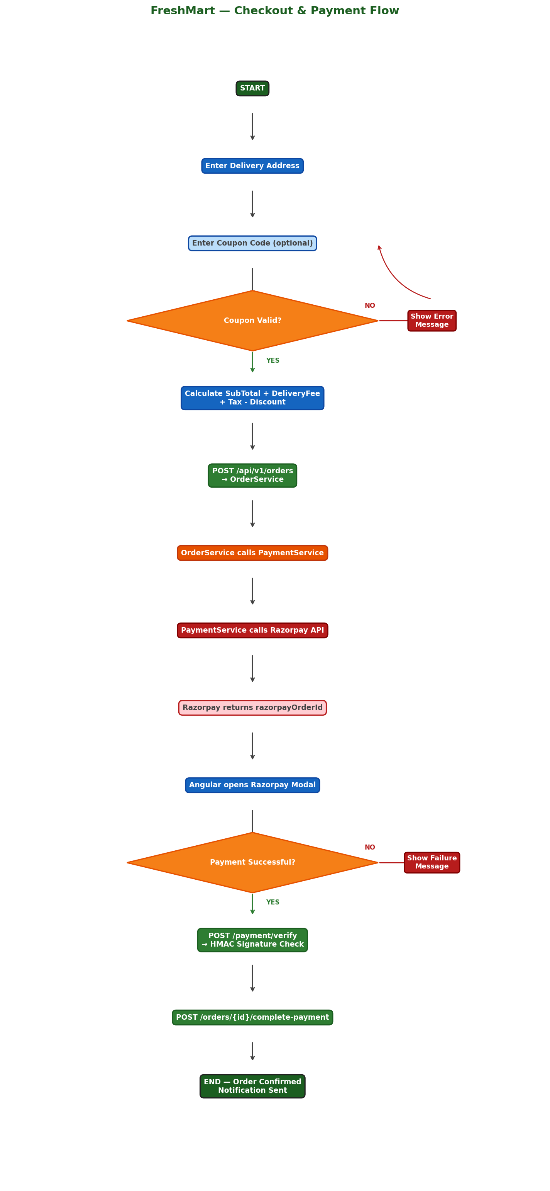
Figure 4: Checkout & Payment Flowchart — OrderService + PaymentService + NotificationService

5.2 Order Status Lifecycle
Every order passes through a defined status lifecycle. Each status change is triggered by a staff member (Admin, StoreManager, or DeliveryDriver) and automatically triggers a SignalR real-time notification and a transactional email to the customer via NotificationService.
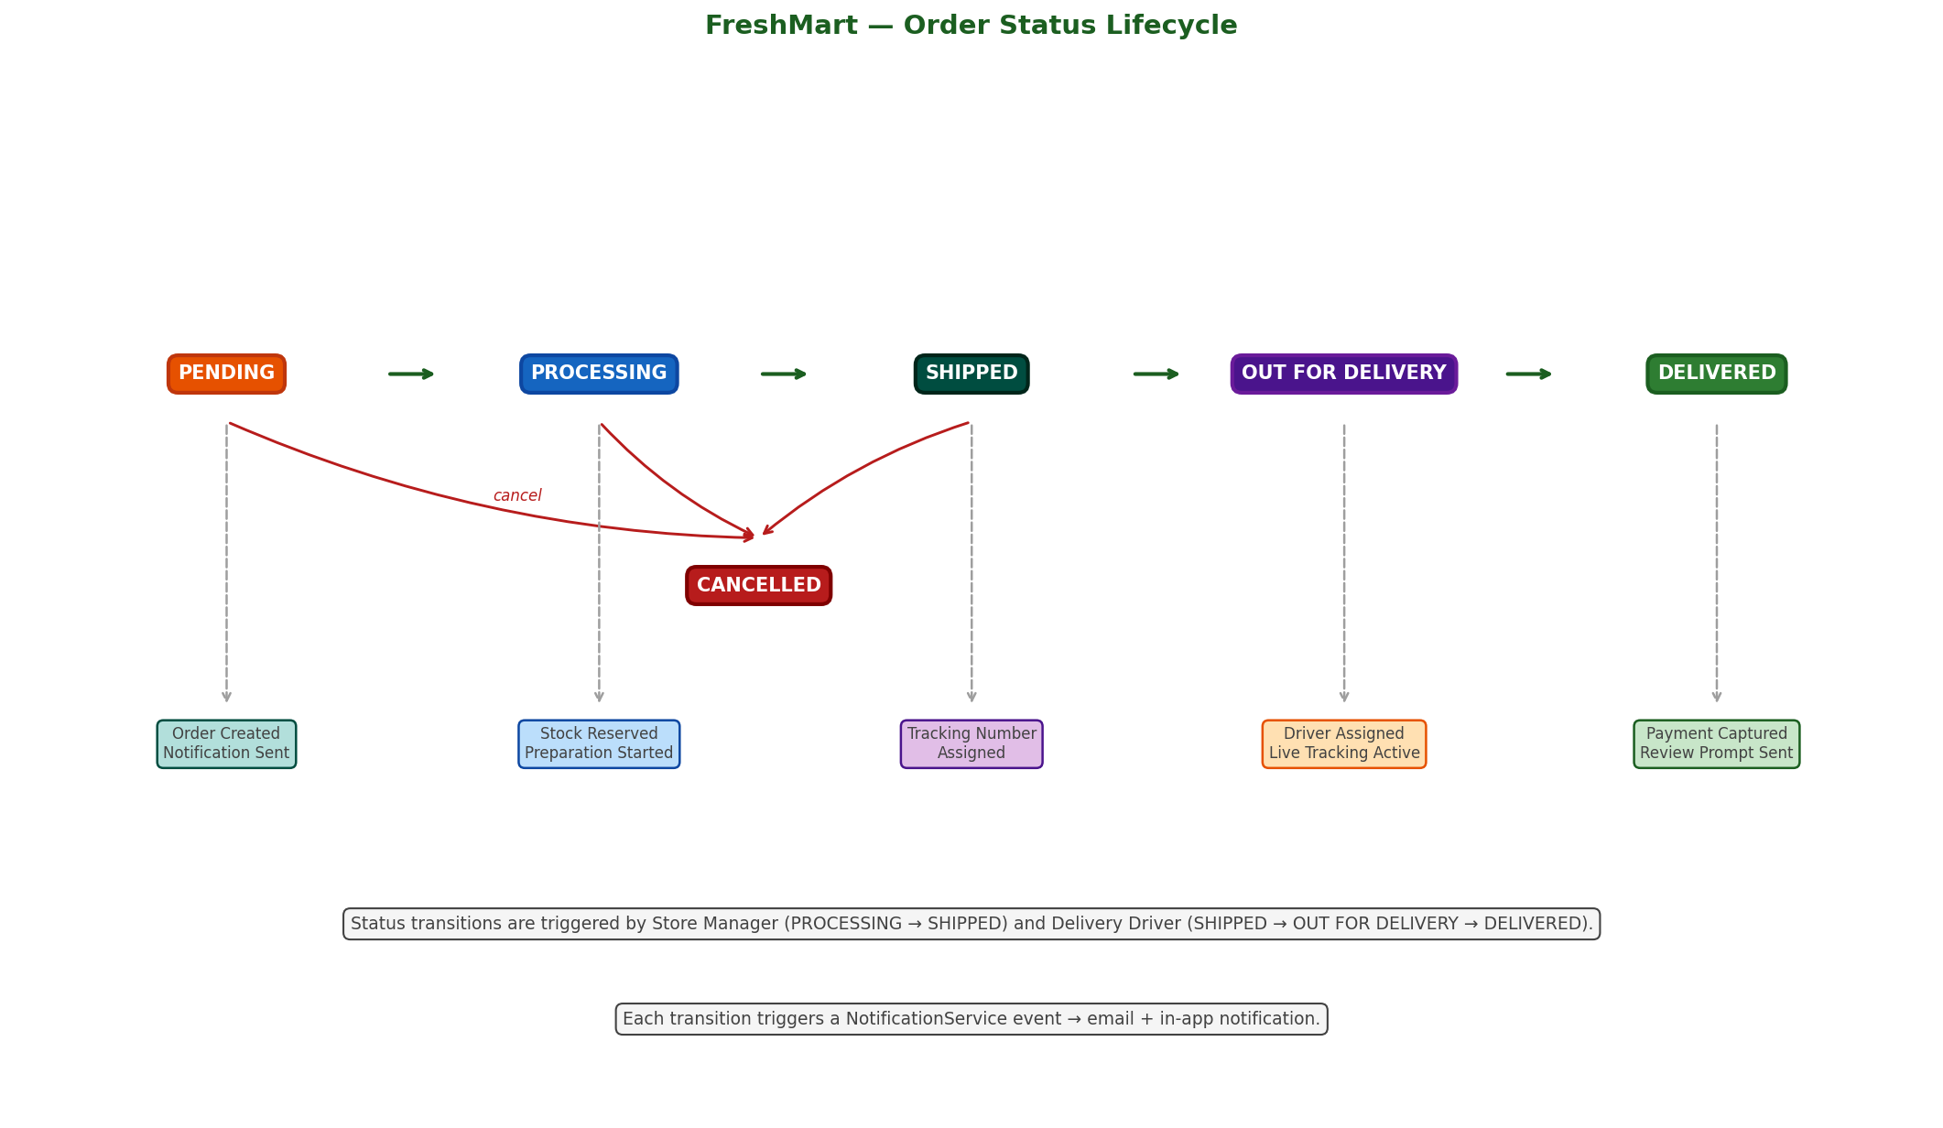
Figure 5: Order Status Lifecycle — Status transitions, who can update, and side effects

5.3 Request Flow Summary
All requests from the browser go through the same path: Browser -> Nginx -> Angular -> API Gateway -> Microservice -> SQL Server. The table below summarizes the key flows.
Flow | Services Involved | Key Steps
User Login | AuthService | POST /auth/login -> BCrypt verify -> JWT issued -> RefreshToken saved to DB
Product Search | ProductService | GET /products?query= -> EF Core LINQ search -> DiscountedPrice computed -> PaginatedResult returned
Add to Cart | OrderService | POST /cart/items -> Stock validated from local cache -> CartItem saved -> SubTotal + isOverBudget returned
Place Order | OrderService -> PaymentService | POST /orders -> Coupon validated -> Order created -> PaymentService called -> Razorpay order created -> razorpayOrderId returned
Verify Payment | PaymentService | POST /payment/verify -> HMAC SHA256 verified -> Payment.Status = Paid
Complete Payment | OrderService -> NotificationService | POST /orders/{id}/complete-payment -> Cart cleared -> SignalR notification -> Email sent
Update Order Status | OrderService -> NotificationService -> AuthService | PATCH /orders/{id}/status -> Status updated -> NotificationService called -> AuthService called for email -> Email sent
Support Chat | SupportService (SignalR) | POST /support/tickets/{id}/messages -> Message saved -> SignalR broadcast to ticket:{id} group
Real-Time Notif | NotificationService (SignalR) | POST /internal/user -> Notification saved to DB -> SignalR send to user:{userId} group

6. Entity-Relationship Diagrams
Each microservice has its own isolated SQL Server database. There are no cross-database foreign keys. Relationships between services are maintained via Guid references only. The yellow highlighted rows in each ER diagram indicate Primary Keys (PK). Gold key icon = PK field.

6.1 AuthService — FreshMart_Auth
Single entity database. All user identity data lives here. AppUser.Id is referenced as a plain Guid by all other services. BCrypt hashes passwords. RefreshToken enables 7-day session persistence. GoogleId enables social login.
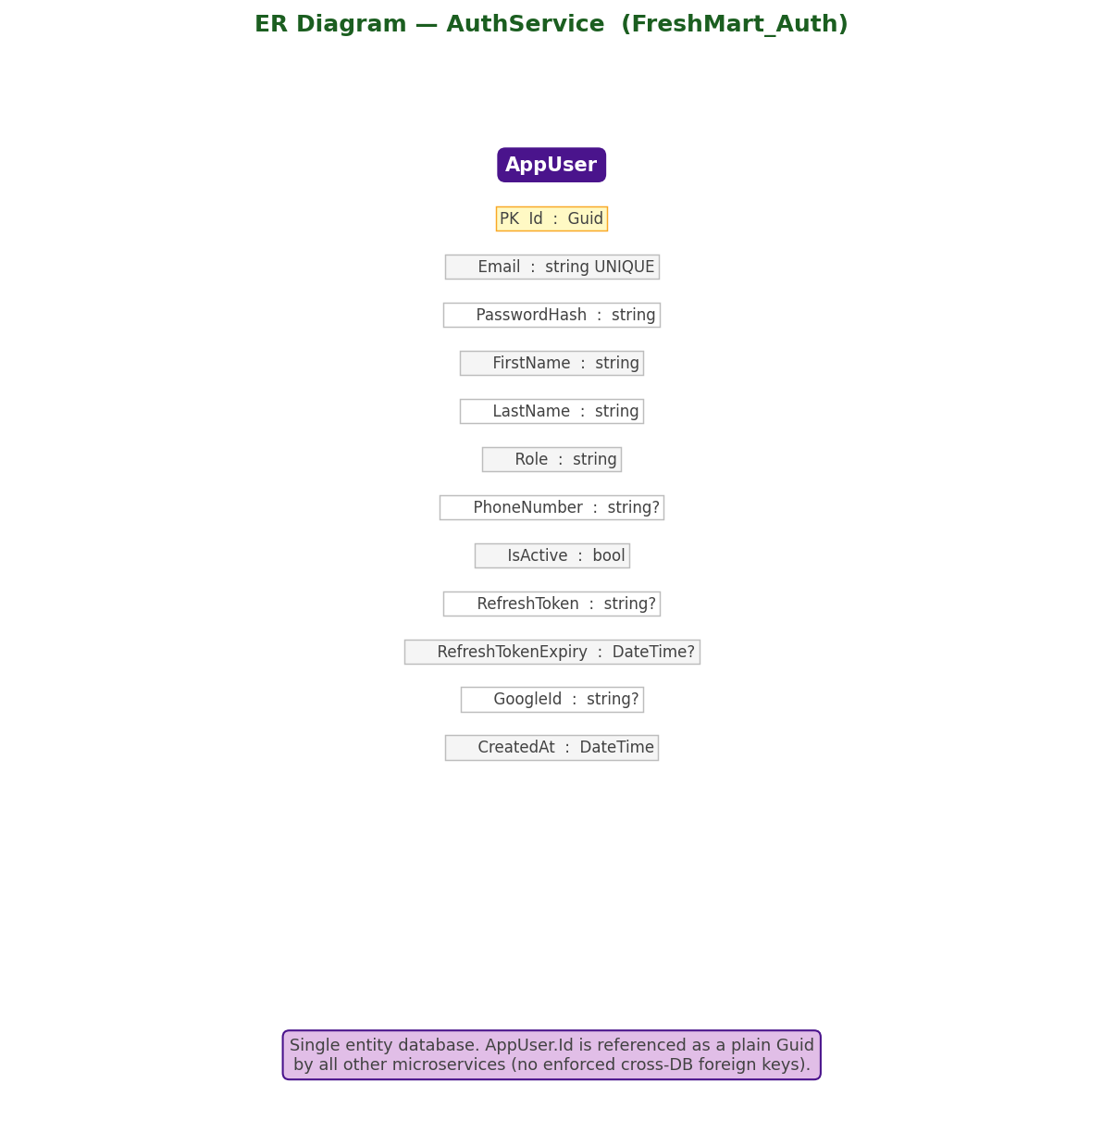
Figure 6: ER Diagram — AuthService (FreshMart_Auth Database)

6.2 ProductService — FreshMart_Product
Three main entities: Category (self-referencing hierarchy), Product (belongs to Category), and Review (belongs to Product). OrderProjection and AppUser are local read-only projections from other services — they have no enforced FK to external databases.
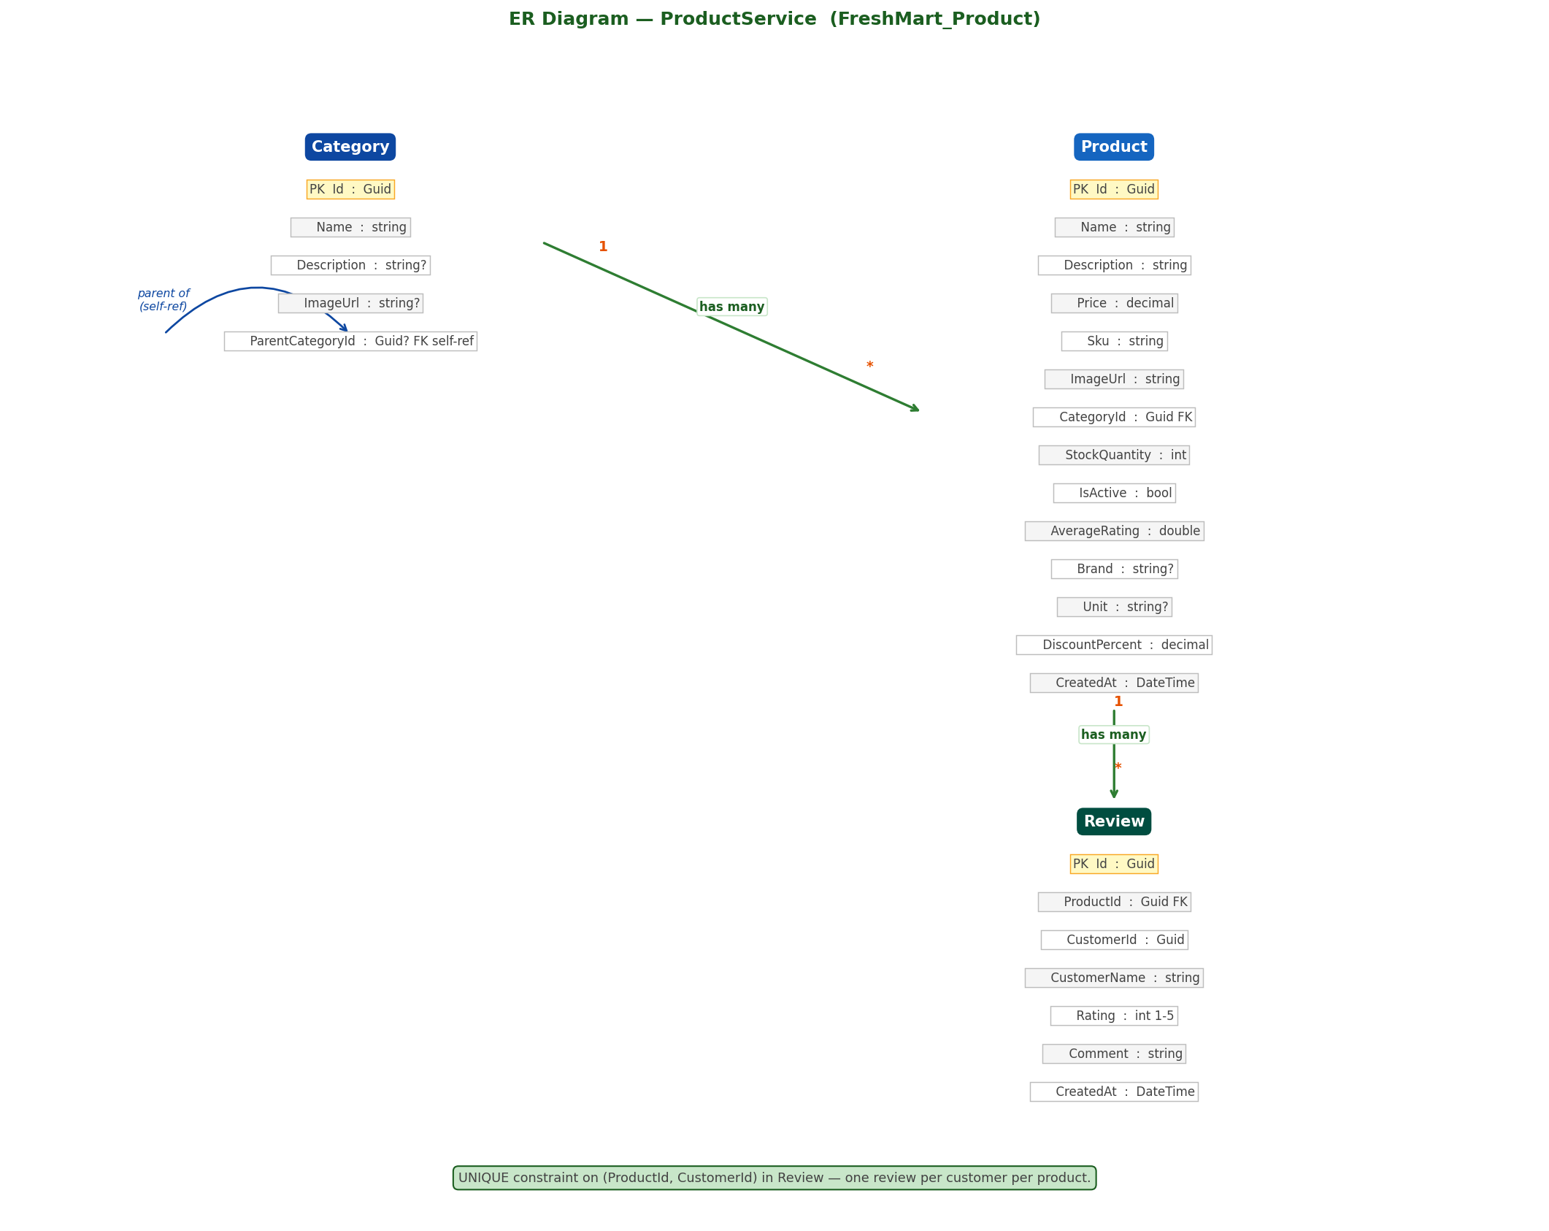
Figure 7: ER Diagram — ProductService (FreshMart_Product Database)

6.3 OrderService — FreshMart_Order
Most complex database. Cart has CartItems. Order has OrderItems. Coupon is standalone. A local Product cache table stores price and discount data synced from ProductService to avoid cross-service calls during checkout. ProductName is snapshotted in OrderItem to preserve order history.
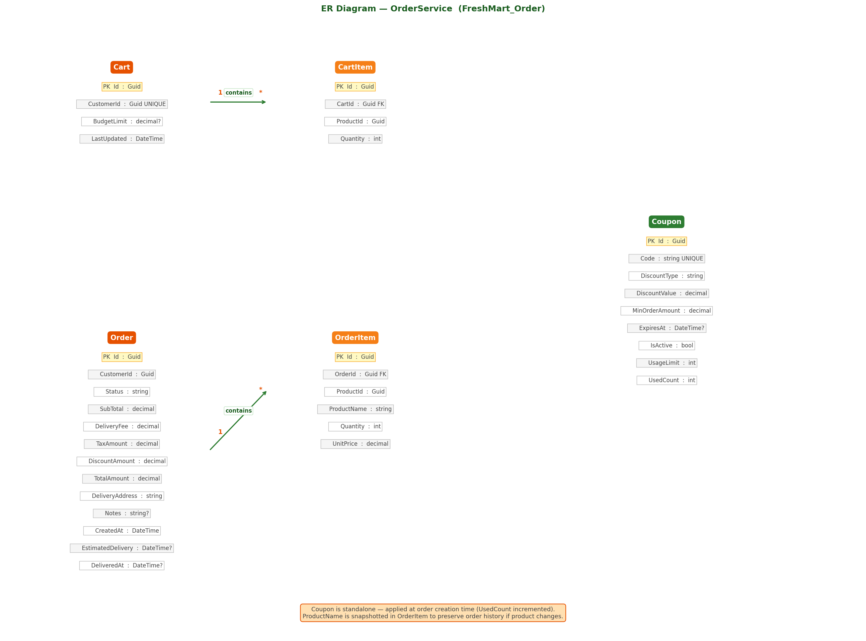
Figure 8: ER Diagram — OrderService (FreshMart_Order Database)

6.4 PaymentService — FreshMart_Payment
Single entity database. Payment stores all Razorpay transaction data. Status is an enum (0=Pending, 1=Paid, 2=Failed, 3=Refunded, 4=Cancelled). UserId and OrderId are plain Guid references — no enforced FK to other service databases.
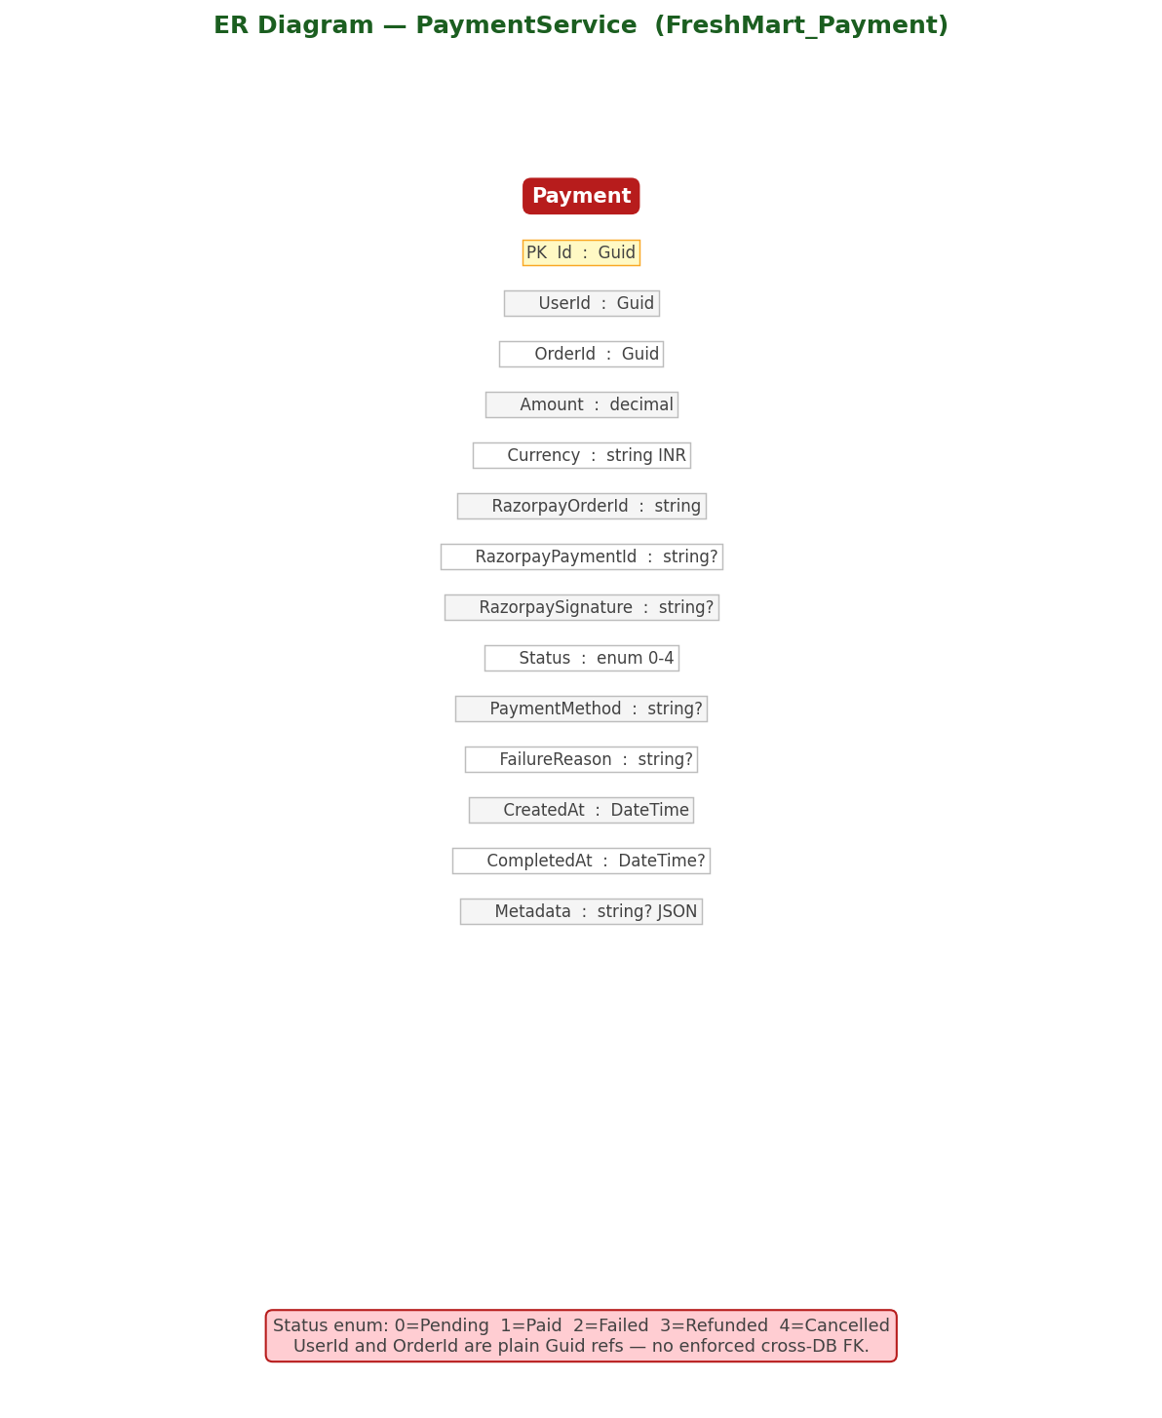
Figure 9: ER Diagram — PaymentService (FreshMart_Payment Database)

6.5 NotificationService — FreshMart_Notification
Notification entity stores all in-app notifications. AppUser is a local projection for user targeting. The NotificationHub uses UserId to route SignalR messages to the correct connected client via group user:{userId}.
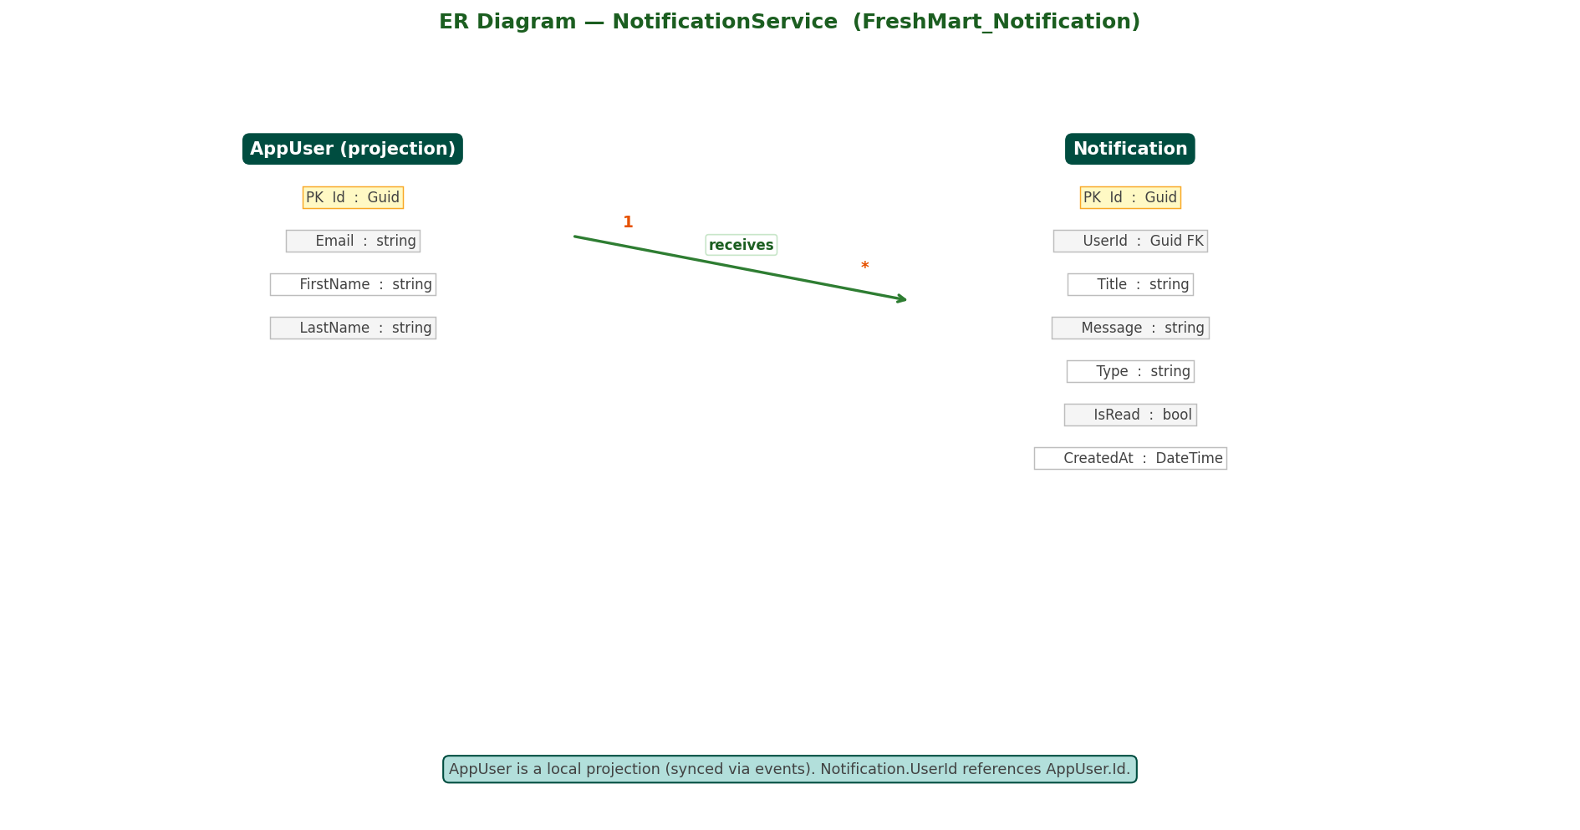
Figure 10: ER Diagram — NotificationService (FreshMart_Notification Database)

6.6 SupportService — FreshMart_Support
SupportTicket has many SupportMessages. Status auto-transitions from Open to InProgress on first staff reply (IsStaff=true). ResolvedAt is set when status becomes Resolved or Closed. SupportHub broadcasts messages in real time to all clients in group ticket:{ticketId}.
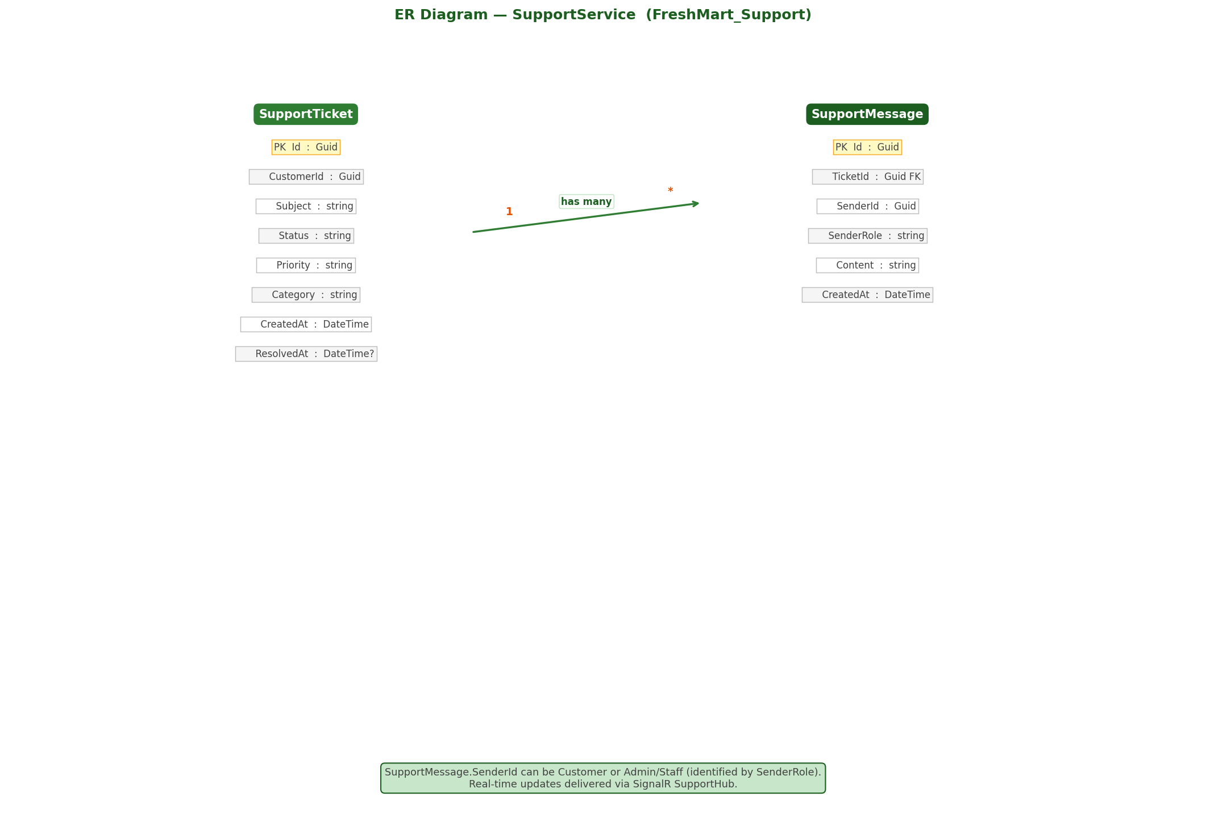
Figure 11: ER Diagram — SupportService (FreshMart_Support Database)

7. Inter-Service Communication
All inter-service communication uses synchronous HTTP (typed HttpClient). There is no message broker. Services call each other directly using Docker internal DNS (container names as hostnames).
Caller | Called Service | Endpoint | When | Critical?
OrderService | PaymentService | POST /api/v1/payment/create-order | Customer places order | YES — order fails if payment service down
OrderService | NotificationService | POST /api/v1/notifications/internal/user | Payment completed | NO — wrapped in try/catch
OrderService | NotificationService | POST /api/v1/notifications/internal/role | New order placed | NO — wrapped in try/catch
OrderService | NotificationService | POST /api/v1/notifications/internal/email/order-placed | Payment completed | NO — wrapped in try/catch
OrderService | NotificationService | POST /api/v1/notifications/internal/email/order-status | Order status updated | NO — wrapped in try/catch
OrderService | AuthService | GET /api/v1/users/{customerId} | Order status updated (for email) | NO — wrapped in try/catch
PaymentService | OrderService | GET /api/v1/orders/{orderId} | Payment creation (order lookup) | NO — optional enrichment

7.1 API Gateway Routing Table
Route Name | URL Pattern | Target Service | Port
auth-route | /api/v1/auth/** | AuthService | 5001
users-route | /api/v1/users/** | AuthService | 5001
products-route | /api/v1/products/** | ProductService | 5002
categories-route | /api/v1/categories/** | ProductService | 5002
orders-route | /api/v1/orders/** | OrderService | 5003
cart-route | /api/v1/cart/** | OrderService | 5003
coupons-route | /api/v1/coupons/** | OrderService | 5003
payment-route | /api/v1/payment/** | PaymentService | 5004
notifications-route | /api/v1/notifications/** | NotificationService | 5005
notif-hub-route | /hubs/notifications/** | NotificationService | 5005
support-route | /api/v1/support/** | SupportService | 5006
support-hub-route | /hubs/support/** | SupportService | 5006

8. Design Patterns Used
Pattern | Where Used | File(s) | Description
API Gateway | Architecture level | ApiGateway/Program.cs, appsettings.json | Single entry point. YARP routes to correct service. JWT validated once centrally.
Dependency Injection | All services | Every Program.cs | ASP.NET Core DI. Services registered as Scoped. Injected via constructor parameters.
Interface Abstraction | PaymentService | IPaymentService.cs + Services/PaymentService.cs | IPaymentService defines contract; concrete class implements it. Enables mocking in tests.
Repository Pattern | All services | Data/*DbContext.cs files | EF Core DbContext acts as repository. Business logic queries through DbContext, not raw SQL.
Service Client | OrderService | Services/PaymentServiceClient.cs, Services/NotificationService.cs | Typed HttpClient wrappers for inter-service HTTP calls with configured base addresses.
Seeder Pattern | Auth, Product, Order | Data/DbSeeder.cs, Data/ProductSeeder.cs, Data/OrderSeeder.cs | Static SeedAsync() called on startup to populate initial data (users, products, coupons).
Middleware Pipeline | All services | Every Program.cs | UseCors -> UseAuthentication -> UseAuthorization -> MapControllers. Order is critical.
Snapshot Pattern | OrderService | OrderItem.cs (ProductName, UnitPrice fields) | ProductName and UnitPrice snapshotted at order time. Preserves history if product changes.
Projection Pattern | Product, Notif, Support | OrderProjection.cs, AppUser.cs (per service) | Local read-only copies of data from other services. Avoids cross-service DB calls.
Multi-Stage Docker | All services + Frontend | Every Dockerfile | Stage 1: SDK/Node builds. Stage 2: Runtime/Nginx serves. Final image has no build tools.
JWT Stateless Auth | All services | JwtService.cs + every Program.cs | JWT signed with shared secret. Any service verifies without calling AuthService.

9. Docker Compose & Quick Reference

9.1 Container Startup Order
Order | Container | Port | Depends On | Database
1st | freshmart-sqlserver | 1433 | None (healthcheck: sqlcmd SELECT 1) | N/A — hosts all 6 DBs
2nd | freshmart-auth | 5001 | sqlserver (healthy) | FreshMart_Auth
2nd | freshmart-products | 5002 | sqlserver (healthy) | FreshMart_Product
2nd | freshmart-orders | 5003 | sqlserver (healthy) | FreshMart_Order
2nd | freshmart-payment | 5004 | sqlserver (healthy) | FreshMart_Payment
2nd | freshmart-notifications | 5005 | sqlserver (healthy) | FreshMart_Notification
2nd | freshmart-support | 5006 | sqlserver (healthy) | FreshMart_Support
3rd | freshmart-gateway | 8080 | auth, products, orders, payment, notifications, support | None
4th | freshmart-frontend | 80 | api-gateway | None

9.2 Run Commands
From the workspace root (where docker-compose.yml is):
docker compose up --build # Build and start all containers
docker compose up --build -d # Run in background (detached)
docker compose down # Stop all containers
docker compose down -v # Stop and wipe all database data
docker compose logs -f # Stream all logs
docker compose logs -f auth-service # Stream logs for one service

9.3 Access URLs
Service | URL | Notes
Frontend (Angular) | http://localhost | Main application UI
API Gateway | http://localhost:8080 | All API calls go through here
AuthService Swagger | http://localhost:5001/swagger | Auth API documentation
ProductService Swagger | http://localhost:5002/swagger | Product API documentation
OrderService Swagger | http://localhost:5003/swagger | Order/Cart API documentation
PaymentService Swagger | http://localhost:5004/swagger | Payment API documentation
NotifService Swagger | http://localhost:5005/swagger | Notification API documentation
SupportService Swagger | http://localhost:5006/swagger | Support API documentation

9.4 Test Accounts (Seeded on Startup)
Role | Email | Password | Access
Admin | admin@grocery.com | Admin@123 | Full platform access — all routes
Store Manager | manager@grocery.com | Manager@123 | Products, orders, support management
Delivery Driver | driver@grocery.com | Driver@123 | Delivery orders only (/delivery)
Customer | customer@grocery.com | Customer@123 | Shopping, orders, support, reviews

9.5 Key Business Rules
Rule | Value | Enforced In
Delivery Fee | Rs.0 if SubTotal >= Rs.500, else Rs.49 | OrderService — CreateOrder
Tax Rate | 5% of SubTotal | OrderService — CreateOrder
JWT Expiry | 1 hour (access token) | AuthService — JwtService
Refresh Token Expiry | 7 days | AuthService — AuthController
Password Hashing | BCrypt cost factor 12 | AuthService — AuthController
Low Stock Threshold | StockQuantity < 10 | ProductService — ProductsController
Review Limit | One review per customer per product | ProductService — ReviewsController
Notification Limit | Last 50 returned per user | NotificationService — NotificationsController
Coupon Validation | IsActive + not expired + UsedCount < UsageLimit + SubTotal >= MinOrderAmount | OrderService — OrdersController
Order Status Flow | Pending -> Processing -> Shipped -> OutForDelivery -> Delivered (or Cancelled) | OrderService — OrdersController
Ticket Status Flow | Open -> InProgress (first staff reply) -> Resolved -> Closed | SupportService — SupportController
DiscountedPrice | Price x (1 - DiscountPercent / 100) | ProductService — ProductsController.ToDto()

End of Document — FreshMart Project Structure & Flow Document

