**Project Title** – RFID & IoT Based Smart Attendance System Using RFID and Google Sheets

**Introduction** - The conventional manual attendance system is highly time-consuming, insecure, and prone to human errors. It proves ineffective as it consumes valuable time and effort in managing attendance through pen and paper. To address this issue, we've implemented a relational database system to store real-time student data. In this project, RFID tags and readers were employed to accurately record student attendance.

* What is RFID Technology?

Radio-Frequency Identification (RFID) uses **electromagnetic fields** to automatically identify and track tags attached to objects. An RFID system consists of a tiny **radio transponder, a radio receiver and transmitter**. When triggered by an electromagnetic interrogation pulse from a nearby RFID reader device, the tag transmits digital data, usually an identifying inventory number, back to the reader. This number can be used to track inventory goods.

Passive tags are powered by energy from the RFID reader's interrogating radio waves. Active tags are powered by a battery and thus can be read at a greater range from the RFID reader, up to hundreds of meters.

Unlike a barcode, the tag does not need to be within the line of sight of the reader, so it may be embedded in the tracked object. RFID is one method of automatic identification and data capture (AIDC).

**Components Used:**

[1] **ESP8266 NodeMCU**

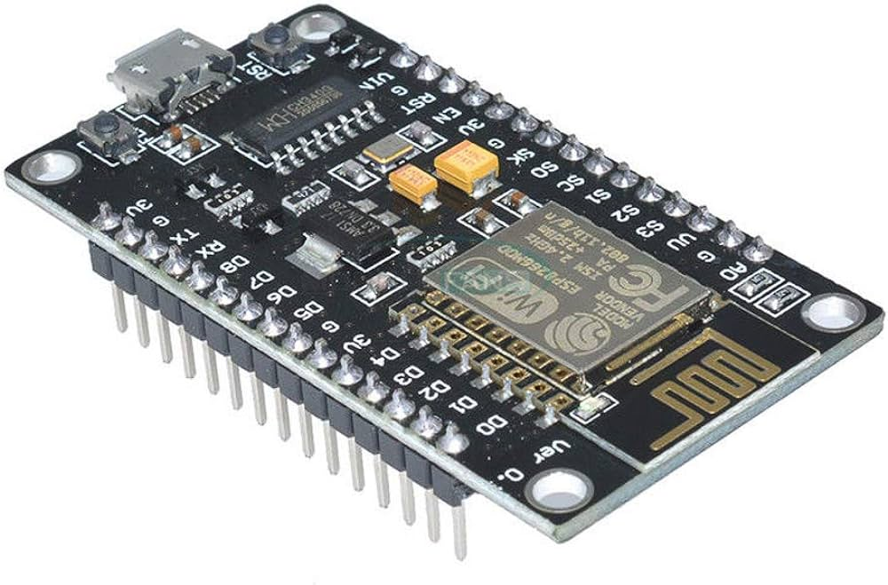In this project, we have used NodeMCU which is an open- source platform. NodeMCU is based on ESP8266 which can be used to connect objects and transfer data using Wi-Fi. In this project, the NodeMCU is used to send the attendance on the spreadsheet via the Wi-Fi module. Whatever the google spreadsheet code has generated the deployment link, we have to copy that link and paste it into the code and with the help, NodeMCU will send the data on the spreadsheet.

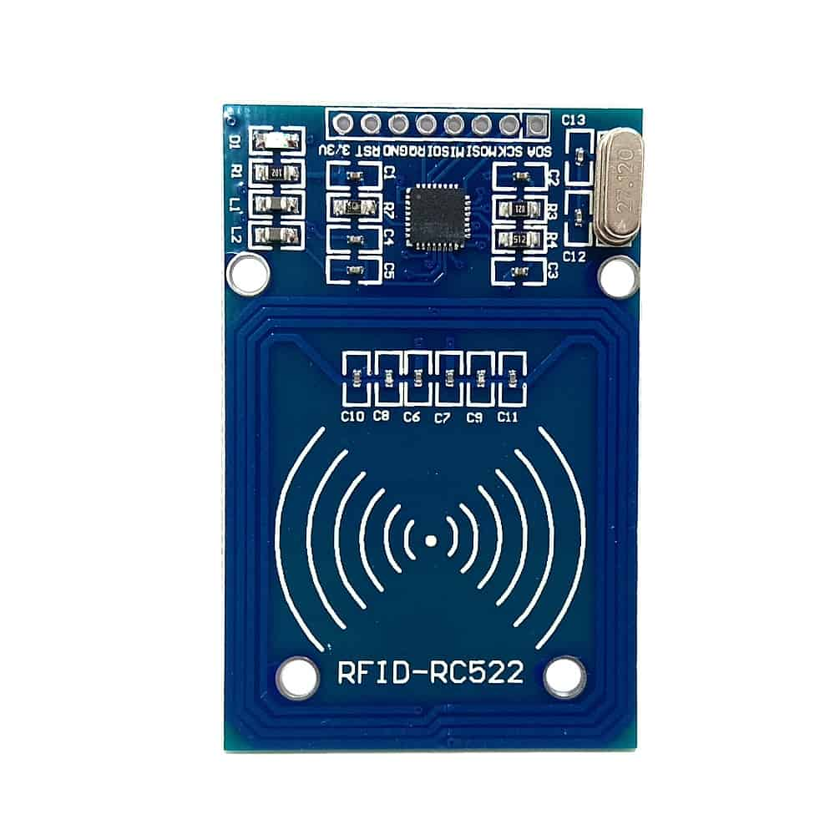

[2] **RC522 RFID Card Reader Module**

An RFID reader consists of an antenna and a radio frequency module which basically generates a high-frequency electromagnetic field. As we all know an RFID tag is a passive device which means that it doesn’t have a power supply or a battery. An RFID reader has a microchip that is used to store

and process the information. And also, it has an antenna that is used to receive to transmit a signal. To read the information on the RFID tag it needs to be placed in very close range of the reader. An RFID reader basically generates an electromagnetic field that causes electrons to move through the tag in the antenna and it powers up the chip.

[3] **RFID Tags and Cards**

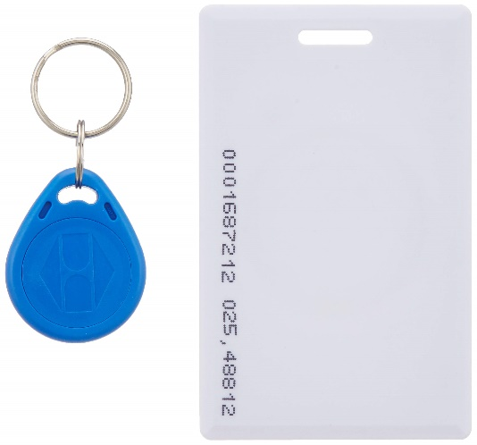The RFID tags are differentiated as passive and active tags. If the device doesn’t have its power supply it is called a passive RFID tag. Thus, the passive tags have to be in very close range of an RFID reader and make use of the radio waves which are broadcasted by the reader to power the response alternatively if the device has its battery power to perform entire operations which are called active RFID tags.

[4] **Buzzer**

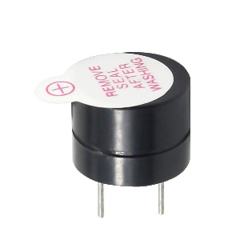This buzzer also has an important role in this module. Whenever the user will scan his/her card then this buzzer beeps for a few seconds so that the one who scanned the card will know that his card is scanned properly. Without a buzzer, one can only assume the card has been detected but he/she will not be sure so the buzzer is important here.

[5] **LEDs**

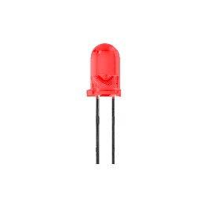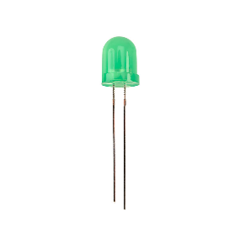Two LEDs are used which are of green and red color. Green color led lights up upon successful entry of attendance (IN or OUT) while red color led lights up in case there is some error in entry of attendance on the Google Sheet.

**Working Principle –**

This system consists of 3 codes.

1) First one is the spreadsheet code which is written on the back end of the spreadsheet

2) Second one is the code in which we will register the card by loading his/her information. That means that the card will be permanently assigned to the student/employee.

3) The third code is the code through which we will scan our id card and then the attendance will be marked on the spreadsheet via NodeMCU.

In the second code, we will write the information which we want to save in the new fresh card. When the information is written in the code, we simply have to upload the code. When the uploading is done, we have to take our new fresh card close to the RFID RC522 module once the information is loaded in the card the serial monitor will show that the block is successfully read “and” Data is stored in Block No 2”. With this we have registered one card, same process is repeated to create the remaining cards, just change the information in the code, upload the code take a new fresh card, and scan. After that in the third code, we have pasted a link to the google spreadsheet which is deployed/generated when we run the google spreadsheet code. So, after registering the card we have to just simply upload the third code when the code is successfully uploaded, we have to take our” Registered Card” close to the RFID-RC522 module once the card has scanned the buzzer will immediately beep for a few seconds and the serial monitor will give us the link and the HTTPS code. If the HTTPS code is 302 that means our data is successfully read on the spreadsheet.

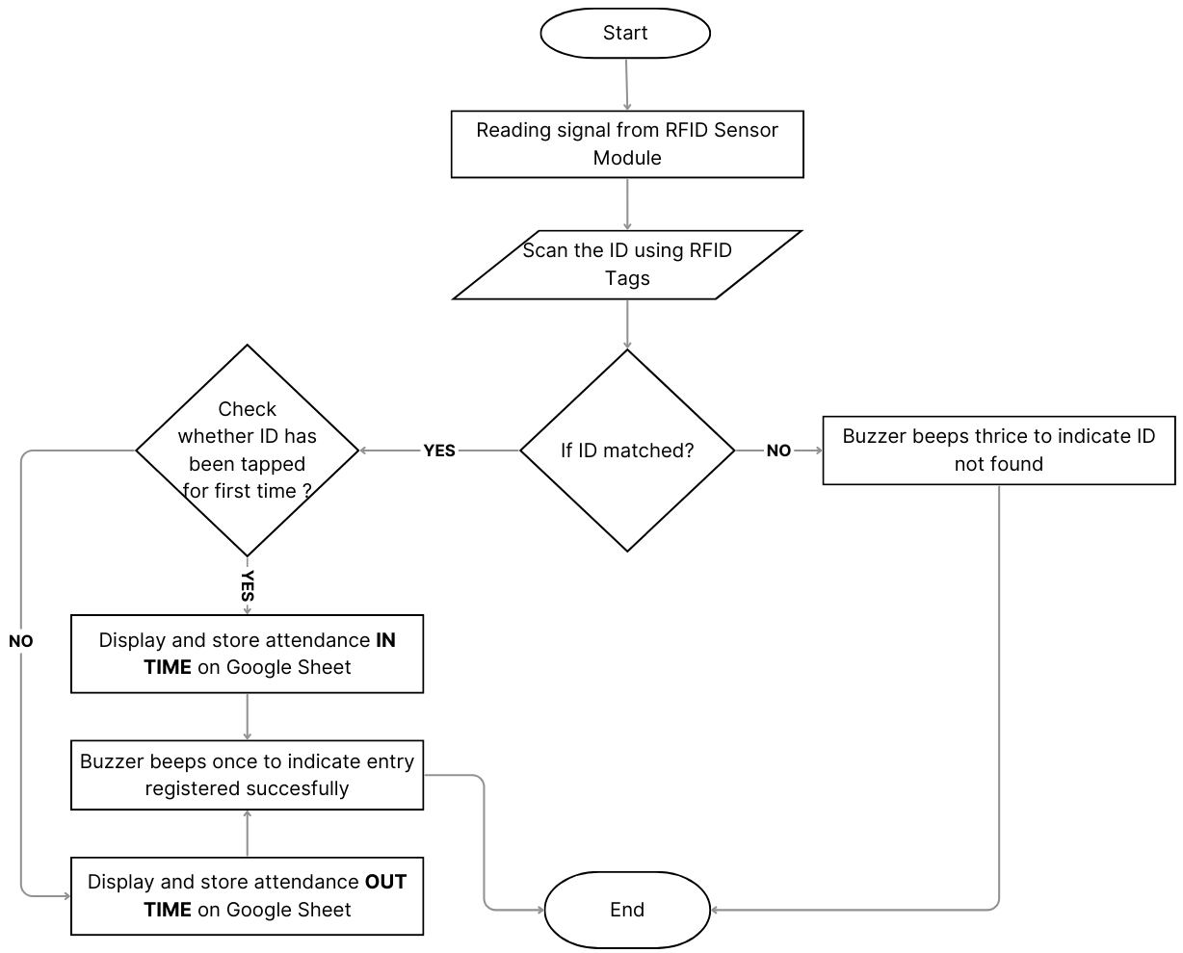

FLOW CHART

**METHODOLOGY**

The following figure shows the block diagram for our project attendance system using RFID. Which mainly consists of NodeMCU (ESP-8266), RFID Cards, RFID reader RC522, a buzzer and a breadboard. Here NodeMCU acts as a Central processing unit (CPU) for controlling all the input/output components. For this project, we have used a 5v power supply to power up the node MCU and other components. FID reader module is interfaced with NodeMCU to read the data from RFID cards/tags. In this system, a student or employee has to place /put his card on an RFID reader. When the RFID reader reads the data, it directly transfers the data to NodeMCU and first If the ID is checked if it matches to the database then the real-time attendance will be displayed and stored on a google sheet. The buzzer beeps after evert successful scan (IN/OUT). In case any unregistered card is scanned the buzzer beeps thrice to indicate that the user is not registered.

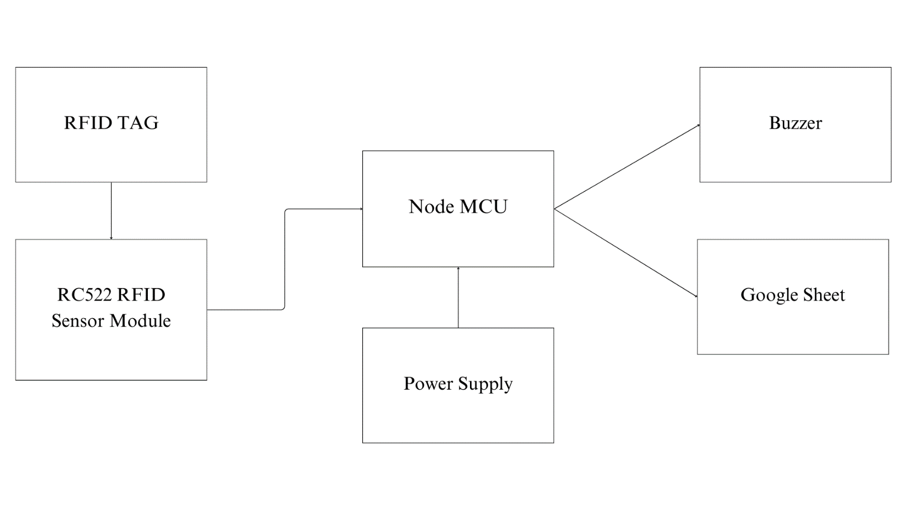

Block Diagram

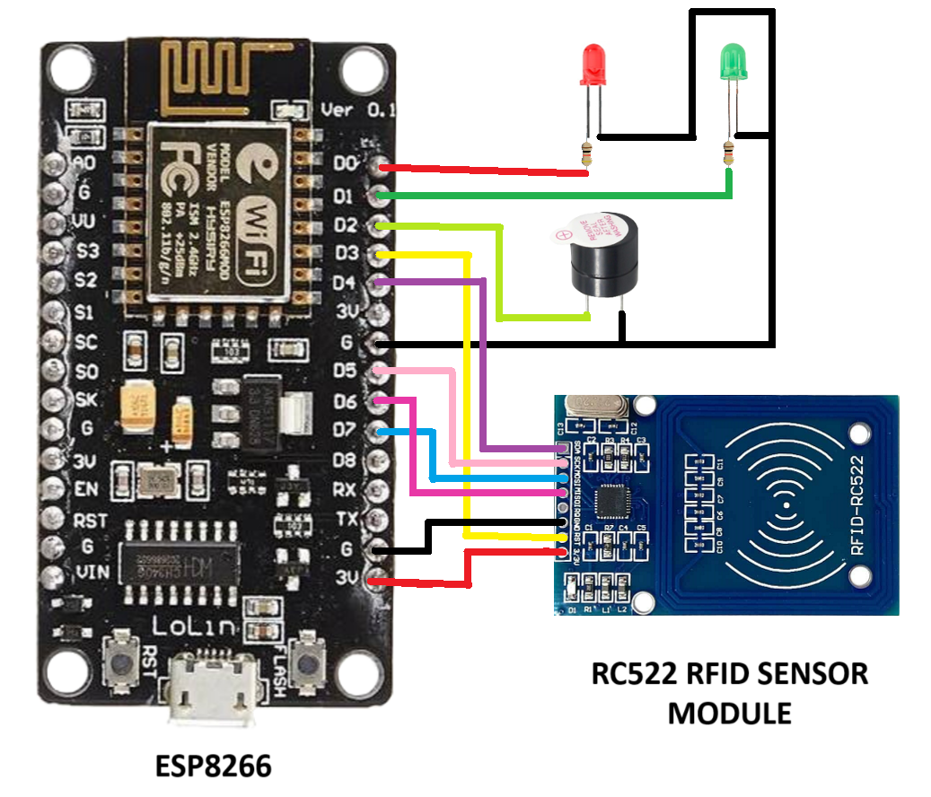

Circuit Diagram

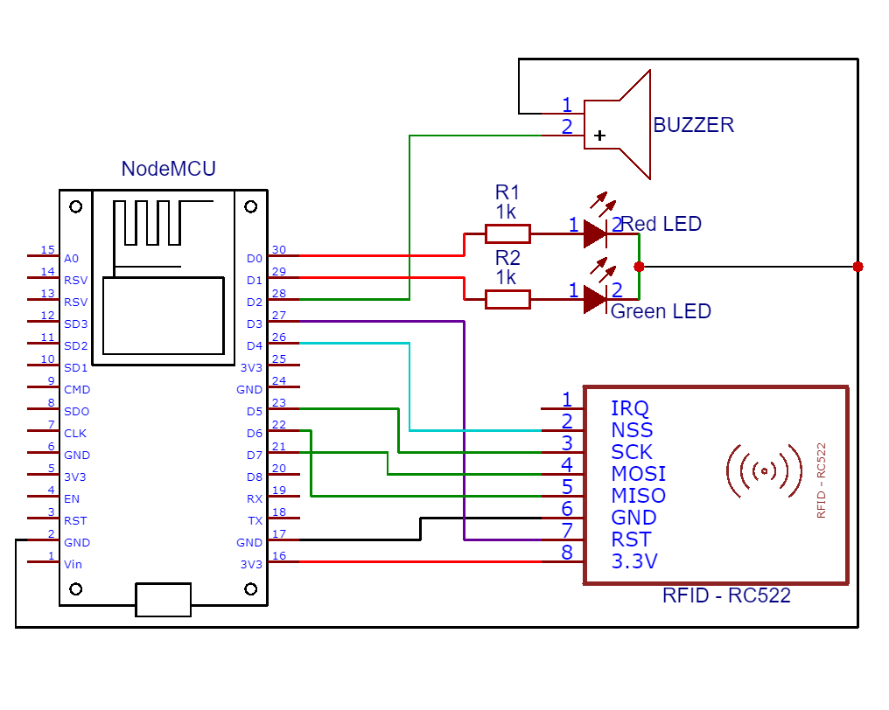

Schematic Diagram

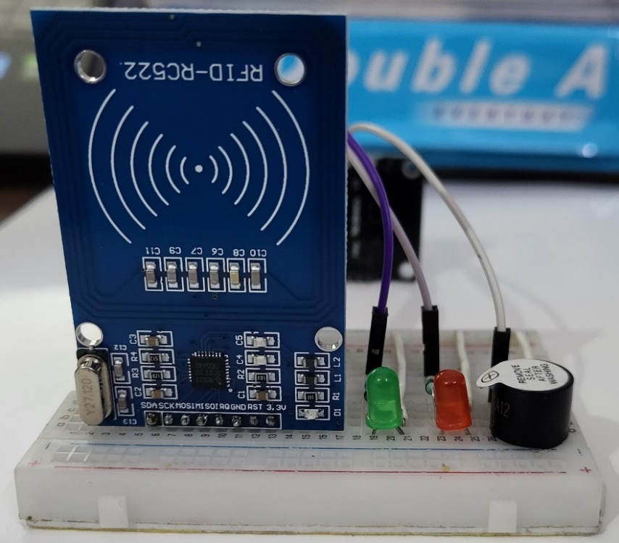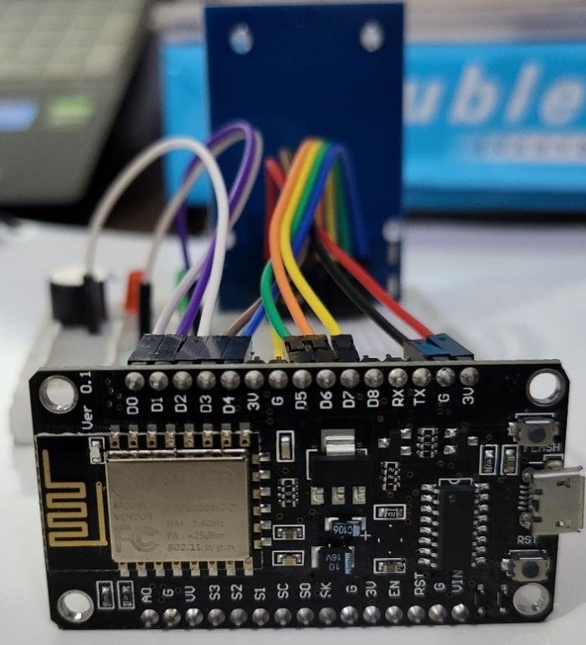RESULT-

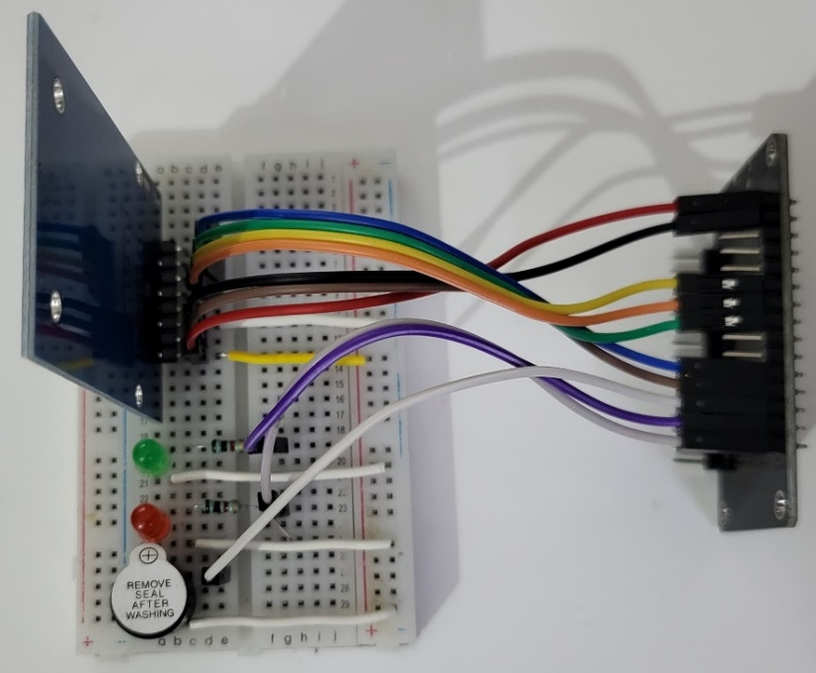

Hardware Implementation

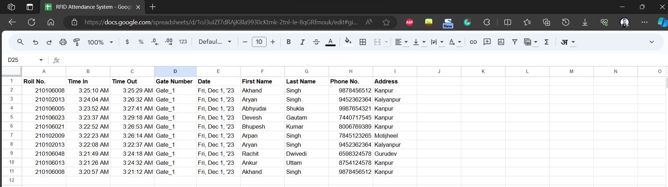 Attendance Marked On Google Sheet

**REFERENCES**

[1] Bhagat, Rinku. “An MQTT based IoT-RFID Attendance System using NodeMCU Firmware: A Review.” International Research Journal of Engineering and Technology (IRJET) 7, no. 06 (2020): 1255-1259.

[2] Lim, T. S., S. C. Sim, and M. M. Mansor. “ RFID based attendance system.” In 2009 IEEE Symposium on Industrial Electronics & Applications, vol. 2, pp. 778-782. IEEE, 2009.

[3] Radio-frequency identification <https://en.wikipedia.org/wiki/Radio-frequency_identification/>

[4] GitHub <https://github.com/>