BABU BANARASI DAS
UNIVERSITY
2026-2027
SCHOOL OF COMPUTER APPLICATIONS
NoSQL Project On
Partner Management System of Luminous Batteries Using MongoDB
Submitted to: Submitted by:
Mr. Harendra Singh Aryan Bhatt
Department: BCA (DS & AI) Section: BCADS22
Date: 25th September Roll no: 1250258135

DOCUMENT STRUCTURE
Each partner is stored as one document in the partners collection with the following fields:
Field | Type | Description
partnerId | Number | Unique ID of the partner
name | String | Name of the partner
age | Number | Age of the partner
amount | Number | Total battery sales amount (in ₹)
city | String | City where the partner operates
type | String | Distributor, Dealer or Retailer

1. CREATE DATABASE
MongoDB Query:
use LuminousDB

Explanation: Creates or switches to the LuminousDB database.
Output Screenshot:
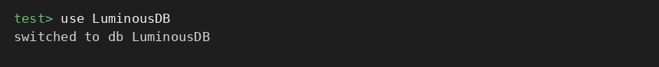

2. CREATE COLLECTION
MongoDB Query:
db.createCollection("partners")

Explanation: Creates a collection named partners.
Output Screenshot:
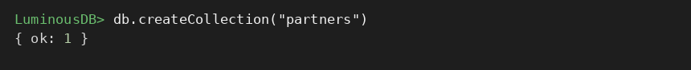

3. INSERT 50 PARTNERS
MongoDB Query:
db.partners.insertMany([
{partnerId:1, name:"Rajesh", age:24, amount:62000, city:"Delhi", type:"Dealer"},
{partnerId:2, name:"Sunita", age:42, amount:60000, city:"Mumbai", type:"Dealer"},
{partnerId:3, name:"Anil", age:55, amount:47000, city:"Mumbai", type:"Retailer"},
{partnerId:4, name:"Pooja", age:32, amount:44500, city:"Delhi", type:"Retailer"},
{partnerId:5, name:"Vikram", age:29, amount:78000, city:"Mumbai", type:"Dealer"},
{partnerId:6, name:"Meena", age:33, amount:83000, city:"Jaipur", type:"Distributor"},
{partnerId:7, name:"Sanjay", age:41, amount:31000, city:"Jaipur", type:"Retailer"},
{partnerId:8, name:"Neha", age:50, amount:80000, city:"Lucknow", type:"Distributor"},
{partnerId:9, name:"Deepak", age:21, amount:76000, city:"Jaipur", type:"Dealer"},
{partnerId:10, name:"Kavita", age:28, amount:48000, city:"Pune", type:"Retailer"},
{partnerId:11, name:"Rohit", age:29, amount:63000, city:"Lucknow", type:"Dealer"},
{partnerId:12, name:"Anjali", age:54, amount:49500, city:"Pune", type:"Retailer"},
{partnerId:13, name:"Manish", age:26, amount:92000, city:"Delhi", type:"Distributor"},
{partnerId:14, name:"Ritu", age:35, amount:36000, city:"Lucknow", type:"Retailer"},
{partnerId:15, name:"Suresh", age:41, amount:80000, city:"Mumbai", type:"Distributor"},
{partnerId:16, name:"Preeti", age:25, amount:66000, city:"Mumbai", type:"Dealer"},
{partnerId:17, name:"Ajay", age:53, amount:57500, city:"Delhi", type:"Dealer"},
{partnerId:18, name:"Swati", age:52, amount:93000, city:"Mumbai", type:"Distributor"},
{partnerId:19, name:"Naveen", age:50, amount:79500, city:"Delhi", type:"Dealer"},
{partnerId:20, name:"Shweta", age:26, amount:91000, city:"Delhi", type:"Distributor"},
{partnerId:21, name:"Arun", age:47, amount:56000, city:"Jaipur", type:"Dealer"},
{partnerId:22, name:"Komal", age:38, amount:53000, city:"Lucknow", type:"Dealer"},
{partnerId:23, name:"Gaurav", age:26, amount:94000, city:"Mumbai", type:"Distributor"},
{partnerId:24, name:"Rekha", age:36, amount:63500, city:"Mumbai", type:"Dealer"},
{partnerId:25, name:"Pankaj", age:47, amount:88000, city:"Pune", type:"Distributor"},
{partnerId:26, name:"Nidhi", age:40, amount:70500, city:"Delhi", type:"Dealer"},
{partnerId:27, name:"Sachin", age:31, amount:40000, city:"Jaipur", type:"Retailer"},
{partnerId:28, name:"Divya", age:46, amount:69500, city:"Mumbai", type:"Dealer"},
{partnerId:29, name:"Ashok", age:39, amount:90000, city:"Delhi", type:"Distributor"},
{partnerId:30, name:"Tanvi", age:55, amount:66000, city:"Delhi", type:"Dealer"},
{partnerId:31, name:"Vivek", age:39, amount:44000, city:"Mumbai", type:"Retailer"},
{partnerId:32, name:"Sonali", age:27, amount:84000, city:"Jaipur", type:"Distributor"},
{partnerId:33, name:"Harish", age:22, amount:86000, city:"Lucknow", type:"Distributor"},
{partnerId:34, name:"Payal", age:55, amount:47000, city:"Lucknow", type:"Retailer"},
{partnerId:35, name:"Nitin", age:59, amount:47000, city:"Delhi", type:"Retailer"},
{partnerId:36, name:"Jaya", age:58, amount:29000, city:"Mumbai", type:"Retailer"},
{partnerId:37, name:"Lalit", age:23, amount:37000, city:"Mumbai", type:"Retailer"},
{partnerId:38, name:"Mansi", age:47, amount:80000, city:"Jaipur", type:"Distributor"},
{partnerId:39, name:"Rakesh", age:21, amount:63500, city:"Delhi", type:"Dealer"},
{partnerId:40, name:"Simran", age:25, amount:55500, city:"Lucknow", type:"Dealer"},
{partnerId:41, name:"Yogesh", age:34, amount:60000, city:"Pune", type:"Dealer"},
{partnerId:42, name:"Bharti", age:24, amount:69500, city:"Jaipur", type:"Dealer"},
{partnerId:43, name:"Dinesh", age:29, amount:39500, city:"Mumbai", type:"Retailer"},
{partnerId:44, name:"Ekta", age:45, amount:52000, city:"Lucknow", type:"Dealer"},
{partnerId:45, name:"Mukesh", age:32, amount:25000, city:"Delhi", type:"Retailer"},
{partnerId:46, name:"Arti", age:42, amount:44000, city:"Pune", type:"Retailer"},
{partnerId:47, name:"Tarun", age:47, amount:39500, city:"Mumbai", type:"Retailer"},
{partnerId:48, name:"Seema", age:55, amount:84000, city:"Mumbai", type:"Distributor"},
{partnerId:49, name:"Varun", age:55, amount:62500, city:"Delhi", type:"Dealer"},
{partnerId:50, name:"Isha", age:22, amount:43500, city:"Mumbai", type:"Retailer"}
])

Explanation: Inserts multiple partner documents into the collection.
Output Screenshot:
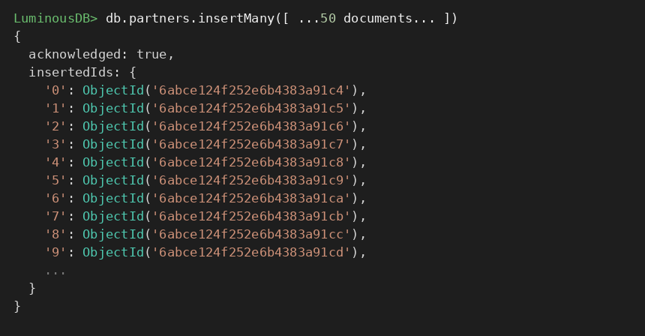

4. DISPLAY ALL PARTNERS
MongoDB Query:
db.partners.find()

Explanation: Retrieves all documents from the partners collection.
Output Screenshot:
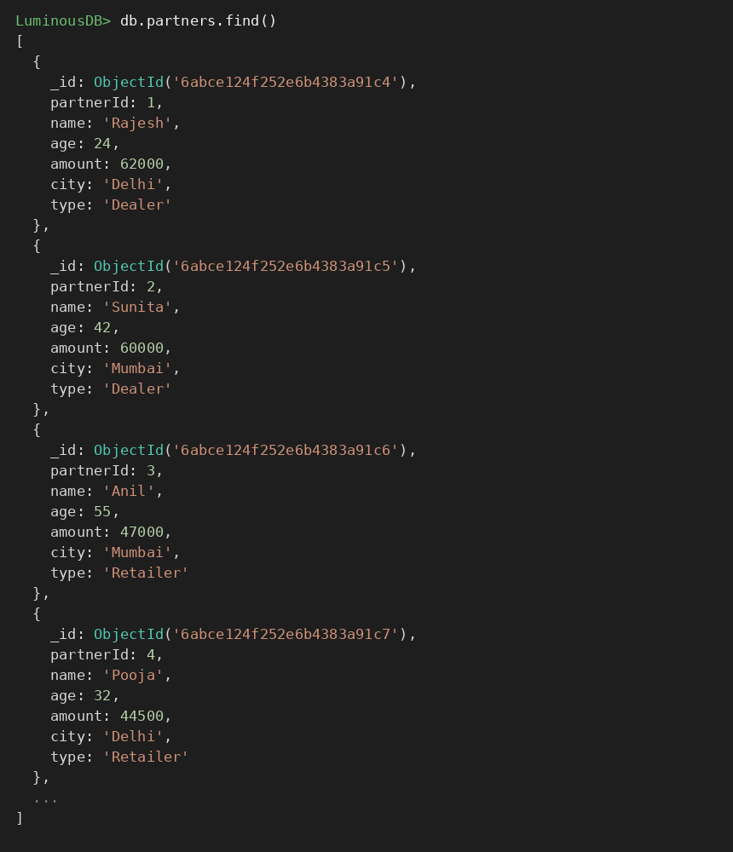

5. EQUAL TO — $eq
MongoDB Query:
db.partners.find({amount: {$eq: 62000}})

Explanation: Finds partners whose amount is exactly 62000.
Output Screenshot:
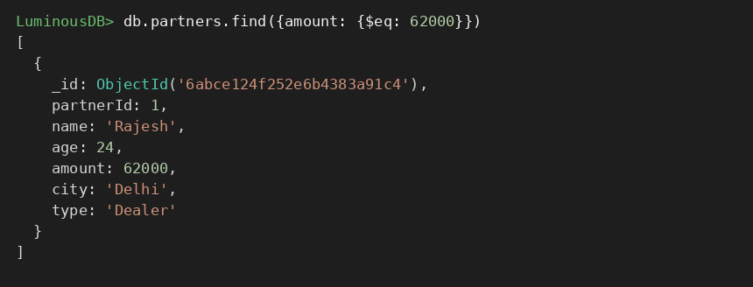

6. GREATER THAN — $gt
MongoDB Query:
db.partners.find({amount: {$gt: 85000}})

Explanation: Finds partners whose amount is greater than 85000.
Output Screenshot:
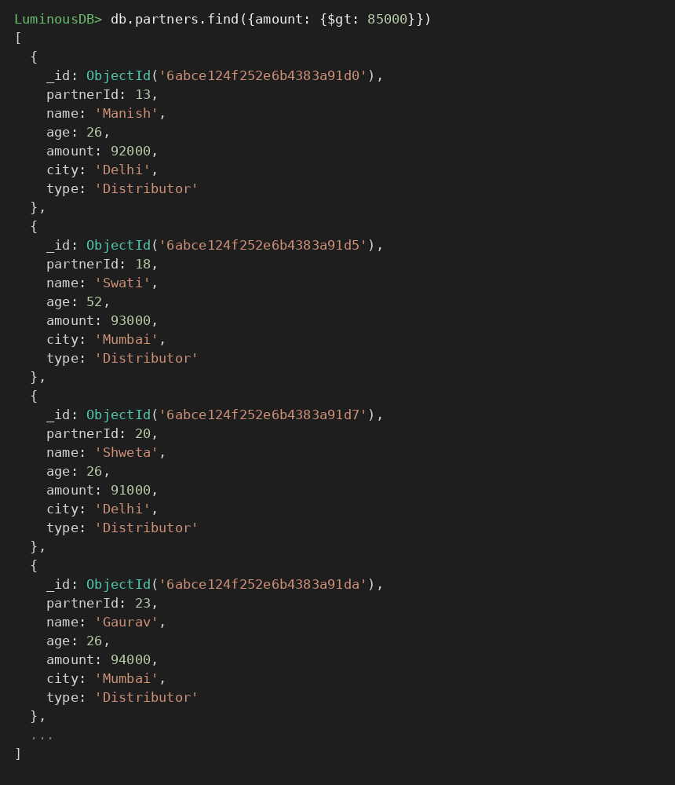

7. LESS THAN — $lt
MongoDB Query:
db.partners.find({amount: {$lt: 35000}})

Explanation: Finds partners whose amount is less than 35000.
Output Screenshot:
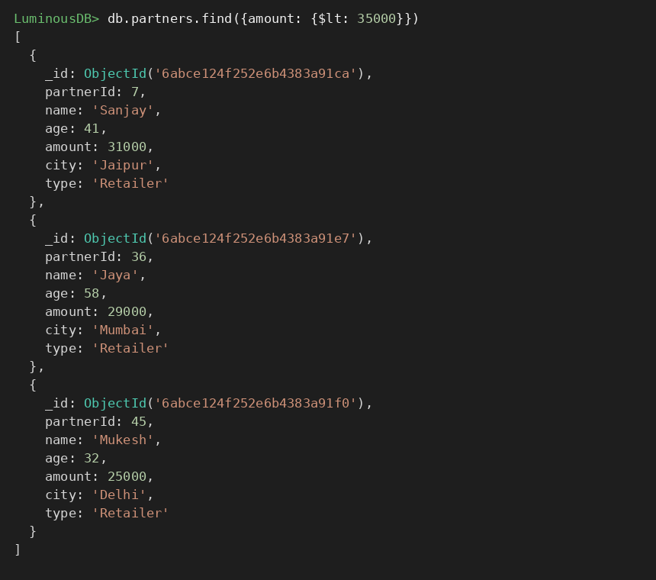

8. GREATER THAN OR EQUAL TO — $gte
MongoDB Query:
db.partners.find({amount: {$gte: 90000}})

Explanation: Finds partners whose amount is 90000 or above.
Output Screenshot:
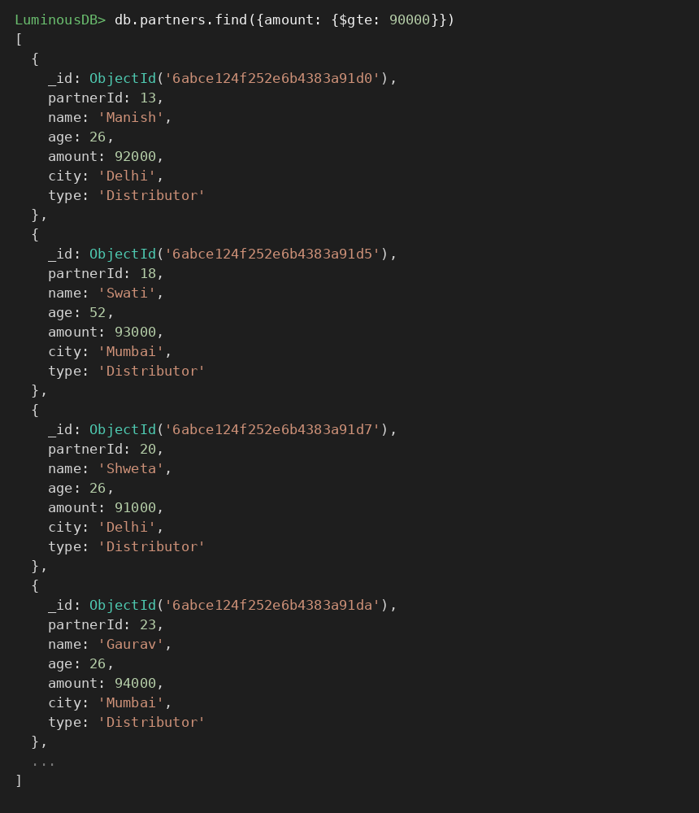

9. LESS THAN OR EQUAL TO — $lte
MongoDB Query:
db.partners.find({amount: {$lte: 40000}})

Explanation: Finds partners whose amount is 40000 or below.
Output Screenshot:
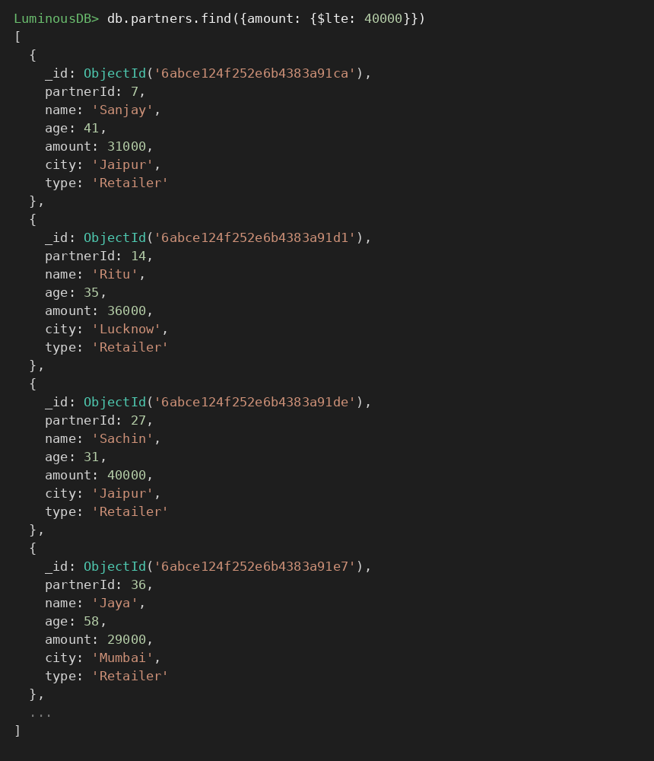

10. UPDATE OPERATION
MongoDB Query:
db.partners.updateOne(
{partnerId:5},
{$set:{amount:95000}}
)

Explanation: Updates the amount to 95000 of the partner with partnerId 5.
Output Screenshot:
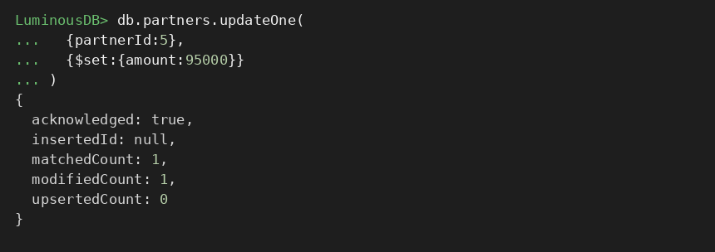

11. DELETE ONE OPERATION
MongoDB Query:
db.partners.deleteOne({partnerId:10})

Explanation: Deletes one document matching partnerId 10.
Output Screenshot:
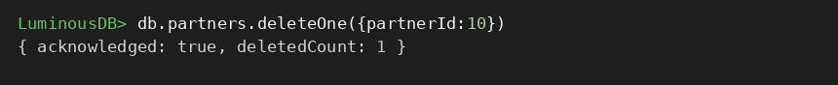

12. DELETE MANY OPERATION
MongoDB Query:
db.partners.deleteMany({
amount: {$lt:35000}
})

Explanation: Deletes all partners having an amount below 35000.
Output Screenshot:
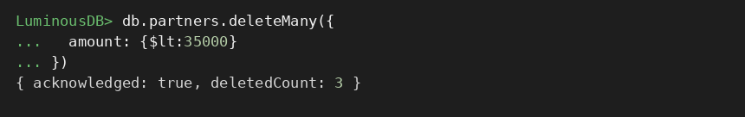

13. AND OPERATION — $and
MongoDB Query:
db.partners.find({
$and:[
{amount:{$gt:80000}},
{age:26}
]
})

Explanation: Finds partners satisfying both conditions (amount greater than 80000 and age equal to 26).
Output Screenshot:
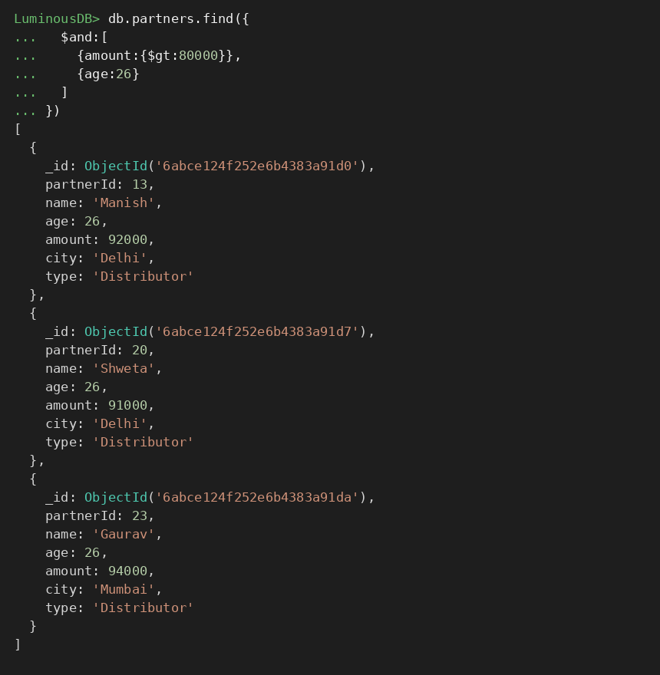

14. OR OPERATION — $or
MongoDB Query:
db.partners.find({
$or:[
{city:"Delhi"},
{city:"Mumbai"}
]
})

Explanation: Finds partners who operate in Delhi or Mumbai.
Output Screenshot:
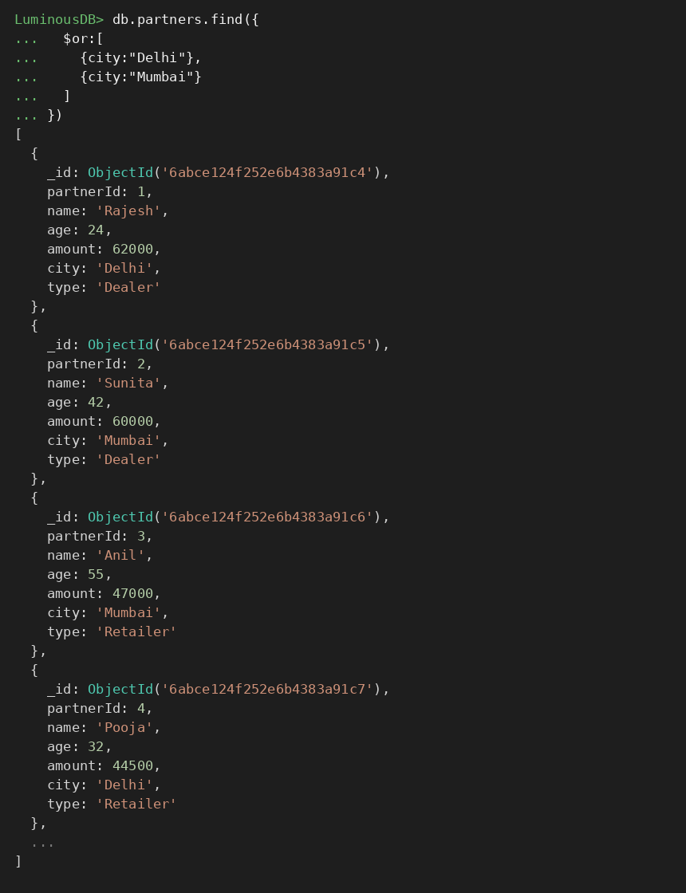

15. SORT OPERATION
A. MongoDB Query:
db.partners.find().sort({amount: 1})

Explanation: Sorts partners by amount from lowest to highest. Use 1 for ascending order.
Output Screenshot:
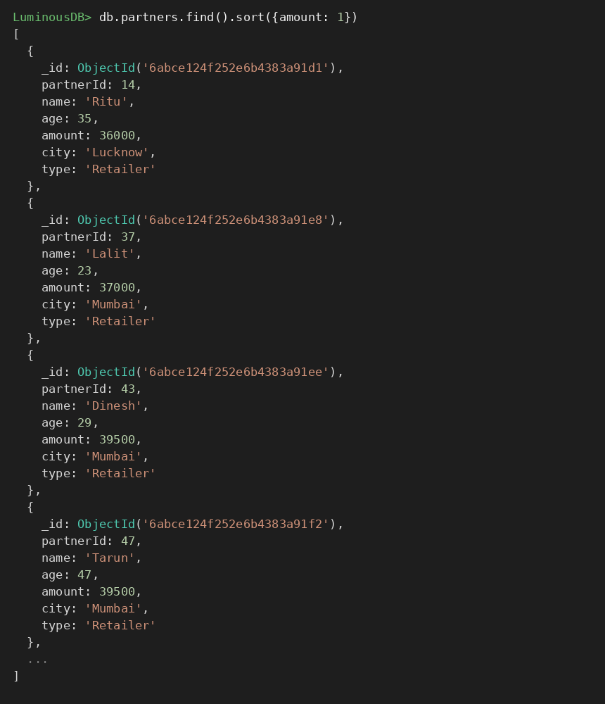

B. MongoDB Query:
db.partners.find().sort({amount: -1})

Explanation: Sorts partners by amount from highest to lowest. Use -1 for descending order.
Output Screenshot:
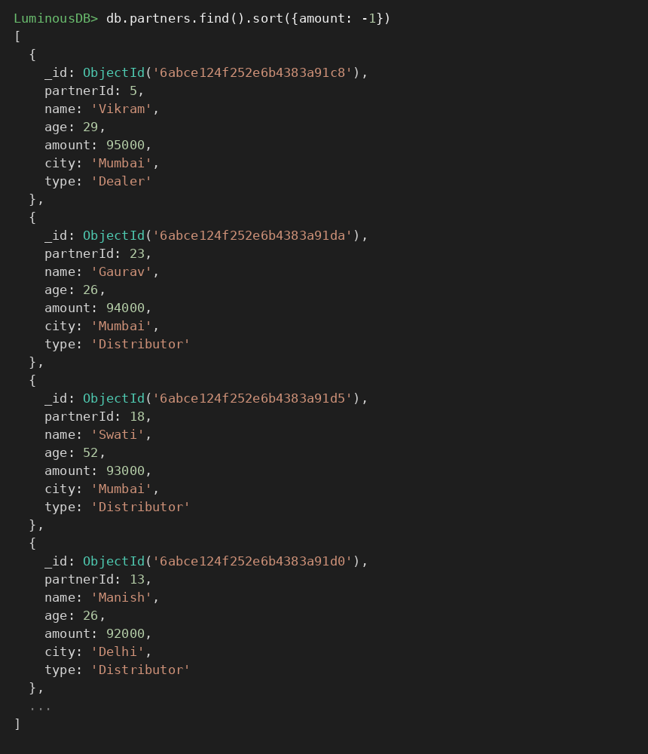

16. LIMIT OPERATION
MongoDB Query:
db.partners.find().limit(5)

Explanation: Displays only the first five documents.
Output Screenshot:
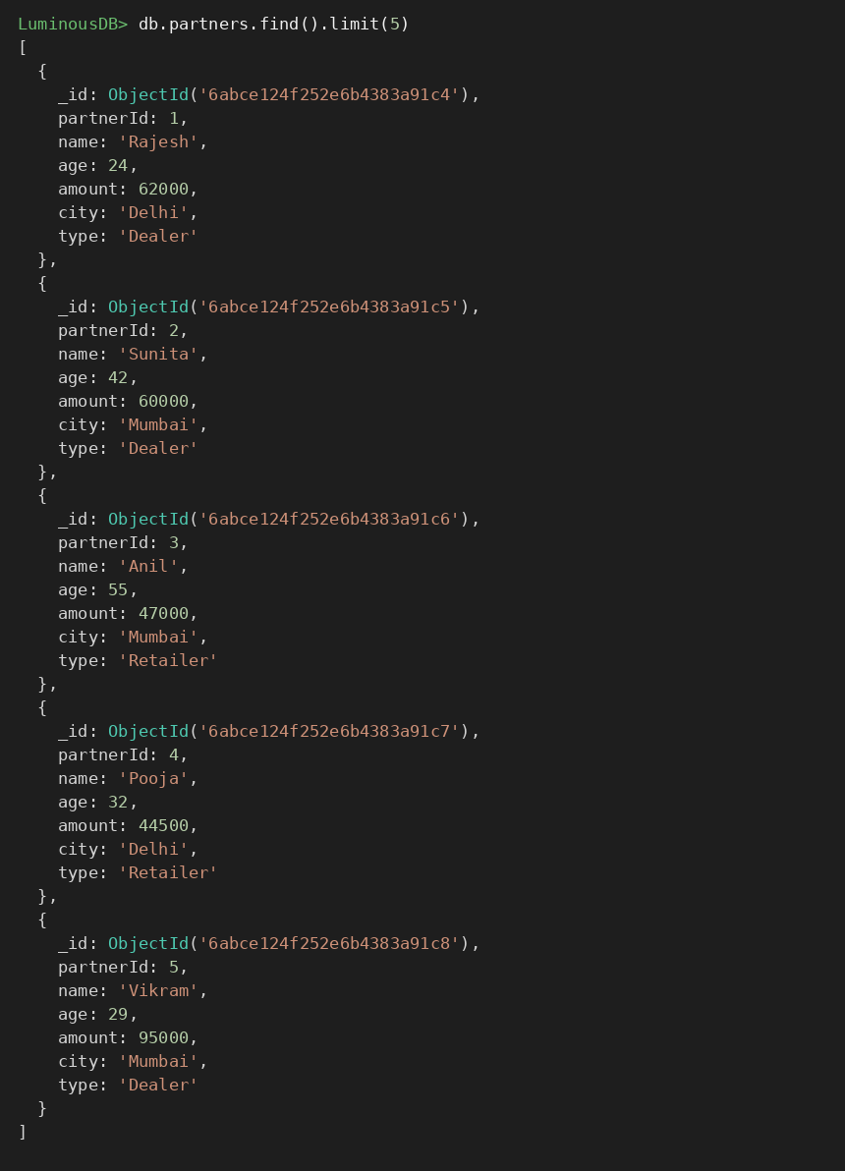

17. SEARCH BY CITY
MongoDB Query:
db.partners.find({city:"Delhi"})

Explanation: Finds all partners who operate in Delhi.
Output Screenshot:
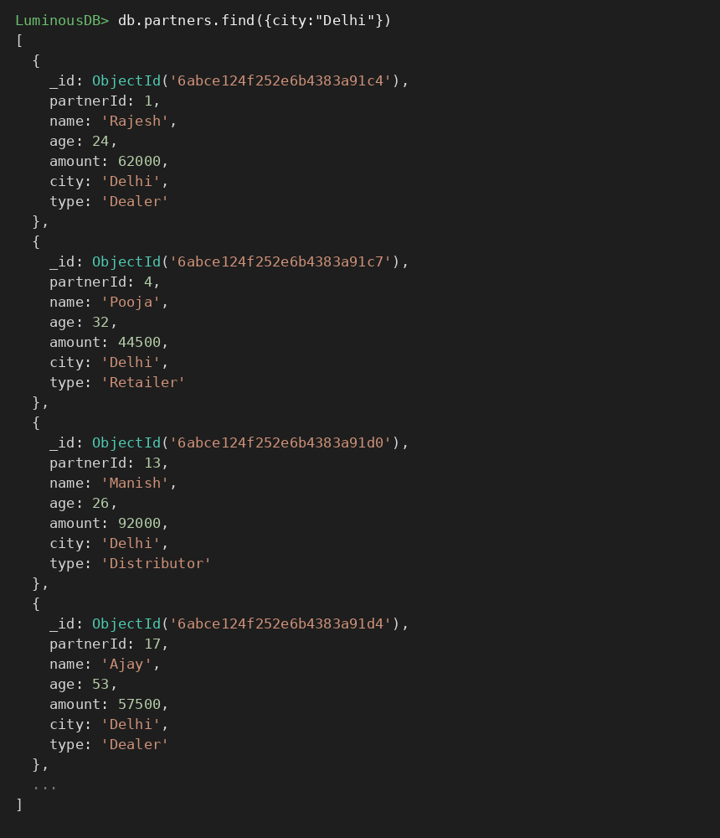

18. COUNT DOCUMENTS
MongoDB Query:
db.partners.countDocuments()

Explanation: Counts documents currently present in the collection (performed after the delete operations).
Output Screenshot:
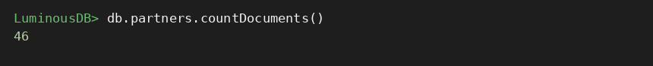

MONGODB OPERATORS USED
Operator | Meaning | Example
$eq | Equal to | amount: {$eq:62000}
$gt | Greater than | amount: {$gt:85000}
$lt | Less than | amount: {$lt:35000}
$gte | Greater than or equal to | amount: {$gte:90000}
$lte | Less than or equal to | amount: {$lte:40000}
$and | All conditions true | $and:[...]
$or | At least one condition true | $or:[...]

CONCLUSION
This project provided practical knowledge of NoSQL databases using MongoDB. A Partner Management System for Luminous batteries containing distributor, dealer and retailer information was created and different MongoDB operations were performed on the data.
Through this project, I learned how to insert, retrieve, update, and delete documents. I also learned how to arrange data in ascending and descending order, how comparison operators such as $eq, $gt, $lt, $gte, and $lte work, along with logical operators such as $and and $or.
Overall, this project helped me understand how MongoDB can be used to manage and query partner data efficiently.

