Understanding Heart-Related Diseases: Symptoms, Causes, Prevention, and Global Impact

Introduction to Cardiovascular Diseases
Cardiovascular diseases (CVDs) encompass a range of conditions that affect the heart and blood vessels. These conditions are a leading cause of morbidity and mortality worldwide, impacting millions of lives annually. Understanding the various facets of CVDs, from their underlying mechanisms to their global prevalence, is crucial for effective prevention and management strategies. This document provides an overview of common heart-related diseases, their recognizable symptoms, principal causes, effective prevention methods, and their global distribution.
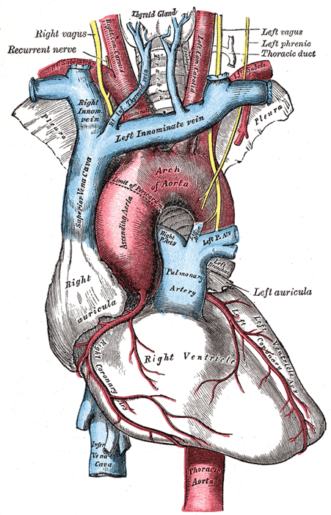

Common Symptoms of Heart Diseases
Symptoms of heart disease can vary widely depending on the specific condition, but some are commonly observed across different types. Early recognition of these signs is vital for prompt diagnosis and intervention.
- Chest pain or discomfort (angina), often described as pressure, tightness, or aching.
- Shortness of breath (dyspnea), especially during exertion or when lying down.
- Pain that radiates to the arm (most often the left), jaw, neck, back, or stomach.
- Fatigue and weakness, particularly if new or worsening.
- Swelling in the legs, ankles, and feet (edema) due to fluid retention.
- Rapid or irregular heartbeats (palpitations).
- Dizziness or lightheadedness, and sometimes fainting (syncope).
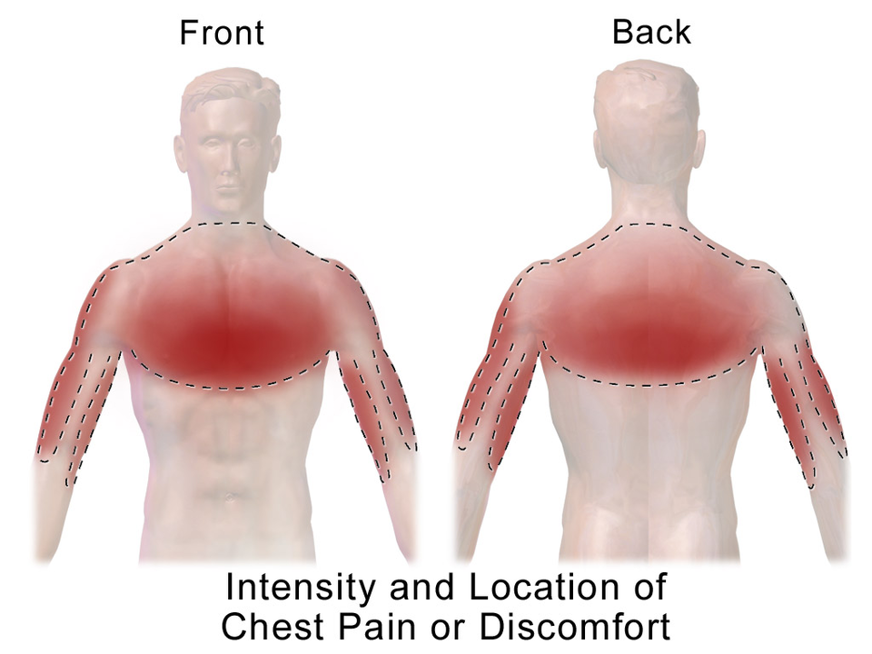

Causes and Risk Factors
Heart diseases are often multifactorial, stemming from a combination of genetic predispositions, lifestyle choices, and environmental factors. Identifying and mitigating these causes and risk factors is key to preventing the onset and progression of CVDs.
- High blood pressure (hypertension): A major risk factor that damages arteries over time.
- High cholesterol: Leading to plaque buildup in arteries (atherosclerosis).
- Diabetes: High blood sugar levels can damage blood vessels and nerves controlling the heart.
- Obesity: Increases the risk of other CVD risk factors like high blood pressure, diabetes, and high cholesterol.
- Smoking: Damages blood vessels and reduces oxygen to the heart.
- Physical inactivity: Contributes to obesity, high blood pressure, and high cholesterol.
- Unhealthy diet: Diets high in saturated fats, trans fats, sodium, and sugar.
- Excessive alcohol consumption: Can lead to high blood pressure and heart muscle damage.
- Stress: Chronic stress can contribute to high blood pressure and other heart issues.
- Genetics: A family history of heart disease can increase an individual's risk.
[Image intended: Unhealthy lifestyle choices]

Prevention Strategies
Preventing heart disease involves adopting a healthy lifestyle and, in some cases, medical management. Many risk factors are modifiable, empowering individuals to take control of their heart health.
- Regular physical activity: Aim for at least 150 minutes of moderate-intensity exercise per week.
- Balanced diet: Emphasize fruits, vegetables, whole grains, lean proteins, and healthy fats while limiting processed foods, red meat, and sugary drinks.
- Maintain a healthy weight: Achieve and sustain a body mass index (BMI) within a healthy range.
- Quit smoking: Eliminating tobacco use is one of the most impactful steps to reduce heart disease risk.
- Manage blood pressure and cholesterol: Regular check-ups and adherence to prescribed medications if necessary.
- Control blood sugar: For individuals with diabetes, diligent management is essential.
- Limit alcohol intake: Consume alcohol in moderation, if at all.
- Manage stress: Implement stress-reduction techniques such as mindfulness, yoga, or hobbies.
- Regular medical check-ups: Monitor risk factors and detect potential issues early.

[Image Placeholder: Healthy diet plate]

Worldwide Distribution of Patients
Cardiovascular diseases remain the leading cause of death globally, accounting for approximately 17.9 million deaths each year, representing 32% of all global deaths. Over three quarters of CVD deaths take place in low- and middle-income countries.
- **Global Burden:** CVDs are prevalent across all regions, but the burden is disproportionately higher in developing nations due to factors like rapid urbanization, changing lifestyles, and limited access to healthcare.
- **Regional Variations:** Specific types of CVDs can show regional variations. For example, rheumatic heart disease is more common in developing countries, while ischemic heart disease and stroke are significant concerns globally, especially in industrialized nations.
- **Economic Impact:** The global economic impact of CVDs is substantial, encompassing healthcare costs, lost productivity, and premature mortality, posing a significant challenge to global public health and economic development.
- **Demographic Shifts:** As populations age globally, the prevalence of CVDs is expected to rise, necessitating robust public health interventions and healthcare infrastructure.

[Image Placeholder: World map heart disease prevalence]

