**Serverless Assignment - FALL 2021**

TEAM - 5THEPEOPLE

15 October 2021

DataScience Cohort Members -

1. Aryan Jadon
2. Swathi Anandram
3. Harika Nalam
4. Shreya Nimbhorkar

Cloud Cohort Members-

1. Supreetha M A

# **Code Base and Repository**

Technologies Used -

Backend - Python Flask framework

Frontend - HTML, CSS and javascript

**Application live link -**

**<https://j1nntoy1l4.execute-api.us-east-1.amazonaws.com/dev>**

Code base and repository link can be found at -

**<https://github.com/aryan-jadon/serverless-assignment-fall2021>**

libraries versions used for this project can be found at-

<https://github.com/aryan-jadon/serverless-assignment-fall2021/blob/main/requirements.txt>

Serverless instructions for S3 image can be found at -

https://github.com/aryan-jadon/serverless-assignment-fall2021/blob/main/serverless.yml

# **UI Screenshots and Application Working**

Each time when a new request comes, website randomly selects a cat and one funny quote and renders them to webpage.

All Screenshots can be found at -

https://github.com/aryan-jadon/serverless-assignment-fall2021/tree/main/screenshots

*Figure 1: Screenshot 1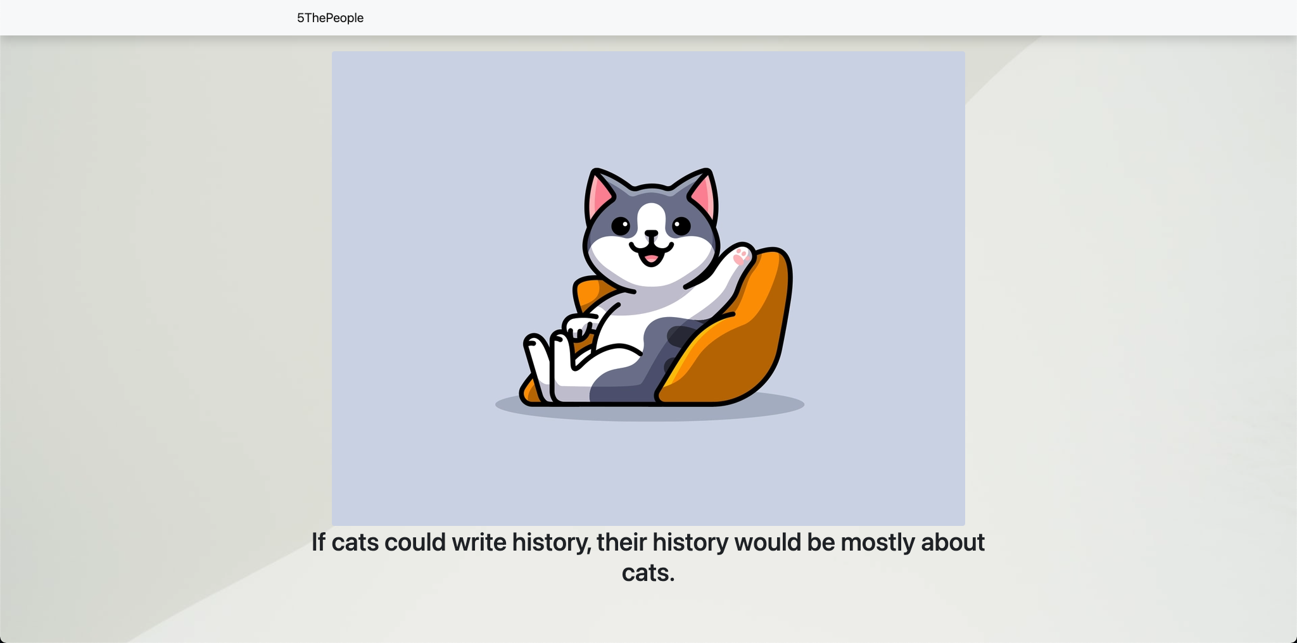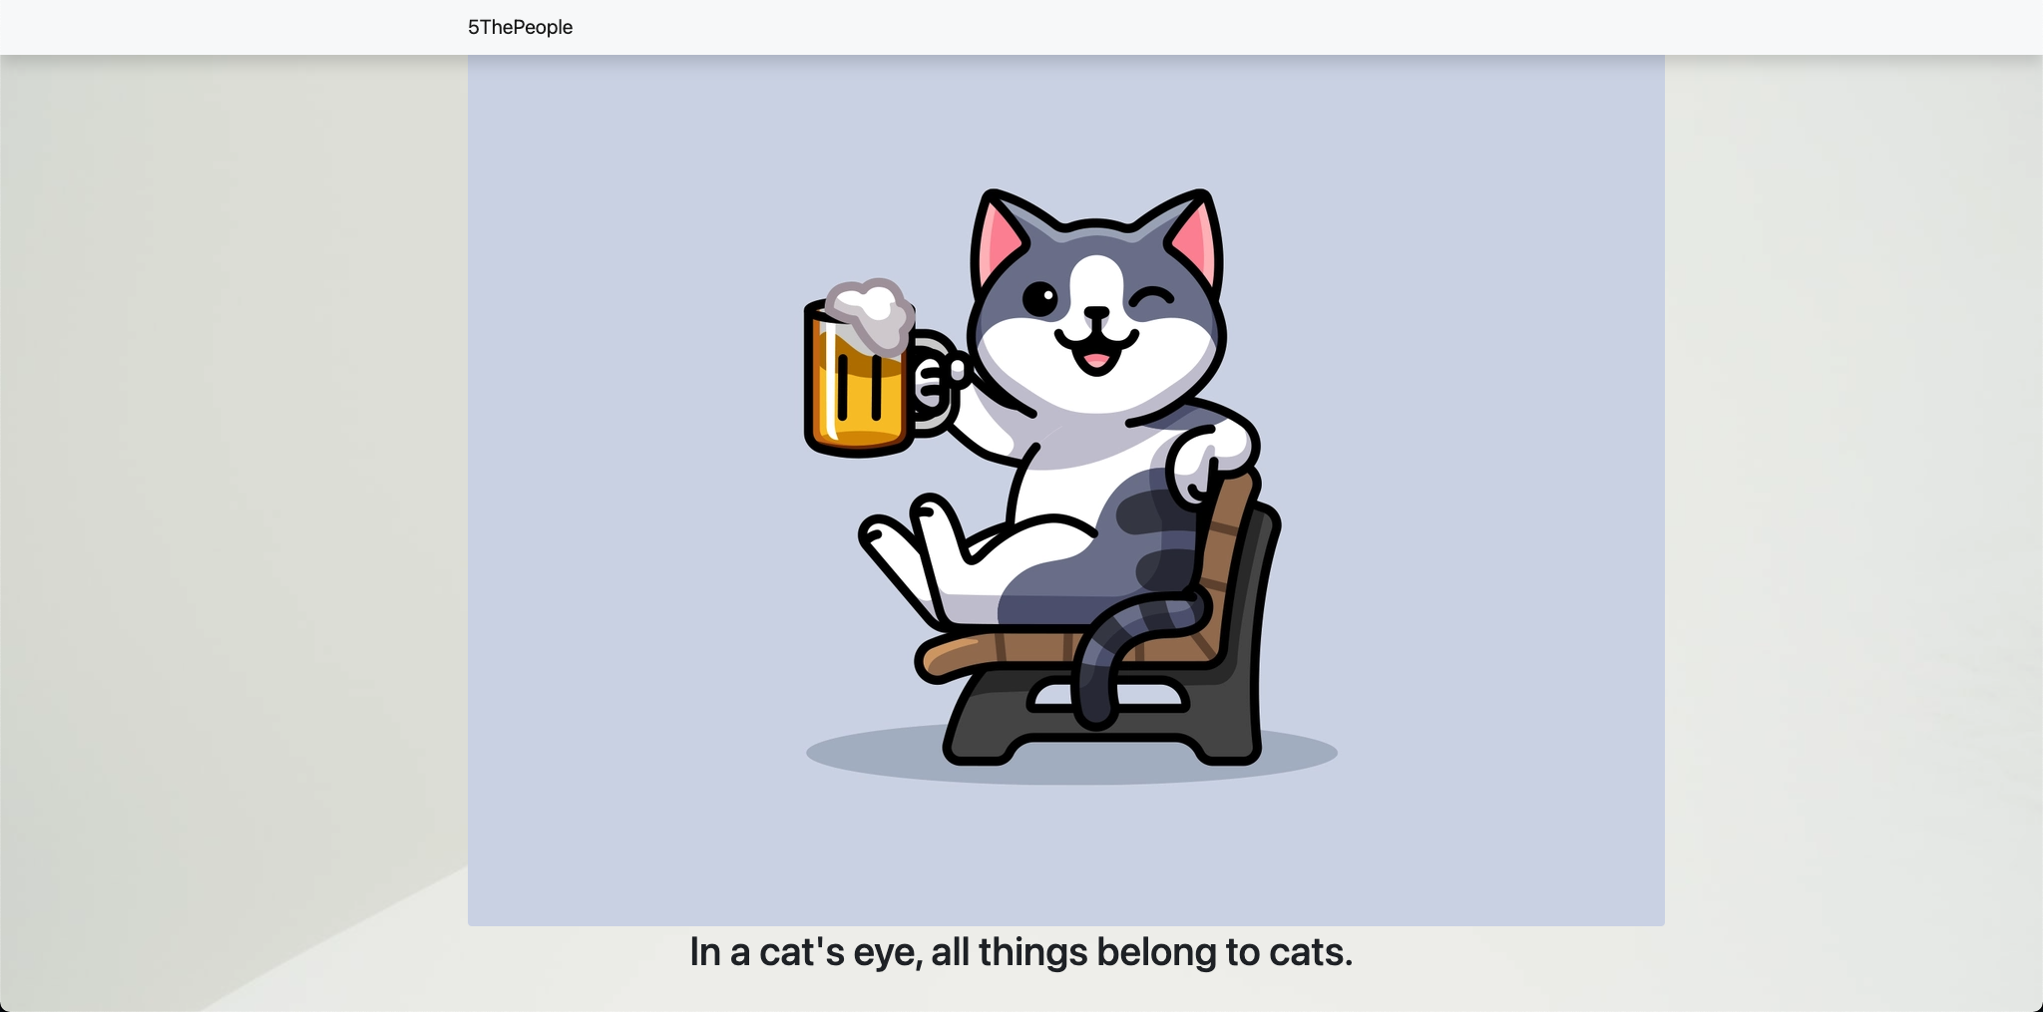*

*Figure 2: Screenshot 2*

*Figure 3: Screenshot 3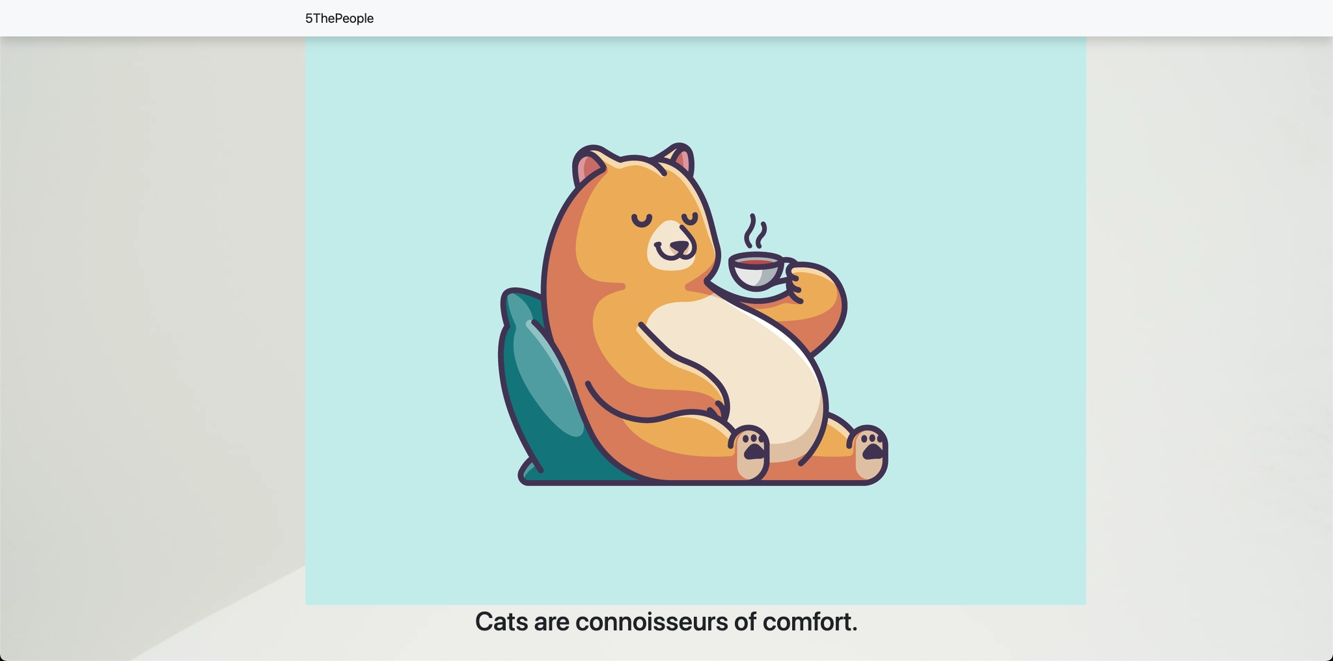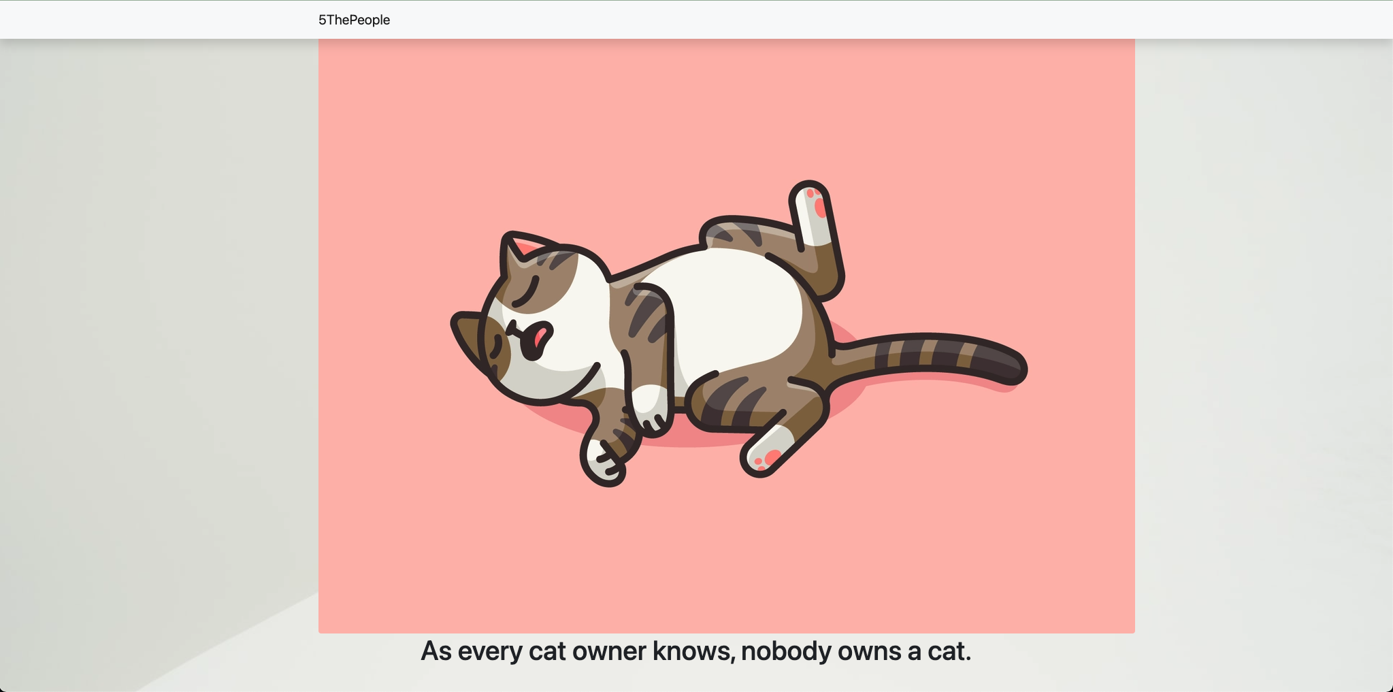*

*Figure 4: Screenshot 4*

*Figure 5: Screenshot 5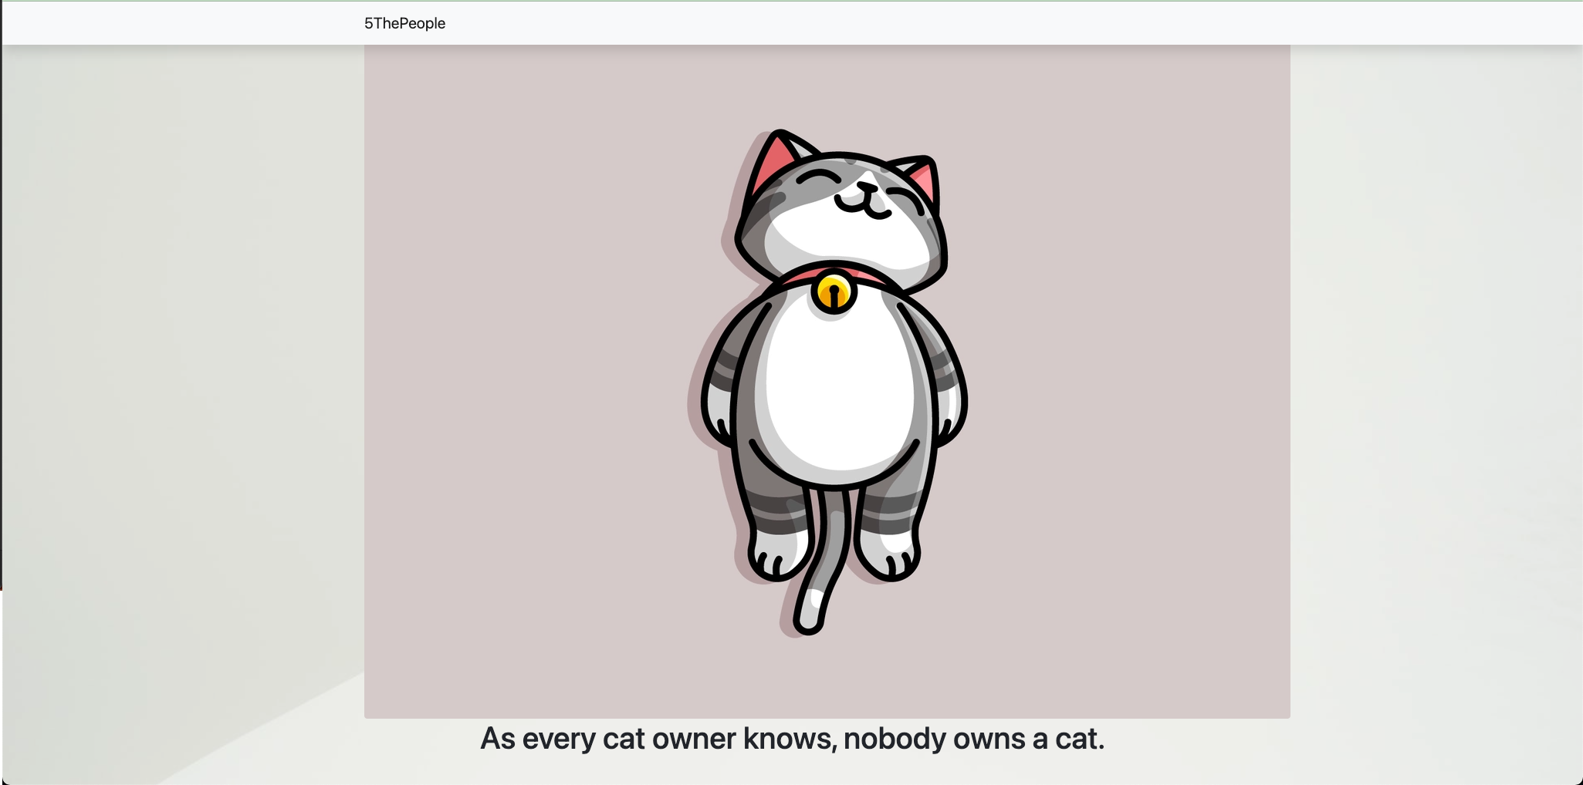*

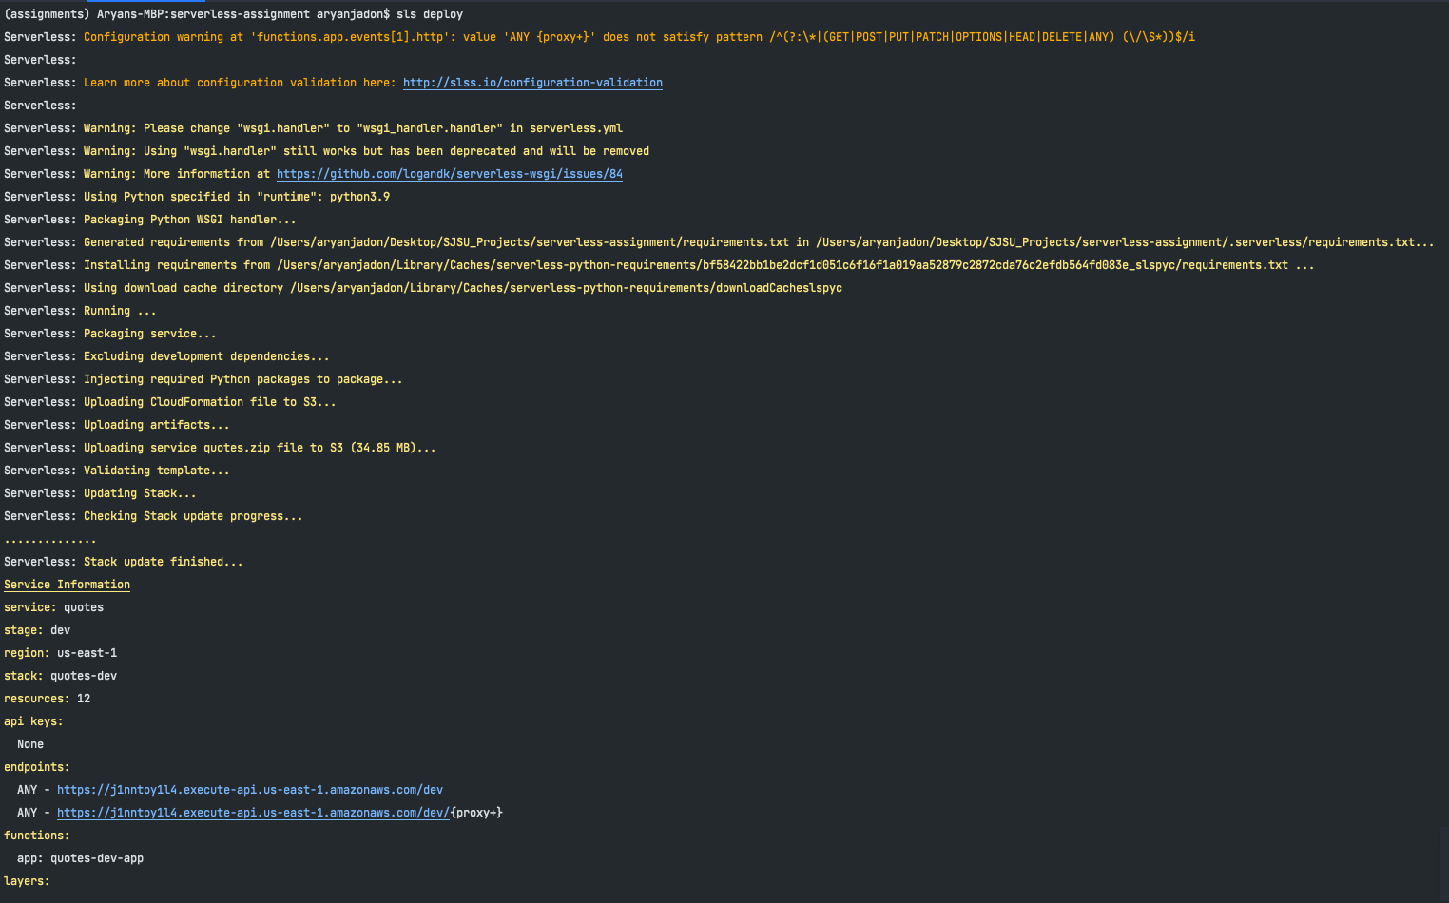

*Figure 6: Screenshot 6 - Serverless Deployment Console*

# Reference -

1. <https://aws.amazon.com/serverless/>
2. <https://aws.amazon.com/lambda/serverless-architectures-learn-more/>
3. <https://www.serverless.com/framework/docs/providers/aws/>