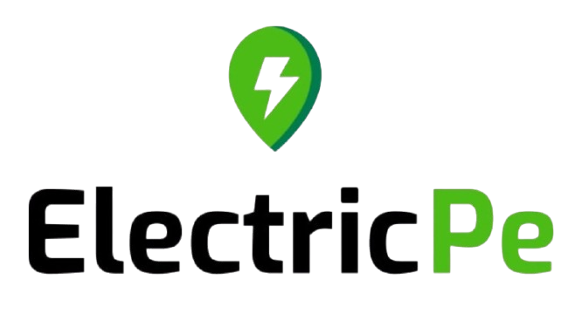

Lead-to-Delivery Performance and Customer Insights Report

1. Overview
This report analyses the lead-to-delivery performance of ElectricPe stores based on real operational data. The goal is to understand how efficiently leads are being converted, how long each stage of the delivery process takes, and what factors are affecting cancellations and customer satisfaction.
The dataset contained 1,000 total leads across four city stores. Using Excel-based analysis, several performance indicators were calculated, including conversion rates, turnaround times (TAT), and customer ratings.

2. Key Insights from the Analysis

A. Lead Conversion
- Out of 1,000 total leads, around 81.2% were successfully delivered.
- The conversion funnel shows a consistent trend across stores once pre-booking happens—indicating strong execution from booking to delivery.
- However, there’s still an untapped potential in improving pre-bookings from initial leads.

B. Delivery Turnaround Time (TAT)
- The average delivery time from lead creation to delivery is 10.6 (10-11) days. - Store-wise variation is low, but minor operational delays appear between booking and delivery in some regions.
- Compared to industry averages, Ather Energy and Ola Electric maintain a TAT of 8–9 days, meaning ElectricPe is slightly behind the top Competitors in Operational speed.

C. Cancellation Patterns
- The overall cancellation rate is 27.1%, mostly due to Price Sensitivity and Financing Issues.
- In comparison, major EV startups like Ola Electric report cancellation rates around 20-22%, indicating ElectricPe’s rate is higher. -Around 40-45 % of cancellations are financially motivated, which signals a need for flexible pricing and finance options.

D. Customer Ratings
- The average customer satisfaction rating is 4.9 out of 10.
- Competitors like Ather Energy and TVS iQube average around 7–8/10 in after-sales satisfaction, showing a gap in customer satisfaction and engagement for ElectricPe.

E. Lead Quality Distribution
- Leads are distributed as Hot (30%), Warm (50%), and Cold (20%).
- The Warm segment has potential but needs focused nurturing strategies as conversion of this segment into bookings needs improvement without major marketing expenses.

3. Bottlenecks
1. Higher-than-expected cancellation rate (27%), mainly due to pricing and financing.
2. Customer satisfaction gap with ratings significantly lower than industry peers.
3. Warm leads not converting effectively, indicating lack of timely follow-ups.
4. Inconsistent delivery time slightly above EV market averages. (10-11 days vs 8-9 days)
5. Limited post-delivery engagement, which may affect repeat purchases or referrals.

4. Recommendations

A. Lead Conversion Improvement
- Automated Follow-up Triggers using lead management system, especially for Warm leads.
- Personalized communication through WhatsApp/calls for leads who show initial interests.
- Sales training focused on long-term cost-benefit education.

B. Reduce Delivery TAT
- Unified Delivery Dashboard across stores for centralized delivery tracking to detect bottlenecks in real time.
- Better coordination between sales and operations. (can reduce TAT by 1-1.5 days)
- Implement weekly delivery windows like Ather Electric. (ensuring predictable TAT)

C. Enhance Customer Satisfaction
- Follow-up call within 48 hours post-delivery, ensuring quick resolution of customer issues.
- Reward high ratings by Customers with vouchers or credits.
- Share expected delivery dates proactively for Transparency and building Customer Trust.

D. Reduce Cancellations
- Partnership with EV finance companies to introduce flexible financing options. (EMI plans)
- Transparent cost communication during pre-booking to avoid “hidden cost” perception.
- Real-time alerts for model availability to prevent bookings for unavailable models.

E. Strengthen Service Follow-ups
- Assign dedicated lead owners, for single point of contact throughout the funnel.
- Integrate lead and feedback data into a single CRM platform for cross-functional insights.

5. Expected Outcomes & Industry Benchmark Comparison
Focus Area | Current | Industry Benchmark | Target (post-improvement) | Expected Impact
Lead-to-Delivery Conversion | 81.2% | ~85% (Ather, Ola) | 86–88% | 5–7% increase in conversions
Average Delivery TAT | 10-11 days | 8–9 days | 8-9 days | 1–1.5 days faster deliveries
Cancellation Rate | 27.1% | 20–22% | 19–21% | ~6–8% reduction
Average Rating | 4.9/10 | 7–8/10 | 6.5–7.5/10 | +1.5–2 point improvement

6. Conclusion
The analysis shows that ElectricPe’s operations are fairly strong but can be optimized further. Key opportunities lie in improving customer experience, nurturing mid-funnel leads, and reducing cancellations. With strategic improvements and technology-driven execution, ElectricPe can align with or surpass industry benchmarks, achieving both operational efficiency and customer trust in the EV ecosystem.

