EV CHARGER REPORT
Name: Aryan Singh Maurya
Project Name: GAP-6225: ICMR - CAR Centre of Advanced Research and Innovations in Assistive and Rehabilitative Technologies for the elderly and Disabled Individuals.

ASSIGNED TASK AND ITS OBJECTIVE:

The main aim is to design and develop an AC-DC Boost Power Factor Correction (PFC) cascaded with an isolated Phase-Shift Full Bridge (PSFB) DC-DC converter. The initial work started simulation of AC-DC Boost PFC open loop configuration, followed by implementation of a Phase Shift Full Bridge Rectifier. The work also included studying and applying carrier based PWM techniques, Close loop control strategy, and small signal modelling. Based on these, control techniques for a AC-DC Boost PFC with Phase shift full bridge Rectifier is designed.
The Phase-Shift Full-Bridge (PSFB) converter is commonly used in high-power DC–DC applications because it provides high-frequency operation, electrical isolation, and good efficiency. In our system, the output power is controlled by changing the phase shift between the switching signals of the two pairs of switching device. Because of this it makes possible and easier to regulate the output voltage while keeping the switching frequency constant. The main challenges in the Phase Shift Full Bridge converter is switching losses and maintaining soft-switching (ZVS) for variable load.
The primary sub-objective of this work is to design and implement a Phase shift Full Bridge converter system with a suitable control strategies to achieve stable and efficient operation. This included developing a good theoretical and practical understanding of phase-shift modulation technique, high-frequency transformer operation, and output filtering required for the converter.
To control these type of system, PI -based control strategy is widely used. PI controller works by predicting the future behaviour of the system which is desired output of the system and selecting the best control action based on a real time output of the system. It is popular because it is simple and easier to implement and provides the reliable and efficient control to the system. In this Phase Shift Full Bridge Converter stage, the output voltage is controlled by adjusting the phase shift between the bridge switching signals, while the switching frequency is maintained at a constant value. Because of this closed loop control strategy I achieve stable operation, good voltage regulation, and reduced output ripple.
However, the commonly used PI controller has some limitations. Its performance completely depends on how well and perfectly the PI gains (Kp,Ki) are tuned.. If the gains are not properly tuned then the system may show overshoot, slower response, or longer settling time, especially when the load changes. The Phase Shift Full Bridge converter also has some abnormal behaviour because of some factors like transformer leakage inductance, circulating current, and changes in operating conditions such as variable load , these affects the controller's performance.
The AC–DC Boost PFC converter is the first stage of the EV charging system. Its main purpose is to convert the rectified AC voltage into a stable DC link while also improving the input power factor which is close to ideal 1. The converter system design consists of an input rectifier, boost inductor, power switch, diode, and DC-link capacitor. By controlling the duty cycle of the switch, the input current is shaped to follow the input voltage, while the output DC-link voltage is maintained at the desired level. In this work, the Boost PFC operates at a 50 kHz switching frequency and supplies the regulated 400 V DC to the next stage, which is the Phase-Shift Full-Bridge converter.
In this work, AC-DC Boost PFC and PSFB converter is designed and analysed for efficient power conversion from a AC input to the desired low voltage DC output. The Boost PFC stage is used to obtain a regulated 400 V DC link while by improving the input power factor, and then the PSFB converter converts this DC-link voltage to a regulated 24 V DC output. This complete system is designed under the rated 1kW load condition, with suitable control strategies implemented to maintain stable output voltage and current.
OBJECTIVES
The main objectives of this work are:
- To design and simulate an AC–DC Boost PFC converter for a 400 V DC link in MATLAB/Simulink.
- To design and develop a Phase-Shift Full-Bridge converter for 24 V DC output in MATLAB/Simulink.
- To implement suitable PI-based control strategies for both stages.
- To analyse the system performance in terms of voltage regulation, power factor, ripple, and stability.
- Hardware testing of a DC-DC Buck converter.
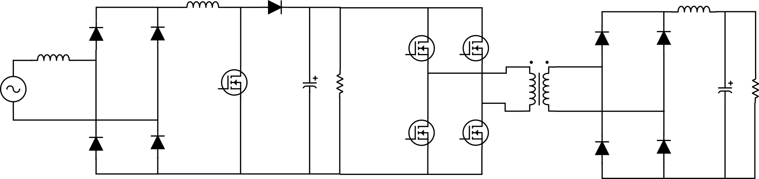

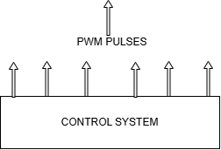
Fig1: complete system architecture

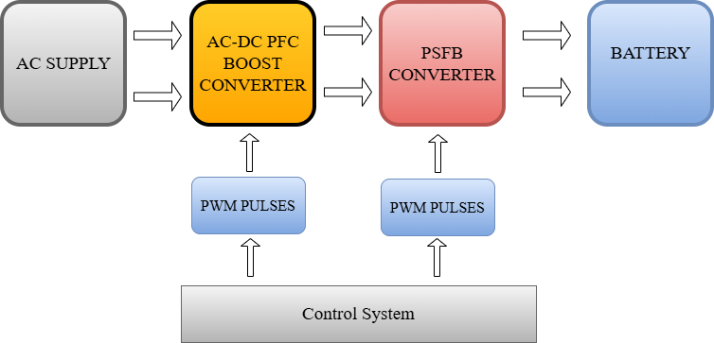

Fig2: System level block diagram

1. AC-DC PFC BOOST CONVERTER

AC-DC PFC converter design is the first step of our complete charging system, the idea of this converter is to take input an AC supply, rectifies it, and produces a stable 400 V DC link output for the next stage of the converter. Here the input supple is 325 V AC, and the system is designed for the rated load of 1kW. The converter operates at a fixed switching frequency of 50 kHz, which helps in achieving better control and reduced size of passive components.

The PFC converter is designed by using the bridge rectifier, boost inductor, power switch, boost diode, and a DC-link capacitor. First, the AC input voltage is converted into an unregulated pulsating DC voltage using the rectifier. Then This voltage is then fed into the boost converter .Our required output voltage (400 V DC) is higher than the rectified input voltage ,so the boost converter used here to steps up the voltage to the desired output level and maintains it at the DC link voltage.

Important calculations formulas:
Output voltage: $Vout=\frac{Vin}{1-D}$

Duty cycle: $D=1-\frac{Vin}{Vout}$

Boost Inductor value: $L=\frac{Vin*D}{∆Il*fs}$

DC –Link capacitor value: $C=\frac{Iout*D}{fs∆Vdc}$

Power Factor = $PF=\frac{P}{\sqrt{p^{2}}+√q^{2}}$

One of the main roles of PFC converter is to improve the power factor. In a normal uncontrolled rectifier, the input current becomes highly distorted and does not follow the input voltage waveform. This results to poor power quality and higher harmonic distortion. In our designed system, the switch (MOSFET) in the boost converter is controlled in way so that the input current closely follows the shape of the input voltage waveform. Thus this makes the complete system significantly of good power factor and reduced harmonics distortion.

To achieve this power factor close to 1 and total harmonics distortion <5% I implemented, a closed-loop control system .Here the output DC-link voltage is continuously measured and it is compared with the reference value of 400 V. now the error is processed through a controller, which generates the required current reference for current control. Based on this control, the PWM signals for the boost switch (MOSFET) are generated at 50 kHz switching frequency. This controller ensures that the DC-link voltage remains stable at 400V even when there are some changes in load or input supply conditions.

In this converter the boost inductor plays a very important role. It smoothes the input current and makes a limits on its rate of change, this limit on rate of change helps in reducing ripple and improving current quality. In the same way the DC-link capacitor acts as an energy tank. It stores energy and provides a steady DC output to the next stage of power conversion, it ensures that the PSFB converter receives a stable input voltage. Correct value of both the inductor and capacitor is important for maintaining good steady-state values.

The performance of the PFC converter is now analysed by observing waveforms such as input voltage, input current, inductor current, switching pulses, and DC-link voltage. PFC converter should shows that DC-link voltage quickly settles around 400 V, while the input current is closely following the input voltage waveform. And the total harmonics distortion is also under the limit of less than 5%.

Now, the regulated 400 V DC output from the PFC converter is supplied to the Phase-Shift Full-Bridge converter, which is the second stage of the EV charging system. Because of this, the performance of the PFC stage directly affects the overall system stability and efficiency. This PSFB converter ensures that both stable DC-link regulation and improved power quality, makes it a crucial part of the our1 kW EV charger.

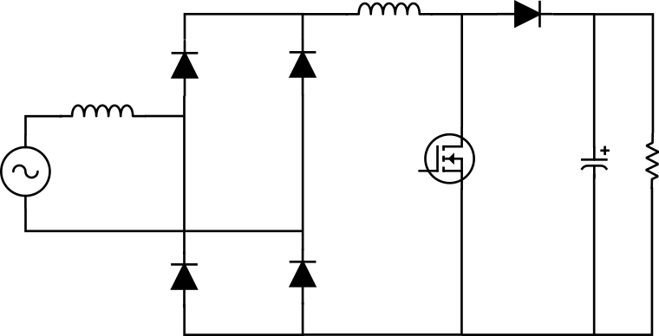

Figure3. AC-DC PFC circuit

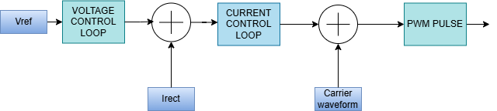

Figure4 .Control Loop Architecture

Results and Findings:

First I perform testing of the AC–DC PFC boost converter in open-loop mode .Without feedback control, it showed poor DC-link voltage regulation and a high input current THD of around 28.6%.

To fix this, i implemented average current mode control. This made a big difference in power quality, pulling down the current THD down to 1.73% and brings the power factor up to 0.993 approx. after testing it on the variable load from 500kW to 1KW the controller handles the voltage settled perfectly to the desired output of 400V DC.

For the next stage of its testing I tested it on both variable load an input supply, by keeping the variation in load and supply doesn’t affected our desired output, controller handles the changes of load and supply perfectly and delivered a desired output of 400V DC.
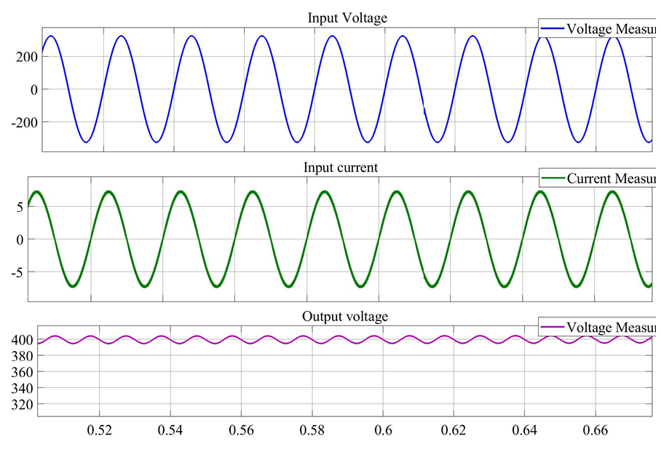

- Here we can see from the output waveform of the PFC converter where output voltage is around 400V DC, AC RMS input current is around 6.35Ampere and Ac input RMS Voltage is 230V which is similar to our desired voltage and current, Thus this shows that our converter is working perfectly.
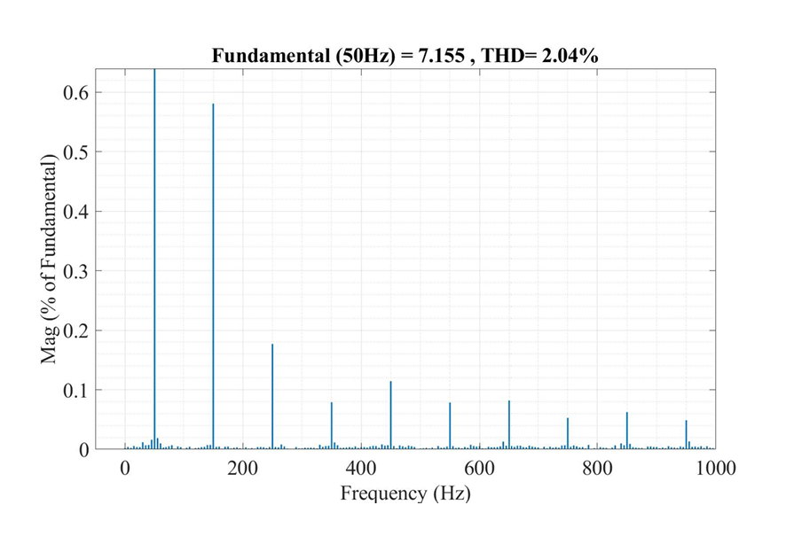
* This time-domain plot shows that the input AC current forms a clean, smooth sine wave with a peak around 7.15 A. The waveform is stable and symmetrical in the complete window with no distortion. This shows that the closed-loop PFC controller is working perfectly and shaping the current to follow the grid voltage and keeps the harmonics low during steady-state operation.
* Here we can see from the THD graph that the main fundamental current is at 50 Hz with a peak of 7.155 A. The overall distortion level is 2.04% which is well below the standard 5% limit. It also shows that some minor odd harmonics coming up mainly the 3rd at 150 Hz (0.58%) and the 5th at 250 Hz (0.18%) but the higher-frequency noise is practically zero. This confirms that the PFC controller working perfectly and pulling a clean sine wave from the grid.
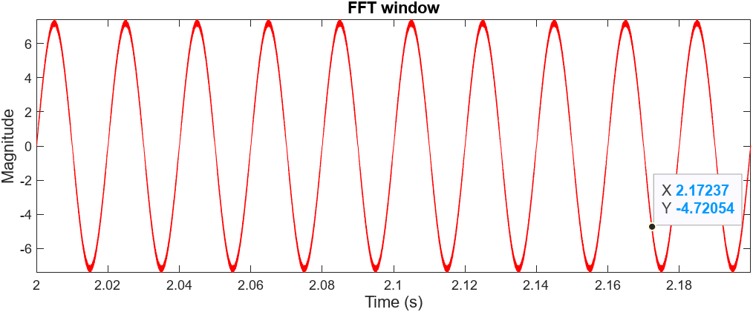

Overall Observation:

PARAMETERS | TARGET VALUE | MEASURED VALUE
Input AC Voltage | 325Vpeak | 325Vpeak
Output DC-Link Voltage | 400VDC | 400VDC
Power Factor(PF) | ≈1.0 | 0.999
Total Harmonic Distortion(THD) | ≤5% | 1.73%
AC Input RMS Current | - | 6.36 A
Input Peak Current(Ipeak) | - | 9.0 A
Inductor Ripple Current | - | 18.0 A

2. PHASE SHIFT FULL BRIDGE CONVERTER

The Phase-Shift Full-Bridge (PSFB) DC–DC converter is the second stage of the EV charging system. Its takes the regulated 400 V DC-link voltage supplied by the PFC converter, The main purpose of this converter is to isolate the vehicle from the main power grid for safety, and step down the voltage to safely charge the electric vehicle's battery pack. Here the converter takes the 400 V DC input and delivers the required charging voltage 24V DC and current corresponding to the 1 kW rated power capacity. To keep switching losses low and maintain high efficiency, the converter operates at a high switching frequency of 50 kHz.

The PSFB Converter key components are full-bridge inverter using four power switches (MOSFET), a high-frequency isolation transformer, a secondary-side rectifier, and an output LC filter. The four switches (MOSFET) in the full-bridge network are arranged in two vertical legs: the left leg and the right leg. In the PSFB controlling the output Instead of by varying the duty cycle of individual switches, the PSFB control system keeps the duty cycle of each switch constant at nearly 50% and varies the phase shift between the gate signals of the two legs. This adjustment of phase angle directly controls the amount of power transferred to the high-frequency transformer primary side.

One of the biggest advantages of using the phase-shift technique is that it enables Zero-Voltage Switching (ZVS) for the primary power switches (MOSFET). During the dead-time interval between the turning off of one switch and the turning on of another in the same leg, the energy stored in the leakage inductance of the transformer discharges the parasitic capacitances of the switches. Because of this switches turn on when the voltage across them is zero, this reduces switching losses and heat generation. This soft-switching capability is very important for running the converter at a high switching frequency of 50 kHz by maintaining high overall efficiency..

The high-frequency transformer plays a dual role in this converter. Firstly, it provides galvanic isolation between the high-voltage DC link and the EV battery, this protects both the user and the battery management system from grid faults. Second one is that its turn ratio steps down the 400 V DC link to the voltage levels needed by the battery pack ( 24 V).
On the secondary side of the transformer, the high-frequency AC output is rectified back into DC using a diode bridge.

For delivering clean charging current to the EV battery, an output filter consist of an inductor and a capacitor is placed after the secondary rectifier. The filter inductor limits the output current ripple, while the output capacitor smoothes out any remaining voltage fluctuations. A closed-loop control system continuously controls the output voltage and current supplied to the battery. Depending on the charging requirements, the controller adjusts the phase-shift angle between the inverter legs to regulate either constant current (CC) or constant voltage (CV) modes.
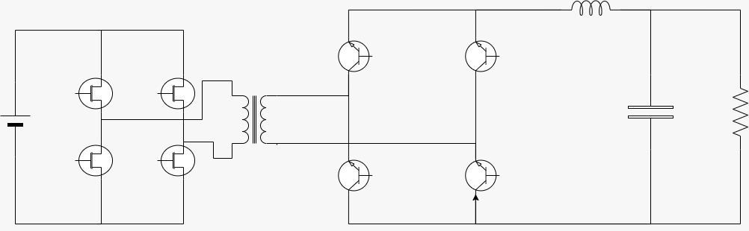

Figure5 .Phase Shift Full Bridge Architecture

Important calculations formulas:

Transformer turn ratio: $Turn Ratio=\frac{VS}{VP}$

Inductor Value: $L=Vl*D*\frac{Ts}{Iripple}$ * $Vl=Vin\frac{VS}{VP}-Vout$

Capacitor Value: $C=Iripple*D*\frac{Ts}{Vripple}$

Results and Findings:

Firstly I started testing the PSFB converter in open-loop mode to establish a baseline. Without feedback control, it showed poor load regulation and an output voltage ripple.

To fix this ripple, i implemented a closed-loop phase-shift controller. This made helps in output voltage regulation. When i put a change in load variation from 500kW to 1kw this closed loop control system perfectly adjusted the output voltage to 24V.

The closed-loop setup also helped maintain Zero-Voltage Switching (ZVS) for the rated load, which cut down primary switching losses. Because of this, the converter efficiently perform good under various dynamic conditions.
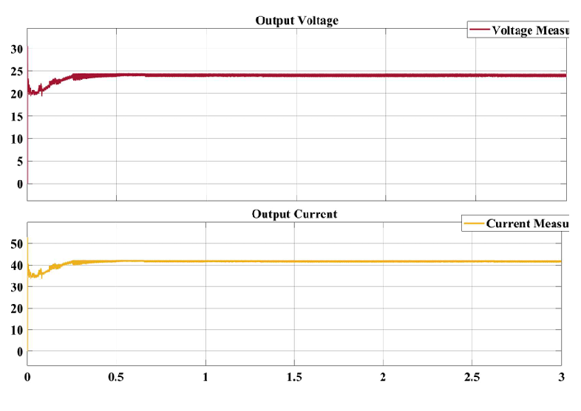

Figure6 .Phase Shift Full Bridge Rectifier Output waveform

- Here we can see from the output waveform of the PSFB that the output voltage is around 24V and current is around 41.66 Ampere, which is similar to our desired voltage and current ,Thus this shows that our converter is working perfectly.

Overall Observation:

Overall, applying closed-loop phase-shift control improved both output regulation and overall efficiency, these are the overall results of our PSFB converter:

PARAMETERS | TARGET VALUE | MEASURED VALUE
Input DC-Link Voltage(V) | 400V(dc-link) | 325Vpeak
Output Voltage(DC) | 24V | 24V
Output Current | 41.66Amp | 41.66Amp
Transformer Turn Ratio(Ns/Np) | 0.07 | -
Load | 1KW | -
Frequency | 100KHz | -

3. HARDWARE TESTING OF BUCK CONVERTER
Before going to hardware testing of the converter, I did some of the related hardware projects which are part of the EV charging system. This includes ESP32-based data acquisition system for monitoring parameters such as voltage, current, and temperature, along with the generation of Phase-Shift complementary PWM generation using a TI controller. These projects help in the important measurement and control setup required for the hardware testing of the buck converter.
3.1 ESP32-BASED DATA ACQUISITION SYSTEM
I made a data acquisition system using an ESP32 microcontroller to monitor converter, battery, chargers etc. parameters in real time and save it to the external storage memory card. The data acquisition system as of now stores voltage, current, and temperature during operation of a system.
The data acquisition system includes a DHT22 temperature sensor, a current sensor, and a voltage sensing circuit. These sensors are used to monitor thermal conditions, load current, and DC voltage levels of a device and then store these values via serial monitor in a external storage memory card in comma separated file (CSV) format.
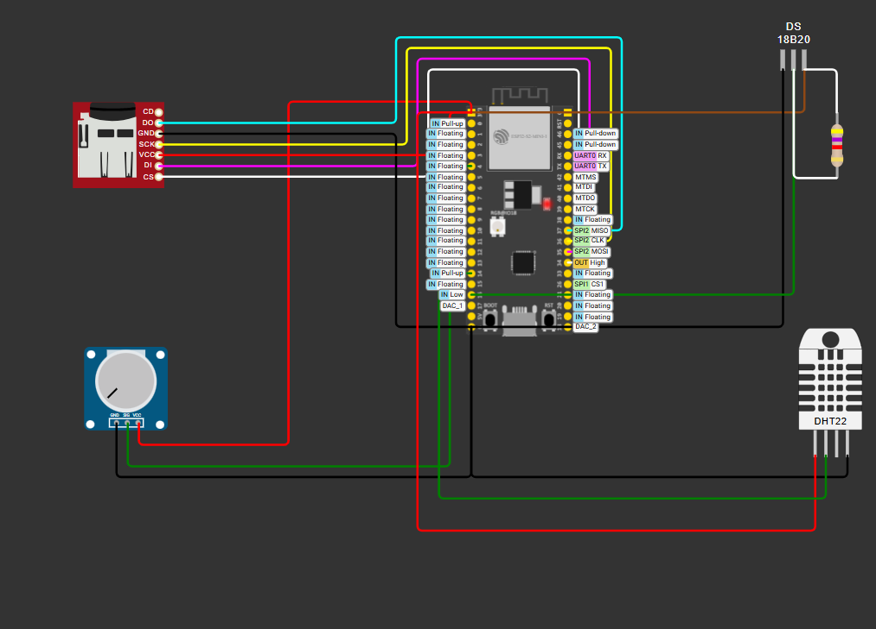
Figure7: Data Acquisition system using esp32

3.2 MICROCONTROLLER PROGRAMMING ON TI BOARD
I generated the Phase-Shift Full-Bridge PWM signals using a TI microcontroller F28027F.
The ePWM is generated on the J6(6 GPIOS) and J2(2 GPIOS) total of 8 PWM signals in which they are complementary with respect to each other.
I had also added a phase shift of 90 degree, dead time of 200ns and the parameters are frequency of 100KHz with duty cycle 30% for smooth and stable operation of a hardware circuit .dead time prevents a circuit from prevent shoot-through currents
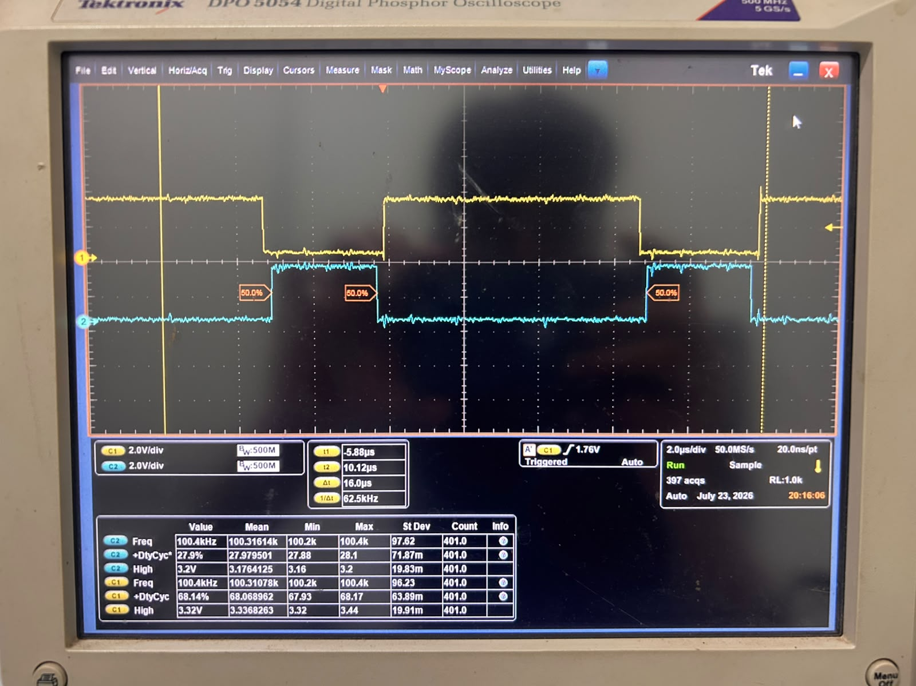
Figure8: Complementary PWM with valid dead time
3.3 HARDWARE TESTING OF DC–DC BUCK CONVERTER
The goal of hardware testing of the DC–DC Buck converter is to check and ensure that all the individual sections are working properly before going for full-power operation. The main idea behind this stage is to check each part separately like the isolated power supplies, gate driver circuits, PWM signals, and voltage sensing circuit so that if any issue is found then it is caught early and fixed before full-power.
I started with the isolated DC–DC converter modules (U1 and U2) . A low input supply is about 5.2 V is measured to both modules. After measurement both of them produced a stable output of around 15.5 V. This shows that the isolated supply section is working properly and is able to provide sufficient voltage for the gate driver circuits.
After that, I checked the MOSFET gate driver circuits (U18 and U19) . I measured the gate-to-source voltage and found it to be around +15.5 V and −4.5 V. This verifies that the driver is correctly generating both turn-on and turn-off signals required for proper switching.
Next, I checked the PWM signals for the high-side and low-side MOSFETs using an oscilloscope. The signals are complementary, which is necessary for proper buck converter operation. It also shows a clear dead time of about 200 ns between the switching transitions to avoid shoot-through. The switching frequency measured as 100 kHz, and the duty cycle around 30%.

Figure9: MOSFET Gate signal with dead time
In the end I checked the isolated voltage sensing circuit (U4). Where an input of about 5.5V is measured, the output measured to be approximately 5.2 V. This indicates that the sensing circuit is working correctly and is providing an accurate and isolated version of the input voltage, which is important for feedback and monitoring.

Results and Findings:
During testing when i connected the power supply to the converter, I found that desired output voltage is not getting observed and also observed that the converter is not drawing the expected current from the input power supply. This tells that although the individual control and supporting circuits are working, the complete power-transfer path is not operating as expected and have some hidden issues
This observed behaviour shows that the some deep debugging in the power stage, switching devices, gate-drive signals, circuit connections, feedback/sensing path, and control operation is still required.
Overall, the initial hardware testing successfully verified several individual key components, but the complete converter is not able to achieve its desirable performance, So debugging and testing are required to identify the real root cause of the limited input-current draw and the incorrect output voltage. This testing of converter provided some useful information about the converter to isolating the problem and improving the converter before attempting higher-power operation.
Conclusion
This complete work focuses on the design and development of a 1 kW EV charging system by using an AC–DC Boost PFC converter cascaded with a Phase-Shift Full-Bridge converter. The PFC converter is designed to obtain a 400 V DC link, while the PSFB converter stage is designed for a 24 V DC output at 50 kHz. Along with this simulation work, I also designed an ESP32-based data acquisition system and TI-based phase-shift PWM for the hardware implementation. The initial hardware testing confirms that the operation of the key components of buck converter, while it still requires deep debugging to achieve the desired output and current. Overall, this complete work provided me a good foundation for the control, measurement, simulation, and hardware development of the EV charging system.

