# Lab Assignment 1

## 4ITRC2 Operating System Lab

## Introduction

An operating system (OS) is a crucial component of a computer system that manages hardware and software resources, providing a stable environment for applications to run. Ubuntu, a popular Linux-based OS, has gained prominence due to its open-source nature, security, and efficiency. It offers users a free and customizable alternative to proprietary operating systems like Windows and macOS. Ubuntu is widely used for personal computing, servers, cloud computing, and development purposes.

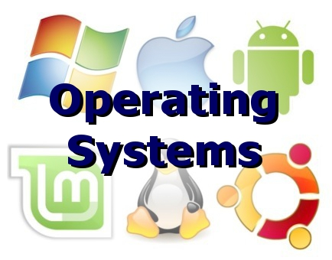

## History



### Origins and Creation (2004 - 2005)

Ubuntu was created by Mark Shuttleworth, a South African entrepreneur and software developer, who previously contributed to Debian, another Linux distribution. Recognizing the complexity of existing Linux distributions for new users, Shuttleworth founded Canonical Ltd. in 2004 to develop Ubuntu, a user-friendly Linux OS based on Debian. Ubuntu 4.10 (Warty Warthog) was the first release, introducing an intuitive interface, simplified software installation, and improved hardware compatibility. The name 'Ubuntu' comes from a Zulu philosophy that means 'humanity to others,' reflecting its community-driven approach.

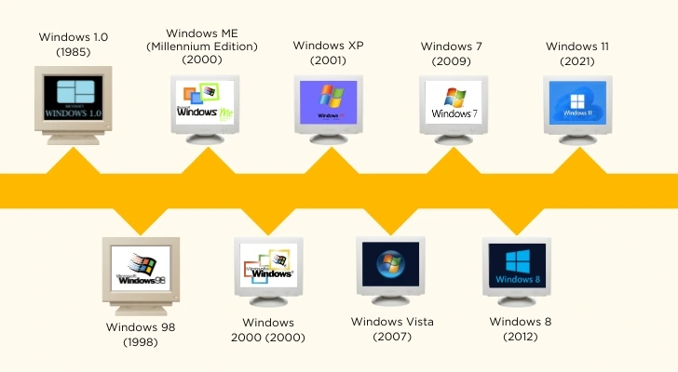

### Early Growth and First LTS Release (2006 - 2009)

Canonical’s dedication to long-term stability led to the release of Ubuntu 6.06 LTS (Dapper Drake) in 2006, marking the first Long-Term Support (LTS) version. LTS releases are supported for extended periods, providing security updates and stability for enterprise users. By 2009, Ubuntu had gained immense popularity among developers, students, and businesses due to its reliability, security, and ease of use.

### Introduction of New Features and UI Enhancements (2010 - 2013)

During this period, Ubuntu saw major improvements in its user interface and system performance. Ubuntu 10.04 LTS (Lucid Lynx) featured a sleek design, faster boot times, and better driver support. However, one of the most significant changes came with Ubuntu 11.04 (Natty Narwhal) in 2011, when Canonical replaced the traditional GNOME desktop environment with Unity. Unity aimed to provide a more modern and touch-friendly experience, though it faced mixed reactions from users.

### Cloud, Snap Packages, and Systemd Integration (2014 - 2018)

As cloud computing became more prevalent, Ubuntu expanded its focus beyond personal computing to cloud environments. Ubuntu Server became a leading choice for cloud providers like AWS and Microsoft Azure. In 2016, Canonical introduced Snap packages, a new packaging system that simplified software installation across different Linux distributions. Additionally, Ubuntu 18.04 LTS (Bionic Beaver) transitioned to Systemd, a system and service manager that enhanced performance and boot efficiency.

### Return to GNOME and Modern Enhancements (2019 - Present)

Starting with Ubuntu 18.04 LTS, Canonical reverted to the GNOME desktop environment, acknowledging user feedback. Ubuntu 20.04 LTS (Focal Fossa) introduced enhanced security, better cloud integration, and an optimized performance for modern hardware. The latest versions, including Ubuntu 22.04 LTS (Jammy Jellyfish), continue to refine the user experience with visual improvements, better ARM support, and AI-driven system optimizations.

### The Future of Ubuntu

Ubuntu is constantly evolving to meet the needs of modern computing. Canonical is investing in artificial intelligence, Internet of Things (IoT), and enterprise solutions, making Ubuntu a key player in technological advancements. With a strong open-source community, Ubuntu continues to push innovation in cloud computing, cybersecurity, and edge computing.

## Features of Ubuntu

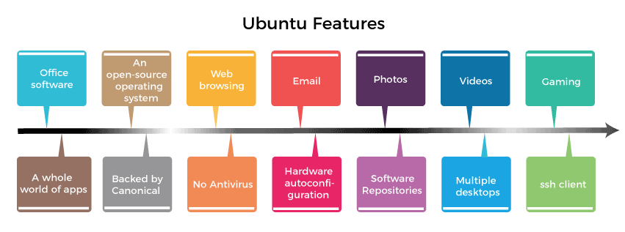

* Ubuntu is completely free and open-source, allowing users to modify and redistribute it freely.
* The GNOME desktop environment offers an intuitive and user-friendly graphical interface.
* Ubuntu is highly secure, featuring built-in security measures such as AppArmor and automatic updates.
* It includes a vast software repository managed through the APT package manager, simplifying software installation.
* It is highly efficient, running smoothly even on older hardware configurations.
* Users can customize the desktop environment with themes, icons, and extensions.
* Ubuntu supports a wide range of programming languages and tools, making it ideal for software development.

## Difference Between Ubuntu and Windows OS

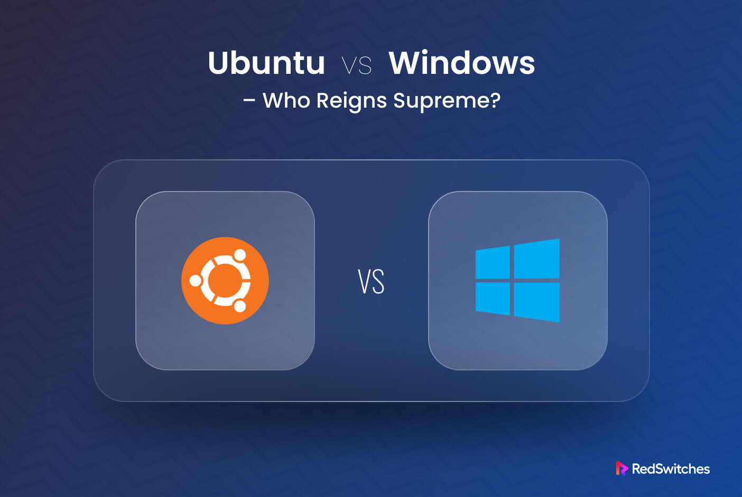

|  |  |
| --- | --- |
| Ubuntu | Windows |
| Ubuntu is free and open-source. | Windows requires a paid license. |
| It is based on the Linux kernel, known for stability and security. | It is based on the NT kernel. |
| Ubuntu uses the GNOME desktop environment, which is highly customizable. | Windows has a fixed interface with limited customization. |
| Software is managed through the APT package manager. | Software installation relies on .exe and .msi files. |
| Ubuntu is less prone to malware and security threats. | Windows is more vulnerable to viruses and cyberattacks. |
| It performs well on older hardware. | Windows requires more system resources to run smoothly. |
| Ubuntu supports multiple desktop environments. | Windows offers a standardized interface with minimal customization options. |
| System updates are frequent and free. | Windows updates may require a valid license upgrade. |
| It is popular for development, cloud computing, and enterprise servers. | Windows is widely used for gaming, office productivity, and general computing. |
| Ubuntu has a command-line-centric approach, which is preferred by developers. | Windows is more graphical user interface (GUI) oriented, with limited CLI use. |