Student Name: ARYAN DAHIYA UID: 24BAI70697
Branch: AIT-CSE-AIML Section/Group: 24AIT_KRG1_B
Semester: 5
Subject Name: ADBMS Subject Code: 24CSP-310

QUESTION A:
You are given with the Employee schema; the task is to find the highest score for each respective department.
For eg: department D1 have the highest score as 5.28. Hence in the output, final updated score for D1 should be 5.28.
Same with the other departments i.e., D2, D3 and D4.
QUERY:
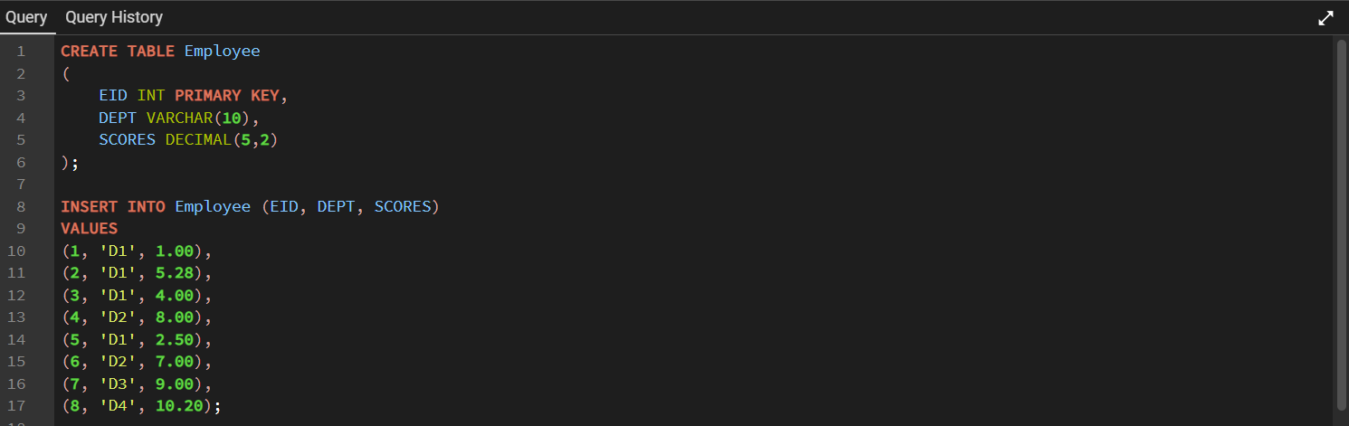
RESULT:
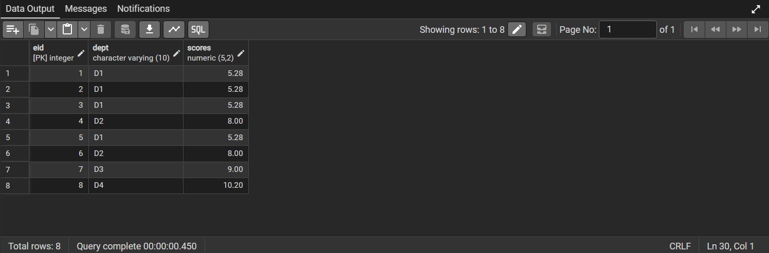

QUESTION B:
A company maintains records of products sold by different salespersons. The management wants to prepare a sales performance report by identifying the salesperson(s) who generated the highest overall sales revenue. If multiple salespersons have the same highest total sales amount, all of them must be included in the final report. Return the seller ID(s) satisfying this condition
QUERY:
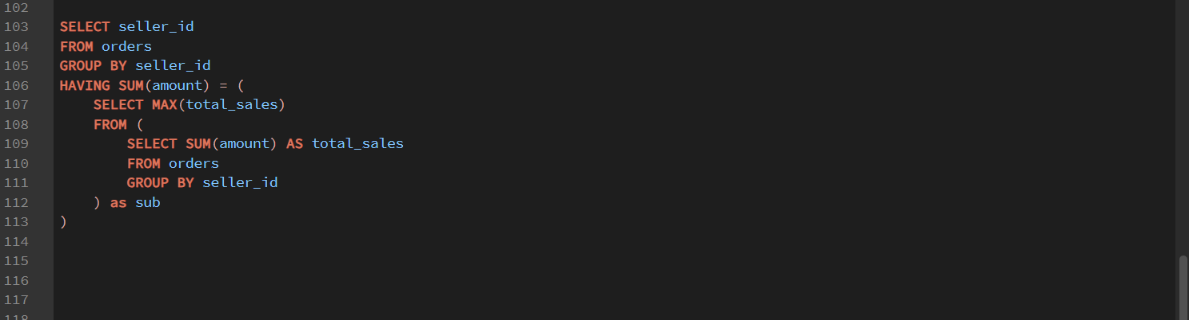
RESULT:
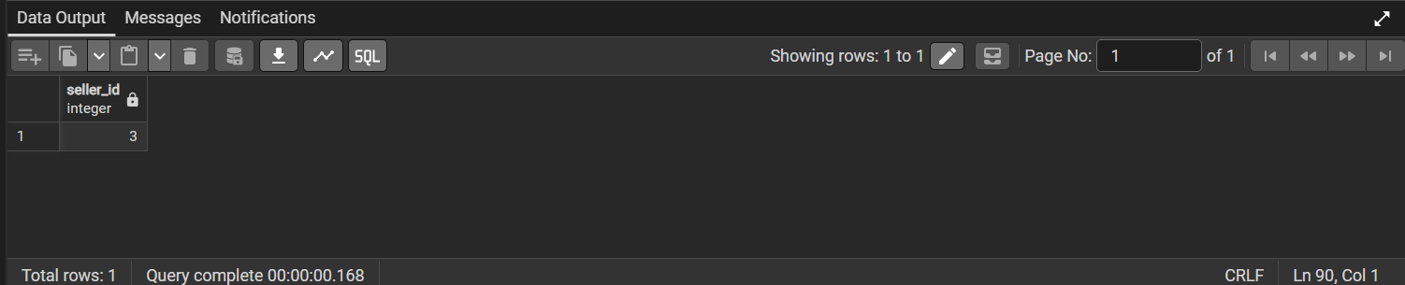

QUESTION C:
A company maintains employee salary records for different departments. The management wants to prepare a report containing employees whose salaries fall among the top three highest distinct salary values within their respective departments. If multiple employees receive the same qualifying salary, all such employees must be included in the final report. Display the department name, employee name, and salary for every qualifying employee.
QUERY:
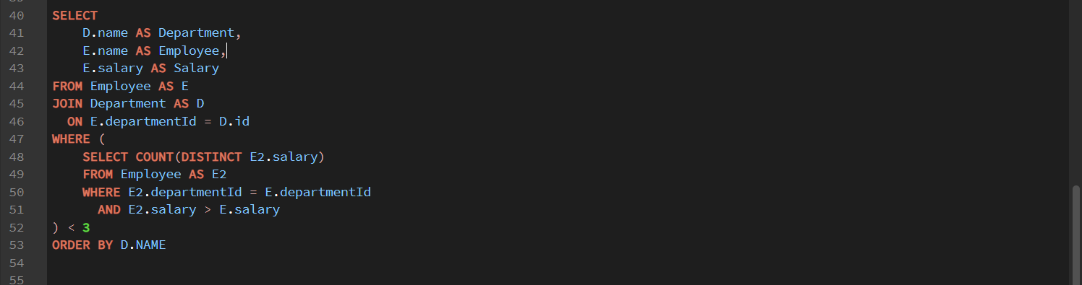
RESULT:

