Student Name: ARYAN DAHIYA UID: 24BAI70697
Branch: AIT-CSE (AIML) Section/Group: 24AIT_KRG2
Semester: 4
Subject Name: Database Management System Subject Code: 24CSH-298

EXPERIMENT – 04
Implementation of Conditional Logic using IF–ELSE and CASE Statements in PostgreSQL

Aim
To implement conditional decision-making logic in PostgreSQL using IF–ELSE constructs and CASE expressions for classification, validation, and rule-based data processing.

Tools Used
• PostgreSQL

Objectives
• To understand conditional execution in SQL
• To implement decision-making logic using CASE expressions
• To simulate real-world rule validation scenarios
• To classify data based on multiple conditions
• To strengthen SQL logic skills required in interviews and backend systems

Theory
In real-world database systems, data often needs to be validated, categorized, or transformed based on business rules. Conditional logic allows the database to make decisions dynamically instead of relying solely on application-layer logic.
PostgreSQL supports conditional logic mainly through:
• CASE Expressions (used inside SELECT, UPDATE, INSERT)
• IF–ELSE constructs (used inside PL/pgSQL blocks such as functions and procedures)

CASE Expression
• Evaluates conditions sequentially
• Returns a value based on the first true condition
• Can be used in SELECT, UPDATE, ORDER BY, and WHERE clauses
Types of CASE
• Simple CASE → compares expressions
• Searched CASE → evaluates boolean conditions

Conditional logic is heavily used in:
• Data classification (grades, salary slabs)
• Violation detection
• Status mapping
• Business rule enforcement

Experiment / Practical Steps

Prerequisite Setup
CREATE TABLE schema_violations (
id SERIAL PRIMARY KEY,
schema_name VARCHAR(50),
violation_count INT
);

INSERT INTO schema_violations (schema_name, violation_count) VALUES
('Finance', 0),
('HR', 2),
('Sales', 5),
('Security', 9),
('Admin', 1);

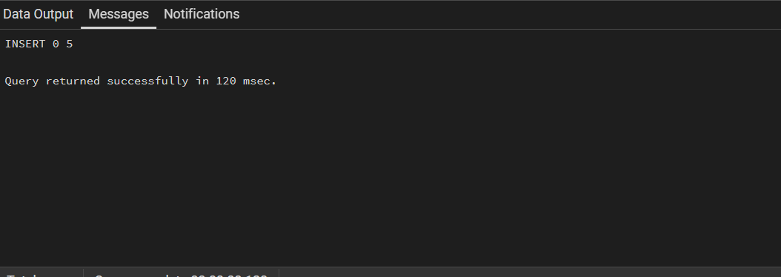
Step 1: Classifying Data Using CASE Expression
SELECT
schema_name,
violation_count,
CASE
WHEN violation_count = 0 THEN 'No Violation'
WHEN violation_count BETWEEN 1 AND 3 THEN 'Minor Violation'
WHEN violation_count BETWEEN 4 AND 7 THEN 'Moderate Violation'
ELSE 'Critical Violation'
END AS violation_status
FROM schema_violations;

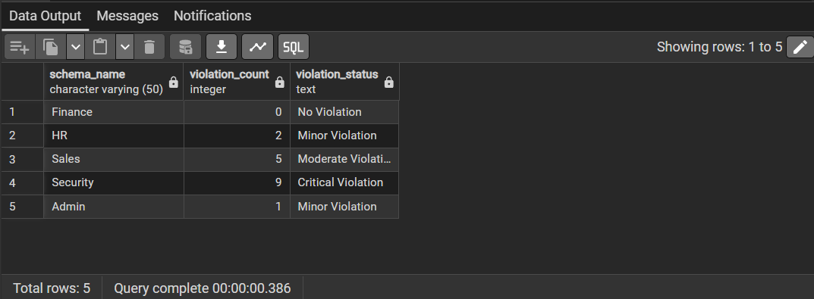

Step 2: Applying CASE Logic in Data Updates
ALTER TABLE schema_violations ADD COLUMN approval_status VARCHAR(20);

UPDATE schema_violations
SET approval_status =
CASE
WHEN violation_count = 0 THEN 'Approved'
WHEN violation_count BETWEEN 1 AND 5 THEN 'Needs Review'
ELSE 'Rejected'
END;

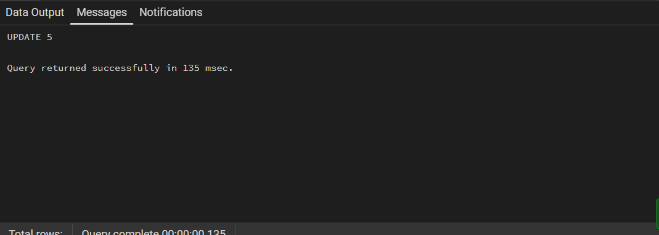

Step 3: Implementing IF–ELSE Logic Using PL/pgSQL
DO $$
DECLARE
v_count INT := 4;
BEGIN
IF v_count = 0 THEN
RAISE NOTICE 'System is clean.';
ELSIF v_count <= 5 THEN
RAISE NOTICE 'System has minor issues.';
ELSE
RAISE NOTICE 'System has critical violations!';
END IF;
END $$;
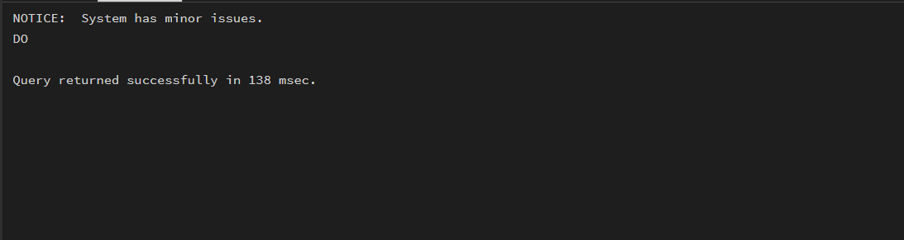

Step 4: Real-World Classification Scenario (Grading System)
CREATE TABLE students (
name VARCHAR(50),
marks INT
);

INSERT INTO students VALUES
('Aryan', 92),
('Riya', 75),
('Karan', 61),
('Megha', 48);

SELECT name, marks,
CASE
WHEN marks >= 90 THEN 'A Grade'
WHEN marks >= 70 THEN 'B Grade'
WHEN marks >= 50 THEN 'C Grade'
ELSE 'Fail'
END AS grade
FROM students;

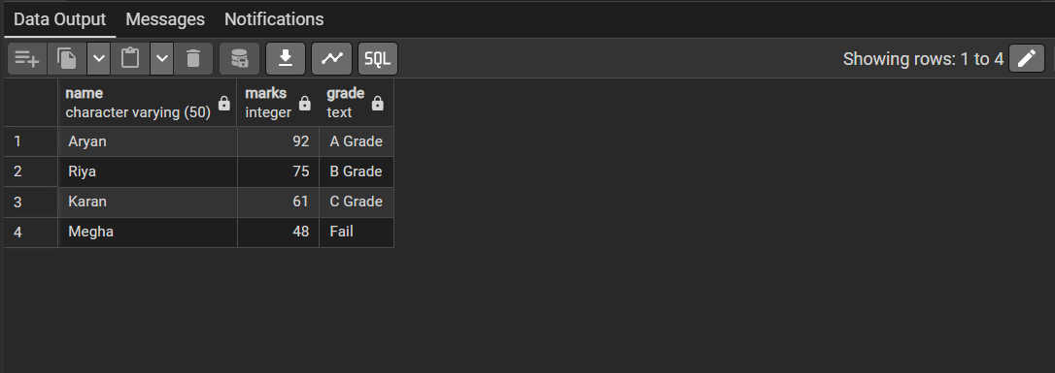

Step 5: Using CASE for Custom Sorting
SELECT schema_name, violation_count
FROM schema_violations
ORDER BY
CASE
WHEN violation_count = 0 THEN 1
WHEN violation_count BETWEEN 1 AND 3 THEN 2
WHEN violation_count BETWEEN 4 AND 7 THEN 3
ELSE 4
END;
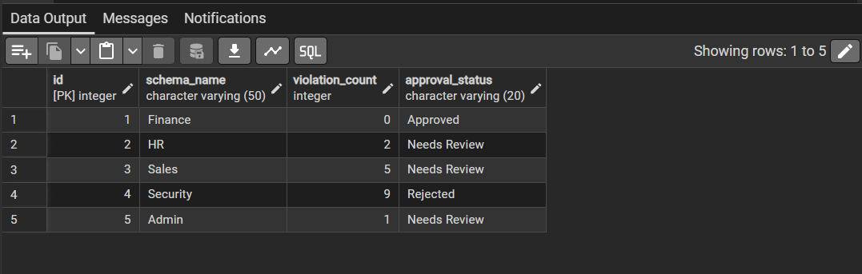

Course Outcome
This experiment demonstrates how conditional logic is implemented in PostgreSQL using CASE expressions and IF–ELSE constructs. Students gain strong command over rule-based SQL logic, which is essential for:
• Backend systems
• Analytics
• Compliance reporting
• Placement and technical interviews

Result
Conditional logic using CASE and IF–ELSE was successfully implemented for classification, approval automation, grading systems, and custom sorting in PostgreSQL.

